Inspection Process
CxOne Standard
0000.doc

December 13, 2002

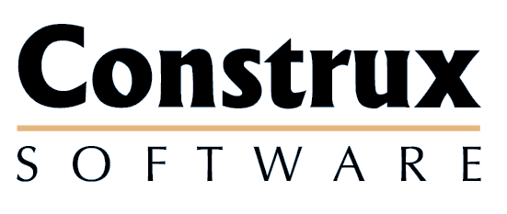

Advancing the Art and
Science of Commercial
Software Engineering
Contents
1 Introduction 1
1.1 Key Terms 1
2 Roles and Tools 2
2.1 Roles 2
2.1.1 Review Roles 2
2.1.2 Project Roles 3
2.2 Inspection Tools 3
2.2.1 Inspection Forms 3
2.2.2 Line Numbering Tool 4
2.2.3 Lines of Code Counter 4
2.2.4 Code Format Verifier 4
3 Inspection 5
3.1 Overview 5
3.2 Process 5
3.2.1 Planning 7
3.2.2 Preparation 8
3.2.3 Inspection Meeting 9
3.2.4 Artifact Appraisal (Outcome) 10
3.2.5 Rework 12
3.2.6 Follow-up 12
3.2.7 Closure 13
4 Reading Inspection 14
4.1 Overview 14
5 Perspectives 15
Copyright Notice
© 2000-2002 Construx Software Builders, Inc. All Rights Reserved.
For further information or support visit www.construx.com.

Introduction
This document defines the CxOne inspection process. CxOne defines any formal review as an inspection, as described in CxStand_ReviewProcess.doc.

Key Terms
Inspection, Reading Inspection, Issue, Moderator, Scribe, Inspector, Editor, Author, Verifier, Sponsor

Roles and Tools

Roles

Review Roles
This section describes all possible roles that can be used in inspections. Individuals can perform more than one role in an inspection.

Author
All artifacts have one or more authors. These people are the major contributors to the artifact and any one of them may represent the artifact in the inspection. The selected author should also inspect the artifact.

Inspectors
One or more individuals other than the author who inspect the designated artifact. Inspectors are generally peers of the author, customers of the artifact, project stakeholders, or quality/testing personnel.
Inspectors may be assigned perspectives to assist in focusing their search for issues in the artifact.
Note: Inspectors chosen for the purpose of education may not follow all of the defined guidelines. For instance, a new inspector is not held to the recommended checking rates.

Moderator
The moderator schedules and coordinates the inspections. Responsibilities include determining if the artifact is ready for a review, creating and distributing the inspection packet, and scheduling the inspection meeting.
The moderator directs the inspection meeting. The moderator is responsible for ensuring that the meeting focuses on identifying the issues in the artifact rather than attempting to find solutions. Discussion on any single issue should be moderated to not last more than 2 minutes. For maximum effectiveness and efficiency, this individual should be trained in moderation.
The project is responsible for designating one or more moderators.

Editor
The editor is responsible for evaluating the issues identified by the inspectors, determining which are defects, and modifying the artifact to resolve the defect. The editor usually an author of the artifact who has participated in the inspection.

Verifier
The verifier follows up on the edits of the artifact to ensure the issues identified in the inspection are properly resolved.

Scribe
The scribe records the issues as the reviewers state them in the inspection meeting.

Project Roles
This section describes the project roles that interact with or consume information from the inspections.

Sponsor
The project entity that initiates the inspection process by requesting that an artifact inspection occur.

Inspection Tools
This section describes the types of tools that are used in the inspection process. Specific tool choices are left to each project.

Inspection Forms
This section describes the forms used in the inspection process. All forms described here are available in CxOne as templates.

Kickoff Sheet
A coversheet for the inspection packet outlining details of the inspection. Contains items like inspector perspectives, meeting time and location, artifact and revision, due date, checking rates, and preparation metrics.

Checklists
Role, perspective, and artifact checklists help obtain complete coverage of the artifact by reminding inspectors to look for a wide range of possible issues and focusing inspectors on different aspects of the artifact.

Inspector Logging Forms
Forms used by the inspectors to log issues found during preparation.

Issue Logging Form
A form used to log all issues from the inspection meeting. For reading inspections, this form may be used to log issues rather than the inspector logging form.

Artifact Appraisal Report
A report from the inspection containing the artifact appraisal, inspector metrics, and inspection metrics.

Inspection Summary Report
A summary report from the completed inspection containing the artifact results and final metrics from the completed inspection process. This report indicates the inspection process has been completed.

Metrics Log
A repository for the inspection metrics.

Line Numbering Tool
A text printer that formats and prints the artifact with line numbers. This is required for all code inspections. An example of a line printer is Ecopad32.

Lines of Code Counter
A counter to determine the number of lines of code.

Code Format Verifier
An automated tool that verifies the code meets the project’s coding standards.

Inspection

Overview
Inspections are a formal process using 2-4 inspectors to identify defects in an artifact.
Use inspections on the following types of artifacts:
- Critical project artifacts
- Complex or critical sections of code
- Sections of an artifact with a high defect count
- A final review on mission critical artifacts
Inspections are generally performed immediately before a product is put into change control. They are also performed on an artifact whenever the product team feels that it is appropriate.
The sponsor initiates an inspection.

Process
The inspection process is outlined in Figure 3-1 below and described in the following sections.
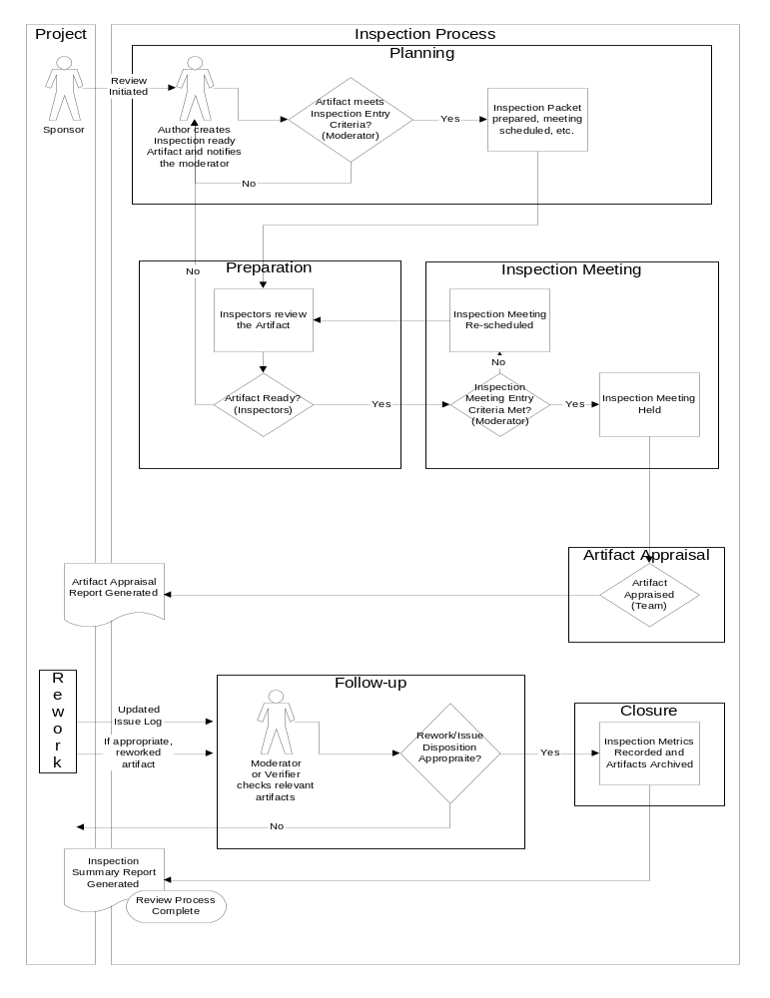 Figure 3-1: Inspection Process

Planning

Entry Criteria
Once an artifact has been designated for an inspection by the sponsor, the author notifies the moderator when the artifact is ready for an inspection. A copy or the location of the artifact, information on upstream artifacts, notable references and, if appropriate, a short summary of the artifact is given to the moderator.
The moderator ensures that the following entry criteria have been meet before selecting the inspection team:
- The author believes the artifact is ready and has applied any appropriate checklists, standards, or tools
- Upstream artifacts and other references are stable and available

Steps
 | Step | Who | Hints/Comments
1 | Ensure artifact is of reasonable size for the inspection | Moderator | - The inspectors should not need more than 2-3 hours to inspect the artifact.  - Large artifacts should be broken into multiple inspections
2 | Select a moderator, a scribe, an editor and 2-4 inspectors | Moderator and Author | - Inspectors should be selected based on willingness, availability, subject knowledge, and project impact.  - The editor may be the author or one of the inspectors.
3 | Select a set of perspectives for the inspection | Moderator and Author
4 | Schedule inspection meeting | Moderator | - Sufficient time, generally about 2-4 days, must be allowed to inspect the artifact.  - For maximum effectiveness and efficiency, the inspection meeting should be no longer than 2 hours.
5 | Compile inspection packet | Moderator

Exit Criteria
The moderator provides the inspectors an inspection packet containing the following:
- A kickoff document containing the meeting time and location, participants and their roles and perspectives, and artifact version and size information.
- A line numbered hard copy of the artifact
- Appropriate inspection checklists (perspectives, artifact, etc.)
- Logging forms
- Copies or pointers to upstream and/or reference artifacts

Preparation

Entry Criteria
Each Inspector receives the inspection packet.

Steps
 | Step | Who | Hints/Comments
1 | Inspect artifact | Inspector | Severity 1 and 2 issues are noted on the logging form. Severity 3 issues can be noted on the logging form or directly on the artifact. The amount of time spent inspecting is recorded.
2 | Ensure meeting preparation | Moderator | The moderator should monitor inspector progress to verify as early as possible whether the artifact needs more work, the inspection should be restructured, or the meeting rescheduled.
Severity Levels
Severity | Description
Severity 1 | The project can not be successfully completed or the user will get no value from the system if the issue is not addressed. (e.g. the user can not accomplish primary task(s),loss of data, frequent crashes, etc)
Severity 2 | Some portion of the project can not be successfully completed or the user will only receive partial value from the system.
Severity 3 | An element of the project is at risk or the user will loss a small amount of value when using the system.
Severity 4 | Cosmetic or trivial issues. (e.g. spelling errors or UI layout issues)

Alternative Paths
If an inspector finds a large number of issues early on or spends significantly more time than planned preparing for the inspection, it is likely that the artifact is not yet ready. If this is the case, the inspector should inform the moderator. The moderator will notify the other inspectors to stop inspecting until a decision has been made on whether to continue. The moderator will work with the inspector and author to determine if additional work needs to be done before the inspection meeting can be held.
If the moderator determines that one or more of the inspectors does not have time available to complete the inspection before the meeting, the moderator can restructure (i.e., drop or substitute an inspector) or reschedule the inspection.

Exit Criteria
Each inspector has the following information:
- A completed logging form
- A total of the number of issues found in the artifact
- A total of the number of issues found in the artifact for each severity type
- A total of the time spent preparing for the meeting

Inspection Meeting

Entry Criteria
The moderator is confident that the meeting is ready to be held and has discussed any issues or changes in plan with the moderator.
The moderator deems the meeting is worth having by querying the inspectors on number of issues found and time spent.

Steps
 | Step | Who | Hints/Comments
1 | Note preparation information on the Artifact Appraisal Report | Moderator
2 | Note major issues or questions which are outside the scope of inspection | Moderator | A third hour engineering discussion can be held to address these issues. See Appendix B for deviations on the process.
3 | Note down the start time of the inspection meeting | Moderator
4 | Poll the inspectors for issues in the artifact being inspected | Moderator | The moderator breaks the artifact into small sections to encourage synergy.
4 | Voice and log issues | Inspector and Scribe | - The inspector provides the severity, checklist Id, location, and a brief description of each issue  - The inspectors continue to look for synergistic issues  - If the editor or author is unclear about the issue’s description, they may ask the inspector to restate or clarify the issue. However, discussion beyond 1-2 minutes must be taken up after the meeting.
5 | Note down the stop time of the inspection meeting | Moderator
6 | Provide Severity 3 issues to the editor | Inspectors

Alternative Paths
If one or more of the inspectors is unprepared the moderator may
- Reschedule the inspection
- Have the unprepared inspector scribe in the meeting
- Have the unprepared inspector perform a reading inspection

Exit Criteria
All issues have been recorded in the issue logging form.

Artifact Appraisal (Outcome)

Entry Criteria
A completed issues list is available.

Steps
 | Step | Who | Hints/Comments
1 | Appraise artifact | Inspection Team | The lowest vote for appraisal of the artifact is taken. If there is a disagreement regarding the lowest vote, discussions with re-votes are allowed.
2 | If necessary, assign a Verifier | Inspection Team
3 | Complete Artifact Appraisal Report | Moderator
4 | Verify Inspection Process | Moderator | The minimum acceptance criteria for a completed inspection is:  - Enough inspectors were prepared for the inspection meeting  - The deliverable received adequate inspection  - The inspection identified an appropriate number of issues for deliverables of its type
5 | Archive the inspection report and issue log(s) | Moderator

Appraisal States
Outcome | Next Steps
Accepted as is | The inspection process is done
Revise with no follow up | The editor makes the artifact changes and notifies the moderator when they are done.
Revise with follow up. Follow up to be done by <verifier>. | A person is designated as the verifier to follow up on changes. The editor makes the artifact changes and notifies the verifier and the moderator when they are done. The verifier reviews the changes and satisfied the changes are complete, the moderator and inspection team members are notified.
Re-review | The editor works with the inspectors to make changes to the artifact and updates the issue log. Artifacts in this state are considered to have “failed” the inspection until they return for a re-inspection.

Alternative Paths
If the artifact appraisal is “Accepted as is”, the inspection process skips the rework and follow-up phases and goes straight to the closure phase.

Exit Criteria
A completed artifact appraisal report is available.

Rework
The rework phase is started after the artifact appraisal is complete. Rework is managed and scheduled by the project team.

Entry Criteria
- The artifact appraisal report is available
- The issue logging form is available

Steps
 | Step | Who | Hints/Comments
1 | Disposition issues | Editor | Determine which are and are not defects and which will or won’t be incorporated into the artifact.
2 | Incorporate changes into the artifact(s) | Editor

Exit Criteria
- An updated log with all issues dispositioned is available
- If appropriate, a reworked artifact is available

Follow-up
The follow-up phase is started after the editor has resolved the issues within the course of the project and completed any appropriate rework on the artifact.

Entry Criteria
- An updated issue log is available
- If appropriate, a reworked artifact is available

Steps
 | Step | Who | Hints/Comments
1 | Ensure all issues have been resolved | Moderator or Verifier | The verifier does this if the inspection team has selected one. Otherwise, it is done by the moderator
2 | If necessary, verify the defects have been addressed in the artifact | Verifier

Exit Criteria
- Issue log has been verified
- If appropriate, a reworked artifact has been verified

Closure

Entry Criteria
Verified issue log is available

Steps
 | Step | Who | Hints/Comments
1 | Update inspection metrics | Moderator
2 | Create, release, and archive Inspection Summary Report | Moderator | The inspection summary report is delivered to the project team.

Exit Criteria
Inspection summary report is available

Reading Inspection

Overview
A reading inspection is very similar to a full inspection, but does not include the inspection meeting or the formal follow-up. Reading inspections should be used when it is not feasible or cost effective to hold a full inspection.
A reading inspection follows the path of the full inspection process with the following differences:
- No inspection meeting is held.
- No scribe is necessary.
- Inspectors log issues into an online issue logging form.
- Each inspector supplies their own artifact appraisal. The lowest vote among the group is taken as the appraisal of the artifact.
- When appropriate, each inspector nominates a verifier for the artifact.
- When necessary, the moderator coordinates with the inspection team to finalize the artifact appraisal and verifier.

Perspectives
The table below defines some common perspectives can be assigned to inspectors. Other perspectives may be used as appropriate.
Perspective | Perspective Description
Back to Front | Inspects the artifact by reading it from back to front. Can be used to ensure artifact flow and consistency. Can also be useful as other inspectors may be less thorough by the end of the artifact.
Bottom Up | Inspects the artifact by inspecting the lower level layers first, and working up through the higher layers. For code inspections, a structure chart / hierarchical call trace diagram should be used as a map to identify higher and lower level methods. The author or the inspector can produce this diagram.
Coder | Inspects the artifact from the point of view of the person who would be responsible for implementing it. Generally used on design inspections.
Customer | Inspects the artifact from the customer perspective to determine if it will meet their needs. Examples of this are product user, client project manager, and end customer.
Maintainer | Inspects the artifact from the point of view of someone who would have to maintain it. See inspection checklist for more details.
Overall System | Inspects the artifact to determine if it fits within the context of the overall system. See inspection checklist for more details.
Portability | Inspects the artifact from the point of view of someone who would have to port the artifact.
Performance | Inspects the artifact for performance issues.
Risk | Inspects the artifact for a specific risk, such as schedule risk.
Standards Specialist | Inspects the artifact for conformance to standards.
Tester | Inspects the artifact to determine that it provides sufficient detail to create test cases.
Top Down | Inspects the artifact by inspecting the higher level layers first, and working down through the lower layers. For code inspections, a structure chart / hierarchical call trace diagram should be used as a map to identify higher and lower level methods. The author or the inspector can produce this diagram.

