Change Management Database
CxOne Pattern
0000.doc

February 21, 2003



Advancing the Art and
Science of Commercial
Software Engineering
Contents
1 Introduction 1
1.1 How to Use the Pattern 1
2 Change Requests 2
2.1 Submitting Change Requests 2
2.1.1 Rippling Changes 2
2.2 Change Control Board 2
2.3 Change Request Lifecycle 3
3 Field Overview 4
4 Role Specializations 6
4.1 Submitter 6
4.2 Sponsor 6
4.3 Owner 6
4.4 CCB / Lead / Manager 6
5 Field Specializations 7
5.1 How Addressed 7
Copyright Notice
© 2000-2002 Construx Software Builders, Inc. All Rights Reserved.
For further information or support visit www.construx.com.

Introduction
This pattern outlines how to implement a change management database and manage the workflow surrounding change requests. CxOne places change management within the area of Corrective Activity Management (CAM) along with managing defects, risks, and issues. See CxStand_ProjectManagment for more details.
Although designed to use terminology that is reasonably self-evident to an experience software engineer, this document relies on CxPattern_CamDatabase to define workflow and the details of the change management fields.

How to Use the Pattern
The information in this pattern can be used whole, in part, or with modifications as part of a project’s change management solution. Normally this document and its parent, CxPattern_CamDatabase will be used together to set up a CAM database.
Depending on the sophistication of your database tool and your project needs, issue management can run from a separate database or in combination with tracking for other CAM items. See the following CxOne patterns for additional information on CAM databases.
CxOne CAM Database patterns
Pattern | Description
CxPattern_CamDatabase | Detailed definition of workflow and all CAM database fields.
CxPattern_ChangeManagementDatabase | Additional support specific to change requests.
CxPattern_DefectManagementDatabase | Additional support specific to defects.
CxPattern_RiskManagementDatabase | Additional support specific to risks.
CxPattern_IssueManagementDatabase | Additional support specific to issues.

Change Requests
A change request is created when there is a need to add, modify, or remove requirement in the system or otherwise change project plans. Change requests are generally captured as reports in a change management database. Depending on project needs there may also be formal documentation describing a change request.
Managing change on projects is a deep discipline that draws from both configuration management and project management. CxOne defines the details of capturing and tracking change requests as part of Corrective Activity Management (CAM). Although much of the management of change requests can be coordinated through a CAM database, there are change management activities that will fall outside the scope of CAM.
The Change Control Board (CCB) is a major part of change management. The CCB is the group responsible for making decisions about change requests. See CxTemp_CmPlan, CxTemp_ChangeControlPlan, and CxStand_ConfigurationManagement for more details.

Submitting Change Requests
Changes are submitted by a project participant or stakeholder when a gap or potential gap between the project’s performance and goals is perceived. The most common source of change requests are requests to modify the requirements defining system behavior, but change may also stem from project plans, processes, and execution. Change requests must:
- Identify the system or artifact in question.
- Describe the proposed changes. If possible, a summary of how those changes will be accomplished and an estimate of their cost should be provided.
- Describe the impact of leaving the system or artifact as is compared with incorporating the suggested change. If possible a simple cost/benefit analysis justifying the change should be provided.

Rippling Changes
Some change requests can ripple throughout a system or project, requiring changes to either upstream or downstream artifacts, or requiring changes to areas that interface with the change. When a change request is addressed, analysis of all impacts should be done, and a list of the artifacts impacted is created. This ensures the CCB can take into account the full scope and cost of the change when making change request decisions.

Change Control Board
The CCB is responsible for controlling change on the project. The CCB directly manages change requests to artifacts that are under explicit change control. The CCB indirectly manages artifacts under implicit change control, by monitoring any changes in implicitly controlled artifacts that would be large enough to require a change in an explicitly controlled one.
The CCB consists of the following individuals:
- Project business manager(s)
- Requirements lead
- Implementation and/or design lead
- QA lead
- Other lead engineer(s) or stakeholders, as appropriate
The CCB ensures that affected stakeholders will be able to analyze a change and provide input to the CCB on the priority of the change. Once the change has been analyzed, a decision is made to accept or reject it. Accepted changes are flowed into project work either by using CAM to manage executing of the change (within existing planning buffers), or by updating project planning to accommodate the change.

Change Request Lifecycle
Figure 2-1 captures a high-level view of major workflow for processing change requests, abstracted from the CAM workflow described in CxPattern_CamDatabase.
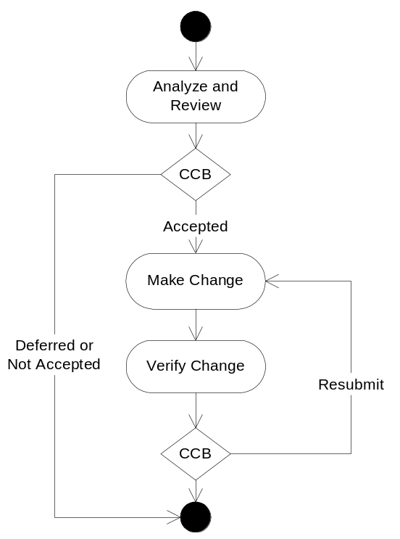
Figure 2-1: Change Request Lifecycle

Field Overview
This section lists the database fields that are useful for performing change management on most software projects. Detailed definitions for each field are in CxPattern_CamDatabase.
In most cases, the information provided in CxPattern_CamDatabase fully defines field behavior related to change management. The table below captures notes where specialization to handle management is useful. Behavior specializations for roles are discussed in section 3, any detailed specializations for fields are covered in section 4.
Change Management Database Fields
♦ | Field required to meet minimal management requirements of most projects.
♦ | Useful field for most projects.
◊ | Possibly useful for depending on goals and unique circumstances

Fields |  | Specialization Notes
Attributes
Title | ♦ | Brief, unique, summary title.
Description | ♦ | Detailed description of the change and a cost/benefit analysis supporting the change.
Item Type | ♦ | Used when combining multiple CAM types in a single database.
How Addressed | ♦ | See section How Addressed below for values optimized for change management.
Resolution | ♦ | This field may be used to store what the resolution should be before the issue is addressed. Once addressed it becomes a description of what the resolution was.
Notes | ♦ | Notes tracking history and information about this item.
ID | ♦ | Unique database ID.
Related Items | ♦ | Reference to related items.
Submit Date | ♦ | Not critical, but useful and often provided by tool automatically.
Closed Date | ♦ | Not critical, but useful and often provided by tool automatically.
Severity | ◊ | Can be useful for tracking what not making the change would mean for product behavior.
Probability |  | Not used.
Impact | ◊ | Can be useful for either tracking the impact of making, or not making, the change to the project.
Exposure |  | Not used.
Resources
Submitter | ♦ | Submitter can be any project participant or stakeholder.
Sponsor | ♦ | Change requests are normally sponsored by the requirements lead or the CCB..
Owner | ♦ | Person responsible for investigating and carrying out the change if it is accepted.
Tracking & Control
State | ♦ | Change requests leverage the default state workflow. The CCB, or a manager acting as a proxy for the CBB, plays the role of manager.
Due Date | ♦ | Date the change request needs to be resolved by.
Next Action Date | ♦ | Used to plan, communicate, and track detailed work on the risk.
Next Action | ♦
Milestone to Resolve | ♦ | Sometimes useful addition or substitute to Due Date.
Priority | ◊ | Priority has less importance with change requests as Due Date often is used to drive when work will be done.
Estimated Effort | ♦ | Depending on management process, may be useful here
Actual Effort | ♦ | Can be used for in-process estimation of effort spent on issues
Version Found | ♦ | Useful for having everyone referring to the same system version.
Version Resolved | ♦ | Useful for having everyone referring to the same system version.
Metrics
How Injected |  | Not used.
How Detected |  | Not used.
When Injected | ◊ | The “when” fields allow for analysis of the lifecycle phases in which change requests are created and resolved.
When Detected | ◊
When Resolved | ◊
Milestone Submitted | ◊ | Track change request manifestation and resolution trends over project milestones.
Milestone Resolved | ◊
WBS ID | ◊ | Identify project areas prone to change requests.
System Area | ♦ | Use to pin-point areas of change in the system.

Role Specializations
This section covers any special behavior related to CAM roles when managing change requests. General CAM roles are described in CxPattern_CamDatabase.

Submitter
Submitter should capture the individual or stakeholder group that submitted the request. In some scenarios this will occur directly (i.e. if stakeholders have access to the CAM database), in others a proxy may submit the change request.

Sponsor
The sponsor for a change request is responsible for precisely defining the change, detailing its cost and benefits, advocating the change to the CCB, and verifying the change is carried out if approved. The submitter and sponsor of change requests will often be the same, but it is not unusual to someone like the requirements lead sponsor change requests submitted by stakeholders external to the project team.

Owner
Usually the owner for a change request is the addressing phase of its lifecycle is the CCB. If work needs to be carried out to gather information to address the change request, an owner may be assigned to carry out the work. If the choice is made to accept the change, the owner becomes the person tasked with ensuring the change occurs.

CCB / Lead / Manager
A representative of the CCB often shares the role of managing the CAM change request database with the requirements lead and possibly the project manager.

Field Specializations
This section describes details for any change request fields which may be significantly specialized beyond the field descriptions in CxPattern_CamDatabase.

How Addressed
Value: See below
Modification: Lead
This field represents the decision made about the change request. This field is set when the State field is set to Addressed. This field should not be used in place of good descriptive information in the Resolution field.
Values for How Addressed issues field
Value | Description
TBD | The change request has not been addressed yet
Accepted – Directly Resolve | The change request has been accepted. The work to add the change will be managed with the resolution pending state and occur within current project planning buffers.
Accepted – Modify Plans | The change request has been accepted. The work to add the change will be handled by updating planned project work, including updates to schedule and budget.
Deferred | The change will not be addressed in current project, but may be revisited in the future.
Rejected | The change request was rejected as invalid or not compelling enough to consider now or in the future.
Logged as Defect | Issue determined to be a defect. Resolution is to create a new CAM defect record for the item.
Logged as Change Request | Issue determined to be a change request. Resolution is to create a new CAM change request record for the item.
Duplicate | Issue is a duplicate of another record.

