Super Widget
GRE-ARC SDD
0000.doc

February 21, 2003
ACME, Inc.

Contents
1 Introduction 1
1.1 System Overview 1
1.2 Purpose 1
1.3 Document Overview 1
2 Design Considerations 2
2.1 Assumptions and Dependencies 2
2.2 System Environment 2
2.3 Design Methodology 2
3 Architecture 3
3.1 Overview 3
4 High Level Design 5
4.1 Overview 6
4.1.1 Event Notify Task 6
4.1.2 Datalink Task 6
4.1.3 Datalink Timer Task 7
4.1.4 Parameter File Module 7
4.1.5 Existing Module and Tasks 7
5 Low Level Design 8
5.1 Event Notify Task 8
5.1.1 Methods 8
EnCleanupSocket 8
EnConnectDatalink 8
EnConnectTransport 8
EnGetAndResetFailCount 8
EnIncrementFailCount 8
EnInitialize 8
EnSignalOCC 8
EnStartTimer 8
EnTransmitSignal 9
5.1.2 Finite State Machine Definition 9
States 9
Events 9
5.1.3 Attributes 10
5.2 Datalink Task 10
5.2.1 Methods 10
DlCalcAndSetTimer 10
DlDialModem 10
DlDisable 10
DlDisablePPP 11
DlEnableActiveModePPP 11
DlEnablePassiveModePPP 11
DlHangUpModem 11
DlProcessCallResult 11
DlReportFailureToEnTask 11
DlReportLinkStatusToEnTask 11
DlResetModem 11
5.2.2 Finite State Machine Definition 12
States 12
Events 13
5.2.3 Attributes 13
5.3 Datalink Timer Task 13
5.3.1 Methods 14
DlTimerInit 14
DlTimerMain 14
DlTimerStart 14
DlTimerStop 14
5.3.2 Attributes 14
6 Special Function Designs 15
6.1 Abort Download 15
6.1.1 Overview 15
6.1.2 Design 16
6.2 ARC Locking 17
6.2.1 Overview 17
6.2.2 Design 19
6.3 Read/Write Lock 22
6.3.1 Overview 22
6.3.2 Design 22

Introduction

System Overview
The Operational Control Center (OCC) product is a server application that resides at a service provider’s central office. It will be connected to a modem pool or MUX that will allow it to remotely access GRE-ARC systems. GRE-ARC systems run embedded software designed to monitor and collect alarm status information from the AirWave systems as well as allow parameter changes and software uploads.
See the Air Wave Architecture for more detail on how the GRE-ARC fits into the system.

Purpose
This document describes the design for modifications to be made to the GRE-ARC embedded software, which will extend the existing GRE-ARC functionality to support the OCC application project. We only focus on the application level changes in this document. Changes to the embedded OS are outside the scope of this document.

Document Overview
The sections that follow will describe the software context, architecture issues, high-level design, and low-level design for the GRE-ARC software modifications.
The special function design sections cover design issues related to the new GRE-ARC behavior, but which are most easily consumed in a stand-alone presentation as they build on existing functionality.

Design Considerations

Assumptions and Dependencies
- PPP with CHAP support will be present in the VxWorks kernel.
- At least two serial ports will be active (configured with the serial driver) in the VxWorks kernel.

System Environment
The GRE-ARC application software runs in a VxWorks embedded operating system environment. The hardware target for this VxWorks environment is the Motorola 68360 processor.

Design Methodology
The current GRE-ARC implementation was created using Structured Analysis. The design described in this document will adhere to this methodology to minimize changes to the existing code-base.

Architecture
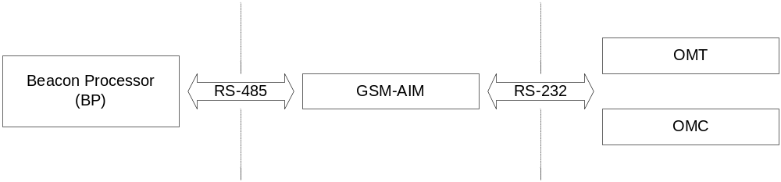
Figure 1 -- GRE-ARC Context Diagram

Overview
The GRE-ARC rests between the Beacon Processor (BP) and the OMT and OCC. The existing GRE-ARC implementation consists of the following set of modules:
- Command In (CI) – Routines responsible for processing OCC/OMT commands.
- Command Out (CO) – Task Responsible for issuing commands to the BP.
- Message Input (MI) – Routines responsible for messaging from the BP to the ARC.
- System Alarm (SA) – Task responsible for processing alarm notifications from the BP.
- Timers (TM) – Task and module responsible for provided re-usable timer services within the ARC software architecture.
- Web Interface (WEB) – Task responsible for processing all HTTP requests from either the OCC or the OMT.

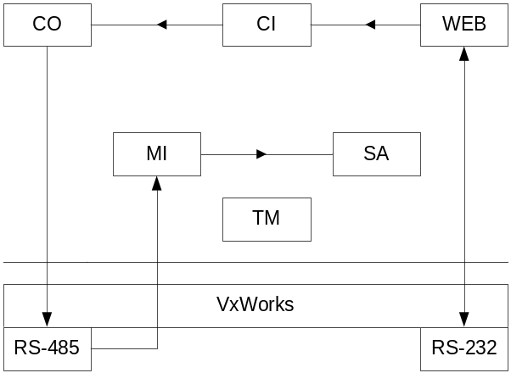
Figure 2 -- ARC System Architecture
Modules that were not necessary for the system overview or are not anticipated to be affected by the GRE-ARC modification design are not listed.

High Level Design
The following matrix shows the linkage between the software requirements as specified in the FDD and the design set forth in this document.
Requirements | Design
Blink LEDs (2.1.5) | Hook into PPP connect / disconnect notifications; use existing LED API and existing timer facility to toggle LEDs on and off at a given rate.
Configuration: | Extend definition of existing parameter file to hold new configuration data; wrap configuration file with API to protect against file offset changes.
Enable/Disable CHAP (2.2.2)
CHAP Secrets (2.2.3)
IP parameters (2.2.5)
OCC address (2.2.5)
OCC phone number (2.2.8)
Dial-out to OCC: | Create a Datalink task which manages the remote PPP port and is responsible for establishing a dial-out connection when necessary; provide API for Datalink; implement retry strategy in state machine.
AT cmds to modem (2.2.11)
Retry strategy (2.2.12) | Use public interface to Notify task to inform of dial-out failure.
Notifications: | Create Notify task to connect to OCC when notification is received and OCC needs to poll for changes; Notify task exports a public interface for other ARC modules to use when interesting events occur.
OMT connect/disconnect (2.4.1 & 2) | Hook into PPP and WEB task; use public interface to Notify task to inform of OMT connect status change.
Alarm set/clr (2.4.3 & 4) | Hook into SA task; use public interface of Notify task to inform of alarm status change.
Parameter change (2.4.6) | Hook into HTTP task; use public interface of Notify task to inform of parameter file change.
Software upgrade (???) | Hook into HTTP task; use public interface of Notify task to inform of software upgrade file upload.

Overview
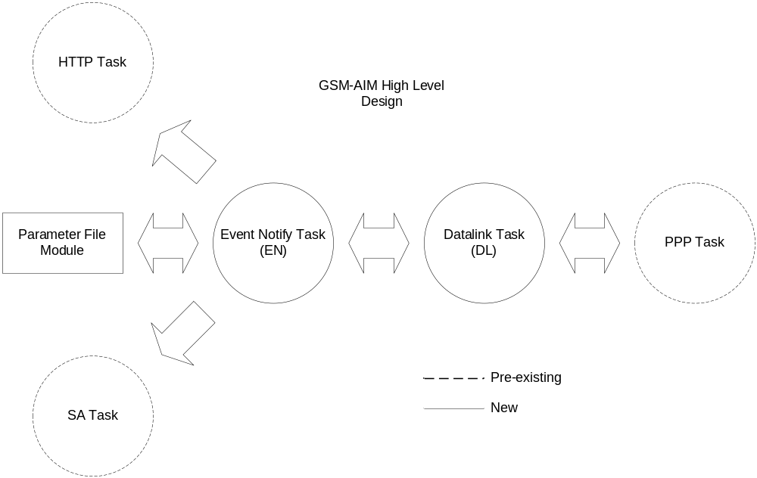
Figure 3 -- GRE-ARC Modification - High Level Overview diagram

In Figure 3 we have the high-level overview diagram. To implement the changes described in the requirements/design matrix we will add two new tasks and one new module. We will also need to add event notification hooks to the HTTP, PPP, and SA tasks.

Event Notify Task
The Event Notify task will be responsible for signaling the OCC when notification events occur in the system. It will drive the dial-up and socket connection processes. Once a Datalink connection has been established a signal is sent to the OCC indicating that the GRE-ARC needs to be polled for event information.

Datalink Task
We will create another new task and code module to implement the OCC dial-out functionality. This task will be responsible for managing the remote PPP serial port (SCC4). It will initially set up passive PPP on the port and prepare for a dial-in connection from the OCC. When dial-out is required, it will communicate with the modem in order to establish an underlying connection over a given serial port. Once the modem connection is established, this module will then interface to the VxWorks PPP implementation in order to start PPP on said serial port and monitor the PPP link.

Datalink Timer Task
This new task interfaces to the existing ARC application’s timer facility to provide timer services to the Datalink and Event Notify tasks. To request time-out notification from this facility, it is necessary to allocate an ARC application Job Handling Control Block (JHCB) and initialize it with the Finite Machine (FM) ID of the requesting task, the event type, and the duration of the timer to be created. Once initialized, the JHCB is submitted using the JHCB interface. The requesting task will receive a notification event in its associated message queue when the timer has expired.

Parameter File Module
This module is a thin layer of software, which exports an API for reading configuration information from the parameter file. Use of this module will insulate the caller from changes to the layout of the parameter file. This is useful since the parameter file has been volatile in the past and is due to change as this system continues to evolve.

Existing Module and Tasks
- We will interface to the MN module in order to access the API for blinking the LEDs while the PPP connection to the OCC is established.
- We will modify the code that runs in the context of the HTTP task so that parameter change and software upgrade notifications can be forwarded to the EN task.
- We will modify the code that runs in the context of the SA task so that alarm status change notifications can be forwarded to the EN task.
- We will modify the code that runs in the context of the PPP task so that PPP link status change notifications can be forwarded to the EN task.

Low Level Design

Event Notify Task
The Event Notify module implements a Finite State Machine (FSM) with an associated Event Notify task (EN Task) running at a priority level of 150. All methods are serialized through the FSM through a message queue. All FSM action routines are executed in the context of the EN task.

Methods

EnCleanupSocket
Close the OCC connection socket and release all other associated resources allocated for establishing a TCP connection to the OCC.

EnConnectDatalink
Start the PPP connection process by interfacing to the Datalink module and calling the Enable method. If the datalink PPP connects successfully, a datalink-connect event will be generated. If the datalink times-out while trying to establish a PPP connection, a datalink-fail event will be generated.

EnConnectTransport
Create a TCP socket and attempt to connect it to the OCC’s listening socket. If the connect attempt is successful, generate a transport-connect event to the FSM. If not generate a transport-fail event to the FSM.

EnGetAndResetFailCount
Returns the current value of failCount and reset it to 0.

EnIncrementFailCount
Increment the current value of failCount.

EnInitialize
Module initialization. This method initializes the EN task and its associated FSM.

EnSignalOCC
Generate a signal event to start off the OCC connection process.

EnStartTimer
When we receive a request to signal the OCC, we transition to the Timer-Pending state and wait for approximately 30 seconds. This method is called to start the timer associated with this delay. When the timer expires, a Time-Out event will be queued to the Event Notify task by the Datalink Timer task, causing the OCC connection process to proceed.

EnTransmitSignal
We don’t need to actually transmit any data since the OCC will use the incoming IP address to determine which GRE-ARC has connected to it. So, this method simply generates a transport-complete event.

Finite State Machine Definition
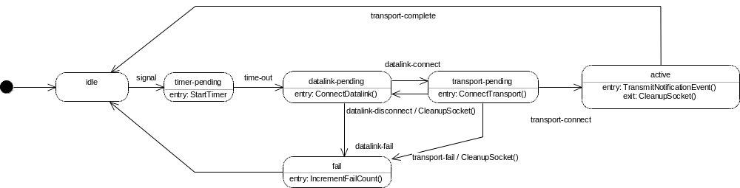
Figure 4 – EN Task FSM

States
- Active – EN task is currently connected to the OCC and communicating. On entry to this state the EnTransmitSignal method is called.
- Datalink-Pending – Waiting for notification that the PPP link to the OCC is established. On entry to this state the EnConnectDatalink method is called.
- Fail – Either the datalink connection attempt failed or the transport connection attempt failed. On entry to this state the EnIncrementFailCount method is called. The FSM will then automatically transition to the IDLE state.
- Idle –No pending notification events.
- Timer-Pending – Waiting for a delay timer to expire. The delay timer is required to filter out spurious faults that have duration less than 30 seconds. On entry to this state the EnStartTimer method is called. Any fault status changes which generate requests to signal the OCC will be ignored during this time.
- Transport-Pending – Currently attempting to establish a TCP connection to the OCC. On entry to this state the EnConnectTransport method is called.

Events
- Datalink-connect – The datalink has successfully dialed-out and established a PPP connection to the OCC. This event is generated by the Datalink task.
- Datalink-disconnect – The datalink connection has been broken due either to a disconnection request from the OCC or modem-disconnect. This event is generated by the Datalink task.
- Datalink-fail – The datalink failed to successfully dial-out and establish a PPP connection to the OCC. This failure could be due to a time-out or a modem-connect failure. This event is generated by the Datalink task.
- Signal – A call to EnSignalOCC indicates that there is a status change in one or more areas of the GRE-ARC software and that the OCC needs to update its copy of the GRE-ARC state.
- Transport-complete – The TCP connection to the OCC is established.
- Transport-fail – The TCP connection attempt to the OCC failed. Most likely the OCC is not listening.
- Time-out – The signal-OCC timer has expired. We may now proceed to signal the OCC.

Attributes
- currentState – The current state of the EN task. Initialized with a value of Idle.
- hOCCSocket – The handle to the socket used for connecting to the OCC. Initialized with a value of INVALID_SOCKET.
- failCount – The number of consecutive attempts to signal the OCC that have failed. Initialized with a value of 0.

Datalink Task
The Datalink module implements a Finite State Machine (FSM) with an associated datalink task (DL Task). All methods are serialized through the FSM through a message queue. All FSM action routines are executed in the context of the DL task.

Methods

DlCalcAndSetTimer
Compare our current time with the start time for the dialing process. If 15 minutes have elapsed, generate a modem-connect-failed event to the FSM. Otherwise, compute the current elapsed time modulo 5. This value should be 5 minutes minus whatever processing time has been taken in the current dialing attempt. Use the value to create a timer. Queue the time to the DL task input queue and return.

DlDialModem
Issue dial commands to the modem with the configured dial-out phone number. Call select() with the appropriate time-out value and wait for an acknowledgement to the dial command. If select() times out or the result received is other than “OK” generate an error event to the FSM. Otherwise, generate an ok event to the FSM.

DlDisable
Bring the PPP datalink down. This call translates into a disable event posted to the DL FSM.

DlDisablePPP
Issue a call to the PPP service to disable itself.

DlEnableActiveModePPP
Start the PPP service in active mode. The PPP service will actively attempt to establish a datalink connection with its remote peer. Modem link is assumed to be established.

DlEnablePassiveModePPP
Program the modem to auto-answer and then start the PPP service in passive mode. This will allow the GRE-ARC to accept incoming PPP datalink connections.

DlHangUpModem
Issue the hang-up command to the modem.

DlProcessCallResult
Issue a select() call with the appropriate time-out value on the serial port attached to the modem. If select() times out, generate and error event to the FSM. If not parse the results and generate the appropriate event based on the results of the parser analysis.

DlReportFailureToEnTask
Queue a message to the EN task notifying it that the requested action failed.

DlReportLinkStatusToEnTask
Queue a message to the EN task notifying it of our current link state.

DlResetModem
Issue a reset command to the modem. Call select() with the appropriate time-out value and wait for an acknowledgement to the reset command. If select() times out or the result received is other than “OK” generate an error event to the FSM. Otherwise, generate and ok event to the FSM.

Finite State Machine Definition
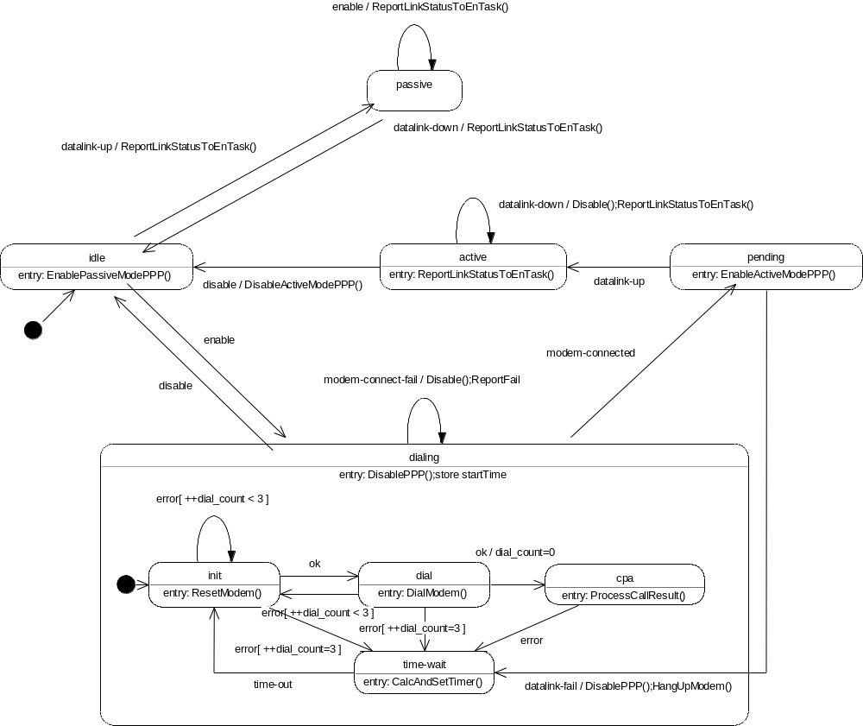
Figure 5 – DL Task FSM

States
- Active – An active datalink connection (dial-out connection) is currently established.
- Dialing – Dial-out connection is in progress.
- Dialing::CPA – Dial-out connection is in progress; waiting for call progress analysis from modem hardware.
- Dialing::Dial – Dial-out connection is in progress; waiting for response from dial command.
- Dialing::Init – Dial-out connection is in progress; waiting for modem initialization to complete.
- Dialing::Time-Wait – Either we failed to get the modem to dial or the result we received back from the call-progress-analysis was not a “Connected” message.
- Idle – Datalink is not connected (passive or active); no connection is in progress.
- Passive – A passive datalink connection (dial-in connection) is currently established.
- Pending – Modem connection is currently active; attempting to establish a PPP datalink connection with remote peer.

Events
- Disable – We have received a request to disable the PPP datalink.
- Datalink-Down – The PPP service reports that a datalink connection that was established is now down.
- Datalink-Fail – The PPP service reports that an attempt to actively establish a PPP datalink connection failed.
- Datalink-Up – The PPP service reports that a datalink connection has been established.
- Enable – We have received a request to enable the PPP datalink.
- Error – An error occurred while trying to communicate with the modem. This can be caused by an error code returned from the modem, or an inability to communicate with the modem.
- Modem-Connect-Fail – The dialing process failed to successfully establish an underlying modem connection.
- Modem-Connected – We have successfully established an underlying modem connection.
- OK – The last command we sent to the modem was received and understood.
- Time-Out – A wait timer created as part of the modem dialing algorithm has fired.

Attributes
- currentState – The current state of the DL task. Initialized with a value of Idle.
- dialCount – The number of consecutive dial attempts made so far. This value is used as part of the dialing algorithm to determine when to give up trying to issue a dial command to the modem.
- startTime – The time we entered the dialing state. This values is used as part of the dialing algorithm to determine how long to persist in trying to establish a modem connection.

Datalink Timer Task
To interface to the existing timer facility built into the ARC application, we need a dedicated task to field incoming timer event messages. We cannot use the message queues created by the Event Notify and Datalink tasks directly because these use a different message format and control block than the one used by the ARC application facility. The Datlink Timer task is needed to convert the ARC application’s timer facility messages to compatible FSM event messages for the Event Notify and Datalink task.

Methods

DlTimerInit
This method performs the one-time initialization of the Datalink Timer module and makes the Datalink Timer facility ready to run. Currently, all that is required for initialization is to start the Datalink task, causing it to run DlTimerMain.

DlTimerMain
This method runs as a task. Its purpose is to receive notification of timer expiration from the ARC application timer facility and forward them to the Datalink or Event Notify task. This method and its associated task will run in a continuous loop blocking on its message queue when no timer event messages are available to be read. When a new message is received it will be converted to the appropriate FSM event for either the Datalink or Event Notify task and then forwarded to said task.

DlTimerStart
This method is called by the Datalink or Event Notify task whenever they wish to create a new timer. Resources required for starting the timer will be allocated and initialized. Then the ARC application timer facility will be invoked to start the timer.

DlTimerStop
This method is called by the Datalink or Event Notify task whenever they wish to cancel (stop) a pending timer. Again we call upon the ARC application timer facility to accomplish this.

Attributes
- dlTimerTaskId – This attribute will hold the Datalink timer task handle value. It will be initialized to a value of ERROR (defined by VxWorks). When DlTimerInit is called, the Datalink Timer task is created. At this time the returned handle value will be stored in dlTimerTaskId. This variable is also used to indicate whether or not the Datalink Timer facility has been initialized. Each of the Datalink Timer methods will check this variable every time they are invoked to determine whether or not the Datalink Timer task has been started. If not they will return and error to the caller. Otherwise, they will proceed normally.

Special Function Designs
These sections cover design issues for maintenance extensions that are better considered on their own.

Abort Download

Overview
The current implementation of remote downloading software images and parameters files does not allow this process to be terminated once it is started. This functionality of the ARC needs to be redesigned to make the process of downloading interruptible so that the download may be aborted before it is complete.
The solution is to support the HTTP PUT method from the Wind Web Server 2.0 implementation. The HTTP request header for the PUT request shall contain a Content-Length header providing the total length of the file to be downloaded. If, at any time during the download, the user wishes to cancel a download in progress, all that is required is to simply close the connection from the user’s side. The ARC will detect that the connection has been closed and compare the number of bytes received to the total number of bytes reported in the Content-Length header. If the total number of bytes have not been read, the download transaction is considered to be aborted and the downloaded data is discarded. If all data is received then the data is written to the appropriate area of flash memory for use by the ARC.
An additional benefit to using HTTP PUT is that we can track progress from the user side of the HTTP connection by counting bytes as data is written to the associated socket. This allows for a much more accurate progress indication than the current method of using a separate HTTP GET request, which is issued periodically to test and see if the download has completed. Figure 6 below illustrates the download transaction sequence. The first request/reply pair shows a successful parameter file update. The second request/reply pair shows an unsuccessful system file update.
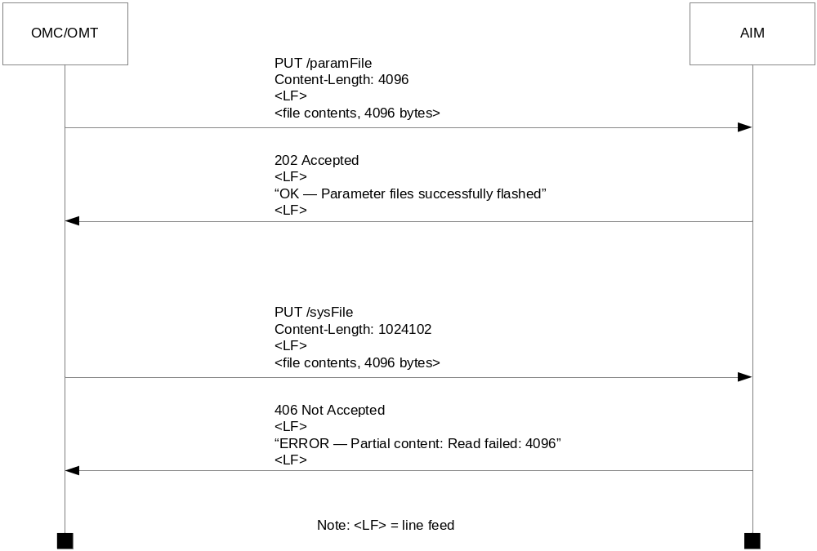
Figure 6 – HTTP Put Sequence

Design
As shown by Figure 7, the high-level structure of the solution for the new download design is simple. By creating an RPM module with handlers for newly specified download URLs we can use tasks from Wind Web Server’s task pool to download software and parameter file updates and then apply them.
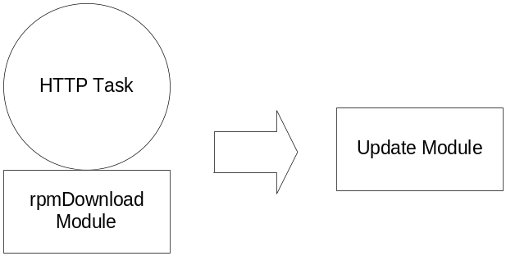
Figure 7 -- Abort Download High Level Structure
The following functions will provide the implementation for the RPM download module:
- ReadPutPayload – This function is called by rpmDownloadParamFile and rpmDownloadSuperFile. It embodies the common functionality need to implement both of its callers. This function extracts the Content-Length header from the PUT request and then reads the payload of the put request into an allocated buffer. If there are any problems reading the payload or if there is a problem with the Content-Length header, this function will return FAIL to the caller immediately after generating an HTTP reply with a specific error response code to the calling HTTP client.
- rpmDownloadParamFile – This function is called by the Wind Web Serve 2.0 dispatcher. It is responsible for handling HTTP PUT requests for the “/paramFile” path. It will download the contents of the PUT request and then pass these contents along with the pre-computed CRC to the UpdateParameterFile function.
- rpmDownloadSysFile – This function, like rpmDownloadParamFile, is called by Wind Web Server 2.0. Its purpose is to download the system or superfile and pass the contents along with the pre-computed CRC to UpdateSuperFile.
- UpdateParameterFile – This function will be implemented by ACME to process the contents of the downloaded parameter file and it’s accompanying CRC.
- UpdateSuperFile – This function will be implemented by ACME to process the contents of the downloaded parameter file and it’s accompanying CRC.
Figure 8 is a Data Flow Diagram illustrating how these functions work together to implement the Abort Download functionality.
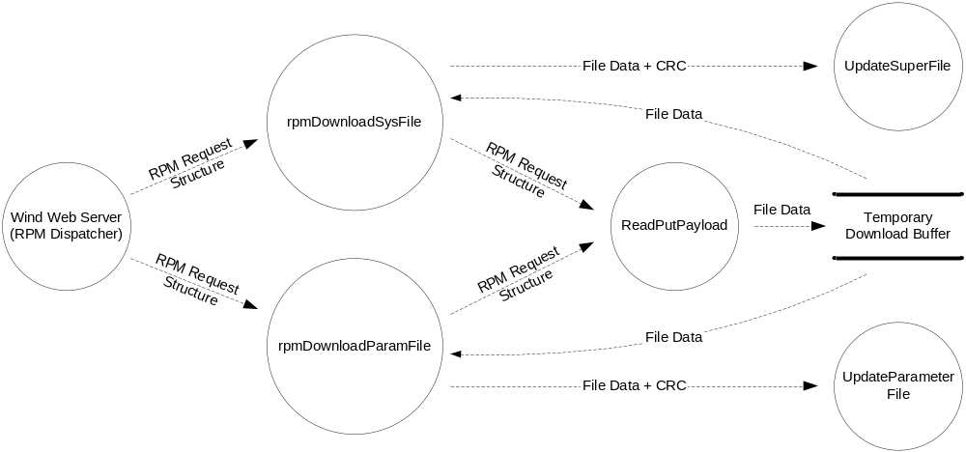Figure 8 -- Abort Downlaod DFD

ARC Locking

Overview
This feature is a direct answer to SRS item 14, Multiple Simultaneous Client Support. Since the Wind Web Server is multi-tasked and some ARC functionality may be accessed by only one task at a time, while others may be accessed by multiple tasks simultaneously, we need a mechanism to ensure that the ARC application remains in a consistent and reliable state.
The current implementation of the ARC application software doesn’t really support this capability. Instead of re-architecting and re-writing the ARC application software to meet this requirement, we instead implemented a locking mechanism to restrict access to certain URLs so that only one task at a time may invoke them.
In the ARC application users equate to HTTP clients and HTTP clients equate to HTTP tasks. Currently the ARC is configured for a pool of four HTTP tasks, which may execute simultaneously.
To address this requirement, we will construct an ARC Lock, which can be held by only one client at a time. The HTTP interface to the ARC will have two classes of URLs: those that require the ARC Lock and those that do not. If a client wishes to access a URL that requires the ARC Lock, it will first be necessary to access the URL designated for acquiring the ARC-Lock. Once the lock has been acquired, the client may proceed and access ‘locked’ URLs. When the client has finished accessing the locked functionality, it must call another URL to release the lock so that other users may acquire it.
The ARC Lock will eventually expire if it has not been used for a given duration. This will allow other clients to proceed and acquire the ARC Lock if the previous lock-holder does not release the ARC Lock as it should when it has completed it processing.
Under certain circumstances, the ARC Lock may be broken by another client while it is being held. When this occurs, the previous lock value is invalidated and a new lock value is generated and tracked as current.
When the ARC Lock is acquired, an optional parameter that may be given is the ID of the user acquiring the lock. This value stored along with the lock status information and may be retrieved by accessing a specific URL, which will return the value of the user ID.
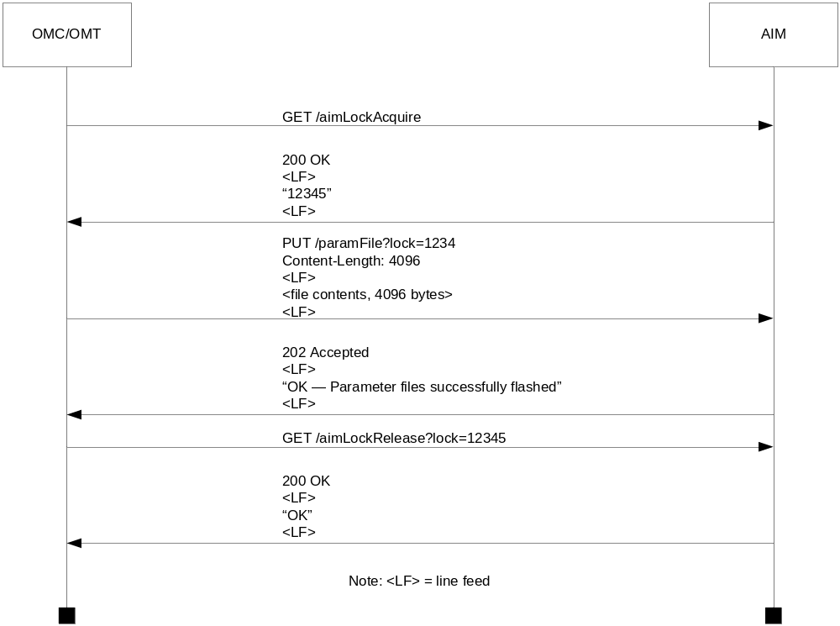
Figure 9 -- ARC Lock Sequence

Design
To implement this functionality we need to register a System RPM Handler with Wind Web Server. This is a special type of RPM handler that is called for every HTTP request, regardless of the method or path. From the context of this system handler we can verify the presence and validity of the ARC-Lock parameter. We can also determine if the request is one that requires the lock. Based on the results of these tests, the System RPM Handler will either allow the request to proceed normally, directly call the User RPM Handler that requires the presence of the ARC Lock, or reject the request as one that requires a valid ARC Lock.
The following functions will be required to implement this feature:
- httpARCLockInit – This function is called only once, at system initialization time, to initialize the ARC Lock facility for use.
- rpmARCLockAcquire – This function is called by the Wind Web Server RPM dispatcher whenever a client wishes to acquire the ARC Lock. If the override parameter is provided or the ARC-Lock is not in use, a new lock value is calculated and returned to the caller. If the user ID parameter is present, it is stored along with the newly computed ARC Lock value. If the override flag is not present and the ARC Lock has already been acquired by another client, a negative response is generated to the calling client.
- rpmARCLockProcess – This function is called by the Wind Web Server RPM dispatcher for every URL accessed by every client. It will verify the need and existence of the ARC Lock. If the requested path is one belonging to a function that does not require the ARC Lock, the function is allowed to proceed normally. If the requested path is one that does require the lock and the lock is present and valid, the function is called directly from this handler and the results of the function call are turned to the calling client. If the requested path is one that does require the lock and the lock is not present or not valid, and error response will be generated to the calling client and the requested functionality will not be accessed.
- rpmARCLockRelease – This function is called by the Wind Web Server RPM dispatcher whenever a client wishes to release an acquired ARC Lock. If the ARC Lock parameter is valid, the lock is released. If the ARC Lock has expired or is invalid, a negative response is generated to the calling client.
- rpmARCLockUser – This function is called by the Win Web Server RPM dispatcher whenever a client wishes to obtain the ID of the user currently holding the ARC Lock. If the lock is not currently held, “None” is returned to the calling client. If the ARC Lock is currently being held but the user ID was not passed in when the lock was acquired, “Unknown” is returned to the caller. Otherwise, the user ID is returned to the calling client.
The following data will be required to implement this feature:
- ARC Lock Entry – This data structure is used to implement the allow-table. The allow-table is consulted every time rpmARCLockProcess runs to determine if the current URL and path require the ARC Lock to proceed. In a matching entry is found in this table, the URL and path do not require the lock and processing may proceed normally.
- ARC Lock Status – This data represents the current state of the ARC Lock. It includes information indicating the current value of the ARC Lock. If the ARC Lock is not currently acquired, the value will be AL_INVALID_LOCK. Also, included in this data is the whether or not the ARC Lock is currently being used. That is, whether or not an RPM handler requiring the lock is currently executing. This data includes the local time the ARC Lock was last acquired. It is used to age and potentially expire the ARC Lock whenever it is accessed.
- ARC Lock User ID – This is where the current user ID will be stored as a character string. This data is updated when ever the ARC Lock is acquired or released. It is also read when rpmARCLockUser is called.
- ARC RPM Entry – This data structure is used to implement our own version of an RPM dispatch table. All RPM handlers that are not in the allow table are represented by this data structure in the ARC-rpm-table. This data structure contains a pointer to the RPM handler function and the URL path string that matches the RPM handler. When rpmARCLockProcess has determined that a lock RPM handler needs to be invoked, the ARC-rpm-table is searched using the path string as an index. When a match is found, the associated function pointer is called.
Figure 10 is a Data Flow Diagram illustrating how these data and functions work together to implement ARC Locking.
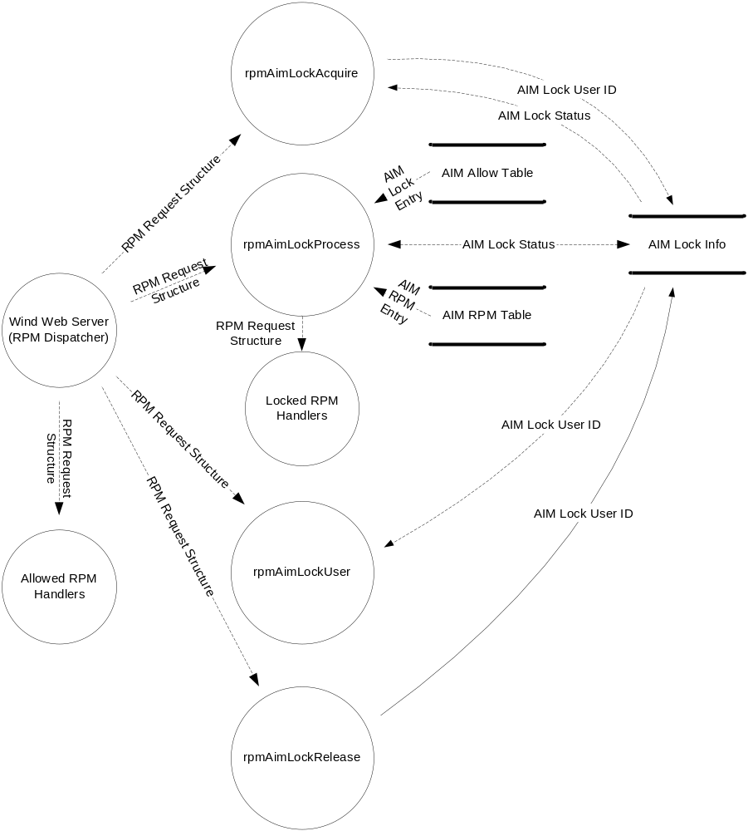
Figure 10 -- ARC Lock DFD

Read/Write Lock

Overview
In section 6.2 of this document we described the main synchronization issues and how they will be solved in the short term by the ARC Lock feature. For some of the ARC functionality the ARC Lock by itself is not sufficient for protecting the ARC application from getting into an inconsistent state.
One specific area where this is the case, is in accessing the parameter file stored on the ARC. The parameter file will be routinely read by both the OCC and, at a much lower frequency, the OMT. Periodically this parameter file will be updated, via the parameter file download. This is a specific case where there will be multiple readers and writers of a shared resource.
For specific cases where we have multiple readers and writes of data within the ARC application, we will implement a non-standard implementation of Read/Write Locks. The Read/Write Lock (RWL) is a synchronization primitive that allows multiple readers to access data simultaneously. Only in the presence of one or more writers does the lock become exclusive.

Design
In creating the RWL facility, it is our intention to create something that can be used in a general way. Though we are implementing RWL to solve a specific problem with accessing the parameter file, we anticipate it will be used to provide a fine-grain locking mechanism within other areas of the ARC application.
Our default implementation will provide a single lock to be used with the parameter file, but it has been designed so that we can easily increase the number of RWL resources defined within the implementation and then simply re-compile.
The key to this ability lies in the way RWL resources are initialized and managed. Figure 11 shows a Data Flow Diagram of the RWL resource manager implementation.
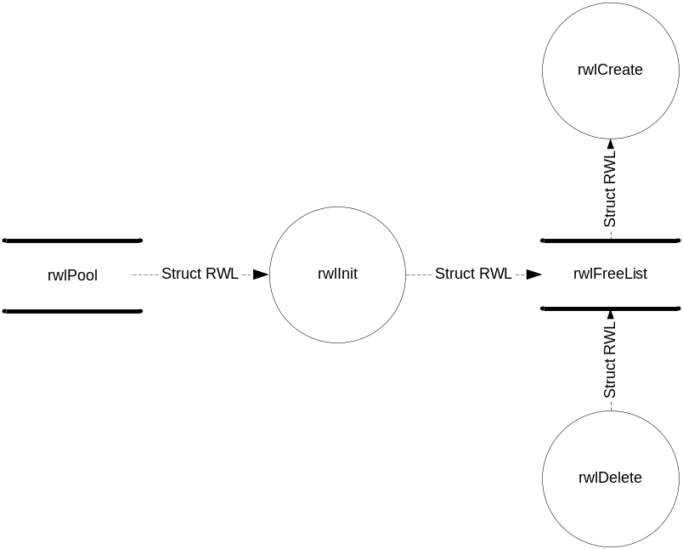
Figure 11 -- RWL Resource Management
As the diagram shows, there are three functions and two data stores that are used to implement the resource manager for the RWL:
- rwlPool – This data store is an array that will be defined to statically allocate the exact number of RWL resources we need to implement our new facility. At the present time the number is one. By changing the value of a preprocessor variable, we can increase that number to whatever we require.
- rwlFreeList – This data store is a doubly-linked list use to hold all instances of RWL resources once they have been initialized at system startup.
- rwlInit – This function is called only once, at system startup time, to initialize the RWL implementation and make it ready for use by client tasks. It will add the predefined number of RWL resources defined in rwlPool to rwlFreeList. It will also initialize the RWL resources to there default state.
- rwlCreate – This function is called whenever a client task wishes to allocate an RWL resource. It will check the free list to determine if any RWL resources are available. If there are, one is removed from the list and converted to an RWL_ID, which is then returned to the caller as an RWL_ID.
- rwlDelete – This function is called whenever a client task wishes to free an RWL resource. It will take the given RWL_ID, convert it to an RWL resource, and then add the RWL resource back to the free list.
Our implementation of the RWL resource has four methods associated with it:
- rwlReadTake – Acquire a non-exclusive read lock. This function takes an RWL_ID and a time-out value as arguments. If the lock is not currently taken, take the lock, increment the number of readers associated with it, and return success. If the lock is currently taken by one or more readers, simply increment the reader count and return success. If the lock has already been taken by a writer, block the calling task until the given time-out value has expired. If the time-out expires, return a failure to the calling task. Otherwise. return success. Note: special time-out values of NO_WAIT and WAIT_FOREVER may be specified. They are self explanatory.
- rwlWriteTake – Acquire an exclusive write lock. This function takes an RWL_ID and a time-out value as arguments. If the lock is not currently taken, take the lock and return success to the caller. If the lock is taken, block the calling task until the given time-out value has expired. If the time-out expires, return a failure to the calling task. Otherwise, return success. The same note regarding the special semantics of NO_WAIT and WAIT_FOREVER apply here.
- rwlReadGive – Release a non-exclusive read lock. This function takes an RWL_ID as its only argument. Decrement the reader count. If the count is now zero, as a result, release the lock. When a lock is released, waiting writers should be signaled that the lock is free.
- rwlWriteGive – Release an exclusive write lock. This function takes an RWL_ID as its only argument. It simply releases the lock and returns.

Refer to ARCHttpInterface.doc for the details about the interface specifiers.
Refer to ARCHttpInterface.doc for the details about the interface specifiers.

