Falstaff
Project Estimate
0000.doc
Revision 1
February 21, 2003

Contents
1 Analysis 1
1.1 Summary 1
1.1.1 Schedule 1
1.1.2 Cost 1
1.1.3 Feature 2
1.2 Assumptions and Constraints 3
1.3 Estimating Techniques 3
1.3.1 Expert Judgment 3
1.3.2 Size Analogy 3
Falstaff Based Estimates 3
Existing WebBooks System Estimates 4
1.4 Tools 4
1.4.1 Construx Estimate 4
1.5 Data 4
2 Expert Judgment Estimate 5
2.1 Technique 5
2.1.1 Strengths 5
2.1.2 Weaknesses 5
2.1.3 Assumptions 6
2.2 Results 8
2.3 Conclusions 8
3 Size Analogy - Falstaff 9
3.1 Design Modules 9
3.1.1 Technique 9
Assumptions 9
Strengths 9
Weaknesses 9
3.1.2 Results 9
3.2 Subsystems 9
3.2.1 Technique 10
Assumptions 10
Strengths 10
Weaknesses 10
3.2.2 Results 10
3.3 Use Case Analogy 10
3.4 Conclusions 10
4 Size Analogy – Existing WebBooks System 11
4.1 Lines Of Code 11
4.1.1 Technique 11
Assumptions 11
Strengths 11
Weaknesses 11
4.1.2 Results 11
4.2 UI Elements 11
4.2.1 Technique 11
Assumptions 12
Strengths 12
Weaknesses 12
4.2.2 Results 12
4.3 Conclusions 12

Charts, Tables, & Figures
Chart 1.1 – Plot of Estimate Results 2
Table 2.1 – Assumed Effort by Domain 6
Figure 2.1 – Falstaff Product Domains 7
Table 2.3 – Construx Estimated Effort by Domain 8

Analysis
This document captures the current project estimate for the Falstaff project. This estimate is made up of a number of different sub-estimates, whose goal is to provide WebBooks with enough information to make sound business planning decisions regarding the Falstaff project.
The original project estimate was presented in April 2001 and ranged from $500K to over $2 million dollars. There were a number questions that needed to be answered before WebBooks made their go/no-go decision on Falstaff. This report revises the estimate based on the work performed during May 2001, with the goal of narrowing the cone of uncertainty.

Summary
The estimation work over the past month has increased the visibility into the scope of future Falstaff work. The planned functionality for the project remains large, and may be beyond the bounds of the project charter. Increased complexity of data structure, increased support for customization of data, and the increased number of dynamic relationships between data appear to be the largest factors driving scope increase over the existing system.
Falstaff is cutting significant new group for WebBooks, and we have limited historical data from previous projects. This means estimates for work on the project still rely heavily on expert judgment. Over time, performance to plan on the project can be used to improve this situation, basing the project more firmly on quantitative data. In the meantime, we’ve used what data was available and used large ranges to reflect uncertainty.
Recent technical prototyping has reduced the some uncertainty. We have confirmed that the tools are feasible and provide adequate design to tools support. A design to tools mentality will be critical to controlling scope and the estimates here rely heavily on that assumption.
To meet WebBooks’s business goals, we will have to aggressively prioritize and rigorously manage the requirements to keep cost and schedule under control. Still the cost and length of the project is going to be on the high end of what WebBooks had originally hoped. A release in 2Q2002 may still be possible, but it would have to be a subset of the entire set of requirements. WebBooks could delay features or functionality that the initial releases of the product do not need. This will involve a more detailed analysis of what features are important to which custom groups, to determine where the best ROI is.

Schedule
The schedule estimate for project work ranges from 12 – 20 calendar months, based primarily on the expert judgment scenario outlined below. The schedule also reflects the constraints outlined in the Falstaff Project Plan.

Cost
The chart below shows projected cost ranges for effort that the various estimation techniques have produced thus far. The details on the techniques appear in Sections 2 through 3.
Chart 1.1 – Plot of Estimate Results
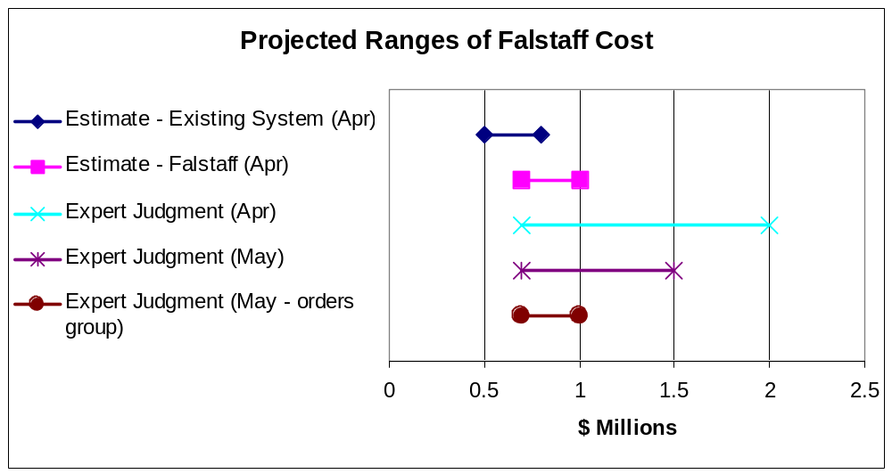
The work performed this past month to decrease the uncertainty surrounding the Falstaff project estimate is reflected in the labeled “Expert Judgment (May).” While the low-end remained the same, the high-end is now approximately $1.5M.
An interesting observation was that the orders group’s high-end estimate was significantly lower than the entire team’s estimate. That group has deeper domain expertise and knowledge of the current system, so their expert judgment needs to be given weight. However, recent experience is based on maintenance vs. new development. The other engineers from the R&D group have significantly experience with new system development.
At this time, we recommend the prudent approach would be to plan on the higher estimate. As the Falstaff progresses, we will be able to use actual data to recalibrate the estimates to provide an increasingly more accurate forecast of the expected costs.

Feature
We did not significantly vary the size of the feature set being estimated from the current Falstaff default. If desired, future estimates could take into account different sizes, groupings, or delivery schedules of feature sets.
Feature scope for estimates is based on the following requirement sources:
- Falstaff Class Model
- Falstaff Requirements Database and Spreadsheet
- Existing system SLOC Spreadsheet
We revised our May estimate based on updates to the class model and use case descriptions developed during May 2001.

Assumptions and Constraints
The following assumptions were used for all estimates in this document:
- R&D group will be doing the bulk of development work on the core software areas of the product, but the orders group will be doing the bulk of the work at the Business Layer, and all the work outside of the software development effort.
- R&D groups work on core software areas of the product is assumed to be the critical path of the project.
- There are still many uncertainties surrounding the project including requirements, technology, and resource level. Thus these estimates should be considered ballpark figures that are used to plan the direction of future work, not an indication of the ultimate outcome of the project.

Estimating Techniques
The following estimation techniques were employed to synthesize this project estimate.

Expert Judgment
Using the requirements work to date, engineers spent time doing detailed workups of the expected effort to create the product, based on expert judgment and personal analogies with past products.
Due to the level of detail, effort, and nature of this method, and the lack of relevant, detailed historical data to support the other techniques, we feel it should be given significant weight.

Size Analogy
A number of quantitative size analogies decomposed the system into different measures, and then compared those measures against historical data for similar work.
This estimation technique is useful, but results can vary widely at this stage in the project due to low resolution of the size measures that are used, since we do not yet have good visibility into the size of the project we are building.

Falstaff Based Estimates
There were two different size analogy estimates done based on Falstaff requirements work:
- One used historical data from an industry partner, and applied that model to a decomposition of Falstaff requirements class model. This data has been decided to be too far removed from the context of the Falstaff project, so this technique has been dropped in this round.
- Using historical data from Construx Estimate estimation software and decomposition of both sub-systems and requirements classes derived from the use case analysis.

Existing WebBooks System Estimates
Estimation tool estimates were worked up based on size data from the existing WebBooks orders system.

Tools
The following tools were used on preparing this estimate.

Construx Estimate
Construx Estimate is a software estimation tool utilizes the SLIM and COCOMO estimation models, together with historical project data to estimate the size, effort, cost, and schedule of software projects.
Estimate provided useful input to this estimation process, but there are two limitations on the accuracy it provides:
- Since data on productivity of WebBooks engineers working on this type of project is not available to calibrate Estimate, we’re relying on historical industry data, which may not always reflect unique aspects of our situation.
- The staffing constraint imposed on the project is on the boundary of the useful operating range of the parametric estimation model that drives Construx Estimate. Some approximations had to be used in terms of the staffing profile of the project.
Uncertainty ranges are handled in a very detailed way in Estimate. To avoid unnecessary complexity in this report, uncertainty ranges are rolled up from several runs on Estiamte into one range for easier analysis.

Data
Sections 2 through 5 of this report contain summary reports of data used to create the project estimate. Detailed data is available for review in various forms in the project’s revision control repository.

Expert Judgment Estimate
This section covers the bottom-up effort estimate based on expert analysis of Falstaff product requirements.

Technique
Expert judgment involves consulting with human experts to use their experience and understanding of a proposed project to provide an estimate for the cost of the project. The steps we used to were:
- Decompose the requirements into domains (Ref: Table 2.1 and Figure 2.1).
- Review the requirements with the experts.
- Estimate the effort required to complete each domain separately.
- Discuss variations in the estimates and revise as needed.
- Combine the domain results to produce entire project effort estimate.
- Compute effort estimate (Ref: Table 2.3)
- Compute cost estimate

Strengths
- This estimate is based on detailed analysis of the system requirements, so is very specific to the planned Falstaff product.
- Provides the highest resolution of estimation techniques used here in terms of assigning size and uncertainty to sub-systems of the product.
- Created by experts closest to the work, who use their experience and knowledge to:
  - Factor in project impacts caused by new technologies, applications, and languages.
  - Fill in gaps in available information by mentally exploring alternative design concepts.
  - Offset the lack of historical data by creating analogies to previous projects.

Weaknesses
- Difficult to perform a bottom-up estimate early in the life cycle process because the necessary information may not be available.
- Expert estimates do not have formal data analysis to support them.

Assumptions
Estimated effort is based on integrating and using third party products to:
- Maintain queries and reports.
- Manage licensees
- Process credit cards
Additional assumptions are listed in the following tables and figure.
Table 2.1 – Assumed Effort by Domain
Category | Domain | Effort Includes
Project  Management  Other Overhead | Project Planning, Tracking, and Control | Project level planning, tracking and control, status reporting, configuration management, project reviews, coordination with other project teams, etc.
Project  Management  Other Overhead | Release Management | Release Cycle Planning, System Integration & Test, System QA, Daily Builds, and Release Cycle Build, etc,
Project  Management  Other Overhead | Environment Setup | Setting up and administering project servers and support systems (e.g. version control, issue control, project web site, development software).
Project  Management  Other Overhead | Platform Compatibility Test | Performing compatibility testing across the range of supported platforms (e.g. Win95, Win98, Win2000, NT 4.0) and configurations (Stand-alone, File-Server, Client-Server).
System  Development and  Test | For each of the product domain | Detail requirements analysis, architecture development, design, prototype (if needed), coding, unit testing, developer integration test, reviews, and feature test.

The revised estimate used the same domain definitions as the original estimate. Based on our experiences to date on the Falstaff project and the extremely good working relationships among team members, we lowered percentage to used to calculate the Project Planning, Tracking, and Control effort to be 10% of the System Development and Test effort.
Figure 2.1 – Falstaff Product Domains
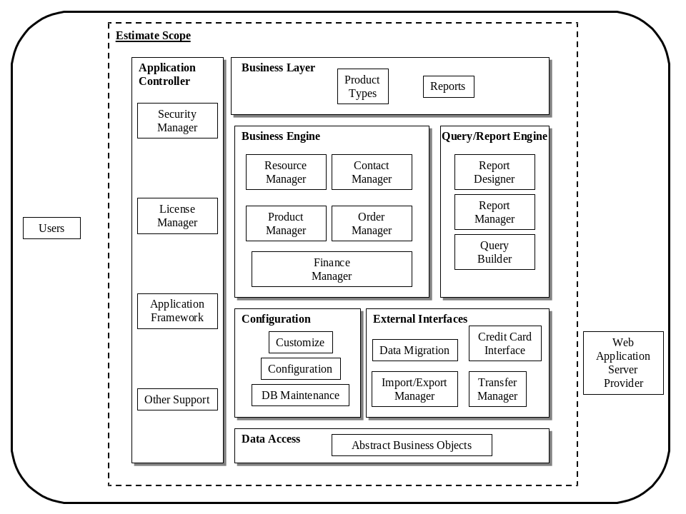
The revised estimate uses the same product domain definitions as the original estimate. The majority our work over the last month, focused on:
- Clarifying requirements in the Business Engine and Configuration layers.
- Prototyping technology needed to support the Configuration, External Interface, and Query & Report Engine layers.

Results
Table 2.3 – Construx Estimated Effort by Domain
Category | Domain | Effort in Staff Weeks |  | Level of  Uncertainty
Category | Domain | Low | High | Level of  Uncertainty
Project  Management  and Overhead | Project Planning, Tracking, & Control | 12 | 26 | Medium
Project  Management  and Overhead | Release Management | 15 | 32 | Medium
Project  Management  and Overhead | Environment Setup | 2 | 3 | Low
Falstaff  Development | Business Layer | 3 | 7 | High
Falstaff  Development | Business Engine | 51 | 128 | Medium – Very High
Falstaff  Development | Configuration Layer | 19 | 34 | Medium
Falstaff  Development | External Interfaces | 13 | 22 | High
Falstaff  Development | Query & Report Engine | 4 | 7 | High
Falstaff  Development | Application Control | 11 | 18 | Medium
Falstaff  Development | Data Access | 0 | 4 | High
Total Estimated Effort |  | 130 | 281

During the process, the experts utilized wideband-Delphi meetings to estimate the total effort needed to fulfill the requirements. This led to the following results:
- Effort ranges from approximately 130 to 280 staff weeks
- Cost ranges from $700,000 to $1,500,000 based on a fully burdened blended cost rate of $130 per staff hour.
- The schedule estimate ranges from 12 – 20 months. Schedule estimate is based on the average staffing constraint of 3.5 FTEs listed in the plan.
In this table, the level of uncertainty is a measure of our confidence in the requirements (high uncertainty indicates we are not confident that we have captured all the requirements.)

Conclusions
The work performed this past month to decrease the uncertainty surrounding the Falstaff project has significantly increased our understanding of the requirements and the proposed technology. This is reflected in the high-end estimate dropping by over $600,000. However, the planned functionality for the project remains large and complex, and further requirements work will be necessary prior to building the system.

Size Analogy - Falstaff
This section covers size analogy estimates using Falstaff requirements as the basis.

Design Modules
The number of classes identified in the requirements class model should correlate roughly to the number of design modules in the final system. Estimate contains conversion factors based on industry data for the size and effort necessary to complete an average design-module.

Technique

Assumptions
- The model incorporates all overhead associated with the project.
- There is a close correlation between the number of requirements classes and significant design classes.
- Uses Estimate’s historical productivity data for a combination of Internet and Shrinkwrap products.
- Uses Estimate’s historical size data for the ASP development environment.

Strengths
- Relies on breakdown of design elements for the actual system.

Weaknesses
- Relies on a low-resolution size measure early in the project, thus the level of uncertainty is high.
- There is little visibility into size and uncertainty of detailed product areas.
- The historical data for industry performance may not match our productivity

Results
Based on the output of the model, optimizing for least cost:
- Effort is approximately 170 staff weeks with the cost of $1,000,000.

Subsystems
Systems are generally broken down into components to be built. The highest level of this decomposition is usually called a sub-system. The size of a sub-system from one project to the next may vary widely, but there does tend to be average correlation of sub-system size that is useful for ballpark estimates. Estimate contains conversion factors based on historical industry data for the size and effort necessary to complete an average sub-system.

Technique
The expected number of subsystems is entered into Estimate.

Assumptions
- The model incorporates all overhead associated with the project, and does not attempt to define or separate activities.
- Uses Estimate’s historical productivity data for a combination of Internet and Shrinkwrap products.
- Uses Estimate’s historical size data for the ASP development environment.

Strengths
- This is the most ballpark of all the estimates, but does leverage industry data for implementing systems in ASP.

Weaknesses
- This is the lowest-resolution measure used for the project estimate, so the level of uncertainty is very high.
- There is little visibility into size and uncertainty of detailed product areas.

Results
Based on the output of the model, optimizing for least cost:
- Effort is approximately 120 staff weeks with the cost of $700,000.

Use Case Analogy
This size analogy, based on data from our industry partner, has been dropped in this estimation round. It was not correlating with the other estimation techniques (3 times higher). A detailed expert inquiry showed the context of the data to be too far removed from Falstaff’s context. Although not precise, the industry average data in Estimate was considered a better representation.

Conclusions
These estimates show correlation with the low end of expert judgment, which is encouraging. The lower high-end of these estimates should carry less weight than the expert judgment for two reasons:
- These figures are based on industry average performance, which is a good indicator, but not extremely detailed in terms of our actual performance.
- The complexity of custom feature that the expert analysis has called out as risk areas is the sort of detail that industry average numbers will have a hard time reflecting.

Size Analogy – Existing WebBooks System
This section covers size analogy estimates using the existing WebBooks system size measures as the basis.

Lines Of Code
The count of lines of code (LOC) from the existing system is used as input to Estimate.

Technique
Typed lines of code counts from the existing system project logs into Construx Estimate.

Assumptions
- That the existing LOC size for will be roughly equivalent to the LOC size for Falstaff. This is assuming that although Falstaff will make more efficient use code, there will be more functionality to provide in Falstaff.
- The model incorporates all overhead associated with the project, and does not attempt to define or separate activities.
- Uses Estimate’s historical productivity data for a combination of Internet and Shrinkwrap products.

Strengths
- Based on the actual line of code count from the existing system.

Weaknesses
- The assumption about equating lines of code is valid for a ballpark estimate, but leaves out a lot of detail.

Results
Based on the output of the model, optimizing for least cost:
- Effort is approximately 130 staff weeks with the cost of $800,000.

UI Elements
The count of UI elements from the existing product is used in a function point based estimate.

Technique
The UI element information for the existing system, converted and augmented by expert judgment as appropriate, is entered into Construx Estimate.

Assumptions
- The model incorporates all overhead associated with the project, and does not attempt to define or separate activities.
- Uses Estimate’s historical productivity data for a combination of Internet and Shrinkwrap products.
- Uses Estimate’s historical size data for the ASP development environment.

Strengths
- Based on the actual UI element count from the existing system.

Weaknesses
- Relies on a low-resolution size measure early in the project, thus the level of uncertainty is high.
- Does not take into account new behavior being proposed for Falstaff.

Results
Based on the output of the model, optimizing for least cost:
- Effort is approximately 90 staff weeks with the cost of $500,000.

Conclusions
The overall smaller scope of the estimates, which assume similar size between existing and new systems, needs to be weighted against the consensus expert judgment that the size and complexity of requirements for Falstaff has increased significantly from the existing system.

