Issue Management Database
CxOne Pattern
0000.doc

February 21, 2003



Advancing the Art and
Science of Commercial
Software Engineering
Contents
1 Introduction 1
1.1 How to Use the Pattern 1
2 Issues 2
2.1 Issue Lifecycle 2
3 Field Overview 3
4 Role Specializations 5
4.1 Submitter 5
4.2 Sponsor 5
4.3 Owner 5
4.4 Lead or Manager 5
5 Field Specializations 6
5.1 How Addressed 6
Copyright Notice
© 2000-2002 Construx Software Builders, Inc. All Rights Reserved.
For further information or support visit www.construx.com.

Introduction
This pattern outlines how to implement an issue management database and manage the workflow surrounding issue management. CxOne places issue management within the area of Corrective Activity Management (CAM) along with managing change requests, defects, and risks. See CxStand_ProjectManagment for more details.
Although designed to use terminology that is reasonably self-evident to an experience software engineer, this document relies on CxPattern_CamDatabase to define workflow and the details of the issue management fields.

How to Use the Pattern
The information in this pattern can be used whole, in part, or with modifications as part of a project’s issue management solution. Normally this document and its parent, CxPattern_CamDatabase will be used together to set up a CAM database.
Depending on the sophistication of your database tool and your project needs, issue management can run from a separate database or in combination with tracking for other CAM items. See the following CxOne patterns for additional information on CAM databases.
CxOne CAM Database patterns
Pattern | Description
CxPattern_CamDatabase | Detailed definition of workflow and all CAM database fields.
CxPattern_ChangeManagementDatabase | Additional support specific to change requests.
CxPattern_DefectManagementDatabase | Additional support specific to defects.
CxPattern_RiskManagementDatabase | Additional support specific to risks.
CxPattern_IssueManagementDatabase | Additional support specific to issues.

Issues
Issues are a broad category covering work that needs to occur, but which falls outside of the project’s planned work mechanisms. Issues usually fall into one of two categories:
- They represent work or activities that need to get done, but which are not planned precisely enough to be executed through tracking and control of planned work.
- They represent an existing threat or problem that needs to be addressed immediately (compare to a risk, which is a possible future problem).
Depending on the lifecycle, size, and management style of a project, the amount of work managed through tracking and controlling planned work vs. directly managing using CAM issues will vary. As long as work is being managed, there is no absolute right or wrong split between planned work and CAM issues.
Project plans should provide buffers of effort and time in which issue management can occur. Some projects may define planned work in great detail, leaving small buffers to manage unplanned issues. Other projects may choose to define planned work with a broad brush, leaving considerable time for details to be managed as unplanned issues. In general evolutionary prototyping lifecycles and “agile” methodologies tend to leave more management bandwidth in the realm of issue management.

Issue Lifecycle
Figure 2-1 captures a high-level view of major workflow related to issues, abstracted from the CAM workflow described in CxPattern_CamDatabase.
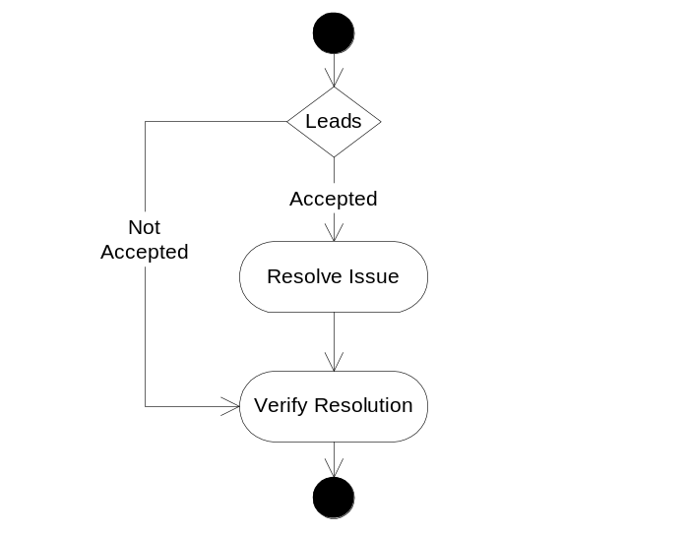
Figure 2-1: Issue Lifecycle
As can be seen, the overall workflow of issues is simple. The detail with issues stems from the fine-grain management of activities both to address and resolve them.

Field Overview
This section lists the database fields that are useful for performing issue management on most software projects. The detailed definitions for each field are in CxPattern_CamDatabase.
In most cases, the information provided in CxPattern_CamDatabase fully defines field behavior related to issue management. The table below captures notes where specialization to handle issue management is useful. Behavior specializations for roles are discussed in section 3, any detailed specializations for fields are covered in section 4.
Issue Management Database Fields
♦ | Field required to meet minimal management requirements of most projects.
♦ | Useful field for most projects.
◊ | Possibly useful for depending on goals and unique circumstances

Fields |  | Specialization Notes
Attributes
Title | ♦ | Brief, unique, summary title.
Description | ♦ | Detailed description of the issue.
Item Type | ♦ | Used when combining multiple CAM types in a single database.
How Addressed | ♦ | See section How Addressed below for values optimized for Issue Management.
Resolution | ♦ | This field may be used to store what the resolution should be before the issue is addressed. Once addressed it becomes a description of what the resolution was.
Notes | ♦ | Notes tracking history and information about this item.
ID | ♦ | Unique database ID.
Related Items | ♦ | Reference to related items.
Submit Date | ♦ | Not critical, but useful and often provided by tool automatically.
Closed Date | ♦ | Not critical, but useful and often provided by tool automatically.
Severity |  | Not used.
Probability |  | Not used.
Impact | ◊ | Can be used to measure impact to project if the issue is not addressed.
Exposure |  | Not used.
Resources
Submitter | ◊ | May be omitted for issues since management or lead often enters the record based on other project activities.
Sponsor | ♦ | Since issues are normally handled as part of project management, other possible names for this field could be Lead or Manager.
Owner | ♦ | The person responsible for resolving the issue.
Tracking & Control
State | ♦ | Issues use the default state workflow.
Due Date | ♦ | The date by which the issue must be resolved, or it will start to impact project goals.
Next Action Date | ♦ | Used to plan, communicate, and track detailed work on the risk.
Next Action | ♦
Milestone to Resolve | ♦ | Sometimes useful addition or substitute to Due Date.
Priority | ◊ | Priority has less importance with issues as Due Date often is used to drive when work will be done.
Estimated Effort | ◊ | Depending on management process, may be useful here
Actual Effort | ◊ | Can be used for in-process estimation of effort spent on issues
Version Found |  | Not used.
Version Resolved |  | Not used.
Metrics
How Injected | ◊ | Can be used to determine what activities are creating and detecting issues.
How Detected | ◊
When Injected | ◊ | The “when” fields allow for analysis of the lifecycle phases in which issues are created and resolved.
When Detected | ◊
When Resolved | ◊
Milestone Submitted | ◊ | Track issue creation and resolution trends over project milestones.
Milestone Resolved | ◊
WBS ID | ♦ | Can identify areas where planning may need improvement.
System Area | ♦ | Can identify areas where planning may need improvement.

Role Specializations
This section covers any special behavior related to CAM roles when managing issues. All CAM roles are described in CxPattern_CamDatabase.

Submitter
Submitter is an optional field for issues, because due to their unstructured nature issues are usually entered with the coordination of a lead or manager. This is to ensure an issue doesn’t overlap a CAM item already present, or is part of planned work the submitter is not aware of.

Sponsor
The sponsor ensures the issue is managed in a timely manner, consistent with the project’s goals. Additionally, this person verifies the issues are addressed to the satisfaction of the project stakeholders. Typically, the sponsor is either project manager or a technical lead.

Owner
The owner is the person responsible for addressing and possibly resolving the issue in a timely manner consistent with the project goals.

Lead or Manager
Due to the unstructured nature of issues, leads and managers will often be closely involved with issues during the entire issue lifecycle.
Since issues are a catch-all for project activities that are not being managed through another mechanism, managers should closely watch the volume of issues to ensure that the amount of a project work being managed through issues is not detrimental to the project. Although some projects (generally smaller and less complex) may actually prefer to manage the majority of project work through issues, most projects should look at a ballooning set of issues as a warning signal that more detailed explicit planning is needed.

Field Specializations
This section describes details for any issue fields which may be significantly specialized beyond the field descriptions in CxPattern_CamDatabase.

How Addressed
Value: See below
Modification: Lead
This field represents the decision made about how to resolve the issue. This field is set when the State field is set to Decision Complete. This field should not be used in place of good descriptive information in the Resolution field.
Values for How Addressed issues field
Value | Description
TBD | The issue has not been addressed yet
Directly Resolve | The issue was accepted and will be resolved within existing project plans.
Modify Plans | The issue has been accepted for resolution, but will require modification of planned project work, and most likely impact existing work plan, budget, and schedule.
No Action | No action will be taken to resolve the issue. This means the impact of the issue is being accepted.
Rejected | The issue has been rejected as invalid.
Logged as Defect | The issue has been determined to be a defect. Resolution is to create a new CAM defect record for the item.
Logged as Change Request | The issue has been determined to be a change request. Resolution is to create a new CAM change request record for the item.
Duplicate | The issue is a duplicate of another record.

