Super Widget
Business Schedule
0000.doc
Revision 5
February 21, 2003
ACME, Inc.

Contents
1 Introduction 1
1.1 Overview 1
1.2 Schedule at a Glance 1
2 Project Milestones 2
3 Feature Delivery Schedule 3

Introduction
This is the Super Widget project business schedule. It defines the top-level timeline, events, and milestones for the project. It is the controlling document for the project’s schedule.
Last Schedule Update: Completion of M5
Last Schedule Baseline: Completion of M4
Portions of the historical planning were updated at the last baseline to reflect actual performance and revised planning. See previous versions of this schedule for the original planning.

Overview
The Super Widget project is in progress, see the project plan and recent status reports for further details on the project.
Super Widget is a schedule driven project. The project will be managed to the dates in this schedule, and changes to this schedule will have to go through the CCB with approval from all external stakeholders. This means feature or effort may need to change to meet these dates.
This schedule is based on input from the project estimate and the project goals described in the charter. See the project plan for a description of how the business schedule maps onto the project’s lifecycle. See the work plan and detailed schedules for task breakdown, estimation, and scheduling.

Schedule at a Glance
The figure below shows mapping of milestones onto calendar time. There is overlap in the future milestones reflecting the uncertainty in the precise dates.
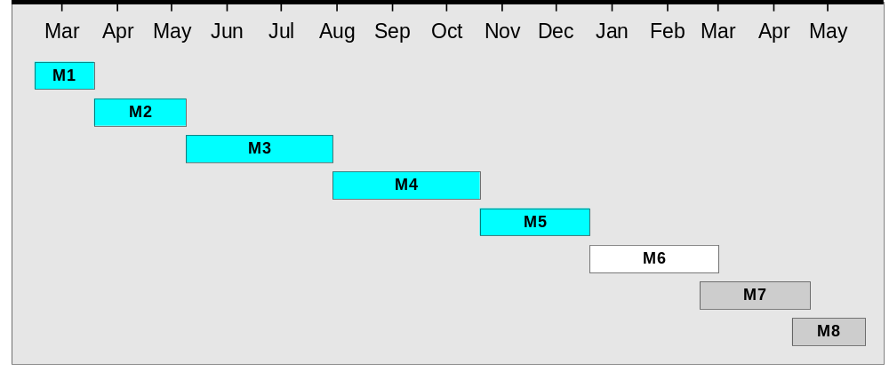
The milestones are described in detail in the next section.

Project Milestones
The table below outlines the details of Super Widget milestones as of the last schedule baseline, and tracking actual performance against that baseline.
Milestone Number | Milestone Name and Description | Scheduled Completion | Actual Completion
M1 | Initial Planning – Requiremetns analysis, architecture, and project planning. . | 3/15/01 | 3/15/01
M2 | Analysis and Design – Finalization of business requirements and architecture. | 5/01 | 5/5/01
M3 | Technical Foundation – Finalization of functional requirements, and UI design. Completion of high-level design. Supporting framework for application functionality is constructed. | 7/01 | 7/28/01
M4 | Core Release – Creation of core system foundation that the rest of the functionality will be based on. Replanning based on progress to date. | 10/02 | 10/23/02
M5 | Feature Release 1 – Addition of new feature as per the staged delivery plan. | 12/02 | 12/20/02
M6 | Feature Release 2 – Addition of new feature as per the staged delivery plan.. | 2/02
M7 | Feature Release 3 – Addition of new feature as per the staged delivery plan.. | 4/02
M8 | Operational Deployment – Final feature completion, deployment of system into operations. | 5/02

Feature Delivery Schedule
The table below outlines the functionality that will be delivered in each milestone and the actual completion milestone for all feature to dare.
See the OCCRequirementsManagementDb for a detailed description of these Super Widget features.
Delivery Schedule for Major Feature Areas
Major Functionality Area | Initial Functionality | Planned Complete | Actual Complete
User Management | M4 | M4 | M4
ARC Management | M5 | M6
List / Update / Schedule | M5 | M5 | M5
Manage / View | M5 | M6
Site Management | M5 | M6
Site Configuration (Add , Edit, Delete) | M5 | M5 | M5
Refresh / Test Site | M5 | M6 | M5
Set Options | M5 | M6
Move Site | M6 | M6
Update Progress Field on Status Page | M6 | M6
Report Management | M5 | M7
Single Predefined Report of Alarms | M5 | M5 | M5
Create/Edit Templates | M5 | M6
Execute/Manage Reports | M6 | M7
Database Management | M3 | M5 | M5
Super Widget ARC Communication | M5 | M7
Receive Status / Polling | M5 | M5 | M5
Update Software Parameters | M5 | M6
Progress Updating | M6 | M7
Test Site / Retry on Lock | M7 | M7
ARC Software | M6 | M8
Event Notification | M6 | M6
Dial-out | M7 | M7
Spurious Fault Filtering | M7 | M7
Abort Download / ARC Locking | M7 | M8
Batch Log Message | M7 | M8

