Extreme Programming

Overview
CxOne is a lightweight, adaptable, flexible process infrastructure that can be used on a variety of projects. This CxOne process flow discusses how to use CxOne resources to run project using Extreme Programming.

Background
Extreme Programming (nicknamed “XP”) is a methodology for building software originally designed to work on in-house information systems projects with 2-10 developers. XP is based on longstanding industry best practices, including evolutionary prototyping, short release cycles, and active end-user involvement in requirements definition. XP’s contribution is that it has bundled and packaged a specific set of practices to form a methodology. The specific practices were chosen based on the belief that they are mutually supportive.
With XP the system is developed in increments so that it can quickly be modified in response to end-user and customer feedback. Most evolutionary-prototyping efforts begin by prototyping the user interface and evolving the completed system from that, but prototyping can start with any high-risk area.
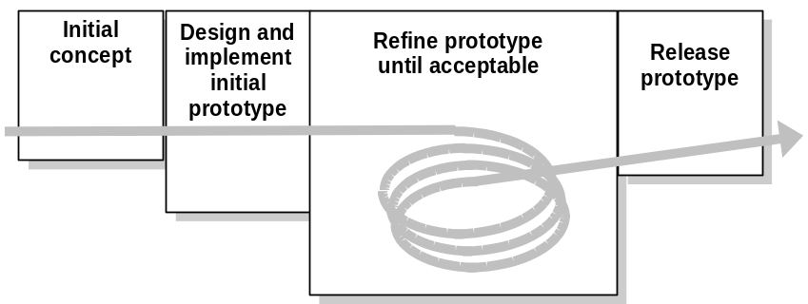

Figure 1: Evolutionary Prototyping Lifecycle

How to Use
CxOne checklists, templates, and guides may be used to support projects using Extreme Programming. This document contains a mapping of the relevant CxOne documents on the basis of the activities within Extreme Programming.

CxOne Materials Guide
Figure 2 outlines the workflow for a software project as run using Extreme Programming. CxOne materials are then mapped to each workflow.

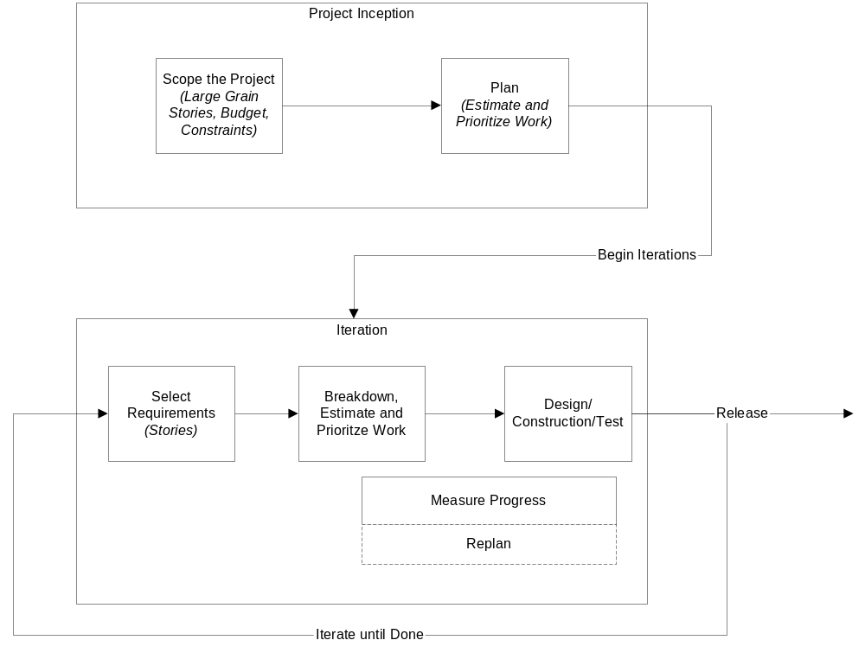
Figure 2: Extreme Programming Lifecycle
The following CxOne materials support each stage.

Project Inception
Activity | CxOne Materials
Project Management | Lite Project Plan  Project Charter  Scheduling and Estimation checklists
Requirements | Use Case Templates and Checklists  Best Practice – Joint Application Development
Business Case | Project Charter

Iterations
Activity | CxOne Materials
Project Management | Scheduling and Estimation checklists
Requirements | Best Practice – Requirements Scrubbing
Design | Design Templates and Checklists  Best Practice - Design for Change
Construction | Construction Templates, Checklists, and Standards  Best Practice – Collaborative Construction  Best Practice – Daily Build and Smoke Test
Test | Test Case Checklists  Best Practice – Construction Testing
Software Release | Release Sign-Off Template  Release Checklist
Process Improvement | Software Project Log Template and Checklist  Software Project History Template and Checklist

