Defect Management Database
CxOne Pattern
0000.doc

December 13, 2002



Advancing the Art and
Science of Commercial
Software Engineering
Contents
1 Introduction 1
1.1 How to Use the Pattern 1
2 Defects 2
2.1 Overview 2
2.2 Submitting Defects 2
2.2.1 Defect Granularity 2
2.3 Defect Lifecycle 3
3 Field Overview 4
4 Role Specializations 6
4.1 Submitter 6
4.2 Sponsor 6
4.3 Owner 6
4.4 Lead or Manager 6
5 Field Specializations 7
5.1 How Addressed 7
Copyright Notice
© 2000-2002 Construx Software Builders, Inc. All Rights Reserved.
For further information or support visit www.construx.com.

Introduction
This pattern outlines how to implement a defect database along with workflow for defect management. Defect management is part of Corrective Activity Management (CAM) along with managing change requests, risks, and issues. See CxStand_ProjectManagment for more details.
Although designed to use terminology that is reasonably self-evident to an experience software engineer, this document relies on CxPattern_CamDatabase to define workflow and the details of the defect management fields.

How to Use the Pattern
The information in this pattern can be used whole, in part, or with modifications as part of a project’s defect management solution. Normally this document and its parent, CxPattern_CamDatabase will be used together to set up a CAM database.
Depending on the sophistication of your database tool and your project needs, defect management can run from a separate database or in combination with tracking for other CAM items. See the following CxOne patterns for additional information on CAM databases.
CxOne CAM Database patterns
Pattern | Description
CxPattern_CamDatabase | Detailed definition of workflow and all CAM database fields.
CxPattern_ChangeManagementDatabase | Additional support specific to change requests.
CxPattern_DefectManagementDatabase | Additional support specific to defects.
CxPattern_RiskManagementDatabase | Additional support specific to risks.
CxPattern_IssueManagementDatabase | Additional support specific to issues.

Defects
Defect reports are proxies for defects in a system. Defect reports are normally the output from project quality control activities, generally testing or reviews. They may also be generated from problems found in the field when a system is in operation.
Defect reports are the core of defect management. The creation of high-quality defect reports helps ensure a high-quality system and allows for efficient management of the removal of defects. CxOne defines defect management as part of Corrective Activity Management (CAM).
CxCheck_DefectReport contains information about what content defect reports should cover. This pattern focuses on general workflow for managing defect reports.

Overview
Defect reports represent a request to fix for a defect in a system or project artifacts. Defect reports (also referred to simply as “defects”) are used when there is a well understood requirement, and some part of the system (whether the executing software or any artifact relating to the system) is not performing to that requirement.
Defects are entered into a defect management database. They are then addressed by being fixed, deferred due to low priority, or determined to be invalid. When necessary, the defect may be returned to the submitter with a request for additional information or clarification.
Project stakeholders are able to monitor all defects in the database. If a stakeholder does not agree with the handling of a defect, the defect may be appealed to the CCB. At this point, the defect will be processed as a change request.

Submitting Defects
Defects are submitted when the problem is identified, qualified, and appropriately quantified. When defect report is submitted it must:
- Identify the precise artifact(s) with the defect.
- Describe the deviation from explicit or implied requirements being exhibited.
- Describe the background, context, location, and any steps to reproduce the defect.

Defect Granularity
Defects should be as atomic as is reasonable. If there are many behavioral aspects to a defect, it should probably be represented as separate defect reports. This allows discrete elements of the defect to be dealt with separately. The best breakdown of behavior to capture in a defect report will not always be obvious. When in doubt, cheat towards creating more reports. However, there are no hard rules, so use judgment to group obviously related items. Your project should settle on style guidelines for granularity.

Defect Lifecycle
Figure 2-1 captures a high-level view of major workflow related to defects, abstracted from the CAM workflow described in CxPattern_CamDatabase..
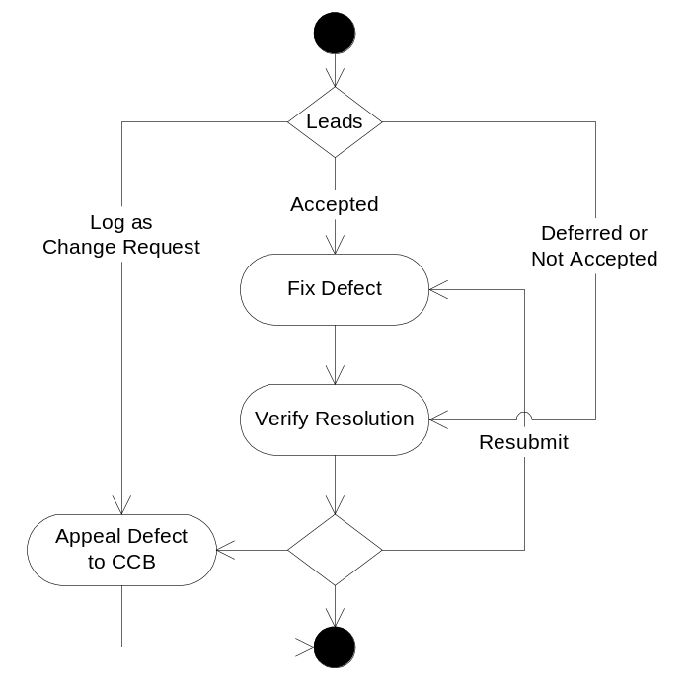
Figure 2-1: Defect Fix Request Lifecycle

Field Overview
This section lists database fields that are useful for performing defect management on most software projects. The detailed definitions for each field are in CxPattern_CamDatabase.
In most cases, the information provided in CxPattern_CamDatabase fully defines field behavior related to defect management. The table below captures notes where specialization to handle defect management is useful. Behavior specializations for roles are discussed in section 4, any detailed specializations for fields are covered in section 5.
Issue Management Database Fields
♦ | Field required to meet minimal management requirements of most projects.
♦ | Useful field for most projects.
◊ | Possibly useful for depending on goals and unique circumstances

Fields |  | Specialization Notes
Attributes
Title | ♦ | Brief, unique, summary title.
Description | ♦ | Detailed description providing the context and steps necessary to reproduced the defect.
Item Type | ♦ | Used when combining multiple CAM types in a single database.
How Addressed | ♦ | See section How Addressed below for values optimized for defect management.
Resolution | ♦ | Depending on management processes and style this field may be useful for defects. In many cases though the resolution for defects may not be that interesting, i.e., “fixed”.
Notes | ♦ | Notes tracking history and information about this item.
ID | ♦ | Unique database ID.
Related Items | ♦ | Reference to related items.
Submit Date | ♦ | Not critical, but useful and often provided by tool automatically.
Closed Date | ♦ | Not critical, but useful and often provided by tool automatically.
Severity | ♦ | Key defect attribute, captures the impact the defect has to system or artifact performance or quality.
Probability |  | Not used.
Impact |  | Not used. Defects will normally use severity effort estimates to model impact to the project.
Exposure |  | Not used.
Resources
Submitter | ♦ | Normally person who finds defect will submit it.
Sponsor | ♦ | Usually the person who submitted the defect will be the sponsor.
Owner | ♦ | The owner generally fixes the defect.
Tracking & Control
State | ♦ | Defects can leverage the default state workflow. Unlike the other CAM types, defects can progress through much of their lifecycle without direct management involvement. Escalating a defect will normally mean sending it to the CCB. Small defects will often jump over the resolution pending state.
Due Date | ◊ | Sometimes useful addition to Milestone to Resolve.
Next Action Date | ♦ | Larger or more critical defects may use Next Action fields to plan, communicate, and track detailed work on the risk.
Next Action | ♦
Milestone to Resolve | ♦ | This is usually more relevant than Due Date for defects.
Priority | ♦ | Priority is normally critical for defects. Much defect fixing is self-directed work by engineers. This fields allows management to communicate clear priorities on what should be fixed first.
Estimated Effort | ♦ | Allows communication and tracking for defect work.
Actual Effort | ♦ | Allows improved estimation of defect work.
Version Found | ♦ | Identifies the system version defect was identified in.
Version Resolved | ♦ | Communicates the system version a defect is fixed in.
Metrics
How Injected | ♦ | Measure injection rate of different activities
How Detected | ♦ | Measure effectiveness of different quality control activities
When Injected | ♦ | The “when” metrics are useful to determine the relationship of defect injection and quality control processes to a project’s lifecycle phases.
When Detected | ♦
When Resolved | ♦
Milestone Submitted | ◊ | Can be used to track detection and removal trends according to milestones.
Milestone Resolved | ◊
WBS ID | ◊ | Can be used to isolate work plan areas more prone to defects.
System Area | ♦ | Can be used to isolate buggy areas of a system.

Role Specializations
This section covers any special behavior related to CAM roles when managing defects. All CAM roles are described in CxPattern_CamDatabase.

Submitter
The person who found the defect and wrote up the defect report.

Sponsor
The sponsor for defects is often an engineer with test responsibilities. The sponsor is responsible for advocating the fix for the defect, assisting the owner to fix the defect, and verifying the fix when it is complete. Quite often the sponsor remains the same for the life of the defect and is the original submitter, but this isn’t critical and in some cases mixing sponsors around mid-stream in a defect’s lifecycle can be healthy.

Owner
Usually an individual responsible for investigating the problem and then fixing it. Assigning an owner is a management decision based on efficient use of resources. CxOne’s collaborative construction advocates not having the owner automatically be the last person who touched the code. It isn’t unusual for the owner to change through the lifecycle if defect isn’t fixed immediately or investigation reveals .
In some cases, a defect will require several fixes in different areas. Collaborative construction encourages individuals to have broad exposure to the entire system. If possible good defect reports should not contain multiple behaviors that cross architectural boundaries. Even so, there will be times when a defect requires fixes that it makes sense to have multiple people do pieces of. When this occurs a small team can be formed with a point person as owner, or the defect can be passed through a succession of owners who each make a change. If the latter occurs, hand-offs should be documented in the notes.

Lead or Manager
The role of leads and managers in defect management will vary depending on the project size, style, lifecycle, and current position in the lifecycle. Unlike other CAM items, defects may often have limited manager involvement, with the leads or managers only communication priorities on defects, and making sure size and trend of unfixed defects is acceptable.

Field Specializations
This section describes details for any defect fields which may be significantly specialized beyond the field descriptions in CxPattern_CamDatabase.

How Addressed
Value: See below
Modification: Lead
This field represents the decision about how to resolve the defect. This field is set when the State field is set to Addressed. This field should not be used in place of good descriptive information in the Resolution field.
Values for How Addressed issues field
Value | Description
TBD | The defect has not been addressed yet
Fixed | The defect was accepted and will be fixed within current project planning (i.e., leverage current project buffer time for rework and defect fixes).
Modify Plans | The defect was accepted and will be fixed, but fix is too large to be managed with existing project plans. Planned project work will be updated, with changes to work plan and schedule likely.
Keep As Built | The defect was determined to be a deviation from specified requirements, but that the “as built” behavior will be kept. This will normally because the as built behavior is considered superior to the specified behavior, or because the existing behavior is good enough for project goals and the cost of correcting it are not worth the benefit. If appropriate, this will be resolved by updating the specified requirements or related artifacts (the test cases).
Working as Designed | The defect was determined to not be a deviation from intended requiremetns or goals. This is the equivalent of rejecting the defect report, but is separated from rejected to allow
Could Not Reproduce | The specifics of the defect report were unable to be reproduced by both the owner and the sponsor.
Deferred | The defect will not be addressed in this project, but will likely be in future projects. This should only be used when it is truly likely the defect will be addressed in the future. Otherwise ‘Keep as Built’, ‘Working as Designed’, or ‘Rejected’ should be used instead.
Rejected | The defect report is either flawed or inaccurate, or it has been determined the behavior in question is too small to every justify fixing.
Logged as Change Request | The defect has been determined to be out of scope for current requirements or goals, and will be handled as a change request.
Duplicate | The defect report is a duplicate of another report.

