Informal Review Process
CxOne Standard
0000.doc

December 13, 2002

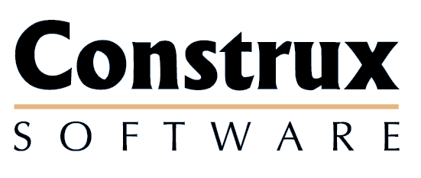

Advancing the Art and
Science of Commercial
Software Engineering
Contents
1 Introduction 1
1.1 Key Terms 1
2 Roles and Tools 2
2.1 Review Roles 2
2.1.1 Author 2
2.1.2 Reviewer 2
2.2 Review Tools 2
2.2.1 Review Forms 2
3 Desk Check 3
3.1 Overview 3
3.2 Process 3
4 Walkthrough 4
4.1 Overview 4
4.2 Process 4
Copyright Notice
© 2000-2002 Construx Software Builders, Inc. All Rights Reserved.
For further information or support visit www.construx.com.

Introduction
This document defines the process used for informal artifact reviews in CxOne.
Informal reviews encompass non-Inspection artifact reviews as described in CxStand_ReviewProcess.

Key Terms
Desk Check, Walkthrough, Review, Reviewer, Moderator, Scribe, Editor

Roles and Tools

Review Roles
This section describes the possible roles that can be used in informal reviews and who in the organization are likely to perform those roles. Individuals can perform more than one role for a review.

Author
All artifacts have one or more authors. These people are the major contributors to the reviewed artifact and any one of them may represent the artifact in the review. In addition, the authors may also review the artifact.

Reviewer
An individual other than the author who reviews the designated artifact to identify issues. Reviewers are generally peers of the author, customers of the artifact, project stakeholders, or quality/testing personnel.

Review Tools

Review Forms
This section describes the forms that may be used in informal reviews. All forms described here are available in CxOne as templates.

Informal Review Metrics
A summary of the time spent and issues found in an informal review.

Desk Check

Overview
A desk check is an informal review utilizing 1-n reviewers to identify issues, questions, and defects in the artifact. Normally desk checking involves an author distributing an artifact for review, and may involve informal follow up or engineering discussion meetings between the authors and reviewer.
Use desk checks:
- During the initial design and development of a artifact
- As a final review of a non mission critical artifact
- When minor changes to a non mission critical artifact occur

Process
Figure 3-1 outlines the desk check process:
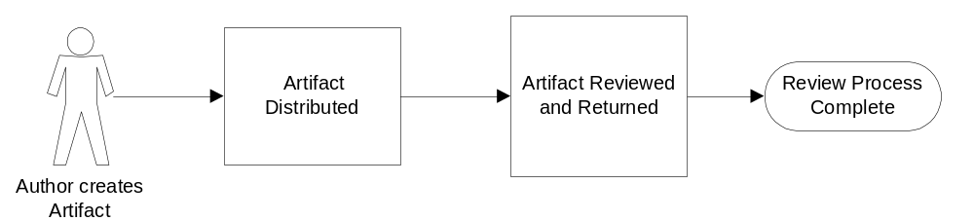
Figure 3-1: Desk Check Process
The author of the artifact determines how and when to use a desk check. The author reviewing their own work counts as a desk check, but normally others are involved as well.
The author provides a soft or hard copy of the artifact to 1-n reviewers of their choice and requests a reasonable deadline for returning comments. The reviewers should respond by the deadline with a marked up copy of the artifact containing their comments.
The time frame of a desk check may vary widely depending on the size and nature of the material being reviewed. A desk check may occur in a 5 minute meeting where the author asks someone to immediately look over a short document, or it may occur over a period of weeks if the author has asked reviewers to look at a large artifact and the project is not time constrained.
Issues identified by the desk check are normally handled informally by the author. Depending on the nature and formality of the project, handling of desk check issues may be defined in the project’s change control process.

Walkthrough

Overview
Walkthroughs have a more structured review process than desk checks, and always involve a meeting. Generally 2-4 reviewers are used to detect issues in a fairly complete artifact or part of an artifact. Discussion for understanding and consensus building is allowed, but significant solution finding is normally postponed. The author normally initiates a walkthrough and leads the process, but a project lead may do so as necessary.
Use walkthroughs:
- As a preliminary review of any artifact
- As a final review of a non-mission critical artifact
- When major changes to a non-mission critical artifact occur

Process
Figure 4-1 outlines the walkthrough process:
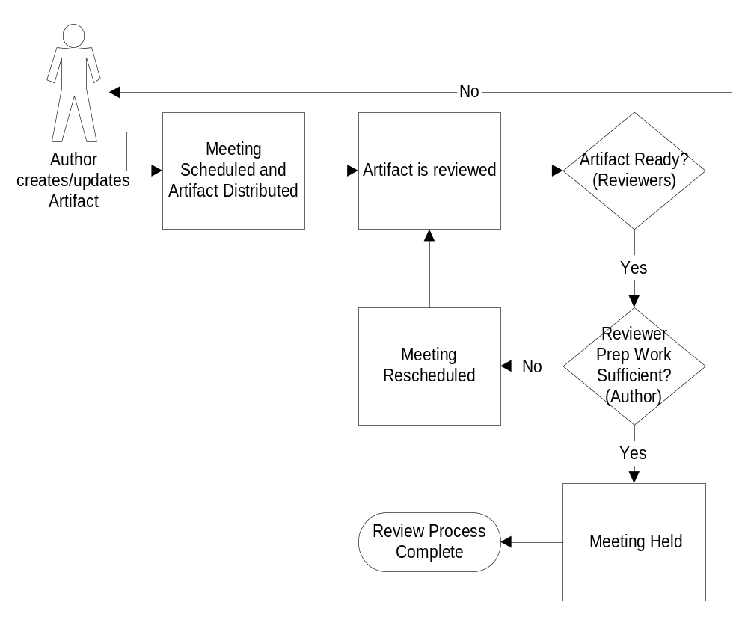
Figure 4-1: Walkthrough Process
The author selects 2-4 reviewers may also select a scribe. The reviewers should be selected based on willingness, availability, subject knowledge, and the relevance of the artifact to them (ex., artifact customers, stakeholders).
The author provides the reviewers with a line numbered copy of the artifact, a meeting time, and location. Sufficient time, generally about 2-3 days, should be allowed to review the artifact.
The reviewers review the artifact and note all issues. Minor or cosmetic issues, such as spelling errors, are noted on the artifact but are not dealt with in the meeting. If a reviewer finds a large number of issues or spends an abnormally long time preparing for the meeting, the artifact may not yet be ready for review. If this occurs, the reviewer and author work together to determine if the meeting needs to be postponed.
Before the meeting, the author ensures that the reviewers are prepared. If all reviewers are not prepared for the meeting, the meeting should be restructured or rescheduled.
When the meeting starts the author ensures necessary participants are present and ready. The author polls the reviewers for issues in the artifact. The scribe or author notes down all issues found during the review. At the author’s discretion, issues may be discussed for the purpose of understanding, but significant discussion or solution finding should be postponed until after the meeting.
At the end of the meeting, the reviewers give the author their marked up copy of the artifact.
The author is then responsible for making all appropriate changes in the artifact and informing the reviewers and appropriate project leads when they are done.
Issues identified by the walkthrough are handled based on the project’s change control process.
The Author records any metrics prescribed by the project.

