Falstaff
Test Plan
0000.doc
Version 1.0
December 13, 2002

Contents
1 Introduction 1
1.1 Overview 1
1.2 Assumptions and Constraints 1
1.3 Risks and Assets 1
2 Testing Goals 2
3 Features To Be Tested 3
3.1 Falstaff Application 3
3.2 Installation 3
3.3 Limited Hardware/Software Compatibility 3
3.4 Online Help Support 3
3.5 Internationalization 3
4 Features Not To Be Tested 4
4.1 Extensive Hardware/Software Compatibility 4
4.2 Localization 4
4.3 End User Documentation 4
5 Approach 5
5.1 Test Objectives 6
5.2 Test Strategies 6
5.2.1 Formal vs. Informal Testing 6
5.2.2 Automated vs. Manual Testing 6
5.3 Types of Testing 6
5.3.1 Construction Testing 6
Unit Testing 6
Single Step Testing 7
Bench Testing 7
Component and DIT Testing 7
5.3.2 System Testing 7
Smoke Testing 7
Feature Testing 7
Release Testing 8
6 Artifacts 9
6.1 Test Cases 9
6.2 Defect Reports 9
6.3 Automated Test Documentation 9
6.4 Test Data 9
6.5 Test Reports 9
7 Test Management 10
7.1 Staffing 10
7.2 Roles & Responsibilities 10
7.3 Schedule 10
7.4 Defect Management 10
7.5 Physical Resources 10
7.5.1 Hardware 10
7.5.2 Software 10

Introduction
The test plan provides high-level detail for the Falstaff team of the testing roles, tasks, coverage, deliverables, and dependencies.

Overview
This plan defines the strategy, coverage, and plan for the test effort on the Falstaff project. This plan does not attempt to describe individual test cases or the implementation of these test cases. Due to this, requirements tracking will be included in the Test Case Specifications (TCS).
This document depends on the information in the Falstaff Project Plan, the Falstaff Software Requirements Specification, and Falstaff Quality Plan.

Assumptions and Constraints
The following assumptions, from the testing perspective, have been made on the Falstaff Project:
- The product delivered to system test will always be stable
- The team will make all attempts to use other tools, such as reviews, to perform upstream defect detection and removal

Risks and Assets
The following risks, from the testing perspective, are seen on the Falstaff project:
- The team may not be able to make good use of an automated system testing tool. There are several issues here. One is the lack of experience in these tools by the current quality team. Another is the lack of understanding of the support for web products by the current tools on the market.

Testing Goals
The Falstaff project has set the following test goals:
- 100% statement coverage, as technology allows. The team will attempt to perform 100% statement coverage by performing the single step testing of all code produced and modified. Some exceptional conditions may not be reproducible.
- 100% component interface testing. All component interfaces will be thoroughly exercised via unit testing.
- 100% requirements coverage. It is likely that there will be a few requirements that are “untestable”; those will be managed on a case-by-case basis. Requirements coverage is handled by the system testing.
- Requirements system testing will replicate a reasonably similar operational environment at nominal loads using the standardized test data
- Requirements construction testing need only to replicate the development environment but should use the standardized test data.
- Speed, resource, and scalability testing will replicate the operational environment at peak loads. This testing will cover 20% of the most likely to be used functional requirements (as determined by requirements and quality leads).
- Test activities will leverage automated testing as much as possible. 80% of unit testing will be automated, 100% of smoke testing, and 50% of release testing.
- 100% regression of all unit and smoke automated tests will be performed daily as part of the build. 100% of all automated tests will be regressed each week.
- Release testing effort and time will be minimized by focusing on upstream quality and testing activities. We’d like only 20% of system testing effort will be in release testing, and only 50% of overall test effort to be in system testing.

Features To Be Tested

Falstaff Application
The functionality defined in the SRS and planned for in the Falstaff Project Plan will be tested. Details on how these features are testing can be found in the Approach section of this document. The test cases and requirements covered are documented in the TCSs and Falstaff Requirements Traceability Matrix.

Installation
Test cases for the client and server installations onto the target platforms outlined the requirements specficiation can be found in the Install TCS.

Limited Hardware/Software Compatibility
The Falstaff client will be tested on Windows 98, NT4, Windows 2000, XP, and Linux systems using IE 5.5 and Netscape 6.0 browsers. The Falstaff server will be tested on Linux and NT 2000.
The Falstaff project is using simple HTML and HTTP on the client systems. As such, we expect minimal issues with cross platform support. Testing of different client operating systems and browsers will occur opportunistically during the development of the system.
A test matrix, Falstaff Test Matrix, describing the platforms and combinations that are tested will be available in Visual Source Safe throughout the project. It can also be obtained by asking the quality lead for a copy.

Online Help Support
Support for mouse over, focus, and context sensitive help will be tested during the Falstaff project. Any components that implement the user interface will have test cases to ensure online help is supported. Testing for Online Help will be contained in the Falstaff System TDS.

Internationalization
Pseudo-localization testing will be performed on the Falstaff project. Pseudo-localization testing consists of converting all strings in the resource file to dots (.) and running the application to verify that no hard coded strings are present.
This resource file will be loaded into the application by setting the browser language preference to be something other than English and naming the .dot enabled resource file to that language.

Features Not To Be Tested

Extensive Hardware/Software Compatibility
Due to the nature of the application, the time available to the project, and the low risk on cross platform issues, we will not perform extensive compatibility testing.

Localization
Localization capabilities are not planned for this release of Falstaff and will not be tested.

End User Documentation
No end user documentation is planned for this release of Falstaff. All user help will be contained in the online help.

Approach
This section describes the test approach for the Falstaff project. This includes the test lifecycle, types of testing, test objectives, and test criteria.
Falstaff will follow a Staged Delivery lifecycle. There will be frequent milestones throughout the project lifecycle, each one with a set delivery date and an expected set of functionality. For additional details, see the Falstaff Project Plan.
The Staged Delivery Cycle means that the tests and test documentation is updated throughout the life of the project. At the beginning and throughout each cycle, the tests and test documentation for new or updated areas are completed. These are used during the phase to perform testing.
The following figure shows the test cycle that a change to the code base would go through for each small milestone. (Dashed items are optional.)
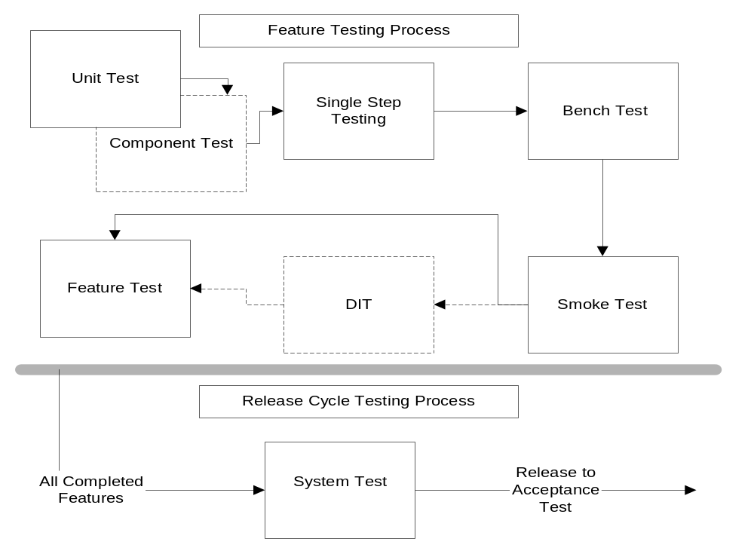
Figure 4-1: Release Cycle Testing

Test Objectives
The primary test objectives for the Falstaff project are to meet the goals described in Section 1. Secondary test objectives are to ensure product quality, stability, and usability.

Test Strategies
The following section describes the test strategies used on the Falstaff project.

Formal vs. Informal Testing
The team will use a combination of formal and informal testing to meet the test objectives.
For efficiency and effectiveness, test cases on the Falstaff project should be reusable. To this end, test cases will usually be documented in the automated test database or in a TCS. Informal testing will be used when it is most effective.
The quality lead will work with the project team to ensure a good balance of formal and informal testing is occurring.

Automated vs. Manual Testing
It is the goal of the Falstaff team to automate wherever and whenever economically justified.
For unit and component testing, all possible automation should be done. These automated tests will then become part of a large test harness used to exercise the product. Manual testing will supplement automation where necessary.
System testing will be a combination of automated testing via the GUI and manual testing.
Automated tests will comprise a major portion of the product regression. For more detailed information see the Falstaff Build Process document.

Types of Testing
This section describes the types of testing that will be used on the Falstaff project. Each type is described in further detail in CxStand_Testing.

Construction Testing
This section outlines the types of testing that will be used during the development activity to ensure high quality code is produced.

Unit Testing
Automated unit testing will be used extensively on the Falstaff project. Automated unit tests will be created to perform bench testing wherever possible.

Single Step Testing
Single step testing will be used to achieve statement coverage goals outlined in Section 1. Every line of production code should be single stepped through a debugger at least once.

Bench Testing
Bench testing will be used to test the integration of newly developed or changed code on a local full product build. Manual testing should cover all nominal code paths with some exception testing to create confidence that development is complete and ready for integration into production code.
Bench testing should cover the following levels of testing:
- Valid input
- Input values that exceed the maximum allowed
- Input values that do not meet the minimum allowed
- Input values that generated output values greater than the maximum allowed
- Input values that generate output values less than the minimum allowed
- Other meaningful boundary cases such as null, negative values, input values that interact to product incorrect output, etc.

Component and DIT Testing
When appropriate, component and DIT testing will be performed. Depending on project needs this testing may be either formal or informal in nature. The quality lead can provide details on where and when this testing is performed.

System Testing
This section outlines system testing that will be performed with the complete system in a replica of the operational environment after development of functionality is completed.

Smoke Testing
Smoke testing will be used to ensure functional daily builds. It can also be used by an engineer to characterize a build to ensure development can continue.
Smoke test cases ensure the basic product functionality is working in the production build. These cases are documented in Falstaff Smoke TCS artifact. Smoke testing is time-boxed to 30 minutes for a complete successful pass.
For effectiveness and efficiency all tests are automated and run after each build.

Feature Testing
As product features are integrated and released, a member of the team is responsible for testing the feature as completely as possible. Feature testing is black box testing that includes full nominal and exception cases.
As part of feature testing, new test cases are added to the appropriate automated tests and TCS’s. The tests created as part of feature testing are used in the final system testing pass.

Release Testing
Release testing ensures consistency of the product at the end of each release as core functionality testing is already completed by the feature testing.
The majority of release testing will be done prior to each milestone release. The quality lead will determine and document the testing coverage necessary for each milestone based on the project needs.

Artifacts

Test Cases
A test cases will be captured in Test Case Specifications (TCS). Each TCS outlines the scope of its testing, specific test requirements, hardware resources and test cases. The documentation of test cases comprises the majority of the TCS. Test Case Specifications will follow the format specified in CxTemp_TestCaseSpecification.
Each test case has the potential to be designated as a Critical Regression test. Tests marked Critical Regression must be run any time that significant changes, such as adding new functionality or rewriting a section, occur in the module or feature area. These are the test cases used to ensure the product remains stable. Critical Regression test cases generally comprise 25% to 40% of all tests.

Defect Reports
Defect reports will be created using the Falstaff defect tracking database. Defect report contents is described by CxPattern_DefectManagement and defined by the defect tracking forms.

Automated Test Documentation
The automated test effort is documented in Falstaff Automated Testing.

Test Data
A snapshot of operational data will serve as the basis for the project’s test data for both construction and system testing. A single version of the test database will be maintained to support all testing. Test data will initially be developed in branches from this database, and then merged back into the tip database when construction or system test cases have stabilized.

Test Reports
A test summary report will be created at the end of each stage. This report includes the total number of test cases, number of test cases executed, and % of test cases that passed.

Test Management

Staffing
Staffing is described in Falstaff Project Plan.

Roles & Responsibilities
Test roles and responsibilities are described in Falstaff Project Plan.

Schedule
Schedule details are contained in Falstaff Project Plan and Falstaff Workbreakdown Structure.

Defect Management
CxOne defect management procedures will be used as described in CxPattern_DefectManagement and as defined in the Falstaff project defect tracking system.

Physical Resources

Hardware
The current testing facilities are sufficient to support the needs of the Falstaff project.

Software
The following software will be used to test Falstaff.
Software | Logistics | Status
Linux | 10 seats, imaged | Ready
Microsoft Windows ME | 4 seats, imaged | Ready
Microsoft 2000 Workstation | 4 seats, imaged | Ready
Windows XP Professional | 6 seats, imaged | Need to make image
Microsoft Internet Explorer v5.5 | 8 seats, imaged | Ready
Netscape Navigator v6.0 | 8 seats, imaged | Need 2 more licenses
Visual Test | 3 seats | Currently available
AQ/Dev Defect Tracking System | 12 seats | Ready

