Weekly Individual Plan
CxOne Guide
0000.doc

February 21, 2003



Advancing the Art and
Science of Commercial
Software Engineering
Contents
1 Introduction 1
1.1 Overview 1
1.1.1 Compared to Time Tracking and Project Schedules 1
1.1.2 Customizing the Plans 1
1.2 Using the WIP Template 2
1.2.1 File Naming 2
1.2.2 Plan Management 2
2 Overview Section 3
3 Miniature Milestone Section 4
3.1 Miniature Milestone Overview 4
3.1.1 Uncertainty 4
3.1.2 Breaking Tasks into Milestones 4
3.1.3 What a Staff-Day and Week Is 6
3.1.4 Days vs. Hours 6
3.1.5 Calendar Time and Scheduling 6
3.2 Miniature Milestone Tables 8
3.2.1 Previous Week Table 8
3.2.2 This Week Table 8
4 Risks and Near-Term Planning 9
4.1 Individual Risks 9
4.2 Near-Term Planning 9
5 Additional Sections 10
Copyright Notice
© 2000-2002 Construx Software Builders, Inc. All Rights Reserved.
For further information or support visit www.construx.com.

Introduction
This user guide describes assumptions and conventions used to create weekly individual plans using CxTemp_WeeklyIndivudalPlan. Also see CxCheck_WeeklyIndividualPlan.

Overview
Weekly Individual Plans (WIPs) are a low overhead way to plan work, support continual improvement of estimation, and identify schedule risks. They also provide managers, leads, and team members visibility into an individual’s planned activities for a week. This supports efficient communication and management of workload and dependencies between engineers.
One plan is completed per engineer, covering all projects they may be working on for the week. This allows for simple coordination of multi-tasked staff between projects.
The WIP defines a minimum level of individual planning and tracking expected from engineers. Engineers may also use more sophisticated mechanisms for their individual planning, tracking, and process improvement activities. If this is the case, information from those personal mechanisms should be rolled into a standard WIP each week for consumption by the rest of the organization.

Compared to Time Tracking and Project Schedules
The focus of WIPs is planning and tracking miniature milestones for each calendar week. These individual plans complement scheduling and time tracking that is occurring elsewhere in a project or organization. They are not an hour by hour log of activities nor do they replace project scheduling. Rather, the WIPs provide a lightweight mechanism for planning, estimating, coordinating, and tracking weekly activities between individuals.
Creating and using WIPS should be a high-leverage activity that provides increased productivity with low cost. This means keeping WIPs at a summary level and avoiding bureaucracy. Only essential and appropriate information should be communicated in these plans.
Details that are more easily communicated informally through e-mail or verbally should be handled in that fashion – not in the WIPs.

Customizing the Plans
This guide describes an effective set of mechanisms and conventions for employing CxTemp_WeeklyIndividualPlan. Organizations, projects, and individuals can customize and extend the plans to use different mechanisms or include other planning or personal process improvement information. When this is done there should be an identifiable, standardized core that will allow easy coordination between individuals, projects, and organizations.

Using the WIP Template
Each engineer should have a folder (preferably under revision control), visible to all other team or organization members, where they will store their individual plans.
The CxTemp_WeeklyIndivudalPlan template (or your organization’s customized template) should be used to create an initial plan. Individuals can then utilize their plan from the previous week as the basis for the upcoming week’s plan. The tables in the plan have been set up to allow maximum reuse from such an approach, minimizing the amount of overhead involved in creating plans.

File Naming
Each plan for each week should be it’s own file in your directory. For example:
If your directory location is:
\\Server\ActiveProjects\IndividualPlanning\JoeZ
Each file should follow the standard naming convention:
JoeZ-WeeklyPlan_yy-mm-dd.doc
Where the yy-mm-dd is the date for the beginning of the plan week. Usually it is simplest to consider weeks as starting on Monday.

Plan Management
Every individual should complete their WIP for the upcoming week either at the end of the previous week or as early as possible in the new week. Usually WIP planning will be driven by weekly project planning that is occurring in parallel.
If weekly status or planning meetings are held, they can be a good forum for discussing any global issues or risks identified in the team member’s WIPs.
To ensure overall efficiency, the WIP process and document should avoid duplication information that is being created or documented in a different context. You may need to make changes to WIP implementation or other project planning processes to ensure optimal weekly planning and tracking on your organization’s projects.

Overview Section
The top of the plan is a brief summary section. The overview should be filled out as described below. A sample is shown below as well.
Overview Description
Name | Your Name
Period | Starting and end date for the UPCOMING week this plan covers, normally the date for the Monday starting the week and Friday ending the week  Use mm/dd/yy - mm/dd/yy date format.
Projects | Project names of all projects that you are currently engaged on in a direct management or individual contributor capacity, even if you don’t have work planned for them this week.
Status | If work is following the plan this section could just state, “Work proceeding as planned”.  If additional information is provided it should be a very brief synopsis of the past week and future plans. This section should not repeat items that will discussed in more detail below, but may briefly summarize them.  Reasons for large deviations from planned activities should be noted here.

Sample Overview
Name | Joe Zeppelin
Period | 2/26/01 - 3/2/01
Projects | Widget A, Web Site Makeover, BlackStar
Status | Widget A and Web Site Makeover work proceeding as planned.  Unexpected sales support for Acme cropped up, affecting BlackStar as noted below.

Miniature Milestone Section
The miniature milestone sections are the most important sections of the WIP. They are used to plan individual execution of project tasks and coordinate weekly work between engineers and between projects. This section describes the miniature milestone process and then some illustrative samples of tables from the template.

Miniature Milestone Overview
The WIP is designed to plan and track one week’s worth of mini-milestones. Miniature milestones are the CxOne recommend technique for planning and tracking time on an individual basis – they are small-grain tasks that are tracked on a binary basis; they are either done or not done, i.e., 70% complete is not allowed. Background and details on miniature milestones may be found in Rapid Development. This section describes conventions for using miniature milestones with the default CxOne WIP template.

Uncertainty
Even when looking inside a project week with daily resolution, there will be some amount of uncertainty associated with completing milestones, both the amount of effort they will require and exactly when they will occur. For most people, optimal efficiency in executing a week’s worth of work will not come from trying to exactly plan out every hour of the week. Instead, the WIP embraces the idea that there will be some uncertainty and flexibility in the execution of the work, and seeks only to provide a planning view that is a reasonable approximation for guiding and coordinating work.
Uncertainty is captured in a number of ways by WIPs:
- Using low-resolution increments for measuring milestone effort.
- Using a low and high range on effort estimates.
- Using low-resolution increments for measuring when the work for a milestone will be executed (i.e., using days instead of hours).
Due to the use of low and high effort estimates, planned work for a week will normally be a range of effort with the average being the nominal work effort expected for that week (e.g., 4-6 days for a 5 day week).

Breaking Tasks into Milestones
Tasks should be broken down into milestones estimated to require between 0-2 days of your effort (this is dedicated effort on the milestone, NOT the calendar time you expect it to take). Increments should not be smaller than a quarter staff-day (e.g., 0.5, 0.75, 1.5, etc.) . The use of these effort increments is intentional, to better capture uncertainty and encourage the breakdown of tasks to occur at a reasonably abstracted and aggregate level.
Try to break down tasks such that the average milestone effort is one day. If you are regularly planning more than 10 milestones per week you should probably break your tasks into fewer milestones. If you regularly have less than 5 you should consider breaking up your work a bit more for better resolution.

How do I break my work up?
There are two major drivers for breaking work up into milestones. The first is dependencies with other individuals. If you are working on something that someone else needs you to finish before they can do their work, or you have to wait for something, it makes sense to break your work up to accommodate these dependencies.
The second major driver is defining the milestone in a way that creates a logical, cohesive work package for you. It should be clear to you (and reasonably clear to others familiar with what you are working on) what a particular milestone implies, and what its binary completion criteria are.
Sometimes it may not be obvious how to break up a task, especially one that you know will run over multiple weeks. When this occurs, think of what reasonable progress you can expect to make this week and define the milestone in those terms. The milestone should have binary completion criteria that is meaningful however. Thus a milestone that says ‘Get XYZ coding half done’ is not good, but one that says ‘Complete coding X part of XYZ’ is.
In the interest of making the creation of miniature milestones efficient, it is not necessary to provide enough detail in your WIP for someone who is not familiar with what you are working on to understand what you are referring to. Ideally, the milestone content of WIPs will be largely a shorthand of task codes and activity names derived from project schedules.

How do I account for overhead?
Overhead varies with job responsibilities, but every engineer will have some overhead to take into account when planning their activities (e.g, responding to unplanned interruptions, e-mail correspondence, etc.).
Normally you should just factor this overhead into the estimates for your milestones. Over time after tracking work in this fashion you will have a history to refer to in terms of estimating your actual productivity on a task.
Sometimes, if you know you will have a consistent level of interruption each week it may make sense to model it as its own milestone. For example, define a mini-milestone each week that is 0.25-0.5 staff days worth of support for the Acme product line.

Zero Effort Milestones
Zero effort mini-milestones are intended to capture significant short tasks or events that occur during a week that are not large enough to plan as a quarter day of effort. Zero length mini-milestones allow for important events to be planned and recorded. If someone has several zero-length mini-milestones in one week, judgment should be used in terms of how it affects work load, because there will be some small amount of effort associated with the zero length milestones. For instance if there are 5 zero length mini-milestones that an engineer expects to take from 5 to 30 minutes of effort, they could be treated as a quarter day of time when calculating out the total planned effort for the week. Individuals should manage this informally using their judgment.

What a Staff-Day and Week Is
Normal planning should include mini-milestones that cover the upcoming work days in the work week. Staff days are assumed to be roughly 8 hours. If 45 hours are spent working in a week then there should be roughly 5.5 staff-days worth of mini-milestones to represent that work.

Days vs. Hours
In the interest of keeping the WIP a lightweight activity, you do not want to attempt to explicitly map out every hour of a week. Rather you want a plan with appropriate flexibility, to allow for efficient use. Thus 0, 0.25, 0.5, 1, and 2 staff-day tasks will not correspond exactly to 0, 2, 4, 8, or 16 hours worth of work, but should roughly represent those levels of effort. The purpose of mini-milestones is not precisely record time spent on activities; that is what time tracking is for. Mini-milestone effort obviously needs to correspond to actual hours of effort spent, but we recommend the association be kept loose in the interest of keeping overhead of creating WIPs low.
If your organization or team is more comfortable using staff hours instead of days to plan and track mini-milestones, then use hours instead of quarter staff days. When using hours for estimates and tracking in the WIP care should be take to avoid attempting to plan in too much detail. A key way the overhead impact of WIP creation is kept small is by not trying to make it overly precise. We do not recommend defining miniature milestones with factional hours.
Remember, some planning is far better than no planning, but increasingly detailed planning will eventually succumb to diminishing marginal returns, where the time you spend creating the plan does not pay back in increased efficiency of work execution. Rigid planning can also be a risk, preventing a project from responding appropriately to changing environments.

Calendar Time and Scheduling
The milestone discussion has focused on effort to this point. This is because within a week time period, ensuring that the amount of effort planned for a week is normally a larger risk to a project than the calendar time and timing (i.e., scheduling) of the work. Timing in a week is still important, e.g., if you are completing the release notes for a release that needs to go out Wednesday you can’t do those notes on Thursday.
Exact timing of critical project events is beyond the scope of your WIP. It is assumed that project scheduling, project management, and informal communication among the team will drive the detailed timing of most issues. However, the WIP does have a mechanism for communicating when you expect to be engaged in particular milestones during the week. This allows for coordination of important dependencies and integrations.
Each planned milestone has a range of days such as Tue-Thur, which bracket the time you expect to be working on something. In any given day it is expected that you may do wthat applies to several different milestones, so it is expected that there is overlap in planned days. If you have a placeholder task for some ongoing activity that you aren’t sure when it will take up your time (e.g., the 0.25-0.5 staff days of support for the Acme) you can say you don’t know or mark it as a Mon-Fri task if you expect to get some e-mails or phone calls throughout the week.
It is a good idea to plan some milestones to be completed earlier in the week, as opposed to planning to wrap everything up on Friday.

Refactoring Milestones
Sometimes your understanding of work will change during the week, or project priorities will significantly shift. When this occurs it may make sense to change the scope of existing milestones, add new ones, etc.

Changing Scope of the Milestone
For example, let’s say you were planning to bring a certain document to a high level of polish and estimated 1-1.5 staff days for the work. If you only brought the document to a medium level of polish by the end of the week, you would normally consider that milestone to not be complete, because you hadn’t met the initial goal. If however, your manager pulls you away to work on something else, the users of the document say it is good enough, and there will be no more work expended on it, you should change the meaning of what completing the milestone means, and mark it as done.
Be sure that this is only occurs when work to be completed is actually never going to be done vs. just being pushed off until later. The later is an important indication that the original work was probably under-estimated and will lead to serious schedule risk if there is always some work that is not truly completed and gets kicked down the road. Normally if the work you wanted to complete for a milestone is not done, that should be made an important part of the project planning so it can be handled in a way that is best for the project.

Unplanned Work
Unfortunately, work will often crop up during the week that wasn’t part of the plan. When this occurs you normally don’t need to bother updating your WIP during that week; just make sure the new work is captured in next week’s WIP. Over time if there are systematic classes of unplanned work that crop up you can model them in your WIP as milestones. For example, creating a regular weekly milestone for ‘Previous Product Support’ and estimating it based on previous data to take from 0-0.5 staff days per week.

Miniature Milestone Tables
The miniature milestones section is both a status report on what happened the previous week, and a plan for the upcoming week. The tables are implemented as embedded Excel spreadsheet. To edit the values double click the table.
Rows can be added and deleted as necessary, although the size of the embedded Excel window may need to be adjusted to ensure everything is visible.
Sample Mini-Milestone Tables
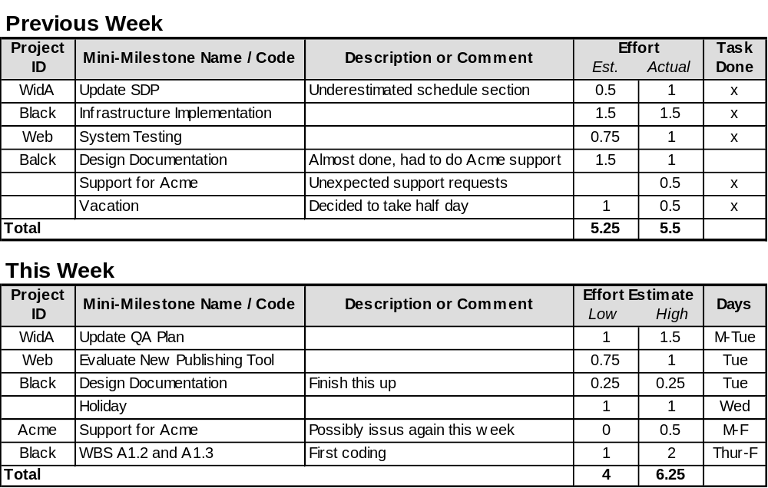

Previous Week Table
Record previous weeks tasks. Tables are designed to allow cut and pasting or columns from the upcoming week table to this one. If you used a range for estimated effort in the previous report, use the high end of the range here. Note any interesting issues and add any unplanned tasks.

This Week Table
Capture planned tasks for upcoming week. It is expected that there will be uncertainty involved with most upcoming week task estimates. As noted in the Miniature Milestone description, there is already some uncertainty built into the staff day break-down for milestones. If more is needed, a range should be provided in the low and high columns. If the range is not needed, use the same number in both columns. Provide expected days in which you plan to work on each milestone.

Risks and Near-Term Planning
The use of the risks and near term planning sections are encouraged but are optional since they are not as critical for intra- and inter-project planning and coordination as the tasks sections. They do provide a useful mechanism for personal issue management, and a formal documented mechanism for communicating with people you’re working with.

Individual Risks
This is a standard risks list that you can use to track and manage individual risks. The level of detail used here should be what the individual finds the most useful.
Rank | Risk | Current Resolution

Near-Term Planning
This area should be used for planning of important individual items that are beyond the scope of the task section. In general this section should NOT be used to reproduce a project’s schedule. Rather it should be used to capture personal tasks that fall outside an existing project, are part of an informal project, or are otherwise not being tracked elsewhere.
Priority | Task Name and/or Description

The following priority terms should be used to provide consistency between reports:
ASAP - Based on current planning, this task must be scheduled as soon as possible.
High - Barring other priorities, this task should be completed in 2-3 weeks.
Medium - Barring other priorities, this task should be completed in 4-8 weeks.
Low - Personal placeholder or remainder for long term task.

Additional Sections
Some engineers may want to augment the standard individual plan to plan or capture items related to their own personal processes, e.g., capturing PSP information. However, these sections should not impair the standardization of the report.
This sort of information can be placed after the standardized plan sections, to allow for efficient consumption of the information in the standard areas. The format and content of additional sections is up to the individual.

