Weekly Individual Plan
Name | Don Pedro
Period | 6/4/01 – 6/8/01 (week 4 of Peto)
Projects | Peto, Falstaff
Status | Project work proceeding as planned, with exception of unplanned project marketing meeting.

Miniature Milestones
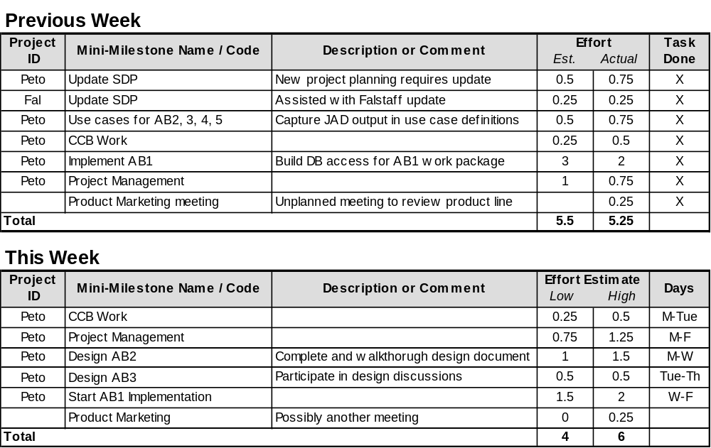

Individual Risks
Rank | Risk | Current Resolution
1 | Fred my need personal time next 2 weeks | Have asked Jody to help cover if necessary.
2 | Overcommitting my time. | Keeping close eye on weekly schedules and keeping estimates reasonable.

Near-Term Planning
Priority | Task Name and/or Description
High | Provide review feedback on Argo project documentation.

