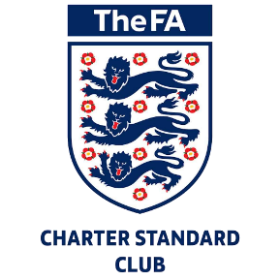

Heading Guidance Policy

The club shall follow The FA heading Guidance.