# Concussion Policy

As a club we will follow The FA concussion guidance.

If in doubt, sit them out.



If in doubt sit them out.

# Summary Points



While injury to the brain can be fatal, most concussions recover completely with correct management

## All concussions should be regarded as potentially serious and should be managed in accordance with the appropriate guidelines

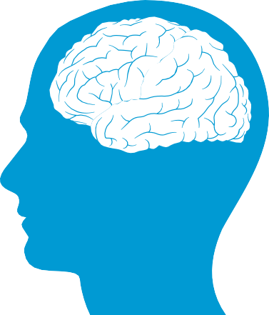

A concussion is an injury to the brain

Incorrect management of concussion can lead to further injury

Loss of consciousness does not occur in the majority of concussions



Anyone with any concussion symptoms following a head injury **must** be removed from playing or training

Return to education or work must take priority over return to play



There must be no return to play on the day of any suspected concussion

## A progressive exercise program that introduces an individual back to sport in a step-wise fashion is recommended after a concussion



An injury to

the cervical spine (neck) may occur at the same time as a concussion and normal principles of cervical spine care should also be followed



### 2

**Introduction**



These guidelines are intended to give guidance to those managing concussion in football at all levels. Professional and elite level players sometimes have access to an enhanced level of medical care which means that their concussion and their return to play can be managed in a more closely monitored way. In this situation only, the guidelines for return to play in an enhanced care setting may be followed.

These guidelines are based on current evidence and examples of best practice taken from other sports and organisations around the world, including the Rugby Football Union, World Rugby and the Cross-Sports Scottish Sports Concussion Guidance. Advice has also been sought from The FA’s Expert Panel on Concussion and Head Injury in Football. The guidelines are in line with the Consensus Statement

on Concussion in Sport issued by the Fifth International Conference on Concussion in Sport, Berlin 2016.

This version has been updated as of August 2019 .

While these guidelines aim to reflect ‘best practice’, all accept that there is a current lack of evidence in respect

to their effectiveness in preventing long- term harm. The FA will continue to monitor research and consensus in the area of concussion and update these guidelines accordingly.

*modified from World Rugby’s

‘Guidelines on Concussion - Management for the General Public'

The following guidance is intended to provide information on how to recognise concussion and on how concussion should be managed from the time of injury through to safe return to football.

At all levels in football, if a player is suspected of having a concussion, they must be immediately removed from the pitch, whether in training or match play. **IF IN DOUBT, SIT THEM OUT.**

**What’s Inside**

### What is concussion

* What is concussion?
* What causes concussion?
* Who is at risk?
* Onset of symptoms

### How to recognise concussion

* How to recognise a concussion
* Visible clues of concussion - what you may see
* Symptoms of concussion - what you are told by the injured player
* Questions to ask a player
* Video footage

### What to do next

* Immediate management of a suspected concussion

### Returning to play

* Ongoing management of a concussion or suspected concussion
* Returning to play after a concussion
* Returning to work and study after a concussion
* Graduated return to play (GRTP) protocol
  + Minimum return to play intervals when following GRTP Protocol
  + Six-stage GRTP Protocol table
  + Table showing minimum return to play intervals
* How are recurrent or multiple concussions managed?
* Return to play pathway in an **Enhanced Care Setting**

### Useful links

* Useful adjuncts to concussion assessment

### 3

**1**

**What is concussion?**



If in doubt sit them out.

**4**

**What is concussion?**

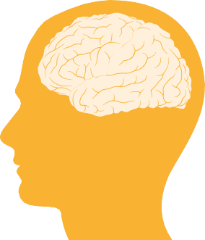

Concussion is an injury to the brain resulting in a disturbance of brain function. There are many symptoms of concussion, common ones being headache, dizziness, memory disturbance or balance problems.

**What causes concussion?**

**Who is at risk?**

Concussions can happen to players at any age. However, **children and adolescents (18 and under)**:

* are more susceptible to brain injury
* take longer to recover
* have more significant memory and mental processing issues
* are more susceptible to rare and dangerous neurological complications, **including death caused by a single or second impact**

Studies indicate that concussion rates in **women** are higher than in men in football.

A history of **previous concussion** increases the risk of further concussions, which may also take longer to recover.

Concussion can be caused by a direct blow to the head, but can also occur when a blow to

another part of the body results in rapid movement of the head

e.g. whiplash type injuries.

### Onset of Symptoms

The symptoms of concussion typically appear immediately, but their onset may be delayed and can appear at any time after the initial injury



***Loss of consciousness*** does not always occur in concussion (in fact it occurs in less than 10% of concussions).

A concussed player may still be standing up and may not have fallen to the ground after the injury.

### 5

**2**

**How to recognise a concussion**



If in doubt sit them out.

**6**

**How to recognise a concussion**

If any of the following signs or symptoms are present following an injury the player should be **suspected** of having a concussion and **immediately removed from play or training and must not return to play that day. The Pocket Recognition tool may be used as an aid to the pitchside assessment (see Useful Links section)**

**If in doubt sit them out.**



**Visible clues (signs) of concussion**

What you may see

*Any one or more of the following visual clues can indicate a concussion:*

* Dazed, blank or vacant look
* Lying motionless on ground / slow to get up
* Unsteady on feet / balance problems or falling over / poor coordination
* Loss of consciousness or responsiveness
* Confused / not aware of play or events
* Grabbing / clutching of head
* Seizure (fits)
* More emotional / irritable than normal for that person



**Symptoms of concussion**

What you may be told by the injured player

*Presence of any one or more of the following symptoms may suggest a concussion:*

* Headache
* Dizziness
* Mental clouding, confusion, or feeling slowed down
* Visual problems
* Nausea or vomiting
* Fatigue
* Drowsiness / feeling like “in a fog“ /difficulty concentrating
* “Pressure in head”
* Sensitivity to light or noise

### Questions to ask a player

*These should be tailored to the particular activity and event, but failure to answer any of the questions correctly may suggest a concussion. Examples with alternatives include:*



##### What venue are we at today?

or

###### Where are we now?

**Which half is it now?**

or

###### Approximately what time of day is it?

**Who scored last in this game?**

or

###### How did you get here today?

**What team did you play last game?**

or

###### Where were you on this day last week?

**Did your team win the last game?**

or

###### What were you doing this time last week?

*An incorrect answer to these questions may suggest a concussion, but a concussed player might answer these questions correctly.*

**Video footage:** If video footage of the incident is available this may be of assistance in establishing the mechanism and potential severity of the injury and can be used to contribute to the overall assessment of the player. This may be viewed by the person assessing the injured player or can be commented on by a third party, such as the tunnel doctor in an elite professional setting. A coach or parent may have video

footage that could be helpful in a non-elite setting. However video evidence must not be used to contradict

a medical decision to remove the player.

### 7

**3**

**What to do next**

Immediate management of a suspected concussion



If in doubt sit them out.

**8**

**What to do next**

**Anyone with a suspected concussion MUST be IMMEDIATELY REMOVED FROM PLAY.**



Once safely removed from play they must not be returned to activity that day.

Team-mates, coaches, match officials, team managers, administrators or parents who **suspect** someone may have concussion MUST do their best to ensure that they are removed from play in a safe manner.

If a neck injury is suspected

suitable guidelines regarding the management of this type of injury at pitchside should also be followed (see useful links for pitchside injury management training)

If ANY of the following are reported then the player should be transported for urgent medical assessment at the nearest hospital emergency department:

##### Severe neck pain

**Deteriorating consciousness (more drowsy)**

**Increasing confusion or irritability**

**Severe or increasing headache**

**Repeated vomiting**

**Unusual behaviour change**

**Seizure (fit)**

**Double vision**

**Weakness or tingling/ burning in arms or legs**

In **all** cases of **suspected concussion** it is recommended that the player is referred to a medical or healthcare professional for diagnosis and advice, even if the symptoms resolve.

### 9

**4**

**Returning to play**

Ongoing management of a concussion or suspected concussion



If in doubt sit them out.

**10**

**Ongoing management**

**Rest the body rest the brain.**

#### Rest is the cornerstone of concussion treatment. This involves resting the body, ‘physical rest’, and resting the brain, known as ‘cognitive rest’. The period of rest allows symptoms to

recover and in the non-professional setting allows a return to work or study prior to resuming training and playing.

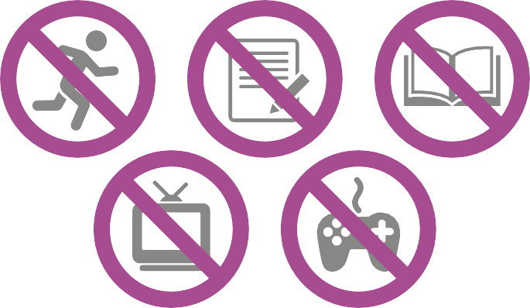

**Rest means avoiding:**

* **Physical activities** such as running, cycling, swimming, physical work activities etc.
* **Cognitive activities (thinking activities)**, such as **school work, homework, reading, television, video games**. Students with a diagnosis of concussion may need to have allowance made for impaired cognition during

recovery, such as additional time for classwork, homework and exams

**Returning to play after a concussion**

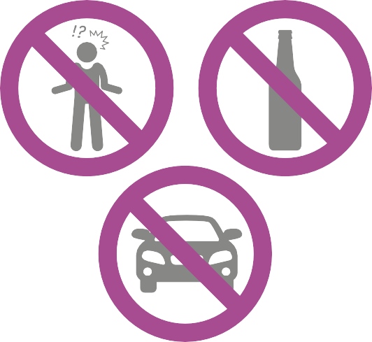

**Anyone with a concussion or suspected concussion should NOT:**

* **be left alone** in the first 24 hours
* **consume alcohol** in the first 24 hours, and thereafter should avoid alcohol until free of all concussion symptoms
* **drive a motor vehicle** and should not return to driving until provided with medical or healthcare professional clearance or, if no medical or healthcare professional advice is available, should not drive until free of all concussion symptoms

The graduated return to play (GRTP) protocol should be followed in all cases. This staged programme commences at midnight on the day of injury and stage 1 (initial rest period) is 14 days in all players unless they are in an enhanced care setting. In all cases, progression to stage 2 of the GRTP can only occur if the player has no symptoms.

### Return to work and study after a concussion

At the non-professional level, adults must have returned to normal education or work and students must have returned to school or full studies before starting physical activity (stage 2) in a GRTP program.

### 11

**Graduated return to play protocol**

#### A graduated return to play (GRTP) protocol is a progressive exercise program that introduces an individual back to sport in a step-wise fashion.

**Stage 2 of the GRTP protocol should only be started when a player**

* is symptom-free at rest and has completed the initial rest period (14 days in a standard care setting and modified in an enhanced care setting)
* has returned to normal education or work if not a professional footballer
* is not receiving treatments and medications that may mask concussion symptoms, e.g. drugs for headaches or sleeping tablets.

**The GRTP Protocol contains six distinct stages**

|  |  |  |  |  |  |
| --- | --- | --- | --- | --- | --- |
| **Stage 1** | **Stage 2** | **Stage 3** | **Stage 4** | **Stage 5** | **Stage 6** |
| Stage 1 is an initial rest period during which symptoms should resolve. This stage must be extended if symptoms persist | The next four stages are restricted, training based activity | | | | Return to full training and match play |

Under the GRTP Protocol, the individual can advance to the next stage **only if there are no symptoms** of concussion at rest and at the level of physical activity achieved in the current GRTP stage.

If any symptoms occur while going through the GRTP program, the individual must return to the previous stage and attempt to progress again after a minimum 24-hour period of rest without symptoms (this is 48 hours in players under 19 years of age).

It is recommended that a Doctor or Health Care Practitioner confirms recovery before an individual enters Stage 5 (full-contact practice).

The 6 stage GRTP protocol should be followed in all cases.

### 12

**Graduated return to play protocol**



EART RA

#### Stages 2-5 take a minimum of 24 hours in adults, 48 hours in those aged 19 and under.

|  |  |  |  |  |  |  |
| --- | --- | --- | --- | --- | --- | --- |
|  | **Stage 1**  Initial rest period  **14 days**  *modified in enhanced care setting* | **Stage 2**  Light exercise | **Stage 3**  Football-specific exercise | **Stage 4**  Non-contact training | **Stage 5**  Full contact practice | **Stage 6**  Return to play |
| ExERCISE ALLOWED | * Complete body and brain rest. After the initial period of 24-48hrs rest, the player should gradually reintroduce their normal activities of daily living provided this does not lead to a worsening of their symptoms. If the symptoms do return the player should rest again until symptom free | * Walking, light jogging, swimming, stationary cycling or equivalent * No football, resistance training, weight lifting, jumping or hard running | * Simple movement activities   e.g. running drills   * Limit body and head movement * NO head impact activities including NO heading | * Progression to more complex training activities with increased intensity, coordination and attention   e.g. passing, change of direction, shooting, small-sided game   * May start resistance training * NO head impact activities including NO heading - goalkeeping activities should avoid diving and any risk of the head being hit by a ball | * Normal training activities   e.g. tackling, heading, diving saves | * Player rehabilitated |
| % MAx  H TE | * No training | **<70%** | **<80%** | **<90%** |  |  |
| DURATION (MIN) |  | **<15** | **<45** | **<60** |  |  |
| ObjECTIVE | * Recovery * No symptoms at the end of 2 weeks | * Increase heart rate | * Add movement | * Exercise, coordination and skills/tactics | * Restore confidence and assess functional skills by coaching staff | * Return to play |

**13**

**Standard Return to Play Pathway**

The minimum time in which a player can return to play in the standard care setting is summarised in the table below. Each day comprises a 24-hour period. The pathway begins at midnight on the day of injury.

|  |  |  |  |  |  |  |  |  |  |
| --- | --- | --- | --- | --- | --- | --- | --- | --- | --- |
|  | **Stage 1**  Initial rest period | | | **Stage 2**  Light exercise | **Stage 3**  Football-specific exercise | **Stage 4**  Non-contact training | | **Stage 5**  Full-contact practice | **Stage 6**  Return to play |
| **ADULT** | 14 days beginning at midnight on the day of injury. The player must be  symptom-free at the end of this period before progressing | Return to academic studies or work | Clearance by doctor recommended | Minimum duration  **24 hours** | Minimum duration  **24 hours** | Minimum duration  **24 hours** | Clearance by doctor/health care professional | Minimum duration  **24 hours** | **Day 19**  Earliest return to play |
| **4 days** if symptom-free | | | | |
| **UNDER 19** | 14 days beginning at midnight on the day of injury. The player must be  symptom-free at the end of this period before progressing | Minimum duration  **48 hours** | Minimum duration  **48 hours** | Minimum duration  **48 hours** | Clearance by  care professional | Minimum duration  **48 hours** | **Day 23**  Earliest return to play |
| **8 days** if symptom-free | | | | |
| **It must be emphasised again, that these are minimum return to play times and in players who do not recover fully within these timeframes, return to play times will need to be longer** | | | | | | | | | |

It is recognised that players will often want to return to play as soon as possible following a concussion. Players, coaches, management, parents and teachers must exercise caution to:

**How are recurrent or multiple concussions managed?**

Any player with a second concussion within 12 months, a history of multiple concussions, players with unusual presentations or prolonged recovery should be assessed and managed by a healthcare provider with experience in sports-related concussions working within a multidisciplinary team.

doctor/health

1. Ensure that all symptoms have resolved before commencing GRTP
2. Ensure that the GRTP protocol is followed
3. Ensure that the advice of medical practitioners and other healthcare professionals is strictly adhered to

After returning to play, all those involved with the player, especially coaches and parents must remain vigilant for the return of symptoms even if the GRTP has been successfully completed.

*If symptoms recur the player must consult a healthcare practitioner as soon as possible as they may need a referral to a specialist in concussion management.*

Outcomes in concussion are better if the injured player is well informed and understands what has happened. Measures to improve understanding and deal with emotional problems and anxiety should also be considered in the management of concussed players.

### 14

**Enhanced Care Setting**

#### In some circumstances (such as Professional Clubs, International teams and Academies) there may be a enhanced level of medical care available which allows closer supervision of a player’s care and graduated return to play (GRTP). In these instances, a shorter timeframe

for return to play (RTP) may be possible, but only under strict supervision by the appropriate

medical personnel as part of a structured concussion management programme. **It is never appropriate for a player under the age of 16 to follow this pathway.**

#### In these circumstances **ONLY**, can the Return to Play Pathway in an Enhanced Care Setting be followed.

**The minimum criteria for an Enhanced Care Setting are as follows:**

* 1. There is a doctor with training and experience in the management of concussion/traumatic brain injury in sport available to closely supervise the player’s care and GRTP, and clear the player prior to RTP.
  2. There is a structured concussion management programme in place for the player as outlined below:
     1. baseline SCAT5 and/or computerised neuro-psychometric/cognitive testing of the player has been conducted prior to the injury
     2. Clinical serial multimodal assessment of the player occurs post-concussion to guide the recovery protocol. Acknowledging that more than one area of brain function can be affected by concussion, this will involve formal documented assessment of areas such as cognitive function, emotional wellbeing, neurological function and any physical trauma sustained
     3. A formalised GRTP programme with regular SCAT5 or equivalent assessments is followed and recorded in the player’s medical records
     4. The player has access to a multi-disciplinary team including neuropsychology / neurology / neurosurgery specialists and other clinicians as required to supervise the return to play and instigate any treatment or investigation required should the RTP progression not be straightforward
     5. A formal and documented concussion education programme exists for coaches and players in the club or team involved

If any element of the above criteria is absent, the player should follow the standard Return to Play Pathway.

**15**

**Enhanced Care Setting**

The minimum time in which a player can return to play in the Enhanced Care Setting is summarised by the table below. Each day comprises one 24-hour period. The pathway begins at midnight on the day of injury.

|  |  |  |  |  |  |  |  |  |  |
| --- | --- | --- | --- | --- | --- | --- | --- | --- | --- |
|  | **Stage 1**  Initial rest period | | | **Stage 2**  Light exercise | **Stage 3**  Football-specific exercise | **Stage 4**  Non-contact training | | **Stage 5**  Full-contact practice | **Stage 6**  Return to play |
| **ADULT** | **24 hours** minimum rest period after which the player must be symptom-free before progressing | | Clearance by doctor recommended | Minimum duration  **24 hours** | Minimum duration  **24 hours** | Minimum duration  **24 hours** | Clearance by  doctor before  stage 5 | Minimum duration  **24 hours** | **Day 6**  Earliest return to play |
| **4 days** if symptom-free | | | | |
| **UNDER 17-19** | **7 days** minimum initial rest period after which the  player must be symptom-free  before progressing | Return to academic | Minimum duration  **24 hours** | Minimum duration  **24 hours** | Minimum duration  **24 hours** | Clearance by  stage 5 | Minimum duration  **24 hours** | **Day 12**  Earliest return to play |
| 4 days if symptom-free | | | | |

**The whole return to play process must be supervised by a suitably qualified doctor within a structured concussion management programme**

**It must be emphasised again, that these are minimum return to play times and in players who do not recover fully within these timeframes, return to play times will need to be longer**

It is recognised that players will often want to return to play as soon as possible following a concussion. Players, coaches, management, parents and teachers must exercise caution to:

**How are recurrent or multiple concussions managed?**

Any player with a second concussion within 12 months, a history of multiple concussions, players with unusual presentations or prolonged recovery should be assessed and managed by a healthcare provider with experience in sports-related concussions working within a multidisciplinary team.

studies or work

doctor before

1. Ensure that all symptoms have resolved before commencing GRTP
2. Ensure that the GRTP protocol is followed
3. Ensure that the advice of medical practitioners and other healthcare professionals is strictly adhered to

After returning to play, all those involved with the player, especially coaches, support staff and parents must remain vigilant for the return of symptoms

even if the GRTP has been successfully completed.

*If symptoms recur the player must consult a healthcare practitioner as soon as possible as they may need a referral to a specialist in concussion management.*

Outcomes in concussion are better if the injured player is well informed and understands what has happened. Measures to improve understanding and deal with emotional problems and anxiety should also be considered in the management of concussed players.

### 16

**Useful links**

Berlin concussion group consensus statement

https:/ /bjsm.bmj.com/content/51/11/838

SCAT5

https://bjsm.bmj.com/content/bjsports/ early/2017/04/26/bjsports-2017-097506SCAT5.full.pdf

Paediatric SCAT5

https://bjsm.bmj.com/content/bjsports/ early/2017/04/28/

bjsports-2017-097492childscat5.full.pdf

Pocket Recognition Tool

<http://bjsm.bmj.com/content/47/5/267.full.pdf>

### Useful adjuncts to concussion assessment and management:

Cogstate

*Baseline cognitive testing*

[www.axonsports.com](http://www.axonsports.com/)

imPACT

*Baseline cognitive testing*

[www.impacttest.com](http://www.impacttest.com/)

ISEH

*Multidisciplinary concussion management team*

[www.iseh.co.uk](http://www.iseh.co.uk/)

Headway

*Guide for GPs*

[www. headway.org.uk](http://www.headway.org.uk/)

**Brain andiSnpe F oundation** *Charity offering support and advice* [www.brainandspine.org.uk](http://www.brainandspine.org.uk/)

FA ATMMiF course

*Advanced pitch-side trauma management for doctors, physiotherapists and allied health care professionals working in football* [http://www.thefa.com](http://www.thefa.com/)

FA ITMMiF course

*Intermediate pitch-side trauma management for doctors, physiotherapists and allied health care professionals working in football* [http://www.thefa.com](http://www.thefa.com/)

**Birmingham Sport Concussion Clinic** <http://www.uhb.nhs.uk/sport-and-exercise-> medicine.htm

**Spire Perform - Southampton** <http://www.spireperform.com/southampton/> services/concussion-servi