HOTEL AND RESTAURANT MANAGEMENT SYSTEM: LOGISTIC 1 ( WAREHOUSE AND VEHICLE RESERVATION) WITH SYSTEMATIZED INVENTORY REPLENISHMENT, AND ITEM TRACKING CAPABILITIES.

A Capstone
Presented to the Faculty of
The College of Computer Studies
Bestlink College of the Philippines
In Partial Fulfilment
Of the Requirements for the Degree of
Bachelor of Science in Information Technology
ALAN JULES R. BONGON
MARK ANTHONY T. FUENTES
RANDOLPH J. GUTIERREZ
JOHN ROBERT E. OCLO
KENNETH PANLILIO
October 2024
i
DECLARATION
pg. 1
The researchers of this group certify that this project study does not incorporate, without acknowledgment, any material previously submitted for a degree or Diploma in any University and to the best of our knowledge and belief. It does not contain any material previously published or written by another person or us except where due reference is made in the text, we also hereby give consent for our project study. If accepted, to be made available for photocopying and for interlibrary and for the title and summary to be available to outside organizations.
Signature of Group/ Individual: | Date: October 2024
MARK ANTHONY T. FUENTES | ALAN JULES R. BONGON
RANDOLPH J. GUTIERREZ
JOHN ROBERT E. OCLO KENNETH PANLILIO
Counter Signed By:
MARI LAYNESA
Project Adviser
pg. 2
ii

APPROVAL SHEET
This capstone entitled HOTEL AND RESTAURANT MANAGEMENT SYSTEM: LOGISTIC 1 ( WAREHOUSE AND VEHICLE RESERVATION) WITH SYSTEMATIZED INVENTORY REPLENISHMENT, AND ITEM TRACKING CAPABILITIES

,prepared and submitted by MARK ANTHONY T. FUENTES, ALAN JULES R. BONGON, RANDOLPH J. GUTIERREZ, JOHN ROBERT E. OCLO, KENNETH PANLILIO in partial fulfillment of the requirements for the degree of Bachelor of Science in Information Technology, has been examined and is recommended for acceptance and approval Pre Oral Defense.
MARI LAYNESA
Adviser

CAPSTONE REVIEW PANEL
Approved by the Committee on Oral Examination with a grade of PASSED.
REYNANTE E. PONAY ROMEO S. ALIX JR.
Member Member
JUNNEL E. AVESTEROS
Chairperson
Accepted and approved in partial fulfillment of the requirements for the degree of Bachelor of Science in Information Technology.
ROSICAR E. ESCOBER, Ph. D
Dean, College of Computer Studies Date of Pre-Oral Defense: November 17, 2024
iii

CERTIFICATE OF ORIGINALITY
This is to certify that the research work presented in this Project Study
entitled HOTEL AND RESTAURANT MANAGEMENT SYSTEM: LOGISTIC 1 ( WAREHOUSE AND VEHICLE RESERVATION) WITH SYSTEMATIZED INVENTORY REPLENISHMENT, AND ITEM TRACKING CAPABILITIES
” for the degree Bachelor of Science in Information Technology at the Bestlink College of the Philippines embodies the result of original and scholarly work carried out by the undersigned. This Project Study does not contain words or ideas for the published sources nor written work that have been accepted as the basis for the award of a degree from any higher education institution, except where proper referencing and acknowledgment were made.
ALAN JULES R. BONGON
MARK ANTHONY T. FUENTES
RANDOLPH J. GUTIERREZ
JOHN ROBERT E. OCLO
KENNETH PANLILIO
Researcher
iv

ACKNOWLEDGMENT
The researchers would like to express their heartfelt thanks and gratitude to the following persons who, in one way or another, have contributed much, and extended the willingness and support needed to make this research possible:
Dr. Maria M. Vicente, President/CEO, Bestlink College of the Philippines, for her generosity and kind heart in establishing this institution and giving opportunities to those less fortunate students to continue their studies and pursue their dreams;
Ms. Edith M. Vicente, Executive Vice President, for providing the needed information to complete this research;
Dr. Charlie I. Cariño, Vice President for Academic Affairs, for his support and encouragement to make this thesis writing possible;
Engr. Diosdado T. Lleno, Vice President for Administration and
Finance, for his words of encouragement and motivation;
Dr. Joy Evelyn A. Ignacio, Director, Center for Research and Development, for her good heart to extend the help needed by the
researchers.
v
Dr. Rosicar E. Escober, Dean, College of Computer Studies of Bestlink College of the Philippines, for providing guideline documentation in the capstone project.
Mr. Rommel J. Constantino, Program Head, Bachelor of Science in Information Technology, for the constant supervision as well as providing necessary information regarding the project and for his support in completing this project.
Mr. Ronald G. Roldan Jr., Research Coordinator, to help us in improving our research and guide us in completing this project.
Mr. Paulo Tolentino, Capstone Adviser, for giving us suggestions and ideas to improve our research and guiding us in completing this
project.
Panelists, Mr. JUNNEL E. AVESTEROS Mr. REYNANTE E. PONAY, and ROMEO S. ALIX JR. Extended their effort and time to be able to
constructively criticize this thesis and share their knowledge with them to deepen and widen their needed information.
Families and Friends, for all the financial and moral support that have enabled the researchers to triumph over all the challenges, especially during the lowest time that served as their inspiration to complete this study; and
vi

Above all, to the Almighty God, for the strength and knowledge that were used for the accomplishment of this research journey.
ALAN JULES R. BONGON
MARK ANTHONY T. FUENTES
RANDOLPH J. GUTIERREZ
JOHN ROBERT E. OCLO
KENNETH PANLILIO

Researcher
pg.
vii

DEDICATION
This business research study is wholeheartedly dedicated first and foremost to the researchers, for executing dedication, time, effort, motivation, sacrifice, and courage to make this study a fruitful and successful piece of work.
To our beloved parents who have been our inspiration and gave us strength when we thought of giving up, who continually provide their moral, spiritual, emotional, and financial support.
To each sibling and circle of friends who shared their words of advice and encouragement to finish this study.
To the research advisers and professors, for extending help by giving guidance, supervision, time, and wisdom to the researchers in conducting this business research study.
And lastly, above all, to our Almighty God, for giving guidance, strength, power of mind, protection, skills, and for giving us a healthy life.
All of these we offer to you.
THE RESEARCHERS
pg.
viii

ABSTRACT
Title: HOTEL AND RESTAURANT MANAGEMENT SYSTEM: LOGISTIC 1 ( WAREHOUSE AND VEHICLE RESERVATION) WITH SYSTEMATIZED INVENTORY REPLENISHMENT, AND ITEM TRACKING CAPABILITIES

”
Authors: ALAN JULES R. BONGON
MARK ANTHONY T. FUENTES
JOHN ROBERT E. OCLO
RANDOLPH J. GUTIERREZ
KENNETH PANLILIO
Degree: Bachelor of Science in Information
Technology
Major: Information Management, Information
Security, Network Administrative
Date of Completion __________
ix

TABLE OF CONTENTS
TITLE PAGE i
DECLARATION ii
APPROVAL SHEET iii
CERTIFICATE OF ORIGINALITY iv
ACKNOWLEDGEMENT v
DEDICATION viii
ABSTRACT ix
TABLE OF CONTENTS x
LIST OF TABLES xii
LIST OF FIGURES xiii
Chapter 1
INTRODUCTION 1
1.1. Background of the Capstone Project 2
1.2. Context and Scope 3
1.3. Problem Statement 4
1.4. Goals and Objectives 5
1.5. Significance and Relevance 7
1.6. Structure of the Document
x
xi

Chapter 2
RELATED STUDIES AND LITERATURE REVIEW | 11
2.1. Agile Scrum Methodology Overview | 11
2.2. Enterprise Architecture Concepts | 12
2.3. Micro-services Architecture | 16
2.4. DevOps and CI/CD | 18
2.4. Relevant Studies and Research | 22
2.6. Integration of Information Systems in Enterprise Environments 27 Chapter 3
METHODOLOGY | 29
3.1. Agile Scrum Methodology in the Project | 28
3.2. Roles and Responsibilities | 28
3.3. Sprint Cycles | 31
3.4. Scrum Artifacts | 37
3.5. Micro-services Architecture | 51
3.6. DevOps Implementation | 56
3.7. Innovation Integration | 56

LIST OF TABLES
Table 1: Goals and Objectives
Table 2: Roles and Responsibilities
Table 3: Sprint Cycles
Table 4: Scrum Artifacts
Table 5: Product Backlog (EIS Information Security)
Table 6: Product Backlog (EIS Standard)
Table 7: UI/UX (Icon, Color, etc.)
Table 8: Product Backlog (Integration)
Table 9: Product Backlog (Analytics)
Table 10: EIS Analytics
Table 11: Sprint Backlog (User Stories)
Table 12: Sprint Backlog (Information Security)
Table 13: Sprint Backlog (EIS Standard)
Table 14: Sprint Backlog (EIS Integration)

LIST OF FIGURES
Figure 1: Microservices
Figure 2: Network Architecture
Figure 3: Data Flow Diagram
Figure 4: DevOps Pipeline
Figure 5: BPA Level 1
Figure 6: BPA Level 2
Figure 7: Sequence Diagram (Admin)
Figure 8: Sequence Diagram (Employee)
Introduction

Background of the Capstone Project
This capstone project aims to create an systematized replenishment inventory system with item-tracking capabilities. To streamline and help the hotel and restaurant management to organize an easy-to-use inventory system and there’s include a tracking services system. Effective management of resources, logistics, and inventory is essential for operational efficiency and customer satisfaction. The interplay between hotel and restaurant management can create significant challenges, particularly in areas like logistics, project management, vehicle reservations, and inventory control. The lack of timeliness and precision in traditional inventory management techniques frequently results in stockouts or surplus inventory.

Context and Scope
A methodical technique to overseeing inventory replenishment procedures is known as a Systematized Replenishment Inventory System. It guarantees that items, products, or raw materials are restocked effectively and methodically, lowering the possibility of supply chain inefficiencies, stockouts, and overstocking. These systems are essential for companies in a variety of sectors, such as manufacturing, retail, healthcare, and logistics, to ensure seamless operations and satisfy client needs.
Businesses may increase supply chain efficiency, save expenses, and enhance inventory control by utilizing automation, predictive analytics, and real-time tracking. This paper examines the background and extent of a systematized replenishment inventory system, including its importance, features, technical integration, and operational implications.

Scope:
- Functional Range
- Stock Level Monitoring: Constantly monitors stock levels.
- Automated replenishment triggers: Utilize min-max stock levels and reorder points.
- Supplier Management: oversees purchase orders and vendor relationships.
- Demand Forecasting: Predicts future demand using AI and previous data.
- Inventory is synchronized between warehouses and retail locations using multi-location integration.
- Reporting & Analytics: Offers information on stock efficiency, lead times, and turnover rates.
2. Process Extent
- The Reorder Point Calculation establishes the appropriate time to place a new order for an item.
- Taking lead time into account guarantees that goods arrives before it runs out.
- Safety Stock Management: Preserves excess inventory for unforeseen needs.
- Stock Allocation: Gives distribution of inventories among sites first priority.
- Restocking is made easier with automated PO (Purchase Order) generation.

3.Technological Range
- Software Integration: Establishes connections with WMS (Warehouse Management Systems), POS, and ERP.
- Barcode and RFID tracking: Increases precision and effectiveness.
Better stock planning is made possible by AI and machine learning, which enhance predictive analytics.
4. Business Extent
- applicable to supply networks, big corporations, and small businesses.
covers the automotive, manufacturing, healthcare, retail, and e-commerce industries.

Problem Statement
Businesses must manage their inventory well in order to balance cost effectiveness and product availability. Regardless of industry, a lot of businesses suffer from ineffective replenishment procedures, which can result in overstocking, stockouts, and operational inefficiencies. These issues are brought on by antiquated inventory control techniques, poor demand forecasting, insufficient supplier collaboration, and a lack of automation.
In the absence of a systematic replenishment inventory system, companies risk higher operating expenses, decreased profits, and disgruntled clients. While excess inventory causes high holding costs, product obsolescence, and financial strain, stock shortages result in lost sales opportunities and harm a company's reputation. Production delays, broken supply chains, and decreased warehouse operational efficiency are other consequences of inefficient replenishment.
A streamlined, data-driven replenishment system is necessary for modern organizations to guarantee that the correct products are available in the right quantity at the right time. Businesses may maximize inventory levels, reduce waste, and enhance supply chain performance by utilizing automation, predictive analytics, and real-time tracking.
- Stockouts and Lost Sales
- Overstocking and Increased Holding Costs
- Inefficient Reorder Processes
- Inaccurate Inventory Tracking
- Supply Chain Disruptions
- Lack of Integration with Sales and Demand Forecasting
- Increased Operational Costs

Objectives and Goals
The objectives of by guaranteeing that products are refilled effectively, reducing waste, and optimizing stock levels, a systematized replenishment inventory system is intended to improve inventory management. This system's aims and objectives center on raising operational efficiency, cutting expenses, and enhancing accuracy.

Goals:
- Maintain Ideal Stock Levels
Make sure that demand and stock availability are properly balanced.
Avoid overstocking, which raises storage expenses, and stockouts, which result in missed sales.
- Automate the Process of Replenishment
Use preset stock criteria to trigger automated reordering.
Minimize human mistake and manual involvement while making restocking decisions.
- Boost Demand Prediction
To forecast inventory requirements, use market trends, historical data, and AI-driven analytics.
Adjust replenishment plans in response to discounts, seasonality, and shifting consumer needs.

- Lower Carrying and Holding Expenses

Reduce the amount of surplus inventory that could cause product obsolescence and expensive storage expenses.

Improve cash flow by putting Just-in-Time (JIT) inventory management techniques into practice.

- Improve Lead Time Management and Coordination with Suppliers

Build trusting connections with your vendors to ensure prompt stock restocking.

To increase productivity, keep an eye on lead times, delivery accuracy, and supplier performance.

- Boost the Accuracy and Visibility of Inventory

Make use of cloud-based inventory management, barcoding, RFID, and real-time tracking solutions.

Accurately synchronize data to minimize differences between recorded and real stock levels.

- Boost the effectiveness of operations

Optimize stock location and cut down on unnecessary handling to streamline warehouse operations. Streamline the work processes of procurement teams, warehouse employees, and inventory management.

Objectives:
- Reduce Stockouts and Raise

Customer Contentment Assure clients that they can always find the things they require, which will boost client loyalty and retention. Minimize urgent restocking scenarios that result in extra expenses and delays.

- Utilize Data Analytics to Improve Decision-Making

Give up-to-date information on supplier performance, replenishment requirements, and stock levels. Encourage improved planning, purchasing, and budgeting techniques

- Combine Business Systems with Inventory Management

Make sure that supply chain management, ERP, and POS systems integrate seamlessly. Facilitate cross-functional cooperation between departments such as sales, finance, and procurement.

- Obtain Cost-Effective Inventory Replacement

Reduce wasteful procurement costs by placing orders in the right quantity. Reduce warehouse operating expenses by getting rid of needless stock movement and storage.

- Reduce Waste and Promote Sustainability

Use effective replenishment to avoid having damaged, out-of-date, or expired stock. Minimize needless storage and shipping to lessen your carbon footprint.
- Encourage the expansion and scalability

businesses Offer an inventory system that is adaptable to managing many locations and business expansion. Permit companies to meet rising demand without sacrificing productivity.

Significance and Relevance

In order to improve operational efficiency in the hospitality sector, the Hotel and Restaurant administration System: Logistic 1 focuses on streamlining car reservations, warehouse administration, systematized inventory replenishment, and item tracking. For hotels and restaurants, this study is important for enhancing supply chain management, logistics, and inventory control.

1. Importance for the Hospitality Sector

optimizes logistics and inventory levels to guarantee smooth operations in hotels and restaurants.
minimizes shortages of food and supplies that could interfere with guest and kitchen services.

Improves the delivery truck reservation and dispatch system, guaranteeing prompt stock replenishment.

2. Importance of Inventory and Warehouse Management

Overstocking and understocking of essential hotel and restaurant supplies are avoided by systematic restocking.

Enhancing visibility through item tracking capabilities lowers the amount of misplaced or lost items.
increases the effectiveness of warehouse retrieval and storage procedures.

3. Importance for Vehicle Management and Logistics

Offers a well-organized vehicle reservation system for moving cargo between warehouses and lodging facilities.

ensures the best possible vehicle scheduling and dispatching, which cuts down on transportation delays.
enhances fleet management and fuel cost effectiveness through better route planning.
4. Importance to Management and Business Owners
- assists managers of hotels and restaurants in making data-driven decisions about logistics and procurement.
- improves order accuracy and minimizes waste, which lowers operating expenses.
- enhances lead time control and supplier collaboration, guaranteeing reliable supply chain operations.

5. Importance to Staff and Employees
- minimizes the amount of manual labor required for vehicle scheduling, warehouse stock management, and inventory tracking.
- improves communication between the logistics teams, kitchen workers, and warehouse employees.
- increases order fulfillment speed, which makes food service and hotel management operations run more smoothly.

6. Importance to Clients and Visitors
- increases client happiness by guaranteeing the steady supply of food, drinks, and other supplies.
- minimizes service delays brought on by logistical problems or inventory shortages.
- helps create a more well-planned, effective, and superior hospitality experience.

Relevance in Today’s Market:
Addressing Supply Chain Challenges: In order to satisfy client requests, the hospitality sector mostly depends on prompt stock replenishment and effective logistics. Business operations are impacted by supply chain interruptions, such as delays in the delivery of food and beverages or shortages of necessary hotel supplies. By maintaining ideal stock levels, hotels and restaurants can cut waste and avoid stockouts with the help of a systematized inventory replenishment system.

Reducing Costs and Maximizing Profitability challenges: While stock shortages result in lost revenue and unhappy customers, overstocking raises holding costs and waste. By balancing supply and demand, systematic inventory replenishment reduces financial losses. Fuel expenses, delivery delays, and fleet utilization are all decreased by effective vehicle reservation and logistics management.
Supporting Sustainability and Waste Reduction: Inventory tracking reduces food spoilage and overordering as sustainable business practices gain more attention. Through the optimization of vehicle routes and deliveries, effective logistics management reduces fuel consumption and the carbon footprint. Cutting less on pointless stock purchases helps save money and protect the environment.

Structure of the Document
- Inventory Report: This is like a daily or weekly report on inventory allowing for quick identification for stocking levels, product information, reorder point, safety stock, and the forecasted demand.
- Replenishment Order Document: A form that is produced electronically once the inventory level gets to the reorder point. The form has fields that include; order number, product details, quantity, supplier name and information on expected delivery date.
- Purchase Order (PO): A document containing order number, date, description of the product, delivery location, and supplier’s details.
- Delivery Receipt: Affirms the supplier end of the receiving process, consists of specific product received, inspected or not, and the signature of the receiver.
- Inventory Adjustment Report: Any changes in the inventory due to such aspects as discrepancy, damage, or returns are recorded with the change, together with the reason for the change and the people involved.
- Supplier Performance Report: A document that measures suppliers according to the lead time, accuracy of delivery, quality, and overall supplier performance, and normally produced on a monthly or quarterly basis.
- Systematized Replenishment Settings Document: Stores system rules associated with replenishment such as order points, quantities as well as the frequency and optimization parameters.
- Exception Report: If there is any problem such as stock outs or delayed deliveries, they are highlighted, and the necessary actions are recommended; all of which are produced as appropriate.
- Replenishment History Document: It keeps a record of all replenishment records including orders made, quantities, supplier’s information and adjustments made for audit purposes.

2. Literature Review
Agile scrum methodology overview
- Comprehending the Agile Principles Cooperation with Customers: In Agile, it's essential to collaborate closely with stakeholders, such as restaurant owners and hotel managers, to collect their needs and input during the project. This guarantees that the finished product lives up to their expectations.
Iterative Development: Rather than constructing the system in its entirety at once, we break the project up into smaller components known as "sprints." Delivering features is the main goal of each sprint, which lasts a few weeks.
Flexibility: Agile is adaptable. The team can swiftly modify their ideas if feedback or market conditions reveal that some features need to be changed.
- The roles of the Scrum Framework: Product Owner: This
individual oversees establishing and overseeing the product backlog, which is a list of all the features and tasks required for the system, on behalf of the stakeholders.
Scrum Master: The Scrum Master leads meetings, assists the team in adhering to Agile principles, and eliminates any roadblocks that could impede advancement. A development team is a collection of designers, developers, and testers who collaborate to create a product.
Important Artifacts: A dynamic list of features, enhancements, and bug fixes is called the product backlog. Tasks like "Create vehicle reservation interface" and "Implement real-time inventory tracking" are a couple examples. A selection of the product backlog's items that the team has agreed to finish in the current sprint is known as the sprint backlog.
Increment: The team should have a functional product with the new features created during each sprint before the conclusion of the sprint.
Events in Scrum: Sprint Planning: The team convenes prior to the start of a sprint to determine what tasks they can accomplish and how to do
so.
Daily Standup: The team meets briefly each day to discuss plans, progress, and any difficulties they may be having. Sprint Review: The team gathers input and shows stakeholders what they have created at the conclusion of each sprint.
Sprint Retrospective: Following the evaluation, the group talks about what worked, what didn't, and how they can get better for the following
sprint.
- Creating Essential Elements Reservation System for Vehicles: The group can create a function that lets customers book cars online.
They can forecast periods of high demand and guarantee that cars are accessible when needed by utilizing machine learning. Management of Warehouses: Establish a real-time inventory tracking system. Creating interfaces for employees to record incoming and exiting goods could be one way to do this. To avoid shortages and guarantee that restaurants have enough inventory, use automation to place new orders as stock levels drop. Tracking Items in Real Time: Incorporate technologies such as barcodes or RFID to precisely track inventory movements. With PHP, backend processing is possible, enabling realtime inventory status updates.
- Using Demand Forecasting and Machine Learning: Predict
future inventory requirements by analyzing historical data, which aids in stock level optimization. Anomaly Detection: To promptly address problems like theft or inefficiencies, use machine learning to find any odd trends in inventory utilization or car reservations. 5. Phases of Implementation
Phase 1: Begin by compiling preliminary requirements and crafting user stories, which outline the features that users desire from the system.
Phase 2: Create essential features, like the system for vehicle reservation for delivery and the fundamental operations of the warehouse.
Phase 3: Include more sophisticated functions, such as realtime tracking for inventory and status of orders. Phase 4: To further improve the system, carry out extensive testing and collect user input.

DevOps and CI/CD
Continuous Integration/Continuous Deployment (CI/CD) -
Set up CI/CD pipelines for automated testing and deployment of new features or bug fixes for each module. Use tools like Jenkins or GitLab CI to manage builds and deployments.
Infrastructure as Code (IaC) - Utilize IaC tools like Terraform or AWS CloudFormation to manage infrastructure for hosting these modules.
●
This ensures consistency and easy replication of environments.
Monitoring and Logging - Implement monitoring tools (e.g., Prometheus, Grafana) to track performance and resource usage
of each module.
Use ELK Stack (Elasticsearch, Logstash, Kibana) for centralized logging and analysis. Version Control - Use Git for version control of all code and documentation, enabling
collaboration and
tracking changes effectively.
Automated Testing - Establish automated testing frameworks for unit, integration, and end-to-end testing to ensure code quality and reduce deployment risks. Project Management Module CI/CD Pipeline - Set up pipelines to automate the build, test, and deployment processes for project management
features like task
tracking and budget management
. Monitoring - Implement real-time monitoring for project progress and resource allocation metrics, alerting the team to
any discrepancies or issues.
Documentation - Maintain version-controlled documentation for all project management processes, including API endpoints
for
integrations with logistics and core systems.
Warehouse Management Module Infrastructure
Management - manage the infrastructure required for stock tracking, replenishment requests, and inventory categorization. Automated Alerts - Set up alerts for low stock levels and
scheduling audits.
Data Integrity Checks - Automate checks for discrepancies between physical stock and recorded inventory, ensuring data integrity through regular audits. Vehicle Reservation System
Route
Optimization Algorithms - Integrate machine learning algorithms to optimize routes for vehicle reservations, improving
efficiency based on historical data.
Real-Time Tracking - Implement real-time tracking for orders features. integrating it with monitoring tools for better logistics management.
Cost Management Automation - Automate cost tracking and reporting by integrating vehicle expense data with the finance module, enabling real-time budget adherence checks.
Collaboration and Communication - ChatOps - Utilize platforms like messenger or discord for team communication, integrating with CI/CD tools to receive notifications on build
statuses or deployment alerts.
Agile Practices - Adopt Agile methodologies for iterative development, ensuring continuous feedback from stakeholders and aligning development with business needs. Security Considerations Access Control - Implement role-based access control (RBAC) for sensitive data in project management and financial modules, ensuring only authorized personnel can access certain functionalities. Data Encryption - Ensure data at rest and in transit is encrypted to protect sensitive information within the modules.
Benefits of CI/CD
- Faster Time to Market-CI/CD makes it possible to release new features, bug fixes, and enhancements more quickly and
frequently. For restaurant and hospitality systems, where patron preferences and operational requirements fluctuate frequently, this is essential.
- Improved Code Quality-CI/CD pipelines ensure that code is automatically tested (unit, integration, performance) every time it is pushed. In a system with real-time inventory tracking and machine learning, automated testing ensures that the algorithms and data handling processes are accurate and
reliable.
- Enhanced Collaboration - CI/CD allows multiple developers to work on different features simultaneously without causing conflicts. For example, the team working on logistics can work independently of those enhancing inventory tracking.
- Efficient Use of Resources - Automating repetitive processes such as testing, code reviews, and deployments, a CI/CD pipeline reduces the need for manual labor, lowering operational costs. The system can be quickly scaled to handle more warehouses, restaurants, or vehicles without being bogged down by manual updates.
Challenges
- Complexity in Managing Multiple Services and Dependencies - The system consists of several integrated services like web-based logistics, vehicle reservation systems, and warehouse management. Ensuring smooth interaction between these services while deploying new updates can be complicated. A small change in one area (e.g., vehicle reservations) could affect the others (e.g., warehouse stock or project timelines), leading to system instability if not handled
carefully.
- Real-Time Data Synchronization and Transaction Management - Handling real-time data (e.g., item tracking, vehicle reservations, inventory levels) adds complexity, especially when multiple users are interacting with the system simultaneously. Ensuring accurate, up-to-the-second data synchronization across all parts of the system without race conditions or data loss is essential but difficult to manage with constant updates and changes.

● Automating Machine Learning Integration and Continuous
Model Updates - Integrating machine learning models (e.g., for inventory prediction or logistics optimization) with DevOps pipelines is challenging because models need to be retrained, tested, and deployed frequently to stay relevant. Keeping these models accurate and seamlessly integrated with the overall system requires specialized testing and monitoring tools to ensure their
performance doesn’t degrade over time. Microservices Architecture
A microservices-based logistics system for hotels and restaurants enables seamless integration of various services, enhancing operational efficiency and customer satisfaction. The system comprises independent, loosely coupled microservices, each
responsible for a specific function, such as:
Inventory Management Service: Manages inventory levels, tracks stock movements, and automates ordering.
Supply Chain Management Service: Coordinates with suppliers, monitors delivery schedules, and ensures timely receipt of goods. Transportation Management Service: Optimizes routes, schedules, and assigns transportation providers.
Warehouse Management Service: Streamlines storage, picking, and packing processes.
Order Management Service: Processes orders, manages menus, and updates inventory.

Relevant Studies and Research

Foreign Research
Elena Besedina's essay on Integrio's blog, "Logistics Management Systems: How to Implement Them" (2022), offers an extensive examination of logistics management systems (L.M.S.) and their fundamental functions. The L.M.S. has multiple modules for inventory management, warehouse operations, transportation planning, and logistics analytics, all designed to enhance supply chain efficiency.
https://integrio.net/blog/logistics-management-systems-howtoimplement-them
Jordan Hollander asserts that in the competitive hospitality sector 2024, efficient hotel inventory management is essential for optimizing profitability and enhancing client pleasure. Hotel
Inventory administration Software (H.I.M.S.) is essential for automating stock tracking, providing real-time inventory updates, and connecting effortlessly with other hotel administration systems. This article examines the five premier software solutions that distinguish themselves in the industry. It offers an in-depth analysis of the features and functionalities that render them indispensable for contemporary hotel operations. https://hoteltechreport.com/news/hotel-inventory-managementsoftware
The Progression of Logistics Tracking: From Manual Methods to AI-Driven Solutions (2024). Monitoring shipments during transit from point A to point B is essential in logistics. Traditional tracking systems invariably create a disparity between actual events and acquired knowledge. A.I. intervenes, transforming the methods by which we track and monitor commodities in
real-time.
This blog will explore transformative A.I. systems enabling precise tracking of shipments, vehicles, and inventory. Join us in examining how A.I. transforms logistics, enhancing
operational efficiency and consumer satisfaction. https://rtslabs.com/ai-solutions-real-time-tracking-logistics
Copper Digital, Inc. The Transformation of Inventory Management in Logistics using AI and Machine Learning (2024). The seamless and effective transportation of commodities is paramount in logistics. Every phase of the supply chain, from production to distribution, depends on efficient administration and collaboration. At the heart of this complex operation is the essential function of inventory management.
Inventory management is fundamental to logistics operations, guaranteeing product availability at the appropriate time and location. Historically, this duty depended significantly on manual procedures and conjecture, resulting in inefficiencies, stock shortages, and superfluous expenses. Today, breakthroughs in artificial intelligence (A.I.) and machine learning have ushered in a new era of inventory management, significantly changing the logistics scene.
https://copperdigital.com/blog/ai-machine-learninginventorymanagement-logistics/
Implementation of Machine Learning in Logistics: Survey Findings (2024). Logistics firms allocate resources to artificial intelligence and machine learning for enhanced data analytics to improve productivity and customer satisfaction. Gartner predicts that 50% of supply chain business activities will utilize AI-driven software with advanced analytics capabilities.
Software utilizing machine learning facilitates automatic route optimization and enhanced demand forecasting, hence
decreasing costs and enhancing operational efficiency.
According to the McKinsey survey, organizations indicated a 15% reduction in logistics costs following the adoption of automation technologies. https://acropolium.com/blog/adopting-machine-learning-in-supplychain-andlogistics-for-successful-automation/

Local Research
The Philippines is an emerging country undergoing rapid development, and investing in the digitalization of its logistics sector is a crucial step to sustain this advancement. Adrian Dalsey, Larry Hillblom, and Robert Lynn (2024) assert that logistics is essential for linking firms, consumers, and suppliers nationwide, constituting a fundamental component of the national economy, encompassing transportation and
marketplace design. Digitalizing the logistics system can enable companies to become market leaders by enhancing supply chain efficiency, reducing costs through improved accuracy, facilitating communication with customers and suppliers, augmenting data visibility and operational management, increasing product tracking capabilities, and optimizing delivery times. In summary, digitization offers significant opportunities for businesses in the Philippines to expand and enhance their growth, positively influencing their operations and the broader national economy.
https://www.dhl.com/discover/en-ph/logisticsadvice/logisticsinsights/digitalizing-the-philippines-logistics-sector
Holly Stanley (2024) has developed an automated inventory management system that enables retailers to utilize technology to streamline the movement of items inside their operations.
Automated inventory management systems monitor products in real time, eliminating the need for manual administration. The method uses software to track inventory levels, identify items that are low in stock, and determine which products require reordering. Automated inventory management conserves time, minimizes human error, and enhances efficiency.
https://www.shopify.com/ph/retail/automated-inventory-management
Alibaba Cloud Philippines (2024). Alibaba Cloud A.I. Supply
Chain solution utilizes data intelligence and artificial intelligence (A.I.) technologies to deliver comprehensive real-time monitoring of your supply chain. It facilitates rapid diagnosis and optimization of inventory, generates precise forecasts of future demand through deep learning models trained on your business data, and mitigates stockouts and supply chain disruptions by conducting inventory simulations based on business objectives and constraints. This enables proactive planning and streamlining of your supply chain, reduces sales losses, and
enhances capital efficiency.
https://www.alibabacloud.com/en?_p_lc=1&utm_key=se_100872018
8&utm_content=se_1008720188&gad_source=1&gclid=CjwKCAiA3N a5BhAZEiwAzrfagAE8l9bywDq61GQBX_gH-
XE13cgma2MwqDMDB4hJ6NApDFtSnKolMxoCpBAQAvD_BwE
A.P. Moller–Maersk Philippines (2024) Lead Logistics integrates the physical and digital realms of supply chain management and
logistics.
It allows for business expansion through offerings that include self-service logistics execution and collaboration on supply chain orchestration. Global operational networks, proprietary asset management, digital technology, and coordination among numerous providers enable customized logistics solutions to meet requirements.
Disregard logistics management and concentrate on expanding business to access the most distant locales. Enhance, safeguard, and streamline supply chains through
comprehensive logistics services, an expanding array of digital technologies, and a worldwide delivery network.
https://www.maersk.com/supply-chain-logistics/lead-logistics
Beverly Odasco and Marilou (2023) state that inventory management is crucial to company operations, including in academic institutions. This study employed a quantitative descriptive research design to examine the processes associated with the University of Baguio Requisition, Procurement, and Inventory System (U.B.R.P.I.S.). This software automates inventory management by optimizing operations for effective inventory maintenance and record management. The report assessed employees' knowledge of inventory management, highlighted system shortcomings, and offered requisite adjustments and alterations. Most respondents know the diverse procedures associated with U.B.R.P.I.S., including requests for non-consumable things, barcode utilization, accountability transfer, removal of condemned items, and physical inventory of accounted non-consumable items. Conversely, almost half of the respondents recognized deficiencies in the procedure, with 38.60% citing the placement of the barcodes and 46.50% highlighting the absence of nonconsumable items as the principal concern, respectively. Although responders are acquainted with the system, users need help with associated processes. It is thus advised that the University invests in inventory management system technology that optimally fulfills the needs of all system users. Regular staff training on the utilization of U.B.R.P.I.S. is also advised.
https://www.researchgate.net/publication/373766654_Analysis_of_th e_Inventory_Management_System_Towards_Enhanced_University_
Service_Delivery
Integration of Information Systems in Enterprise

Environments
Hotel and restaurant management in a logistics system integration involves coordinating and streamlining operations to enhance efficiency, reduce costs, and improve customer satisfaction. By integrating hotel and restaurant management with logistics systems, businesses can achieve operational efficiency, reduce costs, and enhance customer satisfaction.
Agile Principle for Integration:
- Focus on User Feedback - Constant collaboration with hotel and restaurant staff ensures that features like real-time tracking and automated inventory replenishment meet actual needs.
- Adaptability: Agile allows the system to quickly adjust to
fluctuating demands, like inventory needs or vehicle availability, making it more flexible and responsive.
- Seamless Updates: Regularly test and deploy updates to web logistics, machine learning models, and other components to ensure a smooth, always-improving system
Benefits of Integration:

● Improved Efficiency and Automation
Automation: Tasks like inventory replenishment and vehicle reservations are automated, reducing manual effort and minimizing errors. This streamlines daily operations for hotel and restaurant staff. Faster decision-making and operational
efficiency.

● Real-Time Data and Insights
Real-Time Tracking: With real-time item tracking and machine learning, logistics and inventory systems can react instantly to changes in stock levels, or project statuses. Enhanced visibility across logistics, reservations, and inventory, leading to timely actions and better service delivery.

● Scalability and Flexibility
Modular Integration: The system’s various components (e.g., logistics, warehouse) can easily scale with growing business demands and changing requirements. The system adapts seamlessly to business growth, ensuring it remains efficient as the operation expands.
Challenges of Integration:
- Complex Service Coordination: Managing the interaction between multiple system components, where changes in one module (e.g., reservations) can disrupt the entire system, requiring careful dependency management.
- Real-Time Data Synchronization: Ensuring accurate, realtime updates across the system (e.g., inventory levels, vehicle availability) to avoid data inconsistencies and operational delays.
- Machine Learning Integration: Seamlessly deploying and maintaining machine learning models to provide accurate predictions for inventory and logistics management, ensuring system efficiency.
Resolving several obstacles is necessary for the effective integration of a hotel and restaurant management system with project management, logistics, real-time item tracking, and machine learningbased automatic inventory replenishment. These problems, which range from incorporating machine learning models for automation to managing intricate service interactions and guaranteeing real-time data synchronization, require careful planning and execution. The procedure is made more difficult by capability and security concerns, which need for a strong infrastructure and constant supervision. To develop a dependable, effective, and calculable system that improves operational performance and fosters long-term company growth in the hospitality industry, these issues must be resolved.

3. Methodology

Agile Scrum Methodology in the Project
Agile Scrum is a highly adaptable and collaborative approach utilized in
the creation of the HOTEL AND RESTAURANT MANAGEMENT SYSTEM: “LOGISTIC 1 ( PROJECT MANAGEMENT, VEHICLE
RESERVATION, WAREHOUSE) WITH AUTOMATED INVENTORY
REPLENISHMENT, AND REAL-TIME ITEM TRACKING CAPABILITIES USING PHP MACHINE LEARNING” allowing the project team to respond to changes while also delivering value to
stakeholders. For this project, I applied:

Roles and Responsibilities
Name | Role |  | Responsibilities
Mark Anthony T.  Fuentes | Project Manager and Programmer | ●  ● | • Create budgets, timelines, and plans for your projects.  Arrange stakeholder updates and team meetings.
 |  | ● | Control risk evaluations and techniques for reducing it.
 |  | ● | Make sure the project deliverables meet the objectives.

John Robert Oclo | Developer | ● | Front-end: Make UI elements that are responsive, put design mockups into practice, and  maximize performance.
 |  | ● | Back-end: Create and manage database connections, APIs, and  server-side logic.
 |  | ● | Full Stack: Ensure smooth  operation by integrating front-end and back-end systems.
 |  | ● | To learn more about the demands of users, conduct user research.
Kenneth Panililio | UI/UX Designer | ●  ● | To learn more about what users  require, conduct user research.  Design wireframes, prototypes, and high-fidelity mockups.
 |  | ● | Use usability testing to evaluate designs and collect input for  subsequent versions

 |  | ● Work together with developers to guarantee realization of the design integrity.
Randolph  Gutierrez | Security Analyst | - Conduct threat modeling and vulnerability assessments.  - Develop and enforce security policies and best practices.  - Keep an eye out for security  breaches in systems and take appropriate action.  - Stay updated on cybersecurity  trends and compliance  regulations.
Alan jules Bongon | Documentation  Specialist | - Develop user manuals, installation guides, and API documentation.  - Maintain a knowledge base for  project artifacts and resources.  - Make sure all documentation is current and simple to find.
 |  | ● Assist in creating  materials for users. | training

Roles
Scrum Master: To fulfill project goals on schedule, the Scrum Master assists the team in adhering to Scrum practices, eliminates roadblocks, oversees communication, and fosters teamwork.
Product Owner: The principal project manager is the product owner. They establish the project's vision and objectives, set feature priorities, ensure that the product satisfies user demands, and facilitate communication between the stakeholders and development team. This aids in steering the project toward a fruitful conclusion.
Development Team: The development team, which includes individuals with different backgrounds and specialties, is responsible for carrying out the actual development work.
Project Manager: The project manager in IT oversees the planning, execution, and delivery of IT projects. This involves coordinating teams, and managing resources, timelines, and budgets. The project manager ensures that project objectives align with business goals and works to mitigate risks to successfully deliver technical solutions.
Developer: The developer's role is to create, code, and put into place practical solutions to ensure that the technical aspects of the project match the defined objectives. This involves combining user requirements and system functions while solving problems and using new ideas.
UI/UX Designer: The UI/UX Designer's role is to create easy-to-use interfaces and smooth experiences by researching user needs, designing wireframes, and ensuring that the system is easy to use and accessible to meet project goals.
Security Analyst: The security analyst's job is to check, plan, and set up security measures that keep data and systems safe during the project. The analyst makes sure to find and fix any weaknesses in the project's development and launch phases.
Documentation Specialist: The documentation specialist creates, organizes, and maintains project records. This includes technical reports, user manuals, design specifications, and progress documentation. The specialist ensures that the documents are clear, accurate, and compliant with project standards. Sprint Cycles
Regular check-ins and progress evaluations are part of sprint cycles. This could entail holding more frequent feedback meetings between managers and staff in performance management. These check-ins offer the chance to talk about accomplishments, difficulties, and prospective goal revisions.

Scrum Artifacts
Product Backlog: A product backlog in performance
management could be an employee's prioritized list of skills, competencies, or areas for development. It is possible to periodically review and modify this backlog.
Product Backlog (User Stories)
User Story  No. | User Stories | User  Stories  Prioriti es | Revis ion  Priori ty | Sta tus
 | PROJECT MANAGEMENT MODULES

1 | As a logistic manager, I want to visualize task duration so that I can optimize scheduling. | 1 |  | On-
 | Create a visual task timeline for easy analysis. |  |  | goi  ng
2 | As a logistic manager, I want to view a summary of the project status so that I understand overall progress.  Create a project summary view  will be available for  stakeholders. | 1 |  | On-  goi ng

3 | As a logistic manager, I want to visualize workload distribution so that tasks are assigned fairly. | 1 |  | On-  goi ng
 | Create a workload chart will display task distribution across team members.
4 | As a logistic manager, I want to set reminders for personal deadlines so that I don't miss  important tasks.  Create a customizable reminder will be integrated into the alluser dashboard. | 2 |  | On-  goi ng

5 | As a logistic manager, I want to receive alerts when tasks are overdue so that I can address  delays promptly. | 1 |  | On-  goi ng
 | Overdue alerts will be sent automatically to assigned users, and managers.
6 |  | 2 |  | On-  goi ng

7 |  |  |  | 2 |  |  |  | On-  goi ng
8 |  |  |  | 1 |  |  |  | On-
goi
ng
 | WAREHOUSE MODULES

9 | As a logistic manager, I want to monitor stock levels in real-time so that I can avoid stockouts.  Create a live dashboard with automatic low-stock alerts. | 1 |  | On-  goi ng
10 | As a logistic manager, I want to automate the replenishment process for frequently used items to avoid shortages.  Create auto-reordering when stock drops below set levels | 1 |  | On-  goi ng

11 | As a logistic manager, I want to organize warehouse storage by  category (e.g., toiletries, linens, cleaning supplies) to streamline access and replenishment.  Create a layout will help staff find  items quickly and restock  efficiently. | 1 |  | On-  goi ng
12 | As a logistic manager, I want to categorize items by supplier and product type so that I can easily manage inventory.  Create a table add tagging and filtering capabilities to group items | 1 |  | On-  goi ng

13 | As logistic manager, I want to allow mobile access to the inventory system so that staff can update records on the go.  Provide a mobile interface for real-time updates. | 1 |  | On-  goi ng
14 | As a logistic manager, I want to assign vehicles for stock transfers so that delivery is  managed efficiently.  Create a link inventory transfer with fleet management. | 1 |  | On-  goi ng

 |  | As a logistic manager, I want to track vendor delivery times so that performance is evaluated.
15 | Create a monitor delivery time and generate reports. |  | 1 |  |  |  | On-  goi ng
16 | As a logistic manager, I want to limit access to inventory data so that sensitive information is protected.  Create a role-based access  control. |  | 1 |  |  |  | Ongoi ng

17 |  | 1 |  | On-  goi ng
18 | As a warehouse manager, I want to configure minimum  order quantities with suppliers so that  we meet procurement  requirements.  Create a add procurement settings with order quantity  configurations | 1 |  | Ongoi ng
 | VEHICLE RESERVATION MODULES

19 | As a fleet driver, I want to see a  list view of all vehicle  reservations so that I can avoid scheduling conflicts.  Create a list view with visual indicators for availability. |  | 1 |  |  |  | On-  goi ng
20 |  | As a fleet driver, I want to mark deliveries as completed on my mobile device so that updates are instant.  Create an access to a mobilefriendly interface for status updates. |  | 2 |  |  |  | On-  goi ng

21 | As a fleet driver, I want to  compare different vehicle capacities so that I can assign the right vehicle for each job.  Create a Vehicle specifications will be available for comparison during reservations. | 2 |  | On-  goi ng
22 | As a fleet driver, I want to assign alternate drivers in case the  primary driver becomes  unavailable so that deliveries stay on schedule.  Alternate driver assignment will be supported. | 1 |  | On-  goi ng

23 | As a fleet driver, I want to  prioritize deliveries by urgency so that high-priority orders are handled first.  Create a Priority-based  scheduling will ensure important deliveries are made first. | 1 |  | On-  goi ng
24 | As a fleet driver, I want to  prioritize deliveries by urgency so that high-priority orders are handled first.  Create a Priority-based  scheduling will ensure important deliveries are made first. | 1 |  | On-  goi ng

25 | As a fleet driver, I want to assign vehicles based on cargo size so that deliveries are  efficient.  Create a vehicle classification and vehicle matching. | 1 |  | On-  goi ng
As a fleet driver, I want to view
my assigned vehicle and
26 | schedule in advance so that I  can plan my shift accordingly.  Create a section for driver dashboards with assigned vehicle information. | 2 |  | On-  goi ng

27 | As a fleet driver, I want to store driver profiles, including contact  details, licenses, and  certifications, so that I can ensure compliance.  Create a driver profile  management module with fields for personal and professional  details. | 1 |  | On-  goi ng

28 | As a fleet driver, I want to view detailed vehicle specifications  before picking up so that I choose the right vehicle for my needs.  Create a Vehicle details,  including features and capacities, will be included in the reservation module. | 1 |  | On-  goi ng
 | As a fleet driver, how can I  prevent unauthorized  cancellations of deliveries? | 1 |  | On-  goi ng

29 | Create a section for Role-based access control will restrict cancellation permissions to authorized personnel only.
30 | As a fleet driver, I want to view all pending deliveries so that I can prioritize their scheduling.  Create a dashboard will display all pending deliveries with priority filters for easy management. | 1 |  | On-  goi ng
31 | As a fleet driver, I want to track delivery status (in transit, pending, completed) so that I know each shipment’s status. | 1 |  | On-  goi ng
 | Create a tracking status feature will display real-time updates for all deliveries.
Table #: Product Backlog Product Backlog for EIS Information Security
User Story  No. | User Stories | User  Stories  Priorities | Revisio n  Priority | Statu s
1 | As a system developer, I need to  manage user accounts and  permissions  Create a user management system with roles and permissions. | 1 |  | Ongoing

2 | As a system developer, how can I ensure strong password policies are enforced, including minimum length, complexity requirements.  Create a password validation rule that require a combination of uppercase and lowercase letters, numbers, and special characters.  Set a minimum password length. | 1 |  | Ongoing
3 | As a system developer, how can I prevent unauthorized access to administrative accounts and privileges?  Create a strong password policy for administrative accounts. | 1 |  | Ongoing

4 | As a system developer, how can I create and manage user accounts without requiring users to set up their own accounts?  Create a user management  system that allows administrators to create new user accounts,  assign roles and permissions, and modify existing accounts. | 1 |  | Ongoing

5 | As a system developer, can users reset their own passwords if they forget them?  Create a password reset  functionality that allows users to request a password reset link or code. | 1 |  | Ongoing
6 | As a system developer, can users  update their own profile  information, such as contact details or preferences?  Create a self-service portal where users can update their profile information within certain limits. | 2 |  | Ongoing

7 | As a system developer, how can I ensure that user accounts are regularly reviewed and updated to reflect changes in job roles or  security requirements?  Conduct regular user account reviews to verify that users have appropriate permissions. | 2 |  | Ongoing
8 | As a system developer, how can I securely store password hashes in the database?  Encrypt the password hashes using a strong encryption algorithm to protect them from unauthorized access. | 1 |  | Ongoing
Table #: Product Backlog for EIS Information Security
Product Backlog for EIS Standards

UI/UIX
User Story  No. | User Stories | User  Story  Priorities | Revision  Priority | Status
1.
2.
3.
Table #: Product Backlog for EIS Standards
Product Backlog for Integration
User Story  No. | User Stories | User  Story  Priorities | Revision  Priority | Status
1.
2.
3.
Table #: Product Backlog for Integration
Sprint Backlog: A sprint backlog in performance management could be an employee's commitment to completing tasks or goals in a shorter amount of time.
Sprint Backlog
User Story  No. | User Stories | User  Story  Priorities | Requirements  Reference | Revision  Priority | Status
Table #: Sprint Backlog
Micro Services Architecture
Proposed Micro services Architecture for Hotel Logistics System
This architecture modularizes each major function into microservices to handle user management, project management, vehicle reservation, warehousing, and driver logistics. This design achieves flexibility, scalability, and enhanced security for all service interactions.
Key Components:
- User Management: Manages user login and privacy settings for each user in the system.
- Project Management: Processes requests from housekeepers and tracks completed orders and requests.
- Vehicle Reservation: Shows available vehicles and manages upcoming
reservations.
- Warehousing: Monitors stock levels and inventory management for hotel
supplies.
- Drivers: Manages drivers and deliveries of hotel supplies and order
fulfillment.
API Functionality: The API connects the frontend web application to each microservice, handling requests and ensuring secure communication. This setup allows independent scaling and efficient interaction between services, enabling the system to adapt
dynamically to varying demands within hotel logistics. System Micro Services Architecture Diagram
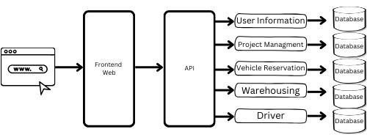

SYSTEM NETWORK ARCHITECTURE
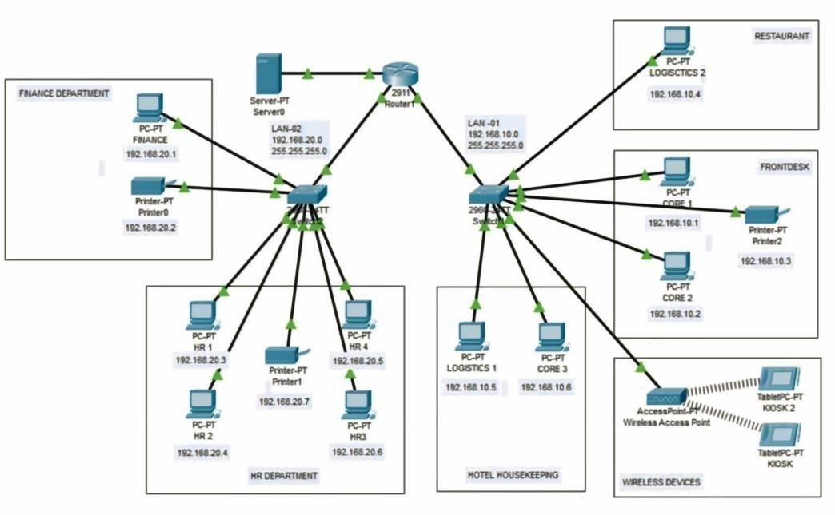
This Star Topology network effectively facilitates hotel operations by centralizing resource management and data transmission. A central server facilitates uninterrupted access to common resources, such as printers, for departments including Finance, HR, Housekeeping, Front Desk, and Restaurant. Each department is interconnected by dedicated switches, minimizing unwanted access, while the router's firewall provides robust security against external threats.
Local backups and network storage mitigate the risk of data loss, while the scalable architecture facilitates the seamless integration of additional workstations and storage as requirements expand. Rapid connections to the central switch enhance performance for wired devices, but wireless kiosks improve guest convenience. This
structured configuration facilitates troubleshooting, mitigates network congestion, and offers safe, centralized management with adaptability for future expansion, rendering it optimal for hotel settings.

CI/CD Pipeline Code
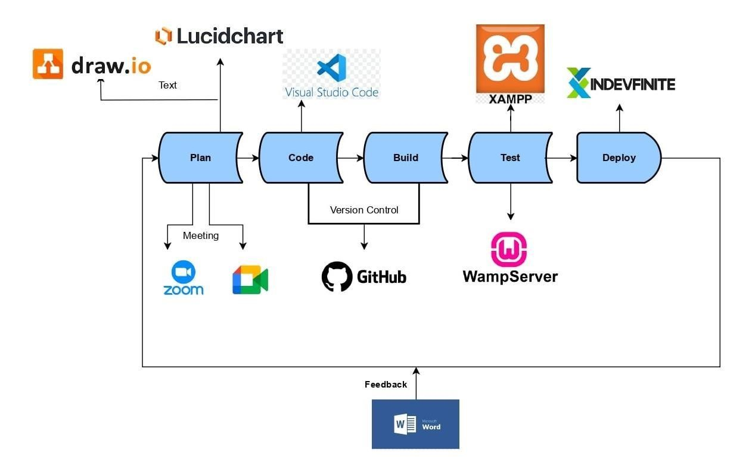
This diagram shows the steps involved in the software development process. Code that represents infrastructure. An overview of the steps is provided below:
- Developers: developers use Visual Studio Code to write the
application code.
- App Code: The Git Hub repository now contains the code.
Git is a repository management system that maintains source control. keep track of every modification made to the code.
- Pipeline: A CI/CD pipeline is created by altering the code in
Git. is initiated.
- Build Code: The application code is automatically generated by the pipeline.
- Wamp server: The created application is used for testing and troubleshooting. set up in a development setting.
- Stage: The created application is put in place for testing and debugging.
In a setting for development. To mimic manufacturing environments, the After being tested in the production environment, the code is transferred to a staging environment.
setting for development.
- Production: Finally, users can access the application in production assuming all goes according to plan in the staging area.
Integration of Innovation
The BPA, or business process architecture, is seen in the
following figures at three different hierarchical levels. Integration
of all Top Level 1 illustrates subsystems and provides an overview of the principal system.
Specifically, the subsystem of the proponents and associated Top Level 2 describes the attributes. At last, the data flow is shown in Top Level 3, which provides a more detailed perspective of the interactions occurring within the subsystem of the proponents.
BPA Top Level 1:
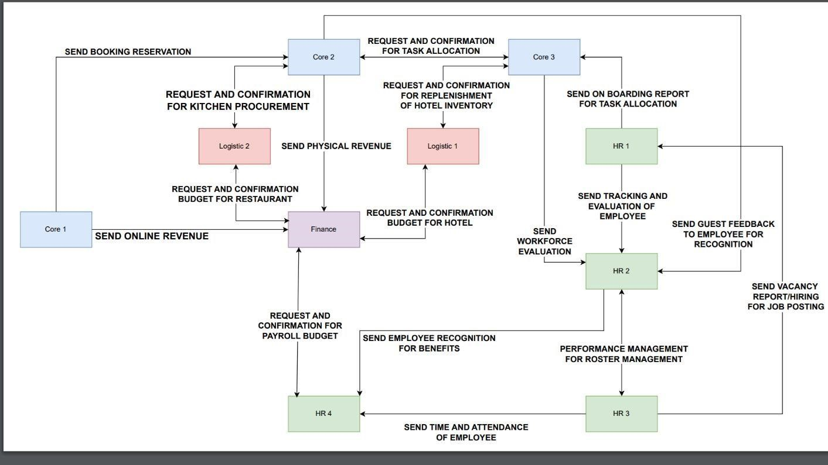
BPA Top Level 2:
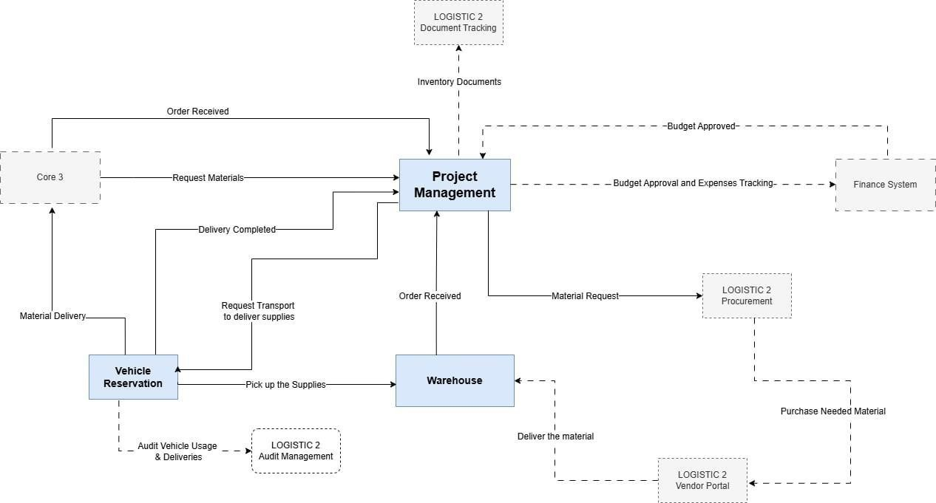
Data Flow Diagram 3 (DFD) – Admin-end:
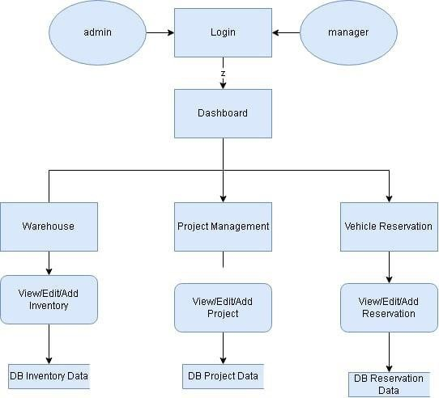
• Admin:
The admin has extensive access to the entire system. They create, update, and delete other users' accounts, including the manager. The admin also can view all data in the system, covering every aspect of Warehouse, Project Management, and Vehicle Reservation.
•Manager:
The manager has a different dashboard than the admin, with potentially limited access depending on the permissions granted for specific modules within the system. In the manager role, the adminside features are not accessible. The manager operates only within the three modules: Warehouse, Project Management, and Vehicle
Reservation.
Data Flow Diagram 3 (DFD) – User-end:
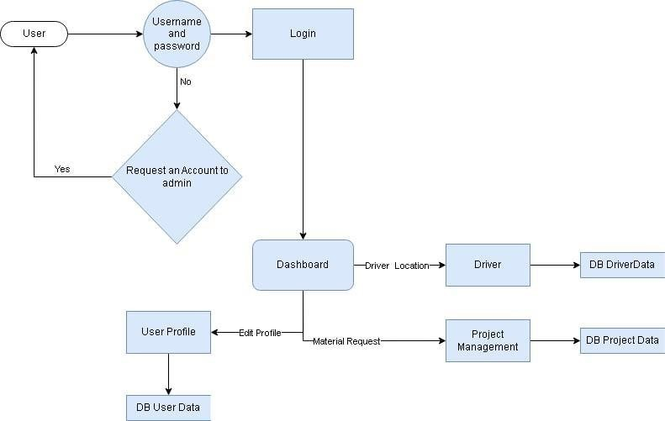
Use - Case Diagram
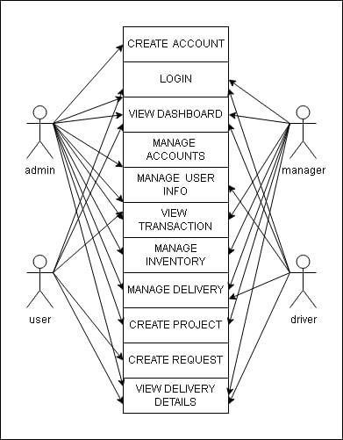
Sequence Diagram
