STANDARD OPERATING PROCEDURE
SOP-001
Hard Drive & Laptop Forensic Imaging and Acquisition
Digital Forensics Training Programme — Module 1: Core Acquisition Competency
Document Control
Document ID | SOP-001-v1.2
Status | Draft — for review / training use
Owner | Digital Forensics Team Lead
Applies to | All trainee and junior forensic examiners
Prerequisite | SOP-000: Chain of Custody & Exhibit Handling (must be signed off first)
Gates progression to | SOP-002: Forensic Image Verification & Processing
Review cycle | Every 12 months, or on tool/version change
Classification | Internal — Confidential

1. Purpose
This SOP defines the mandatory, minimum-standard procedure for the ACQUISITION PHASE of digital evidence from a laptop or desktop computer's internal storage — from the point the exhibit is presented for imaging, to a verified forensic image with its acquisition log. It is a core competency gate in the training programme: a trainee must demonstrate this procedure correctly, under supervision, before progressing to later SOPs covering artefact processing and reporting.
The objective of every acquisition is to produce a complete, verifiable, forensically sound copy of the source media while altering the original evidence as little as technically possible, and to fully document every decision and action taken.
CHAIN OF CUSTODY — COVERED SEPARATELY (SOP-000)
• Chain of custody and exhibit handling procedures (continuity forms, exhibit labelling, secure storage, movement logging) are defined in SOP-000: Chain of Custody & Exhibit Handling.
• SOP-000 MUST be completed and signed off before a trainee begins this SOP.
• Where this document says “record on the exhibit/continuity record” or “per SOP-000”, follow the procedure in that document — it is not repeated here.

2. Scope
This SOP covers the acquisition phase only:
- Initial triage of a computer/laptop prior to acquisition.
- Decision-making for live (running) vs dead-box (powered off) systems.
- Handling of encrypted volumes, RAID/multi-disk configurations, and volatile (RAM) data.
- Physical drive removal and imaging via hardware write blocker.
- In-situ / software acquisition where drive removal is not possible.
- Use of standalone hardware forensic duplicators.
- Image verification: hashing, acquisition log review, and write-blocker discipline.
Out of scope: chain of custody / exhibit handling (SOP-000), mobile device acquisition, cloud/remote acquisition, memory forensics analysis, and file system/artefact examination — these are covered in separate SOPs.
COMPETENCY GATE
• SOP-000 (Chain of Custody & Exhibit Handling) must be signed off before starting this SOP.
• Trainees must not perform an unsupervised acquisition on live evidence until signed off against Section 11.
• All practice runs must use training/test media only — never live case evidence — until sign-off is complete.

3. Authority, Legal Basis & Health and Safety
- Confirm written authorisation/warrant/consent covers the device before touching it. If in doubt, stop and escalate to the Team Lead.
- Photograph the device, all cabling, ports, and the surrounding scene in situ before any interaction, and record the exhibit per SOP-000.
- Use anti-static precautions (wrist strap / mat) when opening a chassis or handling bare drives.
- Never connect a suspect drive directly to a workstation without a write blocker in place.
- If a device appears to be an active, powered cryptocurrency wallet, POS terminal, or server with live client impact, escalate before proceeding — special handling applies.

4. Decision Tree Overview
Every acquisition begins by working through the two decision trees below in order. Figure 1A resolves the power state, volatile data, and encryption triage. Figure 1B resolves the physical acquisition method once the device is safely at rest (or confirmed dead-on-arrival).
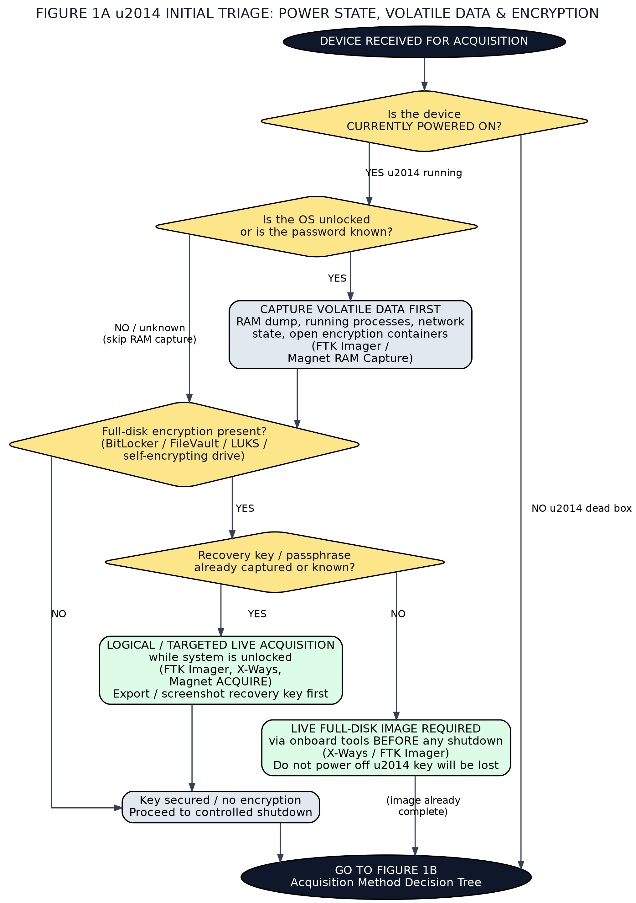
Figure 1A — Initial triage: power state, volatile data capture, and encryption.

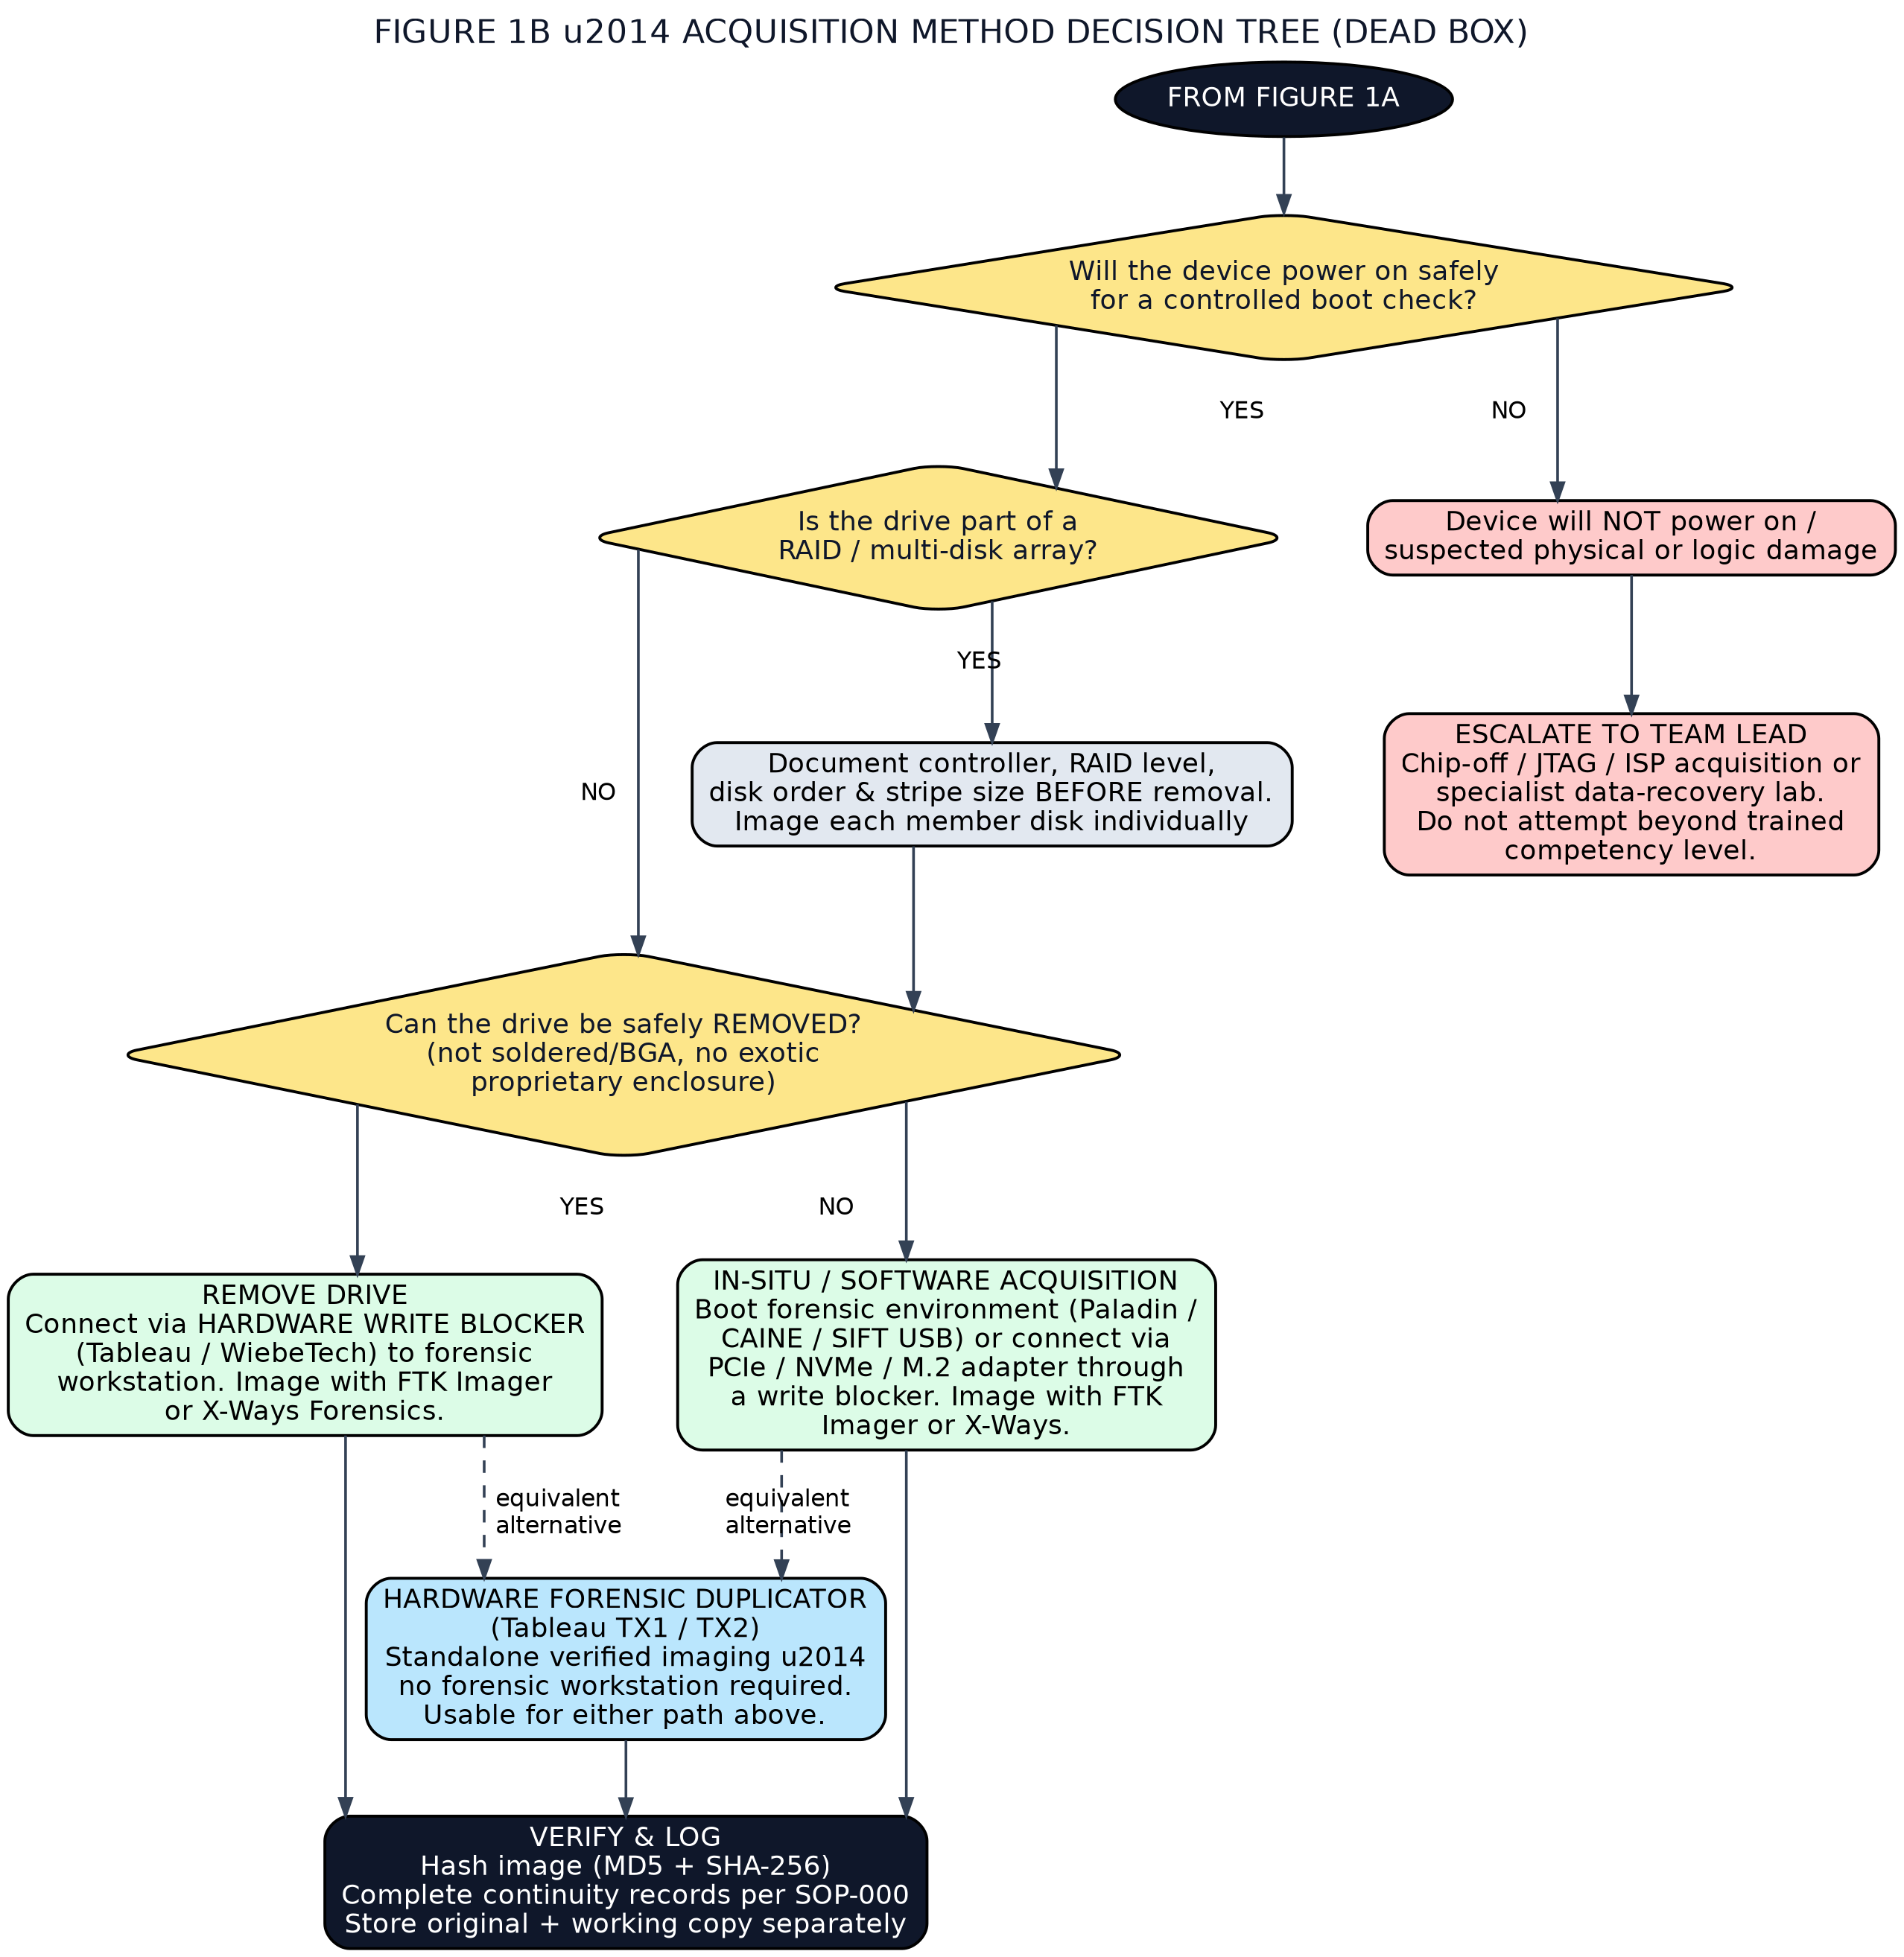
Figure 1B — Acquisition method decision tree for a dead-box / powered-down system.

5. Step-by-Step Procedure

5.1 Initial Triage & Documentation
- Photograph the device as found: all sides, screen state, attached peripherals, port usage, and any visible damage.
- Record make, model, serial number, asset tag, and exhibit/case reference on the exhibit/continuity record per SOP-000.
- Determine power state: is the screen on, are fans/drive activity lights running, is there any display output?
- Proceed to Figure 1A.

5.2 If the Device is Powered On (Live System)
- Do not close the lid, log off, or restart under any circumstance before completing this step.
- If the OS is unlocked or the password is known, assess whether volatile data capture is required (usually yes for active investigations — running processes, network connections, logged-in users, open encrypted containers).
- Capture RAM using a trusted, verified tool run from external write-protected media (FTK Imager or Magnet RAM Capture). Never install software onto the suspect drive.
- Check encryption status: look for BitLocker, FileVault, VeraCrypt, LUKS, or a self-encrypting drive (SED). Where possible, export or screenshot the recovery key (e.g. via manage-bde, or the organisation's Active Directory/Azure AD escrow) while the system is unlocked.
- If encryption is present and no recovery key can be obtained, you must perform a live logical or full-disk image before the system is powered down — shutting down first will make the data unrecoverable without the key.
- If no encryption is present, or the key/recovery password has been secured, perform a controlled, forensically-aware shutdown and proceed to Section 5.3.

5.3 If the Device is Powered Off (Dead Box)
- Confirm the device is safe to briefly power on for a boot/health check (no signs of physical damage, liquid ingress, or burning smell).
- If it will not power on safely, do not force it. Document the fault and escalate per Section 5.6.
- If it powers on safely, check whether the drive is part of a RAID or multi-disk array (inspect BIOS/UEFI, controller card, or physical bay layout).
- For RAID: document the controller make/model, RAID level, disk order, and stripe size before touching any disk. Where possible image each physical member disk individually, then reconstruct the array logically during processing (X-Ways, Magnet AXIOM). If the array cannot be split safely, image through the controller in place instead.
- Determine whether the drive can be safely removed (standard SATA/NVMe drive bay) or whether it is soldered/BGA-mounted, behind a proprietary enclosure, or otherwise impractical to remove.
5.3.1 Drive Can Be Removed
- Power down fully and remove the drive using appropriate tools and anti-static precautions.
- Connect the drive to a forensic write blocker (hardware, not software-only) — e.g. Tableau or WiebeTech.
- Connect the write blocker to the forensic acquisition workstation.
- Image using FTK Imager or X-Ways Forensics, selecting E01 (EnCase) or raw/DD format per case requirements. Capture a full E01 case-info header (examiner name, case number, evidence number, notes).
5.3.2 Drive Cannot Be Removed / In-Situ Acquisition
- Boot the target machine from a trusted forensic boot medium (e.g. Paladin, CAINE, or SIFT USB) that mounts internal drives read-only by default.
- Alternatively, if the drive interface allows it, connect via a PCIe/NVMe/M.2-to-USB adapter routed through a hardware write blocker to the forensic workstation.
- Image using FTK Imager or X-Ways Forensics as above.
5.3.3 Hardware Forensic Duplicator (Either Path)
- A standalone duplicator such as a Tableau TX1 or TX2 may be used instead of a workstation + write blocker + software combination for either 5.3.1 or 5.3.2.
- These devices perform write-blocked imaging, hashing, and verification independently, and are preferred in the field or where a forensic workstation is not available.

5.4 Image Verification
Verification confirms that the forensic image is a complete, unaltered, bit-for-bit copy of the source before the source drive is released and before any analysis begins. This is a mandatory step, not an optional extra — an unverified image is not considered forensically sound.
5.4.1 Write Blocker Requirements During Verification
- Keep the source drive connected via the hardware write blocker for the entire acquisition and verification process — do not disconnect it early to "save time."
- If verification requires re-reading the source drive (e.g. a second hashing pass, or resolving a mismatch), it must be re-read only through a hardware write blocker, never a direct connection.
- If using a standalone hardware duplicator (e.g. Tableau TX1/TX2), confirm the unit's write-block status indicator/log shows the source was write-protected for the full duration of the job before accepting the result.
- Never verify an image by mounting the source drive read-write "just to compare a few files" — this invalidates the acquisition.
5.4.2 Hash Verification
- Generate both MD5 and SHA-256 hashes of the source drive and of the completed image.
- Confirm the acquisition tool reports a hash match between source and image before the source drive is disconnected from the write blocker.
- If hashes do not match, do not discard the failed image or the source drive. Stop, document the discrepancy, and re-image using a fresh target and, where possible, a different tool or write blocker to isolate the cause before escalating to the Team Lead.
- Record both hash values on the exhibit/continuity record (per SOP-000) and in the case management system.
5.4.3 Acquisition Log Review
- Every imaging tool (FTK Imager, X-Ways, or a hardware duplicator) produces an acquisition/audit log — do not close the tool until this log has been exported and reviewed.
- Check the log for: start/end timestamps, source and destination device identifiers, sector counts read vs. expected, any reported bad sectors/read errors, and the final verification (hash match) result.
- Investigate and document any bad sectors or read errors reported in the log, even if the overall hash still verifies — these can indicate a failing drive that should be prioritised for re-imaging or specialist handling.
- Save the acquisition log alongside the image file (same case folder) and attach a copy to the case file per SOP-000 — the log is evidence of the verification, not just the hash values quoted from it.
- Confirm the log's reported source drive serial number and capacity match what was physically recorded in Section 5.1 — this catches cabling/port mix-ups on multi-drive workstations.
5.4.4 Working Copy
- Never work directly from the original (master) image file. Duplicate a working copy for analysis and re-verify its hash against the master before use.
- Store the master image read-only where the file system/storage platform supports it.

5.5 Storage & Handover (see SOP-000)
- Store the original media in an anti-static, tamper-evident bag, labelled with exhibit number, and return it to secure evidence storage per SOP-000.
- Store the forensic image (working copy) on the case storage server.
- Complete all continuity/exhibit records required by SOP-000 before leaving the acquisition workstation.

5.6 Escalation (Device Will Not Power On / Physical Damage)
- Do not attempt chip-off, JTAG, or ISP (In-System Programming) extraction unless you are specifically trained and signed off for that competency.
- Photograph and document the condition of the device and drive.
- Escalate to the Team Lead or a specialist data-recovery/forensic hardware partner.

6. Equipment & Tool Reference
Recommended core and supplementary tooling for this SOP. Trainees should be familiar with at least one option in each category before sign-off.

6.1 Approved Imaging Software (Team Standard)
The team standard imaging tools are FTK Imager, X-Ways Forensics, and Magnet ACQUIRE. Trainees must be competent in FTK Imager (primary) and at least one of the other two before sign-off.
Tool | Role in this SOP | Notes
FTK Imager (Exterro) | PRIMARY: disk imaging, live logical acquisition, RAM capture, image preview | Runs portable from USB for live systems; E01/raw(dd)/AD1 output
X-Ways Forensics | SECONDARY: disk imaging, live acquisition, RAID reconstruction; full analysis suite | Fully portable, very fast, low footprint; E01/raw output; also used in later analysis SOPs
Magnet ACQUIRE | SECONDARY: disk/removable-media imaging, targeted acquisition | Simple guided workflow; good training tool; E01/raw output with logging

6.2 Software Feature Comparison
Capability | FTK Imager | X-Ways Forensics | Magnet ACQUIRE
Full physical (bit-for-bit) disk image | Yes | Yes | Yes
Logical / targeted acquisition | Yes (AD1) | Yes (containers) | Yes (targeted)
Live RAM capture | Yes | No (use FTK Imager) | No (use FTK Imager)
E01 output | Yes | Yes | Yes
Raw (dd) output | Yes | Yes | Yes
Hash verification (MD5/SHA) | Yes | Yes | Yes
Acquisition/audit log produced | Yes | Yes | Yes
Runs portable (no install) | Yes (Imager Lite) | Yes (USB stick) | Portable executable
Evidence preview before imaging | Yes | Yes | Limited
RAID reconstruction | No | Yes | No
Analysis capability beyond acquisition | Preview only | Full suite | No (acquisition only)

6.3 Software Licensing Requirements
Licensing status should be re-confirmed with the vendor before purchase or deployment, as terms change. Status below is as at the date of this document.
Software | Cost | Licence mechanism | Dongle required?
FTK Imager (standard) | Free | Free download from Exterro (registration form); no licence key | No
FTK Imager Pro | Paid — annual subscription per user | Electronic licence code from Exterro | No
X-Ways Forensics | Paid — perpetual licence + update maintenance | USB dongle (local or network) or BYOD (a user-supplied USB device acts as the key) | Yes — dongle or BYOD device must be attached to run
Magnet ACQUIRE | Free | Free download from Magnet Forensics (community registration) | No
Magnet RAM Capture | Free | Free download from Magnet Forensics (free tools page) | No
LICENSING PRACTICE NOTES
• X-Ways dongles are NOT replaced if lost or stolen — treat the dongle as a controlled asset: log it in/out like an exhibit and store it securely.
• Free tools (FTK Imager, Magnet ACQUIRE, Magnet RAM Capture) must still be downloaded only from the official vendor site, and the installer's hash verified and recorded before deployment to forensic workstations.
• Record the exact tool name and version used in every acquisition log entry — version matters if the acquisition is later challenged.

6.4 Hardware Write Blockers
Device | Interface | Notes
Tableau T35689 / T8-R2 | SATA/IDE/USB | Standard bench write blocker
WiebeTech Forensic UltraDock | SATA/IDE/USB | Popular, durable field option
CRU WiebeTech Ditto | Standalone duplicator | Dock + duplication in one unit

6.5 Hardware Forensic Duplicators
Device | Notes
Tableau TX1 | Compact, field-friendly standalone imager with hashing/verification and network acquisition support
Tableau TX2 | Higher-throughput successor to TX1; faster imaging speeds, additional interfaces
Logicube Falcon-NEO | Alternative standalone duplicator, widely deployed in LE labs

6.6 Volatile Data (RAM) Capture Tools
Tool | Use
FTK Imager | Live memory (RAM) capture via Capture Memory function, run portable from external media
Magnet RAM Capture | Free, lightweight live memory acquisition with minimal footprint on the target system

6.7 Bootable Forensic Environments
- Paladin Edition (Linux, forensic-focused, read-only default mounting)
- CAINE (Computer Aided INvestigative Environment)
- SIFT Workstation (SANS)

6.8 Adapters & Consumables
- SATA / mSATA / M.2 (NVMe & SATA) / U.2 to USB3 adapters, ideally routed through a write blocker
- Assorted screwdriver/bit set (Torx, Pentalobe, tri-wing) for laptop chassis entry
- Anti-static bags, evidence tape, exhibit labels, wrist strap
- Spare forensically wiped target drives (verified zero-fill, logged) for image storage in the field

6.9 Suggested Additions for the Training Lab
- A small library of “broken”/edge-case training laptops: one BitLocker-locked, one RAID-1 laptop, one soldered-storage ultrabook, one with a dead motherboard but healthy drive.
- A UFED/Cellebrite touch or similar for later modules, to give trainees a consistent vendor ecosystem across computer and mobile evidence.
- A shared, version-controlled hash-verification log (spreadsheet or LIMS) so trainees get used to formal exhibit tracking from day one.

7. Annotated Imaging Walkthrough (Illustrative)
The figures below illustrate the three screens that matter most during a software acquisition, using a generic dialog layout common to FTK Imager, X-Ways, and Magnet ACQUIRE. They are illustrative diagrams, not vendor screenshots — when this SOP is finalised, replace each figure with a real screenshot captured from the team's licensed installation (Alt+PrtScn on the acquisition workstation, using training media).

7.1 Selecting the Source
Always select the physical drive (not a logical volume) unless the case specifically calls for a logical/targeted acquisition, and always confirm the drive shown is the one presented through the write blocker — check model, serial, and capacity against the exhibit record before clicking Next.
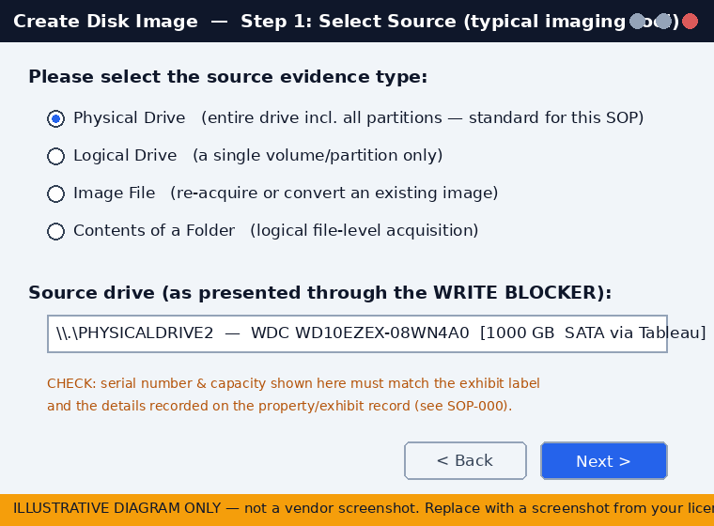
Figure 2 — Source selection (illustrative). The serial/capacity cross-check against the exhibit record happens here.

7.2 Image Type & Evidence Information
The team default is E01 with case information completed in full. The verify-after-creation option must never be unticked — it is what produces the hash comparison relied on in Section 5.4.
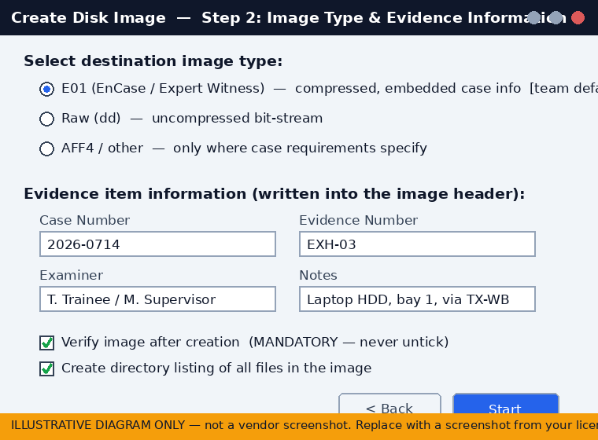
Figure 3 — Image format and evidence information (illustrative). Case info entered here is embedded in the E01 header.

7.3 Reading the Verification Result
A pass requires BOTH hash pairs (MD5 and SHA-256) to match AND the bad-sector count to be reviewed. Export the log before closing the dialog.
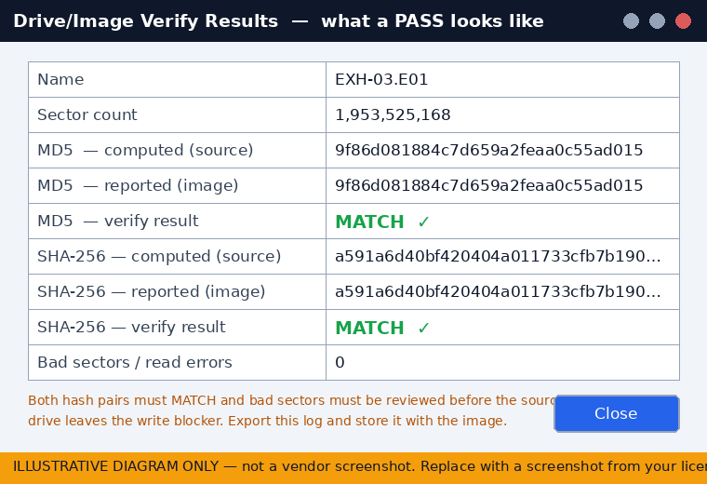
Figure 4 — Verification results screen (illustrative). This is what a pass looks like; any mismatch means stop and follow 5.4.2.

8. Quality Assurance Checklist
To be completed for every acquisition, live or dead box, and retained with the case file.
# | Check | Y/N
1 | Authorisation confirmed before device was touched
2 | Scene and device photographed before interaction
3 | Power state correctly identified and documented
4 | Volatile data captured where required (or justified why not)
5 | Encryption status checked and recovery key secured where possible
6 | RAID/multi-disk configuration documented before disassembly
7 | Hardware write blocker used for all connections to source media
8 | Source and image hashes match (MD5 and SHA-256)
9 | Acquisition log exported, reviewed, and saved with the image (bad sectors/errors checked)
10 | Source drive kept behind a write blocker for the full acquisition and verification
11 | Continuity/exhibit records completed per SOP-000
12 | Original media returned to secure evidence storage

9. Common Pitfalls for New Examiners
- Shutting down an encrypted, unlocked laptop before securing the recovery key — this can make the evidence permanently inaccessible.
- Connecting a suspect drive directly to a workstation's onboard SATA port without a write blocker, even “just to check.”
- Skipping RAID documentation and later being unable to reconstruct disk order.
- Forgetting to hash the source drive itself, and only hashing the resulting image file.
- Assuming a laptop with no visible drive bay has no removable storage — check for M.2 slots under the keyboard/base plate before concluding a chip is soldered.
- Using a personal or non-forensic USB drive as the imaging destination without first verifying it is wiped and logging its serial number.

10. Glossary
Term | Definition
Dead box | A device that is powered off at the time of seizure/acquisition.
Write blocker | Hardware or software device that permits read access to storage media while physically preventing any write commands from reaching it.
E01 / EWF | EnCase Evidence File format — a compressed, hashed, segment-able forensic image container.
Chain of custody | The documented, unbroken record of who has handled evidence, when, and why, from seizure to disposal. Procedures are defined in SOP-000.
SED | Self-Encrypting Drive — a drive with encryption built into its firmware/controller.
Chip-off | Physical desoldering of a memory chip for direct forensic extraction; last-resort, specialist technique.
JTAG / ISP | Low-level hardware interfaces used to extract raw data directly from a device's processor/flash memory.

11. Trainee Competency Sign-Off
To be completed by the supervising examiner once the trainee has demonstrated this SOP end-to-end on training media.
Field | Detail
SOP-000 (Chain of Custody) previously signed off (Y/N)
Trainee name
Trainer / assessor name
Date of assessment
Training media / scenario used
Live acquisition demonstrated (Y/N)
Dead-box drive-removal acquisition demonstrated (Y/N)
In-situ / bootable acquisition demonstrated (Y/N)
Hash verification demonstrated (Y/N)
Acquisition log review demonstrated (Y/N)
Continuity records completed correctly per SOP-000 (Y/N)
Result | Pass / Not yet competent (recheck required)
Cleared to progress to SOP-002 | Yes / No
Trainer signature

