Grating Measurements
ALS BL6.3.2
(24 June 2010)

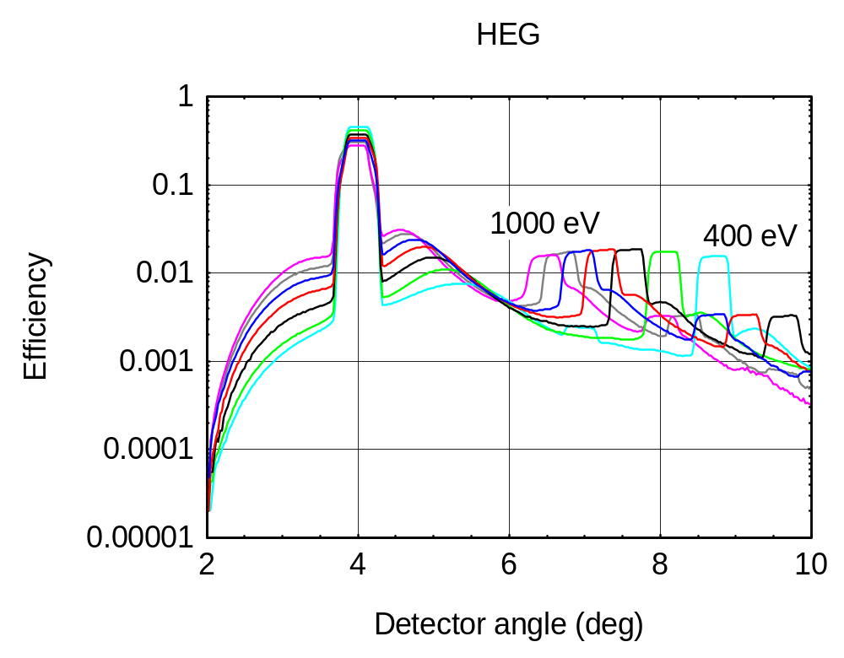
Measurements at 400, 500, 600, 700, 800, 900, 1000 eV

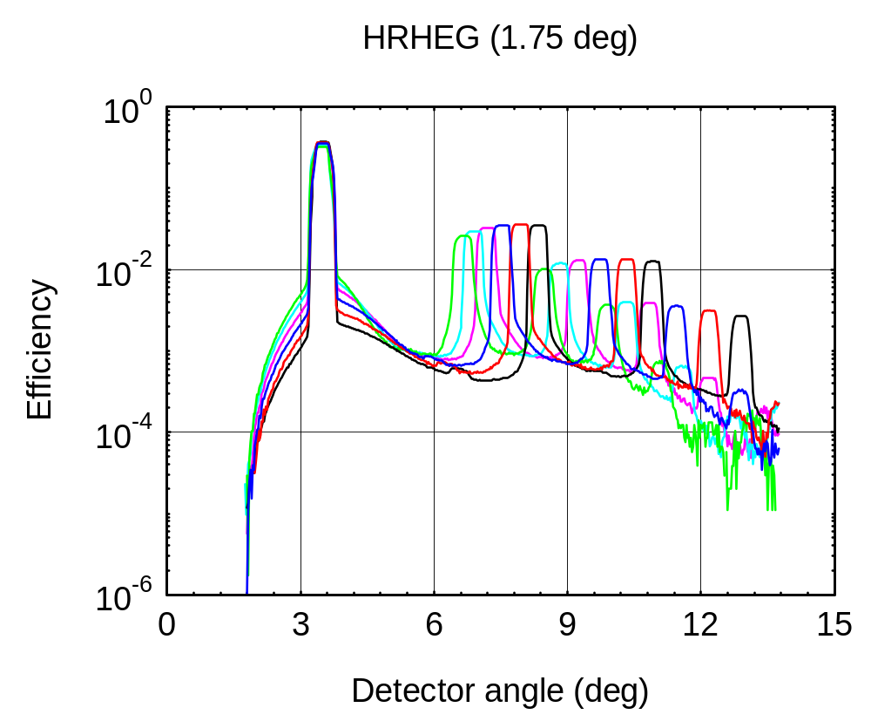
Measurements at 525, 600, 700, 800, 900, 1000 eV

