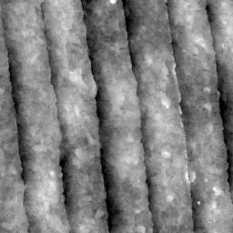
REIXS XES – HEG Grating
August 2010
3 microns x 3 microns AFM scan, grating center

