HEG 8 Sept 2010

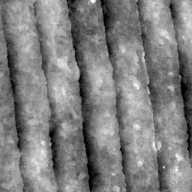

3 microns x 3 microns AFM scan.

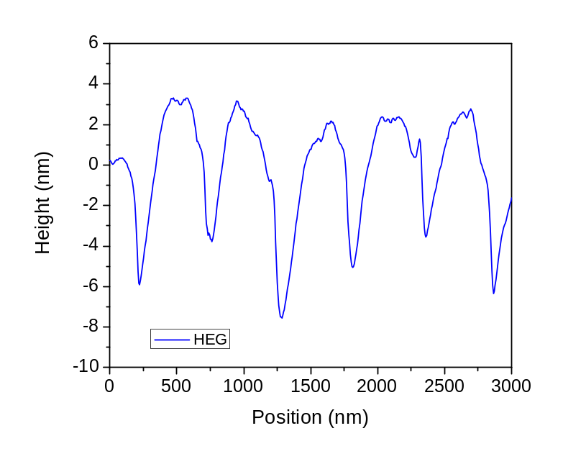
Grating Profile

