

*V*



LPF

MUX

LPF

Σ∆ Modulator

Power  
Supply

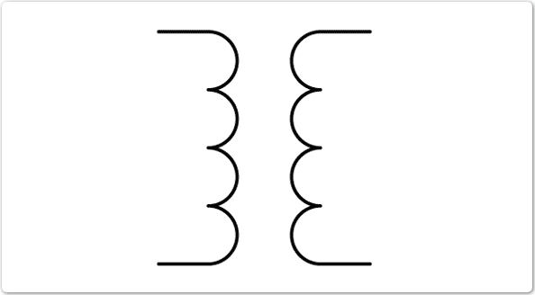

Transformer  
Driver

Transformer  
Driver and  
Data Decoder

PCB

Transformer

µController

Non-Volatile  
 Storage

Display

PC Interface

Acquisition Module 1

Acquisition Module 2

Acquisition Module *n*

…

Commercial IC

FPGA Concentrator   
/ Filter

*I*



*V*



LPF

MUX

LPF

Σ∆ Modulator

Power  
Supply



Transformer  
Driver

Transformer  
Driver and  
Data Decoder

PCB

Transformer

µController

Non-Volatile  
 Storage

Display

PC Interface

Acquisition Module 1

Acquisition Module 2

Acquisition Module *n*

…

Commercial IC

FPGA Concentrator   
/ Filter

*I*



*V*



LPF

MUX

LPF

Σ∆ Modulator

Power  
Supply



Transformer  
Driver

Transformer  
Driver and  
Data Decoder

PCB

Transformer

µController

Non-Volatile  
 Storage

Display

PC Interface

Acquisition Module 1

Acquisition Module 2

Acquisition Module *n*

…

Commercial IC

FPGA Concentrator   
/ Filter

*I*