# CS528 Final Project Readme File

## Bin Yu, Jiang Miao, Fu Zhan

Our project contains server part on computer, hence before you run APK on mobile, the first thing is configuring environment on your own computer.

1. Import our server part into Eclipse.

2. Add these two JAR files into project property;



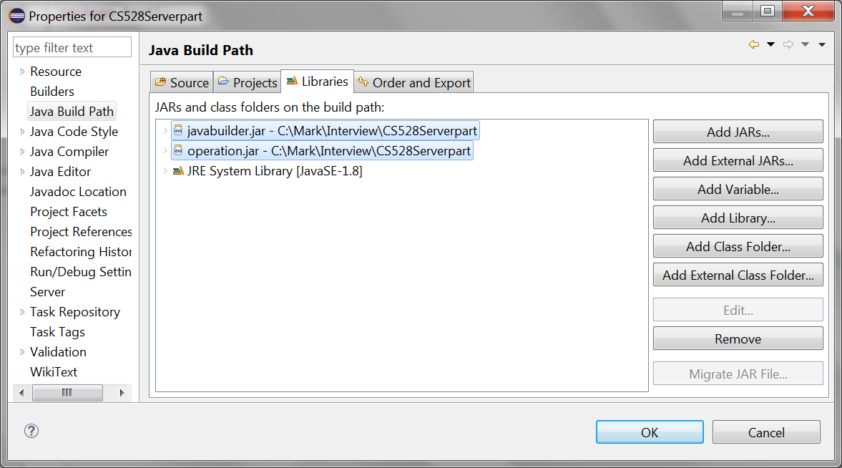

3 Be care about this part, change the path of these three files in ServerReceive.java

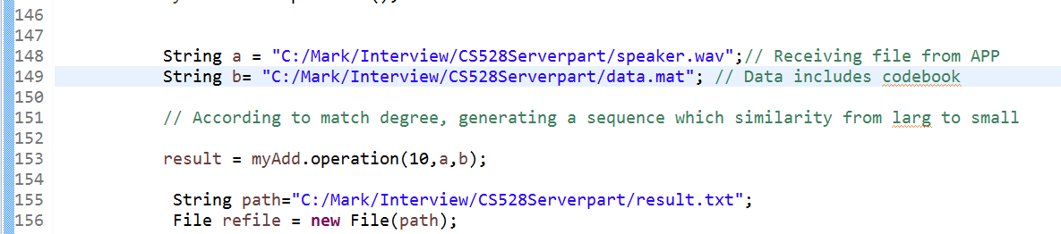

4. Run ServerReceive.java, If you see this figure on console, it represents server running environment is ok

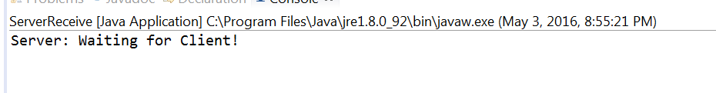

5. Change the IP address and port number at

%YourDir%\FindUrVoice\app\src\main\java\com\example\binyulocal\findurvoice\MainActivity.java

Make sure this is your own server and other services doesn’t occupy the port at this time.

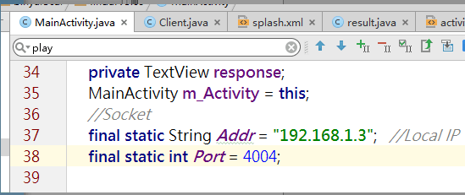

6. Generate APK again, if you can see this splash screen, it means all configuration works have been completed, you can enjoy our APP and sing what you want!

