RUN WIDE-FIELD FLUORESCENCE
Run the function that will process example data files. Select all Tiff files at once by selecting the first Tiff file, then holding SHIFT while clicking on the last Tiff file.
PROCESS INPUT 1
VISUALIZE OUTPUT 8
LOAD UNSCALED VIDEO FILES & PLAY IN MATLAB 12

PROCESS INPUT
Run processFast() function, returning file-names that can be used to restore data, along with RegionOfInterest class ROIs.
[allVidFiles, R, info, uniqueFileName] = processFast();
process fast
Loading Final Submission from 1 files (512 frames)
Correcting Motion
Warning: StartDelay property is limited to 1 millisecond precision.
Sub-millisecond precision will be ignored.
Normalizing Fluorescence Signal
Input MINIMUM: 0
Input MAXIMUM: 30576
Input RANGE: 30576
Input MEAN: 4.113747e+03
Binary file write to disk completed:
1 GB written in 3.652 seconds (or better)
--> 280.4 MB/s
Post-Min-Subtracted MINIMUM: 0
Post-Min-Subtracted MAXIMUM: 26405
Post-Min-Subtracted RANGE: 26405
Post-Min-Subtracted MEAN: 1.396522e+03
Output MINIMUM: 0
Output MAXIMUM: 55890
Output RANGE: 55890
Output MEAN: 2.855054e+03
Warning: StartDelay property is limited to 1 millisecond precision.
Sub-millisecond precision will be ignored.
Processing: F:\Final Submission\Ali26-day5(00001)-2.tif
Binary file write to disk completed:
5.000000e-01 GB written in 1.778 seconds (or better)
--> 287.9 MB/s
Loading Final Submission from 1 files (512 frames)
Correcting Motion
Warning: StartDelay property is limited to 1 millisecond precision.
Sub-millisecond precision will be ignored.
Normalizing Fluorescence Signal
Input MINIMUM: 0
Input MAXIMUM: 33929
Input RANGE: 33929
Input MEAN: 4.038474e+03
Post-Min-Subtracted MINIMUM: 0
Post-Min-Subtracted MAXIMUM: 27216
Post-Min-Subtracted RANGE: 27216
Post-Min-Subtracted MEAN: 1.321272e+03
Binary file write to disk completed:
1 GB written in 3.85 seconds (or better)
--> 266 MB/s
Output MINIMUM: 0
Output MAXIMUM: 57697
Output RANGE: 57697
Output MEAN: 2.852669e+03
Warning: StartDelay property is limited to 1 millisecond precision.
Sub-millisecond precision will be ignored.
Processing: F:\Final Submission\Ali26-day5(00001)-3.tif
Binary file write to disk completed:
5.000000e-01 GB written in 1.772 seconds (or better)
--> 288.9 MB/s
Loading Final Submission from 1 files (512 frames)
Correcting Motion
Warning: StartDelay property is limited to 1 millisecond precision.
Sub-millisecond precision will be ignored.
Normalizing Fluorescence Signal
Input MINIMUM: 0
Input MAXIMUM: 35319
Input RANGE: 35319
Input MEAN: 4.033561e+03
Post-Min-Subtracted MINIMUM: 0
Post-Min-Subtracted MAXIMUM: 28784
Post-Min-Subtracted RANGE: 28784
Post-Min-Subtracted MEAN: 1.316358e+03
Binary file write to disk completed:
1 GB written in 3.894 seconds (or better)
--> 263 MB/s
Output MINIMUM: 0
Output MAXIMUM: 60965
Output RANGE: 60965
Output MEAN: 2.853445e+03
Warning: StartDelay property is limited to 1 millisecond precision.
Sub-millisecond precision will be ignored.
Processing: F:\Final Submission\Ali26-day5(00001)-4.tif
Binary file write to disk completed:
5.000000e-01 GB written in 1.756 seconds (or better)
--> 291.5 MB/s
Loading Final Submission from 1 files (511 frames)
Correcting Motion
Normalizing Fluorescence Signal
Input MINIMUM: 1
Input MAXIMUM: 29814
Input RANGE: 29813
Input MEAN: 4.045595e+03
Post-Min-Subtracted MINIMUM: 0
Post-Min-Subtracted MAXIMUM: 25905
Post-Min-Subtracted RANGE: 25905
Post-Min-Subtracted MEAN: 1.328384e+03
Binary file write to disk completed:
9.980469e-01 GB written in 3.953 seconds (or better)
--> 258.5 MB/s
Output MINIMUM: 0
Output MAXIMUM: 54679
Output RANGE: 54679
Output MEAN: 2.851862e+03
Binary file write to disk completed:
4.990234e-01 GB written in 1.756 seconds (or better)
--> 291 MB/s
Finding groups for 615 Regions Of Interest
Finding groups for 75 Regions Of Interest
Finding groups for 79 Regions Of Interest
Finding groups for 44 Regions Of Interest
Finding groups for 135 Regions Of Interest
Finding groups for 244 Regions Of Interest
Finding groups for 231 Regions Of Interest
Finding groups for 252 Regions Of Interest
Finding groups for 437 Regions Of Interest
Finding groups for 364 Regions Of Interest
Finding groups for 546 Regions Of Interest
Finding groups for 435 Regions Of Interest
Finding groups for 714 Regions Of Interest
Finding groups for 905 Regions Of Interest
Finding groups for 1112 Regions Of Interest
Finding groups for 258 Regions Of Interest
Finding groups for 285 Regions Of Interest
Finding groups for 32 Regions Of Interest
Finding groups for 326 Regions Of Interest
Finding groups for 117 Regions Of Interest
Finding groups for 62 Regions Of Interest
Finding groups for 58 Regions Of Interest
Finding groups for 24 Regions Of Interest
Finding groups for 137 Regions Of Interest
Finding groups for 318 Regions Of Interest
Finding groups for 518 Regions Of Interest
Finding groups for 925 Regions Of Interest
Finding groups for 720 Regions Of Interest
Finding groups for 1327 Regions Of Interest
Finding groups for 1680 Regions Of Interest
Finding groups for 1315 Regions Of Interest
Finding groups for 1085 Regions Of Interest
Finding groups for 371 Regions Of Interest
Finding groups for 84 Regions Of Interest
Finding groups for 29 Regions Of Interest
Finding groups for 86 Regions Of Interest
Finding groups for 97 Regions Of Interest
Finding groups for 84 Regions Of Interest
Finding groups for 61 Regions Of Interest
Finding groups for 196 Regions Of Interest
Finding groups for 35 Regions Of Interest
Finding groups for 33 Regions Of Interest
Finding groups for 31 Regions Of Interest
Finding groups for 31 Regions Of Interest
Finding groups for 35 Regions Of Interest
Finding groups for 36 Regions Of Interest
Finding groups for 115 Regions Of Interest
Finding groups for 59 Regions Of Interest
Finding groups for 180 Regions Of Interest
Finding groups for 382 Regions Of Interest
Finding groups for 1229 Regions Of Interest
Finding groups for 1511 Regions Of Interest
Finding groups for 1358 Regions Of Interest
Finding groups for 373 Regions Of Interest
Finding groups for 25 Regions Of Interest
Finding groups for 59 Regions Of Interest
Finding groups for 15 Regions Of Interest
Finding groups for 50 Regions Of Interest
Finding groups for 602 Regions Of Interest
Finding groups for 1422 Regions Of Interest
Finding groups for 1308 Regions Of Interest
Finding groups for 829 Regions Of Interest
Finding groups for 204 Regions Of Interest
Finding groups for 33 Regions Of Interest
Finding groups for 121 Regions Of Interest
Finding groups for 147 Regions Of Interest
Finding groups for 138 Regions Of Interest
Finding groups for 265 Regions Of Interest
Finding groups for 106 Regions Of Interest
Finding groups for 466 Regions Of Interest
Finding groups for 358 Regions Of Interest
Finding groups for 287 Regions Of Interest
Finding groups for 321 Regions Of Interest
Finding groups for 386 Regions Of Interest
Finding groups for 598 Regions Of Interest
Finding groups for 1115 Regions Of Interest
Finding groups for 1423 Regions Of Interest
Finding groups for 370 Regions Of Interest
Finding groups for 76 Regions Of Interest
Finding groups for 130 Regions Of Interest
Finding groups for 55 Regions Of Interest
Finding groups for 81 Regions Of Interest
Finding groups for 228 Regions Of Interest
Finding groups for 17 Regions Of Interest
Finding groups for 162 Regions Of Interest
Finding groups for 419 Regions Of Interest
Finding groups for 969 Regions Of Interest
Finding groups for 1081 Regions Of Interest
Finding groups for 861 Regions Of Interest
Finding groups for 273 Regions Of Interest
Finding groups for 109 Regions Of Interest
Finding groups for 90 Regions Of Interest
Finding groups for 51 Regions Of Interest
Finding groups for 19 Regions Of Interest
Finding groups for 161 Regions Of Interest
Finding groups for 306 Regions Of Interest
Finding groups for 406 Regions Of Interest
Finding groups for 188 Regions Of Interest
Finding groups for 118 Regions Of Interest
Finding groups for 651 Regions Of Interest
Finding groups for 885 Regions Of Interest
Finding groups for 562 Regions Of Interest
Finding groups for 325 Regions Of Interest
Finding groups for 26 Regions Of Interest
Finding groups for 584 Regions Of Interest
Finding groups for 167 Regions Of Interest
Finding groups for 73 Regions Of Interest
Finding groups for 148 Regions Of Interest
Finding groups for 21 Regions Of Interest
Finding groups for 29 Regions Of Interest
Finding groups for 37 Regions Of Interest
Finding groups for 1116 Regions Of Interest
Finding groups for 134 Regions Of Interest
Finding groups for 69 Regions Of Interest
Finding groups for 98 Regions Of Interest
Finding groups for 48 Regions Of Interest
Finding groups for 116 Regions Of Interest
Finding groups for 194 Regions Of Interest
Finding groups for 640 Regions Of Interest
Finding groups for 964 Regions Of Interest
Finding groups for 726 Regions Of Interest
Finding groups for 446 Regions Of Interest
Finding groups for 1131 Regions Of Interest
Finding groups for 1285 Regions Of Interest
Finding groups for 1338 Regions Of Interest
Finding groups for 830 Regions Of Interest
Finding groups for 565 Regions Of Interest
Finding groups for 40 Regions Of Interest
Finding groups for 17 Regions Of Interest
Finding groups for 85 Regions Of Interest
Finding groups for 17 Regions Of Interest
Finding groups for 22 Regions Of Interest
Finding groups for 44 Regions Of Interest
Finding groups for 20 Regions Of Interest
Finding groups for 170 Regions Of Interest
Finding groups for 317 Regions Of Interest
Finding groups for 11 Regions Of Interest
Finding groups for 362 Regions Of Interest
Finding groups for 303 Regions Of Interest
Finding groups for 456 Regions Of Interest
Finding groups for 763 Regions Of Interest
Finding groups for 889 Regions Of Interest
Finding groups for 882 Regions Of Interest
Finding groups for 58 Regions Of Interest
Finding groups for 44 Regions Of Interest
Finding groups for 562 Regions Of Interest
Finding groups for 105 Regions Of Interest
Finding groups for 96 Regions Of Interest
Finding groups for 177 Regions Of Interest
Finding groups for 149 Regions Of Interest
Finding groups for 235 Regions Of Interest
Finding groups for 499 Regions Of Interest
Finding groups for 633 Regions Of Interest
Finding groups for 1020 Regions Of Interest
Finding groups for 408 Regions Of Interest
Finding groups for 203 Regions Of Interest
Finding groups for 916 Regions Of Interest
Finding groups for 1532 Regions Of Interest
Finding groups for 1370 Regions Of Interest
Finding groups for 900 Regions Of Interest
Finding groups for 570 Regions Of Interest
Finding groups for 16 Regions Of Interest
Finding groups for 77 Regions Of Interest
Finding groups for 27 Regions Of Interest
Finding groups for 19 Regions Of Interest
Finding groups for 176 Regions Of Interest
Finding groups for 60 Regions Of Interest
Finding groups for 531 Regions Of Interest
Finding groups for 17 Regions Of Interest
Finding groups for 36 Regions Of Interest
Finding groups for 11 Regions Of Interest
Finding groups for 72 Regions Of Interest
Finding groups for 16 Regions Of Interest
Finding groups for 23 Regions Of Interest
Finding groups for 35 Regions Of Interest
Finding groups for 58 Regions Of Interest
Finding groups for 1055 Regions Of Interest
Finding groups for 479 Regions Of Interest
Finding groups for 214 Regions Of Interest
Finding groups for 34 Regions Of Interest
Finding groups for 30 Regions Of Interest
Finding groups for 50 Regions Of Interest
Finding groups for 88 Regions Of Interest
Finding groups for 423 Regions Of Interest
Finding groups for 119 Regions Of Interest
Finding groups for 466 Regions Of Interest
Finding groups for 135 Regions Of Interest
Finding groups for 301 Regions Of Interest
Finding groups for 285 Regions Of Interest
Finding groups for 390 Regions Of Interest
Finding groups for 98 Regions Of Interest
Finding groups for 159 Regions Of Interest
Finding groups for 281 Regions Of Interest
Finding groups for 11 Regions Of Interest
Finding groups for 55 Regions Of Interest
Finding groups for 87 Regions Of Interest
Finding groups for 172 Regions Of Interest
Finding groups for 162 Regions Of Interest
Finding groups for 34 Regions Of Interest
Finding groups for 38 Regions Of Interest
Finding groups for 26 Regions Of Interest
Finding groups for 83 Regions Of Interest
Finding groups for 243 Regions Of Interest
Finding groups for 12 Regions Of Interest
Finding groups for 119 Regions Of Interest
Finding groups for 60 Regions Of Interest
Finding groups for 294 Regions Of Interest
Finding groups for 43 Regions Of Interest
Finding groups for 32 Regions Of Interest
Finding groups for 93 Regions Of Interest
Finding groups for 280 Regions Of Interest
Finding groups for 33 Regions Of Interest
Finding groups for 250 Regions Of Interest
Finding groups for 51 Regions Of Interest
Finding groups for 70 Regions Of Interest
Finding groups for 506 Regions Of Interest
Finding groups for 308 Regions Of Interest
Finding groups for 577 Regions Of Interest
Finding groups for 1043 Regions Of Interest
Finding groups for 595 Regions Of Interest
Finding groups for 631 Regions Of Interest
Finding groups for 343 Regions Of Interest
Finding groups for 77 Regions Of Interest
Finding groups for 20 Regions Of Interest
Finding groups for 899 Regions Of Interest
Finding groups for 169 Regions Of Interest
Finding groups for 167 Regions Of Interest
Finding groups for 76 Regions Of Interest
Total 552 ROIs.
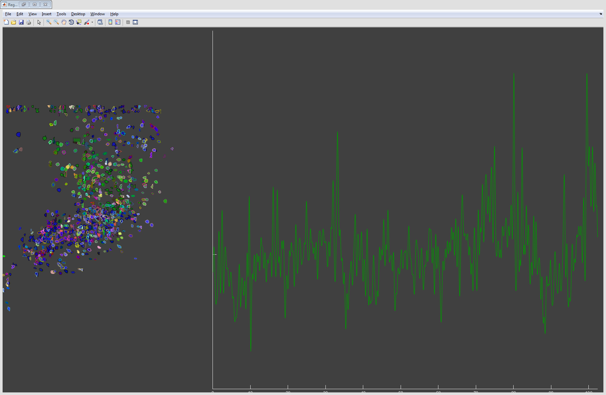

VISUALIZE OUTPUT
Usesthe methods defined by the RegionOfInterest class to aid in the visualization of identified ROIs and their activity over time
try
% SHOW ROIs WITH DEFAULT COLORS
% show(R);
% snapnow
close(h.fig)
% LOAD VIDEO DATA FROM CACHED BINARY FILES
data = readBinaryData(allVidFiles);
% SHOW WITH IMAGE OVERLAY - CLICK ON ROIs TO SHOW TRACES
showAsOverlay(R, range(data,3)*2.5 + 25);
snapnow
close(h.fig)
% MANIPULATE COLORS
set(R, 'Color', [0 0 .9])
set(R, 'Transparency', .65)
% PICK A RANDOM ROI
roiIdx = randi([1 numel(R)]);
roiBinVec = true(numel(R),1);
roiBinVec(roiIdx) = false;
% MEASURE DISTANCE BETWEEN RANDOMLY PICKED ROI & ALL OTHERS
thisR = R(roiIdx);
otherR = R(roiBinVec);
roiDistance = centroidSeparation(thisR, otherR);
% SET COLORS DEPENDENT ON DISTANCE
rdMean = mean(roiDistance);
set( otherR( (roiDistance > rdMean/2) & (roiDistance < rdMean)), 'Color', [0 .6 0])
thisR.Color = [.9 0 0];
% SHOW ROIs IN PATCH MODE - CLICK ON ROIs TO SHOW TRACES
set(R, 'ShowMode', 'patch')
show(R)
snapnow
close(h.fig)
% SHOW AGAIN WITH IMAGE OVERLAY - CLICK ON ROIs TO SHOW TRACES
showAsOverlay(R, range(data,3)*2.5 + 25);
snapnow
close(h.fig)
% SHOW DYNAMIC VIDEO OVERLAY
% showAsOverlay(R, data*2.5 + 25)
catch
end
% ACCESS DATA STORED IN ROI DIRECTLY
x = [R.Trace];
stripSpace = .05 * mean(range(x,1),2);
spacedTrace = bsxfun(@plus, x, stripSpace.*(0:numel(R)-1));
plot(spacedTrace); snapnow
bw = createMask(R);
imshow(bw); snapnow
lm = createLabelMatrix(R);
imshow(label2rgb(lm)); snapnow
% ACCESS REGION-OF-INTEREST DOCUMENTATION TO SEE AVAILABLE PROPERTIES & METHODS
doc RegionOfInterest
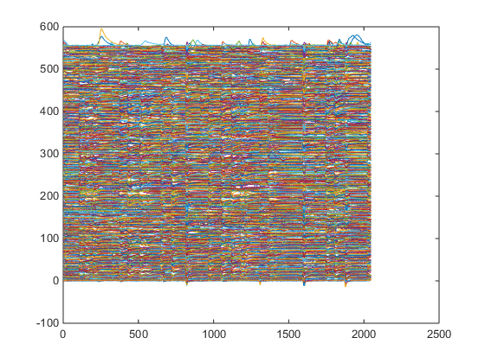
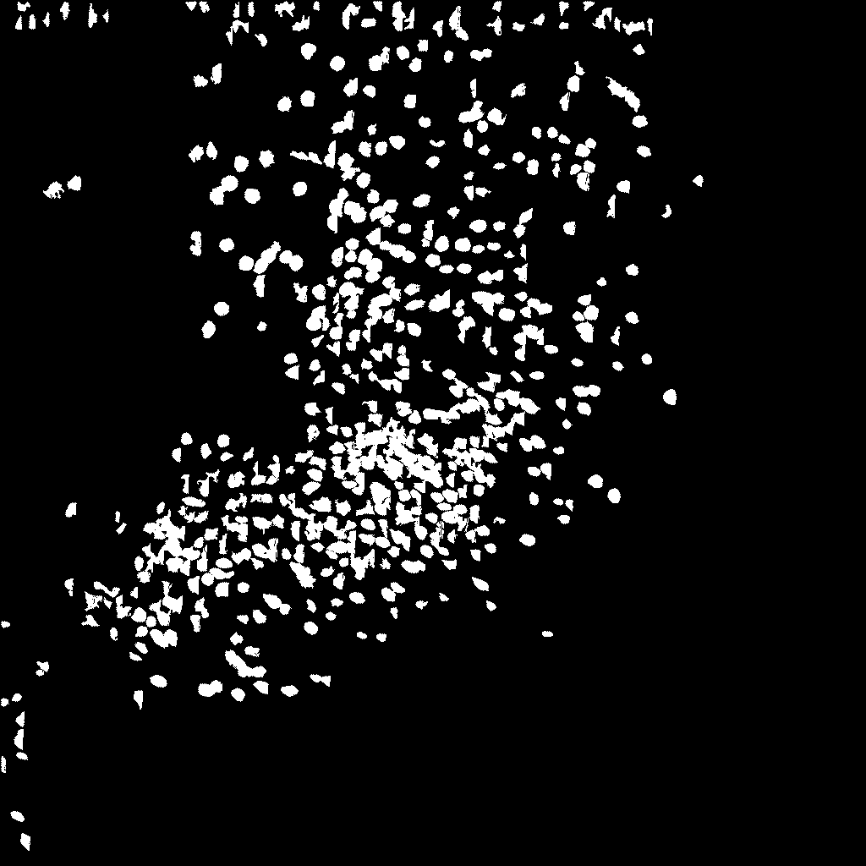
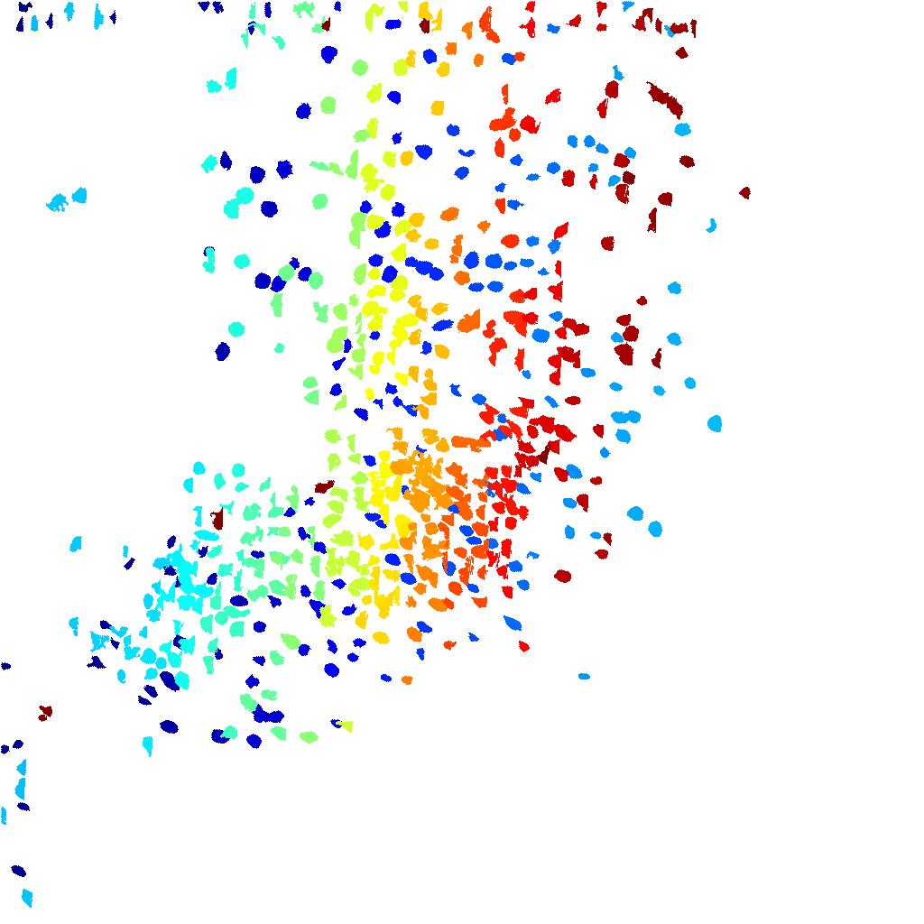

LOAD UNSCALED VIDEO FILES & PLAY IN MATLAB
You will need to select the uint16 type binary files from the \VidFiles folder. You may select more than one, as many as you like. They will be read into your workspace (as long as there is available RAM) and can then be saved as a TIFF. Also you can use built-in MATLAB tools such as the VideoWriter to save as compressed or uncompressed AVI, MP4, etc. We will also apply a recursive temporal filter to aid visualization.
% dataUnscaled = readBinaryData();
% n0 = 2;
% a = exp(-1/n0);
% ykm1 = dataUnscaled(:,:,1);
% for k=2:size(dataUnscaled,3)
% yk = a*ykm1 + (1-a)*dataUnscaled(:,:,k);
% dataUnscaled(:,:,k) = yk;
% ykm1 = yk;
% end
% implay(dataUnscaled)
Published with MATLAB® R2014b

