**Chapter 3  
RESEARCH METHODOLOGY**

This chapter showed the methodology used in developing Thesys: A Research Management System University of Makati, which consisted of research design, population and sample, project development, operation and testing procedure. It also showed the summary of evaluation made by would-be users and Information Technology specialists.

**RESEARCH DESIGN**

The researchers used descriptive and developmental research as the backbone in conducting this study since it is particularly important in the field of Information Technology. The researchers designed a system that could help researchers to easily find references with regards to thesis topics and ideas for their project.

Descriptive research is conclusive in nature, as opposed to exploratory. This means that descriptive research gathers quantifiable information that can be used for statistical inference on your target audience through data analysis. As a consequence, this type of research takes the form of closed-ended questions, which limits its ability to provide unique insights. However, used properly it can help an organization better define and measure the significance of something about a group of respondents and the population they represent (FluidSurveys, 2014).

Developmental research, as opposed to simple instructional development, has been defined as “the systematic study of designing, developing, and evaluating instructional programs, processes, and products that must meet the criteria of internal consistency and effectiveness”.

Thus, the use of descriptive and developmental method of research was suitable in addressing the general and specific problems of the study. It was also used to enumerate the step-by-step procedures needed to fulfill this research project.

**Population and Sample**

The system was evaluated by 30 respondents – fifteen Information Technology (IT) and other fifteen non-IT persons. The IT persons included Technology IT/CS instructors and IT/CS students of the University of Makati while the non-IT respondents were students from University of Makati from other programs. **PROJECT DEVELOPMENT**

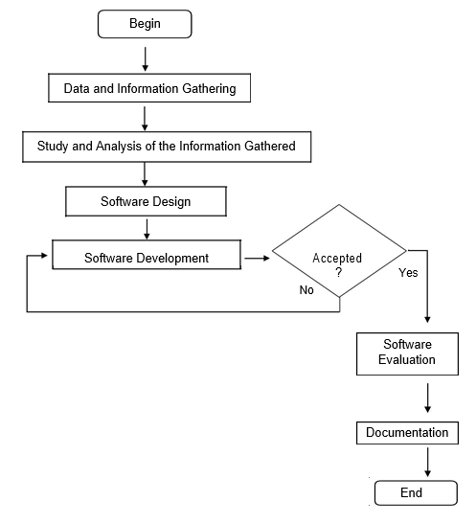The researches underwent different activities in developing the project. The activities involved are illustrated below:

**Figure 2. Project Development Flow Chart**

**Data Information and Gathering**

Several tools and techniques were used to gather the necessary data and information related to the development of this study, which include on-site observations, library and internet research, interview, and documentary analysis.

**Study and Analysis of the Information Gathered**

Similar studies and research undertakings available in the library and on the Internet were analyzed. All data gathered as well as results of the interviews were carefully studied. The sample data, forms, and reports were examined to determine the logical and possible functionality of the system.

The developmental cost in this phase was the expenses incurred for the development and implementation of the system. The following table showed the budgetary requirements for this project.

**Table 1. Development Cost of Thesys: A Research Management System University of Makati Undertaken by the Researchers**

|  |  |
| --- | --- |
| **PARTICULARS** | **AMOUNT** |
| **Software Requirements** |  |
| A. Operating System  Windows 7 to 10 | (already available) |
| B. XAMPP | (already available) |
| C. Sublime Text 3 | (already available) |
| D. Adobe Photoshop | (already available) |
| E. Adobe Reader | (already available) |
| **Hardware Requirements** |  |
| A. Desktop / Laptop  3GB RAM at least  2.0 GHz Processor  1 GB Hard Disk Space at least |  |
| B. Mobile Phone |  |
| Documentation | Php 1,500.00 |
| Research | Php 1,300.00 |
| Total: | Php 2,800.00 |

**Software Design**

In this task, all pertinent input data and required outputs were determined and defined. Data flow diagrams were used as tools to represent the activities and flow of data within the system.

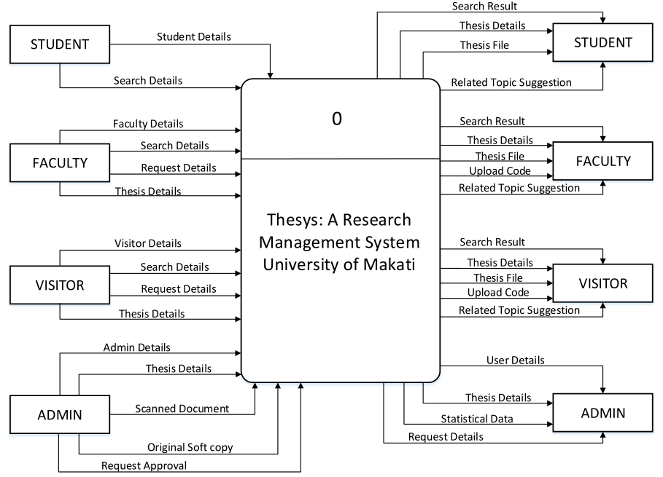The Context Level showed the global view of the system, presenting only the entities and data flows while the Level 0 gave a more detailed representation including the system’s sub-processes. The entities, which were depicted as boxes, are the stakeholders which give input into or receive output from the system. The arrow lines were the data flows whose arrow heads denote if it is received or provided by a certain entity. The context level is shown in Figure 3.

**Figure 3. Context Level Diagram of Thesys: A Thesis Repository Management System University of Makati**

Figure 3 showed that the system has four entities - an administrator and users which were categorized into three: namely student, faculty and visitor. The administrator has an over-all access in the system in terms of managing documents and requests approval. The admin could be a librarian, an IT staff or person who was capable of managing the system.

The faculty and the visitor has the same capability in terms of access in the system, wherein they can search thesis and download their desired document, and the added one is they can submit request to the admin to upload their thesis in the system. However, the student cannot upload thesis.

The Level 0 diagram, as shown in the succeeding page in figure 4, gives a more detailed picture of the functionality of the system by including its sub-processes.

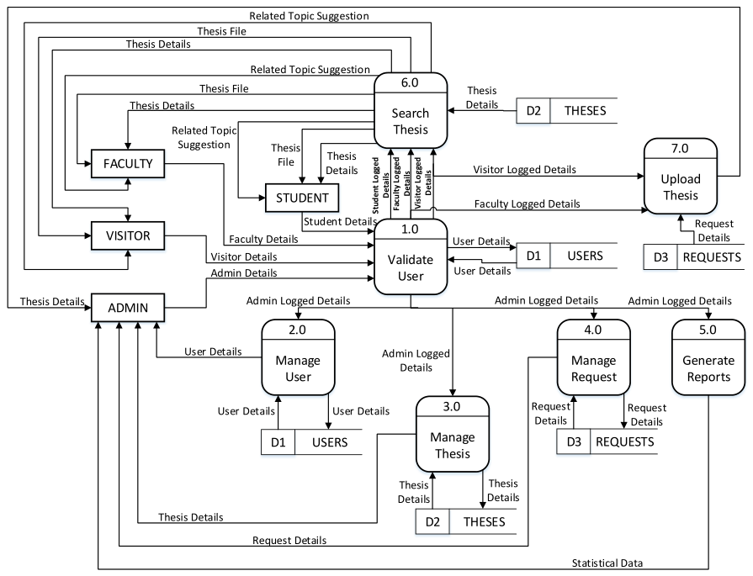­­­­­­

**Figure 4. Level 0 of Thesys: A Research Management System University of Makati**

Figure 4 showed that admin is responsible for over-all monitoring of the system. Every user must log in for them to be able to access the system. The system will validate if the inputted user info exists in the repository, and once confirmed, the account will land to its respective landing page based on the type of his/her account. Administrator could manage the user, thesis, request, can view reports like statistical data, search for thesis and upload document, whether it is scanned or the original soft copy. The three remaining users can view and cite thesis once they successfully entered the system. If he/she wants to download the document, they can do so. Also, the visitor and faculty can submit request for their thesis to be posted in the system. When the admin approved their request, they can upload so.

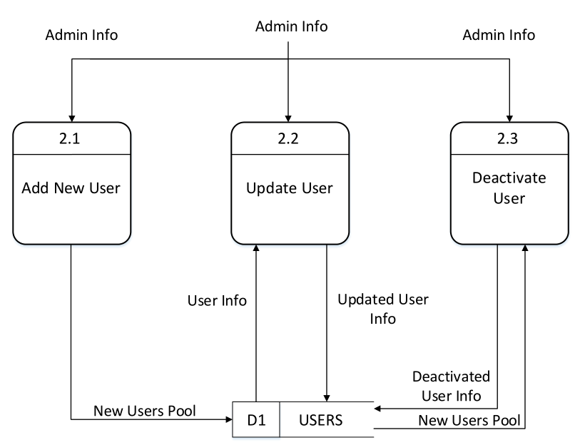Child diagrams of Figure 4 namely: manage user, manage thesis, manage request, search thesis and upload thesis are presented below to show details of the steps to be taken for each process.

**Figure 5. Child Diagram for Manage User of Thesys: A Thesis Repository Management System University of Makati**

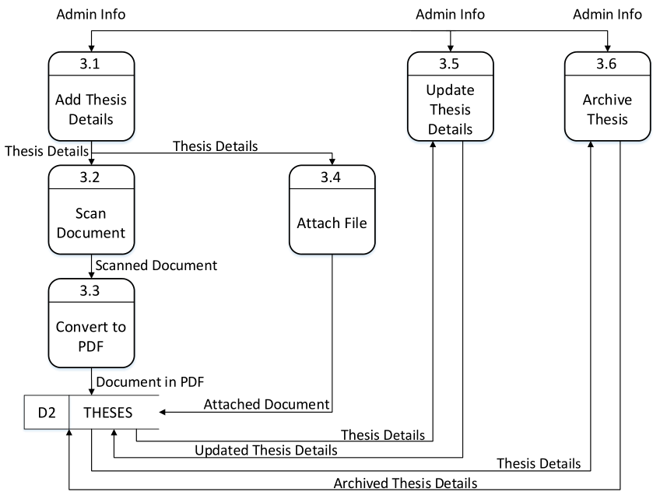Figure 5 showed that administrator can add, edit or update and deactivate user. Any changes will store in users’ database. There will be a new users’ information if ever admin add another user info. Changes will be applied if admin updated and/or deactivated the existing user information.

**Figure 6. Child Diagram for Manage Thesis of Thesys: A Thesis Repository Management System University of Makati**

Figure 6 showed that administrator could add, update and archive thesis. In adding thesis, it was categorized into two - scanned and original soft copy. If the soft copy document of the thesis was not available, then it must be scanned, then must be converted to pdf afterwards. There would be a new thesis list if ever admin add another thesis, changes will apply if admin update and or archive the existing thesis.

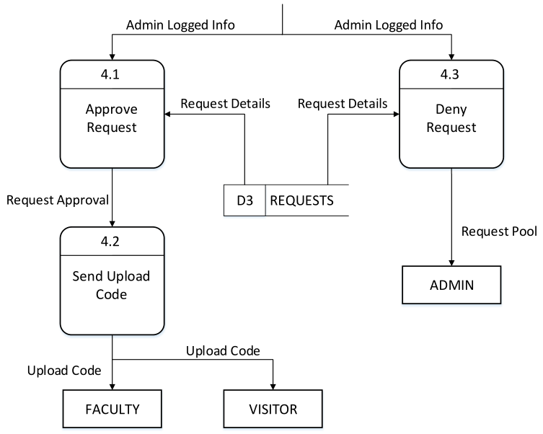

**Figure 7. Child Diagram for Manage Request of Thesys: A Thesis Repository Management System University of Makati**

Figure 7 showed that request details were stored in database requests. Administrator would manage the request. He/she could approve or deny request. If admin approved the request, there would be sending of upload code for the faculty or visitor who asked for the approval of their request/s.

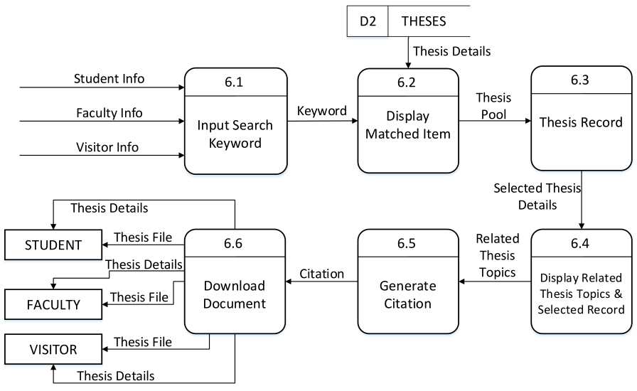

**Figure 8. Child Diagram for Searching Thesis of Thesys: A Thesis Repository Management System University of Makati**

Figure 8 showed diagram for searching theses. The system provided search box and the system will display matched thesis if the item exists. System would display thesis information and other necessary document. User could input search keyword and the system would display related topics and selected record. In able for the user to download the document, they must first get the citation to be able to download their desired document.

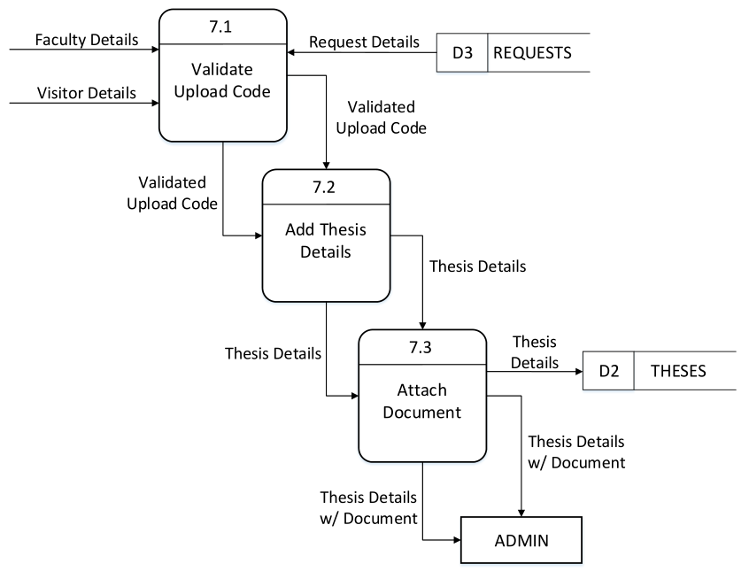

**Figure 9. Child Diagram for Upload Thesis of Thesys: A Thesis Repository Management System University of Makati**

Figure 9 showed the upload of thesis after the approval in request. After the upload code validation, faculty or visitor could add the thesis details, attach the necessary document and submit. For the mean time only, the admin can see the added thesis file after the mentioned process.

**Software Development**

This was the process wherein the researchers created the system’s data flow diagrams into concrete functionality of the system by using algorithms and actual coding using a specific programming language. The system was developed using PHP. MySQL was used for database management system. All requirements set by the end users are carefully incorporated in the design of the system’s interface and features. Various programming techniques and tools were used at this phase.

**Software Evaluation**

This phase required an active participation of the users by testing the system and validating whether the system met their needs and the existing policies of the university. IT experts evaluated the system for modification or improvement. Users also evaluated the system to test its qualities and capabilities. The ISO 9126 software quality model was the basis for the evaluation instrument used in this phase. Wherein, functionality, reliability, usability, efficiency and maintainability were discourse in this phase.

**Documentation**

Documentation was important to retain the necessary activities and substance of the project. This was a good practice for interactive strategy and formality. This phase involved recording all the procedures, processes and tasks which concern the use of the system. The problems encountered with the current processes, as expressed by the students, were also noted. After the system was developed, an effective tool for external documentation, the system’s user manual, was prepared to help the would-be users on how to effectively and efficiently use the system.

**OPERATION AND TESTING PROCEDURE**

In order for the system to be operational, a user should use a laptop with browser to access the system. The back-end retrieved and received all information entered or queried by the end users.

**Operation Procedure**

The main aim of this phase was to elaborate the steps conducted before the implementation of the system to ensure that it is functional, reliable, usable, efficient, and maintainable.

Table 2, found on the succeeding page, showed the steps on how Thesys developed. These steps were: (1) identification of system features; (2) creation of project schedule and resources collation; (3) Preparation of hardware development tools; (4) Installation of software development tools; (5) Utilization of web technologies; and (6) Development of the system.

**Table 2. Operation Procedure of Thesys: A Research Management System University of Makati Undertaken by the Researchers**

|  |  |
| --- | --- |
| **Components / Phases** | **Procedures Conducted** |
| 1. Identification of System  Features | Identified problems encountered with the current processes of searching thesis documentations and related details.  The features used in the system were determined to solve the problem of the students and researchers. |
| 2. Creation of Project Schedule and Resources Collation | Created schedule of activities and tasks needed to be done.  Break down the total expenses and budget needed for the project. |
| 3. Preparation of Hardware  Development tools | Prepared a machine such as laptop/desktop computer and mobile device with browser used as a hardware requirement with the complete specifications. |
| 4. Installation of Software  Development Tools | Installed the software tools in developing the system, which were the following:   1. XAMPP – contains the Apache web server and MySQL Connection 2. Sublime Text 3 – for coding the system 3. Web browser – for running/displaying the system. 4. Adobe Photoshop – for Graphical User Interface design 5. Adobe Reader – for PDF documents. |
| 5. Utilization of Web Technologies | Acquired the necessary technologies to support the features of the website which include the following:   1. PHP, HTML 2. CSS 3. Bootstrap 4. JavaScript 5. MySQL |
| 6. Development of the System | Executed web programming using various framework, programming and scripting language such as Bootstrap, PHP, CSS and JavaScript |

**Testing Procedure**

The researchers performed testing to check the performance and accuracy of the system. The system was tested to ensure that it meets the required specifications and its needs.

**Table 3. Testing Procedure of Thesys: A Research Management System University of Makati Undertaken by the Researchers**

|  |  |
| --- | --- |
| **Components / Phases** | **Procedures Conducted** |
| 1. Functionality | Tested the system based on its functionality and features.  Identify the behavior output of the system. |
| 2. Usability | The system tested according to the flow of the system from page to page and consistency of common objects in the system. |
| 3. Compatibility | Modified the performance and compatibility issue. Would be able to perform without problems using different browsers. |
| 4. Performance | The system tested according to its performance and how long a process is done in the system. |
| 5. Security | Tested according to how it deals with the validations in form and unauthorized access. |

Table 2 showed the test procedures of the developed Thesys: A Research Management System University of Makati performed by the evaluators. These are necessary for the enhancements of the system based on the results of the test cases that were performed.

**EVALUATION PROCEDURE**

To evaluate the system, the following activities were performed:

**1. Preliminary Evaluation**

As soon as the system was completed, the researchers conduct a test to some prospect users. With this, the acceptability and usability of the project was evaluated.

**2. Final Evaluation**

To test the system, the researchers conducted a survey to 30 respondents – fifteen Information Technology (IT) and other fifteen non-IT persons. The IT persons included Technology IT/CS instructors and IT/CS students of the University of Makati while the non-IT respondents were students from University of Makati from other programs.

An evaluation instrument was used for tabulation, analyses, interpretation, and summary of the result.

**3. Evaluation Instrument**

The development of the project undergone statistical treatment to determine or guarantee the quality and feasibility of the software based on accurate data having the right sources and methods of collecting data.

The criteria or indicators used by the researchers were the following: a) functionality; b) reliability; c) usability; d) efficiency; and e) maintainability.

**4. Treatment of Data**

A five-point scale were used to evaluate the study, (thus, the Likert’s Principle.) Each criterion was rated in scale of 1-5, where 5 was Excellent and 1 was Poor. Data had been gathered and analyzed to determine the Weighted Mean and Composite Mean used for the interpretation of the results.

The following descriptive rating scale was used to evaluate the research project and Table 4 showed the Likert’s scale in software evaluation. The equivalent or verbal interpretation and mean score rating was designed to capture ranges probability after averaging the scores.

Formula for Mean:

x = Σ fx / n

Weighted Mean = Σ x / n

where: x = Mean

f = frequency

n = total frequency

x = score

**Table 4. Likert’s Scale**

|  |  |
| --- | --- |
| **Ranges** | **Verbal Interpretation** |
| 4.51 – 5.00 | Excellent |
| 3.51 – 4.50 | Very Good |
| 2.51 – 3.50 | Good |
| 1.51 – 2.50 | Fair |
| 1.00 – 1.50 | Poor |

Researchers considered the aforementioned development phases, factors and tools for the development of the project. Researches were necessary to gain ideas and more knowledge for the improvement and quality of the study.