AfricaAI: Runbook - BOACTAR – BOA
Summary | We collect CTA Model data from the Bank of America Mercury reports.
Source name | Bank of America Corporation - BOA
Link to the source | Link with data
Dataset name | BoA CTA Replication - BOACTAR
Frequency | Weekdaily (BusinessDaily)
SLA | Data is usually published daily after 9AM EST. Please check releases daily.
Expected Time | NA

Instructions:
NB! This data should be processed only via your AWS workspace it requires Bridgewater credentials.
1. Find credentials via link below:
https://vault.data-factory.io/ui/vault/secrets/AfricaAI/kv/BofA/details?version=1
2. Sign in to Vault using the same credentials as for your AWS workspace. Use LDAP method.
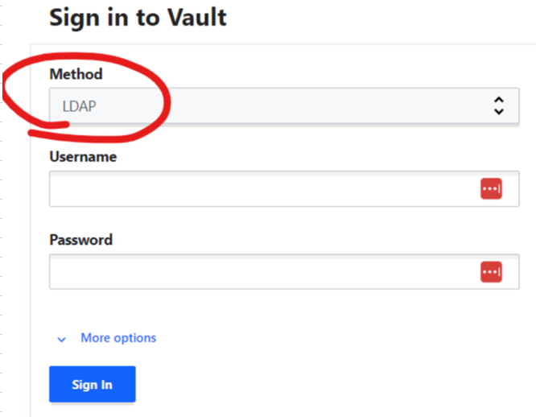
3. Go to the following site and login: https://markets.ml.com/home
3.1. Go to the mailbox africaai@data-factory.io and find token for logging in if required by current session:
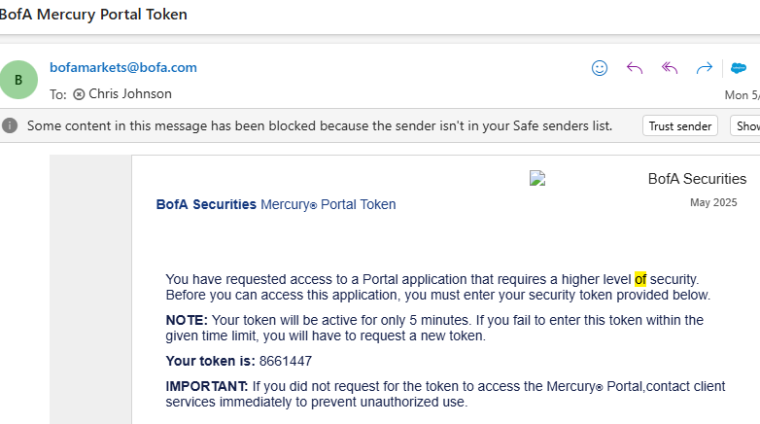
4. Follow Link with data (if link breaks, please repeat following steps):
4.1. Type to the search “CTA Model”
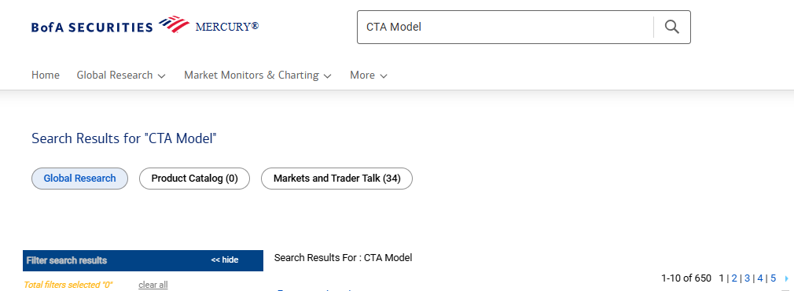

5. Open the latest actual report titled “Systematic Flows Monitor CTA Model Daily Update” which is an Excel file
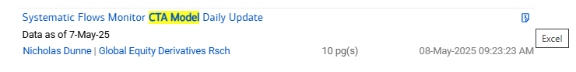

6. Open the file and click the second tab labelled “Summary”. Please collect every row / column on this sheet.
NOTE: Please ingest the “Model CTA Position” as 1 for long and -1 for short, 0 for neutral.
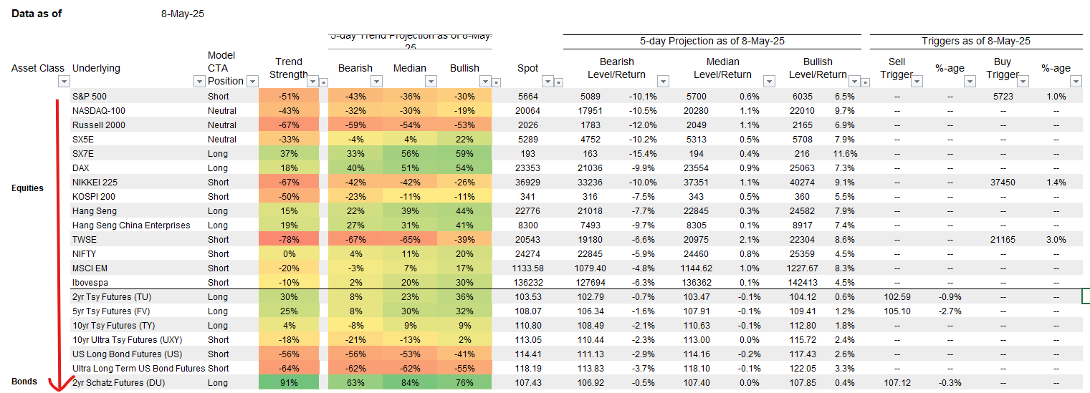
Keep the dashes in the triggers section as NA value.

NB!: Percentage values should be indicated with maximum available digits after comma from excel file, in FULL PERCENTAGE AMOUNT. Be aware that by simply copying percentage values from excel they copying as index, so we need multiple these values by 100 after copying.
For instance, we have value below:
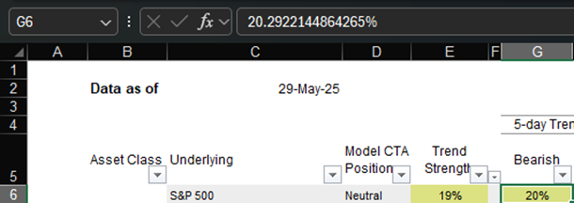

But after copying to another spreadsheet data in most cases can be transformed:
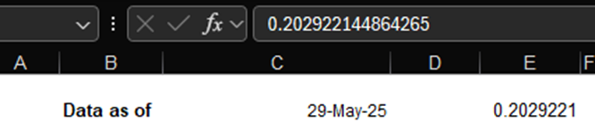

Be aware that we need “20.2922144864265” value in the data file for such cases.
NB! Be aware that some line for spot => current price items were renamed, the actual description was updated:
- SX5E -> EURO STOXX 50 (VG)
- SX7E -> EURO STOXX Banks (CA)
- Hang Seng -> Hang Seng (HI)
- Hang Seng China Enterprises -> HSCEI (HC)

7. Convert each data point period to format YYYY-MM-DD, i.e. Data as of “8-May-25” should be indicated as 2025-05-08 for TIME_PERIOD column.
Only for initial release:
Please collect ALL available back history for list of reports available via filter.
We need 1 release with ALL available daily back history.
The daily reports only go back to late 2023. For older reports when excel will not be available, please go to BoA Mercury and search “Systematic Flows Monitor”:
Then scrape this table:
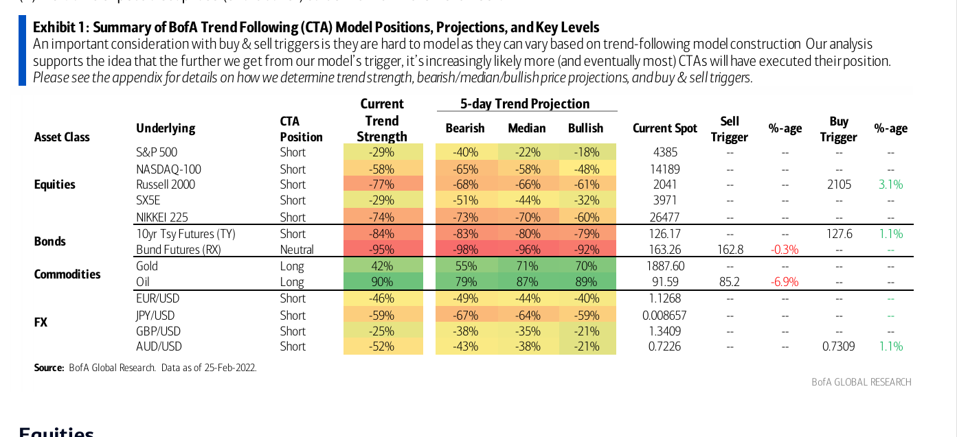
Please set up the same time period based on the as of date below table, i.e. 2022-02-25.
Requirements to the data provided by AfricaAI
Data files format
For on-boarding new datasets and processing new releases the following requirements are applied:
- there should be one archive in .ZIP format that contains 2 files provided in .XLS format per one release - one file with DATA and one file with METADATA (both files are mandatory). Archive name should be as "DATASET_YYYYMMDD.ZIP"", where "DATASET" - specified abbreviation for a dataset, "YYYYMMDD" - timestamp when the file was created, where YYYY - year, MM - month number, DD – day;
- the files format is strictly defined and cannot be changed by AfricaAI team.

File with DATA
Template for file name: “DATASET_DATA_YYYYMMDD.xls”, i.e.” MEXPENFND_DATA_20220601.xls”
Requirements to the file with DATA:
- format - XLS, encoding - Unicode (UTF-8);
- file name: should follow pattern "DATASET_DATA_YYYYMMDD.xls", where "DATASET" - specified abbreviation for a dataset, "YYYYMMDD" - timestamp when the file was created, where YYYY - year, MM - month number, DD - day;
- file content:
  - for data with daily/ weekdaily frequency: YYYY-MM-DD, where YYYY - year, MM - month, DD – day;
  - for data with weekly frequency: YYYY-WW, where YYYY - year, WW - week number (should be two-digits, i.e. 2022-01, 2022-02, etc.). Week number is defined based on the reporting date: reporting date is considered the end of the week, i.e. if reporting date is Wednesday the week is calculated from Thursday till Wednesday – based on that rule the number of the week is defined;
  - for data with monthly frequency: YYYY-MM, MM - month number (should be two-digits, i.e. 2022-01, 2022-02, etc.);
  - for data with quarterly frequency: YYYY-QX, where YYYY - year, X - quarter number;
  - for data with annual frequency: YYYY, where YYYY – year;
  - if provider specifies for reported period that data is Not Available (that could provided in corresponding notes or other way) - fill in that data point with "NA" value;
  - if provider does not specify that data is Not Available and report Empty value for reported period - leave Empty cell;
  - if provider skips some of reporting period - skip it also in the file with data as well;
  - data is provided on one sheet only (multiple sheets are forbidden);
  - two-dimensional format where rows represent reported periods and columns contain timeseries values;
  - reported period(s) should be provided in the following format:
  - values to be provided in decimal format with "." as delimiter (number of digits after "." is limited only by provided value by the source). In order to interpret data correctly the following requirements are applied:
  - column names to be provided in two first rows: in the first row - timeseries ID (CODE), in the second row – timeseries description (description in DATA file is identical to description in file with METADATA).
NB! Timeseries with different frequencies could be provided within the same file as there are different patterns for providing reported periods

File with METADATA
Template for file name: “DATASET_META_YYYYMMDD.xls”, i.e.” MEXPENFND_META_20220601.xls”
Requirements to the file with METADATA:
- format - XLS, encoding - Unicode (UTF-8);
- file name: should follow pattern "DATASET_META_YYYYMMDD.xls", where "DATASET" - specified abbreviation for a dataset, "YYYYMMDD" - timestamp when the file was created, where YYYY - year, MM - month number, DD - day;
- file content: specified metadata attributes that are static unless provider changes something or new timeseries should be added. In case of new timeseries should be added/ updated/ changed - escalate that to Data Engineering team Special BWAT-DFAC Data Engineering <SpecialBWAT-DFACDataEngineering@epam.com> at and Cc: Data Operations team at Special BWAT-DFAC DataOps <SpecialBWAT-DFACDataOps@epam.com>

Notes on METADATA fields from file “DATASET_META_YYYYMMDD.xls”
- With every data release attach file with METADATA
- With every release change only on attribute in the file with METADATA in column “NEXT_RELEASE_DATE” – set “YYYY-MM_DDThh:mm:ss” (YYYY – year, MM – month, DD – day, hh – hour, mm – minutes, ss – seconds. Time should be provide in UTC time) to the time when the next release is going to be processed.

Saving ZIP archive on SFTP
Save the releases in specified per “DATASET” folder (you may create new folder for new DATASET in case of absence of such folder).
Details on SFTP are the following:
1) Dev env
Host: africaai.datadev.dfac.io
2) PRODVAL env
Host: africaai.prodval.data-factory.io
3) PRODHA env
Host: africaai.prodha.data-factory.io
Port: 22

