AfricaAI: Runbook - FREIGHTINFO – MARAD
Summary | We are capturing Number of Container Ships Anchored off U.S. Ports from bts.gov website.
Source name | MARAD Office of Policy and Plans analysis of IHS AIS live data - MARAD
Link to the source | https://www.bts.gov/freight-indicators#anchored-offshore
Dataset name | US Trucking Spot Rates & US port congestion - FREIGHTINFO
Frequency | Weekly
SLA | Containership info, release day is on Tuesday. Should be checked every Wednesday.
Expected Time | NA
The date to which the data refers must be converted to the format yyyy-ww, where ww is the week number.
Instructions:
1. Navigate to the source URL:
https://www.bts.gov/freight-indicators#anchored-offshore
2. Search for recent "Number of Container Ships Anchored off U.S. Ports'' and check for new data by date on top of the graph
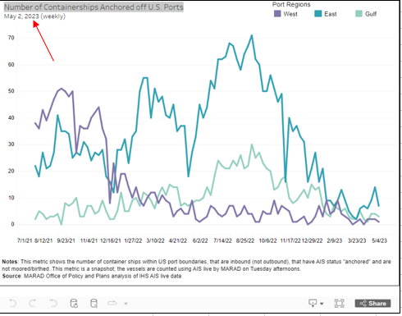
3. Press "Download" (at the bottom of the chart) - Crosstab - CSV or Excel
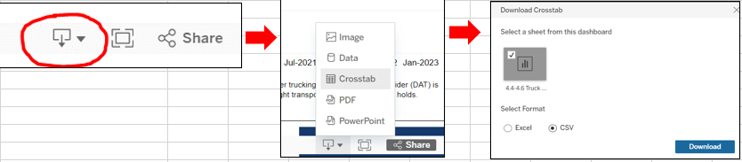
4. Collect the latest data points
Example for 2023-08-08 (csv and excel file):
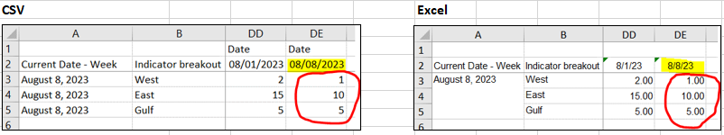
Chart name | Indicator | Measure code | Description
Number of Containerships Anchored off U.S. Ports | West | USA.CONTAINERSHIP_PORT_REGION_WEST.W | USA.Containership port region West
Number of Containerships Anchored off U.S. Ports | East | USA.CONTAINERSHIP_PORT_REGION_EAST.W | USA.Containership port region East
Number of Containerships Anchored off U.S. Ports | Gulf | USA.CONTAINERSHIP_PORT_REGION_GULF.W | USA.Containership port region Gulf

Save data in FREIGHTINFO_MARAD_DATA_YYYYMMDD file.
Requirements to the data provided by AfricaAI
Data files format
For on-boarding new datasets and processing new releases the following requirements are applied:
- There should be one archive in .ZIP format that contains 2 files provided in .XLS format per one release - one file with DATA and one file with METADATA (both files are mandatory). Archive name should be as "DATASET_YYYYMMDD.ZIP"", where "DATASET" - specified abbreviation for a dataset, "YYYYMMDD" - timestamp when the file was created, where YYYY - year, MM - month number, DD – day;
- The files format is strictly defined and cannot be changed by the AfricaAI team.

File with DATA
Template for filename: “DATASET_DATA_YYYYMMDD.xls”, i.e.” MEXPENFND_DATA_20220601.xls”
Requirements to the file with DATA:
- format - XLS, encoding - Unicode (UTF-8);
- file name: should follow pattern "DATASET_DATA_YYYYMMDD.xls", where "DATASET" - specified abbreviation for a dataset, "YYYYMMDD" - timestamp when the file was created, where YYYY - year, MM - month number, DD - day;
- file content:
  - data is provided on one sheet only (multiple sheets are forbidden);
  - two-dimensional format where rows represent reported periods and columns contain time series values;
  - reported period(s) should be provided in the following format:
    - for data with daily/ weekdaily frequency: YYYY-MM-DD, where YYYY - year, MM - month, DD – day;
    - for data with weekly frequency: YYYY-WW, where YYYY - year, WW - week number (should be two-digits, i.e. 2022-01, 2022-02, etc.). Week number is defined based on the reporting date: reporting date is considered the end of the week, i.e. if reporting date is Wednesday the week is calculated from Thursday till Wednesday – based on that rule the number of the week is defined;
    - for data with monthly frequency: YYYY-MM, MM - month number (should be two-digits, i.e. 2022-01, 2022-02, etc.);
    - for data with quarterly frequency: YYYY-QX, where YYYY - year, X - quarter number;
    - for data with annual frequency: YYYY, where YYYY – year;
- values to be provided in decimal format with "." as a delimiter (number of digits after "." is limited only by provided value by the source). In order to interpret data correctly the following requirements are applied:
  - if provider specifies for reported period that data is Not Available (that could provided in corresponding notes or other way) - fill in that data point with "NA" value;
  - if provider does not specify that data is Not Available and report Empty value for reported period - leave Empty cell;
  - if provider skips some of reporting period - skip it also in the file with data as well;
- column names to be provided in two first rows: in the first row - time series ID (CODE), in the second row – time series description (description in DATA file is identical to description in file with METADATA).
NB! Time Series with different frequencies could be provided within the same file as there are different patterns for providing reported periods

File with METADATA
Template for filename: “DATASET_META_YYYYMMDD.xls”, i.e.” MEXPENFND_META_20220601.xls”
Requirements to the file with METADATA:
- format - XLS, encoding - Unicode (UTF-8);
- file name: should follow pattern "DATASET_META_YYYYMMDD.xls", where "DATASET" - specified abbreviation for a dataset, "YYYYMMDD" - timestamp when the file was created, where YYYY - year, MM - month number, DD - day;
- file content: specified metadata attributes that are static unless provider changes something or new time series should be added. In case of new timeseries should be added/ updated/ changed - escalate that to Data Engineering team Special BWAT-DFAC Data Engineering <SpecialBWAT-DFACDataEngineering@epam.com> at and Cc: Data Operations team at Special BWAT-DFAC DataOps <SpecialBWAT-DFACDataOps@epam.com>
Notes on METADATA fields from file “DATASET_META_YYYYMMDD.xls”
- With every data release attach file with METADATA
- With every release change only on attribute in the file with METADATA in column “NEXT_RELEASE_DATE” – set “YYYY-MM_DDThh:mm:ss” (YYYY – year, MM – month, DD – day, hh – hour, mm – minutes, ss – seconds. Time should be provided in UTC time) to the time when the next release is going to be processed.

Saving ZIP archive on SFTP
Save the releases specified per “DATASET” folder (you may create a new folder for new DATASET in case of absence of such folder).
Details on SFTP are the following:
- Dev env
Host: africaai.datadev.dfac.io
- PRODVAL env
Host: africaai.prodval.data-factory.io
- PRODHA env
Host: africaai.prodha.data-factory.io
Port: 22

