The Purple Book 2024 | Introduction | Overview | 01 | 02 | 03 | 04 | 05 | 06 | 07 | 08 | 09 | 10 | 11 | 12 | Appendix | Glossary | Charts | 20
 |  |  |  |  |  |  | Funding |  |  |  |  | Claims and | PPF
 |  |  | Executive | The | Scheme | Scheme | history and | Insolvency | Asset | Risk | PPF levy | schemes in | compensation | PPF risk
 |  |  | summary | data | demographics | funding | sensitivities | risk | allocation | reduction | 2023/24 | assessment | 2023/24 | developments |  |  | and tables
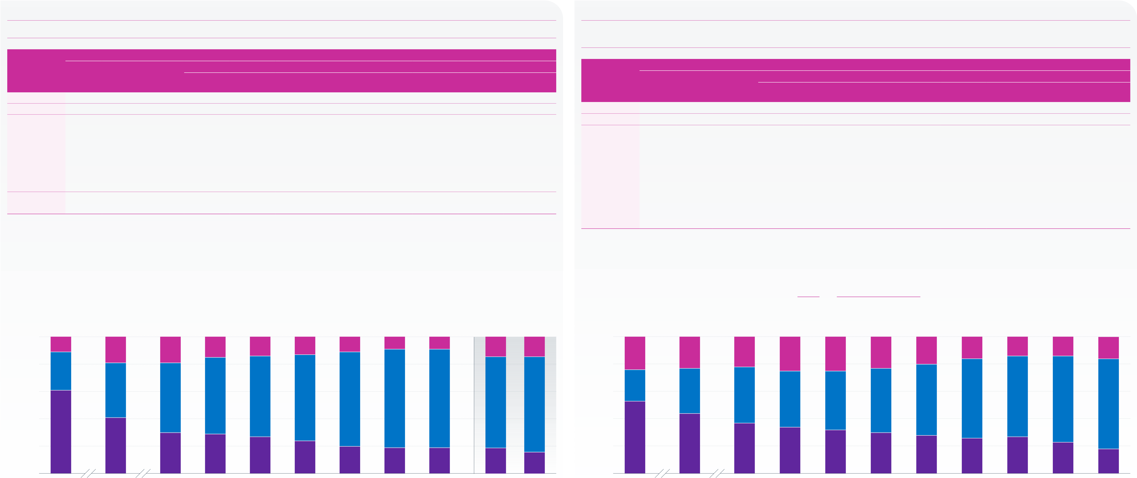
Asset allocation continued
Figure 7.3 | Weighted average asset allocation in total assets Figure 7.4 | Asset allocation: simple averages

The proportions of assets invested in equities continues to decline.

Asset class
Breakdown of other investments Asset class

Year/The Purple |  |  | Other |  |  |  | Cash and |  | Annuities | Diversified | Absolute | Insurance | Hedge funds | Miscellaneous | Year/The Purple | Equities | Bonds | Other | Cash and | Property | Annuities | Breakdown of other investments |  | Insurance | Hedge funds | Miscellaneous
Book dataset | Equities | Bonds |  | investments |  |  | deposits | Property |  | growth funds | returns | policies |  |  |  |  |  |  |  |  |  | Diversified | Absolute
2006 | 61.1% | 28.3% |  |  | 10.6% |  | 2.3% | 4.3% | – | – | – | 0.9% | – | 3.1% | Book dataset |  |  | investments | deposits |  |  | growth funds | returns | policies
2011 | 41.1% | 40.1% |  |  | 18.8% |  | 4.1% | 4.4% | – | – | – | 1.6% | 2.4% | 6.3% | 2006 | 52.6% | 22.6% | 24.8% | 3.9% | 2.1% | – | – | – | 14.9% | – | 3.6%
 |  |  |  |  |  |  |  |  |  |  |  |  |  |  | 2011 | 43.7% | 32.6% | 23.7% | 4.9% | 2.7% | – | – | – | 11.8% | 1.0% | 3.3%
2016 | 30.3% | 51.3% |  |  | 18.4% |  | 3.0% | 4.8% | 2.1% | – | – | 0.1% | 6.6% | 1.7%
 |  |  |  |  |  |  |  |  |  |  |  |  |  |  | 2016 | 36.8% | 41.1% | 22.1% | 5.4% | 3.7% | 2.4% | – | – | 1.2% | 7.9% | 1.5%
2017 | 29.0% | 55.7% |  |  | 15.3% |  | -0.9% | 5.3% | 3.3% | – | – | 0.1% | 6.7% | 0.8%
2018 | 27.0% | 59.0% |  |  | 14.0% |  | -2.5% | 4.8% | 3.4% | – | – | 0.1% | 7.0% | 1.2% | 2017 | 34.5% | 41.4% | 24.1% | 3.6% | 3.7% | 6.8% | – | – | 0.7% | 7.9% | 1.3%
2019 | 24.0% | 62.8% |  |  | 13.2% |  | -4.4% | 5.0% | 4.0% | – | – | 0.3% | 7.4% | 1.0% | 2018 | 32.4% | 43.1% | 24.5% | 1.8% | 3.3% | 8.9% | – | – | 0.6% | 8.5% | 1.4%
2020 | 20.4% | 69.2% |  |  | 10.4% |  | -7.2% | 4.9% | 5.0% | – | – | 0.1% | 6.8% | 0.8%
 |  |  |  |  |  |  |  |  |  |  |  |  |  |  | 2019 | 30.4% | 47.0% | 22.7% | –0.8% | 3.4% | 9.4% | – | – | 0.5% | 8.9% | 1.3%
2021 | 19.0% | 72.0% |  |  |  | 9.1% | -9.5% | 4.7% | 6.6% | – | – | 0.1% | 6.1% | 0.9%
 |  |  |  |  |  |  |  |  |  |  |  |  |  |  | 2020 | 27.8% | 52.3% | 19.9% | –3.2% | 3.4% | 9.7% | – | – | 0.6% | 7.9% | 1.7%
2022 | 19.5% | 71.6% |  |  |  | 8.9% | -8.8% | 4.6% | 6.8% | – | – | 0.1% | 5.2% | 1.0%
 |  |  |  |  |  |  |  |  |  |  |  |  |  |  | 2021 | 25.8% | 58.0% | 16.3% | –6.6% | 3.2% | 10.6% | – | – | 0.6% | 6.9% | 1.7%
2023 restated | 18.8% | 66.5% |  |  | 14.7% |  | -3.3% | 5.3% | 7.3% | 1.5% | 3.0% | – | – | 0.9% | 2022 | 27.1% | 58.5% | 14.4% | –7.5% | 3.0% | 10.7% | – | – | 0.6% | 6.0% | 1.6%
2024 | 15.5% | 69.8% |  |  | 14.7% |  | -5.4% | 5.9% | 9.7% | 1.0% | 2.6% | – | – | 0.9% | 2023 | 23.1% | 62.9% | 14.0% | –10.8% | 2.8% | 11.5% | 6.7% | 1.7% | – | – | 1.9%
Note: figures may not sum to 100 per cent or the ‘Other investments’ total because of rounding. |  |  |  |  |  |  |  |  |  |  |  |  |  |  | 2024 | 17.8% | 66.1% | 16.1% | –8.9% | 2.8% | 13.8% | 5.2% | 1.3% | – | – | 1.9%

The category ‘bonds’ represents those physically held as well as other investments whose economic characteristics resemble bonds, such as LDI. From 2023 the categories ‘insurance policies’ and ‘hedge funds’ have been discontinued. There became two new categories: ‘diversified growth funds’ and ‘absolute returns’.
The weighted average proportion of assets held in cash and deposits is negative. Negative cash holdings are likely to relate to investments such as swaps and repurchase agreements held as part of LDI strategies.
‘–‘ indicates either that schemes may have been invested in these asset classes but the percentages could not be determined from the data held at the time,

Note: figures may not sum to 100 per cent or the ‘Other investments’ total because of rounding.
From 2023 the categories ‘insurance policies’ and ‘hedge funds’ have been discontinued. There are two new categories: ‘diversified growth funds’ and ‘absolute returns’.
The simple average proportion of assets held in cash and deposits being negative represents a large number of schemes with significant negative cash holdings which are likely to be related to investments such as swaps and repurchase agreements.
‘–‘ indicates either that schemes may have been invested in these asset classes but the percentages could not be determined from the data held at the time,

or because the category is new or no longer exists. |  |  |  |  |  |  | 15% | 14% | 13% | 10% | 9% | 9% | 15% | 15% | or because the category is new or no longer exists. |  |  |  |  | 24% | 25% | 23% | 20% | 16% | 14% | 14% | 16%
100 |  |  |  |  |  |  |  |  |  |  |  |  |  |  | 100
11% |  |  |  |  | 19% | 18% |  |  |  |  |  |  |  |  | 25% |  |  | 24% | 22%
80 |  |  |  |  |  |  | 56% | 59% | 63% | 69% | 72% | 72% | 67% | 70% | 80 |  |  |  |  | 41% | 43% | 47% | 52% | 58% | 59% | 63% | 66%
28%
 |  |  |  |  |  |  |  |  |  |  |  |  |  |  | Percentage | 60 | 23% | 33% | 41%
Percentage | 60 |  | 40% |  |  | 51%
 | 40 |  |  |  |  |  | 29% | 27% | 24% | 20% | 19% | 19% | 19% | 15% |  | 40 |  |  |  | 34% | 32% | 30% | 28% | 26% | 27% | 23% | 18%
61%
 |  |  |  |  |  |  |  |  |  |  |  |  |  |  | 20 |  | 53% | 44% | 37%
20 |  |  | 41%
30%
0 |  |  |  |  |  |  | 2017 | 2018 | 2019 | 2020 | 2021 | 2022 | 2023 restated | 2024 | 0 |  |  |  |  | 2017 | 2018 | 2019 | 2020 | 2021 | 2022 | 2023 | 2024
2006 |  |  |  |  | 2011 | 2016 |  |  |  |  |  |  |  |  | 2006 |  |  | 2011 | 2016
Equities |  | Bonds |  | Other investments |  |  |  |  | Year |  |  |  |  |  | Equities |  | Bonds | Other investments |  |  |  | Year
Note: figures may not sum to 100 per cent because of rounding. |  |  |  |  |  |  |  |  |  |  |  |  |  |  | Note: figures may not sum to 100 per cent because of rounding.
Source: PPF |  |  |  |  |  |  |  |  |  |  |  |  |  |  | Source: PPF

The Purple Book 2024 | Introduction | Overview | 01 | 02 | 03 | 04 | 05 | 06 | 07 | 08 | 09 | 10 | 11 | 12 | Appendix | Glossary | Charts | 21
 |  |  |  |  |  |  | Funding |  |  |  |  | Claims and | PPF
 |  |  | Executive | The | Scheme | Scheme | history and | Insolvency | Asset | Risk | PPF levy | schemes in | compensation | PPF risk
 |  |  | summary | data | demographics | funding | sensitivities | risk | allocation | reduction | 2023/24 | assessment | 2023/24 | developments |  |  | and tables
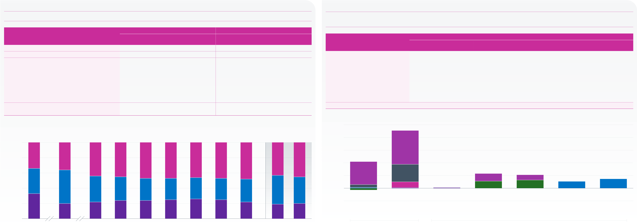
Asset allocation continued

Figure 7.5 | Bond splits – high-level breakdown
The proportions of the high-level types of bonds have remained relatively stable compared to last year.

Figure 7.6 | Bond splits – granular breakdown of The Purple Book 2024 dataset
Government fixed-interest and index-linked bonds are mostly long-dated. Investment grade corporate bond proportions are balanced between territory and term.

Year/The Purple Book dataset | Government | Weighted average | Index-linked | Government | Simple average | Index-linked | Bond category | All | Tier 1 | Short | Weighted average | Short and | Long | Unassigned*
 |  | Corporate |  |  | Corporate
 | fixed-interest | fixed-interest |  | fixed-interest | fixed-interest
2008 | 33.2% | 32.6% | 33.9% | 47.2% | 33.0% | 19.8% |  |  |  |  | Medium | medium
 |  |  |  |  |  |  | Government fixed-interest | 19.5% | 0.4% | –1.4% | 2.5% | – | 18.0% | 0.0%
2011 | 19.6% | 44.3% | 36.1% | 31.2% | 47.1% | 21.7%
2016 | 21.9% | 33.7% | 44.4% | 24.4% | 49.0% | 26.6% | Index-linked | 45.5% | 0.5% | 4.5% | 13.8% | – | 26.7% | 0.0%
2017 | 24.1% | 31.4% | 44.5% | 25.9% | 46.8% | 27.3% | Corporate fixed-interest, of which: | 35.0% | – | – | – | – | – | –
 |  |  |  |  |  |  | Investment grade | 0.4% | 0.4% | – | – | – | – | –
2018 | 24.1% | 28.8% | 47.1% | 27.2% | 42.1% | 30.8%
2019 | 25.4% | 28.4% | 46.2% | 29.0% | 38.9% | 32.1% | UK investment grade | 11.5% | – | – | – | 5.5% | 6.0% | –
2020 | 25.9% | 28.0% | 46.1% | 29.4% | 36.1% | 34.6% | Overseas investment grade | 10.5% | – | – | – | 6.4% | 4.1% | –
 |  |  |  |  |  |  | Sub-investment grade | 5.3% | – | – | – | – | – | –
2021 | 24.6% | 28.2% | 47.2% | 30.4% | 34.8% | 34.8%
2022 | 22.0% | 30.2% | 47.8% | 30.2% | 35.7% | 34.1% | Private debt | 7.3% | – | – | – | – | – | –
2023 restated* | 19.1% | 37.6% | 43.3% | 25.6% | 36.9% | 37.5% | Total | 100% | 1.3% | 3.1% | 16.3% | 11.9% | 54.8% | 0.0%
 |  |  |  |  |  |  | * ‘Unassigned’ is generally where a scheme is in tiers 2 or 3 but did not provide the granular breakdown.
2024 | 19.5% | 35.0% | 45.5% | 27.6% | 35.3% | 37.1%
* Weighted average only. |  | Weighted average |  |  |  |  | 50
Note: the rows may not sum to 100 per cent because of rounding.
 |  |  |  |  |  |  | 40
100
Percentage | 80 | 34% | 36% |  | 44% | 44% |  | 47% | 46% | 46% | 47% | 48% | 43% | 45% | 30 |  |  |  | 27% |  |  |  |  |  |  |  | Investment grade |  | 6% | 4% | 5% | 7%
 |  |  |  |  |  |  |  |  |  |  |  |  |  |  | Percentage |  | 20 |  | 18% |  |  | 14%
 | 60
 |  |  |  |  |  |  |  |  |  |  |  |  |  |  | 10
 | 33% |  | 44% |  | 34% | 31% |  | 29% | 28% | 28% | 28% | 30% | 38% | 35% | 0 |  |  |  | 2% |  |  | 4%
 |  |  |  |  |  |  |  |  |  |  |  |  |  |  |  |  |  |  |  |  |  |  |  |  |  |  |  |  | 5% | 6%
 | 40
 | 20 | 33% | 20% |  | 22% | 24% |  | 24% | 25% | 26% | 25% | 22% | 19% | 20% | -10 |  |  |  | Fixed-interest |  |  |  |  | Index-linked |  |  |  |  | UK | Overseas | Sub-investment | Private debt
 |  |  |  |  |  |  |  |  |  |  |  |  |  |  |  |  |  |  |  |  |  |  |  |  |  |  | (tier 1 only) |  | investment grade | investment grade | grade
 | 0 |  |  |  |  |  |  |  |  |  |  |  |  |  |  |  |  |  |  |  |  |  |  |  |  |  |  |  | (tiers 2 & 3) | (tiers 2 & 3)
 |  |  |  |  |  |  |  |  |  |  |  |  |  |  |  |  |  |  | Government bonds
 |  |  | 2011 |  | 2016 | 2017 |  | 2018 | 2019 | 2020 | 2021 | 2022 | 2023 restated | 2024 |  | Tier 1
 |  |  |  |  |  |  |  |  |  |  |  |  |  |  |  |  |  |  |  |  |  |  |  |  |  |  |  |  |  | Corporate bonds
 | 2008 |  |  |  |  |  |  |  |  |  |  |  |  |  |  |  |  |  |  |  |  |  |  |  |  |  |  | Long
 |  |  |  |  |  |  |  |  | Year
 |  |  |  |  |  |  |  |  |  |  |  |  |  |  |  |  |  |  | All |  | Short |  | Medium |  |  | Short and Medium
 | Government fixed-interest |  |  | Corporate fixed-interest |  |  | Index-linked
 |  |  |  |  |  |  |  |  |  |  |  |  |  |  | Source: PPF
Source: PPF
Note: figures may not sum to 100 per cent because of rounding.

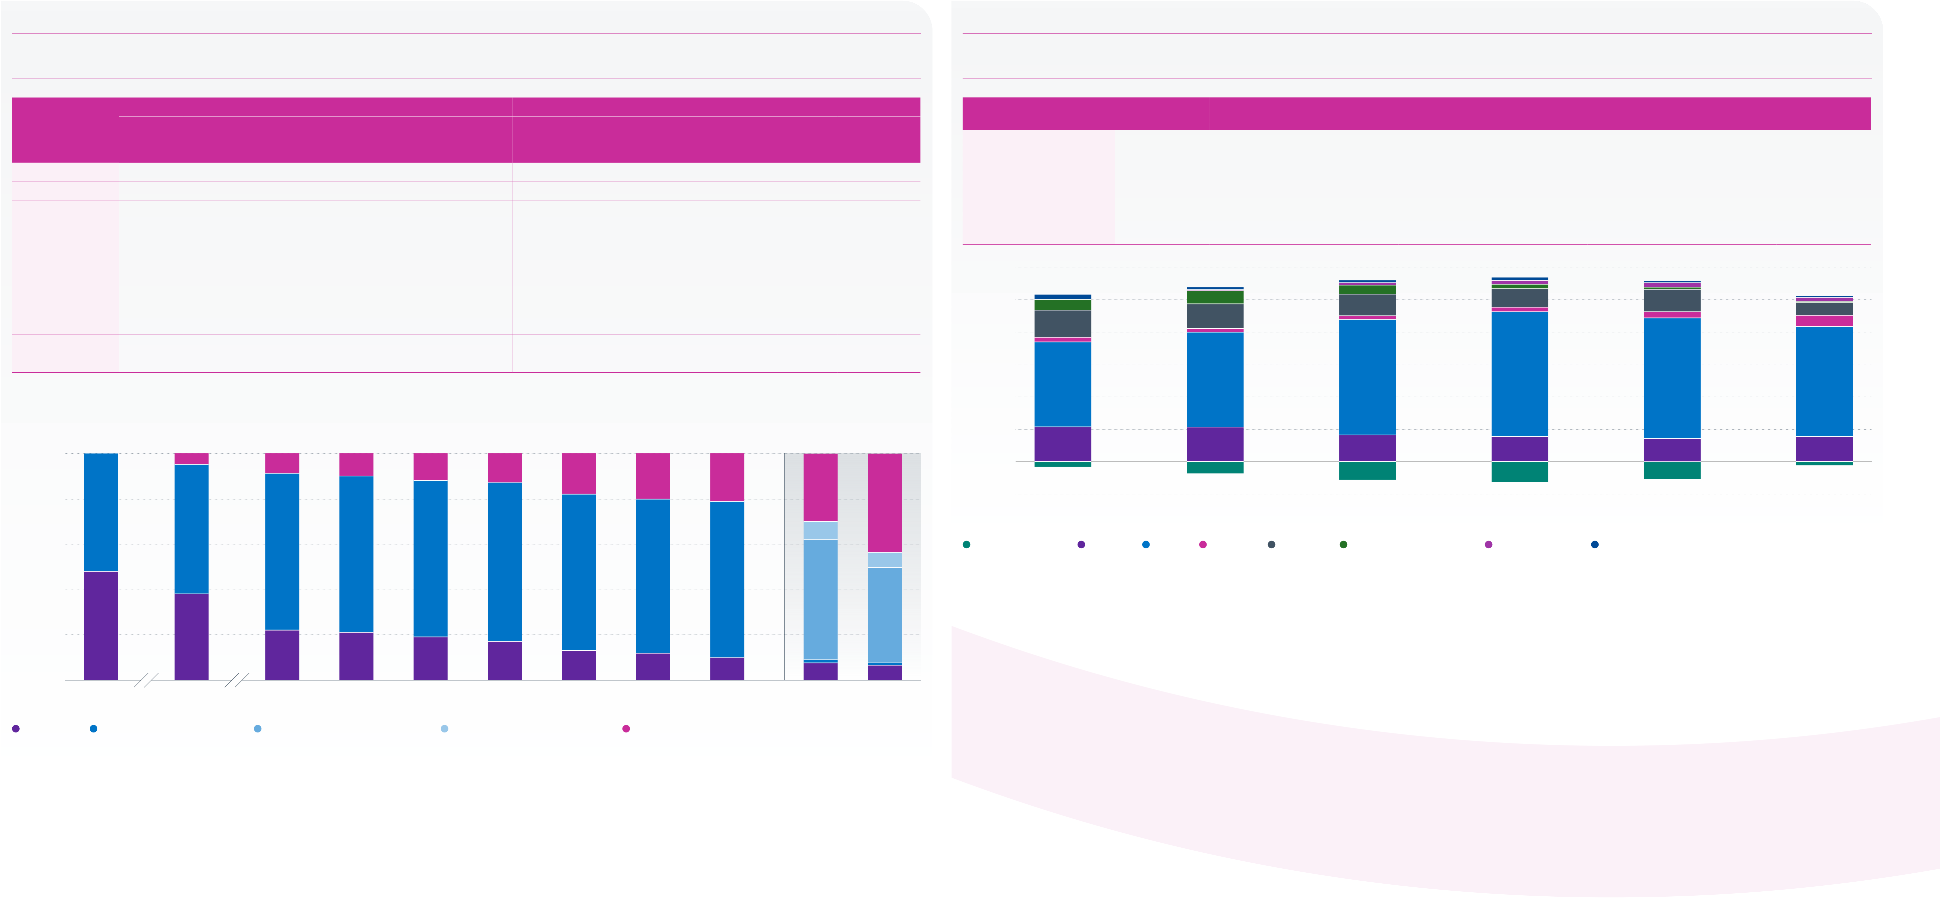
The Purple Book 2024 | Introduction | Overview | 01 | 02 | 03 | 04 | 05 | 06 | 07 | 08 | 09 | 10 | 11 | 12 | Appendix | Glossary | Charts | 22
 |  |  |  |  |  |  | Funding |  |  |  |  | Claims and | PPF
 |  |  | Executive | The | Scheme | Scheme | history and | Insolvency | Asset | Risk | PPF levy | schemes in | compensation | PPF risk
 |  |  | summary | data | demographics | funding | sensitivities | risk | allocation | reduction | 2023/24 | assessment | 2023/24 | developments |  |  | and tables
Asset allocation continued
Figure 7.7 | Equity splits  Within equities, the proportion invested in UK equities continued to fall, but over the last year there was a sharper drop in the proportion invested in overseas equities, in favour of private or unquoted equity, whose proportion has risen to over 40 per cent. |  |  |  |  |  |  |  |  |  |  |  |  |  |  |  |  |  |  |  |  |  |  |  |  |  |  |  |  |  |  |  |  |  |  |  |  | Figure 7.8 | Weighted average asset allocation of schemes by asset size  Schemes with assets less than £10 million have a lower proportion of their assets invested in bonds, with a higher proportion invested in annuities and equities.
Weighted average |  |  |  |  |  |  |  |  |  |  |  |  |  | Simple average |  |  |  |  |  |  |  |  |  |  |  |  |  |  |  |  |  |  |  |  |  |  | Cash and |  |  |  |  |  |  |  |  |  |  |  | Diversified
Overseas quoted |  |  |  |  |  |  |  |  |  | Developed |  |  |  | Emerging |  |  |  |  | Overseas quoted |  |  |  |  |  |  |  | Developed |  |  |  |  | Emerging |  |  |  |  | Asset size |  |  | Equities |  |  | Bonds | deposits |  |  | Property |  | Annuities | growth funds |  | Absolute returns | Miscellaneous
Year/The Purple |  |  | (tier 1 only |  |  |  |  |  |  |  | markets |  |  | markets | Unquoted/ |  |  |  |  |  |  | (tier 1 only |  |  |  |  |  | markets |  |  |  |  | markets |  |  | Unquoted/ | Under £5m |  |  | 21.6% |  |  | 52.5% |  | -3.4% |  |  | 2.9% | 16.8% |  | 6.6% | 0.1% | 2.9%
Book dataset |  |  | UK quoted |  | from 2023) |  |  |  | (tiers 2 and 3) |  |  |  |  | (tiers 2 and 3) |  |  | Private |  | UK quoted |  |  |  | from 2023) |  |  | (tiers 2 and 3) |  |  |  |  | (tiers 2 and 3) |  |  |  |  | Private | £5m–£10m |  |  | 21.3% |  |  | 58.8% |  | -8.0% |  |  | 2.4% | 15.2% |  | 8.3% | 0.3% | 1.7%
2008 |  |  | 48.2% |  |  | 51.8% |  |  |  |  |  | – |  | – |  |  |  | – |  | 60.4% |  |  |  | 39.6% |  |  |  |  |  | – |  |  |  |  | – | –
 |  |  |  |  |  |  |  |  |  |  |  |  |  |  |  |  |  |  |  |  |  |  |  |  |  |  |  |  |  |  |  |  |  |  |  |  | £10m–£50m |  |  | 16.6% |  |  | 71.5% | -12.3% |  |  |  | 2.2% | 13.4% |  | 5.5% | 1.5% | 1.6%
2011 |  |  | 38.0% |  |  | 57.2% |  |  |  |  |  | – |  | – |  | 4.8% |  |  |  | 52.7% |  |  |  | 46.1% |  |  |  |  |  | – |  |  |  |  | – | 1.2% | £50m–£100m |  |  | 15.7% |  |  | 77.1% | -14.0% |  |  |  | 2.8% | 11.5% |  | 2.7% | 2.4% | 1.8%
2016 |  |  | 22.4% |  |  | 68.6% |  |  |  |  |  | – |  | – |  | 9.0% |  |  |  | 38.8% |  |  |  | 58.6% |  |  |  |  |  | – |  |  |  |  | – | 2.6% | £100m–£1bn |  |  | 14.3% |  |  | 74.7% |  | -11.9% |  |  | 3.9% | 13.8% |  | 1.3% | 2.8% | 1.1%
2017 |  |  | 20.5% |  |  | 69.0% |  |  |  |  |  | – |  | – |  |  | 10.5% |  |  | 36.3% |  |  |  | 61.0% |  |  |  |  |  | – |  |  |  |  | – | 2.7%
 |  |  |  |  |  |  |  |  |  |  |  |  |  |  |  |  |  |  |  |  |  |  |  |  |  |  |  |  |  |  |  |  |  |  |  |  | Over £1bn |  |  | 15.7% |  |  | 68.0% |  | -2.5% |  |  | 6.9% | 8.0% |  | 0.5% | 2.6% | 0.8%
2018 |  |  | 18.6% |  |  | 69.4% |  |  |  |  |  | – |  | – |  |  | 12.0% |  |  | 32.1% |  |  |  | 65.0% |  |  |  |  |  | – |  |  |  |  | – | 3.0%
 |  |  |  |  |  |  |  |  |  |  |  |  |  |  |  |  |  |  |  |  |  |  |  |  |  |  |  |  |  |  |  |  |  |  |  |  | 120
2019 |  |  | 16.6% |  |  | 69.7% |  |  |  |  |  | – |  | – |  | 13.7% |  |  |  | 29.6% |  |  |  | 66.7% |  |  |  |  |  | – |  |  |  |  | – | 3.7%
2020 |  |  | 13.3% |  |  | 69.0% |  |  |  |  |  | – |  | – |  |  | 17.7% |  |  | 26.9% |  |  |  | 68.4% |  |  |  |  |  | – |  |  |  |  | – | 4.8% | 100 |  | 7% | 8% |  |  | 6% |  |  |  |  |  | 11% |  | 14% |  | 8%
2021 |  |  | 11.6% |  |  | 68.3% |  |  |  |  |  | – |  | – |  | 20.1% |  |  |  | 24.9% |  |  |  | 69.4% |  |  |  |  |  | – |  |  |  |  | – | 5.8%
 |  |  |  |  |  |  |  |  |  |  |  |  |  |  |  |  |  |  |  |  |  |  |  |  |  |  |  |  |  |  |  |  |  |  |  |  |  |  |  |  |  |  | 13%
 |  |  |  |  |  |  |  |  |  |  |  |  |  |  |  |  |  |  |  |  |  |  |  |  |  |  |  |  |  |  |  |  |  |  |  |  |  |  |  | 15%
2022 |  |  | 9.9% |  |  | 68.6% |  |  |  |  |  | – |  | – |  |  | 21.5% |  |  | 22.5% |  |  |  | 70.9% |  |  |  |  |  | – |  |  |  |  | – | 6.6% | 80 |  | 17% |  |  |  |  |  |  |  |  |  |  |  |  |  | 7%
2023 restated* |  |  | 7.6% |  |  |  | 1.4% |  |  |  | 53.0% |  |  | 8.0% |  | 30.0% |  |  |  | 20.3% |  |  |  | 28.7% |  |  |  |  | 37.1% |  |  |  |  | 4.7% |  | 9.3%
 |  |  |  |  |  |  |  |  |  |  |  |  |  |  |  |  |  |  |  |  |  |  |  |  |  |  |  |  |  |  |  |  |  |  |  |  | Percentage | 60 | 52% | 59% |  |  | 71% |  |  |  |  |  | 77% |  | 75% |  | 68%
2024 |  |  | 6.6% |  |  |  | 1.4% |  |  |  | 41.7% |  |  | 6.7% |  |  | 43.6% |  |  | 17.7% |  |  |  | 29.8% |  |  |  | 33.9% |  |  |  |  |  | 4.4% |  | 14.2%
* Weighted average only.  Note: the rows may not sum to 100 per cent because of rounding.  Weighted average |  |  |  |  |  |  |  |  |  |  |  |  |  |  |  |  |  |  |  |  |  |  |  |  |  |  |  |  |  |  |  |  |  |  |  |  |  | 40
 |  |  |  |  |  |  |  |  |  |  |  |  |  |  |  |  |  |  |  |  |  |  |  |  |  |  |  |  |  |  |  |  |  |  |  |  | 20
 |  |  |  |  |  |  |  |  |  |  |  |  |  |  |  |  |  |  |  |  |  |  |  |  |  |  |  |  |  |  |  |  |  |  |  |  | 22% |  |  | 21% |  |  | 17% |  |  |  |  |  | 16% |  | 14% |  | 16%
100 |  | 52% | 5% |  |  |  |  | 9% |  |  |  |  | 10% | 12% |  |  |  | 14% |  |  | 18% |  |  |  | 20% |  |  |  | 21% |  |  |  |  | 30% |  | 44%
 |  |  |  |  |  |  |  |  |  |  |  |  |  |  |  |  |  |  |  |  |  |  |  |  |  |  |  |  |  |  |  |  |  |  |  |  | 0 |  |  | -8% |  |  | -12% |  |  |  |  |  | -14% |  | -12%
80 |  |  |  |  |  |  |  |  |  |  |  |  |  |  |  |  |  |  |  |  |  |  |  |  |  |  |  |  |  |  |  |  |  |  |  |  | -20
 |  |  |  |  |  |  |  |  |  |  |  |  |  |  |  |  |  |  |  |  |  |  |  |  |  |  |  |  |  |  |  |  |  |  |  |  | Under £5m |  |  | £5–£10m |  |  | £10m–£50m |  |  |  |  |  | £50m–£100m |  | £100m–£1bn |  | Over £1bn
57% |  |  |  |  |  |  |  |  |  |  |  |  |  | 8% |  |  |  |  |  |  |  |  |  |  |  |  |  |  |  |  |  |  |  |  |  |  | Asset size
Percentage | 60 |  | 69% |  |  |  |  |  |  |  |  |  | 69% | 69% |  |  |  | 70% |  |  | 69% |  |  |  | 68% |  |  | 69% |  |  |  |  |  |  |  | 7% | Cash and deposits |  |  | Equities | Bonds | Property | Annuities |  |  | Diversified growth funds |  |  | Absolute returns | Miscellaneous
 | 40 |  |  |  |  |  |  |  |  |  |  |  |  |  |  |  |  |  |  |  |  |  |  |  |  |  |  |  |  |  |  |  |  |  |  |  | Source: PPF
53%
42%
20 |  | 48% | 38%
0 |  |  | 22% |  |  |  |  |  |  |  |  |  | 21% | 19% |  |  |  | 17% |  |  | 13% |  |  |  | 12% |  |  |  | 10% |  |  |  |  | 8% |  | 7%
2008 |  |  |  | 2011 |  |  |  | 2016 |  |  |  |  | 2017 | 2018 |  |  |  | 2019 |  |  | 2020 |  |  |  | 2021 |  |  | 2022 |  |  |  | 2023 restated |  |  |  | 2024
Year
UK quoted | Overseas quoted (tier 1 only) | Developed markets (tiers 2 and 3) | Emerging markets (tiers 2 and 3) | Unquoted/Private
Note: figures may not sum to 100 per cent because of rounding.
Starting with the 2023 scheme return, ‘overseas quoted’ is now split into two categories for tier 2 and 3 schemes – ‘developed markets’ and ‘emerging markets’.
The three overseas equity categories in shades of blue in the bars for 2023 onwards should be compared with the blue bars in the years prior to 2023.
Source: PPF

