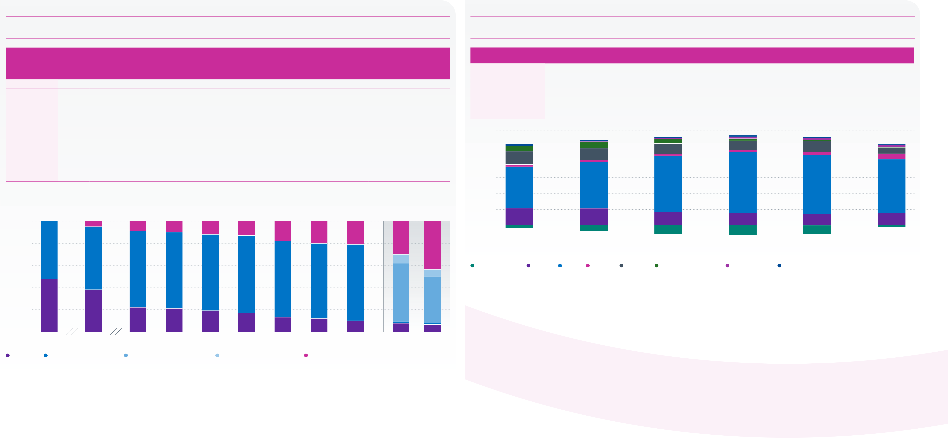
The Purple Book 2024 | Introduction | Overview | 01 | 02 | 03 | 04 | 05 | 06 | 07 | 08 | 09 | 10 | 11 | 12 | Appendix | Glossary | Charts | 22
 |  |  |  |  |  |  | Funding |  |  |  |  | Claims and | PPF
 |  |  | Executive | The | Scheme | Scheme | history and | Insolvency | Asset | Risk | PPF levy | schemes in | compensation | PPF risk
 |  |  | summary | data | demographics | funding | sensitivities | risk | allocation | reduction | 2023/24 | assessment | 2023/24 | developments |  |  | and tables
Asset allocation continued
Figure 7.7 | Equity splits  Within equities, the proportion invested in UK equities continued to fall, but over the last year there was a sharper drop in the proportion invested in overseas equities, in favour of private or unquoted equity, whose proportion has risen to over 40 per cent. |  |  |  |  |  |  |  |  |  |  |  |  |  |  |  |  |  |  |  |  |  |  |  |  |  |  |  |  |  |  |  |  |  |  |  |  | Figure 7.8 | Weighted average asset allocation of schemes by asset size  Schemes with assets less than £10 million have a lower proportion of their assets invested in bonds, with a higher proportion invested in annuities and equities.
Weighted average |  |  |  |  |  |  |  |  |  |  |  |  |  | Simple average |  |  |  |  |  |  |  |  |  |  |  |  |  |  |  |  |  |  |  |  |  |  | Cash and |  |  |  |  |  |  |  |  |  |  |  | Diversified
Overseas quoted |  |  |  |  |  |  |  |  |  | Developed |  |  |  | Emerging |  |  |  |  | Overseas quoted |  |  |  |  |  |  |  | Developed |  |  |  |  | Emerging |  |  |  |  | Asset size |  |  | Equities |  |  | Bonds | deposits |  |  | Property |  | Annuities | growth funds |  | Absolute returns | Miscellaneous
Year/The Purple |  |  | (tier 1 only |  |  |  |  |  |  |  | markets |  |  | markets | Unquoted/ |  |  |  |  |  |  | (tier 1 only |  |  |  |  |  | markets |  |  |  |  | markets |  |  | Unquoted/ | Under £5m |  |  | 21.6% |  |  | 52.5% |  | -3.4% |  |  | 2.9% | 16.8% |  | 6.6% | 0.1% | 2.9%
Book dataset |  |  | UK quoted |  | from 2023) |  |  |  | (tiers 2 and 3) |  |  |  |  | (tiers 2 and 3) |  |  | Private |  | UK quoted |  |  |  | from 2023) |  |  | (tiers 2 and 3) |  |  |  |  | (tiers 2 and 3) |  |  |  |  | Private | £5m–£10m |  |  | 21.3% |  |  | 58.8% |  | -8.0% |  |  | 2.4% | 15.2% |  | 8.3% | 0.3% | 1.7%
2008 |  |  | 48.2% |  |  | 51.8% |  |  |  |  |  | – |  | – |  |  |  | – |  | 60.4% |  |  |  | 39.6% |  |  |  |  |  | – |  |  |  |  | – | –
 |  |  |  |  |  |  |  |  |  |  |  |  |  |  |  |  |  |  |  |  |  |  |  |  |  |  |  |  |  |  |  |  |  |  |  |  | £10m–£50m |  |  | 16.6% |  |  | 71.5% | -12.3% |  |  |  | 2.2% | 13.4% |  | 5.5% | 1.5% | 1.6%
2011 |  |  | 38.0% |  |  | 57.2% |  |  |  |  |  | – |  | – |  | 4.8% |  |  |  | 52.7% |  |  |  | 46.1% |  |  |  |  |  | – |  |  |  |  | – | 1.2% | £50m–£100m |  |  | 15.7% |  |  | 77.1% | -14.0% |  |  |  | 2.8% | 11.5% |  | 2.7% | 2.4% | 1.8%
2016 |  |  | 22.4% |  |  | 68.6% |  |  |  |  |  | – |  | – |  | 9.0% |  |  |  | 38.8% |  |  |  | 58.6% |  |  |  |  |  | – |  |  |  |  | – | 2.6% | £100m–£1bn |  |  | 14.3% |  |  | 74.7% |  | -11.9% |  |  | 3.9% | 13.8% |  | 1.3% | 2.8% | 1.1%
2017 |  |  | 20.5% |  |  | 69.0% |  |  |  |  |  | – |  | – |  |  | 10.5% |  |  | 36.3% |  |  |  | 61.0% |  |  |  |  |  | – |  |  |  |  | – | 2.7%
 |  |  |  |  |  |  |  |  |  |  |  |  |  |  |  |  |  |  |  |  |  |  |  |  |  |  |  |  |  |  |  |  |  |  |  |  | Over £1bn |  |  | 15.7% |  |  | 68.0% |  | -2.5% |  |  | 6.9% | 8.0% |  | 0.5% | 2.6% | 0.8%
2018 |  |  | 18.6% |  |  | 69.4% |  |  |  |  |  | – |  | – |  |  | 12.0% |  |  | 32.1% |  |  |  | 65.0% |  |  |  |  |  | – |  |  |  |  | – | 3.0%
 |  |  |  |  |  |  |  |  |  |  |  |  |  |  |  |  |  |  |  |  |  |  |  |  |  |  |  |  |  |  |  |  |  |  |  |  | 120
2019 |  |  | 16.6% |  |  | 69.7% |  |  |  |  |  | – |  | – |  | 13.7% |  |  |  | 29.6% |  |  |  | 66.7% |  |  |  |  |  | – |  |  |  |  | – | 3.7%
2020 |  |  | 13.3% |  |  | 69.0% |  |  |  |  |  | – |  | – |  |  | 17.7% |  |  | 26.9% |  |  |  | 68.4% |  |  |  |  |  | – |  |  |  |  | – | 4.8% | 100 |  | 7% | 8% |  |  | 6% |  |  |  |  |  | 11% |  | 14% |  | 8%
2021 |  |  | 11.6% |  |  | 68.3% |  |  |  |  |  | – |  | – |  | 20.1% |  |  |  | 24.9% |  |  |  | 69.4% |  |  |  |  |  | – |  |  |  |  | – | 5.8%
 |  |  |  |  |  |  |  |  |  |  |  |  |  |  |  |  |  |  |  |  |  |  |  |  |  |  |  |  |  |  |  |  |  |  |  |  |  |  |  |  |  |  | 13%
 |  |  |  |  |  |  |  |  |  |  |  |  |  |  |  |  |  |  |  |  |  |  |  |  |  |  |  |  |  |  |  |  |  |  |  |  |  |  |  | 15%
2022 |  |  | 9.9% |  |  | 68.6% |  |  |  |  |  | – |  | – |  |  | 21.5% |  |  | 22.5% |  |  |  | 70.9% |  |  |  |  |  | – |  |  |  |  | – | 6.6% | 80 |  | 17% |  |  |  |  |  |  |  |  |  |  |  |  |  | 7%
2023 restated* |  |  | 7.6% |  |  |  | 1.4% |  |  |  | 53.0% |  |  | 8.0% |  | 30.0% |  |  |  | 20.3% |  |  |  | 28.7% |  |  |  |  | 37.1% |  |  |  |  | 4.7% |  | 9.3%
 |  |  |  |  |  |  |  |  |  |  |  |  |  |  |  |  |  |  |  |  |  |  |  |  |  |  |  |  |  |  |  |  |  |  |  |  | Percentage | 60 | 52% | 59% |  |  | 71% |  |  |  |  |  | 77% |  | 75% |  | 68%
2024 |  |  | 6.6% |  |  |  | 1.4% |  |  |  | 41.7% |  |  | 6.7% |  |  | 43.6% |  |  | 17.7% |  |  |  | 29.8% |  |  |  | 33.9% |  |  |  |  |  | 4.4% |  | 14.2%
* Weighted average only.  Note: the rows may not sum to 100 per cent because of rounding.  Weighted average |  |  |  |  |  |  |  |  |  |  |  |  |  |  |  |  |  |  |  |  |  |  |  |  |  |  |  |  |  |  |  |  |  |  |  |  |  | 40
 |  |  |  |  |  |  |  |  |  |  |  |  |  |  |  |  |  |  |  |  |  |  |  |  |  |  |  |  |  |  |  |  |  |  |  |  | 20
 |  |  |  |  |  |  |  |  |  |  |  |  |  |  |  |  |  |  |  |  |  |  |  |  |  |  |  |  |  |  |  |  |  |  |  |  | 22% |  |  | 21% |  |  | 17% |  |  |  |  |  | 16% |  | 14% |  | 16%
100 |  | 52% | 5% |  |  |  |  | 9% |  |  |  |  | 10% | 12% |  |  |  | 14% |  |  | 18% |  |  |  | 20% |  |  |  | 21% |  |  |  |  | 30% |  | 44%
 |  |  |  |  |  |  |  |  |  |  |  |  |  |  |  |  |  |  |  |  |  |  |  |  |  |  |  |  |  |  |  |  |  |  |  |  | 0 |  |  | -8% |  |  | -12% |  |  |  |  |  | -14% |  | -12%
80 |  |  |  |  |  |  |  |  |  |  |  |  |  |  |  |  |  |  |  |  |  |  |  |  |  |  |  |  |  |  |  |  |  |  |  |  | -20
 |  |  |  |  |  |  |  |  |  |  |  |  |  |  |  |  |  |  |  |  |  |  |  |  |  |  |  |  |  |  |  |  |  |  |  |  | Under £5m |  |  | £5–£10m |  |  | £10m–£50m |  |  |  |  |  | £50m–£100m |  | £100m–£1bn |  | Over £1bn
57% |  |  |  |  |  |  |  |  |  |  |  |  |  | 8% |  |  |  |  |  |  |  |  |  |  |  |  |  |  |  |  |  |  |  |  |  |  | Asset size
Percentage | 60 |  | 69% |  |  |  |  |  |  |  |  |  | 69% | 69% |  |  |  | 70% |  |  | 69% |  |  |  | 68% |  |  | 69% |  |  |  |  |  |  |  | 7% | Cash and deposits |  |  | Equities | Bonds | Property | Annuities |  |  | Diversified growth funds |  |  | Absolute returns | Miscellaneous
 | 40 |  |  |  |  |  |  |  |  |  |  |  |  |  |  |  |  |  |  |  |  |  |  |  |  |  |  |  |  |  |  |  |  |  |  |  | Source: PPF
53%
42%
20 |  | 48% | 38%
0 |  |  | 22% |  |  |  |  |  |  |  |  |  | 21% | 19% |  |  |  | 17% |  |  | 13% |  |  |  | 12% |  |  |  | 10% |  |  |  |  | 8% |  | 7%
2008 |  |  |  | 2011 |  |  |  | 2016 |  |  |  |  | 2017 | 2018 |  |  |  | 2019 |  |  | 2020 |  |  |  | 2021 |  |  | 2022 |  |  |  | 2023 restated |  |  |  | 2024
Year
UK quoted | Overseas quoted (tier 1 only) | Developed markets (tiers 2 and 3) | Emerging markets (tiers 2 and 3) | Unquoted/Private
Note: figures may not sum to 100 per cent because of rounding.
Starting with the 2023 scheme return, ‘overseas quoted’ is now split into two categories for tier 2 and 3 schemes – ‘developed markets’ and ‘emerging markets’.
The three overseas equity categories in shades of blue in the bars for 2023 onwards should be compared with the blue bars in the years prior to 2023.
Source: PPF

