The Purple Book 2024 | Introduction | Overview | 01 | 02 | 03 | 04 | 05 | 06 | 07 | 08 | 09 | 10 | 11 | 12 | Appendix | Glossary | Charts | 20
 |  |  |  |  |  |  | Funding |  |  |  |  | Claims and | PPF
 |  |  | Executive | The | Scheme | Scheme | history and | Insolvency | Asset | Risk | PPF levy | schemes in | compensation | PPF risk
 |  |  | summary | data | demographics | funding | sensitivities | risk | allocation | reduction | 2023/24 | assessment | 2023/24 | developments |  |  | and tables
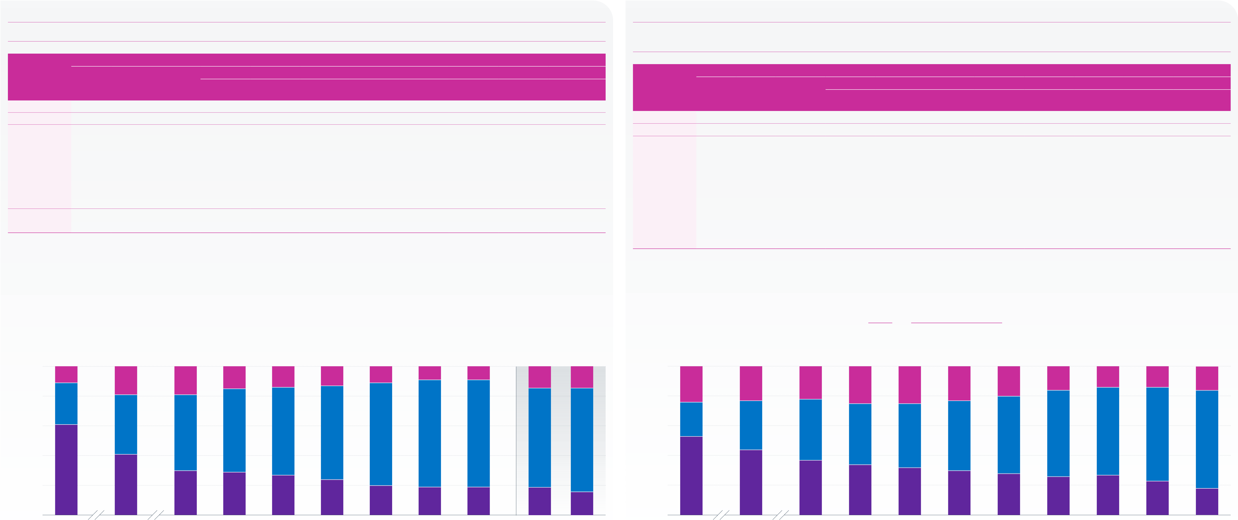
Asset allocation continued
Figure 7.3 | Weighted average asset allocation in total assets Figure 7.4 | Asset allocation: simple averages

The proportions of assets invested in equities continues to decline.

Asset class
Breakdown of other investments Asset class

Year/The Purple |  |  | Other |  |  |  | Cash and |  | Annuities | Diversified | Absolute | Insurance | Hedge funds | Miscellaneous | Year/The Purple | Equities | Bonds | Other | Cash and | Property | Annuities | Breakdown of other investments |  | Insurance | Hedge funds | Miscellaneous
Book dataset | Equities | Bonds |  | investments |  |  | deposits | Property |  | growth funds | returns | policies |  |  |  |  |  |  |  |  |  | Diversified | Absolute
2006 | 61.1% | 28.3% |  |  | 10.6% |  | 2.3% | 4.3% | – | – | – | 0.9% | – | 3.1% | Book dataset |  |  | investments | deposits |  |  | growth funds | returns | policies
2011 | 41.1% | 40.1% |  |  | 18.8% |  | 4.1% | 4.4% | – | – | – | 1.6% | 2.4% | 6.3% | 2006 | 52.6% | 22.6% | 24.8% | 3.9% | 2.1% | – | – | – | 14.9% | – | 3.6%
 |  |  |  |  |  |  |  |  |  |  |  |  |  |  | 2011 | 43.7% | 32.6% | 23.7% | 4.9% | 2.7% | – | – | – | 11.8% | 1.0% | 3.3%
2016 | 30.3% | 51.3% |  |  | 18.4% |  | 3.0% | 4.8% | 2.1% | – | – | 0.1% | 6.6% | 1.7%
 |  |  |  |  |  |  |  |  |  |  |  |  |  |  | 2016 | 36.8% | 41.1% | 22.1% | 5.4% | 3.7% | 2.4% | – | – | 1.2% | 7.9% | 1.5%
2017 | 29.0% | 55.7% |  |  | 15.3% |  | -0.9% | 5.3% | 3.3% | – | – | 0.1% | 6.7% | 0.8%
2018 | 27.0% | 59.0% |  |  | 14.0% |  | -2.5% | 4.8% | 3.4% | – | – | 0.1% | 7.0% | 1.2% | 2017 | 34.5% | 41.4% | 24.1% | 3.6% | 3.7% | 6.8% | – | – | 0.7% | 7.9% | 1.3%
2019 | 24.0% | 62.8% |  |  | 13.2% |  | -4.4% | 5.0% | 4.0% | – | – | 0.3% | 7.4% | 1.0% | 2018 | 32.4% | 43.1% | 24.5% | 1.8% | 3.3% | 8.9% | – | – | 0.6% | 8.5% | 1.4%
2020 | 20.4% | 69.2% |  |  | 10.4% |  | -7.2% | 4.9% | 5.0% | – | – | 0.1% | 6.8% | 0.8%
 |  |  |  |  |  |  |  |  |  |  |  |  |  |  | 2019 | 30.4% | 47.0% | 22.7% | –0.8% | 3.4% | 9.4% | – | – | 0.5% | 8.9% | 1.3%
2021 | 19.0% | 72.0% |  |  |  | 9.1% | -9.5% | 4.7% | 6.6% | – | – | 0.1% | 6.1% | 0.9%
 |  |  |  |  |  |  |  |  |  |  |  |  |  |  | 2020 | 27.8% | 52.3% | 19.9% | –3.2% | 3.4% | 9.7% | – | – | 0.6% | 7.9% | 1.7%
2022 | 19.5% | 71.6% |  |  |  | 8.9% | -8.8% | 4.6% | 6.8% | – | – | 0.1% | 5.2% | 1.0%
 |  |  |  |  |  |  |  |  |  |  |  |  |  |  | 2021 | 25.8% | 58.0% | 16.3% | –6.6% | 3.2% | 10.6% | – | – | 0.6% | 6.9% | 1.7%
2023 restated | 18.8% | 66.5% |  |  | 14.7% |  | -3.3% | 5.3% | 7.3% | 1.5% | 3.0% | – | – | 0.9% | 2022 | 27.1% | 58.5% | 14.4% | –7.5% | 3.0% | 10.7% | – | – | 0.6% | 6.0% | 1.6%
2024 | 15.5% | 69.8% |  |  | 14.7% |  | -5.4% | 5.9% | 9.7% | 1.0% | 2.6% | – | – | 0.9% | 2023 | 23.1% | 62.9% | 14.0% | –10.8% | 2.8% | 11.5% | 6.7% | 1.7% | – | – | 1.9%
Note: figures may not sum to 100 per cent or the ‘Other investments’ total because of rounding. |  |  |  |  |  |  |  |  |  |  |  |  |  |  | 2024 | 17.8% | 66.1% | 16.1% | –8.9% | 2.8% | 13.8% | 5.2% | 1.3% | – | – | 1.9%

The category ‘bonds’ represents those physically held as well as other investments whose economic characteristics resemble bonds, such as LDI. From 2023 the categories ‘insurance policies’ and ‘hedge funds’ have been discontinued. There became two new categories: ‘diversified growth funds’ and ‘absolute returns’.
The weighted average proportion of assets held in cash and deposits is negative. Negative cash holdings are likely to relate to investments such as swaps and repurchase agreements held as part of LDI strategies.
‘–‘ indicates either that schemes may have been invested in these asset classes but the percentages could not be determined from the data held at the time,

Note: figures may not sum to 100 per cent or the ‘Other investments’ total because of rounding.
From 2023 the categories ‘insurance policies’ and ‘hedge funds’ have been discontinued. There are two new categories: ‘diversified growth funds’ and ‘absolute returns’.
The simple average proportion of assets held in cash and deposits being negative represents a large number of schemes with significant negative cash holdings which are likely to be related to investments such as swaps and repurchase agreements.
‘–‘ indicates either that schemes may have been invested in these asset classes but the percentages could not be determined from the data held at the time,

or because the category is new or no longer exists. |  |  |  |  |  |  | 15% | 14% | 13% | 10% | 9% | 9% | 15% | 15% | or because the category is new or no longer exists. |  |  |  |  | 24% | 25% | 23% | 20% | 16% | 14% | 14% | 16%
100 |  |  |  |  |  |  |  |  |  |  |  |  |  |  | 100
11% |  |  |  |  | 19% | 18% |  |  |  |  |  |  |  |  | 25% |  |  | 24% | 22%
80 |  |  |  |  |  |  | 56% | 59% | 63% | 69% | 72% | 72% | 67% | 70% | 80 |  |  |  |  | 41% | 43% | 47% | 52% | 58% | 59% | 63% | 66%
28%
 |  |  |  |  |  |  |  |  |  |  |  |  |  |  | Percentage | 60 | 23% | 33% | 41%
Percentage | 60 |  | 40% |  |  | 51%
 | 40 |  |  |  |  |  | 29% | 27% | 24% | 20% | 19% | 19% | 19% | 15% |  | 40 |  |  |  | 34% | 32% | 30% | 28% | 26% | 27% | 23% | 18%
61%
 |  |  |  |  |  |  |  |  |  |  |  |  |  |  | 20 |  | 53% | 44% | 37%
20 |  |  | 41%
30%
0 |  |  |  |  |  |  | 2017 | 2018 | 2019 | 2020 | 2021 | 2022 | 2023 restated | 2024 | 0 |  |  |  |  | 2017 | 2018 | 2019 | 2020 | 2021 | 2022 | 2023 | 2024
2006 |  |  |  |  | 2011 | 2016 |  |  |  |  |  |  |  |  | 2006 |  |  | 2011 | 2016
Equities |  | Bonds |  | Other investments |  |  |  |  | Year |  |  |  |  |  | Equities |  | Bonds | Other investments |  |  |  | Year
Note: figures may not sum to 100 per cent because of rounding. |  |  |  |  |  |  |  |  |  |  |  |  |  |  | Note: figures may not sum to 100 per cent because of rounding.
Source: PPF |  |  |  |  |  |  |  |  |  |  |  |  |  |  | Source: PPF

