The Purple Book 2024 | Introduction | Overview | 01 | 02 | 03 | 04 | 05 | 06 | 07 | 08 | 09 | 10 | 11 | 12 | Appendix | Glossary | Charts | 21
 |  |  |  |  |  |  | Funding |  |  |  |  | Claims and | PPF
 |  |  | Executive | The | Scheme | Scheme | history and | Insolvency | Asset | Risk | PPF levy | schemes in | compensation | PPF risk
 |  |  | summary | data | demographics | funding | sensitivities | risk | allocation | reduction | 2023/24 | assessment | 2023/24 | developments |  |  | and tables
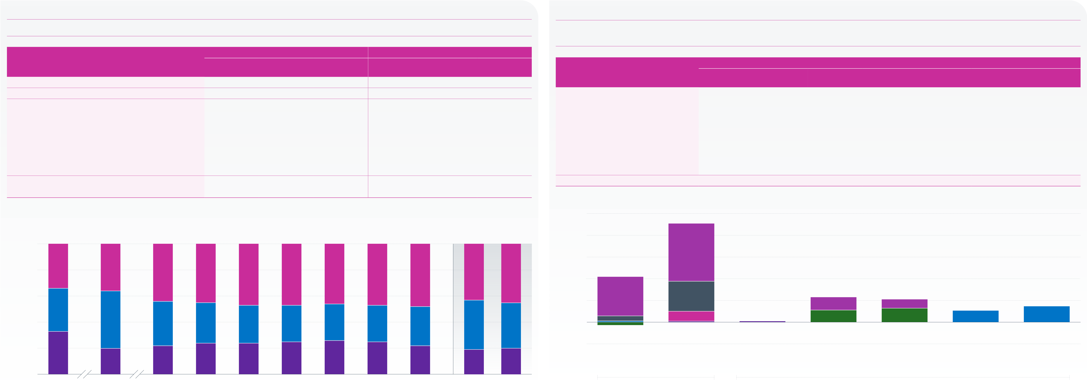
Asset allocation continued

Figure 7.5 | Bond splits – high-level breakdown
The proportions of the high-level types of bonds have remained relatively stable compared to last year.

Figure 7.6 | Bond splits – granular breakdown of The Purple Book 2024 dataset
Government fixed-interest and index-linked bonds are mostly long-dated. Investment grade corporate bond proportions are balanced between territory and term.

Year/The Purple Book dataset | Government | Weighted average | Index-linked | Government | Simple average | Index-linked | Bond category | All | Tier 1 | Short | Weighted average | Short and | Long | Unassigned*
 |  | Corporate |  |  | Corporate
 | fixed-interest | fixed-interest |  | fixed-interest | fixed-interest
2008 | 33.2% | 32.6% | 33.9% | 47.2% | 33.0% | 19.8% |  |  |  |  | Medium | medium
 |  |  |  |  |  |  | Government fixed-interest | 19.5% | 0.4% | –1.4% | 2.5% | – | 18.0% | 0.0%
2011 | 19.6% | 44.3% | 36.1% | 31.2% | 47.1% | 21.7%
2016 | 21.9% | 33.7% | 44.4% | 24.4% | 49.0% | 26.6% | Index-linked | 45.5% | 0.5% | 4.5% | 13.8% | – | 26.7% | 0.0%
2017 | 24.1% | 31.4% | 44.5% | 25.9% | 46.8% | 27.3% | Corporate fixed-interest, of which: | 35.0% | – | – | – | – | – | –
 |  |  |  |  |  |  | Investment grade | 0.4% | 0.4% | – | – | – | – | –
2018 | 24.1% | 28.8% | 47.1% | 27.2% | 42.1% | 30.8%
2019 | 25.4% | 28.4% | 46.2% | 29.0% | 38.9% | 32.1% | UK investment grade | 11.5% | – | – | – | 5.5% | 6.0% | –
2020 | 25.9% | 28.0% | 46.1% | 29.4% | 36.1% | 34.6% | Overseas investment grade | 10.5% | – | – | – | 6.4% | 4.1% | –
 |  |  |  |  |  |  | Sub-investment grade | 5.3% | – | – | – | – | – | –
2021 | 24.6% | 28.2% | 47.2% | 30.4% | 34.8% | 34.8%
2022 | 22.0% | 30.2% | 47.8% | 30.2% | 35.7% | 34.1% | Private debt | 7.3% | – | – | – | – | – | –
2023 restated* | 19.1% | 37.6% | 43.3% | 25.6% | 36.9% | 37.5% | Total | 100% | 1.3% | 3.1% | 16.3% | 11.9% | 54.8% | 0.0%
 |  |  |  |  |  |  | * ‘Unassigned’ is generally where a scheme is in tiers 2 or 3 but did not provide the granular breakdown.
2024 | 19.5% | 35.0% | 45.5% | 27.6% | 35.3% | 37.1%
* Weighted average only. |  | Weighted average |  |  |  |  | 50
Note: the rows may not sum to 100 per cent because of rounding.
 |  |  |  |  |  |  | 40
100
Percentage | 80 | 34% | 36% |  | 44% | 44% |  | 47% | 46% | 46% | 47% | 48% | 43% | 45% | 30 |  |  |  | 27% |  |  |  |  |  |  |  | Investment grade |  | 6% | 4% | 5% | 7%
 |  |  |  |  |  |  |  |  |  |  |  |  |  |  | Percentage |  | 20 |  | 18% |  |  | 14%
 | 60
 |  |  |  |  |  |  |  |  |  |  |  |  |  |  | 10
 | 33% |  | 44% |  | 34% | 31% |  | 29% | 28% | 28% | 28% | 30% | 38% | 35% | 0 |  |  |  | 2% |  |  | 4%
 |  |  |  |  |  |  |  |  |  |  |  |  |  |  |  |  |  |  |  |  |  |  |  |  |  |  |  |  | 5% | 6%
 | 40
 | 20 | 33% | 20% |  | 22% | 24% |  | 24% | 25% | 26% | 25% | 22% | 19% | 20% | -10 |  |  |  | Fixed-interest |  |  |  |  | Index-linked |  |  |  |  | UK | Overseas | Sub-investment | Private debt
 |  |  |  |  |  |  |  |  |  |  |  |  |  |  |  |  |  |  |  |  |  |  |  |  |  |  | (tier 1 only) |  | investment grade | investment grade | grade
 | 0 |  |  |  |  |  |  |  |  |  |  |  |  |  |  |  |  |  |  |  |  |  |  |  |  |  |  |  | (tiers 2 & 3) | (tiers 2 & 3)
 |  |  |  |  |  |  |  |  |  |  |  |  |  |  |  |  |  |  | Government bonds
 |  |  | 2011 |  | 2016 | 2017 |  | 2018 | 2019 | 2020 | 2021 | 2022 | 2023 restated | 2024 |  | Tier 1
 |  |  |  |  |  |  |  |  |  |  |  |  |  |  |  |  |  |  |  |  |  |  |  |  |  |  |  |  |  | Corporate bonds
 | 2008 |  |  |  |  |  |  |  |  |  |  |  |  |  |  |  |  |  |  |  |  |  |  |  |  |  |  | Long
 |  |  |  |  |  |  |  |  | Year
 |  |  |  |  |  |  |  |  |  |  |  |  |  |  |  |  |  |  | All |  | Short |  | Medium |  |  | Short and Medium
 | Government fixed-interest |  |  | Corporate fixed-interest |  |  | Index-linked
 |  |  |  |  |  |  |  |  |  |  |  |  |  |  | Source: PPF
Source: PPF
Note: figures may not sum to 100 per cent because of rounding.

