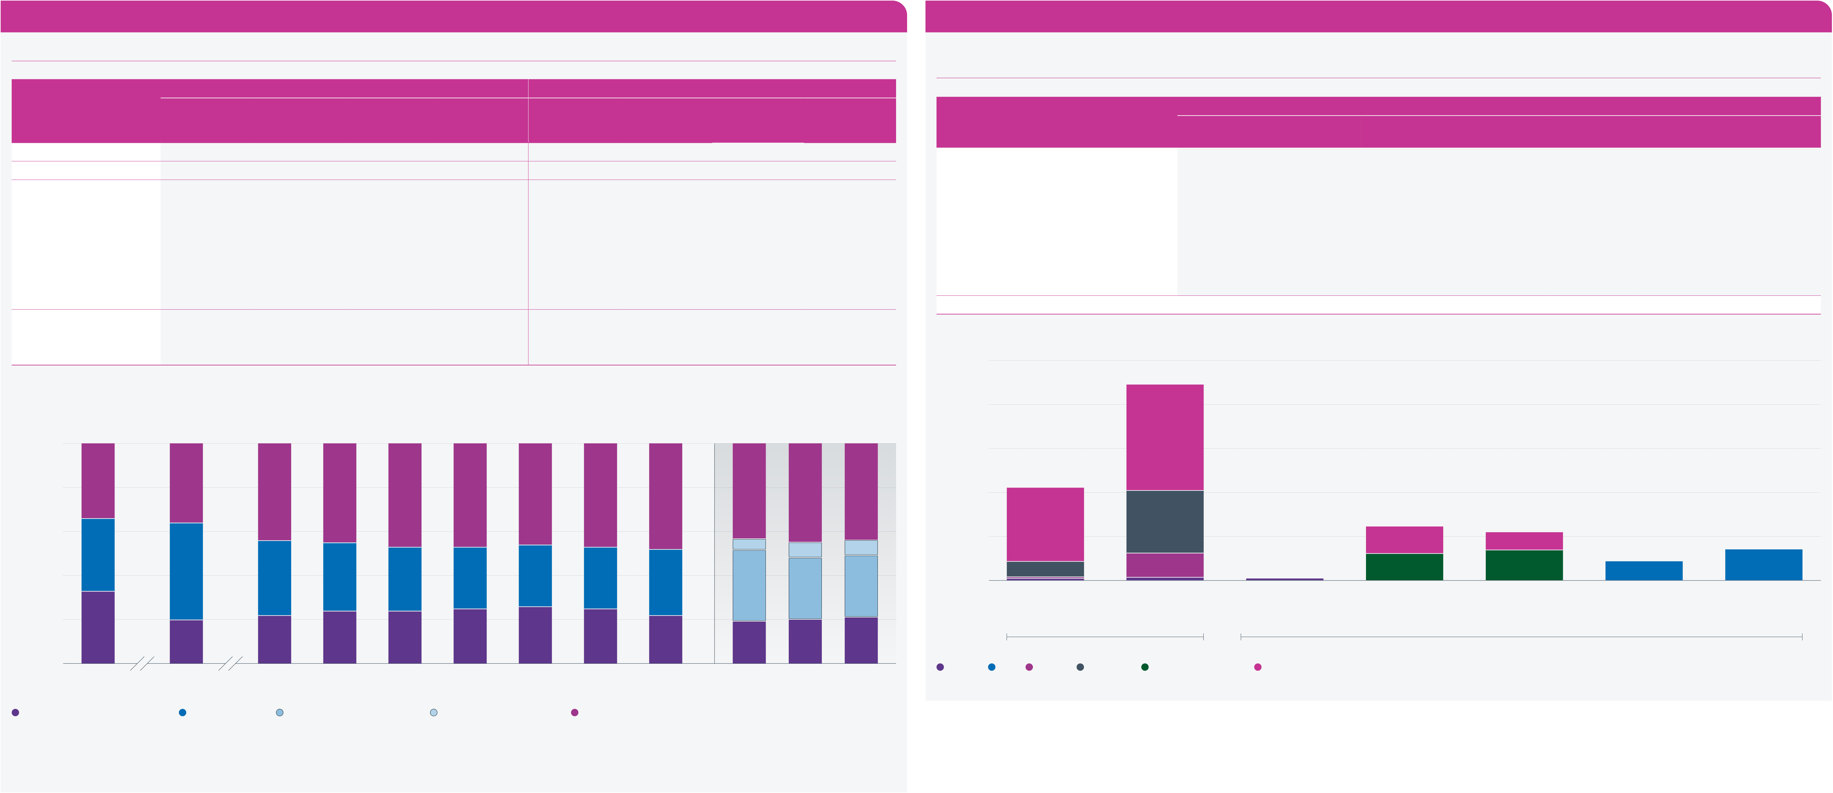
The Purple Book 2025 | Introduction | Overview | 01 | 02 | 03 | 04 | 05 | 06 | 07 | 08 | 09 | 10 | 11 | 12 | Appendix | Glossary | Charts | 23
 |  |  |  |  |  |  |  |  |  |  |  | Claims and | PPF
 |  |  | Executive | The | Scheme | Scheme | Funding history | Insolvency | Asset | Risk | PPF levy | schemes in | compensation | PPF risk
 |  |  | summary | data | demographics | funding | and sensitivities | risk | allocation | reduction | 2024/25 | assessment | 2024/25 | developments |  |  | and tables
Asset allocation continued

Figure 7.5 | Bond splits – high-level breakdown
The proportions of the high-level types of bonds have remained relatively stable compared to last year.

Figure 7.6 | Bond splits – granular breakdown of The Purple Book 2025 dataset
Government fixed interest and index-linked bonds are mostly long-dated. Investment grade corporate bond proportions are broadly balanced between territory and term.

Year/The Purple Book dataset | Government | Weighted average |  | Index-linked | Government | Simple average |  | Index-linked | Bond category | All | Tier 1 | Short | Weighted average | Short and | Long | Unassigned*
 |  | Corporate – |  |  |  | Corporate
 |  | public markets | Corporate – |  |  | – public markets | Corporate –
 | fixed-interest | only from 2023 | private debt |  | fixed-interest | only from 2023 | private debt |  |  |  |  |  | Medium
 |  |  |  |  |  |  |  |  |  |  |  |  |  | medium
2008 | 33.2% | 32.6% | – | 33.9% | 47.2% | 33.0% | – | 19.8% | Government fixed-interest | 20.8% | 0.5% | 0.2% | 3.3% | – | 16.8% | 0.0%
2011 | 19.6% | 44.3% | – | 36.1% | 31.2% | 47.1% | – | 21.7% | Index-linked | 44.4% | 0.6% | 5.5% | 14.2% | – | 24.1% | 0.0%
2016 | 21.9% | 33.7% | – | 44.4% | 24.4% | 49.0% | – | 26.6% | Corporate fixed-interest, of which: | 34.8% | – | – | – | – | – | –
2017 | 24.1% | 31.4% | – | 44.5% | 25.9% | 46.8% | – | 27.3% | Investment grade | 0.4% | 0.4% | – | – | – | – | –
2018 | 24.1% | 28.8% | – | 47.1% | 27.2% | 42.1% | – | 30.8% | UK investment grade | 12.2% | – | – | – | 6.0% | 6.2% | –
2019 | 25.4% | 28.4% | – | 46.2% | 29.0% | 38.9% | – | 32.1%
 |  |  |  |  |  |  |  |  | Overseas investment grade | 10.9% | – | – | – | 6.8% | 4.1% | –
2020 | 25.9% | 28.0% | – | 46.1% | 29.4% | 36.1% | – | 34.6% | Sub-investment grade | 4.3% | – | – | – | – | – | –
2021 | 24.6% | 28.2% | – | 47.2% | 30.4% | 34.8% | – | 34.8% | Private debt | 7.0% | – | – | – | – | – | –
2022 | 22.0% | 30.2% | – | 47.8% | 30.2% | 35.7% | – | 34.1%
 |  |  |  |  |  |  |  |  | Total | 100% | 1.5% | 5.7% | 17.5% | 12.8% | 51.2% | 0.0%
2023 restated* | 19.1% | 32.2% | 5.4% | 43.3% | 25.6% | 35.4% | 1.5% | 37.5% | * ‘Unassigned’ is generally where a scheme is in tiers 2 or 3 but did not provide the granular breakdown.
2024 | 19.5% | 27.7% | 7.3% | 45.5% | 27.6% | 33.3% | 2.0% | 37.1%
2025 | 20.8% | 27.8% | 7.0% | 44.4% | 28.2% | 31.9% | 2.0% | 37.9% | 50
* Weighted average only.
Note: the rows may not sum to 100 per cent because of rounding. |  |  |  |  |  |  |  |  | Weighted average |  | 47% | 48% | 43% | 45% | 44% | 40 |  | 24% |  |  |  | Investment grade | 6% | 4% | 4% | 7%
100 |  |  |  |  |  |  |  |  | 46% | 46% |  |  |  |  |  | Percentage | 30  20
80 |  | 34% | 36% | 44% |  | 44% | 47%
 |  |  |  |  |  |  |  |  |  |  |  |  | 5% |  | 7% | 10 |  | 17% |  | 14%
Percentage | 60 | 33% | 44% | 34% |  | 31% | 29%
 |  |  |  |  |  |  |  |  |  |  |  |  |  | 7%
 | 40 |  |  |  |  |  |  |  | 28% | 28% | 28% | 30% | 32% |  | 28% | 0 |  | 3% |  | 5% |  |  | 6% | 7%
 |  |  |  |  |  |  |  |  |  |  |  |  |  | 28%
 |  |  |  |  |  |  |  |  |  |  |  |  |  |  |  |  |  | Fixed-interest |  | Index-linked |  |  | UK | Overseas | Sub-investment | Private debt
20 |  | 33% | 20% | 22% |  | 24% | 24% |  | 25% | 26% | 25% | 22% | 19% | 20% | 21% | Tier 1 |  | Government bonds |  |  |  | (tier 1 only) | investment grade | investment grade | grade
 |  |  |  |  |  |  |  |  |  |  |  |  |  |  |  |  |  |  |  |  |  |  | (tiers 2 & 3) | (tiers 2 & 3)
 |  |  |  |  |  |  |  |  |  |  |  |  |  |  |  |  |  |  |  |  |  |  |  | Corporate bonds
 |  |  |  |  |  |  |  |  |  |  |  |  |  |  |  |  |  |  |  |  |  | Long
0
 |  |  |  |  |  |  |  |  |  |  |  |  |  |  |  |  |  | All | Short | Medium | Short and Medium
2008 |  |  | 2011 | 2016 |  | 2017 |  | 2018 | 2019 | 2020 | 2021 | 2022 | 2023 restated | 2024 | 2025
Government fixed-interest |  |  | Corporate debt |  | Corporate – public markets |  |  |  | Year |  | Index-linked |  |  |  |  | Source: PPF
 |  |  |  |  |  |  |  |  | Corporate – private debt
Source: PPF
Note: figures may not sum to 100 per cent because of rounding.
Starting with the 2023 scheme return, corporate debt includes a private debt subcategory. The two corporate debt categories in shades of blue in the bars for 2023 onwards should be compared
with the blue bars in the years prior to 2023.

