The Purple Book 2023 | Introduction | Overview | 01 | 02 | 03 | 04 | 05 | 06 | 07 | 08 | 09 | 10 | 11 | 12 | Appendix | Glossary | Charts | 22
 |  |  |  |  |  |  |  |  |  |  |  | Claims and | PPF
 |  |  | Executive | The | Scheme | Scheme | Funding | Insolvency | Asset | Risk | PPF levy | schemes in | compensation | PPF risk
 |  |  | summary | data | demographics | funding | sensitivities | risk | allocation | reduction | 2022/23 | assessment | 2022/23 | developments |  |  | and tables
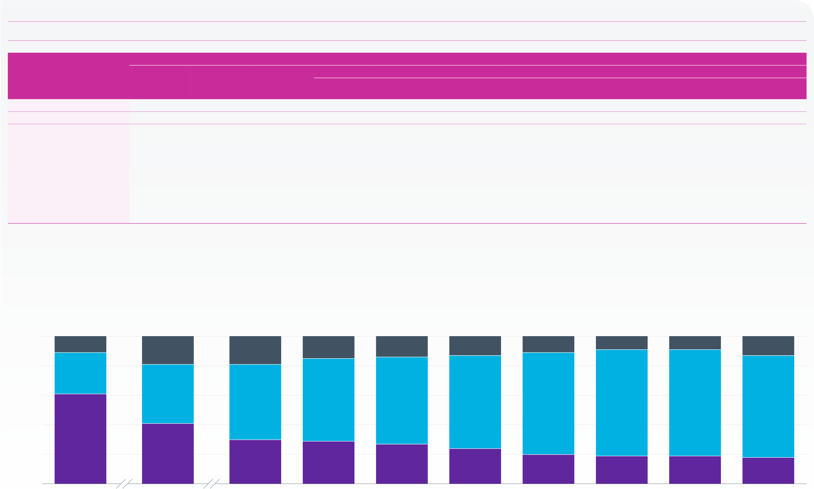
Asset allocation continued
Figure 7.3 | Weighted average asset allocation in total assets
The proportions of assets invested in equities and bonds have been broadly stable since March 2020.
Asset class
Breakdown of other investments
Year/The Purple Book dataset | Equities | Bonds | Other | Cash and | Property | Annuities | Diversified | Absolute returns | Insurance | Hedge funds | Miscellaneous
 |  |  | investments | deposits |  |  | growth funds |  | policies
2006 | 61.1% | 28.3% | 10.6% | 2.3% | 4.3% | n/a | n/a | n/a | 0.9% | n/a | 3.1%
2011 | 41.1% | 40.1% | 18.8% | 4.1% | 4.4% | n/a | n/a | n/a | 1.6% | 2.4% | 6.3%
2016 | 30.3% | 51.3% | 18.4% | 3.0% | 4.8% | 2.1% | n/a | n/a | 0.1% | 6.6% | 1.7%
2017 | 29.0% | 55.7% | 15.3% | -0.9% | 5.3% | 3.3% | n/a | n/a | 0.1% | 6.7% | 0.8%
2018 | 27.0% | 59.0% | 14.0% | -2.5% | 4.8% | 3.4% | n/a | n/a | 0.1% | 7.0% | 1.2%
2019 | 24.0% | 62.8% | 13.2% | -4.4% | 5.0% | 4.0% | n/a | n/a | 0.3% | 7.4% | 1.0%
2020 | 20.4% | 69.2% | 10.4% | -7.2% | 4.9% | 5.0% | n/a | n/a | 0.1% | 6.8% | 0.8%
2021 | 19.0% | 72.0% | 9.1% | -9.5% | 4.7% | 6.6% | n/a | n/a | 0.1% | 6.1% | 0.9%
2022 | 19.5% | 71.6% | 8.9% | -8.8% | 4.6% | 6.8% | n/a | n/a | 0.1% | 5.2% | 1.0%
2023 | 18.0% | 68.9% | 13.1% | -5.1% | 5.3% | 7.4% | 1.5% | 3.1% | n/a | n/a | 0.9%
The category ‘bonds’ represents those physically held as well as other investments whose economic characteristics resemble bonds, such as LDI.
From 2023 the categories ‘insurance policies’ and ‘hedge funds’ have been discontinued. There are two new categories: ‘diversified growth funds’ and ‘absolute returns’.
The weighted average proportion of assets held in cash and deposits is negative which represents a number of large schemes with significant negative cash holdings. These are likely to be related to investments such as swaps and repurchase agreements held as part of LDI strategies.
‘n/a’ denotes not available, where schemes may have been invested in these asset classes but the percentages cannot be determined from the data held, or because the category is new or no longer exists. Note: figures may not sum to 100 per cent or the ‘Other investments’ total due to rounding.
Percentage | 100 | 11% | 19% | 18% | 15% | 14% | 13% | 10% | 9% | 9% | 13%
 | 80 | 28% | 40% | 51% | 56% | 59% | 63% | 69% | 72% | 72% | 69%
 | 60
 | 40
61%
20 | 2006 | 41% | 30% | 29% | 27% | 24% | 20% | 19% | 19% | 18%
0 |  | 2011 | 2016 | 2017 | 2018 | 2019 | 2020 | 2021 | 2022 | 2023
Year
 | Equities |  | Bonds |  | Other investments
Note: figures may not sum to 100 per cent or the ‘Other investments’ total due to rounding.
Source: PPF

