AfricaAI: Runbook - TLDSSF – SSO
Summary | We are collecting quarterly data from the TLD SSF fund's report
Source name | Thailand Social Security Office - SSO
Link to the source | Quarterly: https://www.sso.go.th/wpr/main/knowledge/%E0  Annual: https://www.sso.go.th/wpr/main/privilege/%E0%
Dataset name | TLD Social Security Fund - TLDSSF
Frequency | Quarterly  Annual
SLA | Quarterly: Start checking for this data daily on the 15th day of the first month of each quarter.  Annual: Check the availability of data in the source weekly, starting on January 15th.
Expected Time | The task needs to be updated by 8:00 AM EST
Do not contact the source. Escalate to DataOps Team with any issues in runbook execution that can't be completed with standard DF plays.
Quarterly Instructions:
1. Navigate to the source URL. Use google translate and open up the report
https://www.sso.go.th/wpr/main/knowledge/%E0%B8%A3%E0%B8%B2%E0%B8%A2%E0%B8%87%E0%B8%B2%E0%B8%99%E0%B8%AA%E0%B8%A0%E0%B8%B2%E0%B8%9E%E0%B8%81%E0%B8%B2%E0%B8%A3%E0%B8%9A%E0%B8%A3%E0%B8%B4%E0%B8%AB%E0%B8%B2%E0%B8%A3%E0%B9%80%E0%B8%87%E0%B8%B4%E0%B8%99%E0%B8%A5%E0%B8%87%E0%B8%97%E0%B8%B8%E0%B8%99_category_list-label_1_134_0
2. We want to scrape the pie chart below. Produce one quarterly DF series for each line-item in the pie chart. Use Google Translate to assist with translation--I listed the asset name pairings starting with the largest category and rotating clockwise. Capture the assets value (not %). Additionally, capture the total assets value (red).
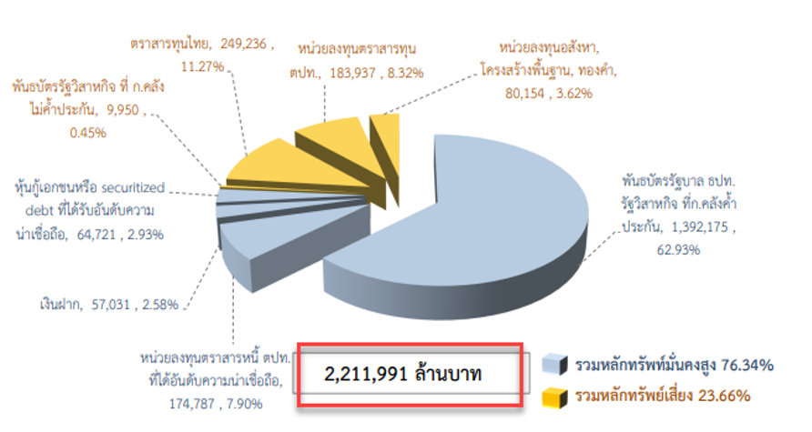
พันธบัตรรัฐบาล ธปท.  รัฐวิสาหกิจ ที่ก.คลังค ้า  ประกัน | DomesticGovernmentBonds
หน่วยลงทุนตราสารหนี ตปท. ที่ได้อันดับความน่าเชื่อถือ | ForeignBonds
เงินฝาก, | Deposits
หุ้นกู้เอกชนหรือ securitized debt ที่ได้รับอันดับความ น่าเชื่อถือ | CorporateBonds
พันธบัตรรัฐวิสาหกิจ ที่ ก.คลัง ไม่ค ้าประกัน | OtherBonds
ตราสารทุนไทย | DomesticEquities
หน่วยลงทุนตราสารทุน ตปท | ForeignEquities
หน่วยลงทุนอสังหา, โครงสร้างพื นฐาน, ทองค้ | Alternatives
ล้านบาท | Total

3. Save data in TLDSSF_Q_DATA_YYYYMMDD file.
Annual instructions:
1. Navigate to the source URL. Open up the fund report
https://www.sso.go.th/wpr/main/privilege/%E0%B8%A3%E0%B8%B2%E0%B8%A2%E0%B8%87%E0%B8%B2%E0%B8%99_sub_category_list-label_1_130_716
2. We want to scrape the entire table below (Social Security Fund, Social Security Office)
Save the data from the table for all periods (for example, for the table below, these are 2020 and 2021)
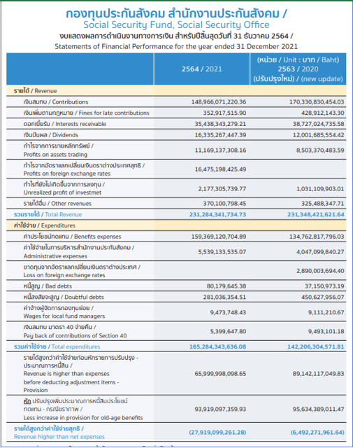
Mapping table rows and measure codes below:
Table row | Measure_code
Revenue - Contributions | TLDSOCIALSECURITYFUND.OUTPATIENTREVENUE.FLOW.BIGPIPE.A.1@TLDSOCIALSECURITYFUNDA
Revenue - Interests receivable | TLDSOCIALSECURITYFUND.INTERESTSRECEIVABLE.FLOW.BIGPIPE.A.1@TLDSOCIALSECURITYFUNDA
Revenue - Dividends | TLDSOCIALSECURITYFUND.DIVIDENDS.FLOW.BIGPIPE.A.1@TLDSOCIALSECURITYFUNDA
Revenue - Points on asset trading | TLDSOCIALSECURITYFUND.PROFITSONASSETS.FLOW.BIGPIPE.A.1@TLDSOCIALSECURITYFUNDA
Revenue - Total | TLDSOCIALSECURITYFUND.TOTALCONTRIBUTIONS.FLOW.BIGPIPE.A.1@TLDSOCIALSECURITYFUNDA
Expenitures - Benefits | TLDSOCIALSECURITYFUND.BENEFITSPAID.FLOW.BIGPIPE.A.1@TLDSOCIALSECURITYFUNDA
Expenitures - Administrative expenses | TLDSOCIALSECURITYFUND.OPERATINGEXPENSES.FLOW.BIGPIPE.A.1@TLDSOCIALSECURITYFUNDA
Expenitures - Total | TLDSOCIALSECURITYFUND.TOTALWITHDRAWALS.FLOW.BIGPIPE.A.1@TLDSOCIALSECURITYFUNDA
3. Save data in TLDSSF_A_DATA_YYYYMMDD file.

Requirements to the data provided by AfricaAI
Data files format
For on-boarding new datasets and processing new releases the following requirements are applied:
- there should be one archive in .ZIP format that contains 2 files provided in .XLS format per one release - one file with DATA and one file with METADATA (both files are mandatory). Archive name should be as "DATASET_YYYYMMDD.ZIP"", where "DATASET" - specified abbreviation for a dataset, "YYYYMMDD" - timestamp when the file was created, where YYYY - year, MM - month number, DD – day;
- the files format is strictly defined and cannot be changed by AfricaAI team.

File with DATA
Template for file name: “DATASET_DATA_YYYYMMDD.xls”, i.e.” MEXPENFND_DATA_20220601.xls”
Requirements to the file with DATA:
- format - XLS, encoding - Unicode (UTF-8);
- file name: should follow pattern "DATASET_DATA_YYYYMMDD.xls", where "DATASET" - specified abbreviation for a dataset, "YYYYMMDD" - timestamp when the file was created, where YYYY - year, MM - month number, DD - day;
- file content:
  - data is provided on one sheet only (multiple sheets are forbidden);
  - two-dimensional format where rows represent reported periods and columns contain timeseries values;
  - reported period(s) should be provided in the following format:
    - for data with daily/ weekdaily frequency: YYYY-MM-DD, where YYYY - year, MM - month, DD – day;
    - for data with weekly frequency: YYYY-WW, where YYYY - year, WW - week number (should be two-digits, i.e. 2022-01, 2022-02, etc.). Week number is defined based on the reporting date: reporting date is considered the end of the week, i.e. if reporting date is Wednesday the week is calculated from Thursday till Wednesday – based on that rule the number of the week is defined;
    - for data with monthly frequency: YYYY-MM, MM - month number (should be two-digits, i.e. 2022-01, 2022-02, etc.);
    - for data with quarterly frequency: YYYY-QX, where YYYY - year, X - quarter number;
    - for data with annual frequency: YYYY, where YYYY – year;
- values to be provided in decimal format with "." as delimiter (number of digits after "." is limited only by provided value by the source). In order to interpret data correctly the following requirements are applied:
  - if provider specifies for reported period that data is Not Available (that could provided in corresponding notes or other way) - fill in that data point with "NA" value;
  - if provider does not specify that data is Not Available and report Empty value for reported period - leave Empty cell;
  - if provider skips some of reporting period - skip it also in the file with data as well;
- column names to be provided in two first rows: in the first row - timeseries ID (CODE), in the second row – timeseries description (description in DATA file is identical to description in file with METADATA).
NB! Timeseries with different frequencies could be provided within the same file as there are different patterns for providing reported periods

File with METADATA
Template for file name: “DATASET_META_YYYYMMDD.xls”, i.e.” MEXPENFND_META_20220601.xls”
Requirements to the file with METADATA:
- format - XLS, encoding - Unicode (UTF-8);
- file name: should follow pattern "DATASET_META_YYYYMMDD.xls", where "DATASET" - specified abbreviation for a dataset, "YYYYMMDD" - timestamp when the file was created, where YYYY - year, MM - month number, DD - day;
- file content: specified metadata attributes that are static unless provider changes something or new timeseries should be added. In case of new timeseries should be added/ updated/ changed - escalate that to Data Engineering team Special BWAT-DFAC Data Engineering <SpecialBWAT-DFACDataEngineering@epam.com> at and Cc: Data Operations team at Special BWAT-DFAC DataOps <SpecialBWAT-DFACDataOps@epam.com>
Notes on METADATA fields from file “DATASET_META_YYYYMMDD.xls”
- With every data release attach file with METADATA
- With every release change only on attribute in the file with METADATA in column “NEXT_RELEASE_DATE” – set “YYYY-MM_DDThh:mm:ss” (YYYY – year, MM – month, DD – day, hh – hour, mm – minutes, ss – seconds. Time should be provide in UTC time) to the time when the next release is going to be processed.

Saving ZIP archive on SFTP
Save the releases in specified per “DATASET” folder (you may create new folder for new DATASET in case of absence of such folder).
Details on SFTP are the following:
- Dev env
Host: africaai.datadev.dfac.io
- PRODVAL env
Host: africaai.prodval.data-factory.io
- PRODHA env
Host: africaai.prodha.data-factory.io
Port: 22

