AfricaAI: Runbook - USAF – SCRSIC
Summary | We are collecting data from the SCRS fund's report
Source name | South Carolina Retirement System Investment Commission - SCRSIC
Link to the source | https://www.rsic.sc.gov/what-we-do/investment-reports.html
Dataset name | USA Funds - USAF
Frequency | Quarterly
SLA | Exact dates of update of reports on the source are not specified. The estimated period for updating quarterly reports about 60 days from quarter end.  Start checking for a new release every week on April 1st, July 1st, October 1st, and January 1st. If there was no release, start checking for a new release every day on May 1st, August 1st, November 1st, and February 1st.  Since the beginning of NRD, most of the releases are expected, so you need to check the updates on the source carefully every day.
Expected Time | NA

Do not contact the source. Escalate to Data Ops team with any issues in runbook execution that can't be completed with standard plays
1. Navigate to the source URL. Open up the latest quarterly report
https://www.rsic.sc.gov/what-we-do/investment-reports.html
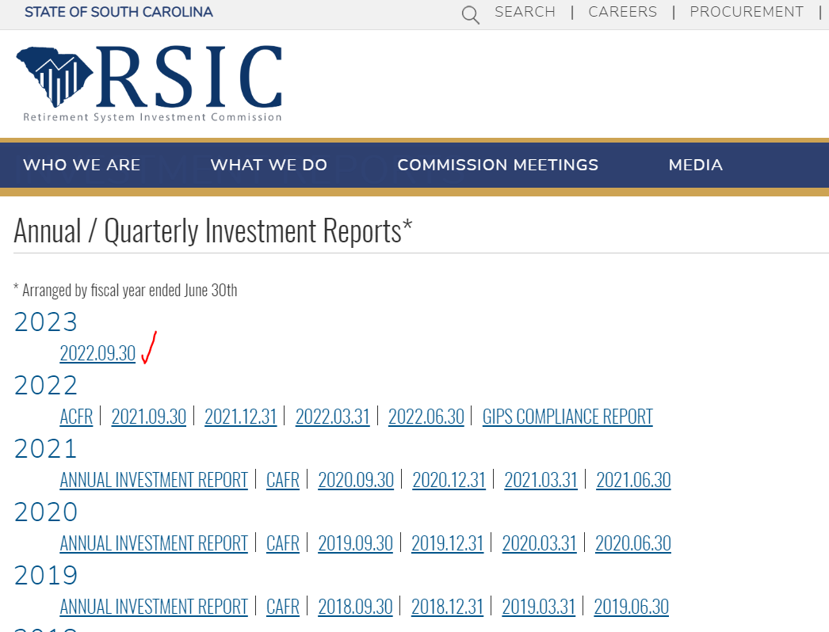

- We need to scrape one table from this report. Collect values for each line item under the headings "Market Value" (Level), "Portfolio" (Actual Allocation), and "Policy Target" (Target Allocation). Note, the quarter the data refers to will be at the top of the PDF (not the same as the FY quarter listed on the website).
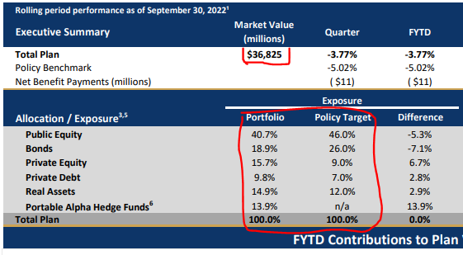

Allocation | Assets | Column | Value
Total Plan | Total | Market value (Level) | 36825
Public Equity | Equities | Portfolio (Actual Allocation) | 40.7
Bonds | Bonds | Portfolio (Actual Allocation) | 18.9
Private Equity | PrivateEquity | Portfolio (Actual Allocation) | 15.7
Private Debt | PrivateDebt | Portfolio (Actual Allocation) | 9.8
Real Assets | RealAssets | Portfolio (Actual Allocation) | 14.9
Portable Alpha Hedge Funds | HedgeFunds | Portfolio (Actual Allocation) | 13.9
Total Plan | Total | Portfolio (Actual Allocation) | 100
Public Equity | Equities | Policy ... (Taget Allocation) | 46
Bonds | Bonds | Policy ... (Taget Allocation) | 26
Private Equity | PrivateEquity | Policy ... (Taget Allocation) | 9
Private Debt | PrivateDebt | Policy ... (Taget Allocation) | 7
Real Assets | RealAssets | Policy ... (Taget Allocation) | 12
Portable Alpha Hedge Funds | HedgeFunds | Policy ... (Taget Allocation) | NA
Total Plan | Total | Policy ... (Taget Allocation) | 100

3. Save data in USAF_ SCRS_DATA_YYYYMMDD file.

Requirements to the data provided by AfricaAI
Data files format
For on-boarding new datasets and processing new releases the following requirements are applied:
- there should be one archive in .ZIP format that contains 2 files provided in .XLS format per one release - one file with DATA and one file with METADATA (both files are mandatory). Archive name should be as "DATASET_YYYYMMDD.ZIP"", where "DATASET" - specified abbreviation for a dataset, "YYYYMMDD" - timestamp when the file was created, where YYYY - year, MM - month number, DD – day;
- the files format is strictly defined and cannot be changed by AfricaAI team.

File with DATA
Template for file name: “DATASET_DATA_YYYYMMDD.xls”, i.e.” MEXPENFND_DATA_20220601.xls”
Requirements to the file with DATA:
- format - XLS, encoding - Unicode (UTF-8);
- file name: should follow pattern "DATASET_DATA_YYYYMMDD.xls", where "DATASET" - specified abbreviation for a dataset, "YYYYMMDD" - timestamp when the file was created, where YYYY - year, MM - month number, DD - day;
- file content:
  - data is provided on one sheet only (multiple sheets are forbidden);
  - two-dimensional format where rows represent reported periods and columns contain timeseries values;
  - reported period(s) should be provided in the following format:
    - for data with daily/ weekdaily frequency: YYYY-MM-DD, where YYYY - year, MM - month, DD – day;
    - for data with weekly frequency: YYYY-WW, where YYYY - year, WW - week number (should be two-digits, i.e. 2022-01, 2022-02, etc.). Week number is defined based on the reporting date: reporting date is considered the end of the week, i.e. if reporting date is Wednesday the week is calculated from Thursday till Wednesday – based on that rule the number of the week is defined;
    - for data with monthly frequency: YYYY-MM, MM - month number (should be two-digits, i.e. 2022-01, 2022-02, etc.);
    - for data with quarterly frequency: YYYY-QX, where YYYY - year, X - quarter number;
    - for data with annual frequency: YYYY, where YYYY – year;
- values to be provided in decimal format with "." as delimiter (number of digits after "." is limited only by provided value by the source). In order to interpret data correctly the following requirements are applied:
  - if provider specifies for reported period that data is Not Available (that could provided in corresponding notes or other way) - fill in that data point with "NA" value;
  - if provider does not specify that data is Not Available and report Empty value for reported period - leave Empty cell;
  - if provider skips some of reporting period - skip it also in the file with data as well;
- column names to be provided in two first rows: in the first row - timeseries ID (CODE), in the second row – timeseries description (description in DATA file is identical to description in file with METADATA).
NB! Timeseries with different frequencies could be provided within the same file as there are different patterns for providing reported periods

File with METADATA
Template for file name: “DATASET_META_YYYYMMDD.xls”, i.e.” MEXPENFND_META_20220601.xls”
Requirements to the file with METADATA:
- format - XLS, encoding - Unicode (UTF-8);
- file name: should follow pattern "DATASET_META_YYYYMMDD.xls", where "DATASET" - specified abbreviation for a dataset, "YYYYMMDD" - timestamp when the file was created, where YYYY - year, MM - month number, DD - day;
- file content: specified metadata attributes that are static unless provider changes something or new timeseries should be added. In case of new timeseries should be added/ updated/ changed - escalate that to Data Engineering team Special BWAT-DFAC Data Engineering <SpecialBWAT-DFACDataEngineering@epam.com> at and Cc: Data Operations team at Special BWAT-DFAC DataOps <SpecialBWAT-DFACDataOps@epam.com>
Notes on METADATA fields from file “DATASET_META_YYYYMMDD.xls”
- With every data release attach file with METADATA
- With every release change only on attribute in the file with METADATA in column “NEXT_RELEASE_DATE” – set “YYYY-MM_DDThh:mm:ss” (YYYY – year, MM – month, DD – day, hh – hour, mm – minutes, ss – seconds. Time should be provide in UTC time) to the time when the next release is going to be processed.

Saving ZIP archive on SFTP
Save the releases in specified per “DATASET” folder (you may create new folder for new DATASET in case of absence of such folder).
Details on SFTP are the following:
- Dev env
Host: africaai.datadev.dfac.io
- PRODVAL env
Host: africaai.prodval.data-factory.io
- PRODHA env
Host: africaai.prodha.data-factory.io
Port: 22

