AfricaAI: Runbook – WKORPUSE – KSD
Summary | We collect weekdaily KSD reports
Source name | KSD - Korea Securities Depository
Link to the source | LINK
Dataset name | Weekdaily KOR Purchase of US Equities - WKORPUSE
Frequency | weekdaily
SLA | Upload a new file every business day
Expected Time | NA

Instructions:
NB! This data should be processed only via your AWS workspace.
- Go to the link: https://seibro.or.kr/websquare/control.jsp?w2xPath=/IPORTAL/user/ovsSec/BIP_CNTS10013V.xml&menuNo=921
- At the top of the table, set the filters according to the screenshot below:
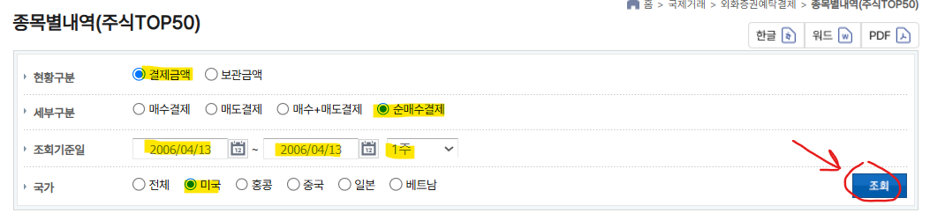
In the date selection fields - select the same date (the latest available date). After selecting the filters, click the button below.
- Wait for the data in the table below to update, then download the Excel file by clicking the button at the bottom of the table:
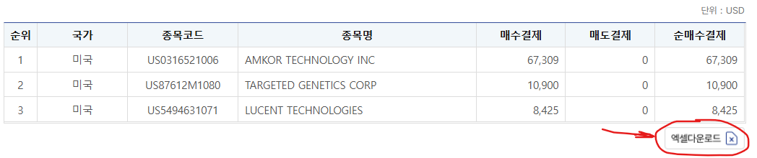
- Save each release data in a separate file in the CSV format (CSV UTF-8). In the file name, indicate the date that was specified during filtering:
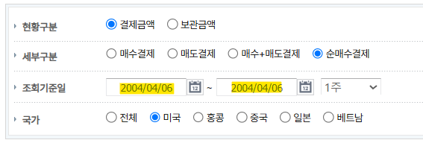
For the example above, the file name would be: WKORPUSE_DATA_20040406.CSV

Upload the csv file (without archiving) to SFTP (to a pre-created folders “KSD” -> “WKORPUSE”).
SFTP folders:
Dev env: dfac-datadev-africaai-tm /Tabular_Manual
PRODHA env: dfac-prodha-africaai-tm /Tabular_Manual

Upload the csv file (without archiving) to SFTP (to a pre-created folder: “purchaseofusequities” -> “koreansecuritiesdepository”).
SFTP folders:
DEV: s3://dfac-common-africaai/tng/
PRODVAL: s3://dfac-prodval-africaai/tng/
PRODHA: s3://dfac-prodha-africaai/tng/

For example:
DEV: s3://dfac-common-africaai/tng/purchaseofusequities/koreansecuritiesdepository/

Please inform the DataOps and DataEngineering teams in case of changes in the source tables.

Requirements to the data provided by AfricaAI
File with DATA
Template for file name: “DATASET_DATA_YYYYMMDD.xls”, i.e.” MEXPENFND_DATA_20220601.xls”
Requirements to the file with DATA:
- format - XLS, encoding - Unicode (UTF-8);
- file name: should follow pattern "DATASET_DATA_YYYYMMDD.xls", where "DATASET" - specified abbreviation for a dataset, "YYYYMMDD" - timestamp when the file was created, where YYYY - year, MM - month number, DD - day;
- file content:
  - for data with daily/ weekdaily frequency: YYYY-MM-DD, where YYYY - year, MM - month, DD – day;
  - for data with weekly frequency: YYYY-WW, where YYYY - year, WW - week number (should be two-digits, i.e. 2022-01, 2022-02, etc.). Week number is defined based on the reporting date: reporting date is considered the end of the week, i.e. if reporting date is Wednesday the week is calculated from Thursday till Wednesday – based on that rule the number of the week is defined;
  - for data with monthly frequency: YYYY-MM, MM - month number (should be two-digits, i.e. 2022-01, 2022-02, etc.);
  - for data with quarterly frequency: YYYY-QX, where YYYY - year, X - quarter number;
  - for data with annual frequency: YYYY, where YYYY – year;
  - if provider specifies for reported period that data is Not Available (that could provided in corresponding notes or other way) - fill in that data point with "NA" value;
  - if provider does not specify that data is Not Available and report Empty value for reported period - leave Empty cell;
  - if provider skips some of reporting period - skip it also in the file with data as well;
  - data is provided on one sheet only (multiple sheets are forbidden);
  - two-dimensional format where rows represent reported periods and columns contain timeseries values;
  - reported period(s) should be provided in the following format:
  - values to be provided in decimal format with "." as delimiter (number of digits after "." is limited only by provided value by the source). In order to interpret data correctly the following requirements are applied:
NB! Timeseries with different frequencies could be provided within the same file as there are different patterns for providing reported periods

