Mark Ciganovic

Project 1

1. The independent variable is the condition of either congruency or incongruency. The dependent variable is the time it took to complete a Stroop task.

2a. µI is the mean of all incongruent Stroop task times in seconds

µC is the mean of all congruent Stroop task times in seconds

The null hypothesis would be that there is no difference in time it takes to complete a Stroop task based upon congruent word conditions as opposed to incongruent word conditions.

µI - µC = 0

The alternative hypothesis is that there is a difference in time it takes to complete a Stroop task based upon congruent word conditions as opposed to incongruent word conditions.

µI - µC ≠ 0

2b.The test that I will perform is a dependent t-test for paired samples. I justify my first claim about what my null and alternative hypotheses would be based upon the important information that this test would indicate, and that is whether the condition of incongruency as opposed to congruency will have a statistically significant difference in the time it takes to complete a Stroop task. I justify my second claim about the test being a dependent t-test, since the same person completes the task twice under two conditions, once when the words and colors are congruent, and another time when the words and colors are incongruent.

3. Mean of congruent samples is 14.05

Mean of incongruent samples is 22.02

Standard deviation of the differences for the paired samples of the incongruent score minus the congruent score is 4.86

4.Congruent Values

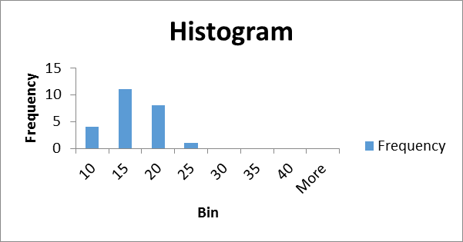

Incongruent Values

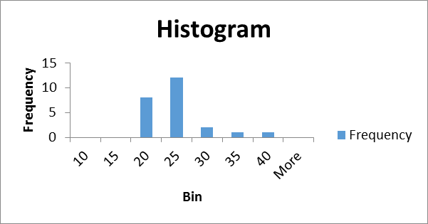

The two histograms show that column of incongruent values seem noticeably higher than the column of congruent values.

5. T-statistic is 8.02

two-tailed P value is less than 0.0001, which by conventional criteria, this difference is considered to be extremely statistically significant.

with an alpha value at .01 and 24 degrees of freedom the t-critical value is 2.80

The test results are that we reject the null hypothesis