Pets

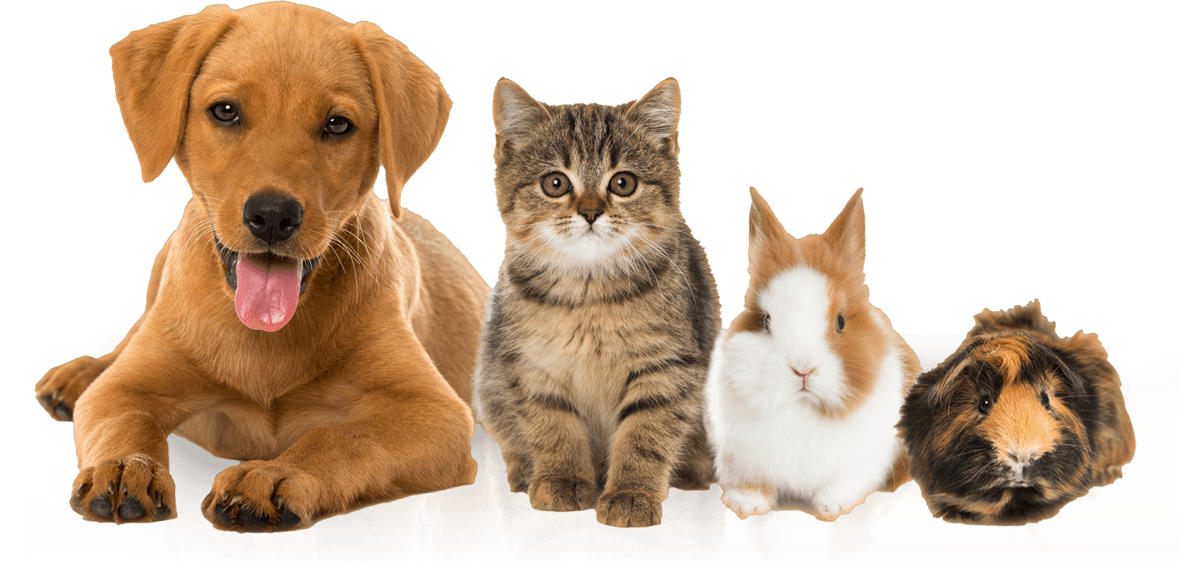

We love animals as much as you but [add your rules here]…