# Trash

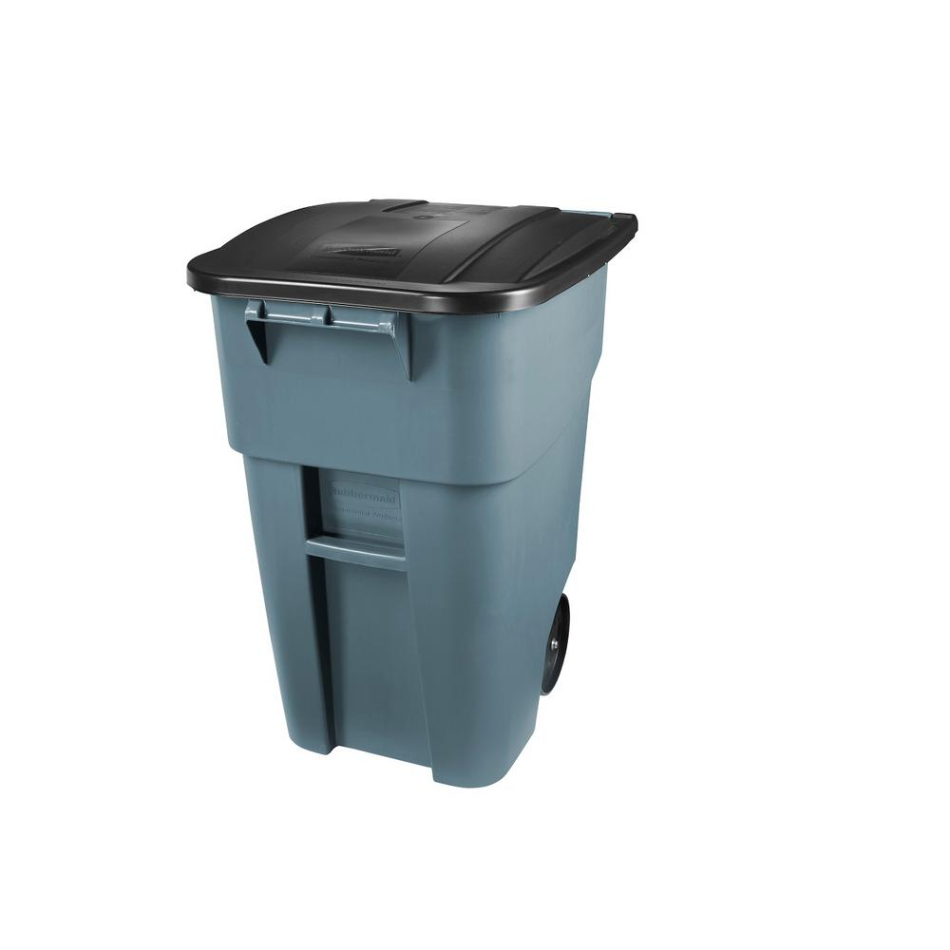

When you stay finishes, please leave your trash [tell them what to do with the trash].

[Try to add text here to get your guests to do some of the work, without making them move too much trash and possibly have an accident or leak something onto your property].