1. How do you set a breakpoint in Developer Tools?

A. In hello.js, click at line number 4. Yes, right on the 4 digit, **not** on the code.

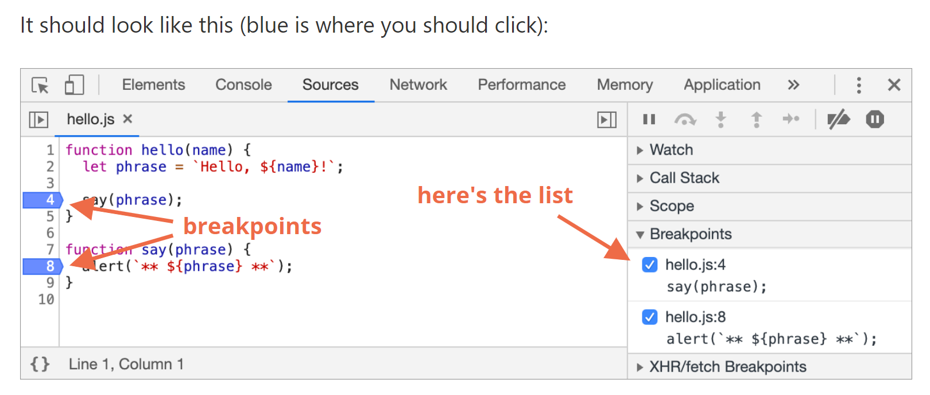

2. Where did you go to find the source JS document in this tutorial?

A. Select the Sources panel.--> The toggler button opens the tab with files. --> Let’s click it and select hello.js in the tree view. Here’s what should show up:

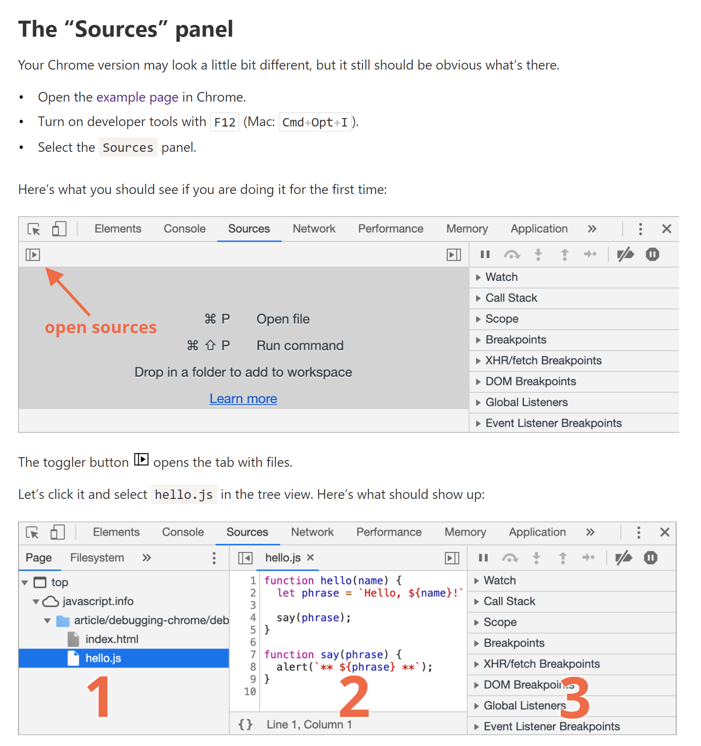

3. How can you pause debugging from within your code?

A. We can also pause the code by using the debugger command in it, like this:

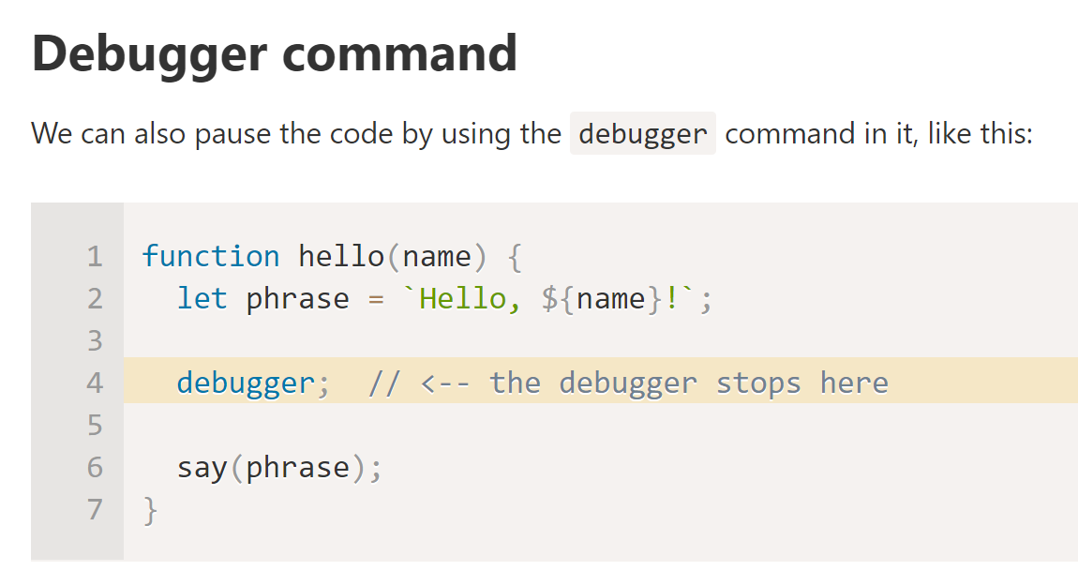

4.What is Debugging?

A. Debugging is the process of finding and fixing errors within a script.

5. While debugging, what does the SCOPE tab show?

**Scope – current variables.**

* ***Local*** shows local function variables. You can also see their values highlighted right over the source.
* ***Global*** has global variables (out of any functions).
* There’s also ***this*** keyword there that we didn’t study yet, but we’ll do that soon.

6. How is logging accomplished in Developer Tools?

To output something to console from our code, there’s console.log function.

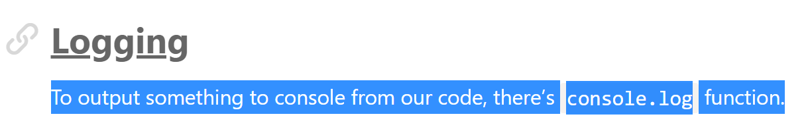

7.

8.

9.

10.