
STI COLLEGE LEGAZPI
Barangay 20 Cabangan East, Legazpi City, Albay, Legazpi

BOARDING HOUSE
MANAGEMENT SYSTEM
(ROOMANTIC)

Adviser:
Belen, Ruthessa Jane

Members:
Almaida, Aaron B,
Codillo, Mark Gilson P,
Guamos, Greg Carlo L,
Valenzuela, John Paul P,
BSIT301D

OCTOBER 2025
INTRODUCTION

The Roomantic Boarding House Management System is a web-based platform developed to automate and streamline the daily operations of a boarding house. It serves as a centralized system that allows administrators to manage rooms, tenants, rental payments, and maintenance concerns in an organized and efficient manner. Instead of relying on handwritten logs, manual reminders, or face-to-face updates, the system offers a digital approach where information is stored, processed, and accessed through a secure online environment. Tenants and administrators are each given specific roles and system access based on their tasks and responsibilities, ensuring clear workflows and secure interactions throughout the platform.
This system is designed for boarding house owners, administrators, and tenants, especially those living in shared accommodations near schools, offices, or city centers. Tenants can log in to view their room details, check payment history, and submit maintenance reports whenever they encounter issues in their rented spaces. On the other hand, owners or administrators can manage tenant records, monitor room availability, track monthly collections, and respond to concerns in a timely manner. Because many boarders are students or employees who have busy schedules, the system enables quick and hassle-free communication, helping them manage their stay more conveniently.
The system is important because it promotes transparency, efficiency, and accuracy in managing boarding house transactions. Manual processes can lead to misplaced records, forgotten dues, miscommunication, or delayed responses to tenant concerns. By automating these tasks, the system minimizes errors and ensures that all data—such as payment records, room status, and concerns—is properly documented and easy to retrieve. It enhances accountability by keeping a clear history of transactions and updates, which benefits both the tenant and the owner. Overall, the Roomantic Boarding House Management System provides a more professional, systematic, and reliable approach to rental management, improving the overall living and administrative experience inside the boarding house.

PROJECT OBJECTIVES
General Objectives
The main objective of this project is to develop a web-based Boarding House Management System that automates tenant management, room monitoring, rental payment tracking, and maintenance reporting. The system aims to improve communication between tenants and administrators while ensuring organized records, accurate transactions, and faster processing of boarding house operations.
Specific Objectives
- To provide a secure login and authentication system that allows tenants and administrators to access their accounts, ensuring that only authorized users can manage and view boarding house information.
- To enable administrators to manage room availability and tenant records, including adding new tenants, assigning rooms, updating information, and monitoring occupancy status in an organized and efficient manner.
- To allow tenants to view their payment history and submit maintenance or room-related concerns through their personal dashboard, reducing the need for face-to-face communication and manual reporting.
- To support accurate monitoring of rental payments by allowing administrators to record and track monthly dues, while giving tenants visibility of their payment status to avoid missed or forgotten payments.
- To generate organized reports on payments, tenant records, and room availability, helping administrators make informed decisions and maintain clear documentation of all boarding house activities.

FEATURES AND FUNCTIONALITIES
The system offers several features and functionalities designed to ensure organized record management, secure access, and convenient communication between tenants and administrators. These include the following:
- User Login and Authentication
Provides a secure login system with role-based access for tenants and administrators, ensuring that only authorized users can access the system.
- Tenant Dashboard
Allows tenants to view payment history, check room information, and submit maintenance or room concerns through a centralized dashboard.
- Room and Tenant Management (Admin Module)
Enables administrators to add, update, assign, or remove tenant records and monitor room availability, preventing double-booking and ensuring accurate occupancy status.
- Payment Monitoring and History Tracking
Allows administrators to track monthly rental payments, while tenants can review their payment history for transparency and reference.
- Notification and Reminder System
Sends automated alerts regarding rent due dates and concern updates, helping reduce missed payments and improving response times.
- Report
Generates organized reports on payments, tenant records, and room availability to support efficient monitoring and decision-making.

TOOLS AND TECHNOLOGIES

- FRONTEND: HTML, CSS. JAVA SCRIPT
- BACKEND: C#
- DATABASE: MONGODB
- PLATFORM: WEB-BASED

TARGET USERS / BENEFIECIARIES
The Roomantic Boarding House Management System is designed for boarding house owners, administrators, and tenants. Owners and administrators will use the system to manage room records, monitor tenant information, track rental payments, and respond to maintenance concerns more efficiently. Tenants will benefit from a convenient platform where they can view their payment history, check room details, and submit concerns without the need for face-to-face communication. The system helps reduce delays, prevent record inaccuracies, and improve coordination between both parties. By providing faster transactions, organized data management, and accessible information, the system enhances the overall boarding house experience for tenants while supporting a more professional and efficient management process for administrators and owners.

TASK BREAKDOWN / PROJECT ACTIVITIES

Task No. | Task Description | Duration | Start Date | End Date
1 | Requirements Gathering | 5 days | Oct 20 | Oct 26
2 | System Design C Wireframing | 5 days | Oct 27 | Nov 1
3 | Database Schema Design | 1 week | Nov 2 | Nov 9
4 | Frontend Development | 1 week | Nov 10 | Nov 17

DATA FLOW DIAGRAM (DFD)

CONTEXT DIAGRAM (Level 0 DFD)
The Context Diagram shows the entire Roomantic Boarding House Management System as a single process. Tenants submit login requests, view payments, and send maintenance concerns, while administrators manage rooms, tenants, payments, and requests. The system sends back responses, updates, and notifications. All information is stored and retrieved from the database.
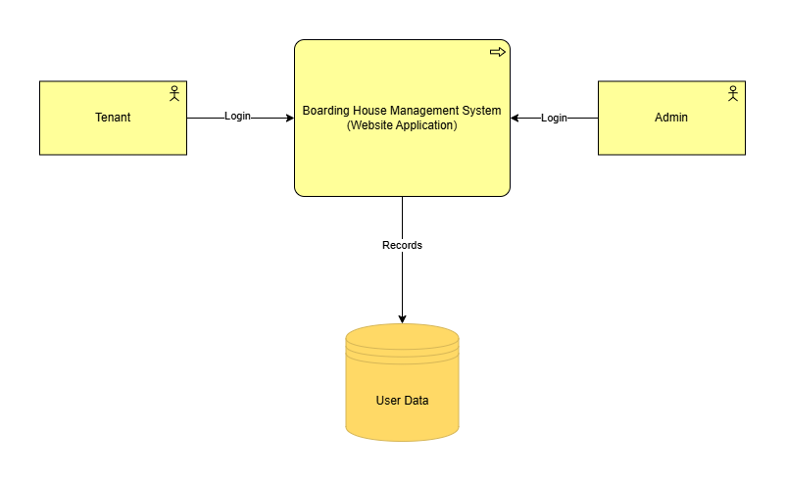

CONTEXT DIAGRAM (Level 1 DFD)
The Level 1 Data Flow Diagram shows the system broken into subprocesses such as Login, Room Management, Tenant Management, Payment Management, Request Handling, and Reports. Tenants and administrators interact with these modules, which read and write data to the database for accurate and real-time updates.
