WEB-BASED MANAGEMENT SYSTEM FOR PSITS REGION XII

A Capstone Project Proposal
Presented to the Faculty of the
Information and Communications Technology Program
STI College – General Santos, Inc.

In Partial Fulfilment
of the Requirements for the Degree Bachelor of Science in Information Technology

Mark Daniel C. Digol
Almar G. Dulangon
Keena L. Enerio
Lides Ken Virgil A. Magbujos

October 2026

ENDORSEMENT FORM FOR PROPOSAL DEFENSE

TITLE OF RESEARCH: WEB-BASED MANAGEMENT SYSTEM FOR PSITS
REGION XII

NAME OF PROPONENTS:

Mark Daniel C. Digol Almar G. Dulangon Keena L. Enerio
Lides Ken Virgil A. Magbujos

In Partial Fulfilment of the Requirements
for the degree Bachelor of Science in Information Technology has been examined and is recommended for Proposal Defense.

ENDORSED BY:

KRISTEL JOY C. TULAGAN, MIT, LPT
Capstone Project Adviser

APPROVED FOR PROPOSAL DEFENSE:
JOLINA M. MIGRIÑO, LPT
Capstone Project Coordinator
JOLINA M. MIGRIÑO, LPT
Capstone Project Coordinator
ANTHONY MARK F. SILONG, MIT
Capstone Project Coordinator

NOTED BY:

ACKNOWLEDGMENT

The completion of this capstone project would not have been possible without the guidance, assistance, and encouragement of the people who supported us throughout its development.

Above all, we give thanks to Almighty God for granting us the wisdom, strength, patience, and determination to complete this project. His guidance helped us remain focused and hopeful as we faced the technical challenges, academic responsibilities, and difficulties that came with developing our system.

We express our sincere appreciation to our capstone adviser for the time, effort, and expertise shared with us throughout this undertaking. The guidance and recommendations provided helped us refine our ideas, improve our system, and develop a better understanding of the processes involved in completing a capstone project. We are grateful for the valuable lessons and direction that contributed to our growth as Information Technology students.

We would also like to acknowledge the Philippine Society of Information Technology Students (PSITS) Region XII for providing the organizational context for this project. The opportunity to develop a management system intended to support its operations allowed us to apply our technical knowledge to practical organizational needs. We hope that our work contributes to the continuous improvement of its membership management, event coordination, payment monitoring, and information management processes.

Our gratitude also goes to our panelists, instructors, and Capstone Project Coordinator for their time, observations, and professional recommendations. Their feedback encouraged us to examine our work more carefully, address areas that required improvement, and ensure that our project remained aligned with its intended objectives.

To our fellow researchers and group members, we extend our appreciation for the cooperation and responsibility demonstrated throughout the project. Developing this system required shared effort, continuous communication, problem-solving, and a willingness to learn from mistakes. Through our combined contributions and commitment, we were able to work through challenges and make progress toward completing our objectives.

We are equally thankful to our classmates and fellow students who shared their knowledge, offered suggestions, and provided encouragement during our academic journey. Their willingness to help and exchange ideas contributed to a supportive learning environment that made the demanding process of completing this project more manageable.

To our families, we offer our heartfelt thanks for their continued understanding, patience, and support. Their encouragement and sacrifices gave us the motivation to persevere, particularly during times when academic demands and project responsibilities became difficult to balance. Their confidence in us reminded us of the importance of completing the work we had committed ourselves to.

We also appreciate our friends and other individuals who offered assistance, advice, and encouragement along the way. Every helpful suggestion and expression of support, regardless of its size, contributed to making this experience more meaningful.

Finally, we recognize everyone who played a part in the completion of this capstone project. The knowledge, assistance, and encouragement we received helped us move forward and learn valuable lessons beyond the technical aspects of system development. This accomplishment represents not only the result of our efforts but also the collective support of the people who guided and encouraged us throughout this academic journey. For this, we extend our sincere gratitude.

ABSTRACT

Title of Research: WEB-BASED MANAGEMENT SYSTEM FOR PSITS REGION XII

Researchers: Mark Daniel C. Digol
Almar G. Dulangon
Keena L. Enerio
Lides Ken Virgil A. Magbujos

Degree: Bachelor of Science in Information Technology

Date of Completion: October 2026

Keywords: Web-Based Management System,
PSITS Region XII, Member Management, Event Management,
Payment Monitoring, Centralized Database, Organizational Management

The Philippine Society of Information Technology Students (PSITS) Region XII serves as an organization that connects information technology students and participating institutions through organizational activities, events, and collaborative initiatives. Managing membership records, officer information, activities, announcements, payment transactions, and organizational reports requires coordinated information management. When these processes rely on separate records and manual procedures, retrieving information, monitoring transactions, coordinating events, and maintaining updated organizational data can become challenging. These circumstances highlight the need for a centralized digital platform that supports the administrative and operational requirements of PSITS Region XII.

This study aims to develop a Web-Based Management System for PSITS Region XII to improve the organization, accessibility, and management of institutional information and activities. The proposed system integrates member management, officer management, activity and event management, announcements, payment monitoring, recorded-video access, partner management, and report generation into a centralized platform. It is designed to provide authorized users with access to relevant information and functions according to their assigned roles and responsibilities.

The member management module supports the recording and monitoring of membership information, applications, renewals, and membership status. The officer management module maintains officer records and service periods while supporting leadership transitions through an election system that facilitates candidate management, voting processes, and the generation of election results. The activity management module enables the creation and management of organizational events, including individual, pair, and team registrations. A centralized announcement board also provides a designated space for disseminating important organizational information.

The payment monitoring module allows members to submit payment receipts and reference numbers for verification by authorized officers. Payments are processed through BPI, while the system supports the manual verification and monitoring of submitted payment information. Registration status and payment status are monitored separately to improve the organization of event participation and financial records. The system also provides a recorded-video module through which authorized officers can upload recorded sessions and members can access and view the available recordings. Furthermore, the partner management module maintains information about organizational partners, sponsors, and industry collaborators. The reporting module generates summarized information to assist officers in monitoring membership, event participation, payment records, and organizational activities.

The system is developed using the Agile Scrum methodology, which supports iterative development, testing, evaluation, and refinement based on identified requirements and feedback. The technologies used in the development include HTML, CSS, JavaScript, Bootstrap, Tailwind CSS, PHP, and Laravel, with GitHub supporting version control and collaboration. Visual Studio Code serves as the primary development environment. The proposed platform is accessible through supported web browsers, allowing authorized users to manage organizational information and perform designated activities online.

Overall, the Web-Based Management System for PSITS Region XII is designed to address challenges associated with decentralized information management by consolidating essential organizational processes into a single platform. Through centralized record management, structured event registration, manual payment verification, recorded-video access, partner coordination, and report generation, the system aims to improve administrative efficiency, information accessibility, communication, and organizational coordination. The project provides a web-based approach to supporting the management and operational needs of PSITS Region XII while helping its officers make more informed decisions through organized and accessible information.

APPROVAL SHEET

This capstone project proposal titled Web-Based Management System For PSITS Region XII prepared and submitted by Mark Daniel C. Digol, Almar G. Dulangon, Keena L. Enerio, Lides Ken Virgil A. Magbujos, in partial fulfillment of the requirements for the degree of Bachelor of Science in Information Technology, has been examined and is recommended for acceptance and approval.

Kristel Joy C. Tulagan, MIT, LPT
Capstone Project Adviser

Accepted and approved by the Capstone Project Review Panel in partial fulfillment of the requirements for the degree of Bachelor of Science in Information Technology

NUR ALIM. PADASAN, LPT, MIT DAN HENLY P. SALES
Panel Member Panel Member

ANTHONY MARK F. SILONG, MIT

Lead Panelist Noted:

Jolina M. Migriño, LPT

Capstone Project Coordinator

Anthony Mark F. Silong, MIT
Program Head

TABLE OF CONTENTS

Page
Title Page i
Endorsement form for Proposal Defense ii
Acknowledgments iii
Abstract v
Approval Sheet vi
Table of Contents iv
List of Appendices v
List of Figures vii
List of Tables viii
Introduction 1
Project Context 3
Purpose and Description 4
Objectives 7
Scope and Limitations 9
Review of Related Literature/Studies/Systems 12
Methodology
Technical Background (Technologies to be Used, Calendar of 24
Activities, Resources)
Requirements Analysis 29
Requirements Documentation 31
Design of Software, System, Product, and/or Processes 34
Result and Discussion 46
Results and Discussion 46
Testing 46
Description of Prototype 48
Implementation Plan 50
Implementation Results 52
Conclusion 63
References 39
Appendices 43
Personal Technical Vitae 115

LIST OF FIGURES

Page
Figure 1. Scrum Methodology 21
Figure 2. Gantt Chart 45
Figure 3.1 Contextual Flow Diagram 47
Figure 3.2 Entity Relationship Diagram 48
Figure 3.3 Data Flow Diagram 49
Figure 4. Mockup Design 51
Figure 5. Instrument Validation Tool 83
Figure 6. Questionnaire 86
Figure 7. Endorsement for Instrument Validation 93
Figure 8. Research Respondent Consent Form 95
Figure 9. Consent Form 98
Figure 10. Revisions List 100
Figure 11. Accomplishment and Consultation Form 104
Figure 12. Proof of Data Gathering 108
Figure 13. Resource Person 114

LIST OF APPENDICES

 | Page
Appendix A. Gantt Chart | 44
Appendix B. Diagrams | 46
Appendix C. Mockup | 50
Appendix D. Instrument Validation Tool | 82
Appendix E. Questionnaire | 85
Appendix F. Endorsement For Instrument Validation | 82
Appendix G. Letter | 94
Appendix H. Consent Form | 97
Appendix I. Revision List | 99
Appendix J. Accomplishment and Consultation Form | 103
Appendix K. Proof of Data Gathering | 107
Appendix L. Transcription | 109
Appendix M. Resource Person | 113
Appendix N. Curriculum Vitae | 115

INTRODUCTION

Project Context

Web-based management systems have become essential tools for organizations in managing data and operational processes efficiently. These systems allow centralized storage of information, real-time access, and automation of administrative tasks, which significantly improve productivity and decision-making (Laudon & Laudon, 2020). By integrating multiple functions into a single platform, web-based systems reduce reliance on manual processes and scattered digital tools, making organizational management more streamlined and accessible (Dizon et al., 2025).

Web-based management systems have become essential in modern organizations due to their ability to centralize data, automate administrative processes, and support real-time collaboration across distributed users. Foreign studies emphasize that these systems improve operational efficiency and decision-making by integrating multiple organizational functions into a single digital platform, reducing reliance on manual processes and fragmented tools Laudon & Laudon (2020). Similarly, research from international academic sources highlights that web-based information systems enhance data accuracy, accessibility, and workflow automation, making them highly suitable for organizations with multiple stakeholders and complex operations ACM Digital Library. Furthermore, studies on educational technology systems show that centralized web platforms improve transparency and coordination in student organizations by enabling structured management of memberships, events, and administrative records, while also reducing redundancy and errors in data handling Dizon et al. (2025) Blancaflor et al. (2021). These findings support the need for a Web-Based Management System for PSITS Region XII to enhance efficiency, accuracy, and organizational performance through a unified and automated digital solution.

The Philippine Society of Information Technology Students (PSITS) Region XII is an academic organization that connects Information Technology students from different
colleges and universities within the region. The organization promotes collaboration, innovation, and professional growth through seminars, competitions, conferences, and academic events. These activities help students enhance their technical knowledge, leadership skills, and industry awareness.

Despite its active role in supporting IT students, PSITS Region XII experiences several operational challenges due to the absence of a centralized and automated management system. Organizational processes are often handled manually or through separate platforms such as spreadsheets, messaging applications, and social media, resulting in scattered information, inconsistent data, and inefficient workflows (ClassConnectPro, 2024).

One major challenge is maintaining accurate membership records, as data from different institutions are collected using various formats and platforms. This leads to outdated information, duplication, and missing records, making it difficult to effectively monitor membership status. In addition, the organization lacks a structured membership lifecycle system that supports application processing, renewal tracking, expiration monitoring, and automated notifications. Without these features, members may fail to renew on time, resulting in inactive or unverified records.

Another concern is the absence of a centralized system for managing officer information and leadership processes. While officer records may be maintained, there is no formal system that supports election processes such as candidate management, program presentation, voting, and result generation. This limits transparency and organization during leadership transitions and may affect continuity within the organization (Laudon & Laudon, 2020).

Furthermore, the organization faces challenges in managing events and competitions, particularly in handling different types of participants such as individual competitors, pairs, and teams. Current practices do not provide a structured system that can accommodate varying registration formats, participant requirements, and team
compositions. This makes it difficult to manage complex events efficiently and increases the likelihood of errors in registration and participation tracking (Blancaflor et al., 2021).

In addition, participation control is limited, as there is no system that allows administrators or officers to regulate or restrict specific members, players, or performers when necessary. The absence of features such as suspension or banning of participants may lead to difficulties in maintaining discipline, fairness, and proper conduct during events and competitions.

Another major issue is the handling of payments, where transactions are verified manually through submitted screenshots or reference numbers. This process is timeconsuming, prone to human error, and lacks real-time validation. Without an automated payment system, it is difficult to ensure accuracy, track transaction status, and provide immediate confirmation of payments. Studies show that automated payment systems improve transaction efficiency, security, and monitoring compared to manual verification processes (Saad et al., 2023).

The organization also lacks a structured system for managing partnerships with sponsors and industry partners. Although collaborations exist, there is no centralized platform to monitor partnership agreements, track provided resources such as funding, equipment, or services, and evaluate partner contributions. This limits the organization’s ability to maximize partnerships and maintain organized records of collaboration (ScienceDirect, 2022).

Moreover, PSITS Region XII does not have a dedicated platform for publishing blogs, news, or stories related to organizational activities. Announcements are often limited to basic updates, and there is no structured way to share event highlights, success stories, or informational content. This reduces member engagement and limits the organization’s ability to showcase its achievements and activities.

Lastly, the absence of a centralized reporting system makes it difficult for officers to monitor organizational performance and make informed decisions. Without structured
reports on membership, event participation, payments, elections, and partnerships, decision-making becomes less data-driven and less efficient (TechnologyOne, 2023; Dizon et al., 2025).

These challenges highlight the need for a centralized and automated web-based management system that integrates membership lifecycle management, election processes, advanced event handling, automated payment processing, partner collaboration, content publishing, and reporting. Therefore, this study proposes the development of a Web-Based Management System for PSITS Region XII to improve efficiency, accuracy, accessibility, and overall organizational performance.

Purpose and Description

The purpose of this capstone project is to design and develop an advanced centralized Web-Based Management System for the Philippine Society of Information Technology Students (PSITS) Region XII. The system aims to address the organization’s existing operational challenges by providing a unified and automated platform that manages membership, leadership, events, payments, partnerships, content, and reporting processes. Through the integration of multiple organizational functions into a single system, the propose solution enhances efficiency, improves data accuracy, and supports better coordination among stakeholders. Web-based systems are widely adopted in modern organizations because they enable real-time access to information, centralized data storage, and automation of administrative tasks, which significantly improve productivity and decision-making (Laudon & Laudon, 2020; Dizon et al., 2025).

The propose system is composed of several interconnected modules, each designed to perform specific functions while working cohesively within the overall system architecture.

The Member Management Module is responsible for managing the complete membership lifecycle within the organization. This includes membership application, approval or rejection, profile management, renewal processing, and expiration tracking.
The system automatically monitors membership status and provides notifications to users regarding upcoming expiration and renewal requirements. By centralizing membership data, the system eliminates issues related to duplication, incomplete records, and outdated information. Furthermore, the module includes participation control features that allow authorized users such as administrators and officers to suspend or ban specific members, players, or performers when necessary. This ensures proper enforcement of organizational rules, promotes discipline, and maintains fairness in events and competitions.

The Officer and Election Management Module handles all officer-related information, including names, positions, roles, and service history. This module ensures proper documentation and continuity of leadership by maintaining historical records of officers. In addition, the system incorporates an election management feature that supports the entire election process, including candidate registration, presentation of candidate programs or platforms, voting procedures, and automated vote tallying. This feature improves transparency, efficiency, and credibility in leadership selection while reducing reliance on manual election processes.

The Activity Management Module provides comprehensive tools for creating, organizing, and managing organizational events and activities. The module supports flexible registration formats, allowing events to accommodate individual participants, pairs, or teams. Each event can define its own registration requirements, such as participant information, team composition, and validation rules. This flexibility allows the organization to handle various types of activities, including seminars, competitions, and collaborative events. The module also includes a centralized announcement board where administrators and officers can post updates, reminders, schedules, and activity related notifications, ensuring that members receive consistent and timely information.

The Video-Based Events and Online Activity Module allows authorized administrators and officers to upload recorded videos of organizational activities, seminars, competitions, and other relevant events. Members can access and watch these recordings through the system, allowing them to review activities even if they were unable to attend in person. This module provides a centralized platform for preserving and sharing recorded organizational content. It focuses on uploaded video recordings that members can watch on demand and does not require the system to support simultaneous livestreaming.

The Payment Module is designed to manage event-related payment transactions through manual verification. Users are required to upload payment receipts or screenshots together with their reference numbers after completing transactions through the official Landbank payment channel of the organization. Authorized users such as administrators or secretaries manually review and verify submitted payments before updating transaction records within the system. The module separates registration status from payment status, allowing accurate monitoring of participant eligibility and payment progress. This approach ensures transparency and proper financial monitoring, since payment transactions are also monitored by both regional and national organizational levels, while preventing individual officers such as the secretary from directly handling all financial transactions within the system.

The Partner Management Module is designed to manage and strengthen collaboration with sponsors and industry partners. The module allows administrators and officers to store partner profiles, record partnership agreements, and monitor sponsorship deals. It also tracks resources provided by partners, such as funding, equipment, services, or event support. By organizing this information within a centralized system, the organization can improve coordination, maintain accountability, and maximize the benefits of partnerships.

The Blogs, News, and Stories Module serves as a content management feature that allows authorized users to publish organizational updates, announcements, event highlights, and success stories. This module enhances communication within the organization by providing a structured platform for sharing information and showcasing achievements. It also improves member engagement by keeping users informed and connected to ongoing activities and developments.
The Reports Module generates summarized and structured data based on system records. This includes reports on membership status, renewal tracking, event participation, payment transactions, election results, and partner contributions. These reports provide valuable insights that support data-driven decision-making, allowing administrators and officers to evaluate performance, monitor trends, and plan future activities more effectively.

Overall, the propose Web-Based Management System for PSITS Region XII provides a comprehensive and integrated solution that addresses the organization’s operational challenges. By combining automation, centralized data management, and advanced system functionalities, the system improves efficiency, enhances communication, supports transparency, and enables better decision making. This allows the organization to operate more effectively while meeting the needs of its members and stakeholders.

Objectives

To develop a web-based management system for the Philippine Society of Information Technology Students (PSITS) Region XII that will improve the organization`s operation.

Specifically, the study aims to:

- To design a member management module that can accurately track new and renewed members, manage membership applications and renewals, automate expiration notifications, and provide authorized users the ability to suspend or ban specific members, or performers when necessary.

- To develop an officer management module that records officer information, tracks service history, supports the smooth turnover of leadership positions, and includes an election system for managing candidates, voting processes, and automated result generation.
- To develop a video-based events and online activity module that allows authorized officers to upload recorded videos of organizational activities, seminars, and competitions, enabling members to access and watch these recordings through the system.

- To develop an activity management module that enables the creation of events with support for individual, pair, and team-based registrations, each with customizable registration formats, requirements, and participant rules, along with a centralized announcement board for posting updates, notifications, and activity reminders within the system.

- To create a payment tracking feature where users upload payment receipts and reference numbers for manual verification by authorized users, while maintaining separate monitoring of registration status and payment status for event-related transactions.

- To provide a partner management module that facilitates the viewing, monitoring, and collaborative engagement with sponsors and industry partners, including the management of partnership deals, resources, and event support contributions.

- To develop a blogs, news, and stories module that allows authorized users to publish organizational updates, event highlights, announcements, and relevant content to improve communication and engagement within the system.

- To generate reports and summarized data that assist officers in making decisions related to membership renewal, event participation monitoring, payment tracking, election results, partner contributions, and overall organizational performance.

Scope and Limitations

Scope

This study focuses on the development of an advanced Web-Based Management System for the Philippine Society of Information Technology Students (PSITS) Region XII.

The system is designed to provide a centralized platform that supports administrative, operational, event-based, payment, partnership, election, content, and reporting processes. The improved system covers member management, officer and election management, live events and online activities, advanced activity management, automated payment processing, partner management, blogs/news/stories, and reports generation. The system is accessible only to authorized users such as administrators, officers, individual members, institutional members, and industry partners, with access privileges depending on their assigned role.

The system includes a Member Management Module that handles membership applications, approvals, renewals, expiration tracking, and member record maintenance. It allows administrators and authorized officers to review applications, approve or reject memberships, monitor active, inactive, expired, and renewed members, and notify users when their membership is near expiration. The module also provides authorized users the ability to suspend or ban specific members, players, or performers from selected events or competitions when necessary. This improves control, accountability, and proper monitoring of member participation.

The system includes an Officer and Election Management Module that manages officer records, positions, assigned roles, and service history. It supports leadership continuity by maintaining records of current and previous officers. In addition, the module includes an election feature that allows authorized users to manage candidates, candidate information, programs or platforms, voting schedules, vote casting, vote tallying, and winner announcement. This supports a more organized and transparent officer selection process within the organization.
The system includes a Video-Based Events and Online Activity Module that allows authorized administrators and officers to upload recorded videos of organizational activities, seminars, competitions, and other relevant events. Members can access and watch these recordings through the system, allowing them to view organizational activities even if they are unable to attend in person. The module focuses on uploaded video recordings that members can watch on demand and does not support simultaneous livestreaming.

The system includes an Advanced Activity Management Module that allows administrators and officers to create, update, and manage organizational events. It supports different types of registration, including individual, pair, and teambased registration. Each event may have different registration formats, participant requirements, team limits, and rules depending on the type of activity or competition. The module also includes a centralized announcement board for posting updates, notifications, activity reminders, and event-related information.

The system includes a Payment Module that supports payment tracking and manual verification for event-related transactions. Users are required to upload payment receipts or screenshots together with reference numbers after completing payments through the organization’s official Landbank payment channel. Authorized users such as administrators and secretaries manually review submitted payment records before approving or rejecting transactions. The module separates registration status from payment status, allowing officers to monitor whether users are registered, pending, paid, unpaid, approved, or rejected. This workflow supports proper financial monitoring and organizational accountability at both the regional and national levels.

The system includes a Partner Management Module that manages sponsors, industry partners, partnership deals, resources, and event support contributions. Administrators and officers can store partner profiles, record sponsorship agreements, monitor provided resources such as funds, prizes, equipment, venues, or services, and track partner involvement in organizational activities. This makes the module more functional than simple partner listing.
The system includes a Blogs, News, and Stories Module that allows authorized users to publish organizational updates, event highlights, news, success stories, and relevant articles. Members can view these posts within the system to stay informed about PSITS activities and achievements. This module supports communication and engagement but does not include public commenting or social media-style interaction.

The system includes a Reports Module that generates summarized data based on system records. These reports may include membership status, renewal records, event participation, payment transactions, election results, partner contributions, and activity performance. Administrators and officers can use these reports to support decisions related to planning, monitoring, evaluation, and organizational improvement.

The system is web-based and designed exclusively for PSITS Region XII. Its scope is limited to the modules and features defined in this study and does not include a dedicated mobile application, external school database integration, advanced predictive analytics, or full social media functions.

Limitation

The developed Web-Based Management System for PSITS Region XII is subject to several limitations that define its operational boundaries. The system is designed exclusively for PSITS Region XII. Although the system includes payment tracking functionality, payment verification remains manual and depends on authorized officers reviewing uploaded receipts and reference numbers submitted by users through the organization’s official Landbank payment channel. The election module is limited to basic candidate management, voting, and automated result
generation and does not include advanced features such as audit trails, voter anonymity verification, or external validation mechanisms. The event management module supports individual, pair, and team-based registration; however, it does not include advanced scheduling optimization, real-time coordination tools, or automated matchmaking systems for participants. The membership management module allows suspension and banning of members for participation control. The partner management module is limited to tracking partnership information, deals, and provided resources and does not include contract automation or legal agreement processing. The blogs, news, and stories module is limited to content publishing and viewing and does not support interactive features such as commenting, sharing, or user-generated content. The system is accessible only through web browsers and does not include a dedicated mobile application. These limitations define the scope of the system and should be considered when evaluating its functionality and applicability.

Review of Related Literature/Studies/System

A web-based management system allows users to access the system anytime and anywhere as long as there is internet connectivity. This improves the workflow of organizations because employees and administrators can monitor activities, update records, and generate reports in real time. Web technologies such as HTML, CSS, JavaScript, and database systems are commonly used to develop these platforms. Because of these advantages, many organizations, schools, and institutions have started to adopt web-based systems to replace manual or paper-based management processes.

Web-based management systems have become essential tools for organizations because they provide centralized data storage, real-time access to information, and automation of administrative processes. According to Software Engineering: A Practitioner's Approach by Roger S. Pressman and Bruce R. Maxim, modern organizations rely on digital systems to improve operational efficiency, communication, and decisionmaking. These systems reduce dependency on manual procedures and disconnected
tools, allowing organizations to manage data more accurately and efficiently. In the context of the Philippine Society of Information Technology Students (PSITS) Region XII, the implementation of a centralized web-based management system is important because the organization manages membership records, events, elections, partnerships, and financial transactions involving multiple institutions across the region.

Accurate membership tracking is a critical component of organizational efficiency. Botangen (2025) developed a web-based records management system for the Office of Senior Citizen Affairs in the Philippines, emphasizing centralized data storage to prevent duplication and outdated records. This aligns with PSITS Region XII’s need to consolidate membership information across institutions. Similarly, studies on digital records systems highlight that electronic records management improves accessibility and reduces redundancy (Mohd et al., 2023). These findings support the design of a member management module that ensures reliable and updated membership records. In addition, modern membership management systems incorporate a lifecycle approach that includes application processing, approval workflows, renewal tracking, and expiration monitoring. These systems also provide automated notifications to remind users of upcoming membership expiration. According to Mohd et al. (2023), lifecycle-based records management improves data accuracy and ensures that organizational databases remain current and reliable. This supports the development of a system that not only tracks members but also manages their complete membership lifecycle.

Membership management is one of the most important functions in organizational systems. According to Botangen (2025), centralized records management systems help organizations maintain accurate and updated information by reducing data duplication, inconsistencies, and missing records. Similarly, Mohd et al. (2023) explained that electronic records management systems improve accessibility, efficiency, and reliability of organizational data through automated record handling and lifecycle management. These studies support the propose member management module of the PSITS Region XII system, which includes membership application, approval, renewal, expiration monitoring, and automated notifications. The integration of lifecycle management improves the
organization’s ability to monitor active and inactive members while ensuring that records remain updated and organized.

Leadership continuity and election management are also important aspects of organizational operations. According to Al-Kahtani et al. (2021), digital leadership management systems improve organizational continuity by maintaining structured records of officers, service history, and administrative roles. Furthermore, Hrcak (2023) emphasized that officer documentation systems improve transparency and accountability in organizations. These studies support the development of the Officer and Election Management Module for PSITS Region XII, which includes candidate registration, voting procedures, vote tallying, and officer history management. Through automation, the organization can conduct elections more efficiently while maintaining transparency and accuracy in leadership transitions.

Digital platforms enhance participation by enabling remote engagement. Studies on online collaboration highlight that streaming technologies foster inclusivity and broaden organizational reach (Wiley, 2020; Springer, 2021). For PSITS Region XII, integrating streaming features allows members to stream in activities regardless of location, addressing accessibility challenges noted in the introduction.

Event management systems streamline organizational activities by integrating announcements, scheduling, and participant registration. Blancaflor et al. (2021) demonstrated that web-based event systems reduce administrative burden by consolidating event data. Similarly, Berlin-based studies on organizational coordination emphasize that centralized platforms improve efficiency in handling multiple events (HTW Berlin, 2020). These findings justify the development of an activity management module for PSITS Region XII.

Effective communication is vital for member engagement such as notification. IEEE (Institute of Electrical and Electronics Engineers) research shows that notification systems improve organizational responsiveness by providing timely updates (IEEE, 2024). Springer
studies further highlight that centralized announcement boards reduce information fragmentation (Springer, 2021). Decision-support models also demonstrate that structured dissemination of information enhances member awareness and participation (ScienceDirect, 2020; ArXiv, 2026). These insights support the integration of an announcement board in the propose system.

Payment tracking systems are important in managing financial transactions within organizations and events. Studies show that systems utilizing manual verification through uploaded receipts and reference numbers can still improve transaction organization, monitoring, and accountability compared to fully paper-based processes (Saad et al., 2023). These systems allow administrators to validate transactions, maintain payment records, and monitor participant eligibility more efficiently. In organizational settings where financial monitoring involves multiple administrative levels, manual verification processes remain relevant to ensure transparency and accountability. This supports the implementation of a payment tracking module that utilizes receipt uploads and manual verification procedures.

Payment management systems also contribute significantly to organizational efficiency. According to Saad et al. (2023), systems that implement manual verification through uploaded receipts and reference numbers improve transaction monitoring and accountability compared to traditional paper-based methods. Although automated payment gateways provide real-time validation, manual verification remains applicable in organizations where multiple administrative levels are involved in financial monitoring. This literature supports the Payment Module of the propose system, where users upload payment receipts and authorized officers manually verify transactions before approval. The separation of registration status and payment status further improves transparency and monitoring of participant eligibility.

Virtual participation expands accessibility and inclusivity. Research on online event systems demonstrates that web-based platforms allow members to engage remotely, fostering collaboration and inclusivity (Theseus, 2024; PMC, 2024). MDPI (Multidisciplinary Digital Publishing Institute) studies further highlight that online
competitions enhance engagement by integrating interactive features (MDPI, 2023). For PSITS Region XII, this supports the integration of online event modules to broaden participation. The rise of online participation platforms has also increased the importance of livestreaming and virtual event systems. According to Wiley (2022), livestreaming technologies enhance accessibility by allowing users to participate in events remotely regardless of geographical location. Similarly, Springer (2021) explained that digital participation systems improve inclusivity and engagement within organizations. These studies support the development of the Live Events Module for PSITS Region XII, which allows officers to provide livestream access to webinars, meetings, and online competitions. This feature ensures that members who cannot attend physically can still participate and remain connected to organizational activities.

Academic-industry collaboration strengthens organizational initiatives. Purdue research emphasizes the role of partnerships in supporting professional and academic engagement (Purdue, 2022). ScienceDirect studies highlight that industry partnerships improve innovation and resource sharing (ScienceDirect, 2022). Springer research further notes that structured collaboration enhances organizational sustainability (Springer, 2023). These findings justify the inclusion of a partner management module in the PSITS system. Partnership and collaboration management systems also play a significant role in organizational sustainability. According to research from Purdue University (2022), academic-industry partnerships strengthen organizational programs by providing funding, resources, and professional opportunities. Likewise, ScienceDirect (2022) highlighted that structured collaboration systems improve coordination, innovation, and resource-sharing among organizations and partners. These findings support the inclusion of a Partner Management Module in the propose system, where partnership agreements, sponsorships, and contributed resources can be monitored and organized efficiently.

Data-driven decision-making is essential for organizational growth. Performance management systems provide structured insights into organizational activities (ScienceDirect, 2023). Analytics platforms such as SAS (Statistical Analysis System) and IBM (International Business Machines Corporation) highlight the importance of business
intelligence in improving decision-making (SAS, 2023; IBM, 2023). Decision support systems and management information systems further emphasize that centralized reporting enhances organizational efficiency (ScienceDirect, 2023). These findings support the development of reporting modules that generate summarized data for PSITS Region XII.

Web-based management systems play a significant role in improving organizational efficiency by providing a centralized platform for managing data and operations. According to Laudon and Laudon (2020), these systems enable real-time access to information, streamline administrative processes, and improve decision-making through integrated data management. By consolidating multiple organizational functions into a single platform, web-based systems reduce the reliance on manual processes and disconnected tools, which often lead to inefficiencies and data inconsistencies. Similarly, Dizon et al. (2025) emphasized that centralized webbased systems enhance data accuracy, accessibility, and reliability by minimizing duplication and ensuring consistency across records. These systems also support better coordination among users by allowing multiple stakeholders to access and manage information within a unified environment. As organizations increasingly adopt digital solutions, web-based management systems have become essential in handling complex processes such as membership management, event coordination, and record tracking. In the context of PSITS Region XII, the use of a webbased management system is relevant as it addresses issues related to scattered data, manual workflows, and inefficient coordination. By centralizing operations such as membership, events, payments, and reporting, the propose system aligns with the advantages identified in existing studies.

Event management systems are designed to simplify the planning, organization, and execution of events by integrating essential functions such as scheduling, participant registration, and activity monitoring. According to Blancaflor et al. (2021), web-based event management platforms significantly reduce administrative workload by consolidating event-related processes into a single system. These platforms improve efficiency by automating registration, organizing event details, and maintaining participant records. In addition, studies on digital competition systems highlight the importance of structured platforms in managing competitive events. Research from MDPI (2023) indicate
online competition systems improve participant engagement by providing accessible platforms where users can register, view event details, and monitor their participation. Similarly, Theseus (2024) explains that web-based competition platforms enhance transparency and accessibility by allowing participants to interact with event information and submit requirements through digital means. These systems are particularly relevant for academic organizations, where competitions and events play a key role in student development. In the case of PSITS Region XII, the integration of an event and competition management module supports efficient organization of activities while enabling members to participate in events using their devices. This improves accessibility and encourages higher levels of participation compared to traditional manual processes.

Live streaming platforms have become an important tool for delivering content and activities in real time, especially in educational and organizational settings. According to Wiley (2022), streaming technologies allow organizations to broadcast events such as seminars, meetings, and conferences to a wider audience, improving accessibility and reach. These platforms eliminate geographical limitations by enabling users to access content remotely.

Content management systems (CMS) enable organizations to publish blogs, news, and stories to improve communication and engagement. These platforms provide a centralized way to share updates, highlight achievements, and distribute information to users. According to Springer (2021), content-based systems enhance user engagement users. According to Springer (2021), content-based systems enhance user engagement and improve information dissemination by organizing content in a structured and accessible manner. This supports the inclusion of a blogs, news, and stories module within the system. Content management systems are also important for improving communication and engagement within organizations. According to Springer (2021), content publishing platforms enhance organizational communication by providing structured methods for sharing blogs, news, announcements, and stories. These systems improve user engagement and allow organizations to showcase achievements and updates effectively. In relation to PSITS Region XII, the Blogs, News, and Stories Module allows authorized users to publish
event highlights, success stories, and organizational updates, which strengthens communication and member participation.

Furthermore, Springer (2021) highlights that online streaming platforms contribute to increased participation by providing users with convenient access to activities without requiring physical presence. This is particularly beneficial for organizations with members located in different areas. Similarly, Saad et al. (2023) explain that livestreaming systems improve engagement by allowing users to stay informed and connected to organizational activities through real-time content delivery. In the context of the propose system, livestream functionality is relevant as it allows PSITS Region XII to provide access to organizational activities such as webinars, meetings, and events through the platform. This supports inclusivity and ensures that members who cannot attend physically can still view and stay updated on organizational programs. Data-driven decision-making is another important aspect of organizational management. According to ScienceDirect (2023), reporting systems provide summarized and organized data that support planning, monitoring, and evaluation processes. Similarly, IBM (2023) and SAS (2023) emphasized that analytics and business intelligence systems improve organizational decision-making by transforming records into useful information. These studies support the Reports Module of the propose system, which generates reports related to membership, event participation, payments, election results, and partner contributions. These reports help administrators and officers evaluate organizational performance and make informed decisions.

Synthesis

The reviewed literature, studies, and related systems emphasize the importance of web-based management systems in improving organizational efficiency, communication, accessibility, and data management. Existing studies show that centralized digital platforms help reduce manual processes, improve record accuracy, streamline operations, and enhance coordination through integrated modules and real-time access to information. These findings support the development of a centralized Web-Based Management System for PSITS Region XII to address issues related to scattered records, manual workflows,
and inefficient organizational processes. The literature also highlights the importance of membership lifecycle management, election systems, event management, livestream participation, payment tracking, partnership monitoring, content publishing, and reporting systems in supporting organizational operations. Studies reveal that these systems improve transparency, accountability, participation, communication, and decision-making through organized and centralized processes. In particular, research supports the use of manual payment verification through uploaded receipts and reference numbers to improve accountability and monitoring in organizations with multiple administrative levels. Overall, the reviewed literature and studies provide strong support for the proposed system by confirming that integrating modules such as membership management, officer and election management, activity management, livestream access, payment tracking, partner management, blogs and announcements, notifications, and reports generation into a single platform can significantly improve the operational efficiency and management of PSITS Region XII.

METHODOLOGY

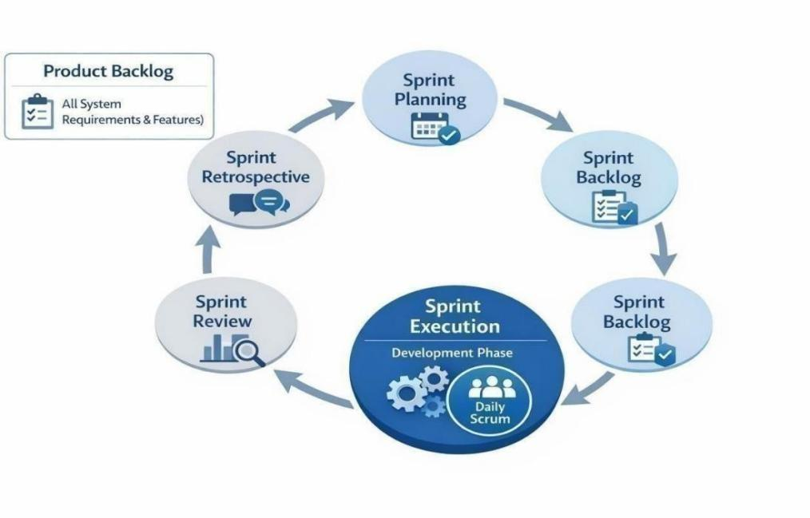
The development of the propose Web-Based Management System for PSITS Region XII follows the Agile Scrum methodology. Agile Scrum is an iterative and incremental software development approach that emphasizes collaboration, continuous improvement, adaptability, and regular feedback throughout the development process. This methodology allows the development team to divide the project into manageable phases called sprints, where each sprint focuses on a specific set of functionalities and deliverables. Through Agile Scrum, the development team is able to continuously evaluate system performance, resolve issues immediately, and improve system features based on feedback and testing.

Figure 1. Agile Scrum Method

Sprint 1 focused on gathering system requirements, analyzing organizational problems, and identifying the core functionalities needed for the propose system. During this sprint, the team conducted discussions regarding membership management, officer management, event handling, payment tracking, partnership monitoring, blogs and announcements, and reports generation.

The proponents facilitated requirement analysis discussions and coordinated the overall sprint activities. The proponents assisted in analyzing technical requirements and
identifying database entities and relationships needed for the system. The proponents contributed to planning the system interface structure and workflow design to ensure userfriendly navigation. The proponents handled the organization of gathered information, documentation of requirements, and preparation of related project materials. The entire team collaborated in validating system requirements and ensuring alignment with the objectives of the study.

Sprint 2 focused on designing the overall architecture of the system, including process flow, database structure, and interface design. During this phase, the development team created the Data Flow Diagram (DFD), Entity Relationship Diagram (ERD), workflow structures, and initial interface layouts.

The proponents supervised the development of the overall system architecture and ensured consistency between modules and system requirements. The proponents focused on database design, table relationships, and backend process structure. The proponents handled interface wireframes, visual layout planning, and responsive design concepts for the system. The proponents documented the design process, organized diagrams, and ensured that all design outputs were properly aligned with the capstone documentation. Collaboration among members was maintained throughout the sprint to improve the accuracy and usability of the propose design.

Sprint 3 focused on the actual development and coding of the system modules. The development team implemented core functionalities including user authentication, member management, officer and election management, activity management, payment tracking, partner management, blogs and announcements, livestream access, and reports generation.

The proponents handled project coordination and assisted in integrating major system components and functionalities. The proponents focused primarily on backend development, database connectivity, API handling, and implementation of system logic. The proponents concentrated on frontend development, interface responsiveness, navigation flow, and user interaction design. The proponents assisted in module testing,
content organization, debugging support, and documentation updates during the development process. Although each member had designated responsibilities, the team continuously collaborated to solve technical issues and ensure successful module integration.

Sprint 4 focused on testing, evaluation, debugging, and refinement of the developed system. During this sprint, the team conducted functionality testing, interface evaluation, validation of workflows, and correction of identified errors.

The proponents coordinated testing activities and monitored whether system functionalities met the project objectives. The proponents focused on debugging backend issues, database validation, and correcting system processing errors. The proponents evaluated user interface consistency, responsiveness, and usability improvements. The proponents documented testing results, organized evaluation feedback, and updated project documentation based on revisions and refinements. The development team collectively participated in identifying issues, improving system performance, and refining features to ensure system quality and reliability.

At the end of every sprint, the development team conducted Sprint Review and Sprint Retrospective meetings to evaluate completed tasks, discuss system improvements, and identify challenges encountered during development. The proponents facilitated discussions and monitored sprint progress. The proponents provided technical updates regarding backend and database implementation. The proponents presented interface improvements and user experience feedback, while The proponents summarized documentation updates, testing observations, and identified recommendations.

During Sprint Reviews, the team evaluated whether the completed functionalities aligned with the planned sprint objectives and system requirements. During Sprint Retrospectives, the members discussed challenges encountered, identified workflow improvements, and propose adjustments for succeeding sprints. This process allowed the
team to continuously improve collaboration, resolve development issues efficiently, and maintain consistent project progress.

Throughout the development process, the Agile Scrum methodology enabled the team to maintain flexibility and adaptability in handling project requirements and revisions. Even though responsibilities were distributed among members, the team maintained a collaborative environment where all members contributed to planning, coding, testing, documentation, and refinement activities whenever needed. Continuous communication, iterative development, and regular feedback helped ensure that the propose Web-Based Management System for PSITS Region XII met the intended objectives, maintained system quality, and addressed the operational needs of the organization effectively.

Technical Background Technology To Be Used
The developments of the propose Web-Based Management System for PSITS Region XII utilizes modern web technologies that support efficiency, scability, and maintainability. For the client-side interface, the system is developed using React with Vite and TypeScript, which enables the creation of a responsive and dynamic Single Page Application (SPA). React allows the development team to build reusable and modular user interface components, improving maintainability and development speed. Vite is used as a fast build tool that enhances development performance and reduces loading time, while TypeScript provides strong typing that minimizes errors and improves code reliability. In addition, React Router is used to manage client-side navigation and implement protected routes, ensuring that only authorized users can access specific modules based on their roles. To enhance the visual design and responsiveness of the interface, Bootstrap and Tailwind CSS are utilized, allowing the system to adapt to different screen sizes and provide a user-friendly experience.

For the application layer, the system uses Node.js with Express, which serves as the back-end framework responsible for handling server-side operations. Node.js enables efficient and scalable processing of multiple user requests, while Express simplifies the
creation of RESTful API endpoints used to connect the front-end and the database. This layer is responsible for managing authentication, enforcing role-based access control, validating user inputs, and processing system operations such as member management, event handling, payment verification, and report generation. The use of these technologies ensures that the system can handle real-time interactions and maintain organized communication between components.

For data storage, the system utilizes MySQL with mysql2, a relational database management system that allows structured storage and retrieval of data. MySQL is used to manage records such as users, officers, events, registrations, announcements, payments, partners, and reports. Its relational structure ensures data integrity, consistency, and efficient querying of information, which is essential for generating accurate reports and monitoring organizational activities. The use of mysql2 enables seamless integration between the Node.js back-end and the database, allowing faster and more reliable database operations. Overall, these technologies were selected based on their proven effectiveness in developing web-based systems, their ability to support modular and scalable architecture, and their capability to handle the functional and data requirements of the propose system.

Resources

The development of the propose Web-Based Management System for PSITS Region XII requires a set of hardware and software resources to support the design, development, testing, and implementation of the system.

Hardware Resources

For the hardware resources, the proponents utilize laptops equipped with processors such as Intel Core i5, Intel Core i7, and AMD Ryzen 7, which are capable of handling programming, database management, and system testing tasks. The devices are supported by at least 8 GB of RandomAccess Memory (RAM), which ensures smooth multitasking and efficient execution of development tools and applications. Storage capacity of at least 256 GB is also used to accommodate system files, development environments, databases,
and project documentation. Standard input devices such as a keyboard and mouse are utilized to facilitate user interaction during system development and testing. These hardware components provide sufficient performance and reliability to support the continuous development and evaluation of the propose system.

Software Resources

For the software resources, the proponents utilize a combination of front-end, back-end, and database technologies to develop the system. The client-side interface is developed using React with Vite and TypeScript, which supports the creation of a dynamic, responsive, and modular web application. React Router is used to manage navigation and implement role-based access through protected routes, while Bootstrap and Tailwind CSS are used to enhance the visual design and responsiveness of the user interface. For the server-side, Node.js and Express are used to handle application logic, manage user authentication, process requests, and enforce rolebased access control. For data storage, MySQL with mysql2 is utilized to store and manage system data, ensuring data integrity, consistency, and efficient retrieval of records. Additional development tools such as code editors, browsers, and version control systems are also used to support coding, testing, debugging, and system maintenance. These software resources collectively provide a reliable and efficient environment for developing and deploying the propose web-based management system.

Calendar of Activities

The listed activities below present the completed and ongoing tasks of the proponents during the development of the capstone project titled “Web-Based Management System for Philippine Society of Information Technology Students (PSITS) Region XII.” Which provide a graphical representation of the project’s progress, development phases, sprint activities, and major milestones throughout the implementation of the propose system.

The project commenced with the orientation phase, during which the proponents
were introduced to the capstone guidelines, project requirements, development expectations, and documentation standards. This was followed by the formation of the project group and the selection of the Capstone Project Adviser to ensure proper supervision and guidance throughout the development of the study. Afterward, the proponents conducted title brainstorming and proposal drafting, where the concept of a centralized web-based management system for PSITS Region XII was developed based on identified organizational challenges related to membership management, event coordination, payment monitoring, communication, and record management. This phase concluded with the successful completion of the title proposal defense, marking the formal approval of the propose system.

Following the approval of the project title, the proponents proceeded to the planning and requirements-gathering phase. During this stage, information was collected regarding the operational processes and organizational challenges experienced within PSITS Region
XII. The proponents analyzed issues related to membership lifecycle management, officer records, election processes, event registration handling, payment verification, sponsorship management, announcements, and reporting. Based on the gathered information, the core functionalities of the system were identified, including member registration and renewal, election management, activity management, livestream access, manual payment verification, partner monitoring, blogs and announcements, and reports generation.

The system development phase followed the Agile Scrum methodology, where the project was divided into multiple sprints to ensure organized and iterative development. During Sprint 1, the proponents focused on requirement analysis, workflow planning, and identification of system functionalities. Sprint 2 concentrated on system architecture design, database structure preparation, interface wireframes, workflow diagrams, Data Flow Diagram (DFD), and Entity Relationship Diagram (ERD). Sprint 3 focused on the actual development and implementation of the system modules, including user authentication, member management, officer and election management, activity management, payment tracking, partner management, blogs and announcements, livestream access, and reports generation. Throughout the development process, the proponents continuously
collaborated, tested modules, resolved technical issues, and refined system functionalities based on evaluation and feedback.

Simultaneously, the proponents prepared and revised the capstone documentation, particularly Chapters 1 to 3, to ensure consistency between the system development process and the objectives of the study. The proponents also coordinated the alignment of system features, methodology, and diagrams to maintain accuracy within the documentation.

Prior to the evaluation phase, the system underwent integration, testing, debugging, and refinement to ensure that all modules functioned properly and interacted efficiently. Necessary revisions and improvements were applied to enhance system performance, usability, interface consistency, and reliability. Documentation was also reviewed and updated in preparation for presentation and evaluation.

The Capstone 1 Final Defense marked the completion of the initial development and documentation phase of the project. Following this, the Capstone 2 phase commenced, focusing on advanced system enhancement, feature refinement, testing procedures, and completion of remaining project requirements. During this phase, additional improvements were implemented in the system interface, workflow optimization, module functionality, and overall user experience. The proponents also conducted system testing and validation procedures to evaluate system functionality, usability, and effectiveness.

In addition, the proponents completed the remaining documentation, particularly Chapters 4 and 5, which include the presentation, analysis, and interpretation of results, as well as conclusions and recommendations. Final revisions and validation procedures were conducted to ensure that the developed Web-Based Management System for PSITS Region XII successfully met its intended objectives in improving organizational management, communication, monitoring, and operational efficiency.

The project concluded with the Capstone 2 Final Defense, where the fully developed and enhanced system was presented, evaluated, and approved, marking the successful completion of the entire capstone project.

Requirements Analysis

The requirements analysis phase focuses on identifying, examining, and organizing the needs of the organization and its users to ensure that the propose system effectively addresses existing operational problems. This phase is essential in defining what the system should do, how it should function, and who will interact with it. For the WebBased Management System for PSITS Region XII, the requirements were gathered based on the current practices of the organization, the challenges encountered in managing operations, and the objectives of the study.

Who – The People Involved

The people involved in the system include administrators, officers, individual members, institutional members, and industry partners of PSITS Region XII. Administrators are responsible for managing the entire system, including user accounts, system configuration, and overall monitoring of operations. Officers handle operational tasks such as managing events, posting announcements, verifying payments, and monitoring participation. Individual members and institutional representatives interact with the system by registering, updating profiles, joining events, submitting payments, and viewing announcements. Industry partners are included as external stakeholders whose information is managed within the system for collaboration and engagement. Each user type has specific roles and access levels, making rolebased access control an essential requirement of the system.

Where – The Work Environment

The operations of PSITS Region XII take place across multiple institutions within the region, making it a distributed organizational environment. Currently, activities are managed using a combination of spreadsheets, messaging platforms, and social media, which leads to fragmented data and communication gaps. The propose system will operate in a web-based environment, allowing users to access the platform through internetconnected devices such as laptops and computers. This enables users from different schools and locations to interact with the system without the need for physical presence.
The webbased setup ensures accessibility, centralized data management, and real-time updates across the organization. This environment supports efficient coordination and information sharing among all users.

When – The Timing of System Use

Organizational activities within PSITS Region XII occur at different times depending on scheduled events, membership periods, administrative process. Membership registration and renewal typically occur at the beginning of an academic period, while events such as seminars and competitions are conducted throughout the year. Announcements are posted as needed to inform members of updates, deadlines, and organizational activities. Payment submissions are also time-dependent, especially during event registration and participation. The propose system must support real-time data processing and allow users to access information at any time. This ensures that updates, transactions, and activities are managed efficiently without delays.

How – The Current and Proposed Process

Currently, the procedures of PSITS Region XII are performed manually or through the use of separate digital tools such as spreadsheets, messaging applications, and social media platforms. Membership data are collected from different institutions and stored in various formats, leading to inconsistencies, duplication, and outdated records. Event management is handled manually, including participant registration and attendance tracking, which makes it difficult to monitor activities efficiently. Announcements are posted across different platforms, resulting in scattered information and missed updates. Payment tracking is also performed manually, where verification is done through submitted proofs without a centralized system for monitoring. These existing procedures highlight the need for a centralized web-based system that can integrate all operations, improve efficiency, and ensure accurate data management.

Requirements Documentation

The proponents developed the Web-Based Management System for the Philippine Society of Information Technology Students (PSITS) Region XII to improve the organization’s administrative operations, communication processes, event management, membership monitoring, and data organization. The system is designed to centralize and digitize organizational processes that were previously handled manually or through scattered platforms such as spreadsheets, messaging applications, and social media pages. Initially, the concept of the project focused mainly on membership management and event coordination; however, to better address the operational needs of the organization, the system was expanded to include membership lifecycle management, election management, livestream access, manual payment verification, partner management, blogs and announcements, participant control features, and reporting functionalities. As a result, the system was designed to support multiple integrated modules that collectively improve the efficiency, organization, accessibility, and overall management of PSITS Region XII activities and records.

The system includes a User Management Module, which provides secure authentication and role-based access for administrators, officers, members, and other authorized users. This module ensures that only authorized individuals can access specific functionalities and organizational records. It also allows administrators to manage user accounts, monitor account activities, and maintain the security and integrity of the system.

A Member Management Module is incorporated to manage the complete membership lifecycle of the organization. This module handles membership application, approval, profile management, renewal processing, expiration tracking, and status monitoring. The system organizes member information in a centralized database to reduce duplication, incomplete records, and outdated information. It also provides automated notifications for membership renewal and expiration reminders. In addition, the module includes participation control features that allow administrators and officers to suspend or
ban specific members, players, or performers when necessary to maintain proper conduct and organizational discipline during events and activities.

The system also includes an Officer and Election Management Module, which manages officer information, positions, assigned responsibilities, and service history. This module also incorporates an election system that allows administrators to manage candidates, display candidate information and platforms, facilitate voting procedures, and automatically tally votes to generate election results. Through this module, leadership selection becomes more organized, transparent, and efficient while maintaining proper records of organizational officers.

An Activity Management Module is also included to support the creation, organization, and management of organizational activities, seminars, competitions, and events. The system supports multiple registration formats, including individual, pair, and team-based participation. Each activity may define its own registration requirements, participant limitations, and validation rules depending on the nature of the event. This module also includes a centralized announcement board where administrators and officers can publish schedules, reminders, updates, and activity-related announcements for members.

To improve accessibility and online participation, the system incorporates a Live Events Module that allows administrators and officers to provide livestream access for seminars, meetings, competitions, and other organizational activities. Members can access and view live sessions directly through the platform, allowing participation even when physical attendance is not possible.

The system also features a Payment Tracking Module, which supports manual payment verification for event-related transactions. Users are required to upload payment receipts or screenshots together with transaction reference numbers after completing payments through the organization’s official Landbank payment channel. Authorized officers and administrators manually review and verify submitted transactions before
updating payment records and participant status within the system. The module separates registration status from payment status to improve transaction monitoring, organizational accountability, and participant validation. Since payment transactions are also monitored by both the regional and national levels of the organization, this process ensures transparency and proper financial tracking.

A Partner Management Module is included to manage sponsors and industry partners associated with PSITS Region XII. This module allows administrators and officers to record partnership information, monitor sponsorship agreements, and track resources provided by partners such as funding, equipment, services, and event support. Through centralized monitoring of partnerships, the organization can improve collaboration management and maintain organized records of partner contributions.

The system also incorporates a Blogs, News, and Stories Module, which enables authorized users to publish organizational announcements, event highlights, updates, success stories, and other relevant content. This module improves communication and member engagement by providing a centralized platform for sharing information and promoting organizational activities.

To support communication and awareness, the system includes a Notification Module that provides users with important updates related to membership renewal, event schedules, registration status, payment verification, announcements, and election activities. These notifications help ensure that members remain informed about organizational activities and system-related updates.

Finally, the system includes a Reports Module, which generates summarized and organized reports based on system records. This module allows administrators and officers to monitor membership statistics, renewal tracking, event participation, payment transactions, election results, partner contributions, and overall organizational performance. Through these reports, the organization can support monitoring, evaluation, planning, and data-driven decision-making.
Through the integration of these modules, the propose Web-Based Management System for PSITS Region XII provides a centralized, organized, and efficient platform that supports membership management, leadership monitoring, election processes, event coordination, livestream participation, payment tracking, partner collaboration, content publishing, communication, and reporting functionalities for improved organizational management and operational efficiency.

Design of Software, System, Product, and/or Processes

The proponents utilized several system design and modeling tools to analyze, organize, and visualize the structure and processes of the propose Web-Based Management System for PSITS Region XII. These tools helped ensure that the system requirements, workflows, and database structure were properly defined before development. A Data Flow Diagram (DFD) (Appendix #, Fig. ##, pg ##) was used to illustrate the flow of data between users, system processes, and the database during activities such as membership registration, event participation, payment verification, election processing, and report generation. An Entity Relationship Diagram (ERD) (Appendix C, Fig. 3.2, pg 55) was utilized to design the database structure and define the relationships between entities such as members, officers, events, payments, partners, and reports. This helped organize data storage and reduce redundancy within the system. In addition, System Workflow Diagrams were used to visualize the operational processes and user interactions within the system. The proponents also applied the Agile Scrum Methodology as the primary development framework to support iterative development, continuous testing, collaboration, and system refinement throughout the project.

Technology Stack

The propose system utilizes a modern web development technology stack composed of front-end, back-end, and database components. For the client-side interface, the system uses React with Vite and TypeScript to develop a dynamic and responsive Single Page Application (SPA). React enables the use of reusable components, while TypeScript
improves code reliability through strong typing, and Vite enhances development speed and performance. React Router is used for navigation and implementation of role-based access through protected routes, while Bootstrap and Tailwind CSS are applied to ensure responsive and user-friendly interface design. For the server-side, Node.js and Express are used to manage application logic, handle API requests, and enforce authentication and rolebased access control. For data storage, MySQL with mysql2 is utilized to manage structured data such as users, events, payments, and reports, ensuring data integrity and efficient retrieval of records.

User Interface Design Standards

The system follows a consistent and user-centered interface design standard to ensure ease of use and accessibility for all users. The interface is designed with a clean layout, clear navigation structure, and organized content to minimize user confusion and improve interaction efficiency. Consistent color schemes, typography, and component styles are applied across all modules to maintain visual uniformity. The system also adopts a responsive design approach, allowing it to adapt to different screen sizes and devices.

Additionally, user interfaces are designed based on role-specific access, ensuring that users only see relevant features and functions according to their responsibilities.

Security Measures

The system incorporates several security measures to protect user data and ensure safe system operation. Authentication mechanisms are implemented to verify user identity before granting access to the system. Role-based access control is enforced to restrict users from accessing unauthorized modules and functionalities. Input validation is applied to prevent incorrect or malicious data from being processed by the system. Secure handling of user credentials and session management is also implemented to maintain account security. These measures ensure the confidentiality, integrity, and reliability of the system’s data and operations.

Processes and Workflow

The system follows a structured process and workflow based on a request-response model that ensures efficient interaction between users, the system, and the database. Users access the system through the web interface and perform actions such as membership application and renewal, event registration, voting participation, payment processing, and data management. These actions generate requests that are sent to the server, where they are processed according to predefined business rules and validation procedures.

For membership management, the system handles the complete lifecycle, including application, approval, activation, expiration, and renewal, with automated notifications for expiring memberships. Authorized users can also apply participation control by suspending or banning specific members, players, or performers from selected events or competitions.

For event management, the system supports multiple registration types, including individual, pair, and team-based participation. Each event may define its own registration format, required fields, participant limits, and validation rules, ensuring flexibility in handling various types of activities and competitions.

For election processes, the system allows candidate management, display of candidate information and programs, vote casting by authorized users, and automated vote tallying to generate results efficiently and transparently.

For payment processing, users are required to upload payment receipts or screenshots together with transaction reference numbers after completing payments through the organization’s official Landbank payment channel or thru GCash. Authorized users such as administrators or secretaries manually review and verify submitted transactions before updating payment records and participant status within the system. The system separates registration status from payment status, allowing accurate monitoring of participant eligibility and financial transactions while ensuring organizational accountability.
For partner management, the system records partnership agreements, sponsorship deals, and resources provided by partners such as funding, equipment, or services. These records support organized collaboration and monitoring of partner contributions.

For content management, the system allows authorized users to publish blogs, news, and stories related to organizational updates, event highlights, and achievements, improving communication and engagement within the platform.

Once the data processing is completed, the server sends a response back to the user interface, displaying updated information or confirmation messages. This workflow ensures accurate data processing, efficient communication between system components, and an update for users.

Development

The development of the system follows the Agile Scrum methodology, which allows the project to be completed through iterative and incremental development cycles. The system is developed in multiple sprints, where each sprint focuses on a specific set of functionalities such as user authentication, member management, event management, payment tracking, and reporting. During each sprint, the development team performs coding, integration, and testing to ensure that the features are functional and aligned with system requirements. Continuous evaluation is conducted to identify errors, improve system performance, and refine features based on feedback. This iterative approach ensures that the system evolves progressively while maintaining quality and consistency.

In addition to system implementation, this phase also involved the development of essential system models, including the Data Flow Diagram (DFD) and the Entity Relationship Diagram (ERD), to clearly illustrate system processes, data movement, and user interactions. The DFD presents how data flows within the system, showing how inputs are processed and transformed into outputs across different modules. On the other hand, the ERD represents the relationships between system entities and data structures, such as users, events, payments, and reports. These models serve as visual guides for understanding
internal structure of the system and ensuring proper database design and process organization. The inclusion of these diagrams supports the accuracy, clarity, and consistency of the system development.

The development process also involves regular coordination among team members to monitor progress and resolve issues encountered during implementation. Testing is integrated into each sprint to ensure that system components function correctly before proceeding to the next stage. Identified issues such as system errors, interface inconsistencies, and data handling problems are addressed immediately to maintain system quality. This continuous testing and refinement process helps ensure that each module operates as intended. Through Agile Scrum, the development team is able to maintain flexibility, improve system quality, and ensure that the final product meets the needs of PSITS Region XII.

In addition to the core system functionalities, the development process also incorporates advanced system features to enhance usability and system capability. These include implementation of election management for leadership processes, support for flexible event registration types (individual, pair, and team-based), and the integration of membership lifecycle management with renewal notifications. Additional functionalities such as participant restriction controls, partner resource tracking, and content publishing modules (blogs, news, and stories) are also included to improve system efficiency, engagement, and overall organizational management.

RESULTS AND DISCUSSION

This chapter shows the results of testing and building the Web-Based Management System for PSITS Region XII. This system is a single, central website made to connect IT students, school officers, and event partners across the region. It replaces old, confusing methods like using messy spreadsheets and chat apps to run the organization. This chapter will explain how the new website was tested to make sure it works well. It will also describe what the final website looks like, share the plan for how people will start using it, and report the feedback gathered from the students and officers who tried it.

Testing

in this part, the proponents checked the website to make sure the system works right. The website was built piece by piece in four steps. After finishing each piece, the system was tested. The testing checked if all the buttons do exactly what the buttons are supposed to do. The process checked if different parts of the website, like the events page and the payments page, connect properly. Finally, the check made sure the website is simple for anyone to use. This happened in two big steps: Alpha Testing and Beta Testing.

User Acceptance Testing

Alpha Testing

Alpha testing is the stage where the proponents test the system to find errors and check if the features work properly. The proponents tested the main modules of the Web-Based Management System for PSITS Region XII. These included login and registration, member management, officer and election management, activity management, payment tracking, partner management, blogs and announcements, livestream access, and report generation. The proponents checked each module, fixed errors, and improved the system when needed. The proponents also checked if the modules worked properly together. Alpha testing helped the proponents find problems and improve the system before the final evaluation.

Beta Testing

Beta testing is the stage where selected users test the system to check if it works properly and is easy to use. The users test the main features of the Web-Based Management System for PSITS Region XII, such as login and registration, member management, officer and election management, activity management, payment tracking, partner management, blogs and announcements, livestream access, and report generation. The users can report errors or problems found while using the system. The proponents use this feedback to fix errors and improve the system. Beta testing helps the proponents check if the system meets the users’ needs and is ready for use.

Description of Prototype

The Web-Based Management System for PSITS Region XII is a website that manages members, officers, elections, activities, partners, announcements, livestream links, and reports. The system helps organize records and makes information easier to access and manage.

System Requirements

The prototype performs the main functions needed by the PSITS Region XII administrators, officers, and members. These functions are provided through the following modules, which support the objectives of the study:

1. User Management Module – manages user login, registration, and access based on user roles.

2. Member Management Module – manages member records, registration, and membership renewal.

3. Officer and Election Management Module – manages officer records and election activities.

4. Activity Management Module – manages organizational activities, events, and event registrations.

5. Partner Management Module – manages records of partners and sponsors.

6. Blogs and Announcements Module – publishes news, updates, and important announcements.

7. Livestream Module – provides livestream links for online events.

8. Reports Module – generates reports to help organize and review system records.

Preliminary Design
The proponents built the visual part of the website using HTML, CSS, and JavaScript. The hidden part that makes the website run uses PHP. All important information is safely saved in a MySQL database. The design is simple and fits perfectly on cellphones, tablets, and computer screens. To keep data safe, the system requires strong passwords and blocks unauthorized users from viewing special admin pages.
The steps start when a user creates an account and logs in. Once logged in, a student can join school activities, watch live videos of events, and vote for new leaders. Finally, the system allows the officers to instantly create and print reports about the events and the members. Pictures showing how the website works are placed at the end of the document.

Evaluation and Testing of the Prototype
The prototype is checked using the two testing steps explained earlier. Alpha testing makes sure the website works smoothly and does not break. Beta testing measures how easy the website is for the students and officers to use. To measure the user experience, the proponents used an online survey form. The survey asks 10 questions, and each question gets a rating from 1 to 4. A rating of 4 means "Strongly Agree," and a rating of 1 means "Strongly Disagree." The answers are then computed using a math rule to find the final grade of the website, which tells the proponents if the system is truly easy to use.

Implementation Results
The implementation and beta testing of the Web-Based Management System for PSITS Region XII were evaluated through a user acceptance testing questionnaire distributed to participants. A total of thirty (30) respondents evaluated the system, consisting of IT students (individual members), school officers, industry members, and institutional members from participating schools such as STI College – General Santos, Stratford International School, Mindanao State University (MSU), Ramon Magsaysay College Gensan, Marymount Academy, GrindHaus, and Computer Society.
Major Implementation Tasks
- Database Configuration – Setting up the MySQL database to safely store student accounts, event details, and election votes.
- Web Deployment –The proponents will put the website on the internet so people can access the pages anytime.
- Module Integration – Making sure all parts, like joining events and voting for officers, work perfectly together.
- User Training – The proponents will teach the school officers how to use the website to manage members and create reports.
- Testing and Quality Assurance – Doing one final check to find and fix any last errors before everyone uses the website.
- System Rollout – Opening the website to a small group of users first before letting the whole PSITS Region XII organization use the system.

Resources Needed
Hardware. A computer server to host the website, a stable internet connection, and cellphones or computers for the users.
Software. HTML, CSS, JavaScript, and PHP to run the website, MySQL to store the data, and a web browser like Google Chrome to open the pages.
Facilities. A room or an online meeting space to train the school officers.
Materials. Simple instruction guides to help users understand how to navigate the website.
Personnel. The proponents to build and fix the system, the school officers to manage the events, and the IT students to use the website.

Implementation Results
The implementation and beta testing of the Web-Based Management System for PSITS Region XII were evaluated through a user acceptance testing questionnaire distributed to participants. A total of thirty (30) respondents evaluated the system, consisting of IT students (individual members), school officers, industry members, and institutional members from participating schools such as STI College – General Santos, Stratford International School, Mindanao State University (MSU), Ramon Magsaysay College Gensan, Marymount Academy, GrindHaus, and Computer Society.

Table 1. Sample UAT Ratings of Officer and Institutional/Industry Member Respondents during Beta Testing
No. | Statement | Officer 1 | Institutional Member 1 | Industry Member 1
1. | The system is easy to navigate. | 3 | 5 | 5
2. | The layout and design of the system are clear and organized. | 3 | 4 | 5
3. | The menus, buttons, icons, and labels are clear and understandable. | 3 | 5 | 5
4. | The system is responsive during use. | 3 | 5 | 5
5. | I can log in and access the features appropriate to my user role without issues. | 3 | 5 | 5
6. | I can view and manage relevant membership information without difficulty. | 3 | 5 | 5
7. | I can access event information registration features without issues. | 3 | 4 | 5
8. | I can view announcements and other organizational information easily. | 3 | 3 | 5
9. | I can use the payment-related features and view payment information as intended. | 3 | 4 | 5
10. | I can access attendance-related features and information as intended. | 3 | 4 | 5
11. | The system provides appropriate access to industry partners related information. | 3 | 4 | 5
12. | The system's reports and records provide useful information for organizational management. | 3 | 5 | 5
13. | I did NOT experience significant bugs while using the system. | 3 | 5 | 5
14. | I did NOT experience system crashes while using the system. | 3 | 5 | 5
15. | The system responds quickly during normal use. | 3 | 4 | 5
16. | The system performs its functions consistently. | 3 | 5 | 5
17. | I can recommend this system to other PSITS Region XII users for its performance. | 3 | 4 | 5
18. | I can recommend this system to other PSITS Region XII users for its reliability. | 3 | 5 | 5

Table 2. Sample UAT Ratings of Individual Member (Student) Respondents during Beta Testing
No. | Statement | Individual Member 1 | Individual Member 2 | Individual Member 3
1. | The system is easy to navigate. | 3 | 4 | 4
2. | The layout and design of the system are clear and organized. | 3 | 4 | 5
3. | The menus, buttons, icons, and labels are clear and understandable. | 3 | 4 | 5
4. | The system is responsive during use. | 3 | 5 | 5
5. | I can log in and access the features appropriate to my user role without issues. | 3 | 5 | 5
6. | I can view and manage relevant membership information without difficulty. | 3 | 4 | 4
7. | I can access event information registration features without issues. | 3 | 4 | 5
8. | I can view announcements and other organizational information easily. | 3 | 4 | 5
9 | I can use the payment-related features and view payment information as intended. | 3 | 4 | 4
10 | I can access attendance-related features and information as intended. | 3 | 4 | 5
11 | The system provides appropriate access to industry partners related information. | 3 | 5 | 5
12 | The system's reports and records provide useful information for organizational management. | 3 | 4 | 5
13 | I did NOT experience significant bugs while using the system. | 3 | 3 | 5
14 | I did NOT experience system crashes while using the system. | 3 | 4 | 5
15 | The system responds quickly during normal use. | 3 | 5 | 5
16 | The system performs its functions consistently. | 3 | 4 | 5
17 | I can recommend this system to other PSITS Region XII users for its performance. | 3 | 5 | 5
18 | I can recommend this system to other PSITS Region XII users for its reliability. | 3 | 5 | 5

Table 3. Summary of All Respondents’ Ratings on System Usability Evaluation
Rating | Description | Frequency | Percentage (%)
5 | Strongly Agree | 72 | 13.33%
4 | Agree | 214 | 39.63%
3 | Neutral | 212 | 39.26%
2 | Disagree | 35 | 6.48%
1 | Strongly Disagree | 7 | 1.30%
Total: |  | 540 | 100.00%

As shown in Table 3, across all 18 evaluation items rated by the 30 participants (540 total ratings), the highest frequency was recorded for Agree (214 ratings, 39.63%), followed by Neutral (212 ratings, 39.26%), Strongly Agree (72 ratings, 13.33%), Disagree (35 ratings, 6.48%), and Strongly Disagree (7 ratings, 1.30%). Over 92% of all responses were positive or neutral, demonstrating strong overall user acceptance. The overall calculated mean rating across all items and respondents is 3.57 out of 5.00 (71.4%), which represents a Good overall usability rating for the platform.

Table 4. Computed Category Scores and Evaluation Ratings
Respondent Category | Sample Size | Mean Rating (Out of 5.00) | Equivalent Score (%) | Adjective Rating
Officers & Institutional/Industry Members | 10 | 3.85 | 77.0% | Good / Very Satisfactory
Individual Members (Students) | 20 | 3.52 | 70.4% | Good / Satisfactory
Overall Average (All Respondents) | 30 | 3.57 | 71.4% | Good / Satisfactory

Interpretation
As shown in Table 4, Officer, Institutional, and Industry Member respondents obtained an average rating of 3.85 out of 5.00 (77.0%), corresponding to a "Good / Very Satisfactory" rating. Among Individual Student Members, respondents obtained an average rating of 3.52 out of 5.00 (70.4%), corresponding to a "Good / Satisfactory" rating. The overall average across all 30 respondents was 3.57 out of 5.00 (71.4%), which falls under the "Good / Satisfactory" category. This indicates that the system is easy to use and performs well for all user groups in PSITS Region XII.

A closer look at individual responses shows that organizational officers, institutional representatives, and industry partners rated administrative functions very favorably. System tools for managing member records, setting up events, and viewing reports provided high administrative value. Student members were also positive, giving solid ratings to role-based login, online event registration, announcement boards, community forums, and live streaming features.

Overall, the evaluation results confirm that the system successfully addresses the issues associated with manual paper forms and disconnected communication channels. The proponents developed a unified platform that provides PSITS Region XII with a reliable web portal for organizational management.

CONCLUSION
The Web-Based Management System for PSITS Region XII made a significant impact in improving the organization, accessibility, and management of regional activities, particularly in connecting IT students, school officers, and event partners. To highlight the achievements:

A User Management Module that regulates user login, registration, and access according to particular user roles was created by the proponents.

In order to maintain the accuracy of the organization's data, the proponents created a Member Management Module that handles member records, registration, and membership renewals.

An Officer and Election Management Module was created by the proponents to manage officer records and manage the voting process for new leaders.The proponents developed an Activity Management Module that manages organizational activities, events, and student event registrations.

A Partner Management Module that maintains records for sponsors and event partners was created by the proponents.

In order to eliminate the need for confusing chat apps, the proponents created a Blogs and Announcements Module that publishes news, updates, and important notices.

In order to make it simple for members to watch online events, the proponents created a Livestream Module that offers livestream video links.

The proponents developed a Reports Module that allows officers to instantly generate reports to organize and review system records.

During alpha testing, the proponents checked the main modules to find errors and ensure the features work properly. Errors were found and fixed, and these corrections guided the improvement of the system before final evaluation. During beta testing, thirty (30) respondents—consisting of ten (10) school officers, institutional representatives, and industry members, and twenty (20) student members—evaluated the system. The system obtained an overall average rating of 3.57 out of 5.00 (71.4%), which is rated "Good / Satisfactory". Officers, institutional members, and industry members gave an average rating of 3.85 (77.0%), described as "Good / Very Satisfactory," while student members gave an average rating of 3.52 (70.4%), described as "Good / Satisfactory".

Based on the findings, the proponents accomplished the objective of developing a single, central website with integrated user, member, election, event, and reporting modules. Alpha testing was effective in finding problems early, allowing the proponents to fix the errors and to strengthen the system before the website was tested by actual users.

In conclusion, when the proponents tested the system during the beta testing phase, the platform received an overall rating of 3.57 out of 5.00 (71.4%) from the thirty (30) respondents—ten (10) officers/partners and twenty (20) students—which corresponds to a descriptive rating of “Good / Satisfactory”. Officer and partner respondents rated the system especially high, with an average score of 3.85, corresponding to a “Good / Very Satisfactory” rating, indicating that the system met expectations by providing high administrative value in managing records and setting up events. Student respondents rated the system at an average score of 3.52, corresponding to a “Good / Satisfactory” rating, indicating that the website was also well received on the student side for features like role-based login, online event registration, and live streaming. Overall, the evaluation results confirmed that the Web-Based Management System for PSITS Region XII successfully achieved the project objectives and provided a reliable platform that replaces messy spreadsheets and chat apps with a single, easy-to-use website.

Recommendations
Based on the evaluation results and the planned implementation tasks, the proponents recommend the following actions for the Web-Based Management System for PSITS Region XII:
1. System Deployment and Rollout: The proponents recommend proceeding with the web deployment to move the website from the testing computers to a live internet server. Opening the website in stages—starting with a small group before a full rollout—will ensure a smooth transition for all participating schools in the region.
2. Conduct User Training: The proponents recommend organizing training sessions for the school officers. Providing simple instruction guides will help the administrators easily understand how to navigate the website, manage member records, create events, and generate reports.
3. Regular System Maintenance: The proponents recommend setting up a schedule to maintain the server and monitor the MySQL database. Regular checks will ensure that student accounts, election votes, and payment records remain safely stored and that the website does not slow down during major events.
4. Future User Interface Improvements: For future software updates, the proponents recommend further adjusting the website design to ensure the menus and buttons fit perfectly on smaller cellphone screens, making it even easier for students to use on the go.
5. Real-Time Notification Upgrades: The proponents recommend adding automated mobile or browser alerts to the Blogs and Announcements Module. This will ensure that members receive instant updates when officers post new activities or livestream links.

References

Al-Kahtani, N., Al-Shehri, A., & Al-Mutairi, H. (2021). Knowledge retention and leadership continuity in organizations. Journal of King Saud University – Computer and Information Sciences, 33(5), 512–520. https://doi.org/10.1016/j.jksuci.2021.03.006

ArXiv. (2026). Structured dissemination and member engagement. https://arxiv.org/abs/2604.07059

Blancaflor, J., et al. (2021). Web-based event management systems: Efficiency and coordination. Academia.edu.
https://www.academia.edu/download/94068613/1879.pdf

Botangen, K. A. (2025). Development of a web-based records management system: An ERMS initiative for the Office of Senior Citizen Affairs in the Philippines. ResearchGate. https://www.researchgate.net/publication/388177309

Hrcak. (2023). Officer management and organizational documentation. Croatian Journal of Information Systems, 12(3), 77–89. https://hrcak.srce.hr/file/436942

HTW Berlin. (2021). Organizational coordination through centralized platforms. https://sisis.rz.htw-berlin.de/inh2009/12373765.pdf

IBM. (2023). Business intelligence for decision-making. https://www.ibm.com/topics/business-intelligence

IEEE. (2024). Notification systems for organizational responsiveness. IEEE Xplore. https://ieeexplore.ieee.org/document/10413362
InformationWeek. (2023). IBM cognitive colloquium spotlights uncovering dark data. https://www.informationweek.com/cloud/software-as-a-service/ibm-cognitive-colloquium-spotlights-uncovering-dark-data/d/d-id/1322647

Laudon, K. C., & Laudon, J. P. (2021). Management information systems: Managing the digital firm (16th ed.). Pearson Education.

MDPI. (2023). Online competitions and interactive engagement. Proceedings, 83(1), 53. https://www.mdpi.com/2504-3900/83/1/53

Mohd, N., Ahmad, R., & Hassan, S. (2023). Electronic records management systems organizational efficiency. Journal of Digital Society Development, 5(2), 45–60. https://ejournal.uum.edu.my/index.php/jdsd/article/view/23015

PMC. (2023). Remote participation in academic organizations. https://pmc.ncbi.nlm.nih.gov/articles/PMC9951154/

PMC. (2024). Virtual engagement in organizational events. Journal of Digital Health, 12(3), 45–56. https://pmc.ncbi.nlm.nih.gov/articles/PMC11612232/

Pressman, R. S., & Maxim, B. R. (2020). Software engineering: A practitioner’s approach (9th ed.). McGraw-Hill Education.

Purdue University. (2022). Academic-industry partnerships in technology. School of Engineering Technology Faculty Publications. https://docs.lib.purdue.edu/soetfp/35/

R1Soft. (2023). Dark data: What is it and why should I care? https://www.r1soft.com/blog/dark-data-what-is-it-and-why-should-i-care

Saad, A., et al. (2023). Payment verification systems and transaction monitoring in organizations. IEEE Xplore. https://ieeexplore.ieee.org/document/10142894
SAS. (2023). Data analytics and business intelligence. https://www.sas.com/en_ph/insights/analytics/what-is-data-analytics.html

Schwaber, K., & Sutherland, J. (2020). The Scrum guide: The definitive guide to Scrum: The rules of the game. Scrum.org. https://scrumguides.org/scrum-guide.html

ScienceDirect. (2022). Industry collaboration and innovation. Journal of Engineering and Technology Management, 63, 101–115. https://doi.org/10.1016/j.jengtecman.2022.101115

ScienceDirect. (2023). Decision support systems in organizational management. https://www.sciencedirect.com/topics/computer-science/decision-support-system

ScienceDirect. (2023). Management information systems and efficiency. https://www.sciencedirect.com/topics/computer-science/management-information-system

ScienceDirect. (2023). Performance management systems in organizations. https://www.sciencedirect.com/topics/business-management/performance-management-system

ScienceDirect. (2024). Decision-support models for information dissemination. Expert Systems with Applications, 39(5), 4567–4575. https://doi.org/10.1016/j.eswa.2012.01.015

Sommerville, I. (2021). Software engineering (10th ed.). Pearson Education Limited.

Springer. (2020). Structured collaboration for sustainability. Journal of Business Economics, 88(4), 567–589. https://doi.org/10.1007/s11573-018-0916-6
Springer. (2021). Online participation and inclusivity in digital platforms. Journal of Digital Society, 3(1), 15–28. https://doi.org/10.1007/s42001-021-00125-9

Springer. (2021). Content management systems and organizational communication. Journal of Digital Society, 3(1), 15–28. https://doi.org/10.1007/s42001-021-00125-9

Springer. (2023). Centralized announcement boards in organizations. In Advances in Information Systems (pp. 233–245). https://doi.org/10.1007/978-3-642-23535-1_33

Theseus. (2024). Online event participation and inclusivity. https://www.theseus.fi/handle/10024/814555

Wiley. (2022). Streaming platforms and digital collaboration. Journal of Ethnic and Migration Studies, 45(12), 2345–2360. https://doi.org/10.1111/jems.12452

APPENDICES

APPENDIX A. (GANTT CHAR)
CAPSTONE PROJECT CALENDAR OF ACTIVITIES
On progress
Completed
STI General Santos College G.S.C. Legend:
WEB-BASED MANAGEMENT SYSTEM FOR PSITS REGION XII

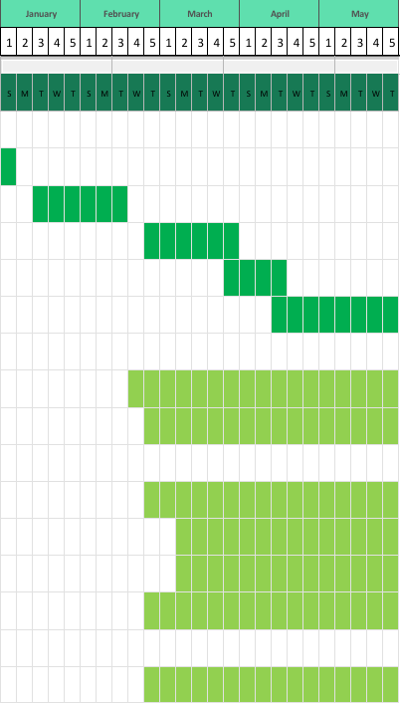
Project start date: 24/1/2026

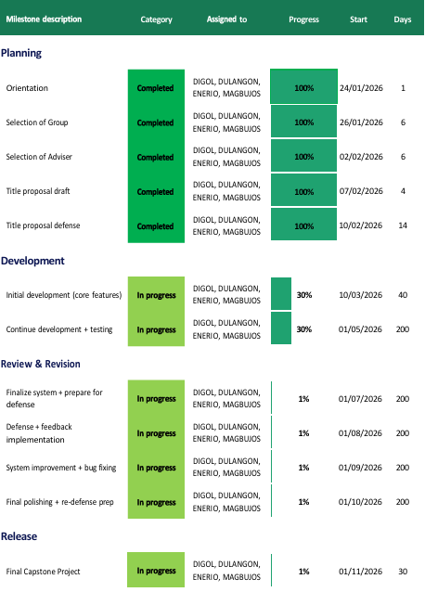
Scrolling Increment: 60

CAPSTONE PROJECT CALENDAR OF ACTIVITIES
STI General Santos College G.S.C. Legend:
Completed
On progress
WEB-BASED MANAGEMENT SYSTEM FOR PSITS REGION XII

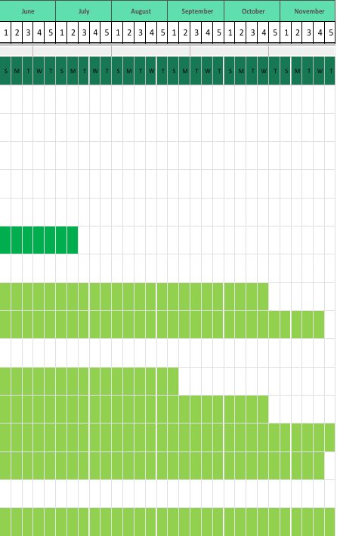
Project start date: 24/01/2026
Scrolling increment: 60

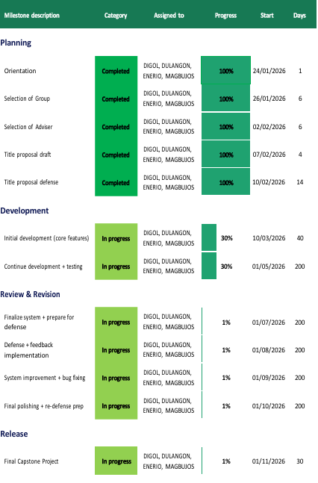

APPENDIX B.

(DIAGRAMS)

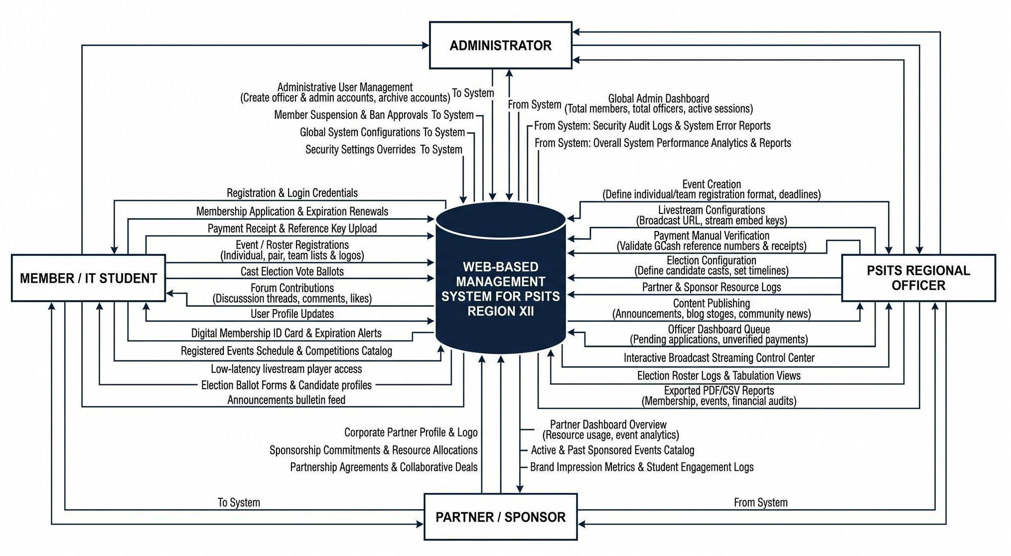

Figure 3: Contextual Flow Diagram (Proposed System)
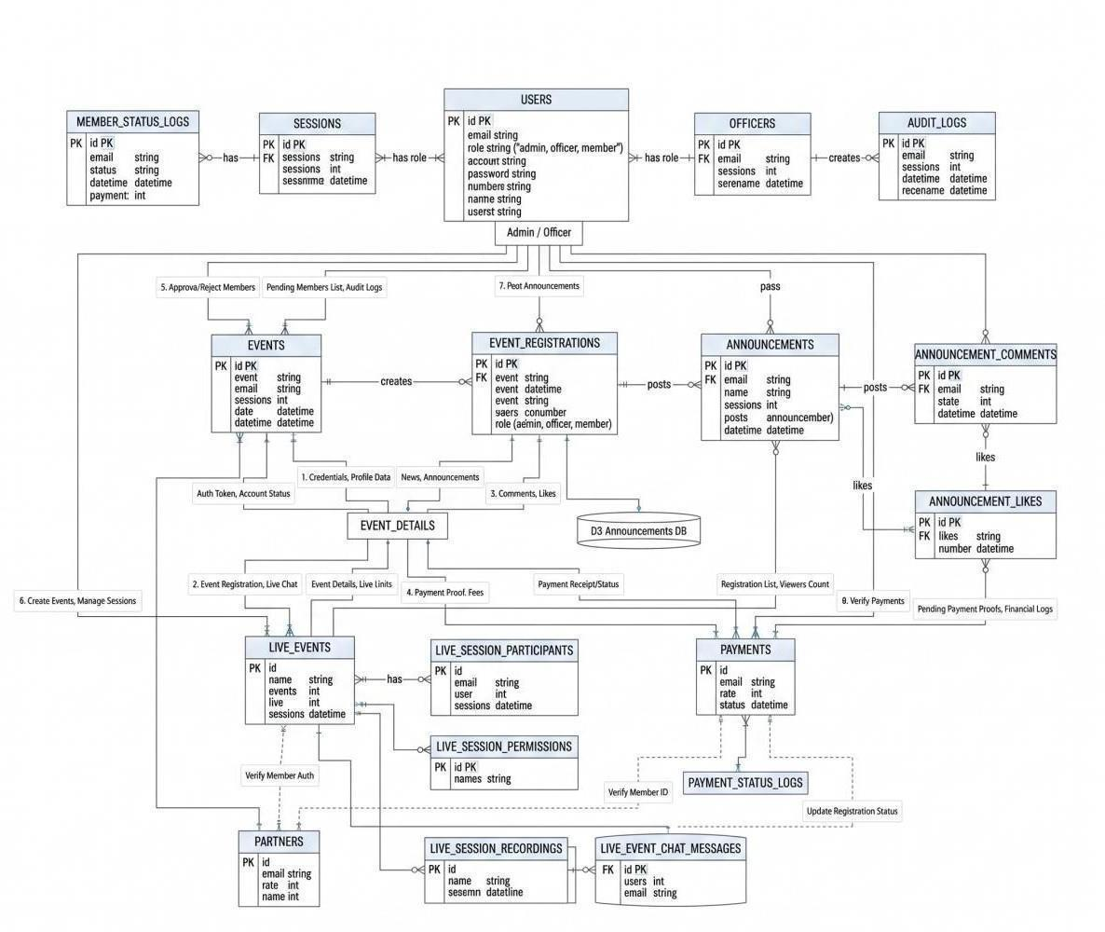

Figure 3.1: Entity Relationship Diagram

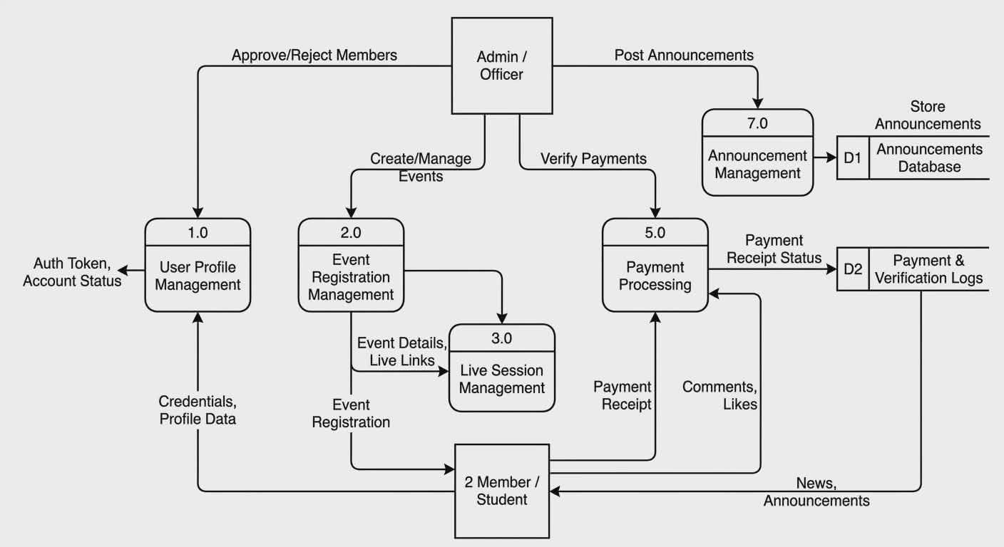

Figure 3.2 : Data Flow Diagram

APPENDIX C.

(MOCKUP)
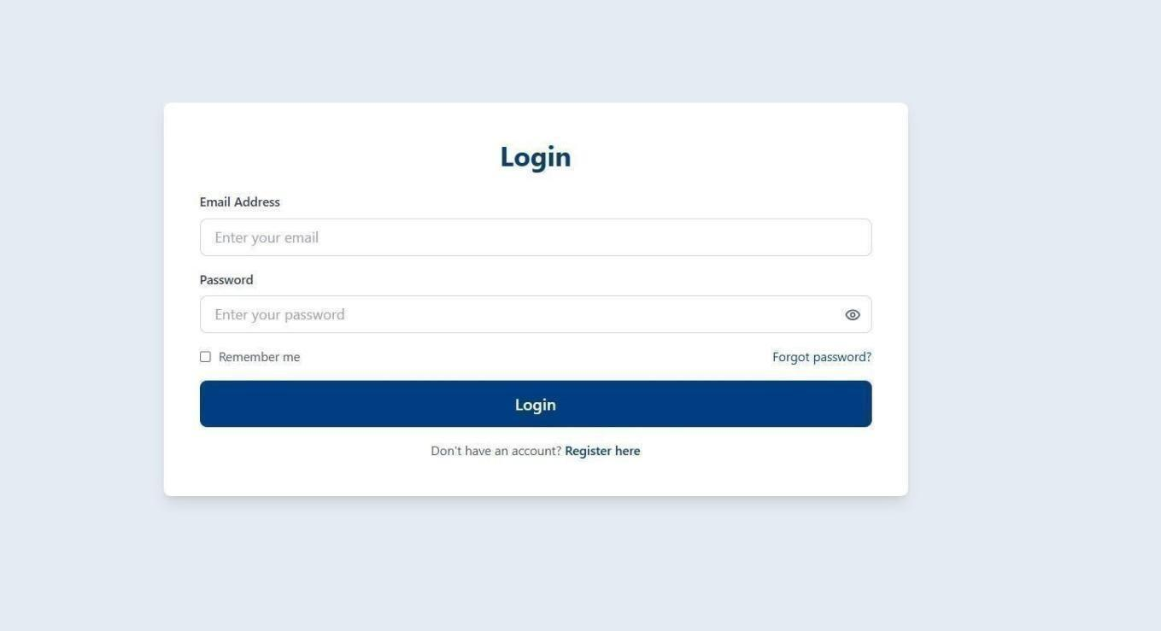
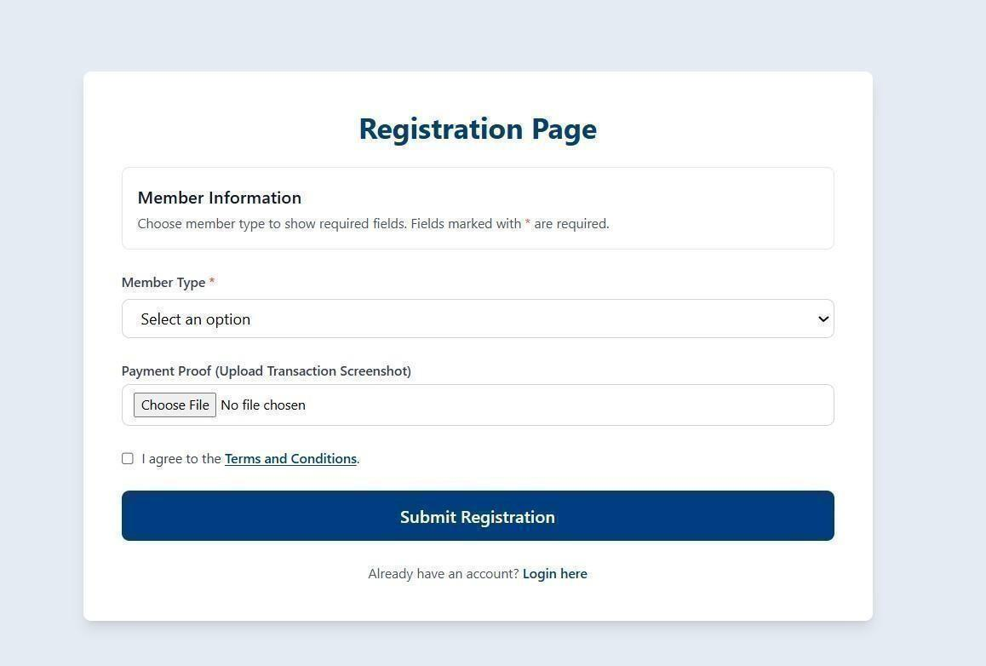
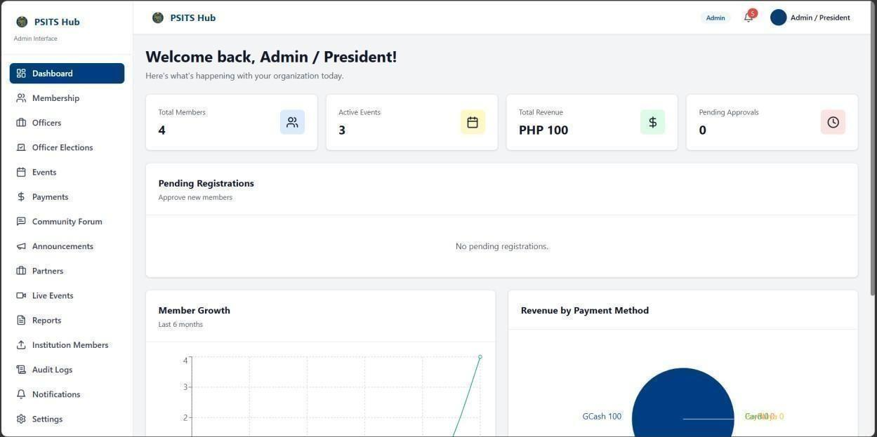
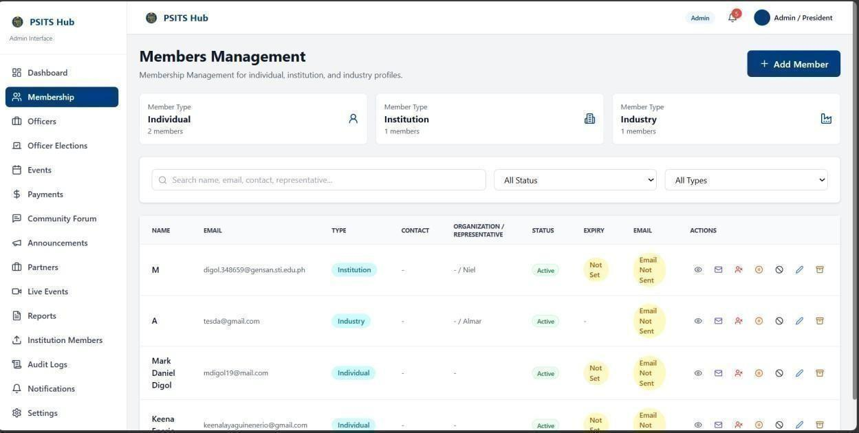
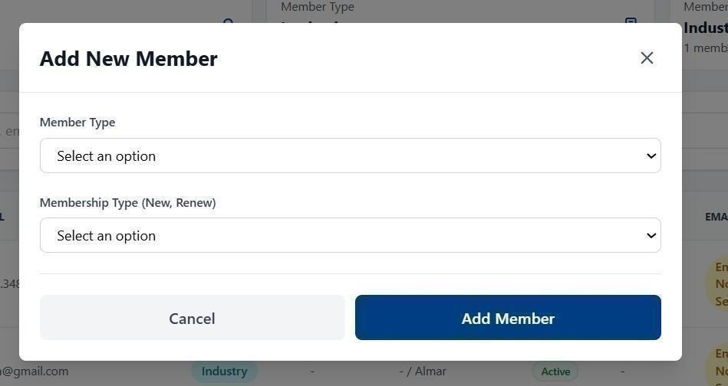
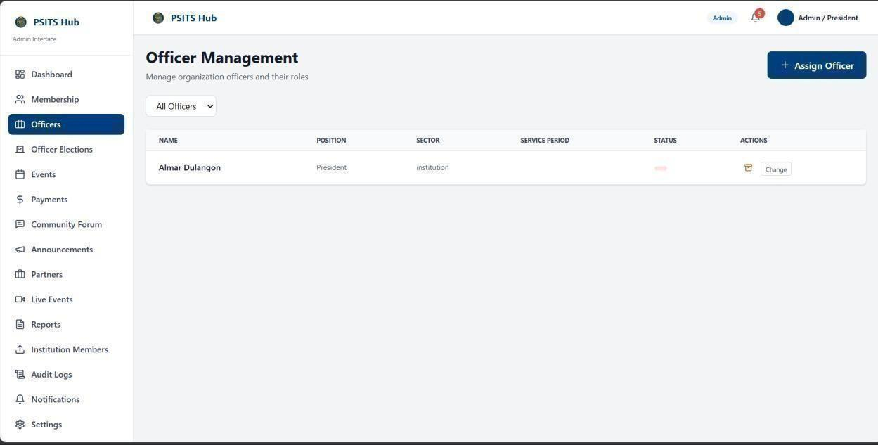
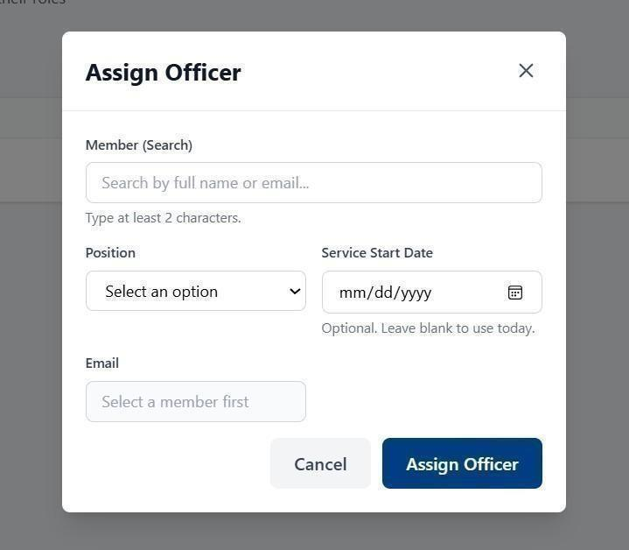
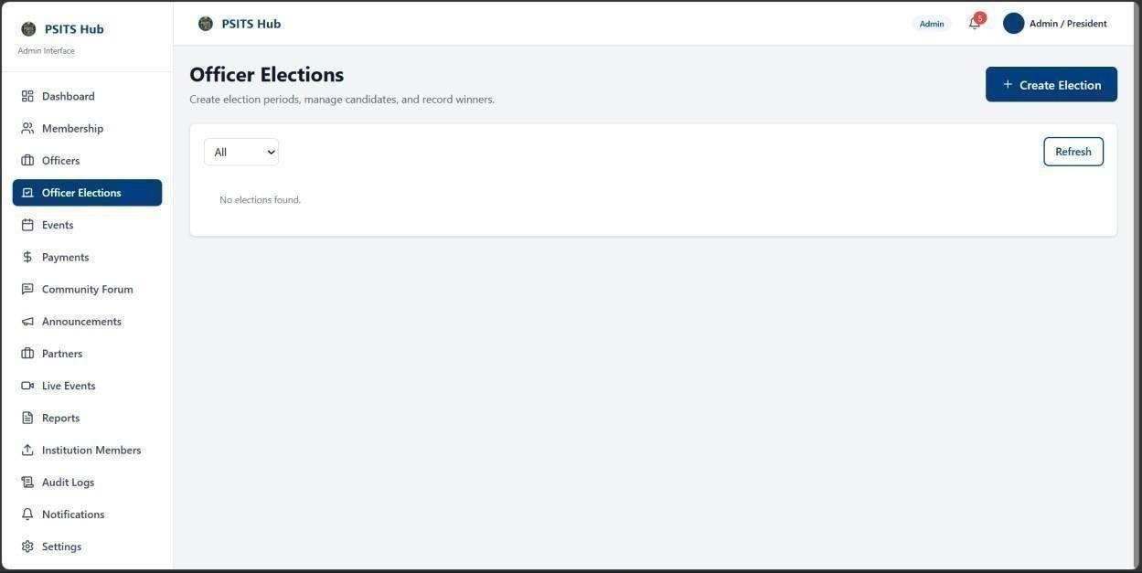
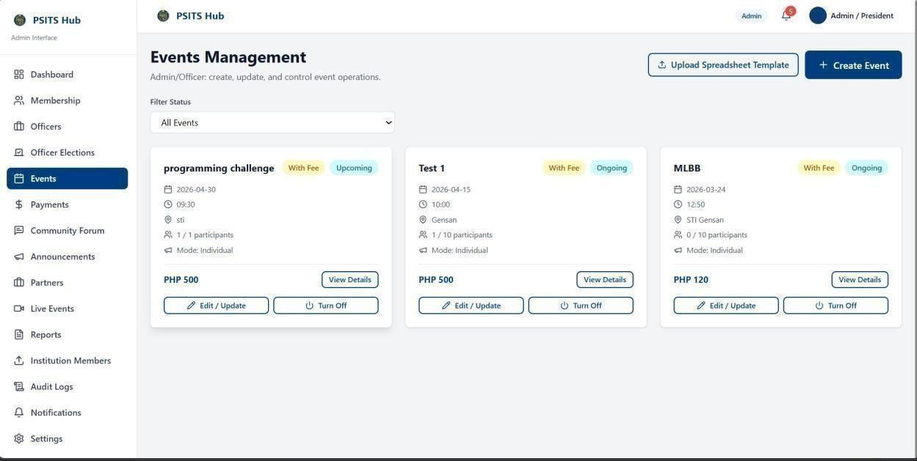
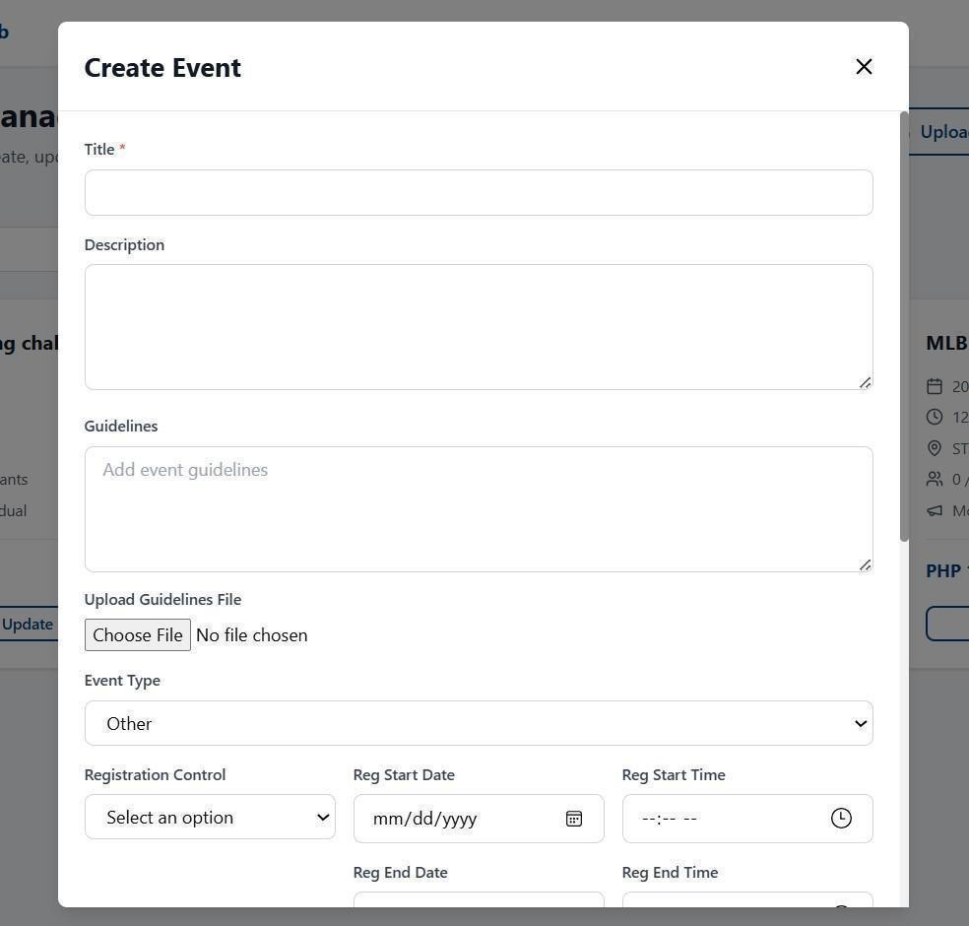
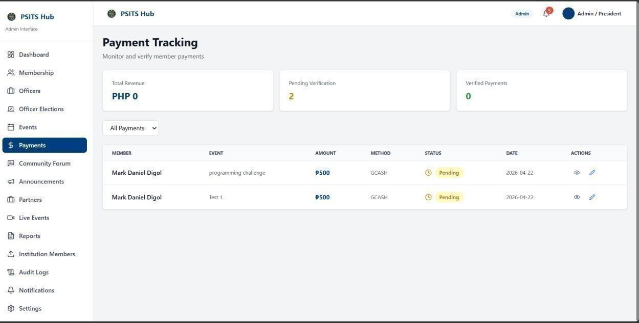
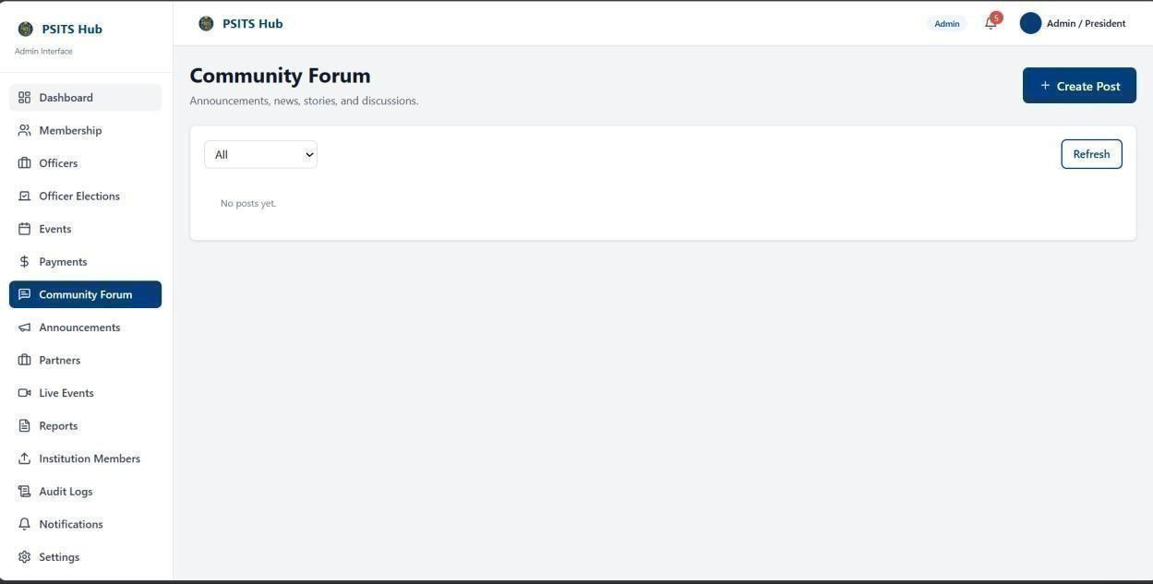
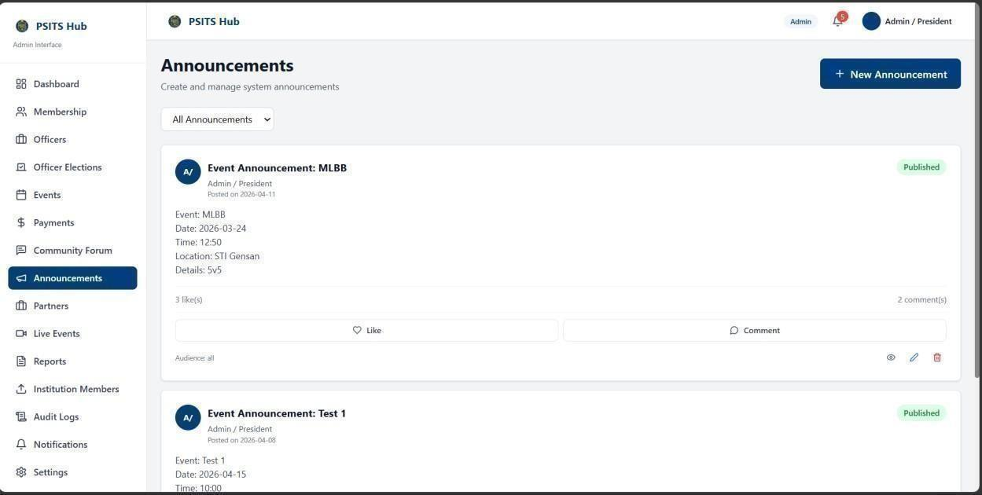
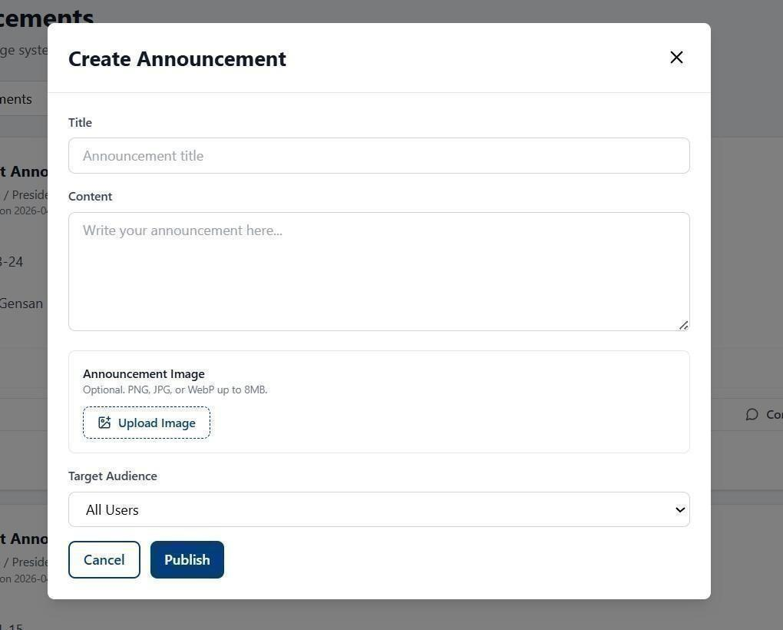
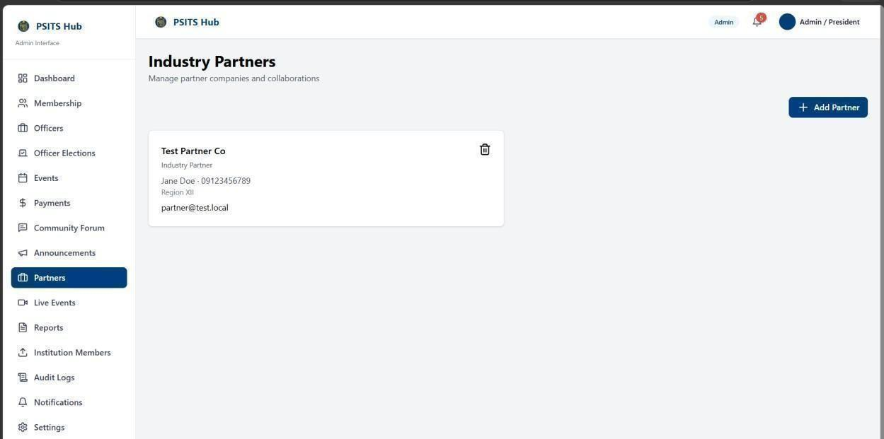
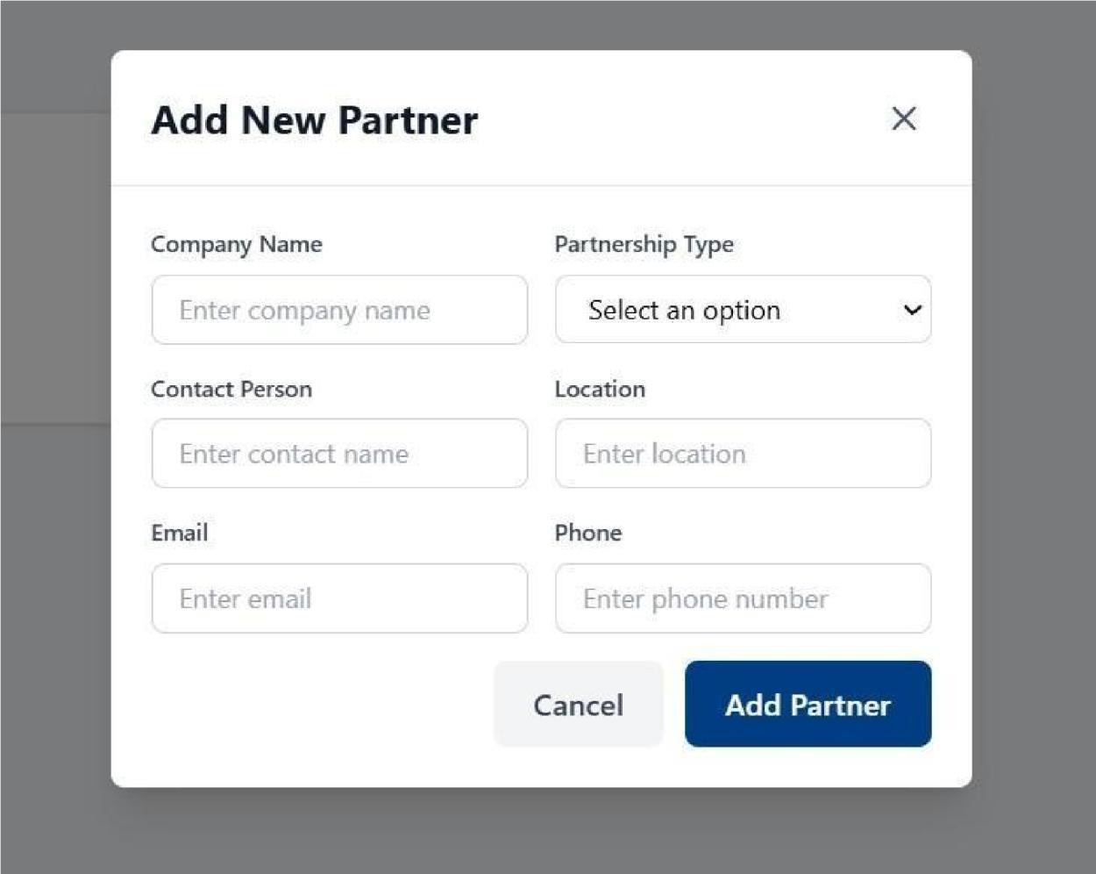
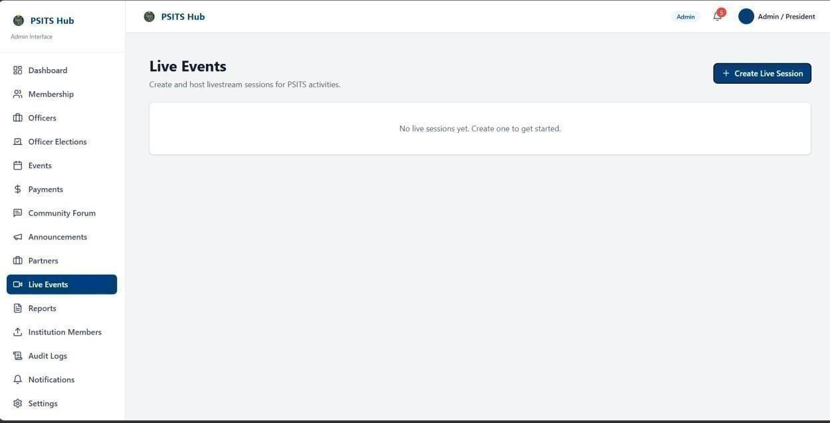
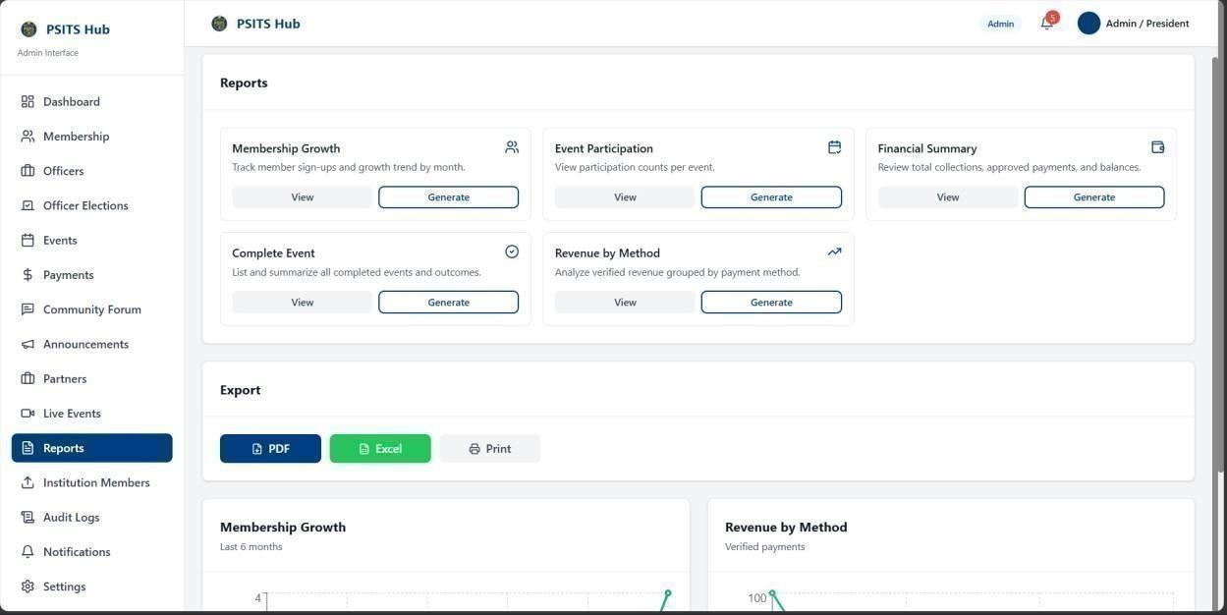
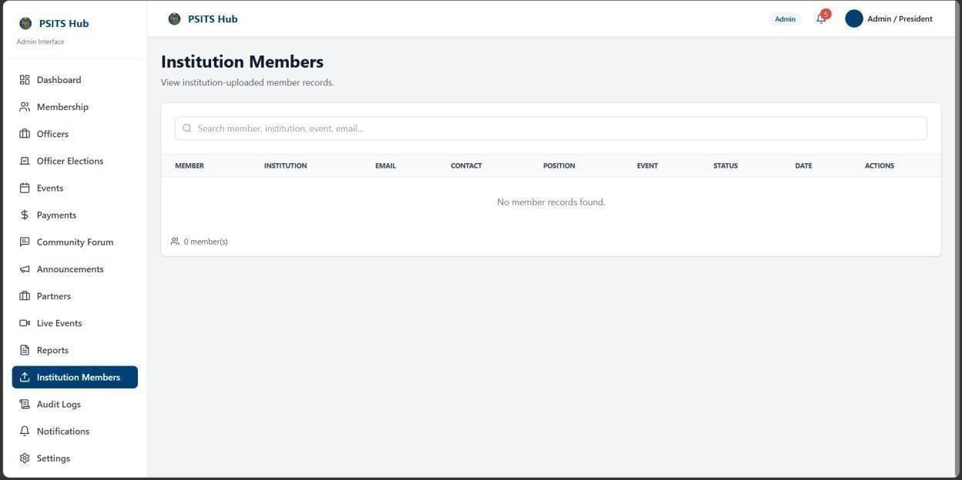
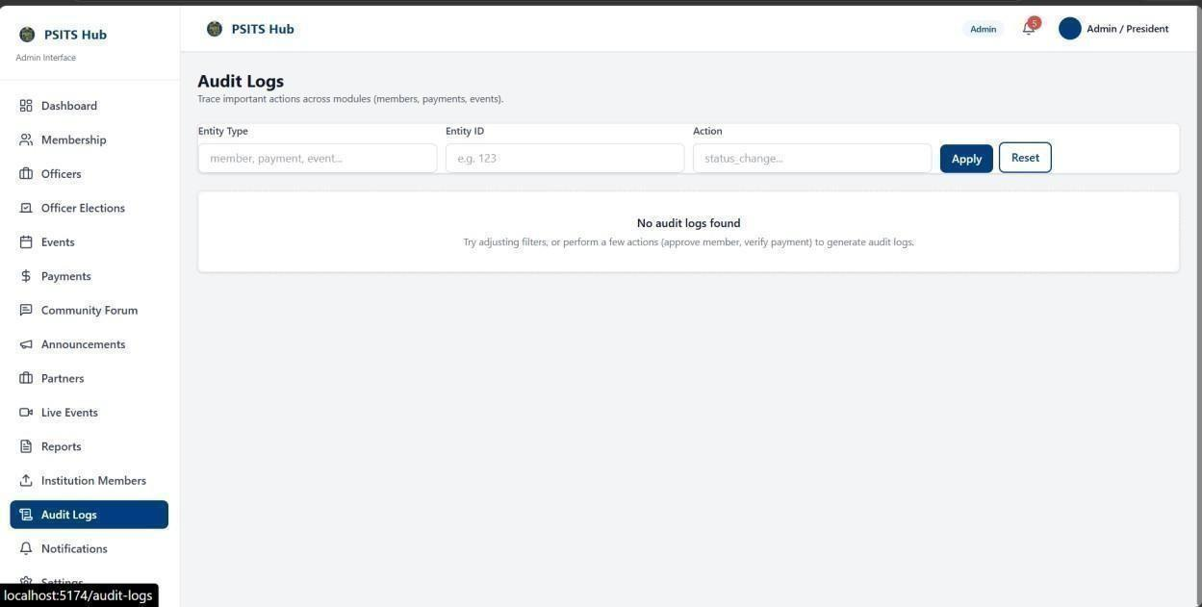
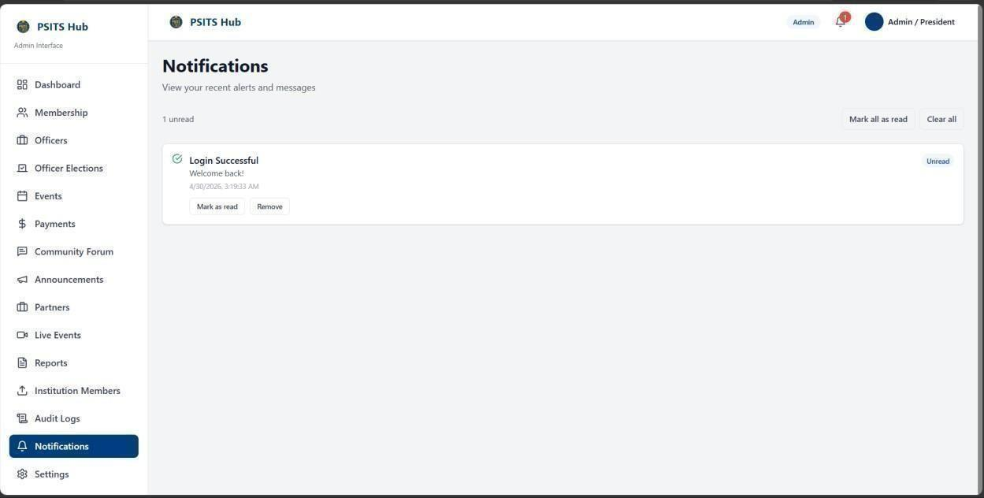
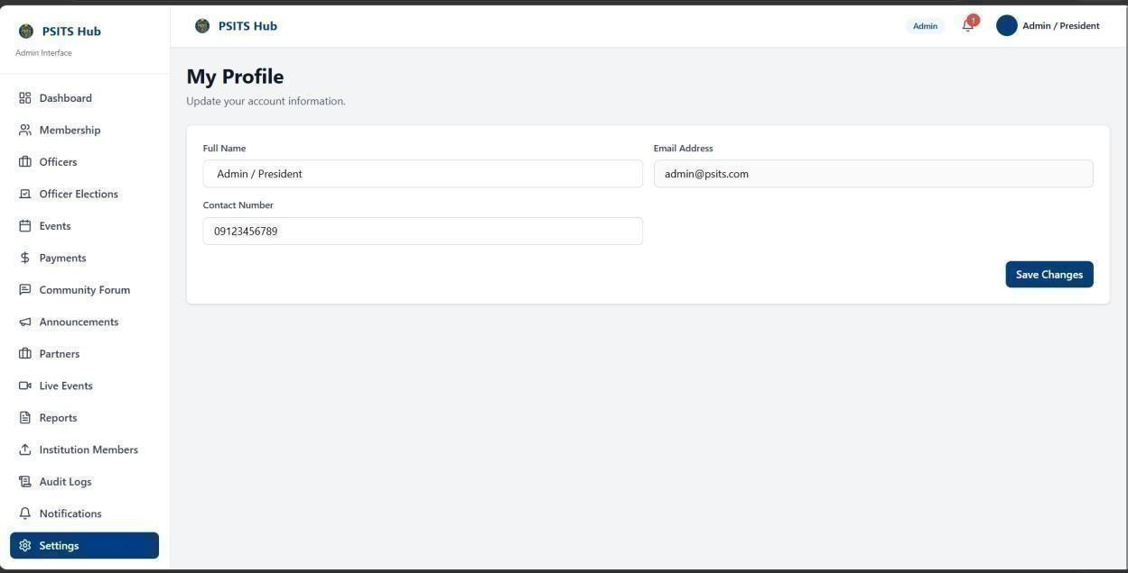
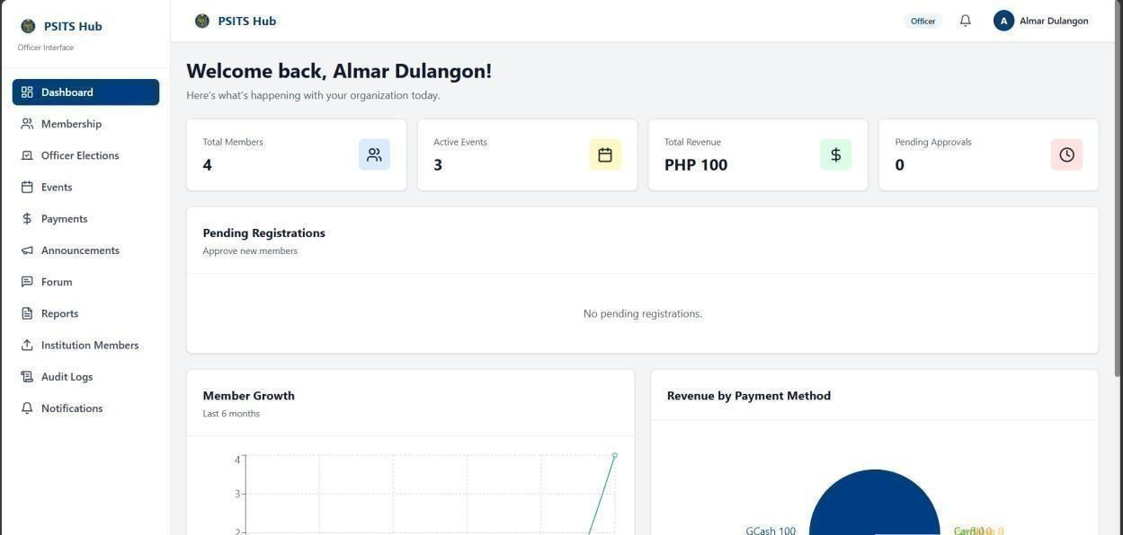
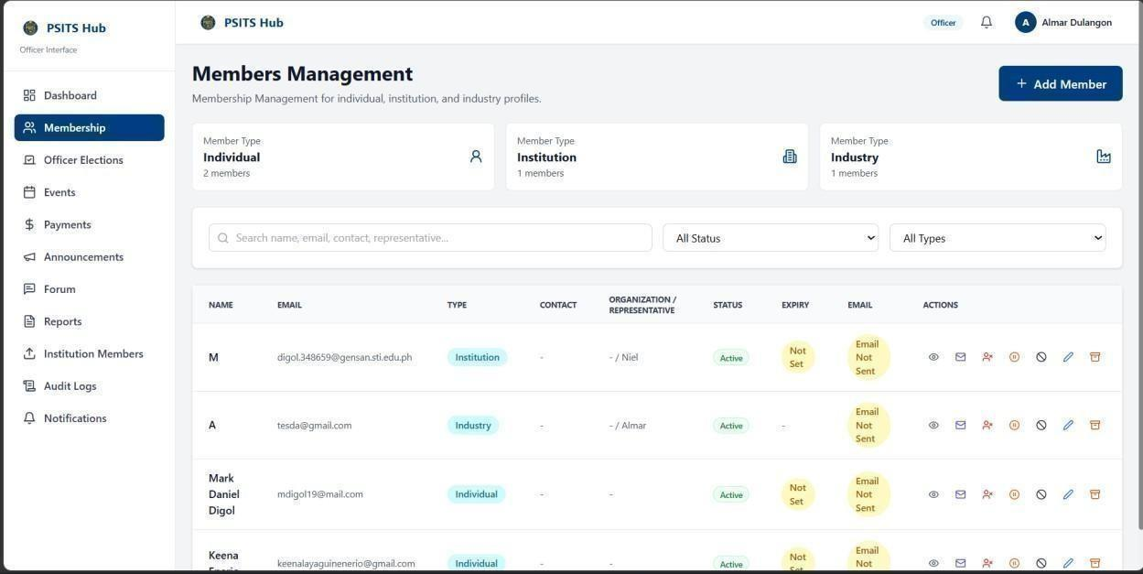
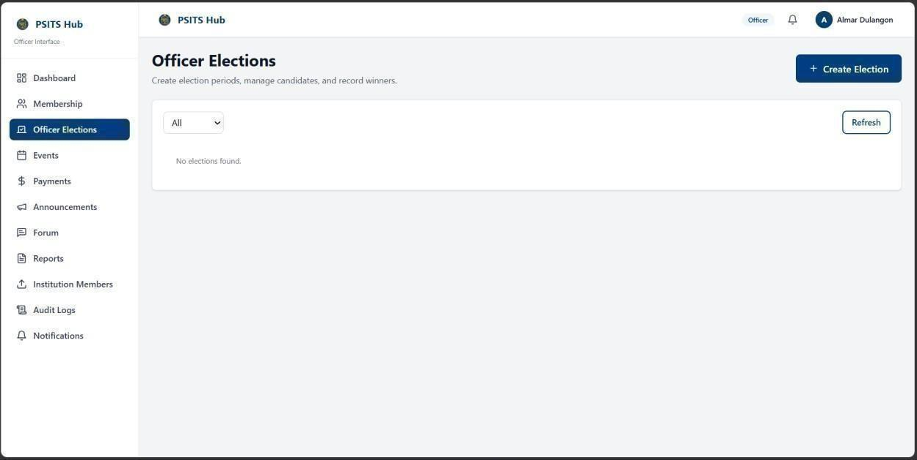
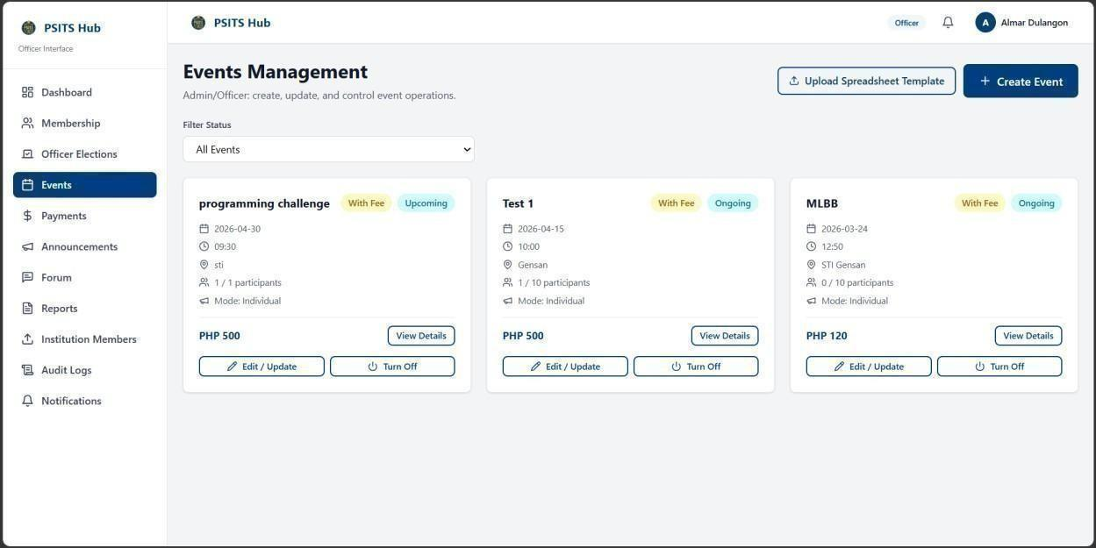
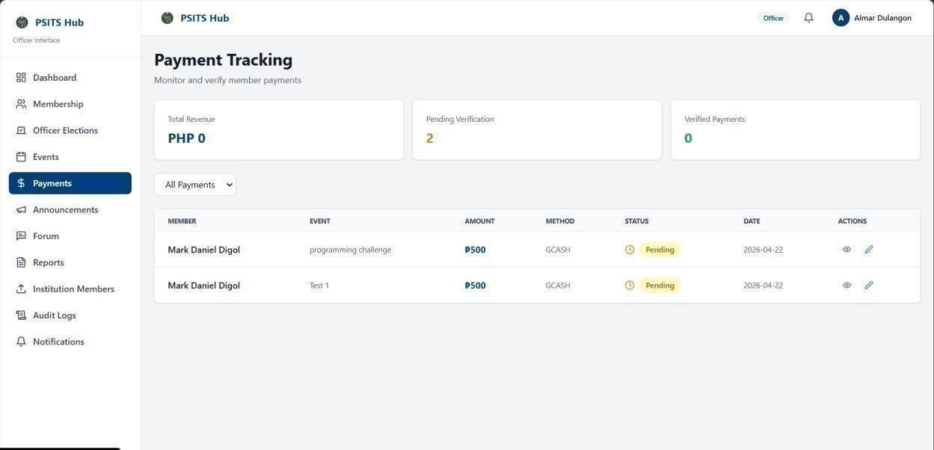
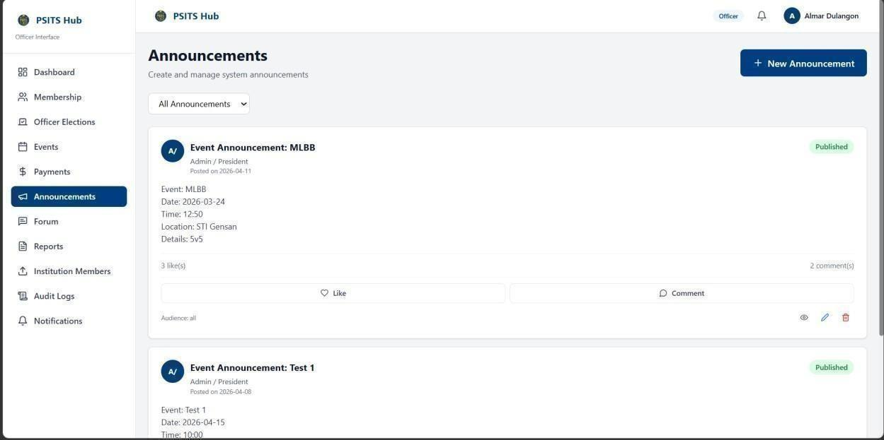
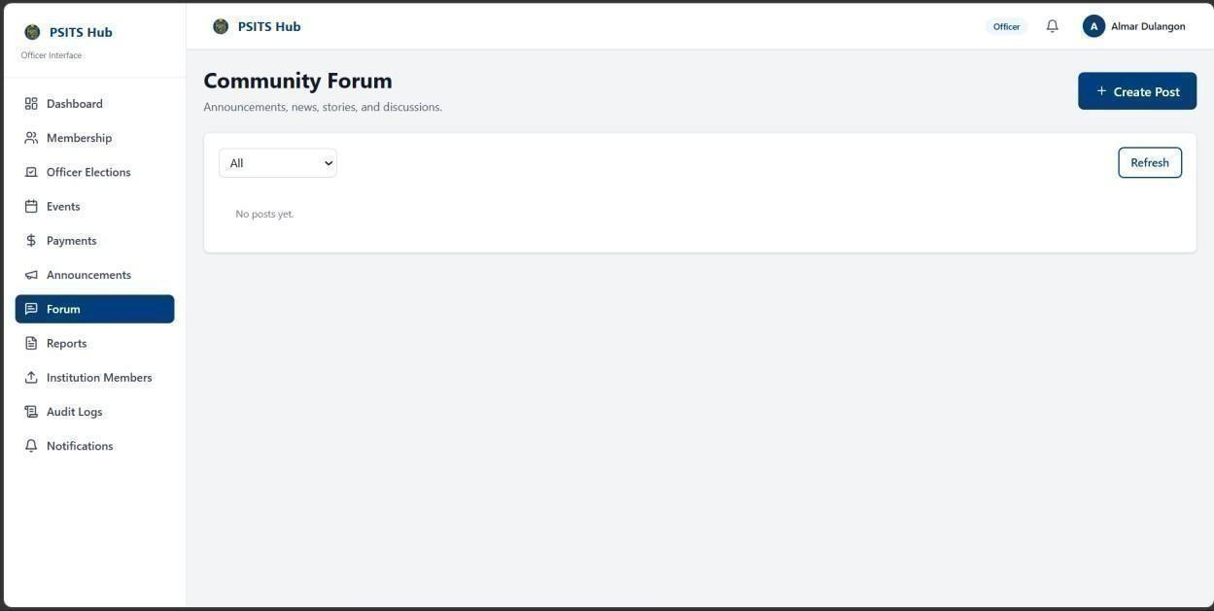
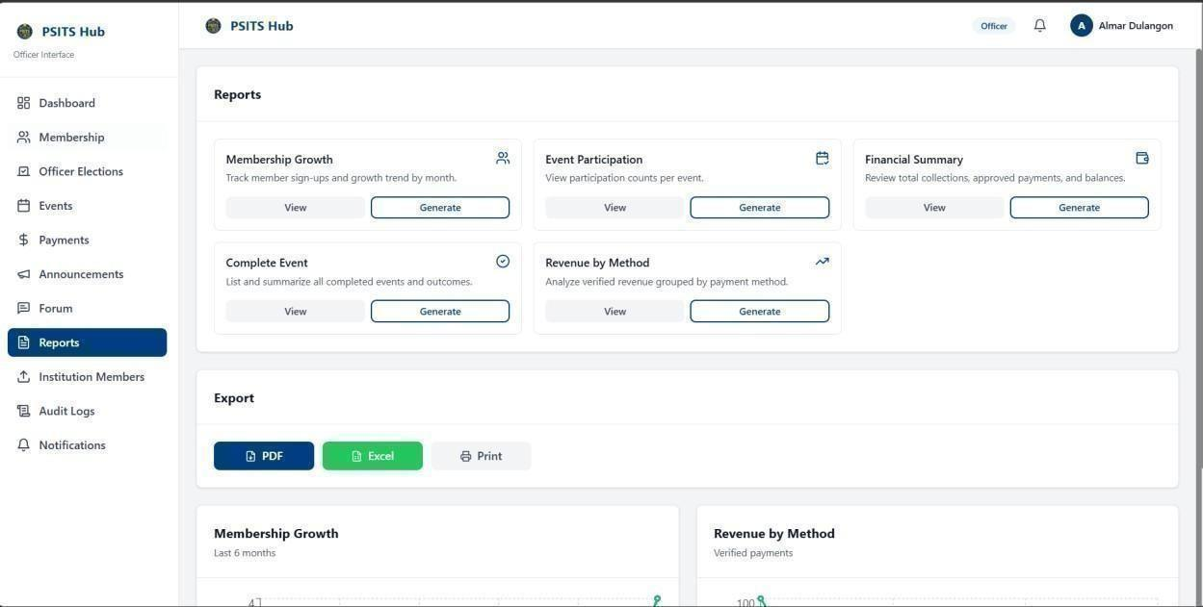
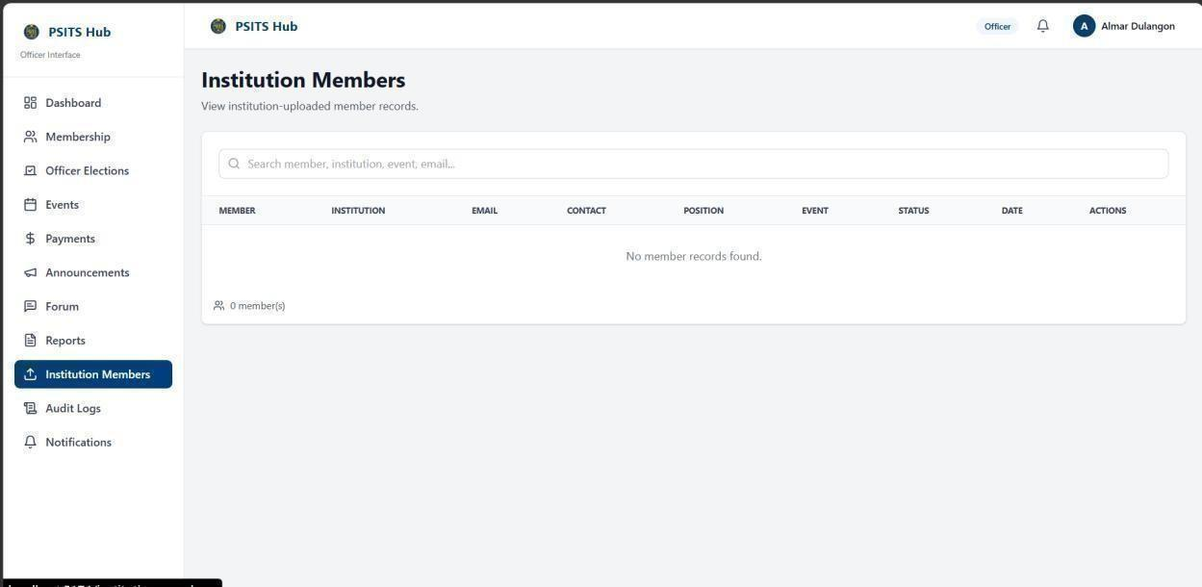
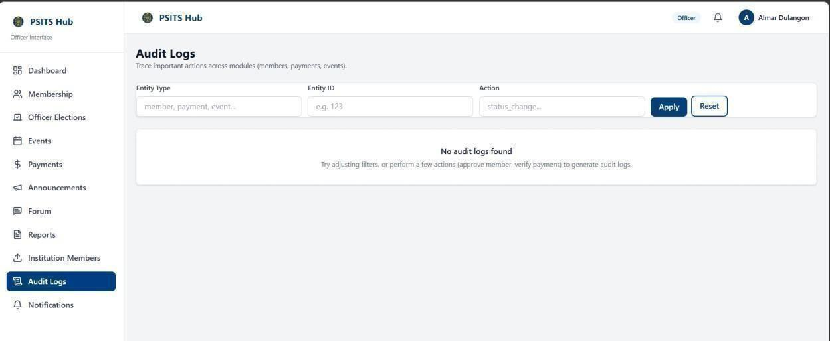
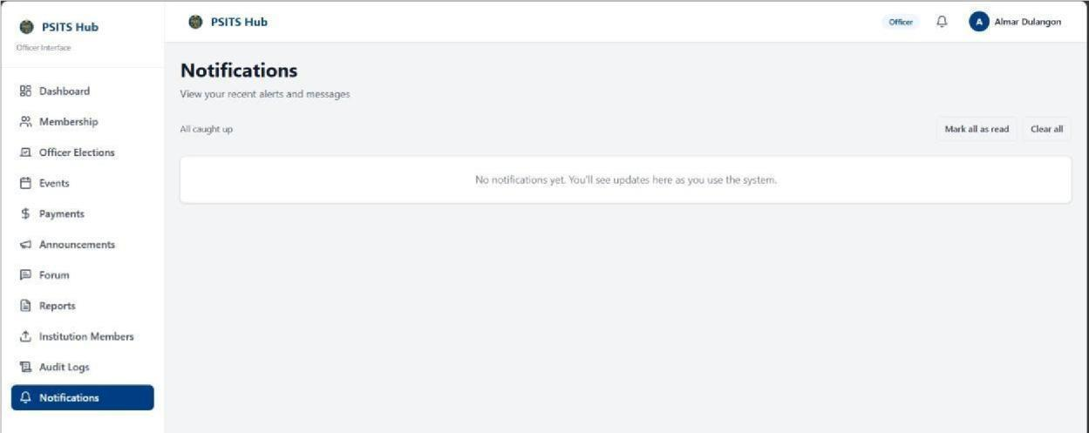

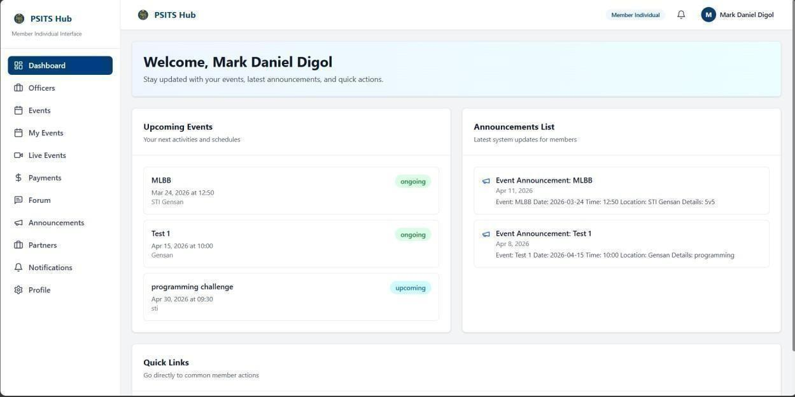
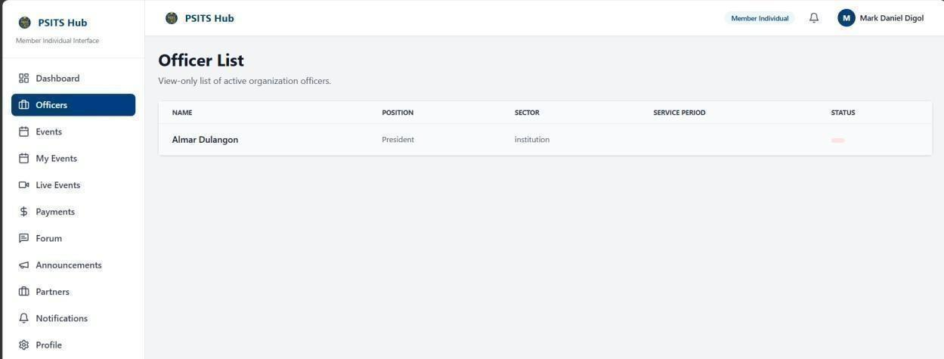
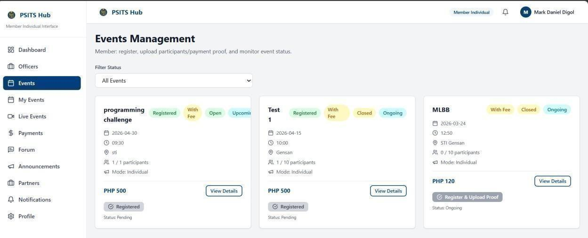
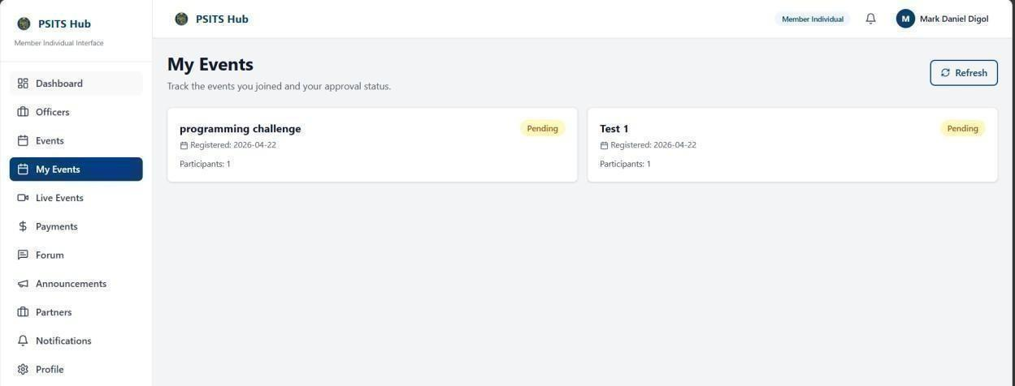

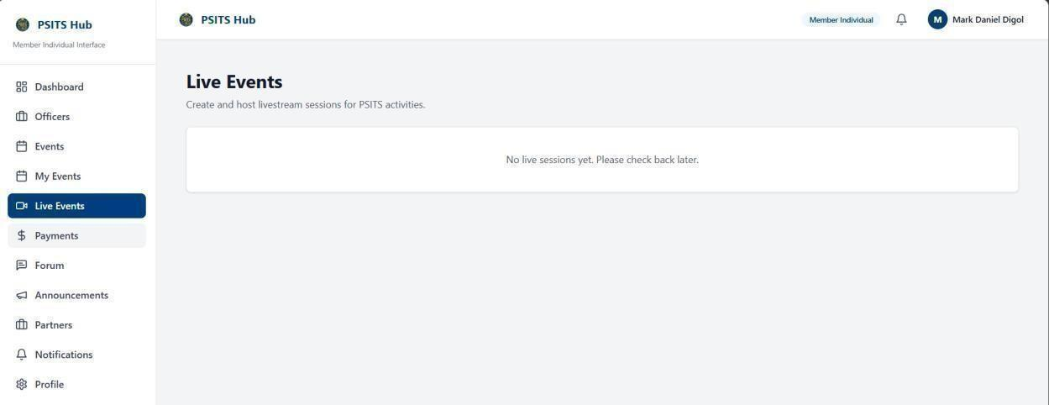
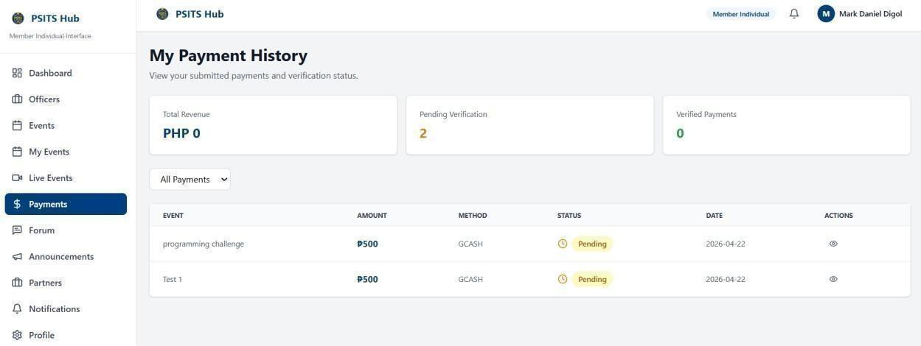
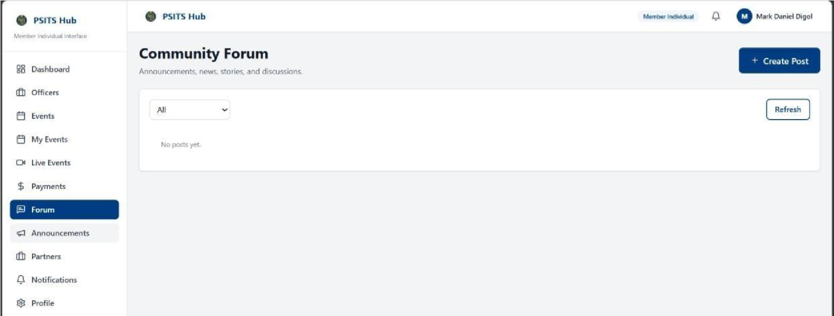

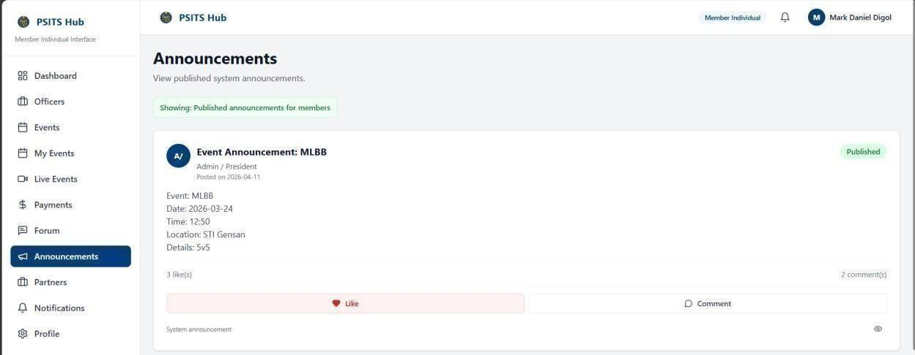
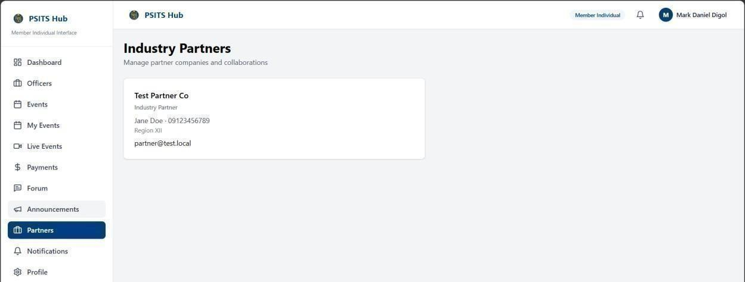
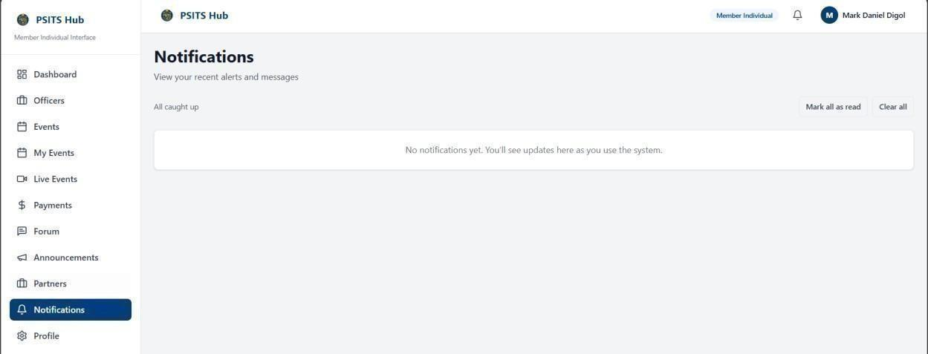

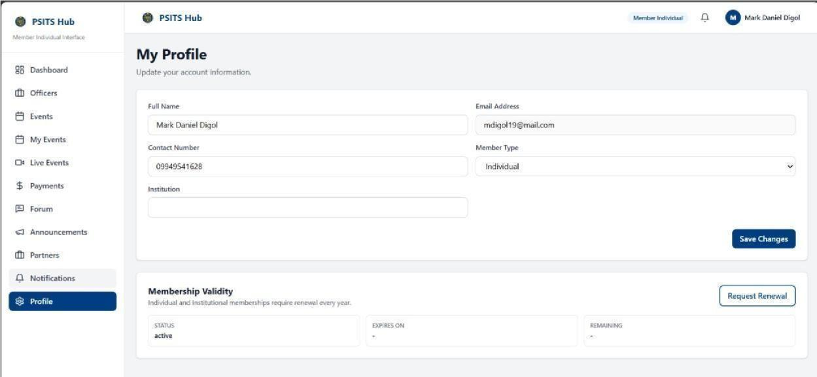

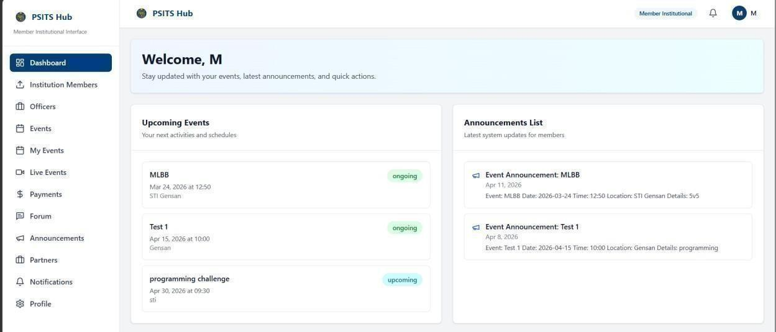
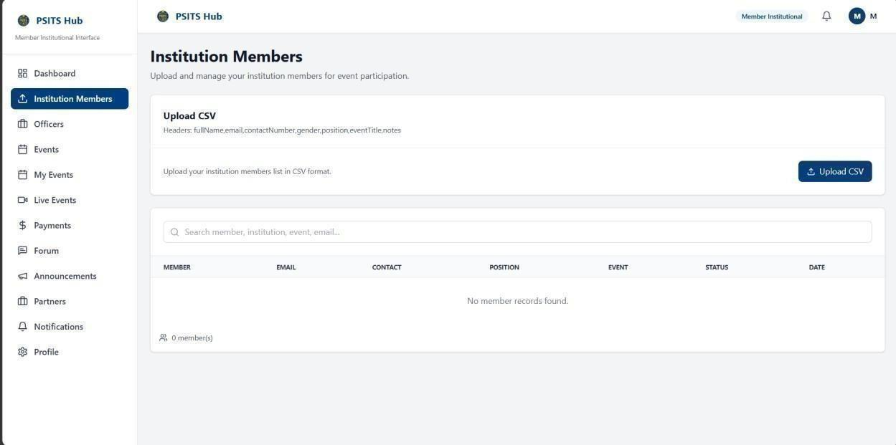
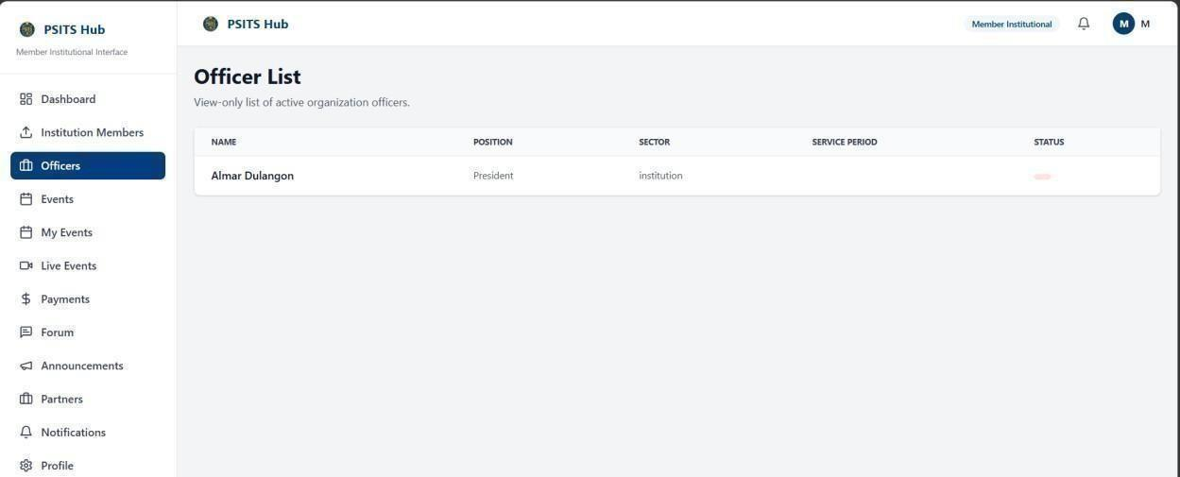
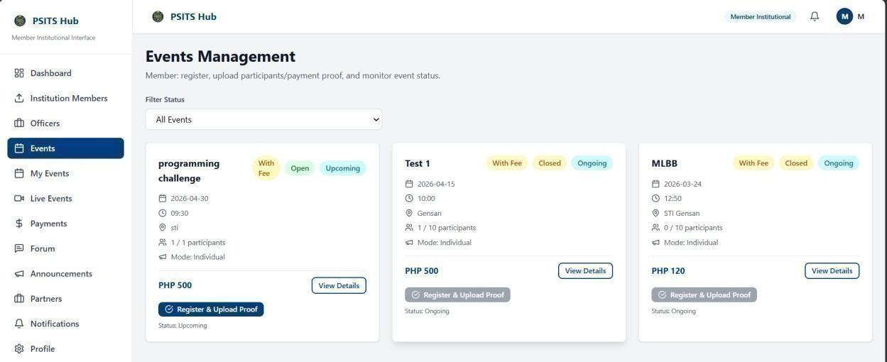
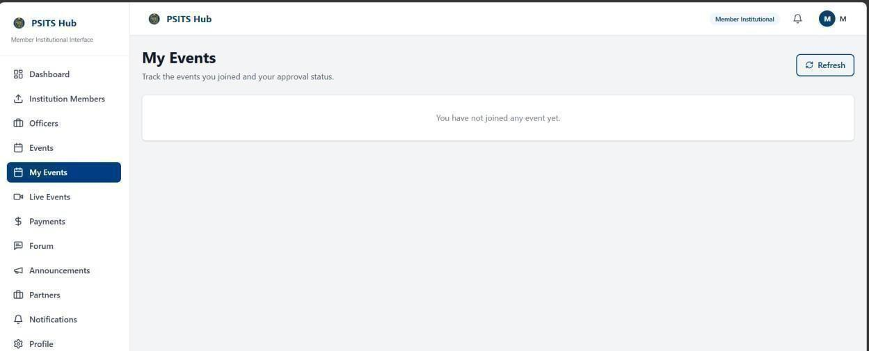

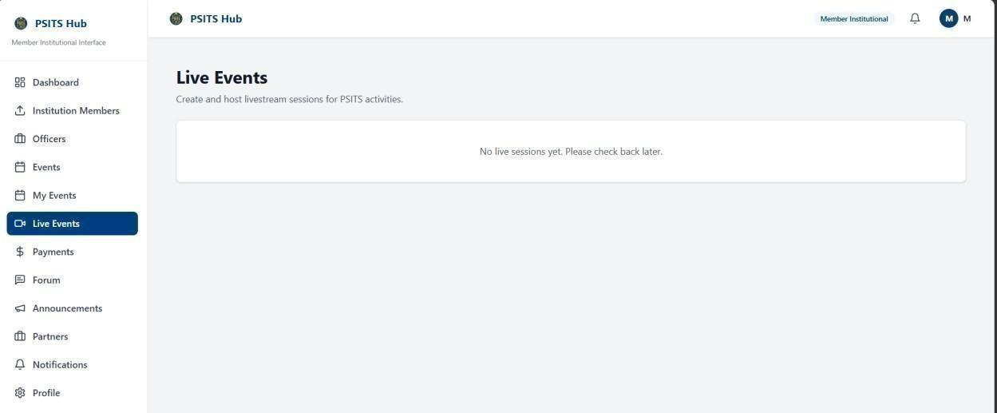
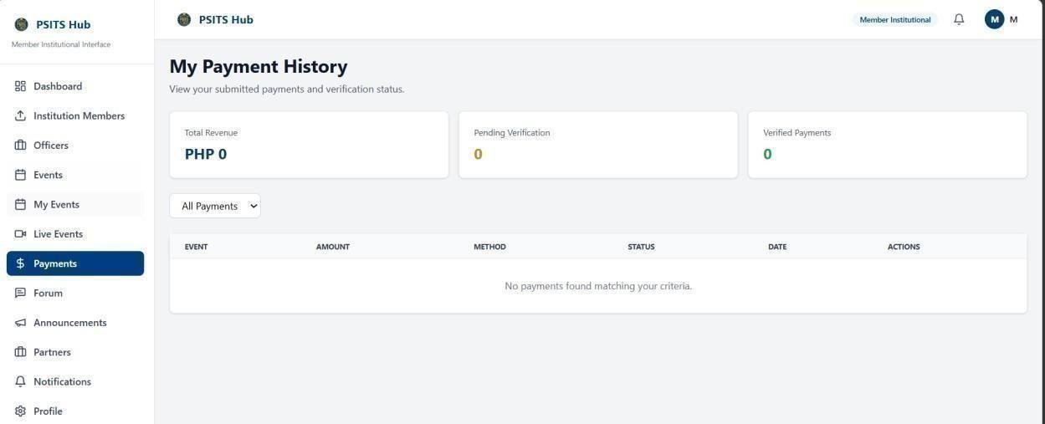
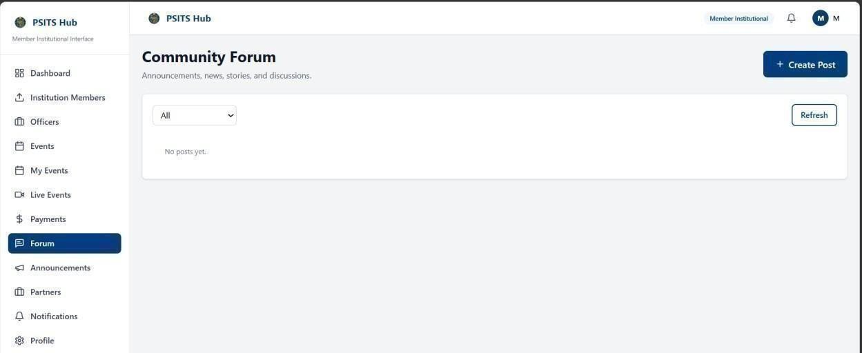
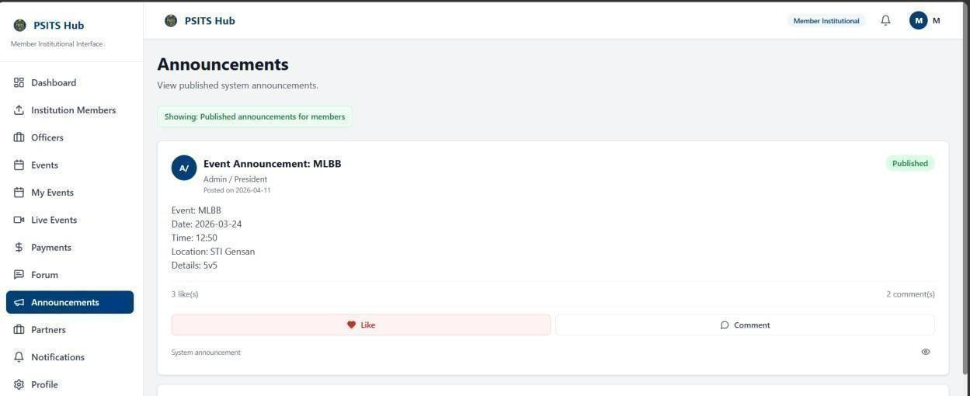

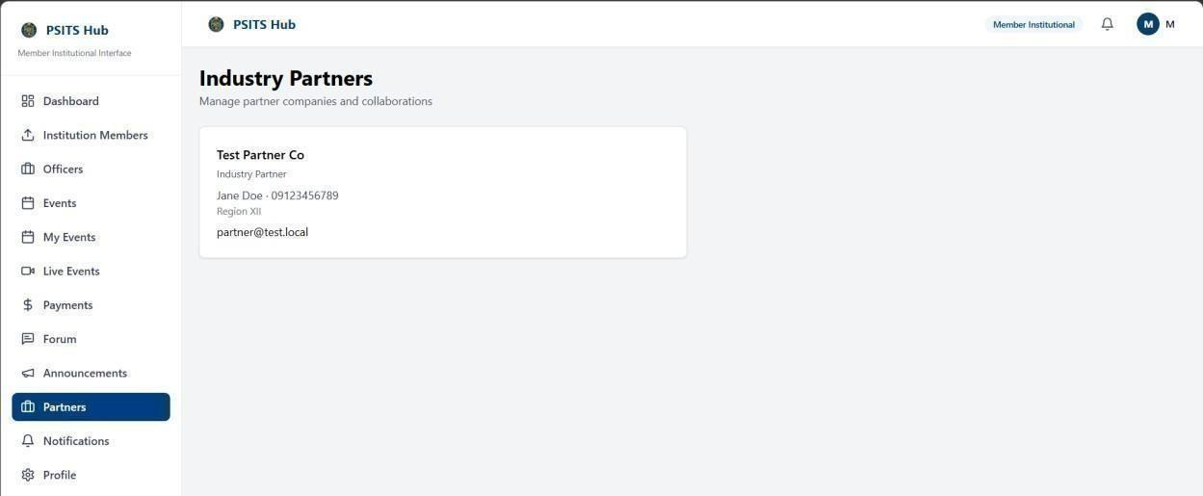
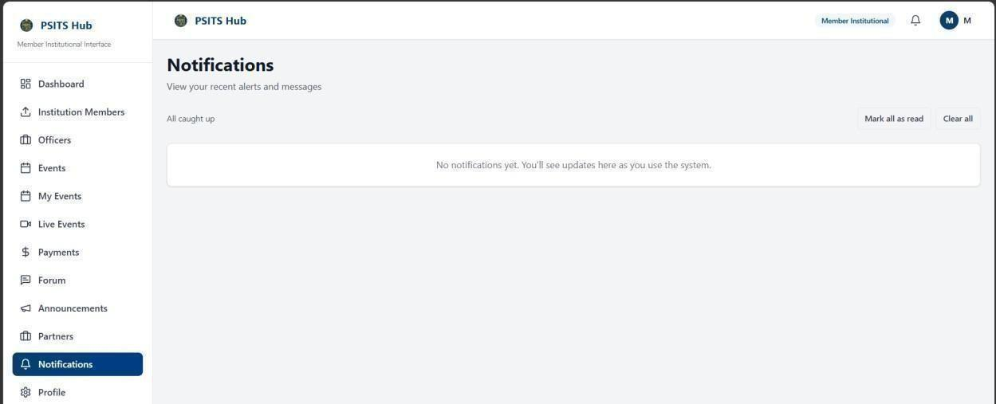
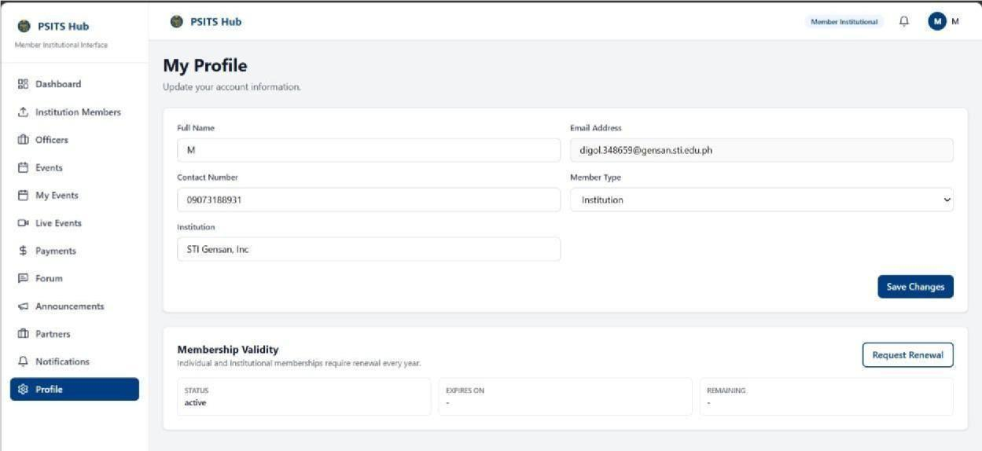
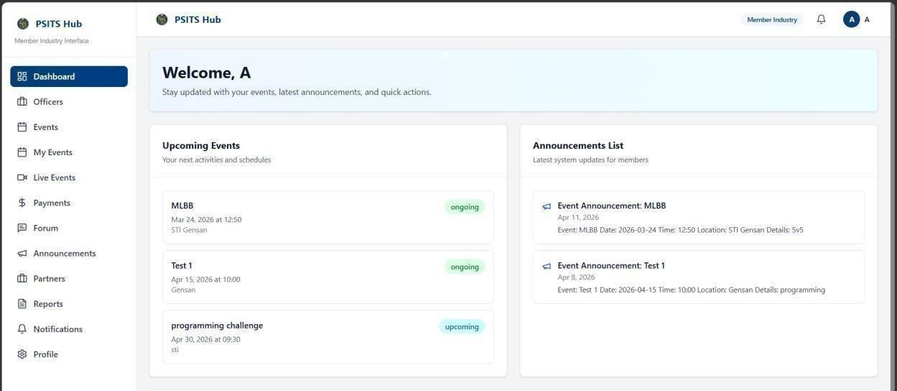
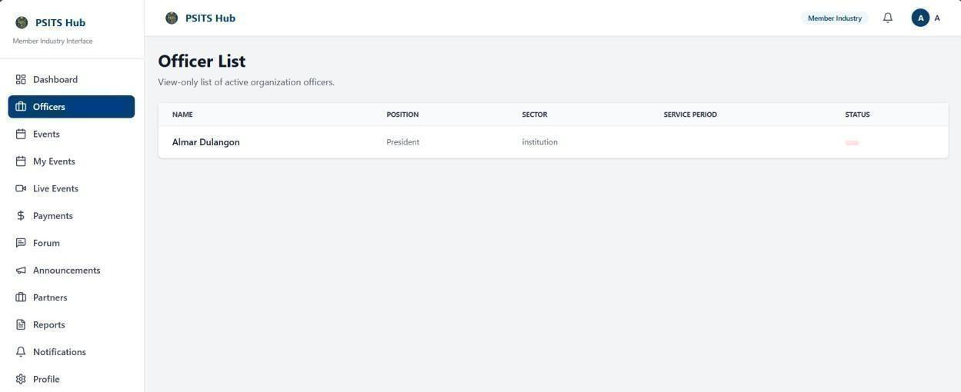
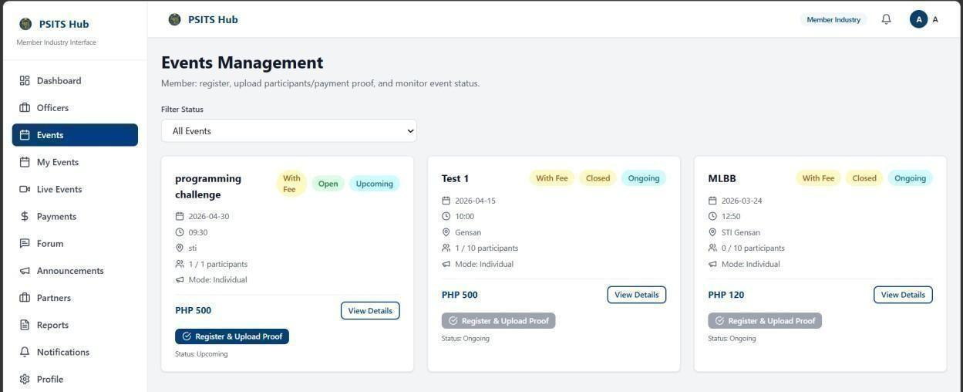
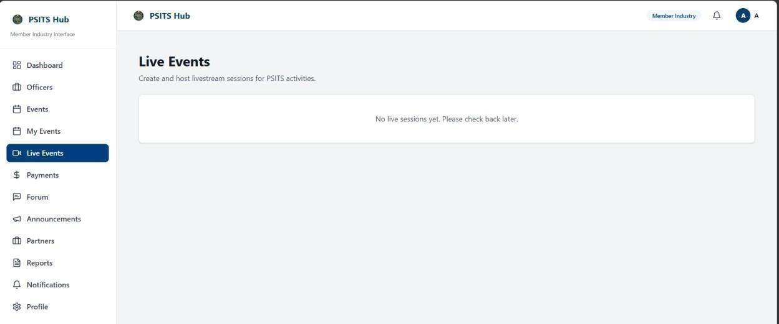

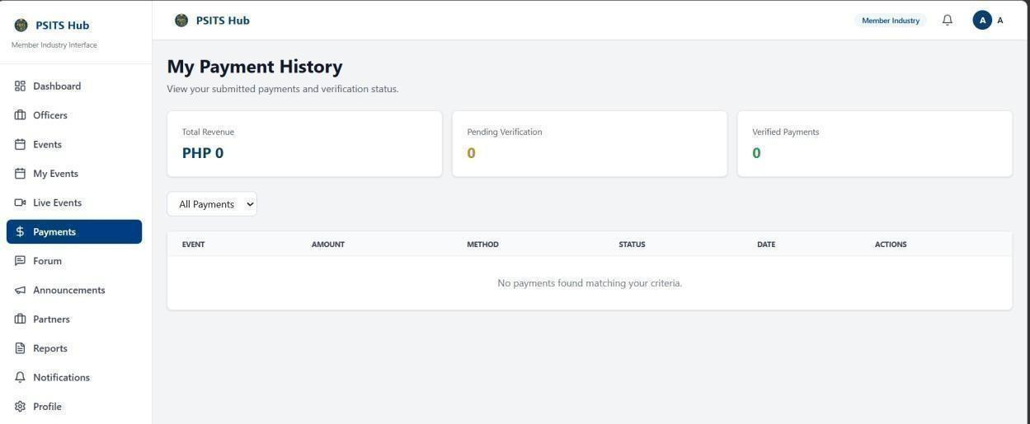
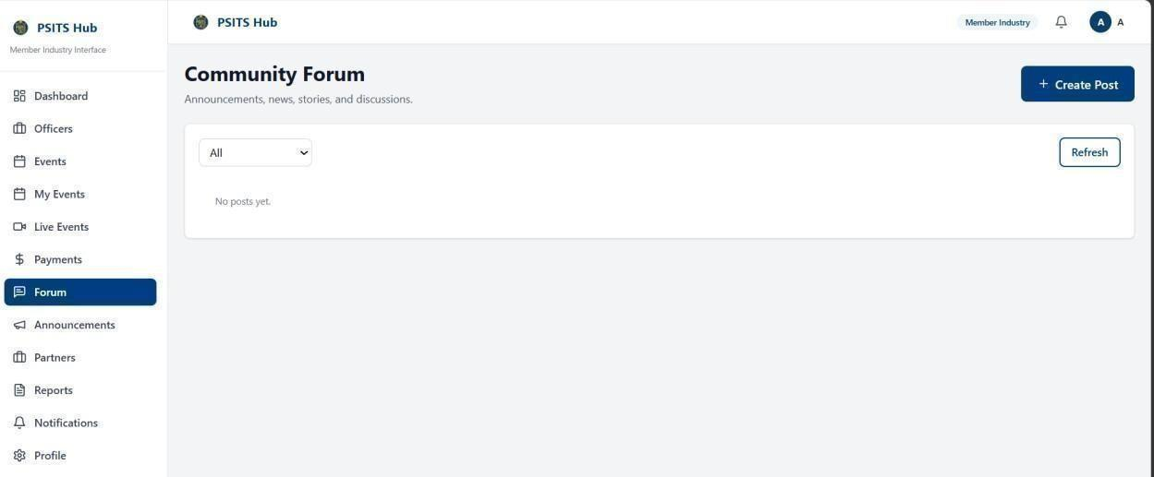
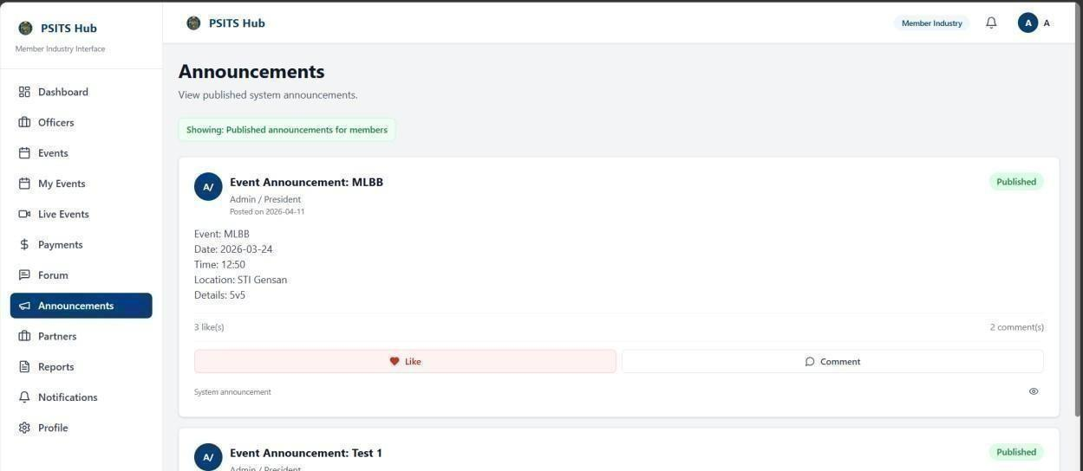

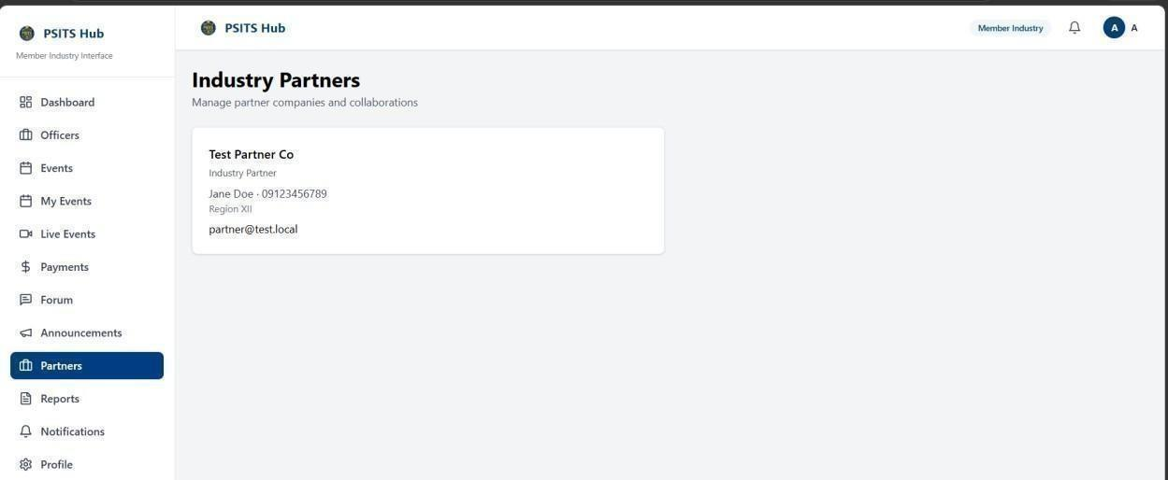
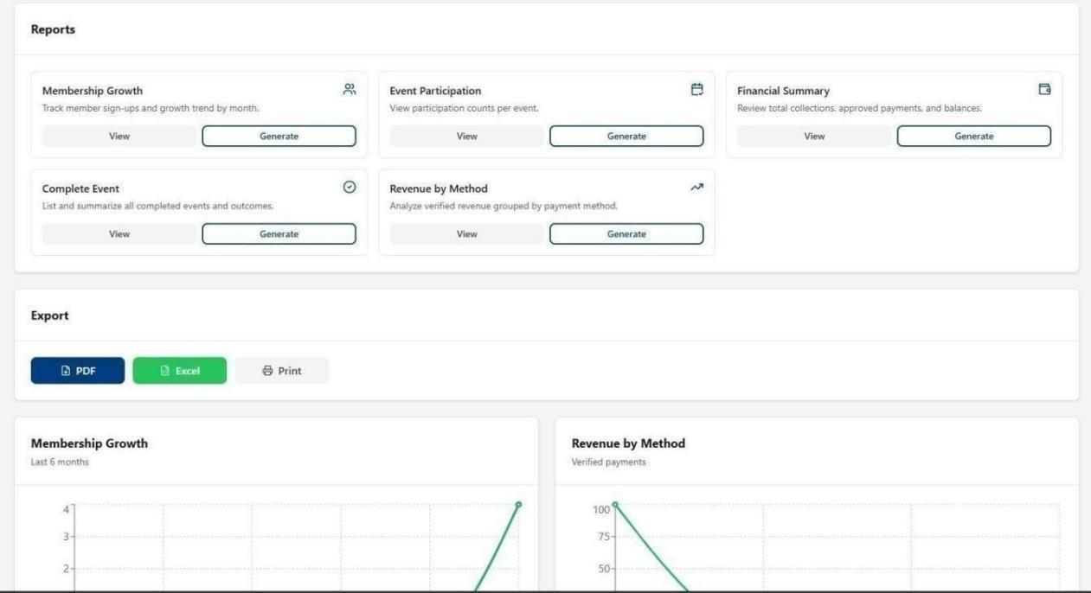
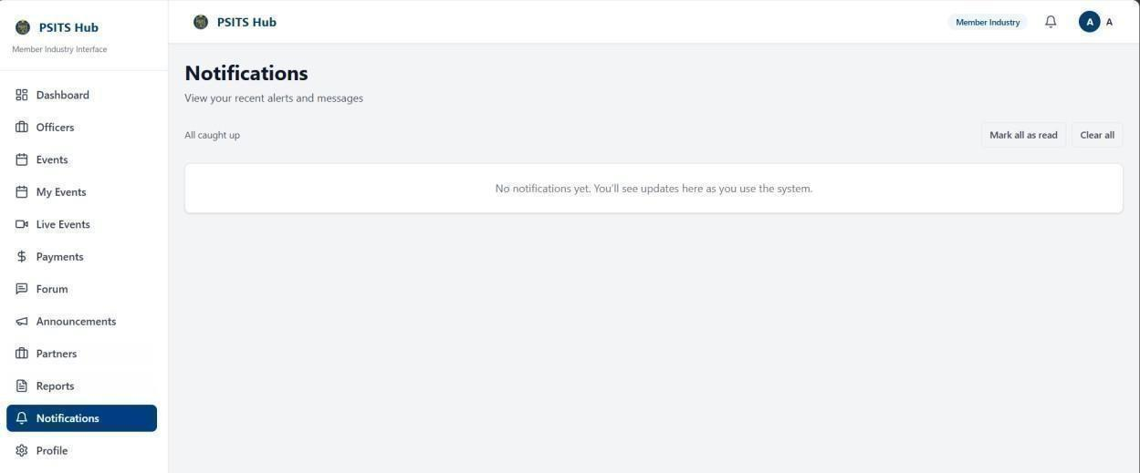
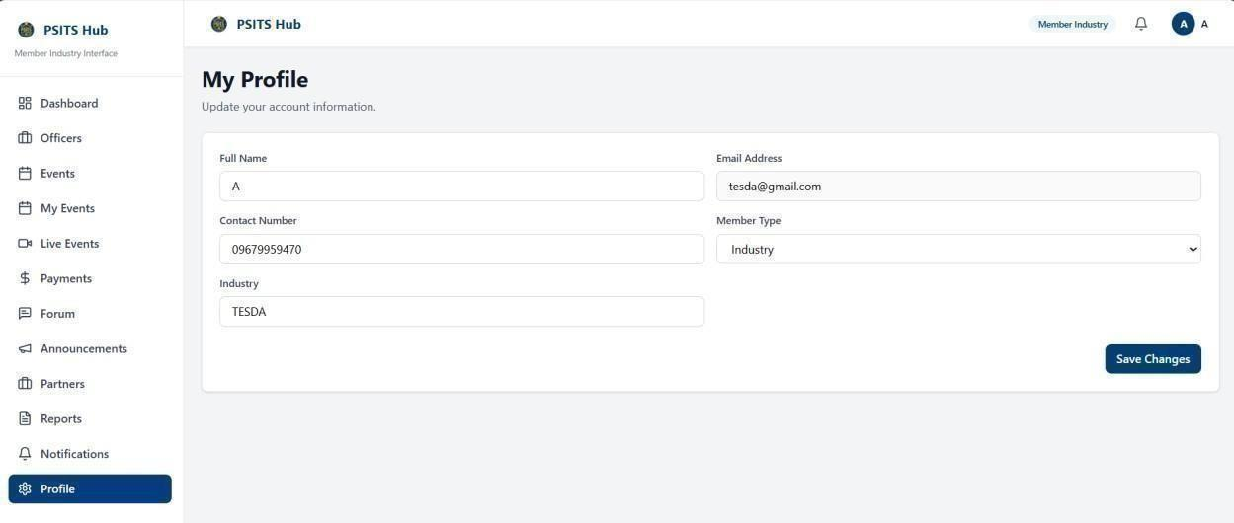

APPENDIX D. (INSTRUMENT VALIDATION TOOL)
Figure 5: Instrument Validation Tool (Part 1)

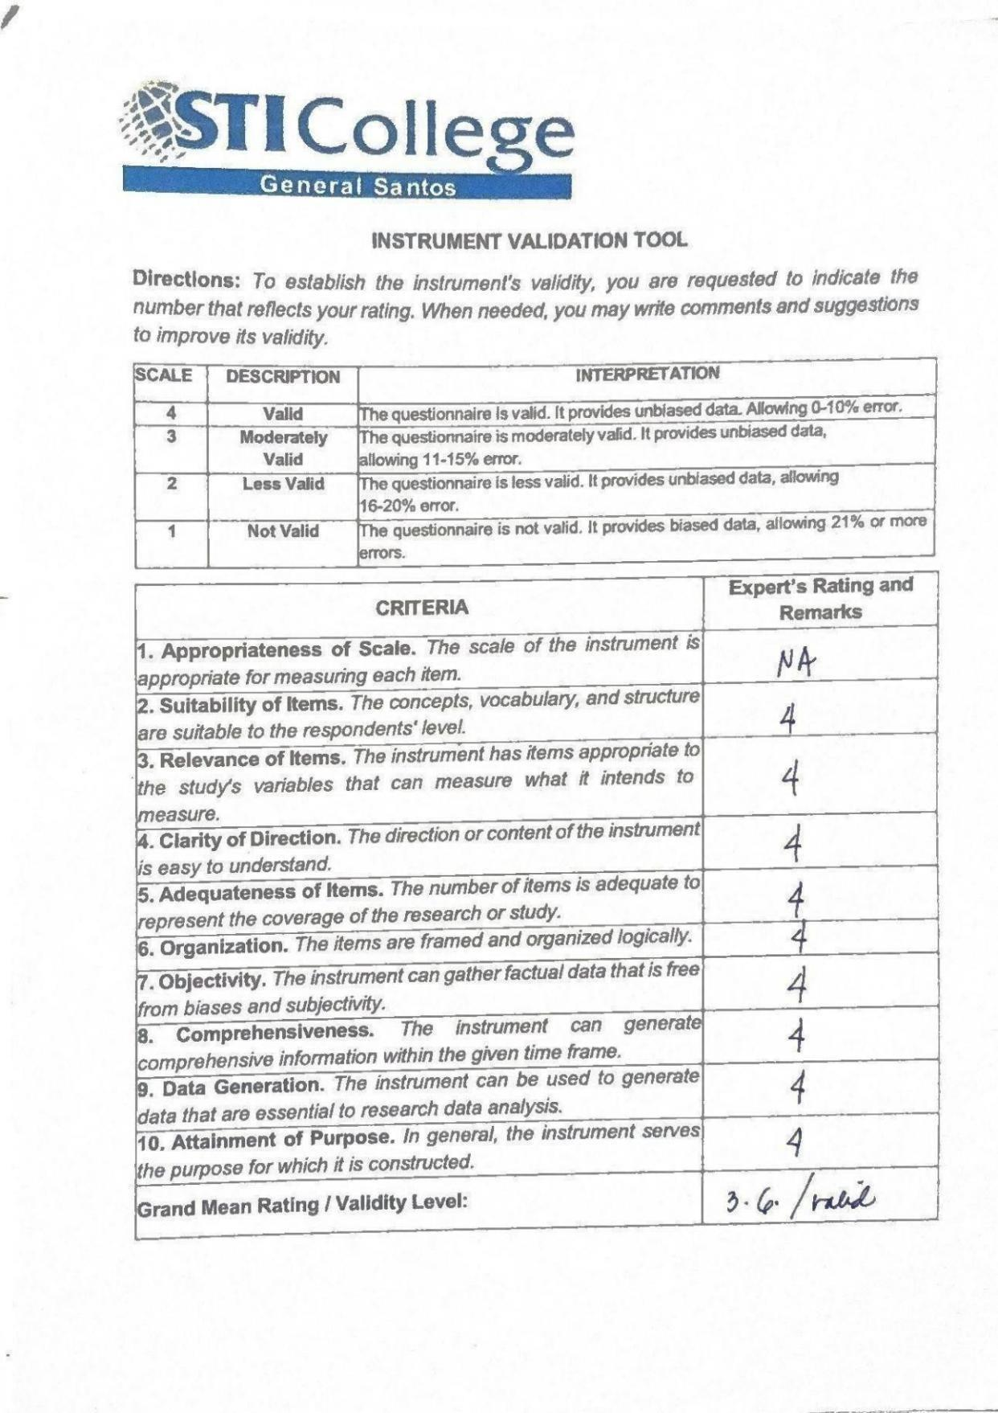


APPENDIX E. (QUESTIONNAIRE & TOI)
Figure 6: Questionnaire

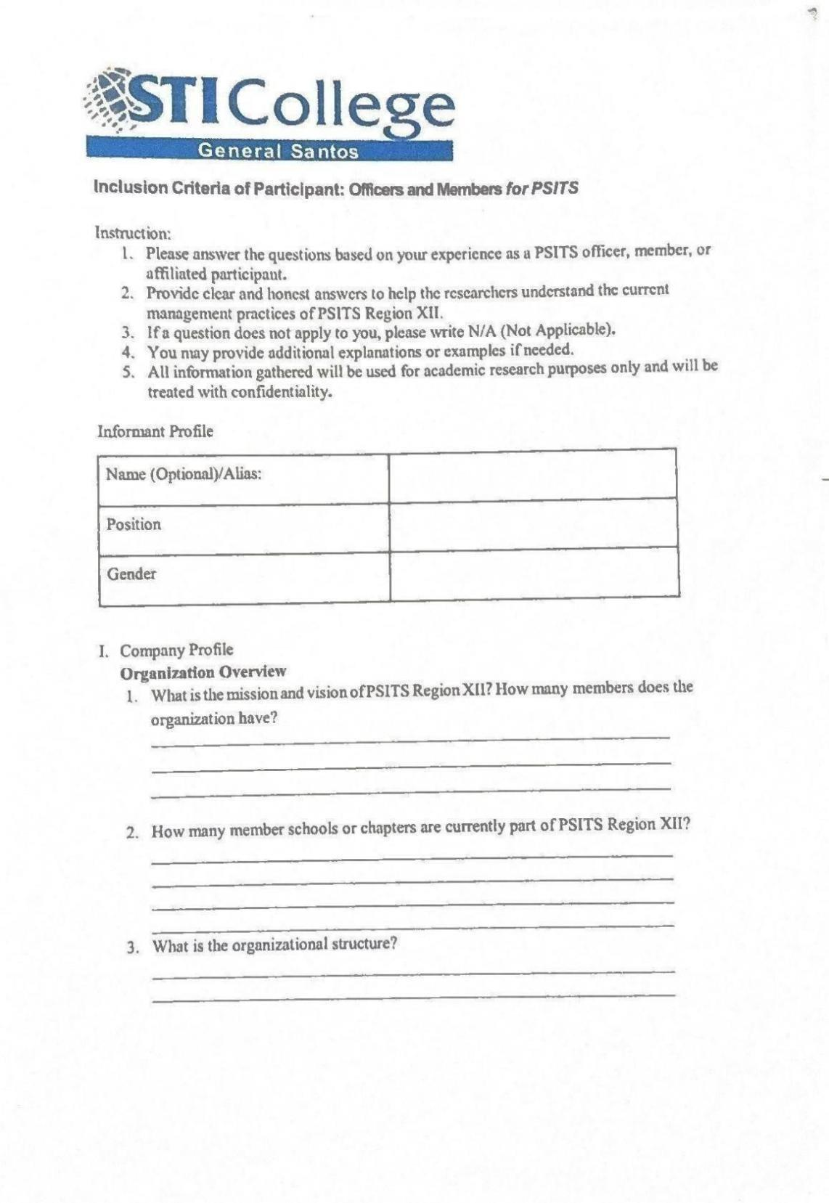
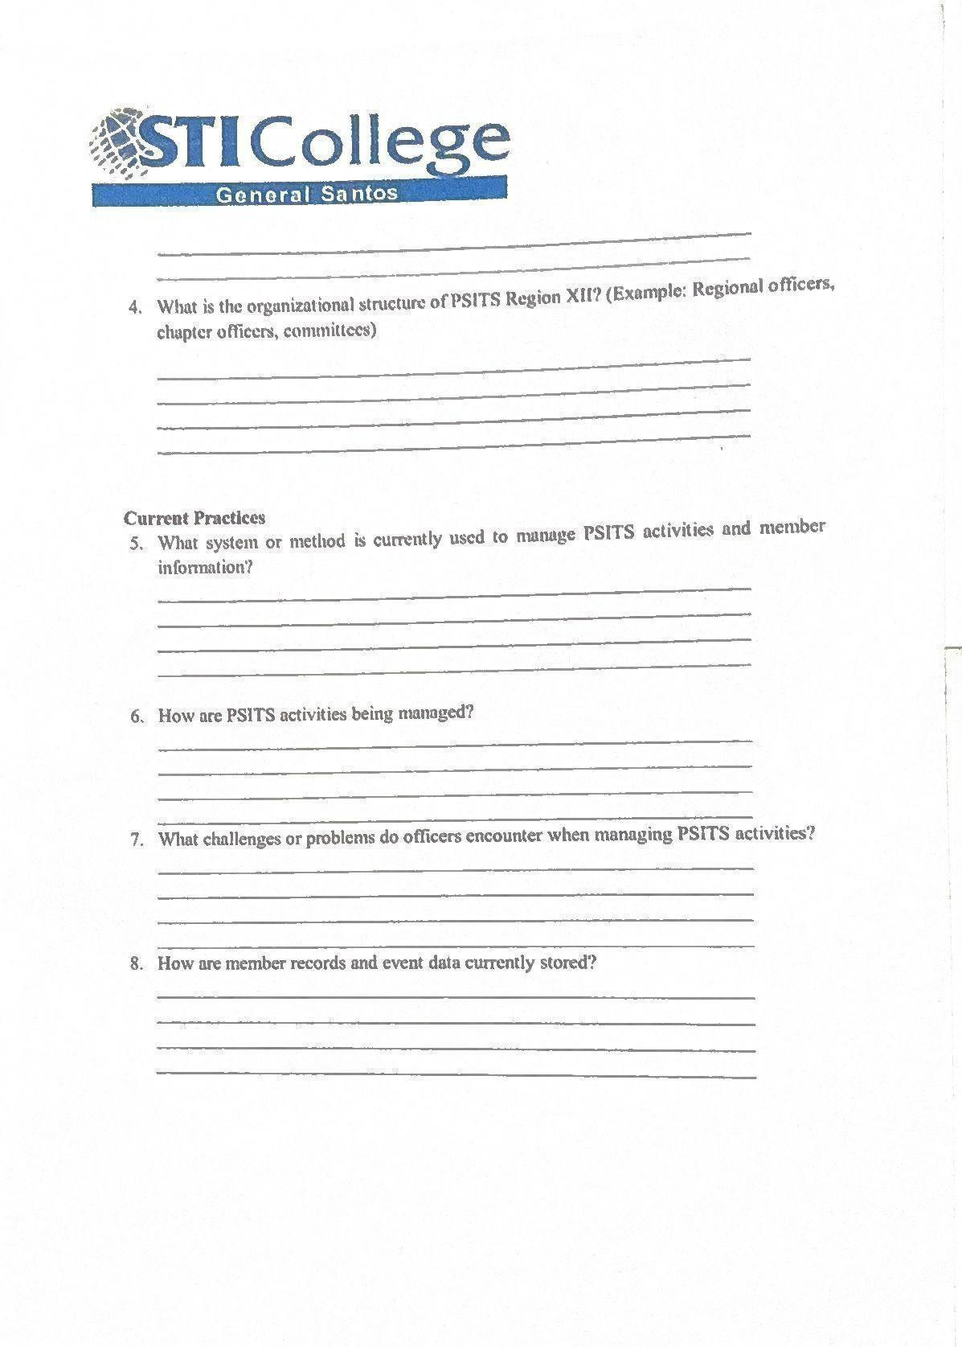

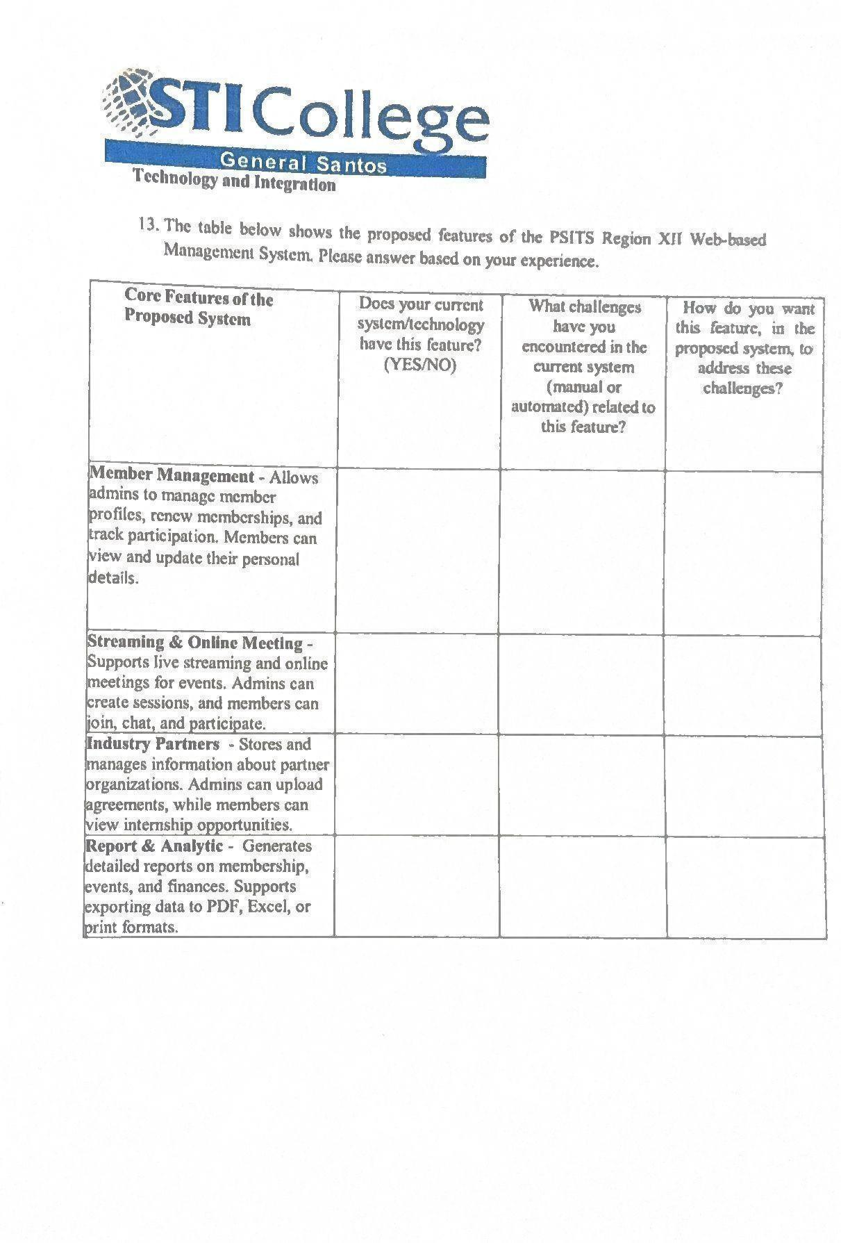


APPENDIX F.

(ENDORSEMENT FOR INSTRUMENT VALIDATION)
Figure 7: Endorsement for instrument validation

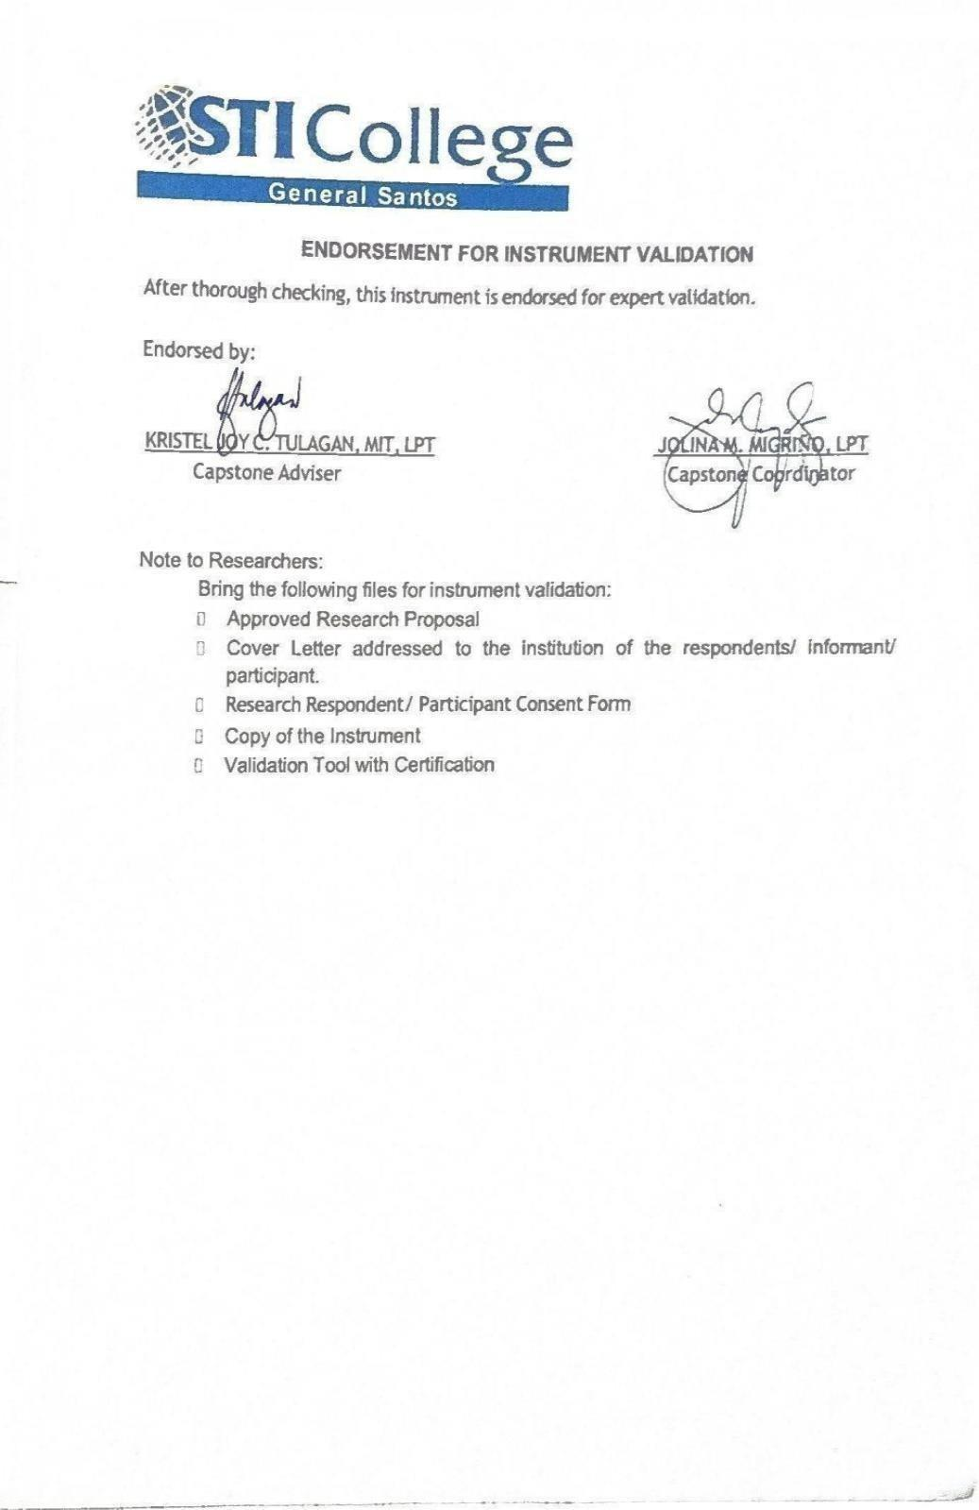

APPENDIX G.

(LETTER)
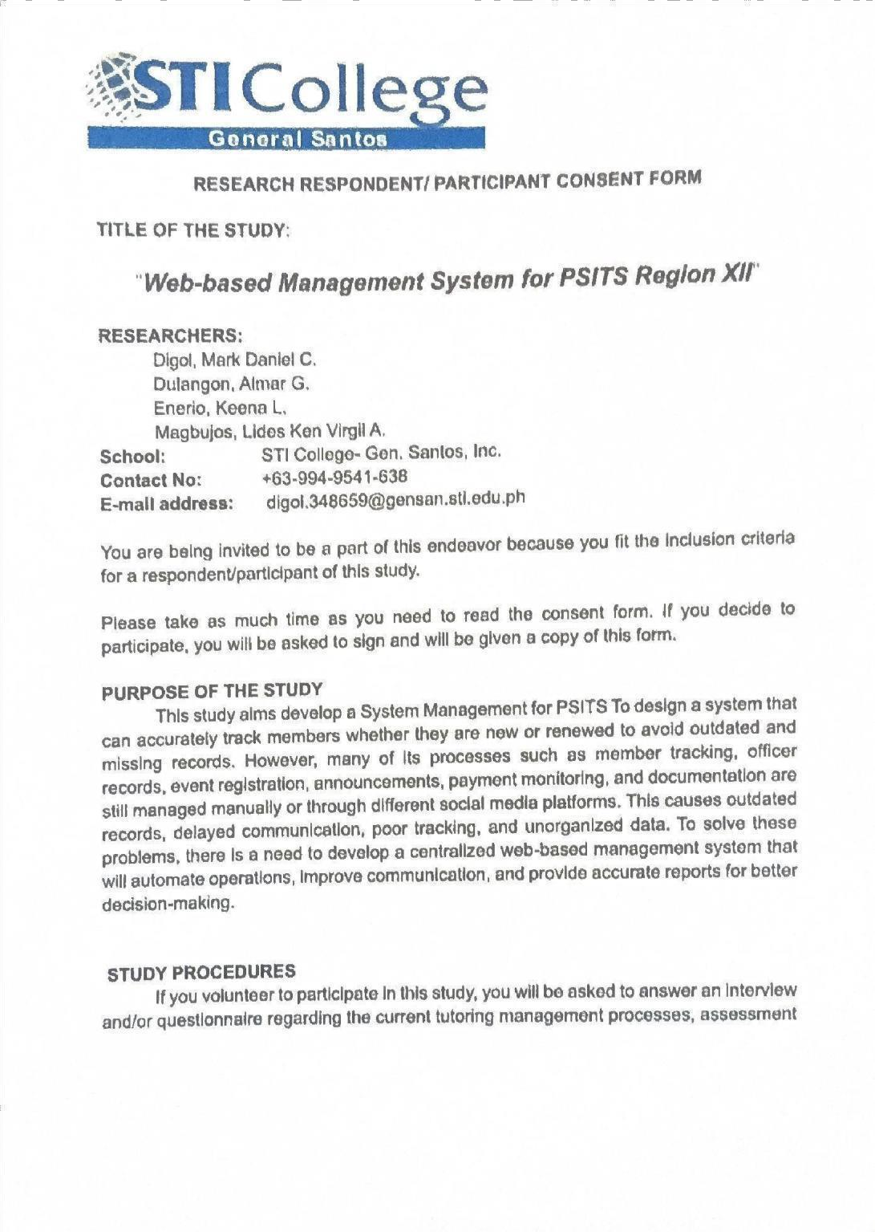

Figure 5: Endorsement for instrument validation


APPENDIX H. (CONSENT FORM)
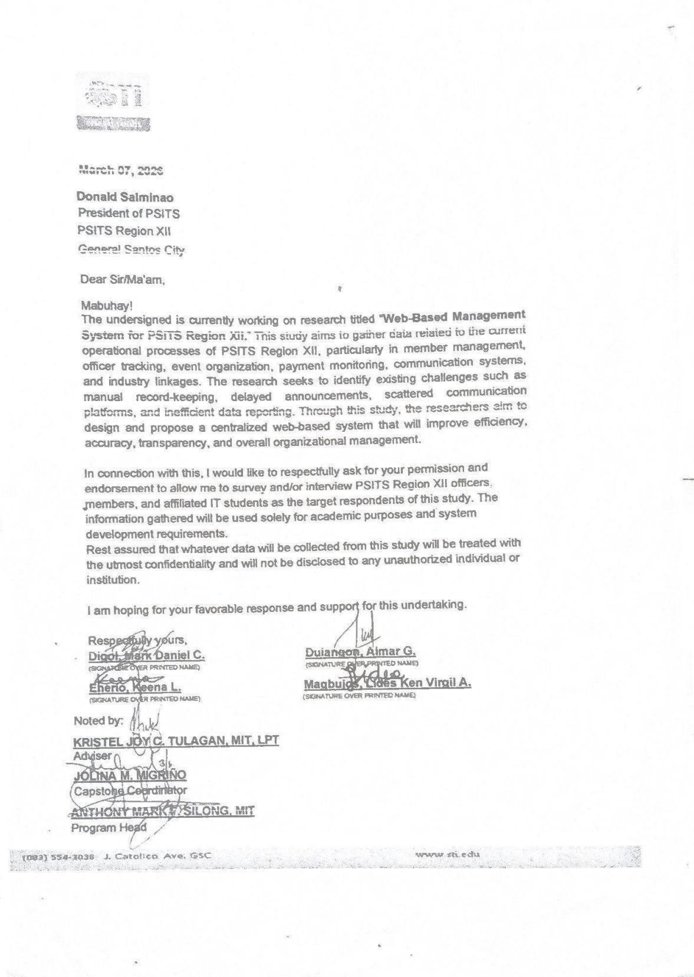

Figure 8: Consent Form

APPENDIX I. (REVISIONS LIST)
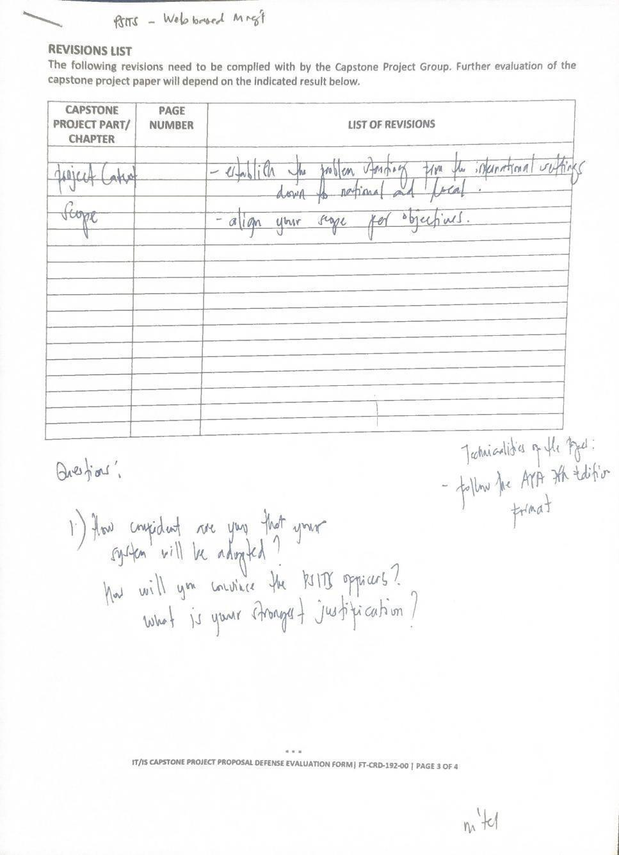

Figure 9. Revisions List
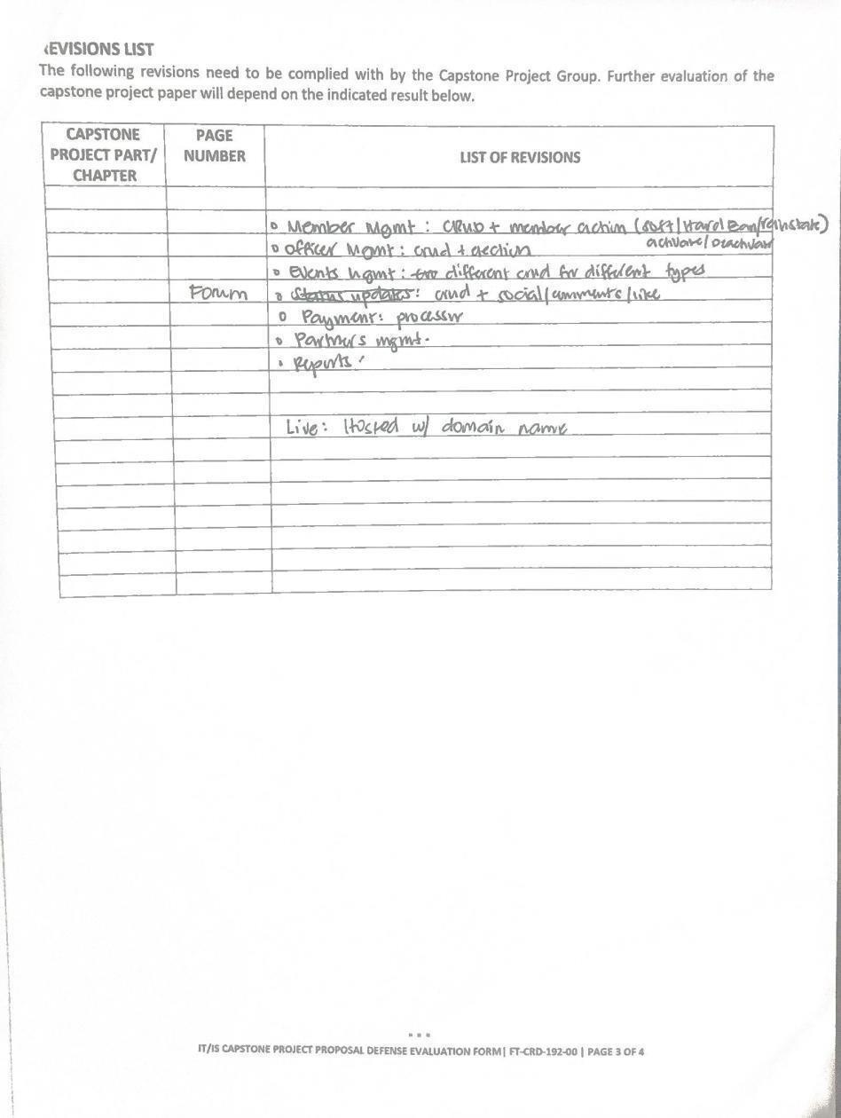
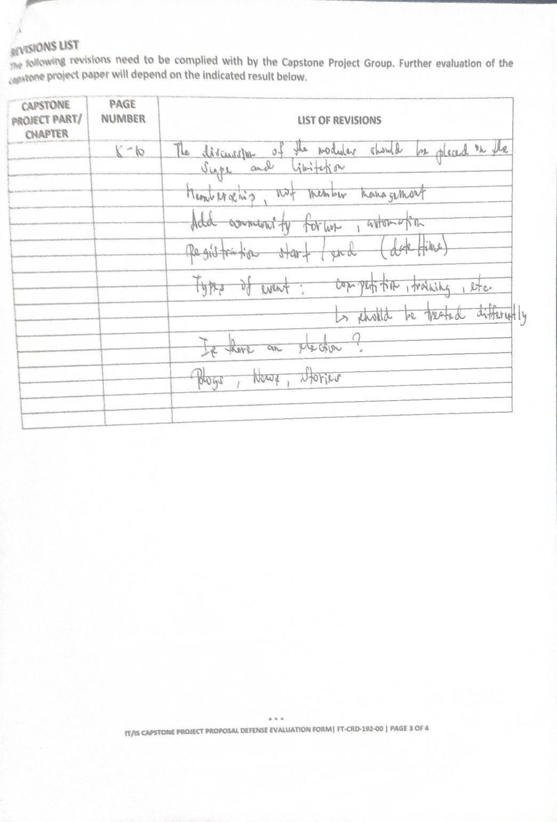

APPENDIX J. (ACCOMPLISHMENT AND CONSULTATION FORM)
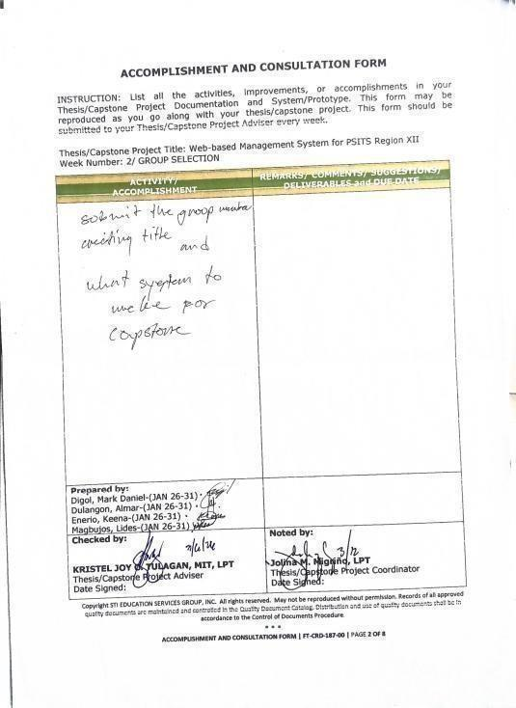
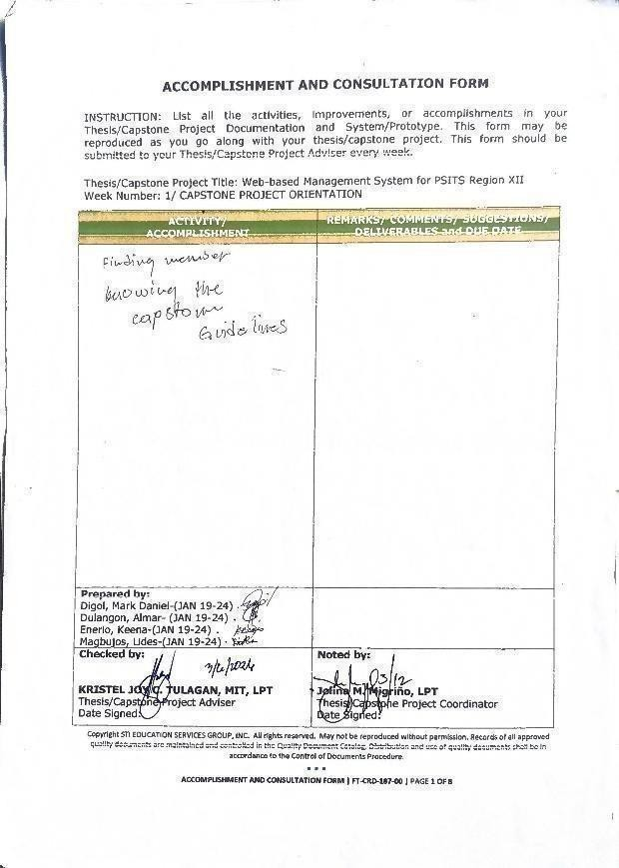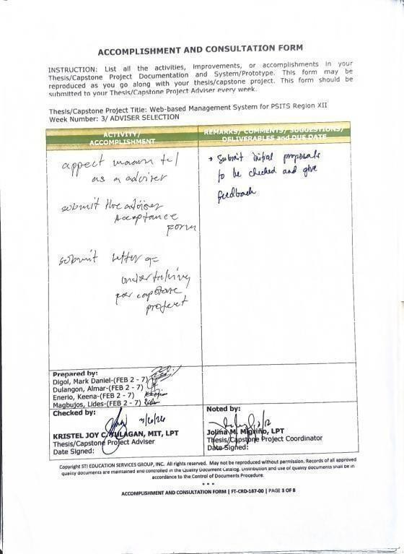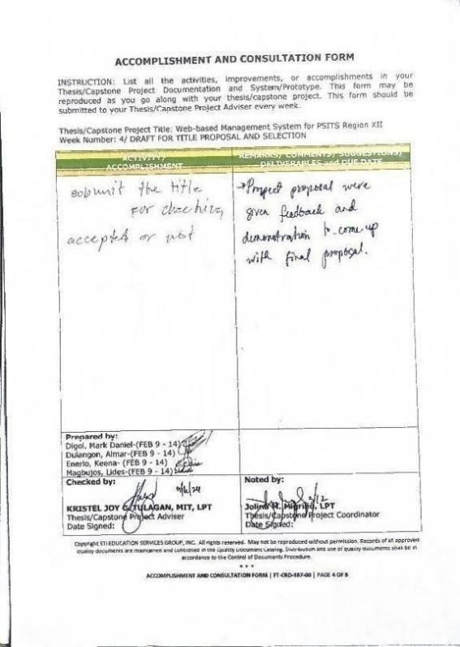

Figure 10. ACF
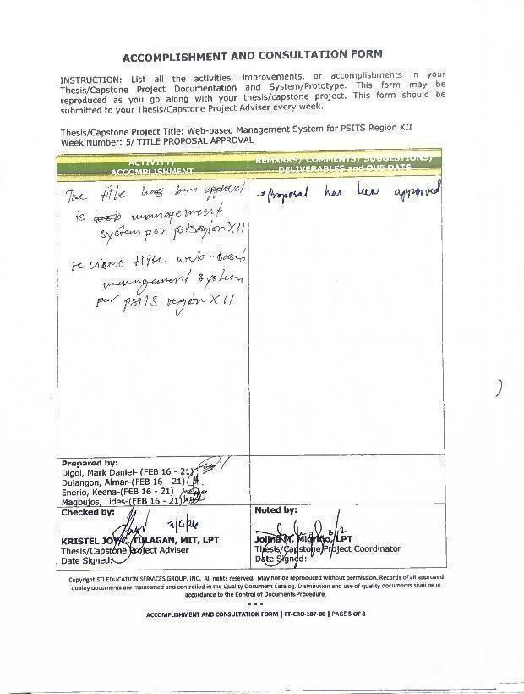
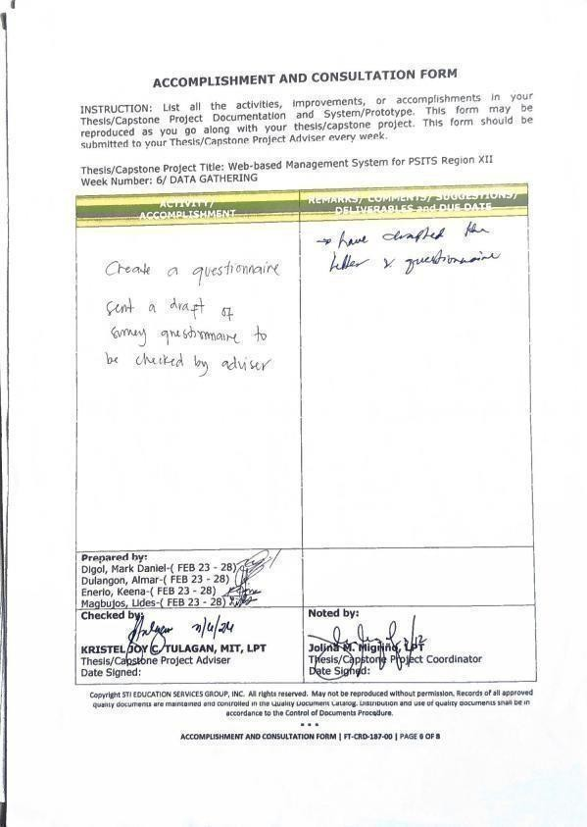
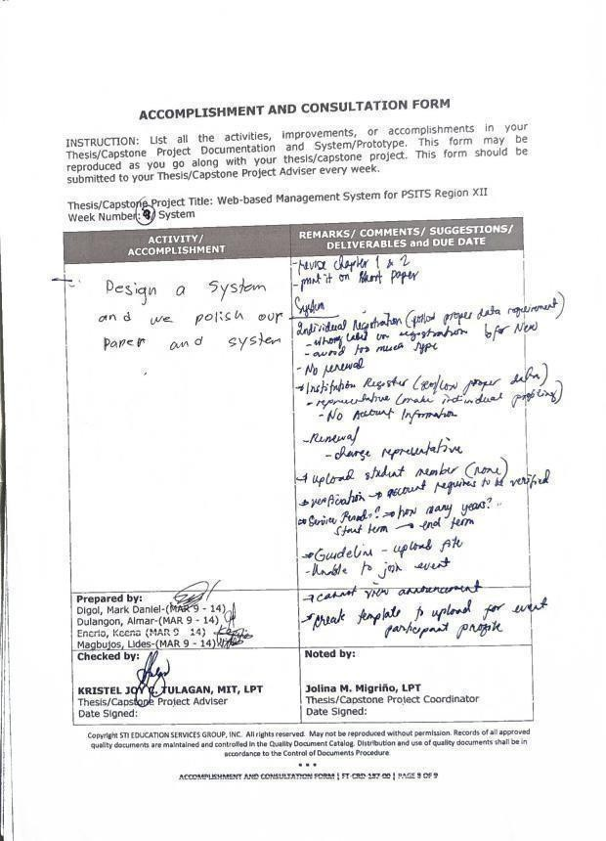
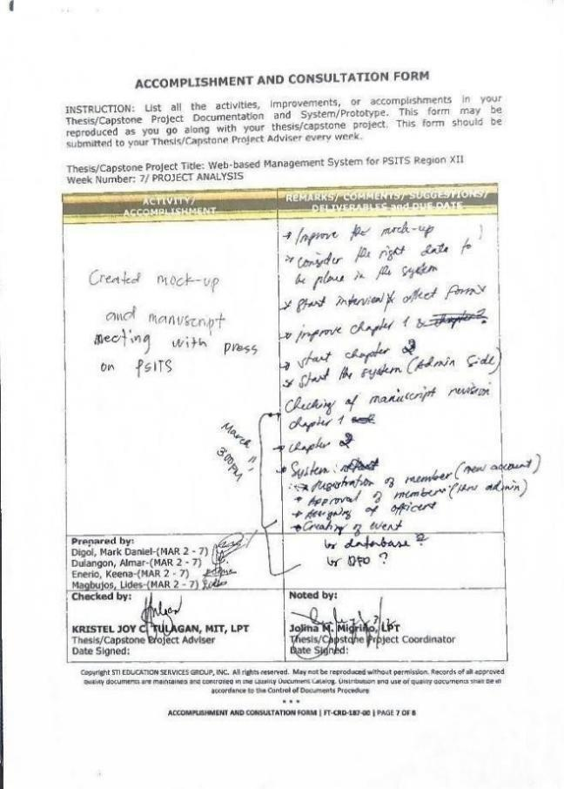

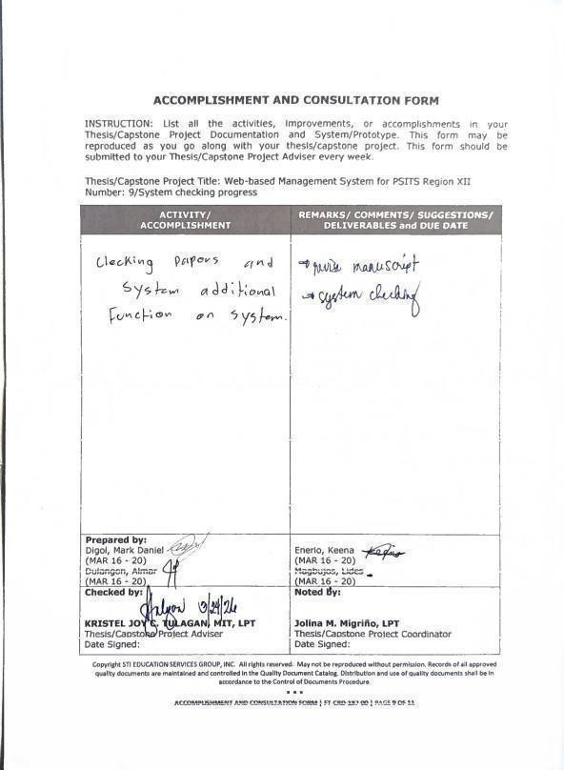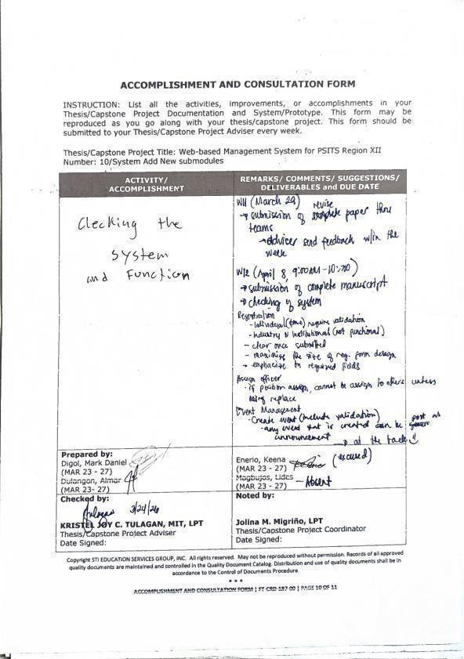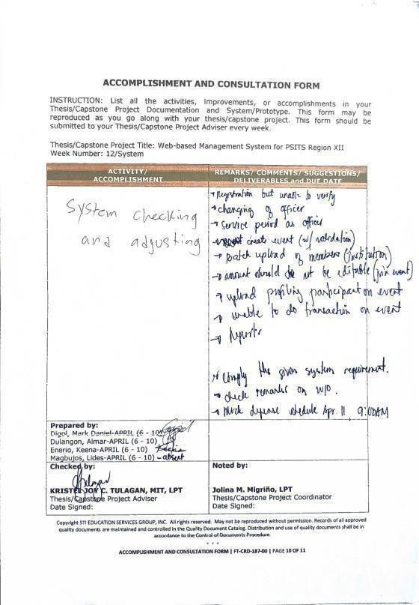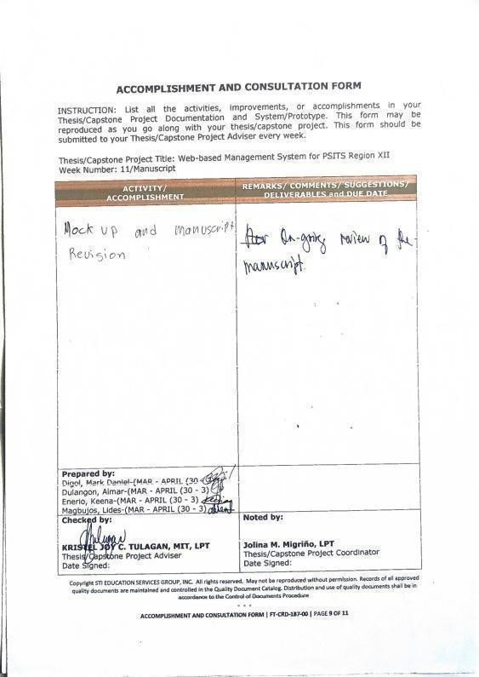

APPENDIX K.
(PROOF OF DATA GATHERING)

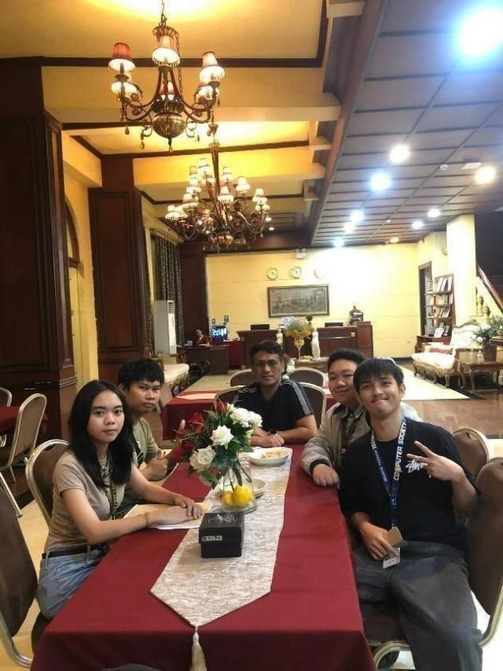

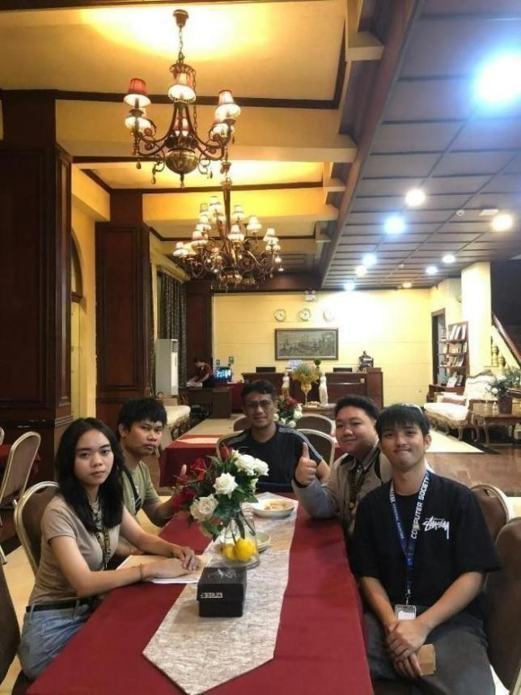

Figure 11. Proof of Data Gathering

APPENDIX L. (TRANSCRIPTION)

Transcription of Meeting with PSITS President

General Information and Membership
Q: Is there any fee for students to participate in Psits events?
A: Students do not have to pay any membership fees; it's automatic. They only pay when they join a convention.
Q: Can there be different types of membership within a school?
A: Yes, there can be school-wide memberships where the school has two faculty representatives, as well as individual memberships.
Q: Is there a system to manage officer information?
A: Yes, there is a developer/officer management module that records all officers' information and tracks their positions. It also includes an integrated communication platform for officers and members to send and receive queries.
Communication and System Integration
Q: What is the suggested mode of communication for the system?
A: One suggestion is to integrate a chatbot with Facebook Messenger. This way, users can interact with the system via Messenger, which then links back to the main portal's chatbox. This avoids the need for users to constantly open a separate website.

Q: What is an example of this integration in a school setting?
A: In some schools, students can set up appointments through Messenger, which is then linked to a Google Form. The system then crawls the data from the Google Form to process the request.
Event Management and Competitions
Q: How does the system handle online events and competitions?
A: The system features an online event competition module that allows members to view, watch, and participate in activities regardless of their location or device. This includes live streaming of events.
Q: How is student participation validated during events?
A: For events like the Psits convention, students can upload their credentials through the event management module for validation. This helps in making the process paperless. When they arrive at the venue, their participation is already validated through the portal.
Q: How does the system handle registration for team competitions?
A: Teams can register for activities like programming competitions through the portal. A school's membership must be active for its teams to be visible and eligible for registration. Coaches or faculty members can also be authorized to upload the necessary registration documents for their students.
Technical Specifications
Q: What frameworks are recommended for developing the system?
A: While native PHP can be used, frameworks like Laravel or CodeIgniter are recommended because they provide a more secure and structured approach to development, including built-in routing and security layers.
Q: Is there a way to test the system without incurring costs?
A: The developers can use a virtual private server (VPS) with a subdomain to host and test the website. This allows them to work on and upload their code at any time without extra expenses.

Q: How are late registrations or large-scale registrations handled?
A: If there are many participants (e.g., 100+), the system can be designed to allow bulk uploads of registration data. This is especially useful for teachers or school administrators who need to register multiple students at once.
Q: How is user accountability maintained during data uploads?
A: Every user who uploads data is registered in the system's logs, ensuring there is a record of who performed each action.
Q: Can students choose any school during registration?
A: The system can be set so that the school defaults to the student's actual school to prevent them from accidentally or intentionally selecting a different one.
Project Functionality and Logic
Q: How will the system handle different event versions, like the 14th vs. 15th Regional Convention?
A: The system will allow an officer or organizer to create an event specifically for a convention (e.g., the 14th PSITS Regional Convention) and "toggle" activities on or off based on current availability. The speaker emphasized the importance of "mapping" events in the database so that when a new event is created next year, it doesn't conflict with or overwrite previous event data.

Q: What is the user interface experience for students versus administrators regarding event visibility?
A: On the school/student side, inactive or "off" events will be hidden from view to streamline navigation. On the admin side, all events remain visible but are marked with their current status (on/off) for management purposes.
Technical Standards and Surveys
Q: What standards should be used for the project's User Acceptance Survey?
A: The speaker recommended following the ISO 25010 standard (formerly part of ISO 9126) for the implementation survey. This standard provides a set of pre-defined questions regarding functionality, security, and usability, which saves the students from having to draft their own questions from scratch.
Q: Which diagrams does the mentor find most helpful for understanding the system flow?
A: The mentor expressed a strong preference for Activity Diagrams and UML Diagrams. They noted that these visual tools make it much easier and faster to understand the data flow and system logic compared to reading text alone.
Organizational Details and Timeline
Q: Who are the primary stakeholders and organizations involved in this project?
A: The project involves the following entities:

PSITS: The student organization.

PSITE: The educator-led organization that manages the students.

Target Users: All IT (Information Technology Education) students under the PSITE umbrella, estimated at 20–25 members for the current organizational structure being mapped.
Q: What is the timeline for the project's completion and testing?
A: The students aim to finish the project by the end of the first semester of the next academic year (Capstone 2). The mentor suggested that if they finish early enough in the first semester, they might be able to "beta test" the system during the actual Regional Convention.

Q: What are the next steps for documentation?
A: The mentor agreed to send a soft copy of the organizational structure and the set of ISO-based questionnaire samples via Messenger (GC) to help the students avoid manual encoding.
Approved by:

Donald Salminao
PSITS President

APPENDIX M. (RESOURCE PERSON)


Figure 12. Resource Person

APPENDIX N. (PERSONAL TECHNICAL VITAE)


Curriculum Vitae of
MARK DANIEL DIGOL
Purok Tinago, Phase 17, General Santos City digol.348659@gensan.sti.edu.ph 09856032353

EDUCATIONAL BACKGROUND
Level | Inclusive Dates | Name of school/ Institution
Tertiary | 2024-2025 | STI - Gensan
Vocational/Technical
High School Elementary

PROFESSIONAL OR VOLUNTEER EXPERIENCE
_{Inclusive Dates} Nature of Experience/ Job Title

Name and Address of Company or Organization

Listed in reverse chronological order (most recent first). AFFILIATIONS
Inclusive Dates Name of Organization Position

Listed in reverse chronological order (most recent first). SKILLS
SKILLS  BroadBand Installation  (Fixed Wireless Systems) NCII | Level of Competency Competent | Date Acquired 2024
Computer Service Servicing NCII | Competent | 2024
Visual Graphics Design | Competent | 2026
NCIII

TRAININGS, SEMINARS, OR WORKSHOPS ATTENDED
Inclusive Dates Title of Training, Seminar, or Workshop

Listed in reverse chronological order (most recent first).


Curriculum Vitae of

ALMAR DULANGON
Brgy .Bula, Purok 4-B Rajah Muda, General Santos City dulangon.353580@gensan.sti.edu.ph
0967995970

EDUCATIONAL BACKGROUND
Level Inclusive Dates Name of school/ Institution Tertiary 2023-present STI College General Santos City
Vocational/Technical month year
High School 2018-2020 Marymount Academy

Elementary
2010-2015 Stratford international school

PROFESSIONAL OR VOLUNTEER EXPERIENCE
_{Inclusive Dates} Nature of Experience/ Job Title

Name and Address of Company or Organization

Listed in reverse chronological order (most recent first).

AFFILIATIONS
Inclusive Dates Name of Organization Position

Listed in reverse chronological order (most recent first).

SKILLS
SKILLS Level of Competency Date Acquired
BroadBand Installation (Fixed Wireless Systems) NCII Computer Service Servicing NCII
Competent 2024
Competent 2024

Visual Graphics Design NCIII Competent 2026

TRAININGS, SEMINARS, OR WORKSHOPS ATTENDED
Inclusive Dates Title of Training, Seminar, or Workshop

Listed in reverse chronological order (most recent first).


Curriculum Vitae of

KEENA ENERIO
Saranggani Phase 1 General Santos City enerio.377659@gensan.sti.edu.ph 09073188931

EDUCATIONAL BACKGROUND
Level Tertiary
Vocational/Technical
Inclusive Dates 2023-Present month year
Name of school/ Institution STI College General Santos City

High School 2017-2020 Lagao National High School Elementary 2011-2017 Lagao Central Elementary School

PROFESSIONAL OR VOLUNTEER EXPERIENCE
_{Inclusive Dates} Nature of Experience/ Job Title

Name and Address of Company or Organization

Listed in reverse chronological order (most recent first).

AFFILIATIONS
Inclusive Dates Name of Organization Position

Listed in reverse chronological order (most recent first).

SKILLS
SKILLS Level of Competency Date Acquired
BroadBand Installation (Fixed Wireless Systems) NCII Computer Service Servicing NCII
Competent 2024
Competent 2024

Visual Graphics Design NCIII Competent 2026

TRAININGS, SEMINARS, OR WORKSHOPS ATTENDED
Inclusive Dates Title of Training, Seminar, or Workshop

Listed in reverse chronological order (most recent first).


Curriculum Vitae of

LIDES KEN VIRGIL MAGBUJOS
Bria Homes, Lagao, General Santos City magbujos.301088@gensan.sti.edu.ph 09987314517

EDUCATIONAL BACKGROUND
Level | Inclusive Dates | Name of school/ Institution
Tertiary | 2023 - Present | STI General Santos City
Vocational/Technical
High School Elementary

PROFESSIONAL OR VOLUNTEER EXPERIENCE
_{Inclusive Dates} Nature of Experience/ Job Title

Name and Address of Company or Organization

Listed in reverse chronological order (most recent first).

AFFILIATIONS
Inclusive Dates Name of Organization Position

Listed in reverse chronological order (most recent first).

SKILLS
SKILLS Level of Competency Date Acquired
BroadBand Installation (Fixed Wireless Systems) NCII Computer Service Servicing NCII
Competent 2024
Competent 2024

Visual Graphics Design NCIII Competent 2026

TRAININGS, SEMINARS, OR WORKSHOPS ATTENDED
Inclusive Dates Title of Training, Seminar, or Workshop January 2024 CSS NCII

Listed in reverse chronological order (most recent first).

