Expedition to the Barrier Peaks
Level I: Officials, Officers, and Technicians Quarters
DM Quick Reference (5e Conversion)

Illustration Quick Reference
# | Subject / When to Show
1 | Standard Door - Show whenever party approaches a color-coded door
2 | Drop Tube - Show when examining any drop tube/chute
3 | Ship Exterior - Show when party first sees the metal doors in hillside
4 | Vegepygmies with Thornies - Southern vegepygmy encounters
5 | Police Robot - Any police robot encounter
6 | Worker Robot - Any worker robot encounter
7 | Vegepygmies (Northern) - Northern vegepygmy encounters
8 | Android Nurse (MED 1) - Female android in emergency treatment room
9 | Android Surgeon (MED 2) - Male android in emergency operating room
10 | Security Chief's Office - South room of Police HQ
11 | Monitoring Console - Console in Security Chief's Office
12 | Small Arms Locker - Gray card armory
13 | Computer Central - Main computer room with 'altar'
14 | Computer Console Detail - Key console close-up
15 | Small Repair Robot - Damaged robot at encounter #2
16 | Police Robot Area - Encounter #3 robot station
17 | 'Tween Decks Area - Service deck areas (Levels II and V)
18 | Wheely Sled - Maintenance vehicle
19 | Repair Robot - Worker robot at power terminal
30 | Police HQ - Main police robot station
14 | Computer Console Detail - Key console close-up
15 | Small Repair Robot - Damaged robot at encounter #2
16 | Police Robot Area - Encounter #3 robot station

Random Encounters
Check: 1 in 12 per turn. Roll 1d6 for encounter type.

Southern Hemisphere
d6 | Encounter | Illustration
1 | 9-16 Vegepygmies with 2-5 Thornies | #4
2 | Police Robot | #5
3 | 2-3 Displacer Beasts | —
4 | Worker Robot | #6
5 | Lurker Above | —
6 | 9-16 Vegepygmies with 2-5 Thornies | #4

Northern Hemisphere
d6 | Encounter | Illustration
1 | Worker Robot | #6
2 | 14-24 Vegepygmies | #7
3 | 2-5 Shadows | —
4 | Police Robot | #5
5 | 14-24 Vegepygmies | #7
6 | 1-2 Will-o'-Wisps | —

Loot Tables

Lounge Search Results (roll d6, once per lounge)
d6 | Treasure Found
1 | Notes on escaped intellect devourer (Level II) - requires comprehend languages; after first roll of 1, find brown card instead
2 | 1-3 ampules of disease cure serum (70% potent, 20% neutral, 10% poison)
3 | 1 piece of jewelry worth 300-1,800 gp
4 | 3 pieces of jewelry worth 1,000-4,000 gp each
5 | Jet Black color card
6 | Violet or Orange color card (50%/50%)

Lab c - Special Chemicals (20 containers each type)
Container | Effect
3rd white powder bottle | Defoliant: 1d10 damage to plant creatures, destroys 10' sq vegetation (10 handfuls)
2nd, 7th, 9th bottles | Clear acid: 3d4 damage to living creatures
5th green powder jar | Deadly poison: Save at -1 if touched, -5 if tasted
20th pink powder jar | Infravision chemical: 90' range for 6 turns (36 doses)
1st ceramic bottle | Plant growth fluid: +2d8 HP to plant creatures OR plant growth 10x10' (20 applications). Vegepygmies go berserk within 30'
2nd ceramic bottle | Deck-eating acid: dissolves 10' diameter metal in 1 turn. Weapon: 3d6/2d6/1d6 damage over 3 rounds

Color Card Reference
Higher rank cards open lower rank doors. Wrong card triggers alarm and is confiscated. Show ILLUSTRATION #1 whenever party approaches a color-coded door.
Color | Rank/User | Notes
GRAY | Ship Commander | Opens all doors
RED | Police/Security Officials | Opens all except Gray
YELLOW | Medical Officers | Does NOT open Orange doors
ORANGE | Security Personnel | Opens Orange, Violet, Brown, Jet
VIOLET | Technicians | Opens Violet, Brown, Jet
BROWN | Crew/Maintenance | Opens Brown, Jet
JET BLACK | Passengers/Colonists | Lowest rank
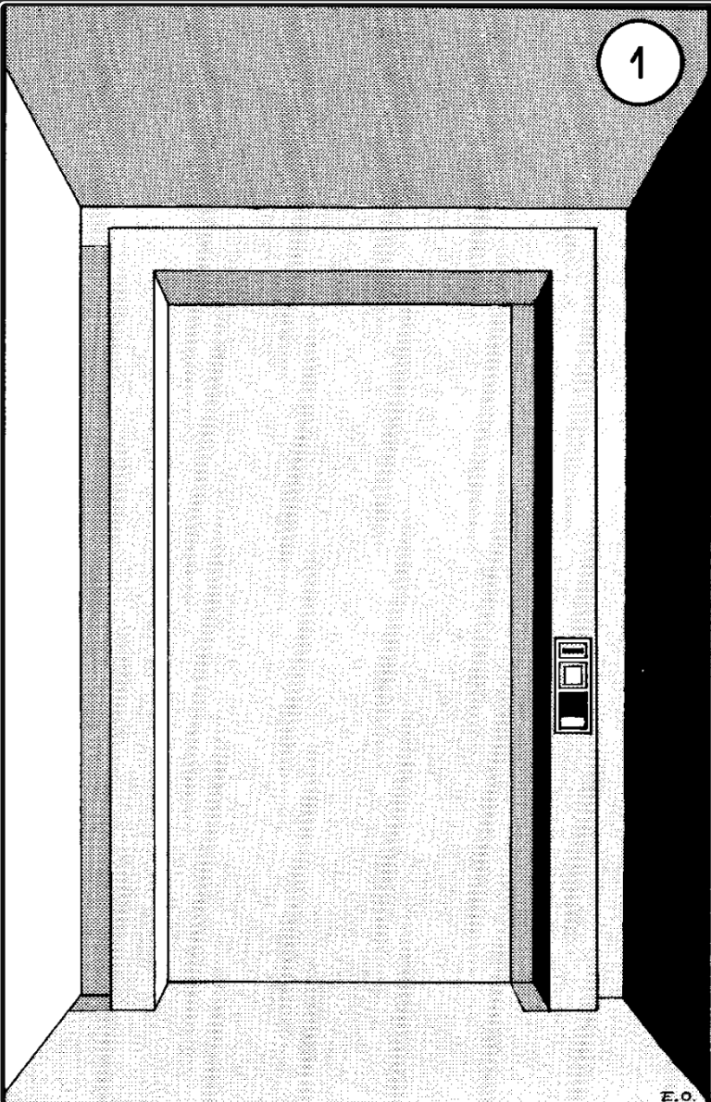

Numbered Encounters

1. Lurker Above
Loot: Violet card (under debris with bones and rags)

2. Small Repair Robot (Damaged) [ILLUSTRATION #15]
Loot: 2-5 gem bearings (50 gp each). Risk: 1-in-6 chance of 1d6 electrical damage per gem removed.
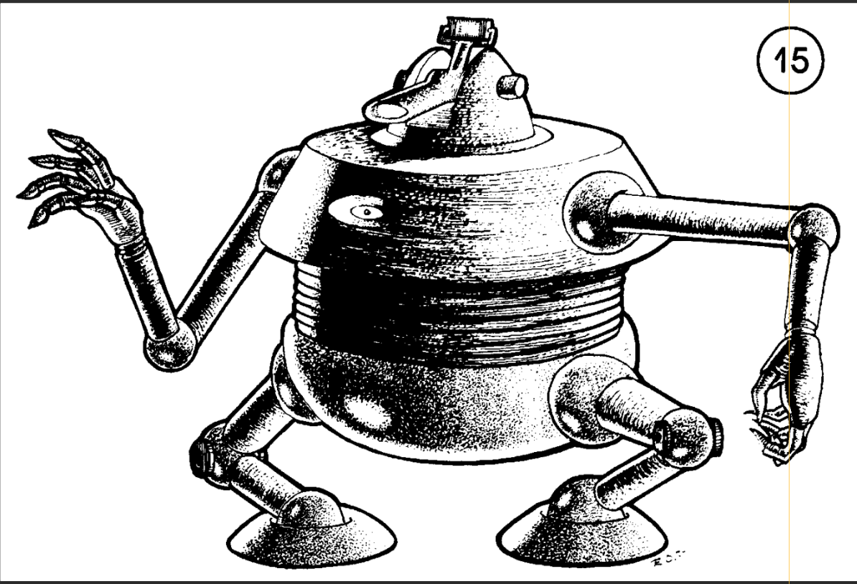

3. Police Robot Area [ILLUSTRATION #16]
1-6 Police Robots present. Will not question those with Orange, Red, or Gray cards.
- 3a. Repair Parts: 12 power discs (5 rounds searching)
- 3b. Disabled Robots: 11 police robots in repair, 1 worker robot working. Nothing of value.
- 3c. Arsenal: Cases of grenades and power discs. 12 each of sleep/incendiary/explosive grenades visible. Robot checks every 3rd round - items must be hidden to take.
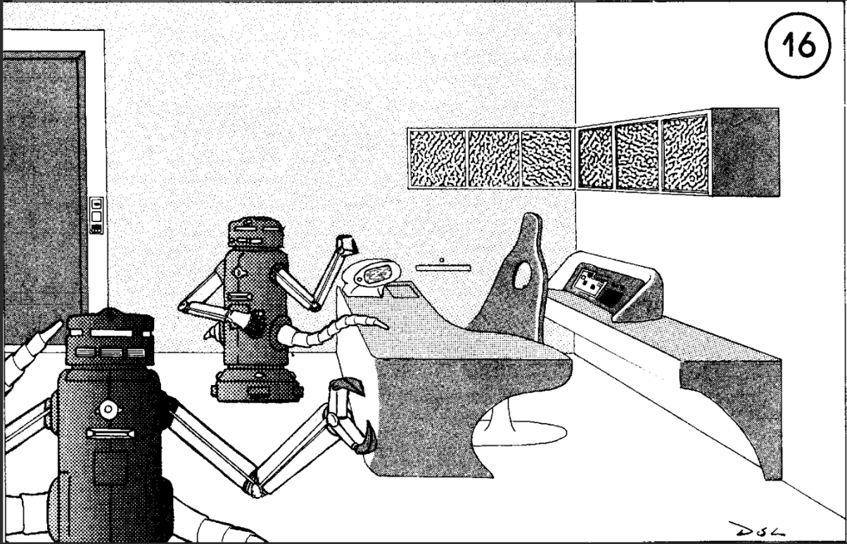

4. Berserk Female Android
Appears unconscious. Attacks when creatures within 20'. Armed with metal bar and paralysis pistol (6 charges).

5. Displacer Beast Lair
5 Displacer Beasts. 60% chance to flee if 10+ visible opponents.
Loot: Brown color card in nest debris.

6. Phase Spiders (Dwarf Variety)
3 spiders (1 adult HP 23, 2 young HP 7, 5). Full strength poison (-2 saves).
Loot: Jet black card in ceiling webs. 7 beryl gems (100 gp each) in pool below.

7. Ship Commander's Quarters (5 rooms)
Main room: Living/reception, several skeletons, nothing of value.
- 7a. Commander's bedroom: Full card set (jet, brown, violet, yellow, orange, red) in desk. Gray card hidden in papers. Closet (handprint lock): needler + 4 clips. Lavatory: 2 cyanide capsules (instant death). Plasteel safe (6 laser charges to open): orders, 100 diamonds (100 gp each), booby-trapped packet (50 HP damage, 10' radius).
- 7b. Private lounge/dining: 6 crystal flasks. #1=deadly poison (-4 save), #2-4=intoxicating (delay 6 turns), #5=+1 DEX for 1 turn (20 oz), #6=double vision (-2 attacks, +2 to be hit) for 3 turns.
- 7c. Master bedroom: Tin spaceship model = platinum (1,000 gp).
- 7d. Commander's wife's room: Jewelry case: 4 rings (2000/750/300/50 gp), 6 bracelets (2 worth 1000/600 gp), 3 necklaces (one with 7 aquamarines 500 gp each = 4000 gp total). Gray card hidden in shoe near skeleton.

8. Security Chief's Quarters
- 8a. Lounge/dining: Truth serum liquor (1 oz = 3 rounds truth-telling, 7 oz left).
- 8b. Office: 3 orange cards in hidden desk panel. Ruined blaster (shorted power disc).
- 8c. Dressing room: 2 intact uniforms.
- 8d. Bedroom: Police robot control box (keyed to chief - useless for commands). Press orange+red simultaneously = shut off all police robots within 30'. Either button alone calls 1-2 robots. Works 7 times before malfunction.

9. Will-o'-Wisps
3 Will-o'-Wisps (HP 49, 41, 38). 2-in-6 chance 1-2 are away (return in 3-30 rounds).
Loot: Mixed in shiny junk: 2 gems (100 gp), 6 gems (50 gp), language translator device (3 uses remaining).

10-11. Shriekers and Vegepygmies [ILLUSTRATION #7]
Position 10: 5-8 shriekers at each location. Fungi grow along passage.
Position 11: Northern vegepygmy territory. 4 vegepygmies per 10' (1 each of 1-4 HD). 1 jet black card per room.
- 11a. Leader (6 HD, 38 HP) + 5x 4HD sprouts. Has orange + violet cards. Hoarded weapons (d6): 1-2=2 sleep grenades, 3=explosive grenade, 4-5=laser pistol (4 charges), 6=blaster rifle (2 charges). 10% malfunction on first use.
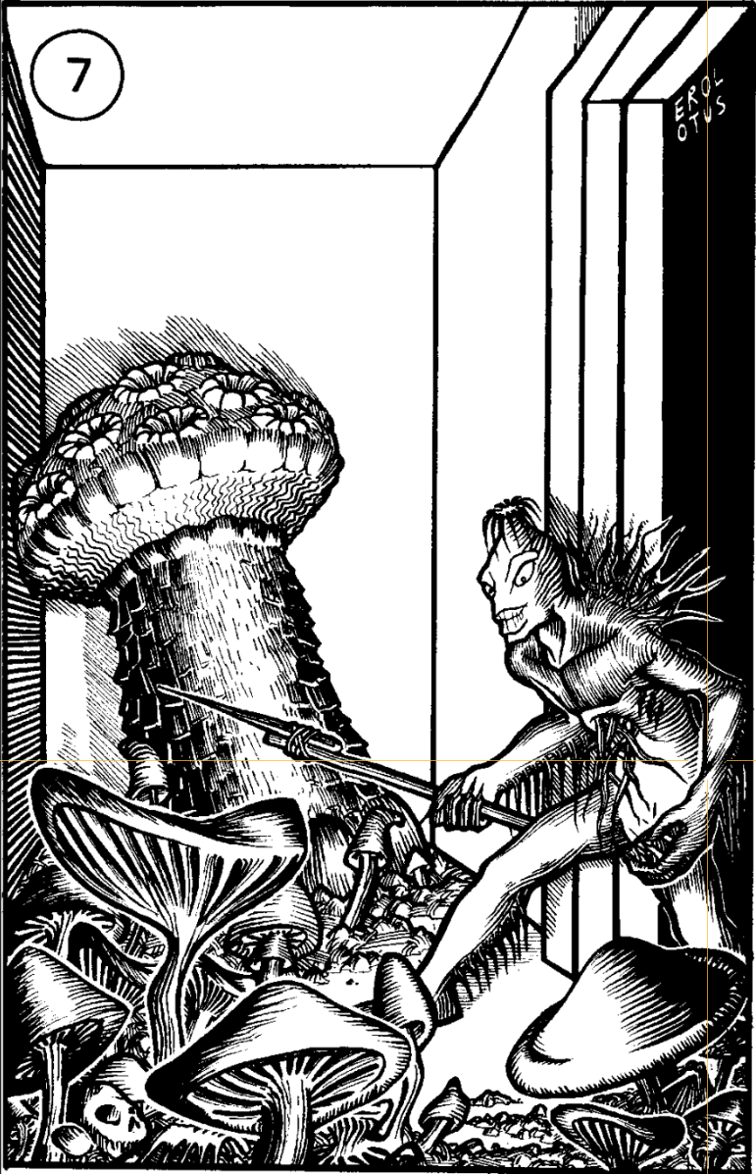

12. Southern Vegepygmies (with Thornies) [ILLUSTRATION #4]
Green-splotched variety. 3 vegepygmies per 10' (1-3 HD each) + 1 thorny per room. Jet black card per room.
- 12a. Subchief (5 HD) + 3x 3HD + 3 thornies. Yellow card.
- 12b. Subchief (5 HD) + 5x 3HD + 4 thornies. Violet card.
- 12c. Subchief (5 HD) + 2x 3HD + 2 thornies. Brown card.
- 12d. Chief (6 HD) + 4x 4HD + 6 thornies. Has aerosol hypnotic (6' range, save vs poison at -3 or sleep/suggestion 5 rounds). Hollow bed frame: red card, poison gas grenade, sleep gas grenade, 4 gem bearings (100 gp each), broken communicator.
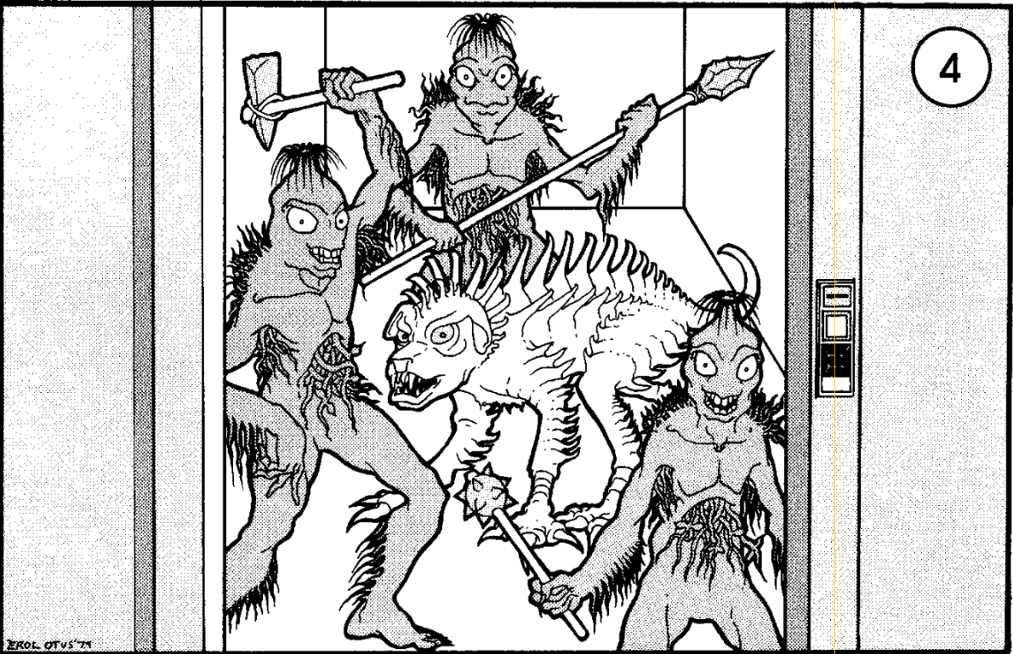

13. Radiation Areas
Save vs poison or radiation sickness in 2-5 turns. After 6 turns: lose 1 STR/hour. At STR 2: cannot walk. At STR -1: death. Anti-radiation serum stops progression; STR returns 1/hour.

14. Art Workroom
- 14a. Foreroom: Pigments, broken easels, canvases.
- 14b. Sculpture room: 2 Gray Oozes (HP 22, 17). One covers 3' bust, one on ceiling (6'x2'). Bust has 2 topaz gem eyes (500 gp each).

15. Doppelganger Pack
9 Dopplegangers lurking near drop tube. Wait until creatures use tube, attack those waiting.
Drop tube poster shows level map and all 4 tube locations. Instructions readable with magic.

16. Hidden Blaster Pistol
On floor in debris. Per person passing: 5% kicked and noticed, 2% stepped on and ruined. Searching floor: 10% per searcher to find. Full power disc (6 charges).

Key Locations

Medical Areas
Main Records: Robotic voice (alien language) directs to MED 1/2. 10%/round to find yellow card in desks. Touching desk triggers alarm - police robot in 1-4 rounds (once only).
- MED 1: [ILLUSTRATION #8] Female android nurse. Auto-heals wounded humans (2d12 HP, 5 charges). Can cure disease/poison/radiation within 3 turns if asked (requires ship language).
- MED 2: [ILLUSTRATION #9] Malfunctioning male android surgeon (AC 3, 35 HP, STR 18/01). Grapples, anesthetizes, and kills in 2 rounds. Lightning shorts it out.
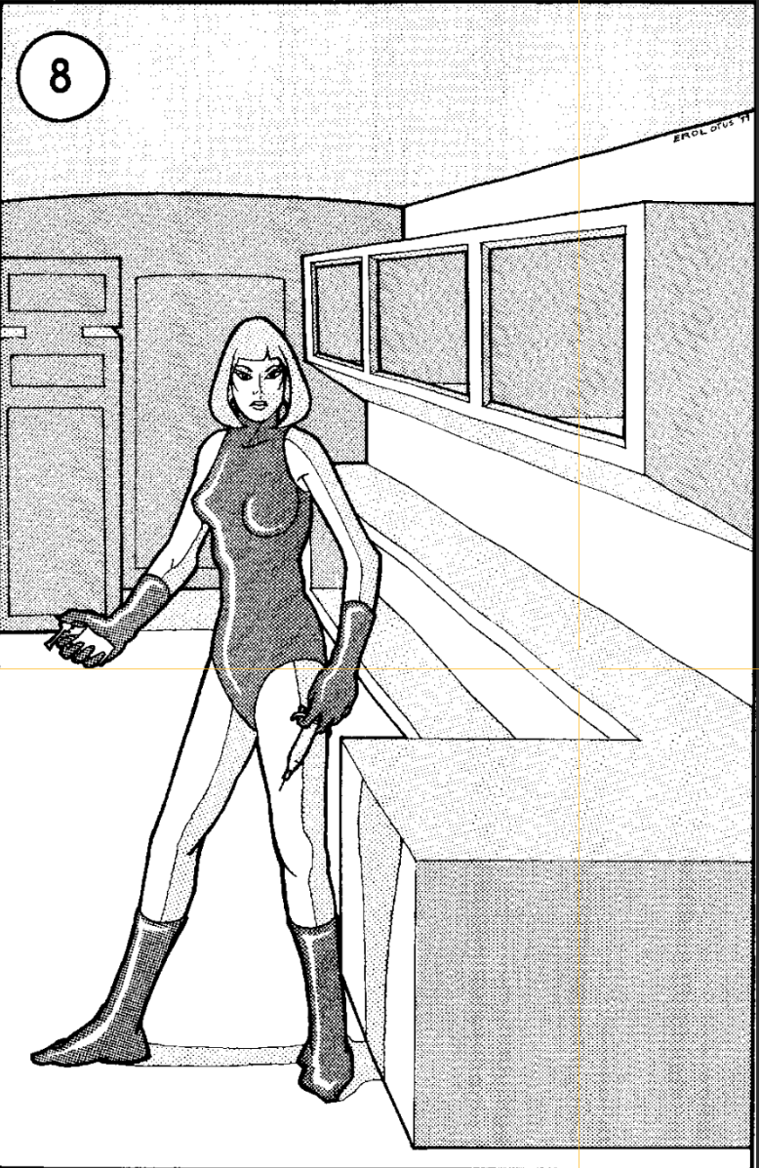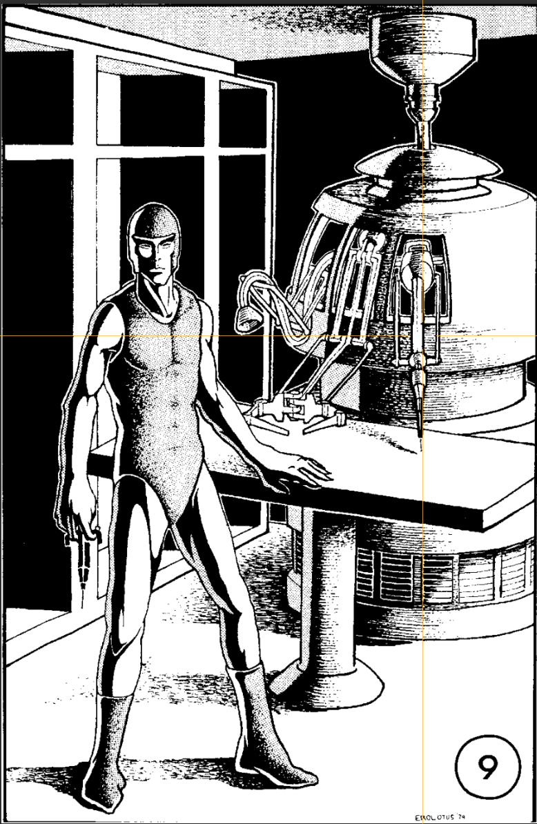

Lab a
Worker robot still working. Show yellow+ card for access. Loot: 2 poison antidotes, 3 disease cures, healing spray (2d12 HP, 3 charges). No card/interference = top-security alarm (1-3 police robots in 1-4 rounds).

Lab b - Russet Mold Hazard
If any computer console used prior: room FULL of mold. Opening door = avalanche over 10' sq area. Within 3' of mold: save vs poison or become mold culture (death in 2-5 turns, vegepygmy rises in 21-24 hours). Save = 5d4 damage.

Police HQ [ILLUSTRATION #30]
1-3 police robots. Require red/gray/orange card or imprisonment. Cells have force fields (magic doesn't pass). First robot destroyed: 50% chance to recover red card (-10% per DEX above 14).
Metal chest: 2 gas masks, 12 sleep grenades, 2 needler pistols + clips.
South Room (red card): [ILLUSTRATION #10] Security chief's office. Monitoring system [ILLUSTRATION #11] (56 positions, room dials). Locker: 3 jewelry pieces (1-4k gp), blaster pistol (full), MALFUNCTIONING powered armor.
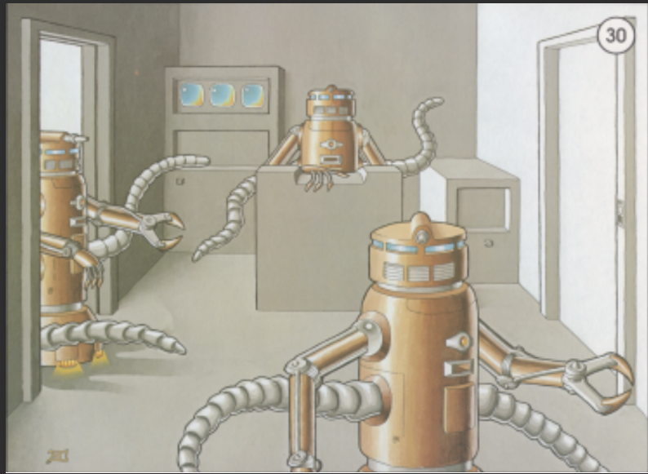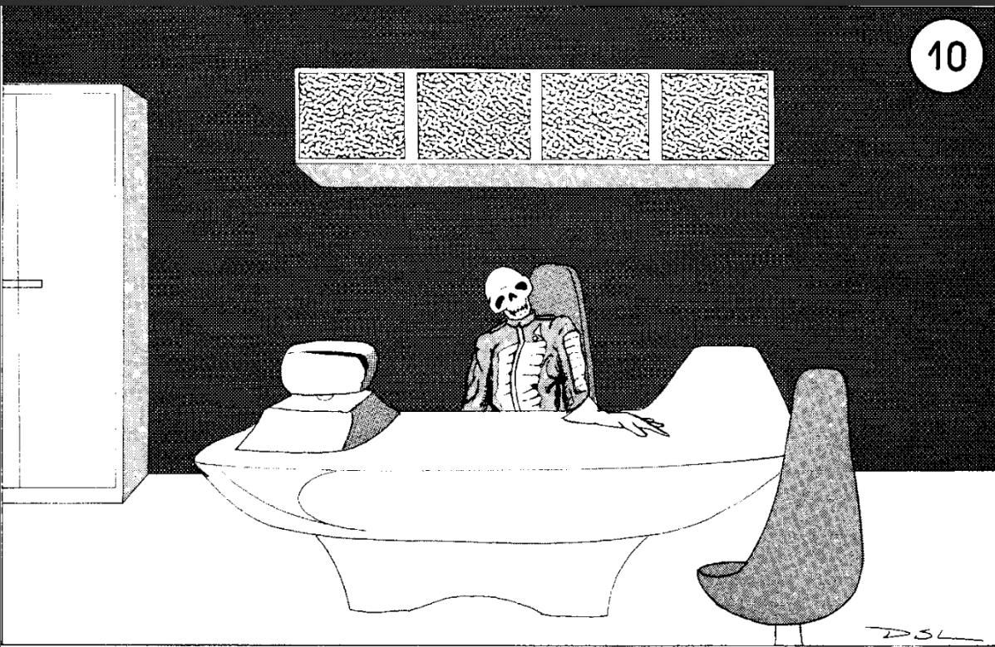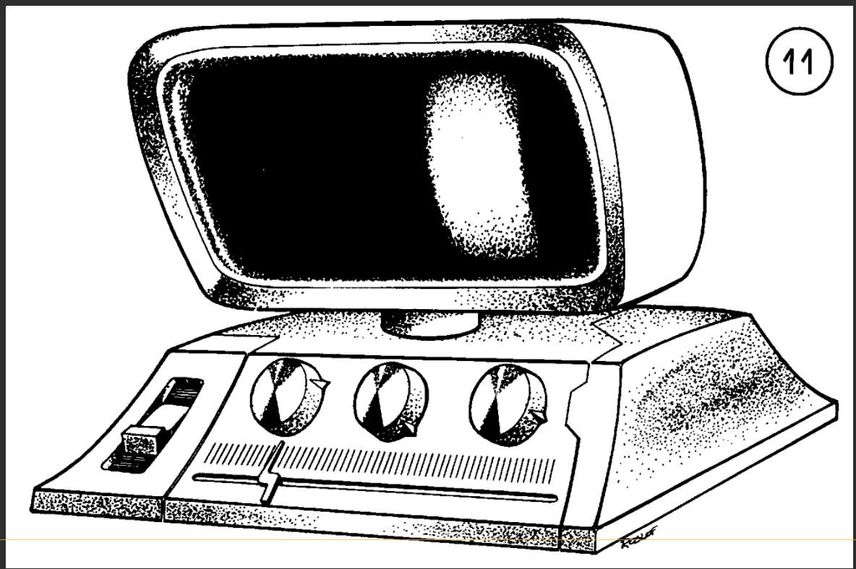

Stores
100 iron rations equivalent. 4 each: disease cure, poison antidote, radiation antidote ampules. 14 healing spray canisters (1-in-6 working, 1-6 charges each at 2d12 HP). Brown box with violet label: Worker Robot Remote Control (2% cumulative malfunction/turn).

Small Arms Locker (Gray card only) [ILLUSTRATION #12]
10 needler pistols, 8 paralysis pistols, 4 laser pistols, 2 laser rifles, 1 blaster rifle. 3 boxes of 20 grenades each (sleep, incendiary, explosive). Full powered armor in locked locker. Metal chest: 20 power discs, 20 needler clips.
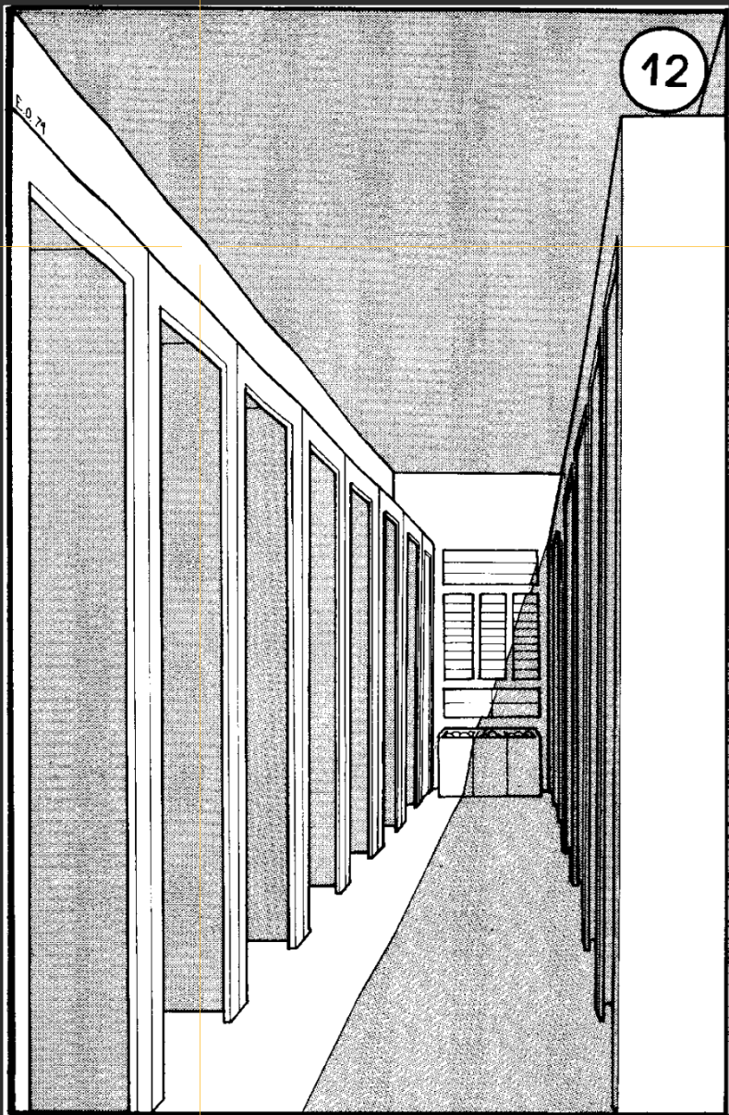

Computer Central [ILLUSTRATION #13] [ILLUSTRATION #44]
Touching any control feeds Lab b mold culture AND triggers random effect (d12):
1=minor fire (auto-extinguished, repair robot in 1-3 turns), 2=lights brighten/dim, 3=screen malfunction (repair+police robots in 1-3 turns), 4=cargo unload (bulette released!), 5=reverse gravity 1 round then 10' fall, 6=all doors close/lock (4 police robots unless 7 or 10 occurs), 7=unlock doors, 8=android power off/on, 9=worker robot power off/on, 10=police robot power off/on, 11=drop tubes sealed, 12=FULL ALERT (all doors lock, red lights, alarm, sleep gas in 1 round, 4 police + 2 worker robots in 2-8 rounds - only gray card + action 7 cancels).
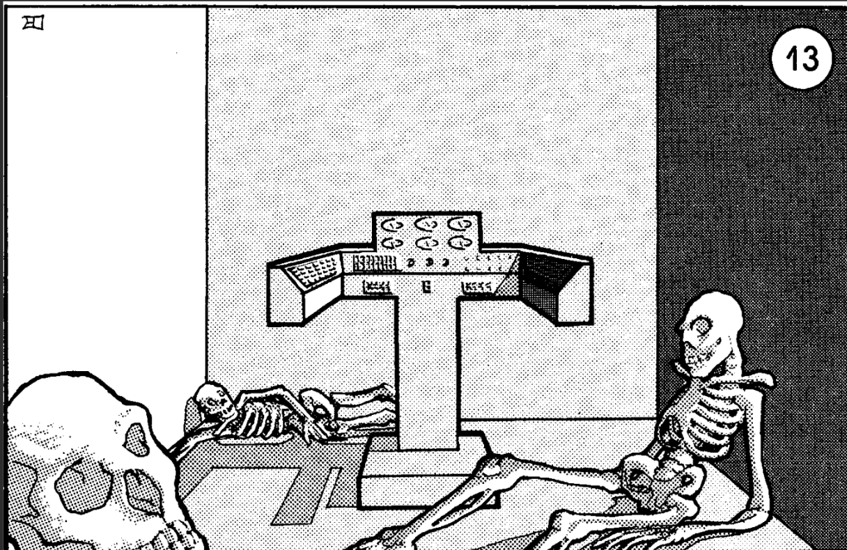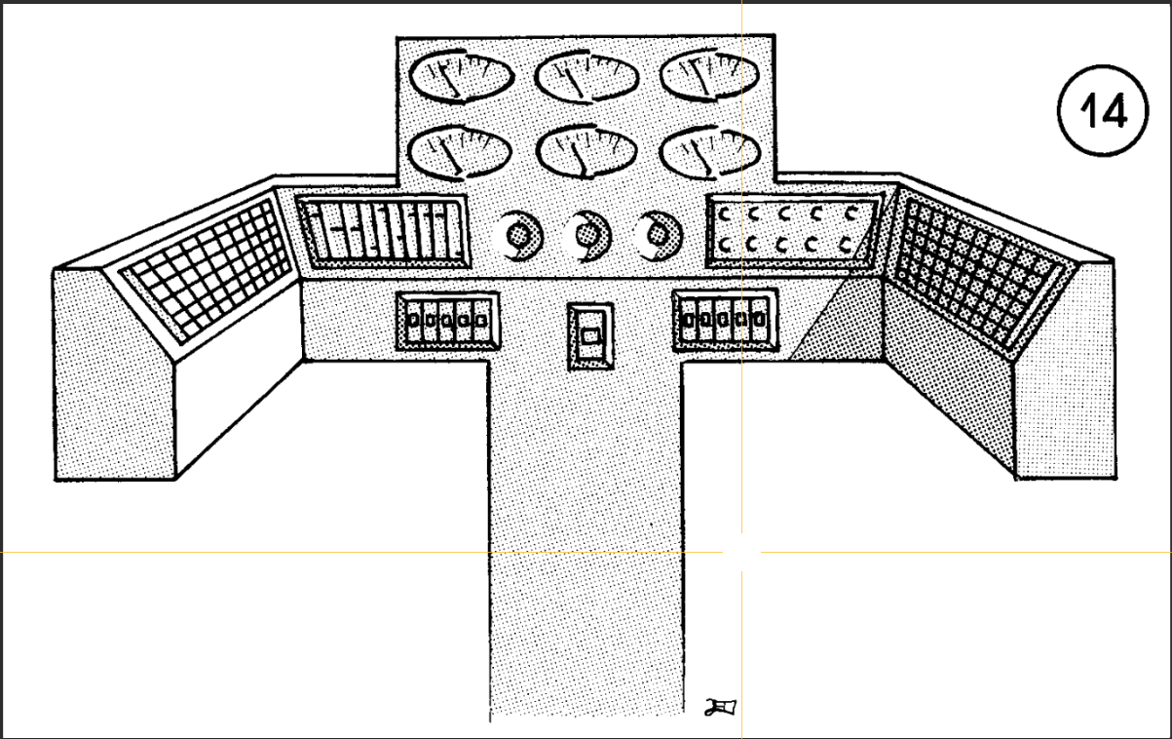

Library
24 microfilm viewers (1-in-6 operational). After 2 turns viewing: 1-in-6 shows ship level schematics (I, III, V). 6 questions per level allowed. 1-in-6 viewer breaks after each level shown.
Under one table: skeleton in uniform (important person). Gray card hidden under sealed cabinet nearby (careful examination or 10' search required).

Monster Stat Blocks (5e Conversion)

Vegepygmy [ILLUSTRATION #4] (south) [ILLUSTRATION #7] (north)
Small plant, neutral
AC 13 (natural armor) | Speed 30 ft.
STR | DEX | CON | INT | WIS | CHA
11 (+0) | 14 (+2) | 12 (+1) | 6 (-2) | 11 (+0) | 7 (-2)
Skills: Stealth +4 | Damage Resistances: Lightning, Piercing | Senses: Darkvision 60 ft., PP 10
Plant Camouflage: Advantage on Stealth in terrain with vegetation. 50% invisible against ship walls.
Regeneration: Regains 3 HP at start of turn if has 1+ HP and in contact with ground.
By Hit Dice:
HD | HP | Attack | Damage | Weapon
1 | 5 | +3 | 1d4+2 | Dart (thrown)
2 | 11 | +3 | 1d6+2 | Javelin
3 | 17 | +4 | 1d6+2 | Club
4 | 24 | +4 | 2d4+2 | Mace
5 | 31 | +5 | 2d4+3 | Flail
6 | 38 | +5 | 1d10+3 | Halberd

Thorny (Dog-Creature) [ILLUSTRATION #4]
Medium plant, unaligned
AC 14 (natural armor) | HP 30 (4d8+12) | Speed 30 ft.
STR | DEX | CON | INT | WIS | CHA
14 (+2) | 14 (+2) | 16 (+3) | 2 (-4) | 10 (+0) | 6 (-2)
Damage Resistances: Piercing (only 1 HP from piercing attacks) | Senses: Darkvision 60 ft., PP 10
Actions: Bite. +4 to hit, 5 ft., 1d6+2 piercing. On hit, target grappled (DC 12 escape). Grappled creature takes 2d6 piercing at start of each turn from thorns.

Police Robot [ILLUSTRATION #5]
Large construct, lawful neutral
AC 16 (armor plating) | HP 75 (10d10+20) | Speed 30 ft.
STR | DEX | CON | INT | WIS | CHA
18 (+4) | 12 (+1) | 14 (+2) | 10 (+0) | 14 (+2) | 6 (-2)
Damage Immunities: Poison, Psychic | Condition Immunities: Charmed, Exhaustion, Frightened, Paralyzed, Petrified, Poisoned
Senses: Darkvision 120 ft., PP 12 | Languages: Ship's language | Can scan color cards visually.
Actions: Multiattack (2 slams or 1 stunner). Slam: +6 to hit, 5 ft., 2d6+4 bludgeoning. Stunner (Recharge 5-6): 30 ft. cone, DC 14 CON save or stunned 1 minute (repeat save end of turns).

Worker Robot [ILLUSTRATION #6]
Medium construct, unaligned
AC 14 | HP 45 (6d8+18) | Speed 30 ft.
STR | DEX | CON | INT | WIS | CHA
16 (+3) | 10 (+0) | 16 (+3) | 8 (-1) | 10 (+0) | 6 (-2)
Damage Immunities: Poison, Psychic | Condition Immunities: Charmed, Exhaustion, Frightened, Paralyzed, Petrified, Poisoned
Non-Combatant: Will not attack unless defending itself. Calls police robots if threatened without brown/violet/gray card.
Actions: Slam. +5 to hit, 5 ft., 1d8+3 bludgeoning.

Displacer Beast
Large monstrosity, lawful evil
AC 13 (natural armor) | HP 85 (10d10+30) | Speed 40 ft.
STR | DEX | CON | INT | WIS | CHA
18 (+4) | 15 (+2) | 16 (+3) | 6 (-2) | 12 (+1) | 8 (-1)
Senses: Darkvision 60 ft., PP 11 | Avoidance: Advantage on saves vs effects it can see.
Displacement: Attack rolls against it have disadvantage. If hit, trait disabled until end of next turn.
Actions: Multiattack (2 tentacles). Tentacle: +6 to hit, 10 ft., 1d6+4 bludgeoning plus 1d6 piercing.

Will-o'-Wisp
Tiny undead, chaotic evil
AC 19 | HP 22 (9d4) | Speed 0 ft., fly 50 ft. (hover)
STR | DEX | CON | INT | WIS | CHA
1 (-5) | 28 (+9) | 10 (+0) | 13 (+1) | 14 (+2) | 11 (+0)
Damage Immunities: Lightning, Poison | Damage Resistances: Acid, Cold, Fire, Necrotic, Thunder; bludgeoning/piercing/slashing from nonmagical attacks
Ephemeral: Can't wear/carry anything. Incorporeal Movement: Pass through creatures/objects. Variable Illumination: Shed 5-20 ft. light or none.
Tactics: Lure victims to radiation areas (encounter #13).
Actions: Shock. +4 to hit, 5 ft., 2d8 lightning. Invisibility: Turns invisible until attacks or light changes.

Lurker Above
Large aberration, neutral
AC 13 | HP 59 (7d10+21) | Speed 10 ft., fly 40 ft.
STR | DEX | CON | INT | WIS | CHA
16 (+3) | 8 (-1) | 16 (+3) | 2 (-4) | 10 (+0) | 6 (-2)
Skills: Stealth +5 | Damage Resistances: Bludgeoning | Senses: Blindsight 60 ft., PP 10
False Appearance: Indistinguishable from ceiling while motionless. Surprises on 4-in-6.
Actions: Smother. +5 to hit, 5 ft., 1d6+3 bludgeoning. Target grappled (DC 14 escape) and restrained. While grappled, target can't breathe, takes 2d6+3 bludgeoning at start of lurker's turns. Smothers in 2-5 rounds.

Phase Spider (Dwarf Variety)
Small monstrosity, unaligned
AC 12 | HP varies (Adult 23, Young 5-7) | Speed 20 ft., climb 20 ft.
STR | DEX | CON | INT | WIS | CHA
10 (+0) | 14 (+2) | 12 (+1) | 6 (-2) | 10 (+0) | 6 (-2)
Skills: Stealth +4 | Senses: Darkvision 60 ft., PP 10
Ethereal Jaunt: As bonus action, shift to/from Ethereal Plane.
Actions: Bite. +3 to hit, 5 ft., 1d4 piercing plus 2d8 poison (DC 11 CON save for half). Potent Venom: Saves at disadvantage (-2 in 5e terms).

Android (Berserk) — see also [ILLUSTRATION #8] and [ILLUSTRATION #9]
Medium construct, unaligned
AC 15 (synthetic skin) | HP 35 | Speed 30 ft.
STR | DEX | CON | INT | WIS | CHA
18 (+4) | 14 (+2) | 14 (+2) | 10 (+0) | 10 (+0) | 10 (+0)
Damage Resistances: Acid, Fire (half damage) | Damage Vulnerabilities: Lightning (shorts out)
Malfunction: At 7 HP or less, 50% chance each round to cease functioning.
Actions: Multiattack (2 attacks). Slam: +6 to hit, 5 ft., 1d8+4 bludgeoning. Metal Bar: +6 to hit, 5 ft., 2d6+4 bludgeoning. Paralysis Pistol: See equipment.

Doppelganger
Medium monstrosity (shapechanger), neutral
AC 14 | HP 52 (8d8+16) | Speed 30 ft.
STR | DEX | CON | INT | WIS | CHA
11 (+0) | 18 (+4) | 14 (+2) | 11 (+0) | 12 (+1) | 14 (+2)
Skills: Deception +6, Insight +3 | Condition Immunities: Charmed | Senses: Darkvision 60 ft., PP 11
Shapechanger: Polymorph into Small/Medium humanoid or back. Ambusher: Advantage on attacks vs surprised. Surprise Attack: Extra 2d6 vs surprised.
Read Thoughts: Detect thoughts at will. Actions: Multiattack (2 slams). Slam: +6 to hit, 5 ft., 1d6+4 bludgeoning.

Gray Ooze
Medium ooze, unaligned
AC 8 | HP 22 (3d8+9) | Speed 10 ft., climb 10 ft.
STR | DEX | CON | INT | WIS | CHA
12 (+1) | 6 (-2) | 16 (+3) | 1 (-5) | 6 (-2) | 2 (-4)
Skills: Stealth +2 | Damage Resistances: Acid, Cold, Fire | Condition Immunities: Blinded, Charmed, Deafened, Exhaustion, Frightened, Prone
Amorphous: Move through 1-inch spaces. Corrode Metal: Nonmagical weapon hitting it corrodes (-1, destroyed at -5). False Appearance: Looks like wet rock/oily pool.
Actions: Pseudopod. +3 to hit, 5 ft., 1d6+1 bludgeoning plus 2d6 acid. Metal armor corrodes.

Shadow
Medium undead, chaotic evil
AC 12 | HP 16 (3d8+3) | Speed 40 ft.
STR | DEX | CON | INT | WIS | CHA
6 (-2) | 14 (+2) | 13 (+1) | 6 (-2) | 10 (+0) | 8 (-1)
Skills: Stealth +4 (+6 in dim/dark) | Vulnerabilities: Radiant | Resistances: Acid, Cold, Fire, Lightning, Thunder; nonmagical B/P/S | Immunities: Necrotic, Poison
Amorphous: Move through 1-inch spaces. Shadow Stealth: Hide as bonus in dim/dark. Sunlight Weakness: Disadvantage in sunlight.
Actions: Strength Drain. +4 to hit, 5 ft., 2d6+2 necrotic. Target's STR reduced by 1d4 (dies at 0, becomes shadow in 1d4 hours).

