Chapter 1 - The Summons

Introduction

Background
Over a year has passed since your extraordinary adventure that brought together the Wayward, The Friends, where you forged an unlikely alliance with dragons to restore order to the realm. The mission was a resounding success—chaos has been quelled, the land prospers once more, and peace reigns where discord once threatened to tear the kingdom apart.
Yet victory came with profound changes none of you anticipated.
The Administrator, the enigmatic figure who had long governed the networked world of the ancients from the orbital space station above, perished during the climactic events aboard the station. In the aftermath, as order was restored, Jak—your steadfast companion from the southern continent—found himself chosen to fill this most powerful of roles. Rather than ruling from the distant space station as his predecessor had done, Jak made the descided to establish his seat of earthbound power at the Temple of Nord in his homeland: the bustling port city of Greenfjord on the southern continent.
Where the previous Administrator had worked in shadows and secrecy, ruling only through hidden computer networks, Jak has emerged as a charismatic leader who openly blends religious authority with political power. He has expanded his role, using his personal army of warrior women—the Spásistren—to extend his influence across all the lands. For the first time in living memory, the Administrator governs not just the ancient machines, but the entire world—the lands, the people, and the technology that binds them together. He walks among the people, speaks directly to crowds, and rules not from the shadows but in the full light of day. The ancient Temple of Nord has become both seat of government and center of a new form of spiritual-political movement that draws followers from across the known world.

The Interlude
Each of you processed these monumental changes in your own way:
- Some celebrated the victory and returned home as heroes
- Others found themselves drawn to witness the transformation of Greenfjord from merchant city to seat of global power
- A few pursued new studies, driven to understand how the ancient forces you unleashed had reshaped not just the heavens, but the very structure of worldly authority
- Many simply tried to adjust to a world where their friend from humble origins now commanded the fate of nations from an earthbound throne

The Summons
Yesterday, each of you received an identical summons—delivered not by any earthly messenger or by ancient technology, but by a dis-trans bat, the strange creature's leathery wings beating silently as it appeared from nowhere. The bat carried a small glass tube sealed with the new seal of administration: a fusion of Greenfjord's traditional anchor and compass rose with the mystical symbols of the Temple of Nord. Inside the tube, a single slip of parchment reads simply: "Put this in your ear."
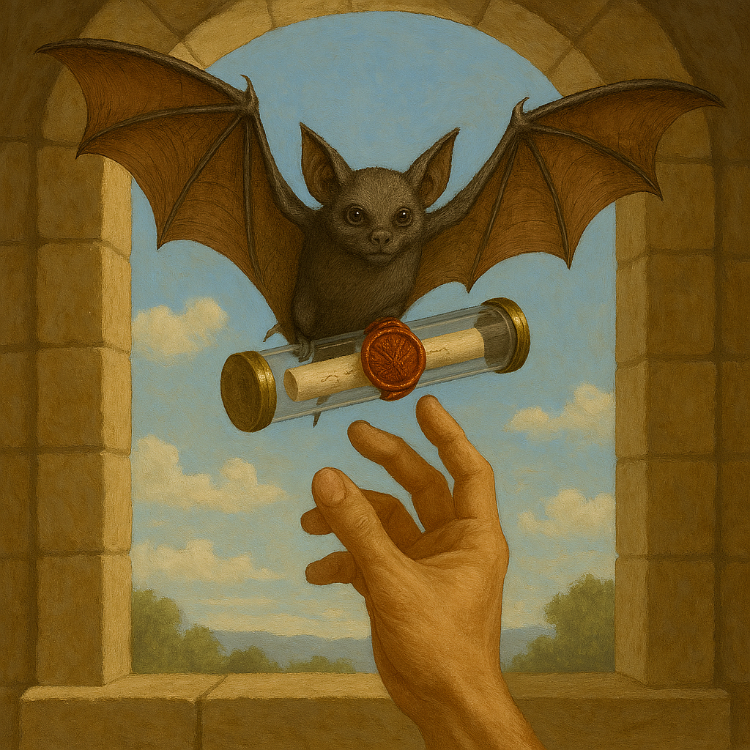
When you follow the instruction and hold the tube near the bat, the creature whispers into it, and Jak's voice emerges through the glass, the message embedded in the bat's mind and transmitted through the tube:
"My trusted friends, I have urgent need of your counsel. Unknown forces move against the peace we fought to create, and I fear I cannot face this mystery alone. Please, come to me at the Temple of Nord in Greenfjord with all haste. Time grows short, and there are secrets I can share only with those I trust most."
The message repeats once, then the bat falls silent, leaving you to ponder this strange interaction.

Your Arrival
You now stand in the harbor district of Greenfjord as the sun sets over the southern seas, painting the bustling port in hues of gold and crimson. The city you once knew has been transformed almost beyond recognition. At its heart, the Temple of Nord—long dormant and nearly forgotten among the merchant warehouses—now stands as the center of worldly power. Its ancient stone edifice towers over the surrounding buildings, its brutalist architecture both imposing and somehow unsettling in the fading light.
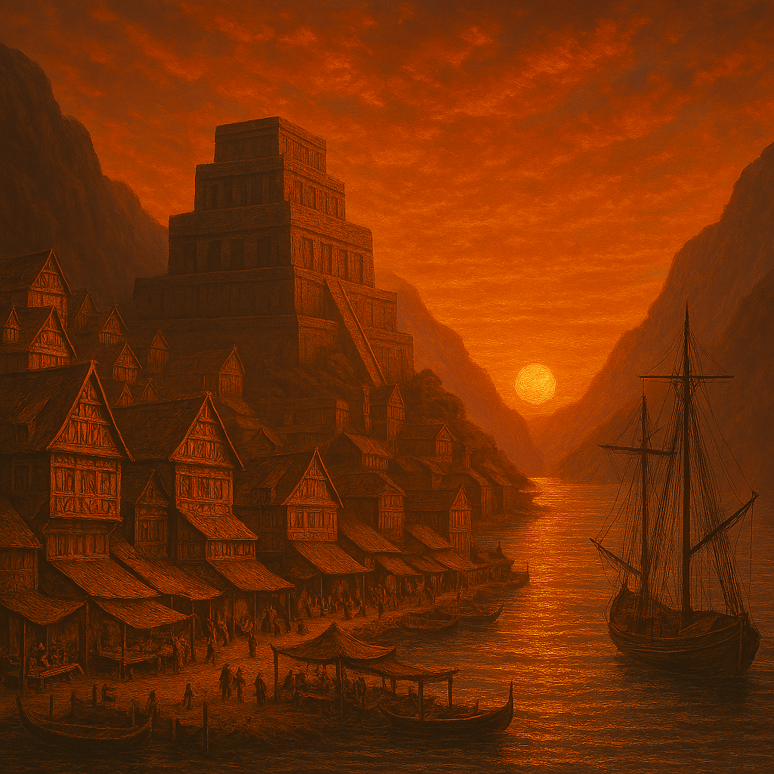
Yet beneath the prosperity and celebration, you sense an undercurrent of tension. Guards patrol with weapons ready, and the delegations from distant lands seem to whisper more urgently in shadowed corners. The harbor, always busy, now teems with vessels that bear the marks of hasty preparation.
As you are escorted through streets both familiar and strange by members of Jak's elite guard—the Spásistren, their simple monk-like robes flowing in the twilight—you notice how the old merchant quarter has expanded around the awakened Temple.
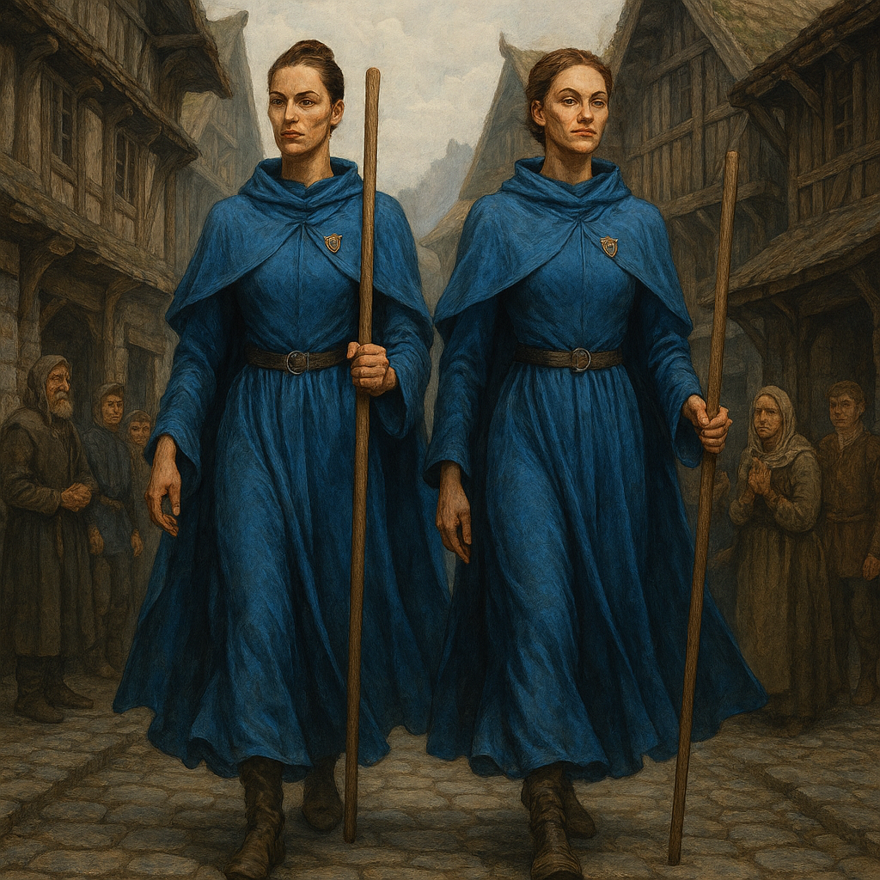
Your path leads directly to the Temple of Nord itself—its ancient stones now humming with activity, as if the building itself shares Jak's growing concern about the hidden threats that lurk beyond sight.
Finally, you arrive at the entrance to the Temple's inner sanctum—doors that bear the weight of authority, and the weight of secrets that may soon demand action from the Wayward, The Friends.
Beyond these doors waits your friend, the boy from Greenfjord who now bears the burden of protecting a world that may not yet understand the price of its peace.

Next Steps: Player Checklist
Before entering the adventure, take time to:

Things to Do
- Review Jak’s Summons: Reflect on what you know about Jak’s rise to power and the urgency in his message.
- Observe the Changes: Consider how Greenfjord and the world have transformed since your last adventure.
- Determine Your Story for the Gap Year: Decide what your character did during the year between campaigns. Did you travel, study, train, build relationships, or pursue personal goals? Be prepared to share your story with the group.

Things to Think About
- Jak’s Transformation: How do you feel about your friend now wielding global power? What concerns or hopes do you have?
- Political Tension: What do you make of the city’s preparations and the nervous energy in the air?
- Mysterious Enemies: Who might be working against Jak and the peace you helped create? Are there old rivals or new threats?
- Personal Goals: What do you want to achieve in Greenfjord—beyond simply answering Jak’s call?

