George Decay - Infected Scientist NPC
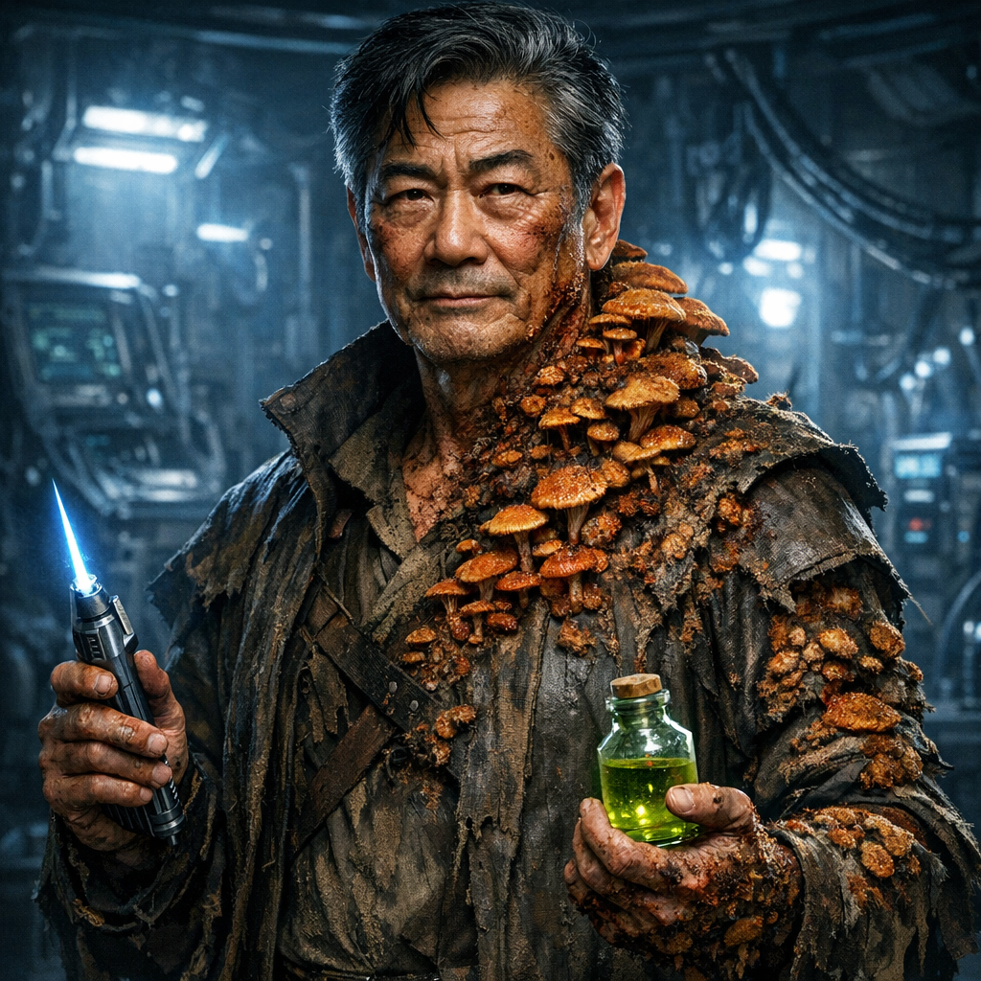
"Oh my... you've arrived. How fortuitous. And dramatic."

Background
George Decay is a scientist and explorer sent by Jak Bjornsson to investigate the frozen vessel and locate the source of the russet mold contamination that has been producing vegepygmies in the region.
He entered the ship a month ago and descended to the lower levels to track the contamination to its source. During his exploration, he was exposed to russet mold spores. The infection has taken hold - golden-brown and rust-red fungal growths sprout from his skin, concentrated on his torso, arms, and creeping up his neck toward his face. The mushrooms are literally eating him alive from within.
Through a carefully calibrated cocktail of experimental drugs synthesized from the ship's medical supplies, George has managed to slow the infection and maintain his mental faculties. His mind remains sharp, his wit intact, and his dedication to the mission unwavering - though he knows he's dying. The drugs are running dangerously low, which is why he's returned to Level 1 to obtain more supplies from the medical android.
Connection to Erleena Riser: George was not alone on this mission. Erleena Riser - whom the party knows from their previous world-saving adventure - accompanied him into the ship. When both were exposed to the spores, they made different choices: George chose the experimental drug regimen to fight the infection chemically, while Erleena opted to wear a containment suit from her last mission with the party to physically isolate herself from further contamination. She went searching for an exit route while George continued mapping the lower levels. George hasn't seen her in several days and worries about her fate. When he meets the party, he asks if they've encountered her, mentioning that she spoke highly of them and their previous heroic deeds.
Despite his horrific condition, George maintains an air of dignity, theatrical flair, and dry humor that borders on the absurd given his circumstances.

5e Statistics
George Decay Medium humanoid (human), lawful good
Armor Class 12 (leather coat) Hit Points 32 (5d8 + 10) Speed 30 ft. (reduced to 20 ft. when exhausted)
STR 10 (+0) DEX 14 (+2) CON 14 (+2) INT 18 (+4) WIS 16 (+3) CHA 12 (+1)
Saving Throws Int +7, Wis +6 Skills Arcana +7, Investigation +7, Medicine +9, Nature +10, Survival +6 Damage Resistances Poison (from constant exposure) Condition Immunities None Senses Passive Perception 13 Languages Common, Dwarvish, Elvish, Giant; can read ship language (limited) Challenge 2 (450 XP)

Special Traits
Infected (Russet Mold Contamination) George is infected with russet mold spores. Visible mushroom growths cover approximately 30% of his body. Every 24 hours without treatment, he must succeed on a DC 15 Constitution saving throw or lose 1d6 maximum hit points (currently has taken 8 damage to maximum HP). If reduced to 0 HP by this infection, he will die and transform into a vegepygmy in 1d4+20 hours.
Stimulant Cocktail (3/day) As a bonus action, George can inject himself with stimulants. For 10 minutes, he gains advantage on Intelligence checks and saving throws, and his speed increases to 35 ft. After the effect ends, he gains 1 level of exhaustion.
Scientific Expertise George has advantage on all Intelligence checks related to biology, medicine, fungal contamination, or analyzing unknown substances. He can identify ship technology and medical equipment with a DC 12 Intelligence check.
Desperate Clarity When reduced to half his current hit points or fewer, George's focus sharpens his mind. He gains advantage on Intelligence and Wisdom checks, but disadvantage on Charisma checks as his deteriorating condition becomes more apparent.

Actions
Scalpel Melee Weapon Attack: +5 to hit, reach 5 ft., one target. Hit: 4 (1d4 + 2) slashing damage.
Laser Scalpel (8 charges) Ranged Weapon Attack: +5 to hit, range 30/60 ft., one target. Hit: 11 (2d8 + 2) radiant damage. Uses 1 charge per shot.
Alchemical Vial (3/day) George throws an alchemical substance. Choose one effect:
- Acid: Ranged attack (+5 to hit), range 20 ft., 7 (2d6) acid damage
- Alkaline Neutralizer: Neutralizes acid, kills russet mold in a 5-ft radius
- Flash Powder: All creatures in 10-ft radius must succeed DC 14 Dex save or be blinded until end of their next turn
- Command Medical Android (Recharge 5-6) If the medical android is within 60 feet, George can attempt to override its programming with verbal commands in ship language. DC 15 Intelligence check. On success, the android follows one simple command for 1 minute.
Item | Description/Contents
Leather coat | with many pockets and pouches
Medical bag | scalpel, sutures, bandages, 2 doses of healing spray (2d12 HP each), 3 vials of alchemical substances
Laser scalpel | appears as a silver pen with blue crystal tip
Notebook | filled with observations about the ship, mold contamination, and vegepygmy behavior (in Common)
Atmosphere analyzer | indicates radiation, gas, and mold/spores
Anti-fungal stimulant | 3 doses (his personal mixture - expires in 2 days)
Gray color-coded access card
Water flask, dried rations

Personality & Mannerisms (George Takei Inspired)
Speech Pattern | Description
Delivery | Refined, theatrical delivery with excellent diction
Voice | Deep, resonant baritone voice that commands attention
Pauses | Occasional dramatic pauses for effect
Exclamation | Uses "Oh my!" as signature exclamation
Vocabulary | Sophisticated vocabulary and precise grammar
Wit | Dry wit even in dire circumstances
Statements | Tends toward grand, theatrical statements

Physical Mannerism
Maintains dignified posture despite the horror of his condition
Gestures expressively with his hands when speaking
Raises eyebrow dramatically when skeptical or amused
Touches the fungal growths with clinical detachment while discussing them
Periodic tremors when infection causes pain, but quickly regains composure
Projects confidence and authority even while dying

Character Trait
Maintains dignity and grace under horrific circumstances
Uses humor to cope with existential dread
Deeply committed to social responsibility (stopping the contamination)
Intellectually curious about everything, including his own infection
Theatrical and expressive, yet sincere
Values loyalty, courage, and doing what's right
Sees the absurd humor in his situation but never gives up

Ideals
The needs of the many outweigh the needs of the few (or the one)
Knowledge and understanding must be preserved and shared
Dignity should be maintained even in death
Science and reason guide the path forward

Bonds
Sworn oath to Jak Bjornsson to complete this mission
His research must survive him to save others
Feels deep responsibility for those infected by the contamination
Believes in the nobility of self-sacrifice for the greater good

Flaws
Can be overly dramatic at inappropriate moments
Sometimes prioritizes the theatrical delivery over urgency
Refuses to admit defeat even when death is imminent
May take risks because he's "dying anyway"

Roleplaying George Decay
Voice and Delivery | Details
Baritone | Deep, rich baritone (think: "Space... the final frontier...")
Dramatic Pauses | "The contamination... pause ...is quite extraordinary."
Enunciation | Enunciates clearly and precisely
Completion | Never mumbles or trails off - always completes thoughts with authority
Theatrical Emphasis | Uses theatrical emphasis on key words
Surprise Phrase | "Oh my!" when surprised, shocked, or impressed
Chuckle | Occasional knowing chuckle at the absurdity of his situation

Signature Phrase or Expression
Oh my...
How extraordinary!
Fascinating... and terrifying.
Well, this is certainly dramatic.
I find that most... intriguing.
The irony is not lost on me.
chuckles The universe has quite the sense of humor.
We must press forward. There is no other choice.

Physical Performance
Stands tall despite pain (military bearing)
Expressive eyebrow raises
Gestures with open hands when explaining
Occasional hand to chest when deeply moved or pained
Never slouches - maintains dignity
When infection causes pain: brief wince, then immediate recovery to composed state
Touches fungal growths matter-of-factly while discussing them

Conversation Topics Table
d20 | George Decay's Statement | Context/Trigger
1 | "The contamination's source lies in the hydroponic laboratories. Level Three. The ship's systems continue to nurture it. pause Most unfortunate." | Discussing the mold source
2 | "Oh my. You wish to know how much time I have remaining? touches fungal growth Three days. Perhaps four. The transformation is... dramatic pause ...inevitable." | When asked about his condition
3 | "The vegepygmies - these mushroom people - retain nothing of their former selves. raises eyebrow Complete metamorphosis. I've documented this seventeen times. Fascinating... and horrifying." | Discussing vegepygmies
4 | "The medical android is quite insistent about 'helping.' I've learned to negotiate with it. We have an understanding. knowing smile More or less." | Regarding medical android
5 | "Ah! Jak Bjornsson sent you. Excellent. gestures dramatically You arrive at a most opportune moment. pauses, concerned Tell me... have you seen Erleena Riser? She spoke so kindly of you all when we departed together." | Meeting the party
6 | "dry chuckle The irony is exquisite. I came to stop the contamination. Now I AM the contamination. raises eyebrow The universe has quite the sense of theater." | Moment of dark humor
7 | "Do not - and I cannot stress this enough - touch the golden-brown patches on those walls. Russet mold. Three-foot kill radius. pause Learn from my mistakes." | Warning about hazards
8 | "This vessel's technology is dramatic pause extraordinary. Centuries beyond anything we know. Perhaps millennia. Oh my... what wonders they possessed." | Expressing wonder at ship
9 | "I encountered a colony of them in the lower cargo holds. pause for effect At least forty vegepygmies. I strongly advise avoiding that particular area." | Warning about danger zone
10 | "holds up card These color-coded keys grant access. Gray for medical facilities. I've also located brown, violet, and one orange card below. Most useful." | Explaining access system
11 | "Every person who dies from these spores becomes one of those... creatures. intense gaze We MUST destroy the source. The alternative is... unacceptable." | Emphasizing mission urgency
12 | "The transformation requires twenty-one to twenty-four hours after death. matter-of-factly We must burn or dissolve the bodies. There is no other way." | Technical information
13 | "sharp intake of breath Ah. Forgive me. The mycelium network has reached my nervous system. The pain is... composes himself ...considerable. But I persevere." | During pain episode
14 | "I've synthesized a treatment from the ship's pharmacopeia. touches growth Alas, it merely delays the inevitable. The mold adapts with remarkable speed." | Discussing his treatment
15 | "This ship fell from the stars long ago. Centuries past. The crew perished here. Some... meaningful pause ...became the first vegepygmies. A tragic fate." | Ship history observations
16 | "The contamination spreads through the forest near Grønnfjord even now. If we fail here, the entire region will fall. dramatic emphasis We cannot fail." | Explaining stakes
17 | "I have mapped the functional areas of this vessel. I can guide you. meets their eyes But I require your assistance to reach Level Three. What say you?" | Offering alliance
18 | "Oh my! staggers slightly These fruiting bodies are quite aggressive today. steadies himself with dignity Where were we? Ah yes..." | When infection flares up
19 | "The medical android will attempt to 'treat' you. Its protocols are... raises eyebrow ...dangerously flawed. Allow me to intervene on your behalf." | During android encounter
20 | "Erleena... she chose the containment suit from your last mission together. Wise, perhaps. worry crosses his face I haven't seen her in days. She was searching for an exit. I do hope she's found one." | When asked about Erleena

Additional Dramatic Moments

When First Revealing His Condition
"opens coat to show extensive fungal growth Oh my. Yes. Quite the predicament, wouldn't you say? dry humor I've had better months."

About Erleena Riser
"expression becomes concerned Erleena Riser came with me. You know her, yes? She spoke of your heroism during that... gestures vaguely world-saving affair. pause When we were both exposed, we made different choices. I chose chemistry. touches growth She chose physics - the containment suit from your last adventure together. Quite sensible, really. She went searching for an exit several days ago. worry evident I haven't seen her since. Have you?"

If Party Mentions Finding Erleena
"visible relief Oh, thank the stars! She's resourceful, that one. wistful I had hoped... well. Please, if you see her again, tell her I'm still working toward our goal. The mission continues."

If Asked About Pain
"Pain? waves hand dismissively A small price for consciousness. I've calibrated my drug regimen to keep my mind sharp. taps temple The body may decay, but the mind must endure."

When Explaining His Mission
"stands tall Jak Bjornsson sent Erleena and myself to find the source and eliminate it. dramatic pause I intend to complete that mission. Even if..." touches growth "...circumstances have become complicated."

If Party Expresses Sympathy
"gentle smile Your concern is... touching. Truly. But there is no time for sentiment. We have work to do. Come! gestures dramatically Adventure awaits!"

During Android Battle Intervention
"STOP! commanding voice Medical android designation MED-2, authorization code Decay-Gamma-Seven! Stand down!" turns to party "Oh my... that was rather close, wasn't it?"

About The Final Oath
"grasps party member's arm If I transform... you must destroy me immediately. No hesitation. intense stare Promise me this. It is the only honorable path. pause And if you find Erleena wearing that suit... ensure she doesn't make the same mistake I did. The suit can fail."

Using George Decay in Your Campaign

Encounter Setup - Medical Bay Drama
The party encounters George Decay when the Surgeon Android attacks. At the moment of greatest danger, a commanding voice rings out:
"STOP!"
George emerges from behind medical equipment, standing dramatically in the doorway despite his horrific condition. Fungal growths visible on his exposed skin, he raises one hand commandingly:
"Medical android designation MED-2, authorization code Decay-Gamma-Seven! Stand down immediately!"
The android pauses (successful DC 15 Intelligence check), giving George time to stride forward with theatrical dignity:
"Oh my. surveys the party You must be the reinforcements Jak sent. slight bow George Decay, at your service. gestures at frozen android Shall we discuss our situation somewhere less... surgical?"

First Impressions
First Impression | Details
Posture and composure | Maintains perfect posture and composure despite obvious infection
Speech | Speaks with refined diction and dramatic flair
Humor | Uses humor to defuse tension: "As you can see, I've had better months."
Authority and competence | Projects authority and competence despite dying
Knowledge | Immediately establishes himself as knowledgeable about the ship
Attitude | Shows no self-pity, only determination

Observation
Despite obvious infection, maintains perfect posture and composure
Speaks with refined diction and dramatic flair
Uses humor to defuse tension: "As you can see, I've had better months."
Projects authority and competence despite dying
Immediately establishes himself as knowledgeable about the ship
Shows no self-pity, only determination

Key Information | Details
Access Cards | Explains the color-coded system (gray = medical, brown = crew, violet = maintenance, orange = command)
Contamination Source | Located in hydroponics labs on Level 3
Vegepygmy Nature | Former humans transformed by russet mold
Ship Technology | Basic operation of medical devices, atmosphere analyzers, etc.
Danger Zones | Areas with high mold concentration or vegepygmy populations
Jak's Mission | Confirms party was sent by Jak Bjornsson

Story Hook | Description
Finding Erleena | George asks the party to look for Erleena Riser, who is somewhere in the ship wearing a containment suit. She was searching for an exit days ago and hasn't returned. This creates an additional quest objective.
The Containment Suit | Erleena's suit may still be protecting her from spores, or it may have failed. The party might find her alive (potential ally) or transformed (tragic encounter).
Contrasting Choices | George chose drugs to slow infection while maintaining mobility. Erleena chose isolation in a suit. This presents different approaches to the contamination problem.
The Cure | George believes there may be a broad-spectrum decontamination system in the ship's engineering section
His Research | His notes contain detailed maps of Levels 1-3 and observations about ship systems
Tragic End | If the party delays too long, they may witness his transformation
Final Request | He asks the party to deliver his research notes to Jak Bjornsson if he doesn't survive, and to tell Erleena (if she lives) that he completed the mission

Role | Knowledge Source | Tech Support | Guide | Time Pressure
Tactical | Answers questions about the ship and contamination | Can operate medical equipment and override some androids | Knows safe routes and dangerous areas | His deteriorating condition adds urgency to the mission

Character Development Options

If Saved
If the party finds a cure (possibly in the engineering section or hydroponics control center), George becomes a valuable long-term ally who can help interpret ship technology.

If He Transforms
A tragic encounter where the party must fight what George became - a vegepygmy that retains none of his brilliance, just primal aggression.

Heroic Sacrifice
George might sacrifice himself to:
- Seal a contaminated section
- Distract vegepygmy horde while party escapes
- Activate the decontamination system (which kills him in the process)
- Provide medical aid knowing it will accelerate his transformation

