REPUBLIQUE DU CAMEROUN
PAIX -TRAVAIL-PATRIE

REPUBLIQUE OF CAMEROON
PEACE-WORK-FATHERLAND



SHADERL
One Love, One Mind, One Legacy! BP : Monti(YAOUNDE)
LinkedIn: shaderl
Tel: (237) 678358509/692199722
Site Web: www.shaderl.com

AFRICAN INSTITUTE OF COMPUTERS SCIENCES
BP: 13 719 Yaoundé (Cameroun)
Tel: (237) 22 72 99 57 / (237) 22 72 99 58
Site Web: www.iaicameroun.com

THEME : CONCEPTION AND REALISATION OF A STUDENT MANAGEMENT SYSTEM
Case study : saint albert conprehensive high school
ACADEMIC INTERNSHIP REPORT

Internship carried out from the 1st July to 30th September 2025
In view of obtaining a Higher Technician Diploma (HTD) in Software Engineering.

Written By
NKWENGE GREYSON ANIMBOM
LEVEL 2
AICS CAMEROON

Supervised By
PROFESSIONAL SUPERVISOR
MR. Bill Nelson
IT Engineer

ACADEMIC SUPERVISOR
MR. Messio Ulrich
Lecturer at AICS-Cameroon and Software Engineer

ACADEMIC YEAR 2024-2025

DEDICATION

THIS WORK IS DEDICATED TO THE NKWENGE’S FAMILY

ACKNOWLEDGEMENTS
This work would not have been successfully accomplished without the invaluable help, guidance, encouragement, and advice of the following individuals and organizations.
- We extend our profound gratitude to the African Institute of Computer Sciences (AICS), specifically to the Resident Representative, MR. ARMAND CLAUDE ABANDA.
- Our sincere thanks go to the director of Shaderl, MR. ASANE DERICK, and his entire staff for providing us with the opportunity to serve as interns at their prestigious enterprise.
- We are deeply indebted to our professional supervisor Mr. BILL NELSON for their expert guidance throughout our internship.
- A special note of thanks to our academic supervisor and lecturer at AICS Cameroon, Mr. MESSIO ULRICH, for his invaluable advice, guidance, and constant encouragement.
- We also wish to thank all the teachers at the African Institute of Computer Sciences for their foundational role in our education.
- Our gratitude extends to the entire amazing Shaderl family for their tremendous support and welcoming environment during our internship period.
- On a personal note, a special thanks to my dear parents, Mr. and Mrs.NKWENGE, for their unconditional love, unwavering financial support, and countless sacrifices. To my brothers and sisters, thank you for your love and support.
- We acknowledge the countless contributors of the open-source programming community, whose resources were instrumental in helping us learn essential skills and solve complex problems.
- Finally, thanks to my fellow mates, and senior Kamsu Marcelle, for their camaraderie and collaboration.

SUMMARY
DEDICATION i
ACKNOWLEDGEMENTS ii
SUMMARY iii
LIST OF FIGURES iv
LIST OF TABLES vi
LIST OF ABBREVIATIONS vii
ABSTRACT viii
RESUME ix
GENERAL INTRODUCTION 1
PART ONE : INSERTION PHASE 2
PART TWO: TECHNICAL PHASE 14
DOCUMENT ONE: EXISTING SYSTEM 15
DOCUMENT TWO: SPECIFICATION BOOK 24
DOCUMENT THREE : ANALYSIS PHASE 38
DOCUMENT FOUR: CONCEPTION PHASE 70
DOCUMENT FIVE : REALISATION PHASE 88
DOCUMENT SIX: TESTING OF FUNCTIONALITIES 103
DOCUMENT SEVEN: USER GUIDE 110
PERSPECTIVE 118
GENERAL CONCLUSION 119
ANNEXE ix
BIBIOGRAPHY x
WEBOGRAPHY xi
TABLE OF CONTENTS xii

LIST OF FIGURES
Figure 1: Organization of shaderl 10
Figure 2: Geographical location of shaderl 11
Figure 3: Gantt project 33
Figure 4:uml diagrams 42
Figure 5: 2TUP 44
Figure 6: Use case formalism 47
Figure 7: General use case diagram 50
Figure 8: Specific use case for marking attendance 51
Figure 9:specific use case manage time table 51
Figure 10: formalism of activity diagram 55
Figure 11: Activity diagram for authentication 58
Figure 12: Activiy diagram for marking attendance 59
Figure 13: Grade student activity diagram 60
Figure 14: formalism for sequence diagram 61
Figure 15: sequence diagram for authentication 63
Figure 16: sequence diagram for mark attendance 64
Figure 17: sequence diafram for grade student 65
Figure 18: formalism for communication diagram 66
Figure 19: mark attendance communication diagram 68
Figure 20: grade student communication diagram 68
Figure 21:hardware diagram of the system 73
Figure 22: n-tier architecture 75
Figure 23:MVC architecture 76
Figure 24 : formalism of class diagram 77
Figure 25: system class diagram 79
Figure 26: formalism of the state machine diagram 80
Figure 27:submit assignment state machine diagram 82
Figure 28: Grade student state machine 83
Figure 29: formalism of package diagram 84
Figure 30: system package diagram 86
Figure 31:system component diagram 93
Figure 32: system deployment diagram 96
Figure 33: authentication API test 107
Figure 34:login 107
Figure 35:logout 108

LIST OF TABLES

Table 1:actors of the system 29
Table 2:chronogram of Activities 31
Table 3:list of participants 32
Table 4:hardware Resources 34
Table 5: software Resources 34
Table 6:human Resources 35
Table 7: total estimated cost 35
Table 8:elements of a use case diagram 48
Table 9: actors of our system 49
Table 10: textual description for Authentication 52
Table 11: Textual description for grade students 53
Table 12: elements of an Activity diagram 56
Table 13: elements of a sequence diagram 62
Table 14: elements of the communication diagram 67
Table 15: Elements of a class diagram 78
Table 16: elements of a state machine 81
Table 17: elements of a package diagram 85
Table 18: elements of a component diagram 92
Table 19: elements of deployment diagram 95
Table 20: technical choice 97

LIST OF ABBREVIATIONS

- AICS – African Institute of Computer Sciences
- HTD – Higher Technician Diploma
- SMS – Student Management System
- UML – Unified Modeling Language
- 2TUP – Two-Track Unified Process
- MVC – Model View Controller
- AI – Artificial Intelligence
- IT – Information Technology
- DBMS – Database Management System
- UI/UX – User Interface / User Experience
- API – Application Programming Interface
- PR – Public Relations
- OS – Operating System
- FCFA – Franc de la Communauté Financière Africaine

ABSTRACT
Technology has become indispensable and crucial in the lives of people around the world due to its impact across various fields, including communication, medicine, education, agriculture, the arts, and administration. For organizations and institutions to remain efficient and competitive, it is essential to adopt and apply modern computer technologies. Schools, in particular, continue to face challenges with manual record-keeping, paper-based attendance systems, grade calculations, and slow communication between stakeholders. This research project, titled CONCEPTION AND REALISATION OF STUDENT MANAGEMENT, was given to us to provide professional experience in solving real-world educational problems while preparing us for the labor market.
To achieve this, we researched to gather the necessary information and applied UML modeling based on the 2TUP methodology. This approach enabled us to design a complete method that covers system analysis, design, and implementation. The resulting Student Management System offers role-based access for students, parents, teachers, and directors, ensuring efficient grade management, attendance tracking, digital timetables, real-time parent communication, and automated report card generation. This project highlights how digitalization can transform traditional school administration into a smart, secure, and user-friendly platform for all stakeholders.
Keywords:
- Digitalization
- Education
- Student Management
- School Administration
- Automation

RESUME
La technologie est devenue indispensable et importante dans la vie des populations à travers le monde en raison de son impact dans divers domaines tels que la communication, la médecine, l'éducation, l'agriculture, les arts et l'administration. Pour que les organisations et les institutions restent efficaces et compétitives, il est essentiel d'adopter et d'appliquer les technologies informatiques modernes. Les écoles, en particulier, sont encore confrontées à des défis liés à la tenue manuelle des dossiers, à la prise de présence sur papier, au calcul manuel des notes et à une communication lente entre les parties prenantes. Ce projet de recherche, intitulé CONCEPTION ET RÉALISATION D’UN SYSTÈME DE GESTION DES ÉTUDIANTS., nous a été confié pour nous offrir une expérience professionnelle dans la résolution de problèmes éducatifs concrets tout en nous préparant au marché du travail.
Pour y parvenir, nous avons mené une recherche pour recueillir les informations nécessaires et avons appliqué la modélisation UML basée sur la méthodologie 2TUP. Cette approche nous a permis de concevoir une méthode complète couvrant l'analyse, la conception et la mise en œuvre du système. Le Système de Gestion Scolaire qui en résulte offre un accès basé sur les rôles pour les élèves, les parents, les enseignants et les directeurs, garantissant une gestion efficace des notes, un suivi de la présence, des emplois du temps numériques, une communication en temps réel avec les parents et une génération automatique des bulletins. Ce projet met en lumière comment la numérisation peut transformer l'administration scolaire traditionnelle en une plateforme intelligente, sécurisée et conviviale pour toutes les parties prenantes.
Mots-clés :
- Numérisation
- Éducation
- Gestion Scolaire
- Administration Scolaire
- Automatisation

GENERAL INTRODUCTION
Technology is advancing at an incredible rate, impacting almost every sector from business to agriculture and beyond. Due to these significant technological advancements, we now live in a fast-paced society where everything is gradually being digitalized, making life easier. As a developing country, many businesses in Cameroon strive to take advantage of the digital economy to grow and, in turn, boost the national economy. To achieve such goals, enterprises need qualified personnel with skills in computer science and related fields. Second-year students at AICS Cameroon are required to complete a three-month academic internship at an enterprise to apply the knowledge acquired in school to a professional setting. For this reason, we applied for an internship at Shaderl, a company specializing in providing IT solutions. During our internship, we were assigned the theme “Conception and Realization of a Student Management System.”
We have structured this report into several sections, as follows:
- Insertion phase: In this book, we shall present the company in which we spent our internship period and the integration of interns.
- Existing System: Here, we shall present the already present system in place,
- Specification Book: In this book, we specify the needs of the user, taking into consideration the time and cost of the project.
- Analysis Phase: Here, we shall present the analysis method chosen, together with the presentation of all the diagrams used for the analysis of this project.
- Conception phase: This presents the generic and detailed conception of the project to bring out real-world constituents.
- Realization phase: This phase will permit us to visualize the implementation process of the solution.
- Functional testing: In this phase, we shall present to you the different functionalities or modules of our application and how they work.
- User Guide: This elaborates on all conditions necessary to use the application and how to use it.

PART ONE : INSERTION PHASE

Preamble
This section of the report will cover details of how we were welcomed in the host company, the presentation, and a brief introduction to our project.

Content

INTRODUCTION
The insertion phase in a company is a period during which we discover our work.
Environment, the staff of the company, and other interns. Here, we will begin by discussing our first two weeks in the company, how we were welcomed, and how we began adapting to our internship environment. We will proceed by exploring the history of the company, discovering its missions, learning what its major activities are, and witnessing some of its key realizations. We will also get to understand how the company is structured administratively and functionally so that it operates effectively and accomplishes its goals. Furthermore, we will look at the hardware equipment used by the company and the software resources used in its daily operations. We will then introduce our chosen theme for the internship period, briefly elaborate on it.

WELCOME AND INSERTION
We arrived at SHADERL on Tuesday, 01st July 2025, at 08:00 a.m. We were received by the Shaderl team, who introduced us to our workspace, gave us an official welcome to the enterprise, its activities, and its different rules and regulations. Also, we discussed the enterprise’s preferred languages and frameworks, and our professional supervisor encouraged us through his past working experiences in different enterprises.
In the first two weeks, we started with our internship report by configuring our MS WORD processor, reviewing key concepts like page numbering, styles, section breaks, page breaks, etc. There was a talk on project ideas; we were advised to propose project ideas, and we were assigned the task of researching these ideas. The objective was that the enterprise did not want to impose any themes on us. For those who could not find a theme, the enterprise could propose an idea for them to think about.

GENERAL REPRESENTATION OF SHADERL

Background:
Shaderl is a dynamic, non-governmental tech startup founded in 2023 by Mr. Asane Derick with a bold vision: to bridge the gap between traditional industries and the rapidly evolving digital economy. Recognizing the urgent need for digital transformation, Shaderl is committed to providing cutting-edge IT solutions while empowering the next generation of innovators.

Mission
At Shaderl, we harness the power of AI and cutting-edge technology to democratize digital transformation. Our mission is to empower individuals and businesses with intelligent tools, accessible education, and personalized mentorship, bridging the gap between today’s potential and tomorrow’s opportunities. We believe AI should augment human potential, not replace it. By making AI-driven solutions practical and ethical, we equip the next generation to lead, innovate, and thrive in an era where human creativity meets machine intelligence.

Vision
At Shaderl, we envision a world where technology unites humanity, where innovation is driven by collective purpose, not just profit. By putting “People First”, we strive to build a future where:
- One Love→ Technology fosters inclusion, empathy, and global collaboration, breaking down barriers.
- One Mind→ AI and digital tools amplify human potential, creating shared knowledge and opportunity.
- One Legacy→ Every individual we empower leaves a lasting impact, shaping a smarter, kinder, and more connected world.
We don’t just adapt to the digital age; we redefine it with humanity at the core.

Activities
The activities of Shaderl range from computer science, engineering, and training. We can outline the following:
- Conception, realization, and hosting of websites.
- Software development and maintenance.
- Training in software-related fields.
- Conception and realization of multimedia.
- IT consulting and innovation.
- IT support.

ORGANISATION OF SHADERL
Shaderl is administratively organized as follows:
Executive Leadership
This department is responsible for:
✓ Setting the company's vision, mission, and strategic direction
✓ Making high-level decisions about investments, partnerships, and growth
✓ Representing Shaderl in key meetings with investors and government agencies
✓ Ensuring all departments align with the company's core values and objectives
✓ Overseeing the overall performance and sustainability of the organization

. Software Engineering Department
This department is responsible for:
✓ Designing, developing, and maintaining all of Shaderl's software products
✓ Implementing AI and machine learning solutions for company offerings
✓ Ensuring software security, scalability, and optimal performance
✓ Collaborating with other departments to understand technical requirements
✓ Staying updated with emerging technologies and industry best practices

. Human Resource Department
This department is responsible for:
✓ Recruiting and onboarding top talent that aligns with Shaderl's values
✓ Managing employee relations, welfare, and performance evaluations
✓ Developing training programs to enhance staff skills and capabilities
✓ Maintaining company culture and ensuring a positive work environment
✓ Handling compensation, benefits, and conflict resolution

Communication Department
This department is responsible for:
✓ Managing Shaderl's public image and brand reputation
✓ Developing and executing marketing and PR strategies
✓ Handling all internal and external communications
✓ Managing social media platforms and digital content
✓ Organizing corporate events and press engagements

. Department of Financial Affairs
This department is responsible for:
✓ Managing all financial operations and accounting
✓ Preparing budgets and financial forecasts
✓ Handling payroll, taxes, and financial reporting
✓ Ensuring compliance with financial regulations
✓ Managing investments and financial partnerships

Functional organisation
The functional branch of Shaderl is organized as follows:
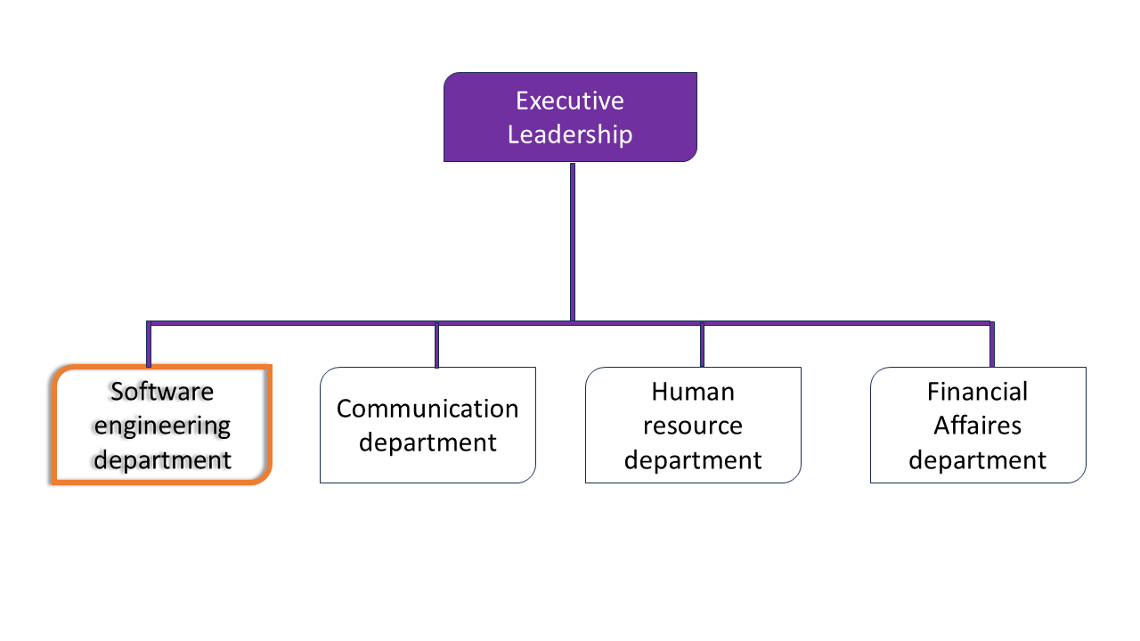
Figure 1: Organization of shaderl

GEOGRAPHICAL LOCATION

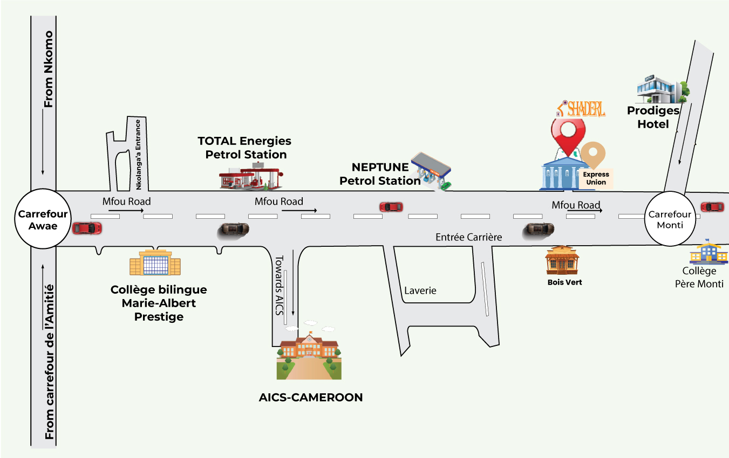
Figure 2: Geographical location of shaderl

BRIEF PRESENTATION OF THE PROJECT THEME
During our insertion phase in SHADERL, we were asked to look for themes which solves a specific problem and something innovative. professional supervisor took some time to look into what we proposed as themes and he also proposed some themes ideas. Finally, we had to go for Conception and Realization of a Student management system. Schools today still struggle with paper attendance sheets, manual grade calculations, scattered student records, and slow parent communication. These outdated methods waste time, create errors, and frustrate both teachers and parents. Our solution is a smart, all-in-one Student Management System that auto-generates report cards, provides digital timetables, sends parents real-time alerts on attendance, grades, and events, and reduces paperwork for teachers. Students gain easy access to schedules, grades, and AI assistance, while schools benefit from centralized, secure digital records. In short, we’re turning old-school paperwork into a modern, easy-to-use system that helps everyone in education work better together.

CONCLUSION
Being at the end of the insertion phase, which covered the general presentation of our company and our familiarity with the work environment. This environment gives room for hard work, perseverance and collaboration, what most students are looking for. We learned about the missions of the company, its activities. In addition, this phase was a benefit to us due to the perception of the need, importance of collaborative work and especially the most important aspect confronting the realities of the workspace.

PART TWO: TECHNICAL PHASE

DOCUMENT ONE: EXISTING SYSTEM

Preamble
The existing system is a document that provides a view of the system currently in place, that is how it carries out its different activities, also it provides a deep understanding of this system associated to the various limitations, the problems that result from these and the solution we propose.

Content

INTRODUCTION
I. PRESENTATION OF THE THEME
II. STUDY OF THE EXISTING SYSTEM
III. CRITICISMS OF THE EXISTING SYSTEM
IV. PROBLEMATICS
V. PROPOSED SOLUTION
CONCLUSION

INTRODUCTION
As Engineers our role in the society is problem-solving which is targeted at making life easier for everyone and in order to bring forth a solution, we ought to ask ourselves some questions to know why the problem exist in the first place and how it is being dealt with at the time. The existing system refers to the system put in place to carry out the work done in the field on which our theme is based. Understanding this system is a great step in solving the problems that we might identify. It’s of great importance that we take into consideration this system before proposing a suitable solution that will ameliorate or replace the current one.

PRESENTATION OF THE THEME
In the modern world of education, schools and institutions encounter several challenges in managing their day-to-day operations effectively. Manual processes often lead to disorganization, delays, and a lack of transparency among students, teachers, parents, and administrators. To overcome these challenges, we propose the development of a comprehensive Student Management System (SMS). This digital platform is designed to streamline school operations, reduce administrative workload, and improve communication among all stakeholders.

Our Vision:
To design and implement a Student Management System that is efficient, user-friendly, and impactful, transforming the way schools manage academic and administrative processes. By leveraging technology, our solution will enhance the overall educational experience for students, empower teachers with effective tools, and provide parents and directors with real-time access to important information.
- Student Information Management: A centralized platform to securely store and manage student data, including personal details, academic performance, and attendance records.
- Course Management: Tools to manage courses, class schedules, and resource allocation.
- Admission and Enrollment: A module to digitize the admission process
- Notification System: A real-time alert system to keep students, parents, and staff updated on events, deadlines, and announcements.
- Personalized Guidance: AI-powered assistance and support services to help students with academic queries, study tips, and progress tracking.

STUDY OF THE EXISTING SYSTEM
The current student management practices in Cameroon are largely dependent on manual and paper-based processes. These outdated methods create inefficiencies, increase errors, and limit accessibility. Below is an analysis of the existing system:

a. Administrative Chaos
- Attendance Tracking: Teachers still use paper registers, which can easily be lost, misplaced, or miscalculated.
- Grading and Report Cards: Grades are calculated manually, consuming time and creating room for errors. Report cards are handwritten or individually typed, which delays distribution.

b. Communication Gaps
- Parent-School Interaction: Updates on fees, events, and grades are passed through notices or word of mouth. Parents often miss critical information such as exam schedules and fee deadlines.

c. Student Support Limitations
- Homework Help: Assistance is only available during the teacher's office hours, limiting accessibility. Online learning systems are available.

CRITICISMS OF THE EXISTING SYSTEM
The analysis of the current school management practices reveals several limitations that hinder efficiency, transparency, and effective communication. The major criticisms include:
- Inefficiency: Manual processes slow down daily operations such as attendance and grading,
- Error-Prone: Paper-based records increase the likelihood of mistakes in calculations and student records
- Poor Communication: Parents and teachers lack a reliable communication channel, leading to missed information and frustration.
- Lack of Accessibility: Important resources such as report cards, past exams, and announcements are difficult to access outside the school premises.

PROBLEMATICS
After analyzing the existing school management system and identifying its limitations, it is clear that the current approach is inefficient, outdated, and disconnected from the needs of modern education. Since education is the foundation of societal progress, it is crucial to simplify and optimize school administration to ensure transparency, efficiency, and accessibility for all stakeholders: students, teachers, parents, and administrators. Through these observations, we address the core problem by asking: “How can we streamline school administration, enhance communication between teachers and parents, and provide students with better academic support? “This question guides our research and leads us to propose digital solutions that will revolutionize school management in Cameroon.

PROPOSED SOLUTION
To address the challenges identified, we propose the development of a comprehensive Student Management System (SMS). This platform integrates all core academic and administrative functions into a single digital solution.
Key Aspects of the Proposed Solution:
- Automation of Core Processes: Attendance, grading, and report card generation will be automated to reduce errors and save time.
- Centralized Database: All student, teacher, and administrative records will be stored in a secure, centralized database.
- Real-Time Communication: Parents, teachers, and students will receive instant updates regarding grades, attendance, and updates.
- AI-Powered Assistance: An integrated chatbot will guide students with academic questions, study tips, and personalized learning support.

DELIMITATION OF THE FIELD OF STUDY
The reason for delimiting our field of study is to focus on a particular problem and develop an efficient solution. Our project focuses on developing a Student Management System, specifically designed for managing student records, communication, and file management. We will explore relevant technologies, platforms, and documentation to create an efficient and effective solution. The study will concentrate on the process of designing and implementing the system, ensuring compliance with relevant regulations.
To ensure an efficient and focused solution, our project will concentrate on: Core Student Management Functions, Attendance tracking, Grading and report generation, Parent-school communication, and Student academic support.

CONCLUSION
Having reached the end of this part, we studied the existing system by surveying students and organizers to identify limitations leading to inefficiencies and errors. Finally, we proposed our solution, which is the CONCEPTION AND REALISATION OF A STUDENT MANAGEMENT SYSTEM

DOCUMENT TWO: SPECIFICATION BOOK

Preamble
This specification book is the document where we expose the detailed study of the project. In this section of the report, we shall discuss the project, its origins, its objectives, as well as the human, hardware, and software resources necessary for its realization.
Content

INTRODUCTION
- CONTEXT AND JUSTIFICATION
- OBJECTIVES OF THE PROJECT
- EXPRESSION OF NEEDS
- PROJECT COST ESTIMATIONS
- PROJECT PLANNING
- LIST OF PARTICIPANTS VII.
- DELIVERABLES

CONCLUSION

INTRODUCTION
The specification book gives us the different directives on the product to be delivered with the agreement of the client(s) and the proposed solution. In this section, we shall present the context in which we are to implement our project and describe what the system should do and how the system should do it. These specifications are to avoid the production of inadequate outputs. We shall include project details such as the team involved, outline the various constraints, the budget, deadlines, the target population, and the beneficiaries’ constraints and deliverables.

CONTEXT AND JUSTIFICATION

Context
Over the past decade, Cameroon’s education sector has faced critical inefficiencies due to outdated administrative practices, poor communication, and limited access to digital tools. Despite technological advancements globally, many schools still rely on paper-based systems for attendance, grading, and fee management, leading to:
- Lost records and errors in student data.
- Delayed parent-school communication, causing frustration.
- Limited academic support for struggling students.
The rise of digital transformation in other sectors (e.g., finance, healthcare) highlights the urgent need for schools to modernize. With increasing smartphone penetration and internet access, the time is ripe for a Student Management System (SMS) that bridges these gaps.

Justification
Cameroon’s education system serves a growing tech-savvy population, yet schools lack the tools to match this evolution. Here’s why an SMS is indispensable:
- Dual Challenges of Scale and Complexity
- Schools manage hundreds of students with manual processes, increasing workload.
- Rural-urban disparities mean some schools lack resources, while others are ready for digitization.
- Economic and Regulatory Demands
- The government’s push for education digitization (e.g., paperless exams) requires compliant systems.
- Parental demand for transparency in grades and attendance is rising.
- Technological Readiness
- Mobile adoption is high parents and teachers can access apps easily.
- Cloud technology enables affordable, scalable solutions even for low-budget schools.
- Social Impact
- Reduces dropout rates by identifying at-risk students early.
- Empowers teachers to focus on teaching, not paperwork.
- Prepares students for a digital future with AI.

OBJECTIVES OF THE PROJECT

General Objective
The primary goal of this Student Management System (SMS) is to digitally transform school administration, enabling efficient communication, seamless academic tracking, and real-time collaboration among teachers, students, parents, and administrators.

Specific Objectives
To achieve this, the system will:
- Digitize Student and Staff Records
- Upload and manage student/teacher profiles (bio, class, subjects).
- Automatic attendance.
- Enhance Parent-School Engagement
- Allow parents to view grades, attendance in real time.
- Streamline Academic Processes
- Automate grading, report generation, and timetable scheduling.
- Provide an AI Chatbot for homework help.

EXPRESSION OF NEEDS

Actors of the platform
An actor is defined as a model element that interacts with a system; it can be an abstract
person(customer) or another external system. The different actors concerned with our application are:
Director: Manages school data (student/teacher, parent, system settings).
Teacher: Marks attendance, submits grades, and gives assignments.
Student: Views timetable, checks grades.
Parent: Monitors child’s progress.
AI Chatbot: Answers director/student/teacher/parent queries
Table 1:actors of the system
Module | Functionality
1. Account Creation | The Director creates teacher/student/parent accounts.
2. Account Management | Users can update profiles (e.g., contact info, password).
3. User Authentication | Secure login (username + email + password).
4. Student Management | The director creates/edits student records (class, subjects).  - Parents/students view academic profiles.
5. Attendance Tracking | Teachers mark attendance  Parents receive the child’s attendance.
6. Grading & Reports | The teacher's input grades director generates report cards.  Parents access grades via the portal.
7. Timetable Scheduling | Automated class/teacher timetables.  Conflict detection for rooms/teachers.
8.AI Chatbot | The director can help with administrative tasks  The teacher can assist with class management  Parents help with their child's education and school-related matters.  Student here to help with your studies, assignments, and any school-related questions.

Non-functional needs
They specify the quality attribute of a software system. They judge the software system of application based on Performance, Responsiveness, Usability, Security, Portability, and other non-functional standards that are critical to its success. Failing to meet non-functional requirements can result in a system that fails to satisfy user needs. Performance, Scalability, and Security Performance defines how fast a software system, or its piece, responds to a certain user’s action under a certain workload. In most cases, this metric indicates how long a user must wait before the target operation occurs (such as the page rendering or a transaction being processed), given the overall number of users at that moment. But it’s not always like that.
Performance requirements may describe background processes invisible to users. Our goal will be to provide our users with the best performance as it affects the overall user experience.
Scalability assesses the highest workloads under which the system will still meet the performance requirements. In this project, the application should have a friendly user interface (UI) and should be easy to use. The code should be clear to facilitate future development and improvement. The web application should be resizable when opened on a device.
Security is also one of the most important aspects of any system, especially those dealing with sensitive users’ information. The application should provide a strong security mechanism to reassure users that they can trust it for their sensitive information.

PROJECT PLANNING
For the successful realization of our project, we would need to progress through several sequential steps in a period of 3 months. To help us stay on track and on time, we have represented the schedule phases of our project in a Gantt chart.

Chronogram of Activities:
Table 2:chronogram of Activities
Phase | Objective | Duration | Output | Period
Insertion | Collection of information on the enterprise | 2 weeks | Insertion book | 01st July to 12th July
Existing system | Bring out the structure of a system that exists | 5days | Existing system | 14th July to 19th July
Specification | Specification of the user needs | 5day | Specification Book | 20th July to 25th July
Analysis | Capture of needs, Use case, and textual description, Modeling | 2 weeks | Analysis Book | 26th July to 08th August
Conception | Preliminary conception and Detailed conception | 2 weeks | Conception book | 09th August to 24th August
Realization |  | 3 weeks | Realization book | 26th August to 14th September
Test of functionalities |  | 5days | Test of functionalities | 16th September to 20th September
User guide |  | 5days | User Guide | 21st September to 26nd September
Finalizing the report |  | 3days | Final report | 28th September to 30th September 2024

List of Participants:
Table 3:list of participants
Name | Title | Role
Mr. Messio Ulrich | Lecturer at AICS-Cameroon | Academic Supervisor
Mr. Bill Nelson | IT Engineer at Shaderl | Professional Supervisor
Mr. Nkwenge Greyson Animbom | Software Engineering student at AICS-Cameroon | AICS Student

Gantt Project planning:
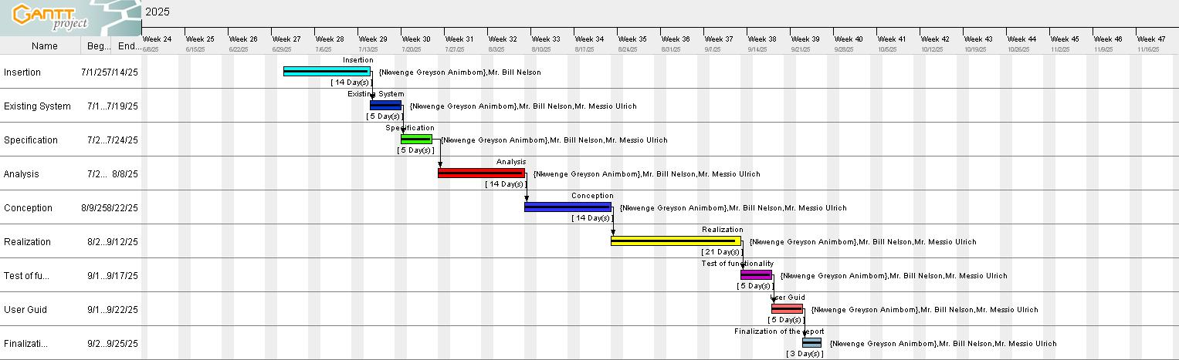
For the success of the project, the work has been scheduled and performed in several parts, and each task represents a particular phase of progress and realization of our project. The diagram below shows the arrangement of these different phases.
Figure 3: Gantt project

PROJECT COST ESTIMATIONS

Hardware Resources
Table 4:hardware Resources
Resource | Hardware | Quantity | Unit Cost(FCFA(
Computer | FUJISTSU  Intel Core i7 | 1 | 575000
Modem | Wi-Fi box | 1 | 25000
Hard drive | Hard disk drive | 1 | 14000
Removable disk | 64GB USB key | 1 | 1500
Smart phone | techno | 1 | 200,000
Total 1 |  | 1 | 815,500

Software resources
Table 5: software Resources
Resource | Resource Designation | Usage | Unit Cost (FCFA)
Text editing & Presentation | Microsoft Office 2016 Professional Plus | Writing of the report (Word) and designing a presentation (PowerPoint) | 240,000
Operating System | Microsoft Windows 10 | Computer operating system | 50,000
Database management | PostgreSQL | To communicate with the database | Free Download
Web browser | Google Chrome | View web pages | Freeware
Code Editor | Visual Studio Code | For writing the code of the application | Freeware
Project planning | Gantt Project | For building a Gantt chart | Freemium
Open router | OpenAI | AI integration | 10000
Illustrating tool | Echogram | For building a geographical location of the enterprise | Freemium
UML Analysis | Visual Paradigm | For drawing UML diagrams | Freemium
Total |  |  | 300,000

Human Resources
Table 6:human Resources
ROLE | NUMBER OF DAYS | QUANTITY | COST PER DAY (FCFA) | TOTAL PRICE (FCFA)
Project Manager | 60 | 01 | 230,000 | 13,800,000
Analyst | 21 | 01 | 225,000 | 4,725,000
UI/UX Designer | 18 | 01 | 220,000 | 3,960,000
Programmer | 35 | 01 | 318,000 | 11,130,000
Tester | 14 | 02 | 100,000 | 2,800,000
Total |  |  |  | 36,415,000

Total estimation cost
Table 7: total estimated cost
Total1 | Total2 | Total3 | Overall total
815,500 | 300,000 | 36,415,000 | 37,530,500
THIRTY-SEVEN MILLION FIVE HUNDRED THIRTY THOUSAND FIVE HUNDRED FCFA

CONSTRAINTS OF THE PROJECT
With any project, some limitations and risks need to be taken into account and addressed to ensure
the project’s ultimate success. Therefore, we have the following constraints:
- Technical constraint: For the development of our system, we have sufficiently robust tools to guarantee a minimum of security, extensibility, and excellent scalability. Moreover, the programming phase will have to follow all the technical standards for a better performance in a reduced execution time; this is why the choice of the development technologies is crucial.
- Time Constraint: The required deadline is 03 months after the validation of this document, starting from the beginning date, 01st July 2024.
- Cost constraint: The realization of our project will require expenditures in human resources, material, and very limited software.

DELIVERABLES
At the end of this project, we are expected to submit an application, a PowerPoint presentation and a document containing the following:
- An insertion phase.
- A specification book.
- An analysis book.
- A conception phase.
- A realization phase.
- A user guide.

CONCLUSION
The specification book in which presented the aim of the project, its requirements (both functional and non-functional needs) as well as the project team, plan, cost, and constraints, now helps us to come up with the solution required by the project by taking into consideration the above information to avoid errors and problems of compatibility.

DOCUMENT THREE : ANALYSIS PHASE

Preamble
The existing system is a document that provides a view of the system currently in place, that is, how it carries out its different activities, also it provides a deep understanding of this system associated with the various limitations, the problems that result from these, and the solution we propose.
Content

INTRODUCTION
- METHODOLOGY
- MODELLING OF THE PROPOSED SOLUTION
CONCLUSION

INTRODUCTION
The analysis phase is a systematic study that permits bringing out the differences between the various parts or components of a problem and finding the solutions to it, following a well-defined methodology. Thus, after the specification of our needs, we are going to do our analysis using the Unified Modeling Language (UML), following the 2TUP process. Here, we are going to determine the various diagrams necessary for our analysis, priority functions, and take into consideration all the elements that can help in solving the problem.

METHODOLOGY

Comparative study of UML and MERISE

MERISE
MERISE stands for “Méthode d’Étude et de Réalisation Informatique pour des Systèmes d’Entreprise”. MERISE is a method for designing, developing, and carrying out IT projects. The goal of this method is to achieve the design of an information system. The MERISE method is based on the separation of data and processing to be carried out in several conceptual and physical models. The essentials of the approach lie in its three cycles: the decision cycle, the life cycle, and the abstraction cycle, which cover data and process elements equally. The separation of data and processing ensures longevity in the model. Indeed, the arrangement of data does not have to be often overhauled, while treatments are more frequently.

UML
UML (Unified Modeling Language) is a standard notation for the modeling of real-world objects as a first step in developing an object-oriented design methodology. Its notation is derived from and unifies the notations of three object-oriented design and analysis methodologies: Grady Booch's methodology for describing a set of objects and their relationships, James Rumbaugh's Object-Modeling Technique (OMT), and Ivar Jacobson's approach, which includes a use case methodology. Other ideas also contributed to UML, which was the result of a work effort by Booch, Rumbaugh, Jacobson, and others to combine their ideas, working under the sponsorship of Rational Software. UML captures information about the static and dynamic views of a system. UML 2.5 comprises 14 diagrams that represent the different views of a system. The 14 diagrams can be subdivided into two: Static or structural diagrams and Dynamic diagrams. These diagrams include;

Structural diagrams
- The class diagram
- The object diagram
- The package diagram
- The composite structure diagram
- The component diagram
- The deployment diagram
- The profile diagram

Behavioral Diagram
- The use case diagram
- The activity diagram
- The sequence diagram
- The state machine diagram
- The communication diagram
- The timing diagram
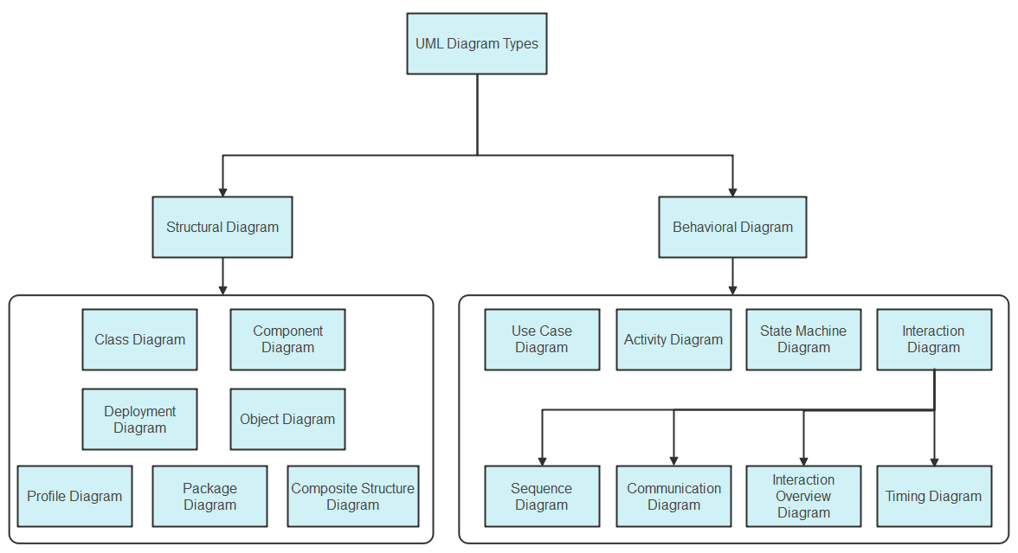
- The interaction overview diagram
Figure 4:uml diagrams

It is important to note that UML is a modeling language and not a method or procedure. Hence, to give it an approach, we need to associate UML with a unified process (UP) to give our conception a methodology to follow. A unified process is a generic method for developing software. This implies that it is necessary to adapt the UP to the context of the project.

Comparative study of unified process

Unified Process
A Unified Process is a process of development of software constructed on UML; it is iterative, incremental, centered on architecture, driven by use cases and requirements.
- Iteration is a distinct sequence of activities with a basic plan and evaluation criterion that produces an internal or external output. Either the content of an iteration is improved, or the evolution of the system is evaluated by users.
- An increment is the difference between two released products at the end of two iterations. Each iteration that the group is capable of integrating the technical environment in order to develop a final product and give users the possibility of having tangible results.
- Centered on architecture, the different models derived during the establishment of the system must be reliable and coherent.
- Driven by use case and requirements enables the clear definition of a user’s needs and priorities, respectively, thereby minimizing the risk of project failure.

The Two Track Unified Process (2TUP)
2TUP is a unified process that is built on UML and has as objective to bring a solution to constraints of functional and technical changes imposed on information systems by strengthening controls on development capacities. It proposes a Y-shaped development life cycle that separates the functional aspect from the technical aspects, and the merging of these two forms the implementation aspect. 2TUP distinguishes, therefore, two branches: the functional and technical branches. The combination of the results of these two branches forms the third: the realization branch, where we realize our system. The diagram below illustrates the branches of 2TUP.
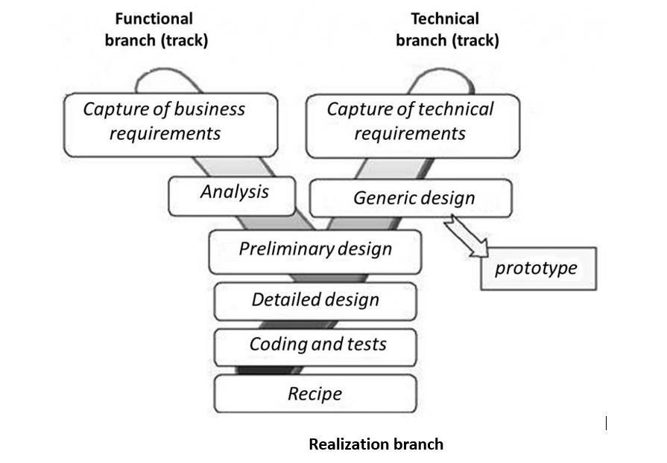
Figure 5: 2TUP
2TUP is an approach that makes it possible to visually represent the different stages and components of a software project using UML diagrams. It proposes a development cycle in the Y shape, which separates the functional aspects from the technical aspects. It begins with a preliminary study, which consists of identifying the actors that will interact with the software to be built, the messages that the actors and the system exchange.
2TUP is based on three phases:

The Functional Branch
It capitalizes on the knowledge of the business of company. This branch includes:
- The capture of functional needs, which produces a model of needs focused on the business of the users. It is essential to qualify as early as possible the risk of producing a system that is unsuitable for users.
- The analysis, which consists in précising studying the functional specification to obtain an idea of what the system will achieve in terms of business. The result of the analysis does not depend on any performance technology.

The Technical Branch
The technical branch lists the technical needs and proposes a generic design validated by a prototype. The pre-necessary techniques revealed in the preliminary study, showing the operational needs and the strategic choices of development, lead to the development of the construction process. To do this, some stages are necessary:
- The inventory of technical specifications related to the hardware.
- The inventory of the software specifications.

Implementation branch
The middle branch supports the preliminary design, the detailed design, coding, the test, and validation. The preliminary design is one of the most sensitive steps of the 2TUP process. It represents the fusion of the functional and technical tracks. It finishes when the deployment model (working station, architectures), the operating model (components, applications), the logical model (class diagrams, classes), interfaces (users and components), and the software configuration model are defined.

CHOICE OF THE ANALYSIS METHOD
The reasons why we chose UML modelling language and the software development process 2TUP instead of many others that exist are:
- UML is the current standard for programming in object-oriented languages. Therefore, it is widely understood and well known, making it easy for a new programmer to join the project and be productive from the very first day.
- 2TUP is centered around the creation and maintenance of a model, rather than the production of a mountain of documents.
- UML is a graphical modelling language, that is, it issues diagrams with named symbols to represent concepts. This makes UML readable and understandable.
- 2TUP is iterative and incremental, hence it enables the project team to produce refined ameliorations if necessary and easily integrate them into the already existing system.

MODELLING OF THE SYSTEM

Use Case diagram

Definition
A use case diagram shows the functionalities of a system, their inter-dependencies, and how they relate to the actors of the system. A use case is a specification of behavior.
The main objectives of the use case diagram are:
- Provide a high-level view of the system;
- Identify the functions of the system.
- Identify the expectations of the system
Use case diagrams are completed with a textual description of each use case that is intended to define the use case in greater detail.

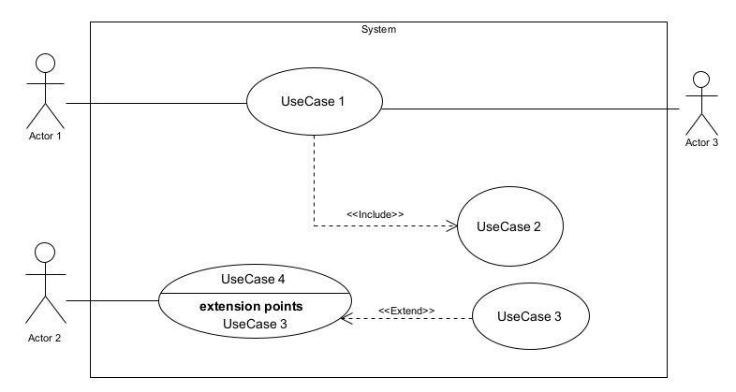
Formalism:
Figure 6: Use case formalism

Elements of use case diagram
Table 8:elements of a use case diagram
Elements Notation Description
Actors | 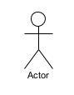 | Represents an entity that directly interacts with the system. The actor is what performs the different possible actions of the system.
Use case | Use Case  1 | A use case represents a  functionality of the system. It is an action that can be performed by an actor.
Association | 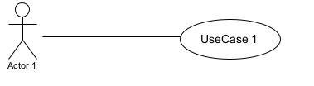 | It indicates that an actor takes part in a use Case.
Include | 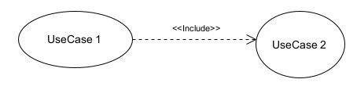 | An inclusion denotes that an included action must be performed before the including action can be performed.
Extend | 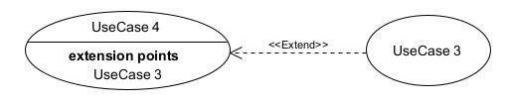 | An extension denotes that an extending action may be performed while an extended action is being performed.
Generalization | 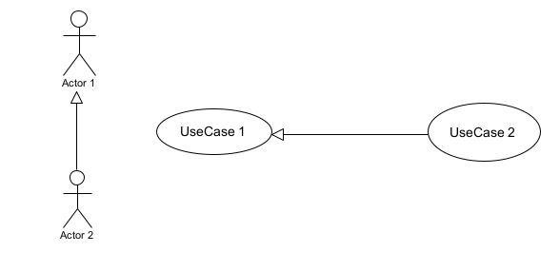 | This shows that an actor or a use case is a kind of another abstract or concrete actor that can be defined and later specialized using a generalization relationship.
System | 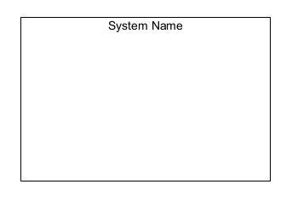 | It is a container of use cases that interact with external actors.

The Actors of Our System
Table 9: actors of our system
Actors of the System | The action they perform
Student | View attendance, grades, and timetable. View and submit assignment and chat with AI|
Parent | View child’s attendance and grades.
Teacher | Takes attendance, grades students gives assignments
Director | Manage accounts, classes, and timetables. View statistics and generate a report card

General Use case
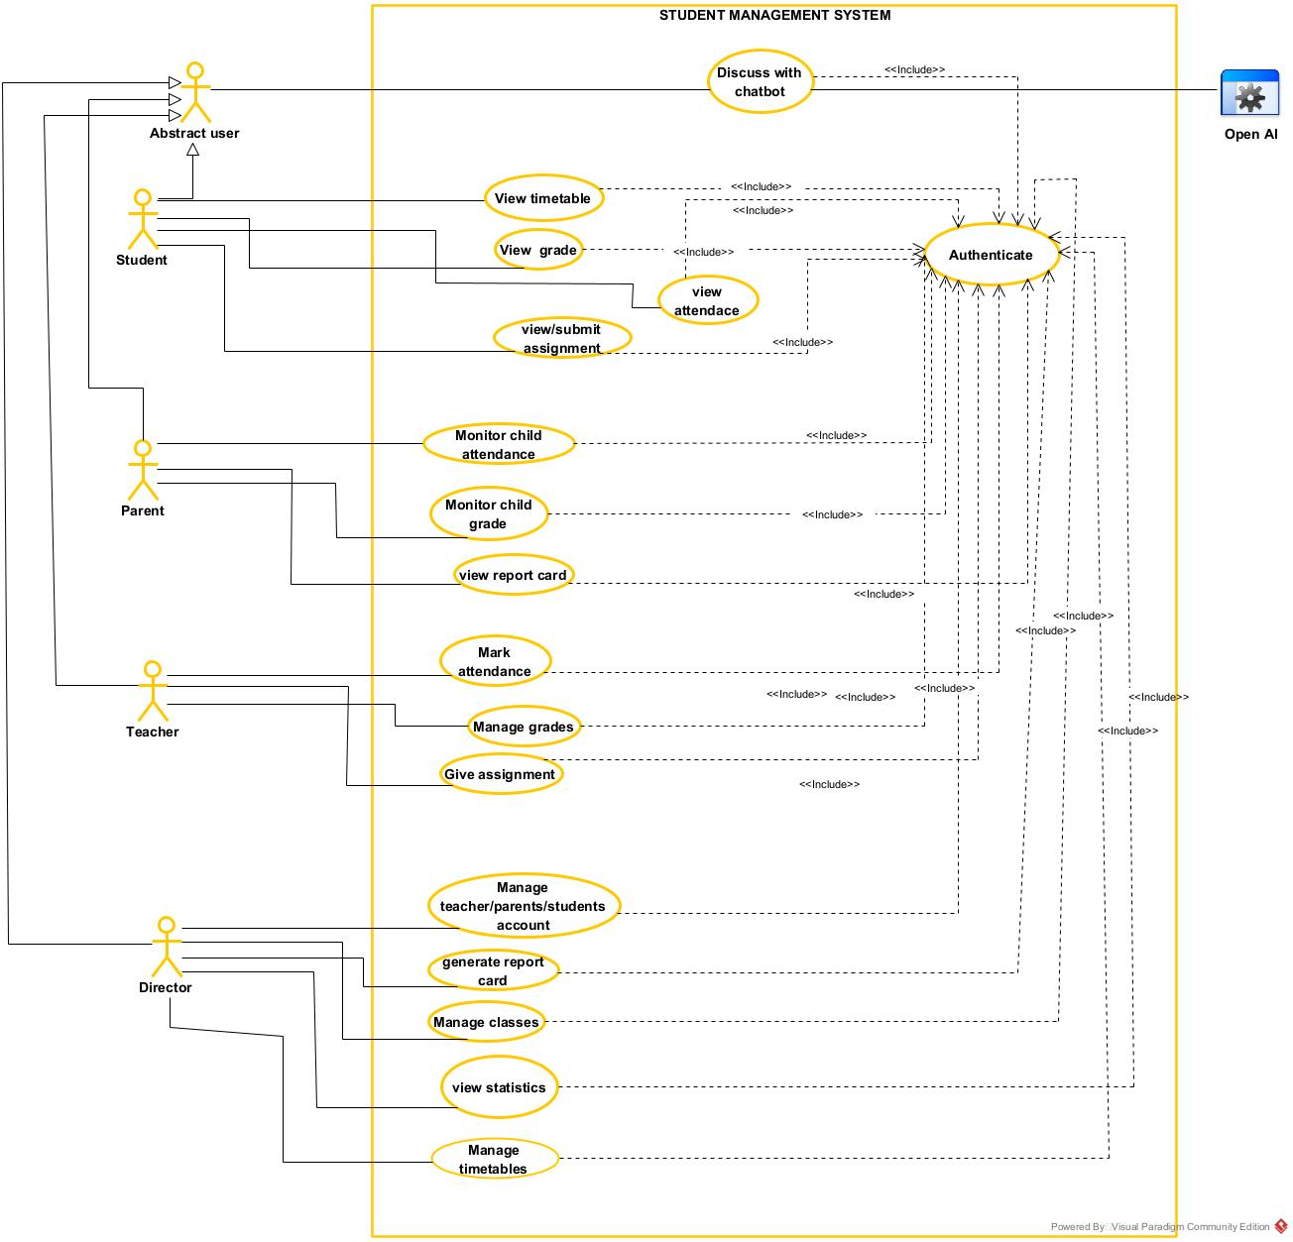
Figure 7: General use case diagram

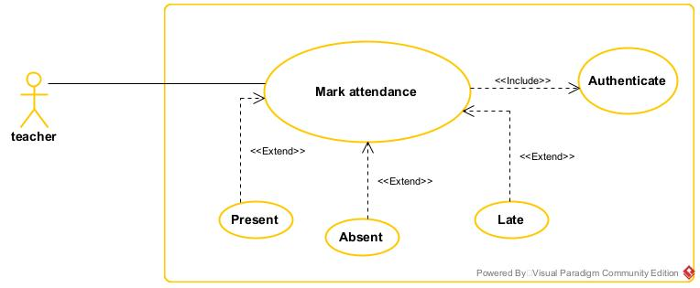
Specific use case: mark attendance.
Figure 8: Specific use case for marking attendance

Specific use case managing the timetable
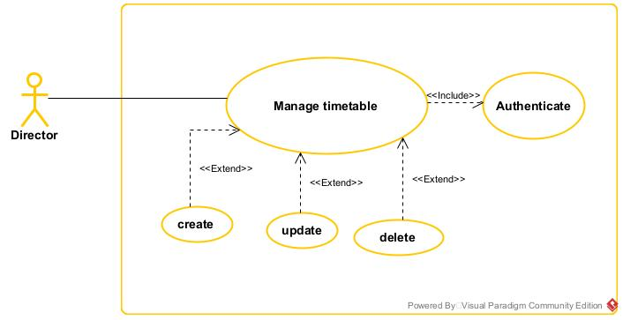
Figure 9:specific use case manage time table

Textual description for Authentication
Table 10: textual description for Authentication
Title
Summary | The user needs to authenticate
Actors | Student, Parent, Teacher, Director
Date | August 11, 2025
Stakeholder | Mr. NKWENGE GREYSON ANIMBOM
Version | 1.0
Precondition (s) | The application is launched. The user must have an account on the platform.
Triggers | The user clicks on the login button.
Nominal Scenario | - The system displays the login form.  - The actor fills and submits the form.  - The system verifies the form (fields) conformity  - The system sends the data to the DBMS.  - The DBMS executes the authentication query  - The DBMS sends the results to the system  - The system processes the results sent by the DBMS  - The user receives a successful message displayed by the system.
Alternative Scenarios | At step 4 of the nominal scenario, the user enters mismatched or missing information.  The system displays an error message and then returns to step 2 of the nominal scenario.

Textual description for grade student
Table 11: Textual description for grade students
Title
Summary | An authenticated teacher enters and submits examination marks for a student in a specific class and subject.
Actors | Teacher
Date | August 12, 2025
Stakeholder | Mr. NKWENGE GREYSON ANIMBOM
Version | 1.0
Precondition (s) | - The teacher is successfully authenticated and logged into the system.  - The student, class, subject, and exam type (e.g., Mid-Term, Final) must exist in the system.  - The grading period for the selected exam is active.
Triggers | The teacher clicks on the "Grade Student" menu or button from the main dashboard.
Nominal Scenario | - The system displays the "Grade Student" interface.  - The actor selects the relevant Exam Type (e.g., First Term, Quiz) from a dropdown list.  - The actor selects the Class of the student.  - The actor selects the Subject for which they are grading.  - The system loads the list of students enrolled in the selected class and subject.  - The actor enters the mark for a specific student in the provided input field.  - The system automatically checks the validity of the mark (e.g., is it a number, is it within the minimum and maximum possible score?).  - The system sends the grade data to the Database Management System (DBMS).  - The DBMS executes the query to insert or update the grade.  - The DBMS sends a success confirmation back to the system.  - The system processes the result and displays a "Grade submitted successfully" message to the actor.
Alternative Scenarios | 7a. invalid marks entered  - At step 7 of the nominal scenario, the system detects an invalid mark (e.g., a non-numeric character, a value above the maximum).  - The system displays an error message (e.g., "Invalid mark. Please enter a number between 0 and 20.").  - The system returns to step 6 of the nominal scenario, prompting the actor to correct the mark.  10a. Database update failed  - At step 10 of the nominal scenario, the DBMS fails to update the record (e.g., due to a connection error or constraint violation) and sends a failSure message.  - The system processes the result and displays a "Failed to submit grade. Please try again." message to the actor.  - The use case fails. The actor may trigger the use case again.

Activity diagram

Definition
An activity diagram is a graphical representation of workflows that show the steps needed in the realization of a process, showing the details from a start point to an end point through all decisions and actions that can possibly be performed. Activity diagrams are intended to model both the computational and organizational processes. The flow can be sequential, branched, or concurrent. Below is an activity diagram formalism.

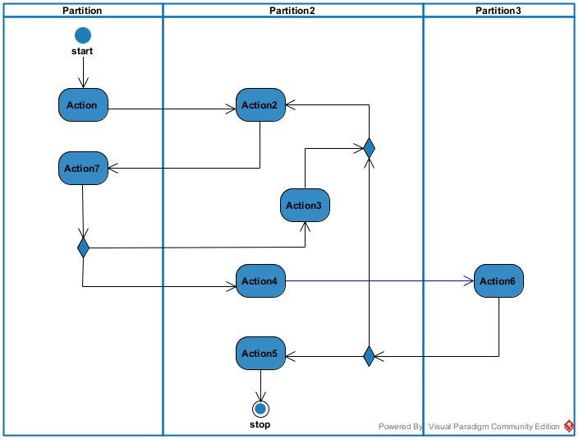
Formalism
Figure 10: formalism of activity diagram

Elements of Activity Diagram
Table 12: elements of an Activity diagram
Elements Diagrammatic Representation |  | Description
Activity | 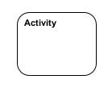 | Used to represent a set of actions.
Action | 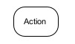 | Represent a task to be performed.
Activity edge |  | A directed connection between two activity nodes through which tokens may flow.
Initial node |  | Shows the beginning of an activity or set of actions.
Final node |  | Stops all controls and object flows in an activity.
Object node | 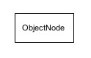 | Represents an object connected to a series of object flows.
Decision node | 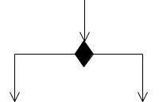 | Represents a test condition that splits an incoming activity edge into opposite outgoing activity edges.
Merge node | 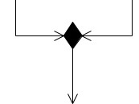 | Reunite different decision paths created using a decision node.
Fork node | 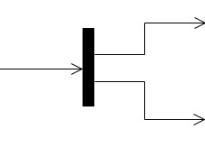 | Splits behavior into parallel or concurrent flows of activities  (or actions)
Join node | 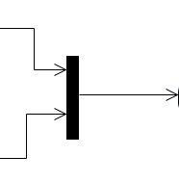 | Unites a set of parallel or concurrent flows of activities or actions.
Swim lane and partition | 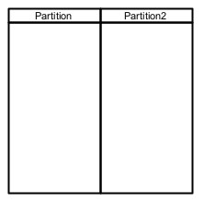 | A way of grouping activities performed by the same actor in an activity diagram, or to group actions in the same thread.

Authentication Activity diagram:

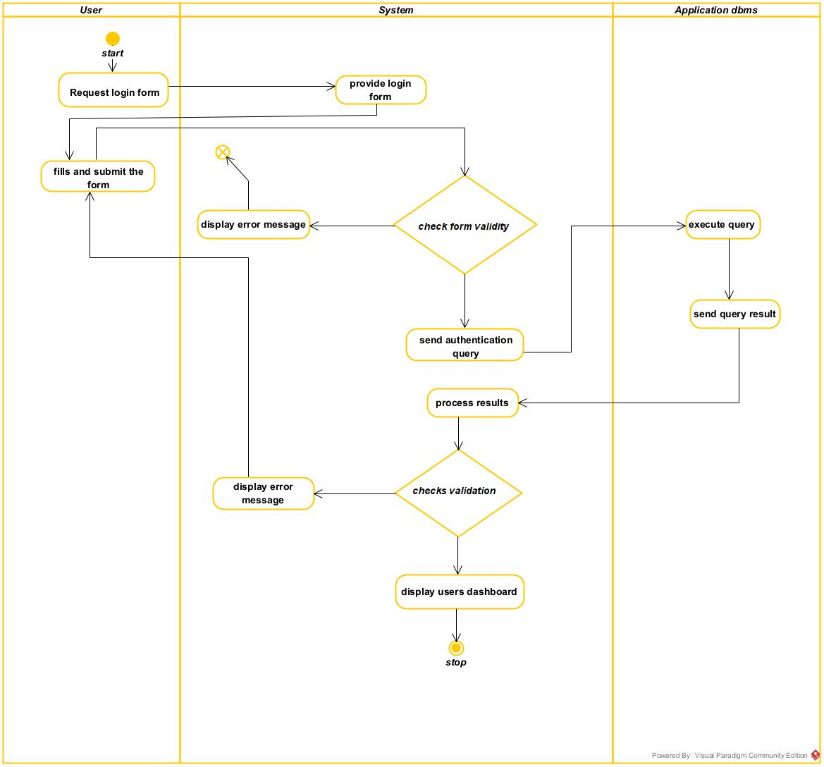
Figure 11: Activity diagram for authentication

Mark attendance
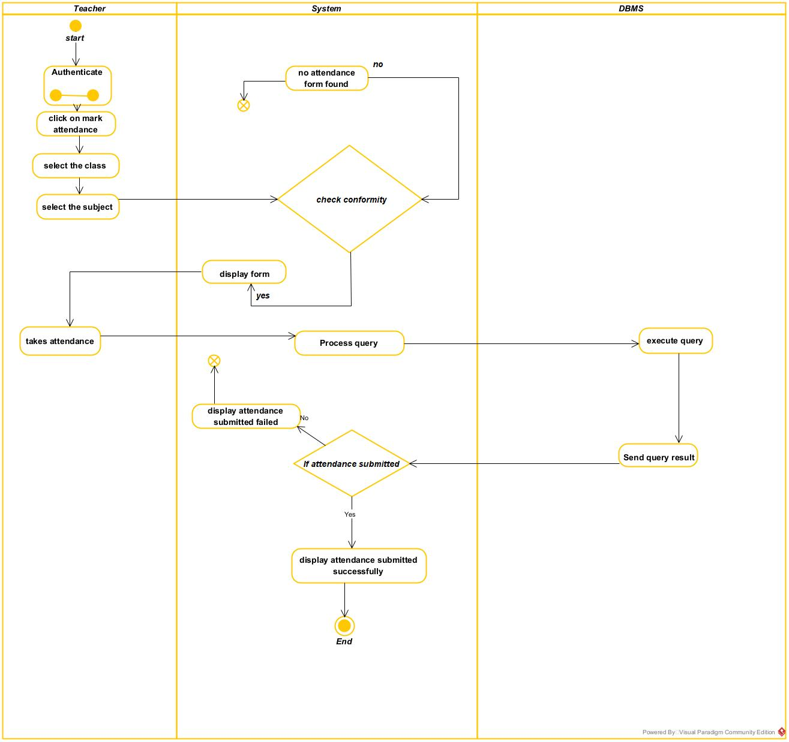
Figure 12: Activiy diagram for marking attendance

Grade student
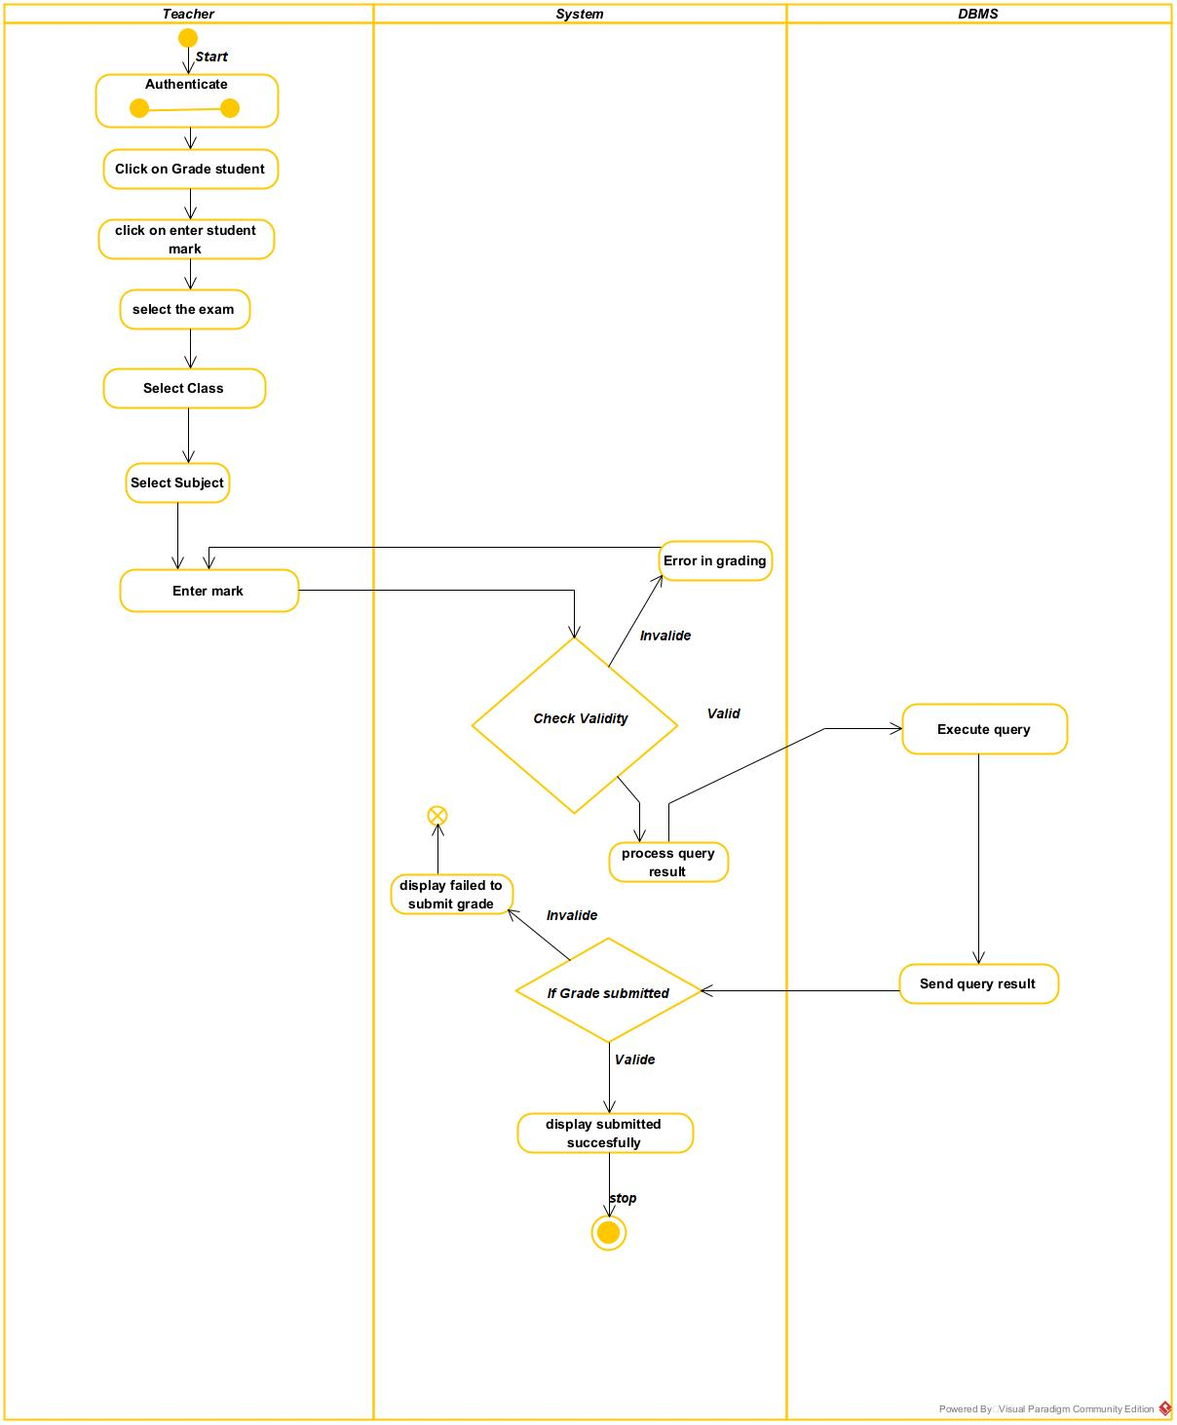
Figure 13: Grade student activity diagram

Sequence diagram

Definition
A sequence diagram is an interaction diagram that represents the flow of messages between elements in a system, it is termed an event diagram. It portrays the communication between any two lifelines as a time-ordered sequence of events.

Formalism
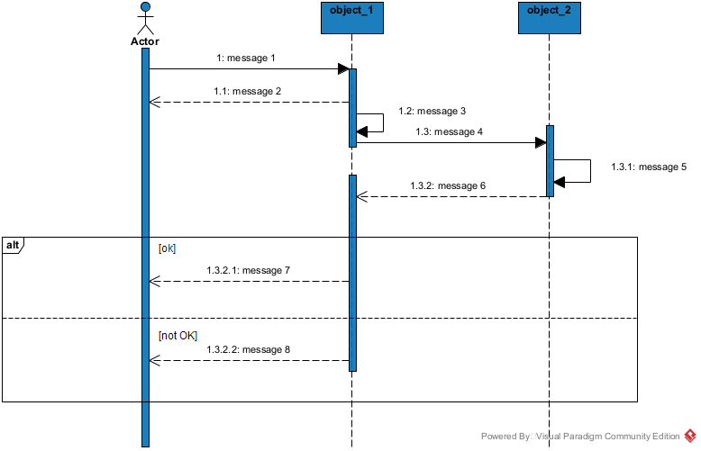
Figure 14: formalism for sequence diagram

Elements of a Sequence Diagram
Table 13: elements of a sequence diagram
Element | Representation | Description
Lifeline | 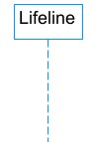 | An individual participant in a sequence diagram, it is position at the top of the diagram.
Combined fragment | 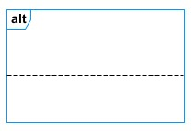 | It represents a choice of behavior in which at most one operand will be chosen.
Messages | 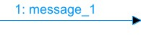  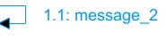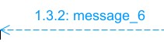 | These are arrows which shows the direction of message flow. We have the synchronous, the asynchronous and the self -messages.
Activation | 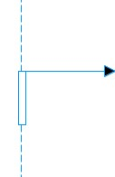 | It describes the time period in which an operation is performed by an element.

Authenticate sequence Diagram

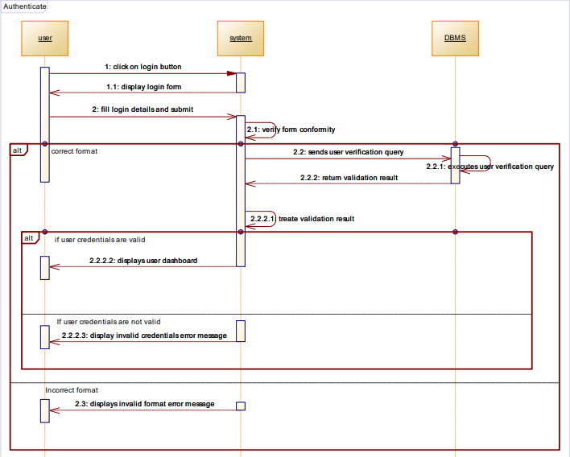
Figure 15: sequence diagram for authentication

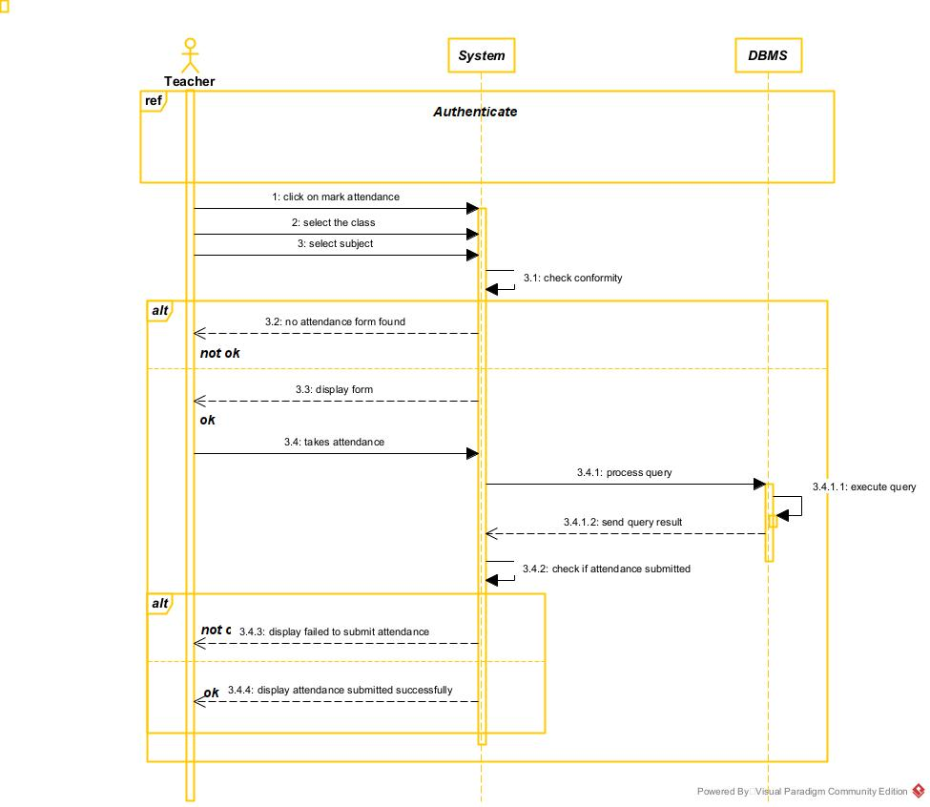
Mark attendance sequence diagram
Figure 16: sequence diagram for mark attendance

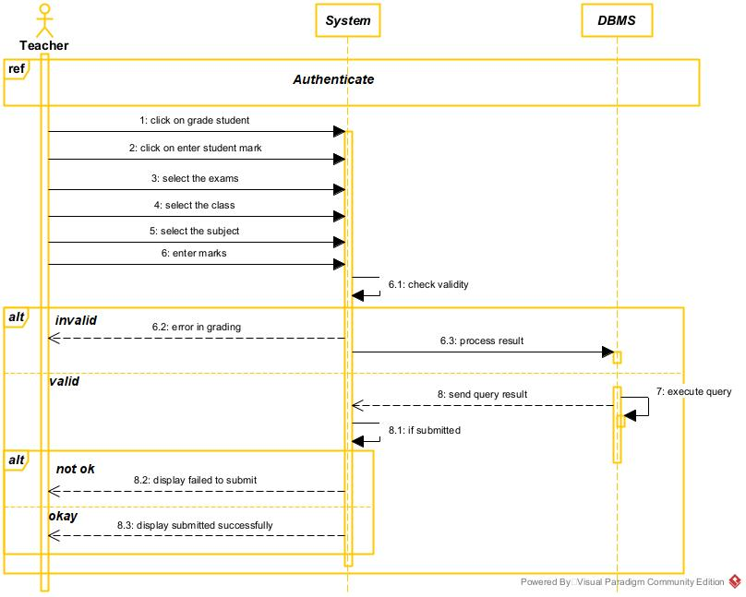
Grade student sequence diagram
Figure 17: sequence diafram for grade student

Communication Diagram

Definition:
It is a diagram which is used to show the relationship between the actors of a system, both the sequence and the communication diagrams represent the same information but differently. Instead of showing the flow of message. It depicts the architecture of the object residing in the system as it is based on object-oriented programming.

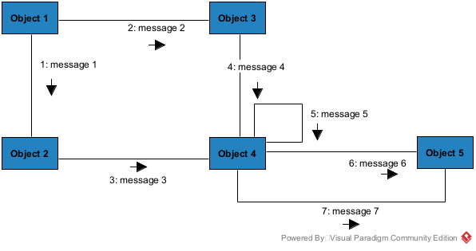
Formalism
Figure 18: formalism for communication diagram

Element of Communication Diagram
Table 14: elements of the communication diagram
Element | Representation | Description
Object | 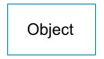 | An actor represents an individual participant in the interaction conversation.
link |  | It initiates an association it connects two objects together for them to communicate.
Actor | 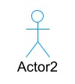 | A role play by an entity that interacts with the subjects.
message | 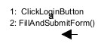 | Defines a particular communication between lifelines in an interaction.

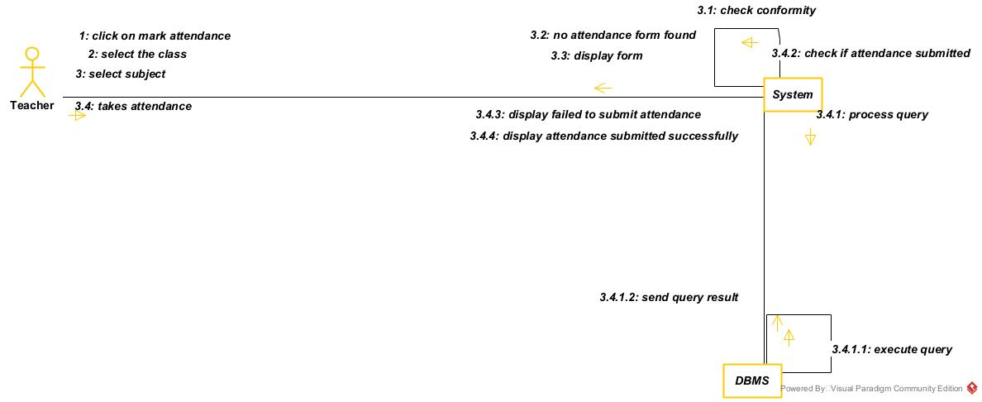
Mark attendance communication diagram
Figure 19: mark attendance communication diagram

Grade student communication diagram

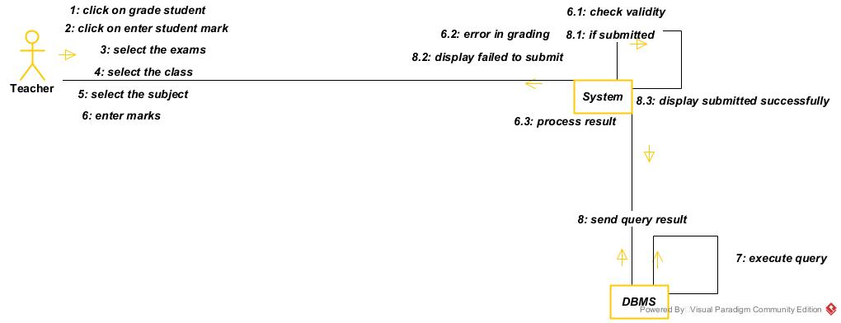
Figure 20: grade student communication diagram

CONCLUSION
In the analysis phase, we chose a software development process and modelling language, after which we presented the existing system, its limitation and our proposed solutions. We went forth explaining the functional need of our system, we saw the use case diagram which shows the relationship between the actors and use case (the action the actor can perform on the system), we saw the activity diagram which shows the work-flow of our system, and lastly the State machine diagram which shows the behavior of a single object in response to an event. We will now move to the conception phase in which we will present the other two branches of the 2TUP which are the Technical and the realization branch of our system.

DOCUMENT FOUR: CONCEPTION PHASE

Preamble
The conception phase will permit us to present in an orderly manner the components necessary for the good functioning of our software and also the architecture used for the proposed solution. It bridges the gap between the analysis phase and the realization phase.
Content
INTRODUCTION
- TECHNICAL BRANCH
- GENERIC DESIG
- CAPTURE OF TECHNICAL NEEDS
- RELATED UML DIAGRAMS
- Class Diagram
- State machine Diagram
- Package Diagram
CONCLUSION

INTRODUCTION
The conceptual phase will describe in detail the necessary specifications, features, and operations that will satisfy the functioning requirements of the proposed system as modeled in the analysis phase. This phase is meant to identify and consider essential components (hardware /or software), structure (network capabilities), processes, and procedures for the system to accomplish its objectives. We will look at some diagrams, such as the component diagram, package diagram, communication diagram, class diagram, and object diagram.

I. TECHNICAL BRANCH

GENERIC DESIGN

Hardware diagram of the system:
The hardware diagram simply shows how the system components of our system are deployed; it shows the positioning of each device in its right proportion.
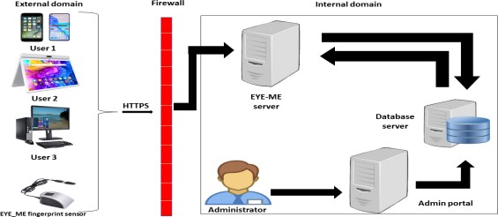
Figure 21:hardware diagram of the system
Server

HIGH LEVEL ARCHITECTURAL DIAGRAM OF THE SOFTWARE
The high-level architecture diagram provides an overview of the entire system, identifying the main components that would be developed for the product and their interfaces. The high-level architecture diagram below illustrates this.

CAPTURE TECHNICAL NEEDS.

Physical architecture
The design of the Student Management system is based on a cloud-first, n-tier architecture that partitions the solutions into separate, lovely couple modules so each tier can be developed, scaled, or replaced independently. This modular separation groups components by how users interact with the system and by how data is stored and processed. Clearly defined interfaces (APIs, message queues, and storage contracts) ensure each layer can evolve without disrupting others.
The n-tier architecture for the Student Management System consists of the following components:

Client Tier (Presentation Interface):
This tier is the user-facing surface where students, parents, teachers, and administrators interact with the system. It includes a web portal and mobile apps for students to view timetables, submit assignments, and check grades; parent portals to monitor progress and payments; teacher dashboards for attendance, grade entry, and lesson planning; and admin consoles for enrollment and school management. The client tier focuses on usability, accessibility, and delivering responsive, role-specific experiences.
Application Tier (Business / Application Logic):
Hosted on web and API servers, this tier implements the core business logic: user authentication and role management, enrollment and registration workflows, attendance capture, grade management and report card generation, timetable scheduling and conflict resolution, fee/payment processing, notifications and messaging, and document/assignment processing. The application tier exposes REST/GraphQL APIs and microservices that orchestrate workflows, validate rules, and delegate heavy tasks (e.g., bulk report generation or document conversion) to background workers.
Data Tier (Persistence & Storage):
This tier comprises the DBMS cluster for transactional, structured data (student records, enrollments, grades, schedules), object/file storage for large assets (assignment submissions, scanned documents, multimedia), and a data warehouse or data lake for analytics and historical reporting. The data tier enforces security, backup, and retention policies, and provides ACID guarantees for critical operations (grade changes, financial transactions) while enabling efficient queries for dashboards and compliance audits. LLM / AI Tier (Optional Intelligence Services):
An additional LLM/AI tier provides advanced features such as an intelligent chatbot for student/parent support, automated draft generation for progress reports, assistance in grading or plagiarism detection, and personalized learning or remedial recommendations. These services are exposed as inference APIs that the application tier can call; training data and model outputs are logged to the data lake for continuous improvement.

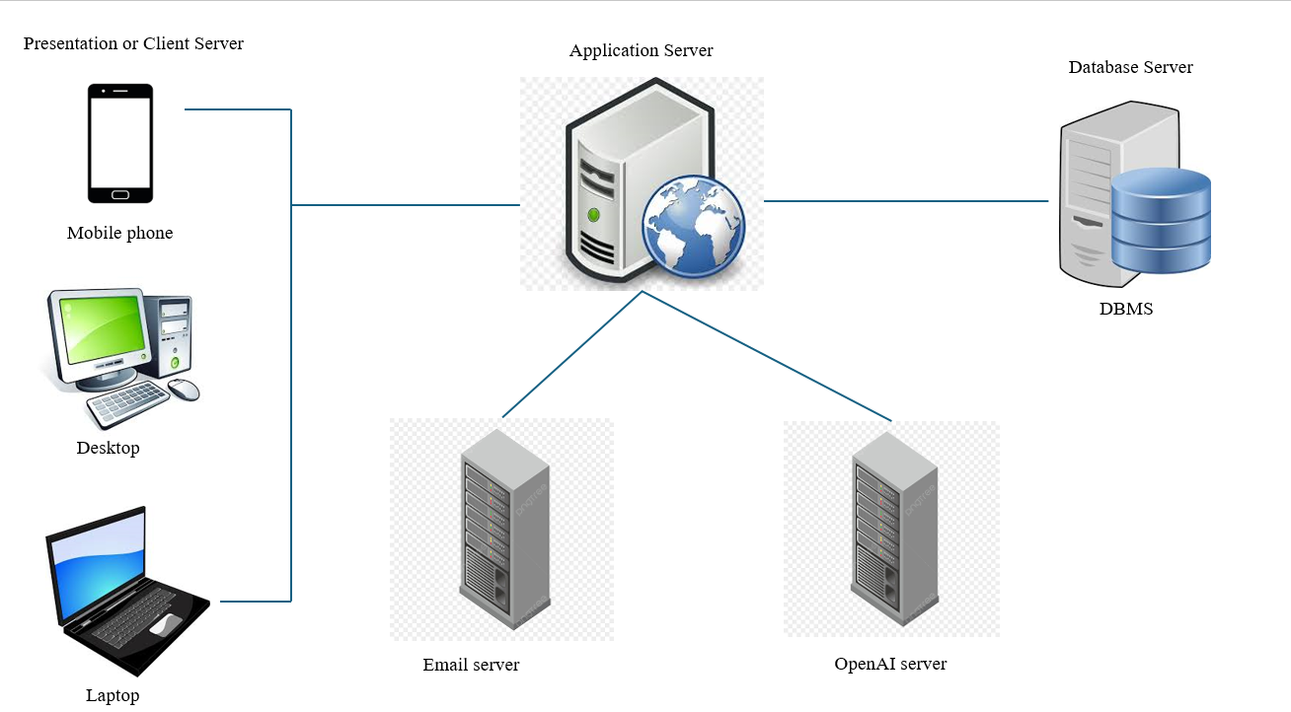
Figure 22: n-tier architecture

Logical Architecture
Model View Controller, or MVC as it is popularly called, is a software design pattern for developing applications. A model-view-controller pattern is made up of the following three parts.
❖ Model: The lowest level of the pattern, which is responsible for maintaining data.
❖ View: This is responsible for displaying all or a portion of data to the user.
❖ Controller: It handles software code that controls the interactions between the model and the view.
MVC is popular as it isolates the application logic from the user interface and supports the separation of concerns. Here, the controller receives all requests for the application, then works with the model to prepare data needed by the view. The view then uses the data prepared by the controller to produce a final response. The MVC can be represented as follows:
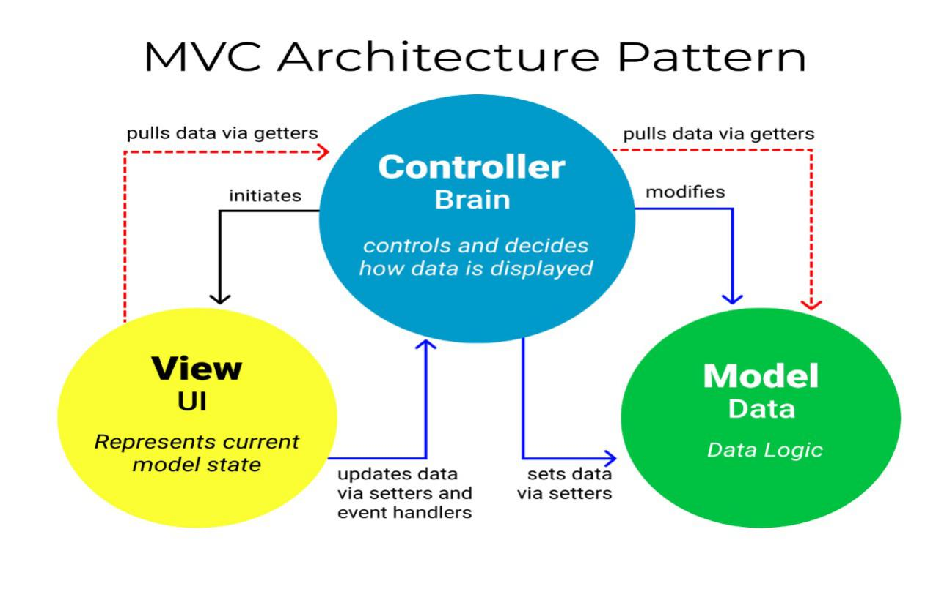
Figure 23:MVC architecture

III RELATED UML DIAGRAMS

1. Class Diagram

Definition
A class diagram is a static diagram. It is a type of structure diagram because it describes what must be present in the system being modelled. The main components in a class diagram are the building blocks of UML. A class is a type of something. We can think of a class as a blueprint out of which objects can be constructed. Class diagrams describe the attributes and operations of a class and constraints imposed on the system. Its purpose is to model a static view of an application. A standard class diagram is composed of the three sections (upper section, middle section, and bottom section.

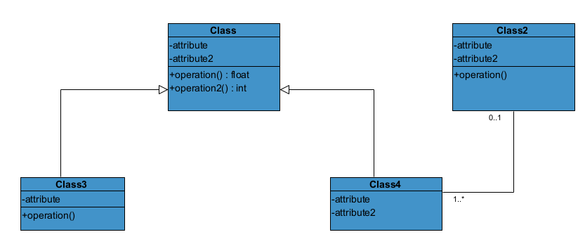
Formalism:
Figure 24 : formalism of class diagram

Class Diagram Elements Description
Table 15: Elements of a class diagram
Element | Representation | Description
class | 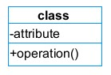 | A class is an element that defines the attributes and behaviors that an object can generate.
Composition | 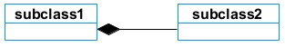 | If a parent of a composite is deleted, usually, all of its parts are deleted with it.
Aggregation | 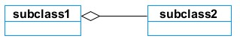 | If the parent of the aggregate is deleted, usually the children are not deleted.
Dependency | 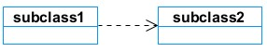 | It existed between two classes; if one changes, it may cause a change in the order, but not the other way around.
Generalization | 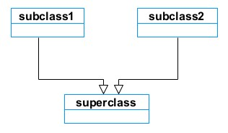 | It is a relationship between a whole thing (called a superclass) and a more specific thing (called a subclass)
Association | 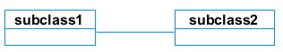 | It is a general type of relationship between elements, which may include cardinality, roles, etc.

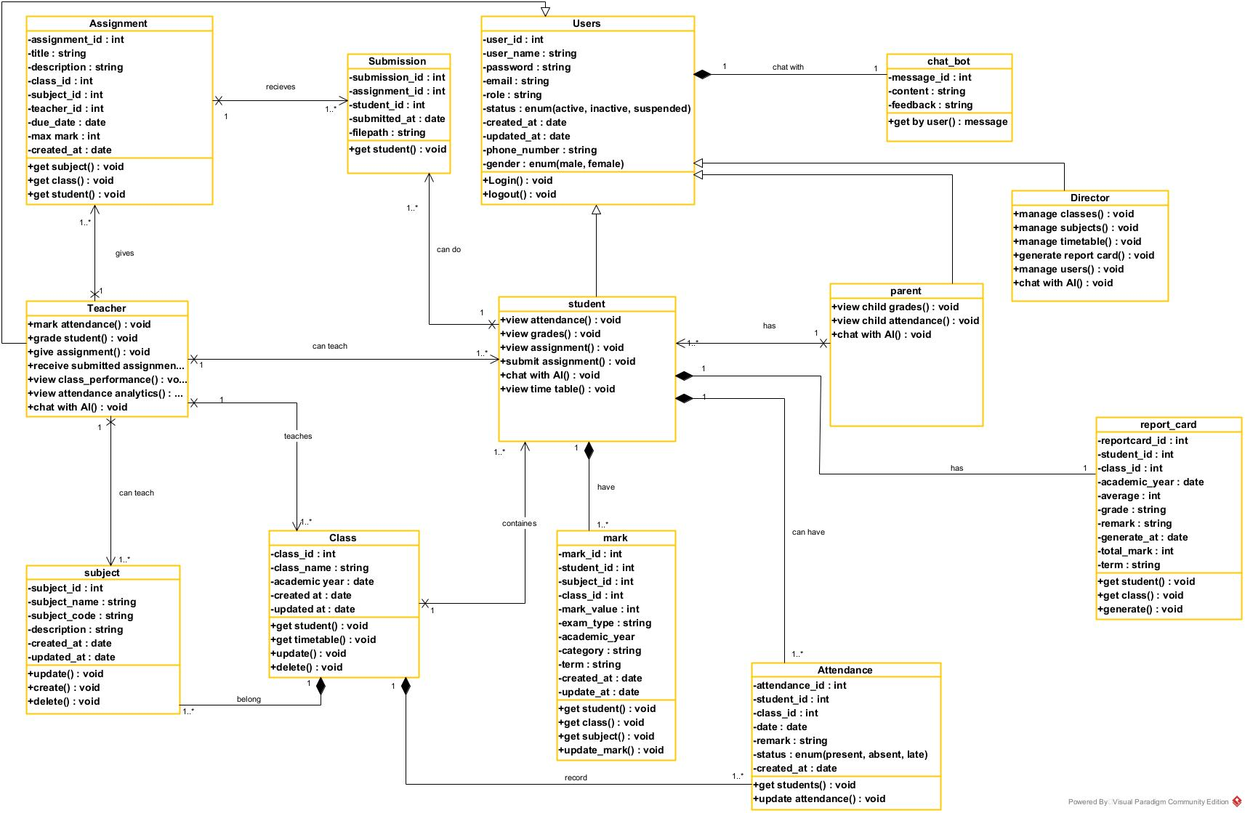
System class diagram
Figure 25: system class diagram

State Machine Diagram

Definition
A state machine diagram describes the behavior of a single object in response to a series of events in a system. Also known as the state machine diagram, it models the dynamic flow of control from the state of a particular object within a system.

Formalism:
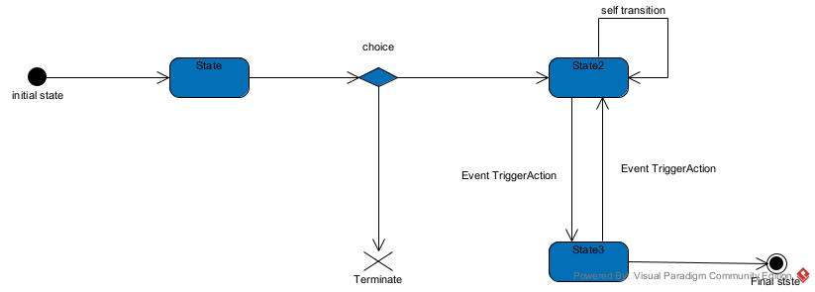
Figure 26: formalism of the state machine diagram

State Machine Diagram Elements
Table 16: elements of a state machine
Components | Diagram Relationship | Description
State | 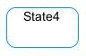 | Models a situation in which a certain invariant condition holds.
First (Initial) State |  | It represents a default vertex, that is, a source for a single transaction to the default or composite state.
Final State |  | A state specifying that the enclosing region is complete.
Transition | 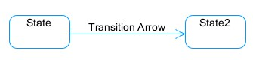 | A direction relation between a source and a target vertex.
Choice pseudo State |  | A diamond symbol that indicates a dynamic condition with branched potential results
Terminate | 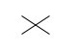 | Implies that the execution of a state by means of its context is terminated.
Diagram Overview | 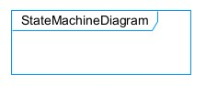 | A placeholder for the linked states in a state machine diagram.

Submit the assignment state machine
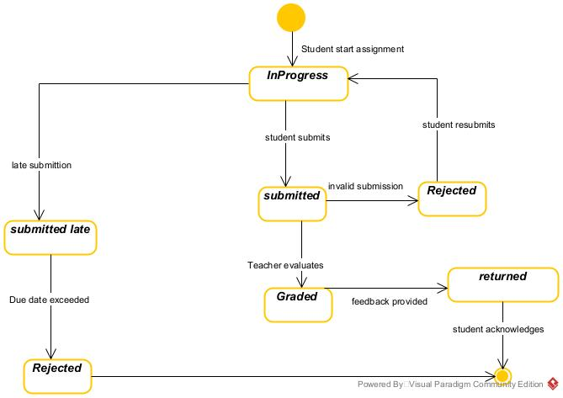
Figure 27:submit assignment state machine diagram

Grade student state machine

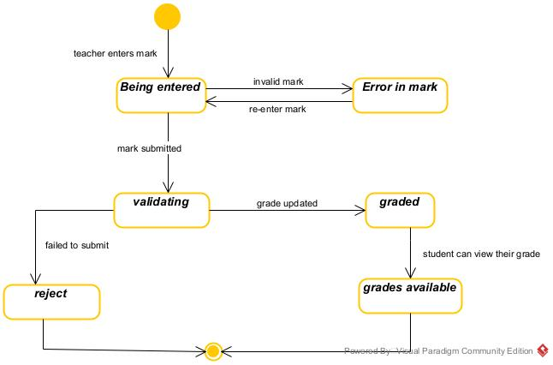
Figure 28: Grade student state machine

3. Package Diagram:

Definition:
This is a structural diagram used to show the organization and arrangement of various model elements in the form of packages. A package diagram is the grouping of related UML elements, such as classes, diagrams, or even other packages.

Formalism:
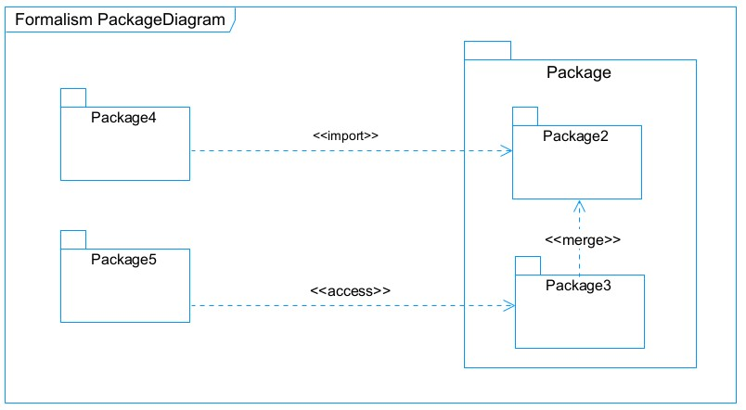
Figure 29: formalism of package diagram

Formalism for package diagram
Table 17: elements of a package diagram
Name | Representation | Description
Package | 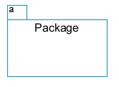 | A package is a namespace used to group related elements; it is a mechanism used to group elements into a better structure in a system.
Package import | 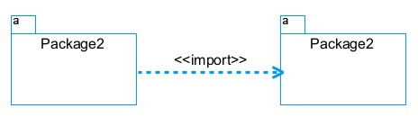 | A relationship indicates that functionality has been imported from one package to another.
Package access | 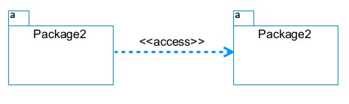 | A relationship indicates that one package requires assistance from the function of another package.
Package merge | 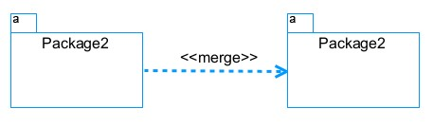 | It is a relationship that shows that the functionality of two packages is combined into a single function.

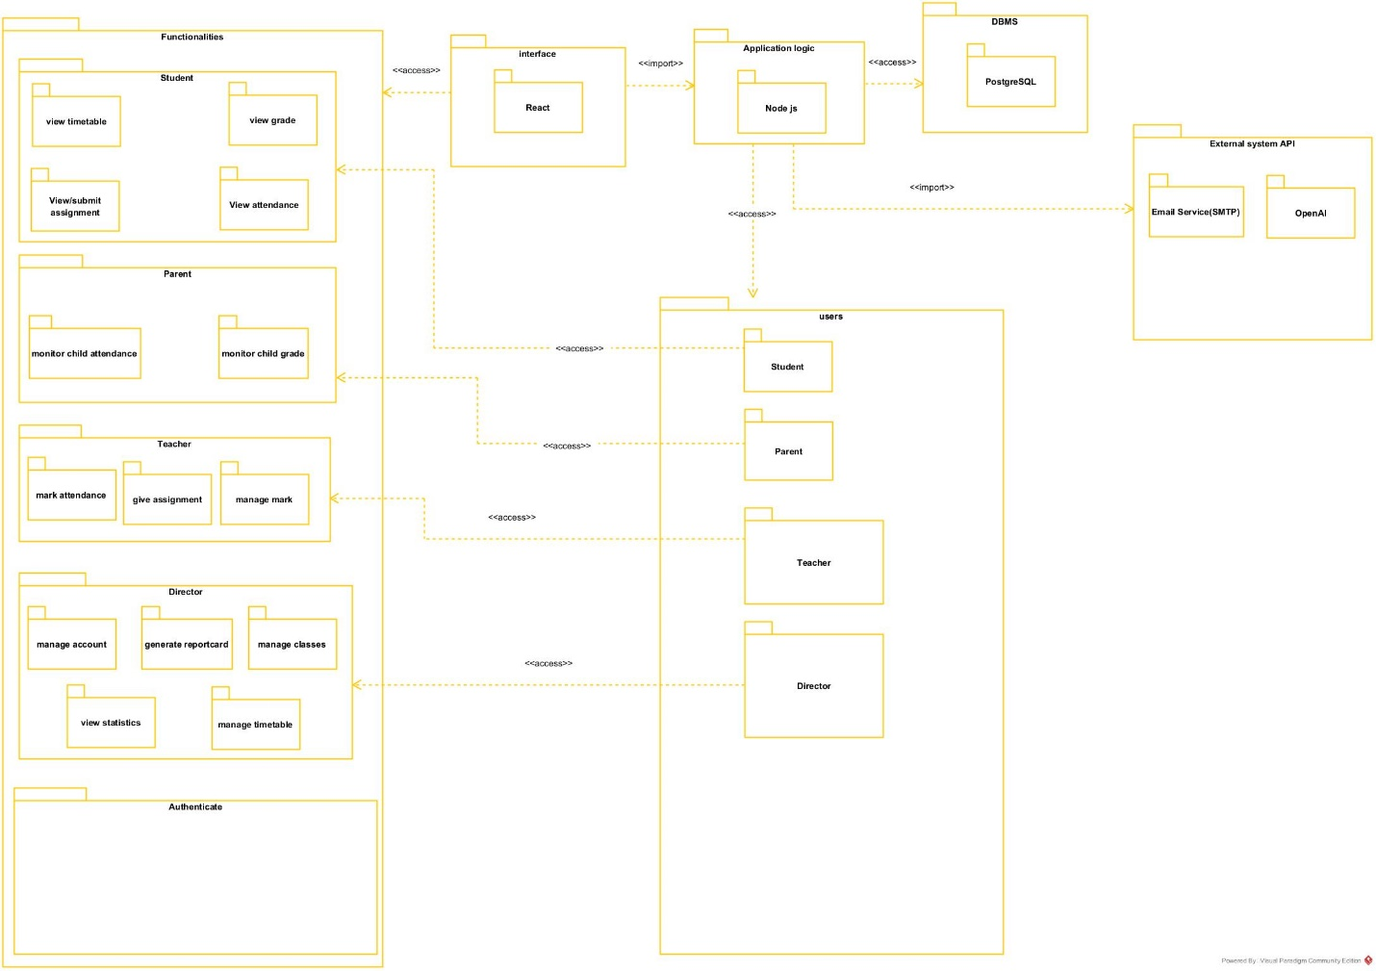
System package diagram
Figure 30: system package diagram

CONCLUSION
In the conception phase, we set as an objective to plan the different aspects of our system by showing how it will be structured and deployed within existing technical architectures. We began by taking into account the technical constraints for our system, after which we proceeded to identify the components of our system, how they are grouped, and how they should be deployed on appropriate deployment targets. We finished this phase by looking at interactions between the various aspects and actors of our system. The next phase of our report is the realization phase, where we will look at aspects concerning the implementation of our system.

DOCUMENT FIVE : REALISATION PHASE

Preamble
In this phase, we will be forward in the implementation of our solution, we will base ourselves on the analysis and conception phases. Content
Content
INTRODUCTION
- PRELIMINARY CONCEPTION
- Component Diagram
- Deployment Diagram
- TECHNOLOGICAL CHOICES
- Material Choices
- Software Choices
- Technological Choices
CONCLUSION

INTRODUCTION
Here in the realization phase, we will concentrate on building or implementing our solution, based on the different analyses and conceptions that we had carried out, which will help to facilitate our work. This phase is as critical as the previous phases. We are going to look at the relationship that exists between the entities of the entity relational diagram. Furthermore, we will see the choices of technologies used for the implementation of our system.

I. PRELIMINARY CONCEPTION:

Component Diagram:

Definition:
Component diagrams are used to model the physical aspect of a system. Now the question is what is this physical aspect? They are elements such as Executables, libraries, files, documents etc., which resides in a node. The component diagram does not describe the functionality of the system, but it describes the components used to make those functionalities.

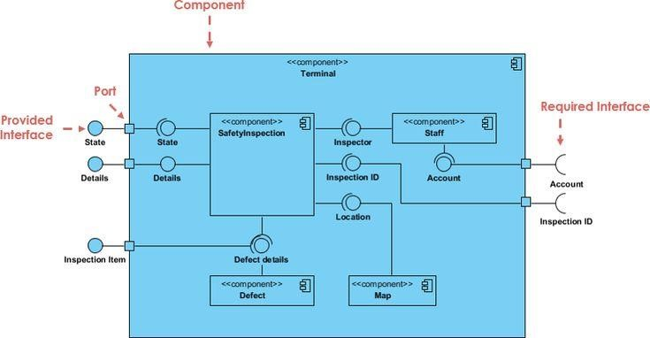
Formalism:

Formalism for component diagram
Table 18: elements of a component diagram
NAME | REPRESENTATION | DESCRIPTION
A component | 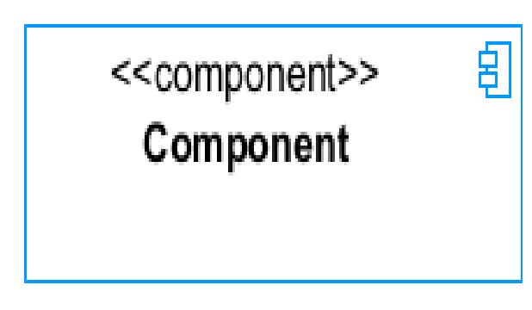 | A component is an abstract logical unit block of a system. It is represented as a rectangle with a smaller rectangle in the upper right corner, which serves as its icon for recognition.
Dependency | 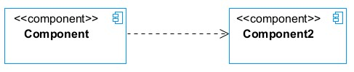 | Dependency is a directed relationship that is used to show that some components are dependent on others for their correct functioning.
interface | 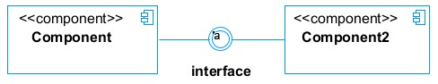 | An interface is a circle or a semicircle attached to a stick that looks like a lollipop. It describes groups of operations provided or required by components.
port | 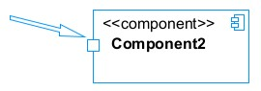 | A port (represented by a small square at the end of a required or provided interface) is used when the components delegate the interfaces to an internal class.

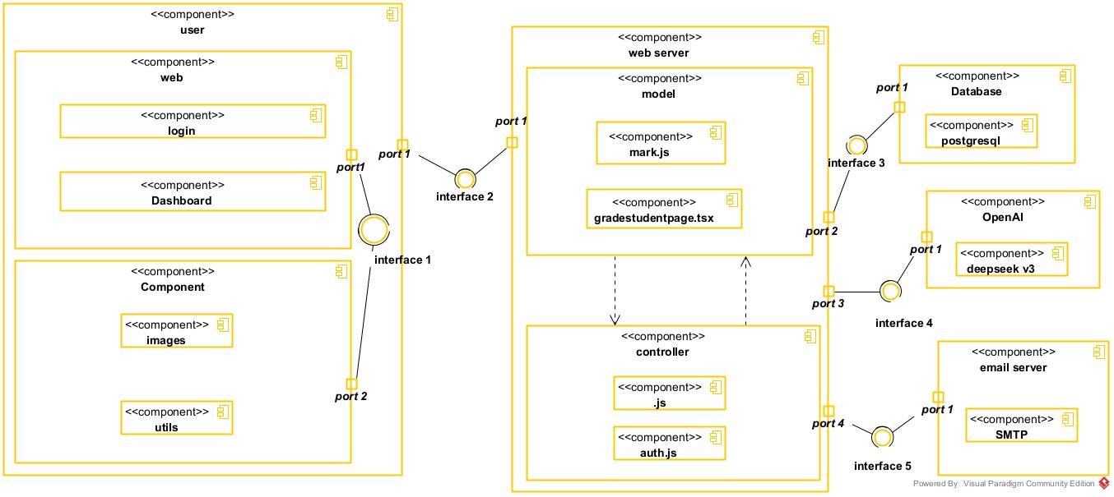
System component diagram

Figure 31:system component diagram

Deployment diagram:

Definition:
Consists of nodes. Nodes are nothing but physical hardware used to deploy the application Deployment diagram is a structural diagram used to visualize the topology of the physical components of a system, where the software is deployed. They consist of nodes and their relationship. It is related to the component diagram because the components are deployed using the deployment diagram. A deployment diagram

Formalism:

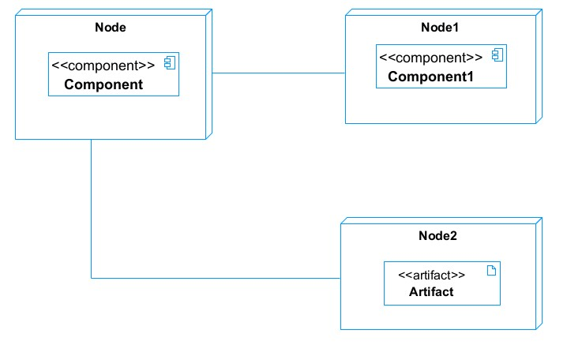

Elements of Deployment Diagram
Table 19: elements of deployment diagram
Element | Representation | Description
Node |  | It is hardware used to deploy the application.
Artifact | 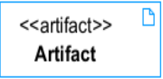 | An artifact is a major product that is produced or used during the development of software. E.g., diagrams, data models, setup scripts
Component |  | It represents a modular part of a system that encapsulates its content and whose manifestation is replaceable within its environment.
Association |  | An association helps to connect two nodes, which permits them to communicate together.

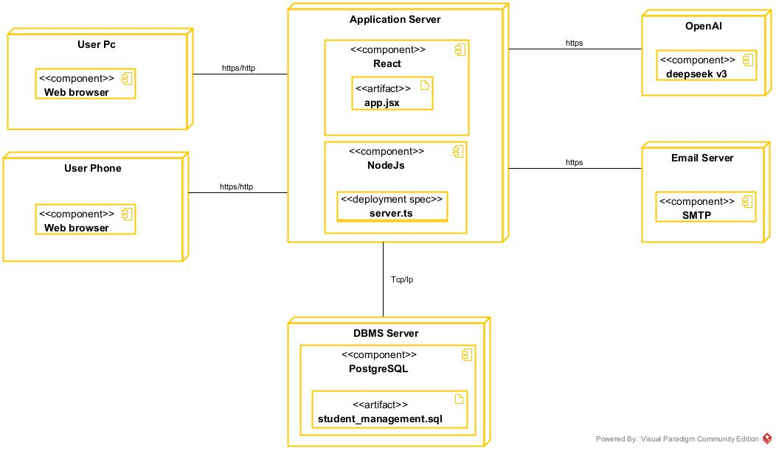
System deployment diagram
Figure 32: system deployment diagram

TECHNICAL CHOICES
Table 20: technical choice
Material | Quantity | Function | Image
FUJITSU | 1 | The computer was used for the programming of the microcontroller, the analysis, research, and the design of the system architecture. This was the main component of this project. | 
TECHNO | 1 | For testing app responsiveness | 

Software | Role | Reason for use | Image
OS  WINDOWS  10 | The operating system required to run the software is the one on which we have worked. | Windows 10 has a user-friendly interface that is familiar to many users, making it easy to navigate and use. | 
Visual Paradigm | The software engineering workshop is used for solution modelling. We utilized this tool for modelling the various diagrams of our system | . Supports multiple modelling languages and methodologies, making it suitable for various project requirements and enabling teams to adapt to different development processes. | 
Visual stAudio code | Visual Studio Code is a lightweight, open-source code editor developed by Microsoft, supporting multiple programming languages. Used for writing application code. | . Combines tools for version control, debugging, and terminal access in one interface, improving efficiency and reducing the need for multiple applications. | 
Github | It is a website and cloud service that helps developers store and manage their code. | Git allows developers to track changes, revert to previous versions, and maintain a history of modifications, ensuring that no work is lost and enabling easy recovery. | 
Framework  react | A popular JavaScript library for building UI. It provides a component-based approach and allows for efficient rendering and state management. Used for building the Frontend | Promotes the creation of reusable components, which enhances code maintainability and allows for easier updates and testing. | 
Node.js | Node.js is an open-source and cross-platform JavaScript runtime environment. It is a popular tool for almost any kind of project! | It is used to build our backend, helping us to have a dynamic web application | 
PostgreSQL | PostgreSQL is a popular open-source relational database management system | It is used to store and manage our data | 
MS Word | MS Word is a widely used word processing application that allows users to create, edit, and format text documents. Use in the creation of the report | Offers extensive options for formatting text, images, and layouts, enabling the creation of professional-quality documents. | 
MS PowerPoint | MS PowerPoint is a presentation software that allows users to create dynamic slideshows comprising text, images, videos, and animations. Able to create slideshow presentations for the application. | Its intuitive interface and templates make it easy for users to create professional presentations quickly, regardless of their technical skill level | 
Chrome | Google Chrome is a fast, secure, and user-friendly web browser developed by Google. Used to test our application UI | Chrome is optimized for fast page loading and efficient resource management, providing a smooth browsing experience. | 
GanttProject | GanttProject is a free, open-source project management tool that allows users to create Gantt charts for planning and scheduling projects | Allows users to assign tasks, set deadlines, and manage resources effectively, facilitating better project coordination and efficiency. | 
Openrouter | Opensource for ai models | Allows user to create and api key and used ai models | 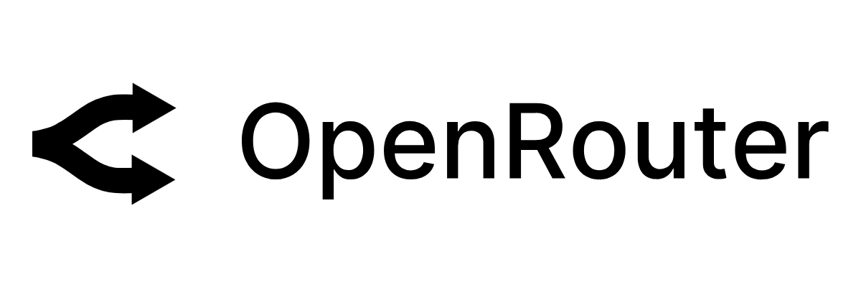

CONCLUSION
In our realization phase, we set as an objective to plan the different aspects of our system by showing how it will be structured and deployed within existing technical architectures. We began by taking into account the technical constraints for our system, after which we proceeded to identify the components of our system, how they are grouped, and how they should be deployed on appropriate deployment targets. We finished this phase by looking at interactions between the various aspects and actors of our system. The next phase of our report is the realization phase, where we will look at aspects concerning the implementation of our system.

DOCUMENT SIX: TESTING OF FUNCTIONALITIES

Preamble
In this phase, we will present the various functionalities of our application.

Content
INTRODUCTION
- APPLICATION FUNCTIONALITIES
- TEST SHOWCASE
CONCLUSION

INTRODUCTION
The test of functionalities phase helps us to know more about the solution we are building be it web or mobile. It provides the different functionalities or modules found in our application and how they are beneficial to the users. Hence, we are going to explore the different functionalities present in the system.

APPLICATION OF FUNCTIONALITIES
- Authentication: This functionality enables the users to have access to their workspace or dashboard. In case he/she does not have an account he/she will register.
- Manages school data (student/teacher, parent, system settings): the director can manage
. the deferent users account, create a class, create a subject and assign it to a class and teacher, create timetable generate report card
- Marks attendance, submits grades, and gives assignment.: the teacher can take the attendance base on if the time and subject and if he teaches that subject
- Views timetable, checks grades.: students can view their time tables and attendance analytics with their grades and can view and submit their assignment
- Monitors child’s progress.: parent can monitor their child’s grade and attendance
- Answers director/student/teacher/parent queries: we integrated AI which answers director, teachers, student and parent’s inquiries

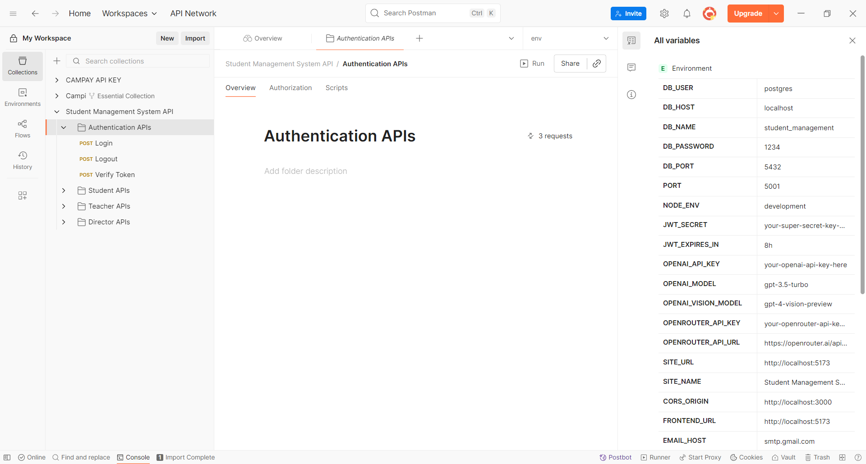
TEST SHOWCASE
Figure 33: authentication API test
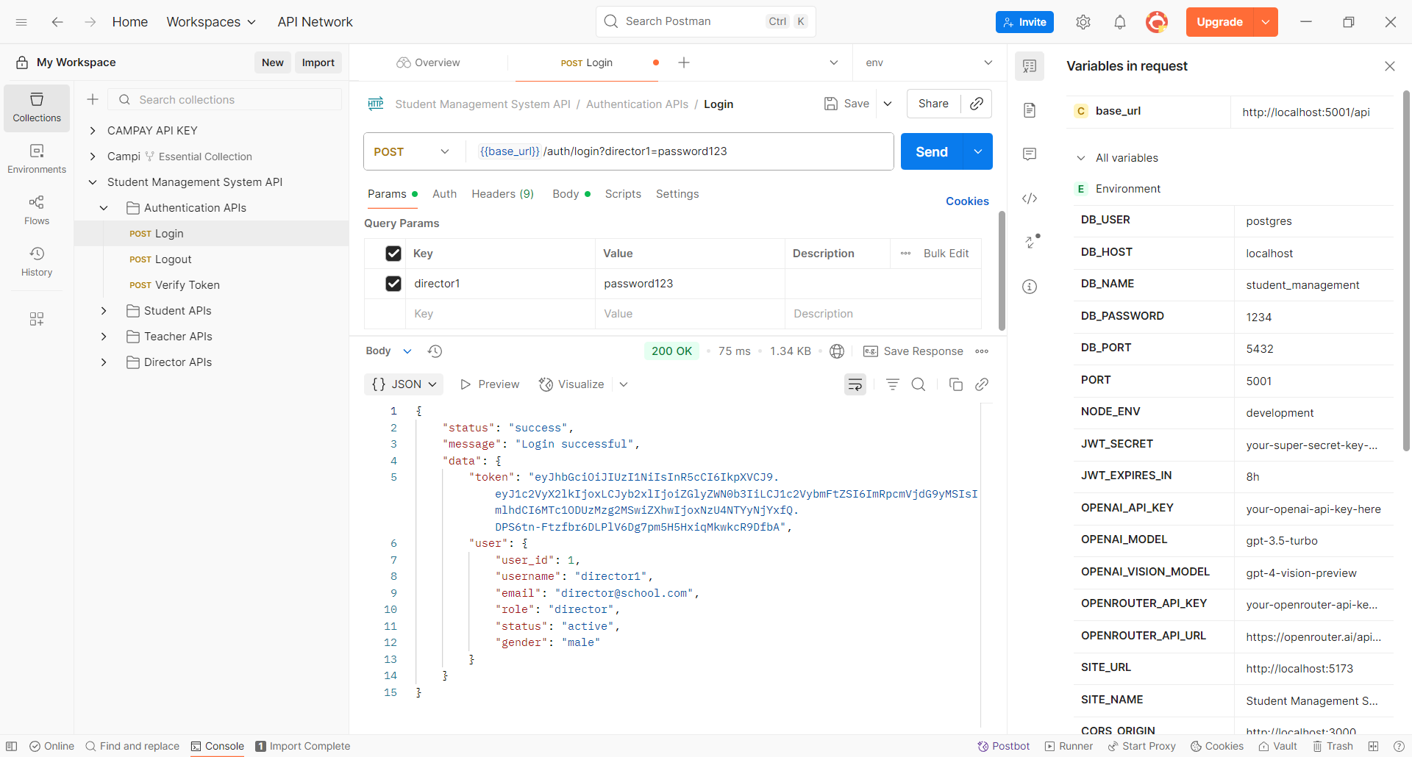
Figure 34:login

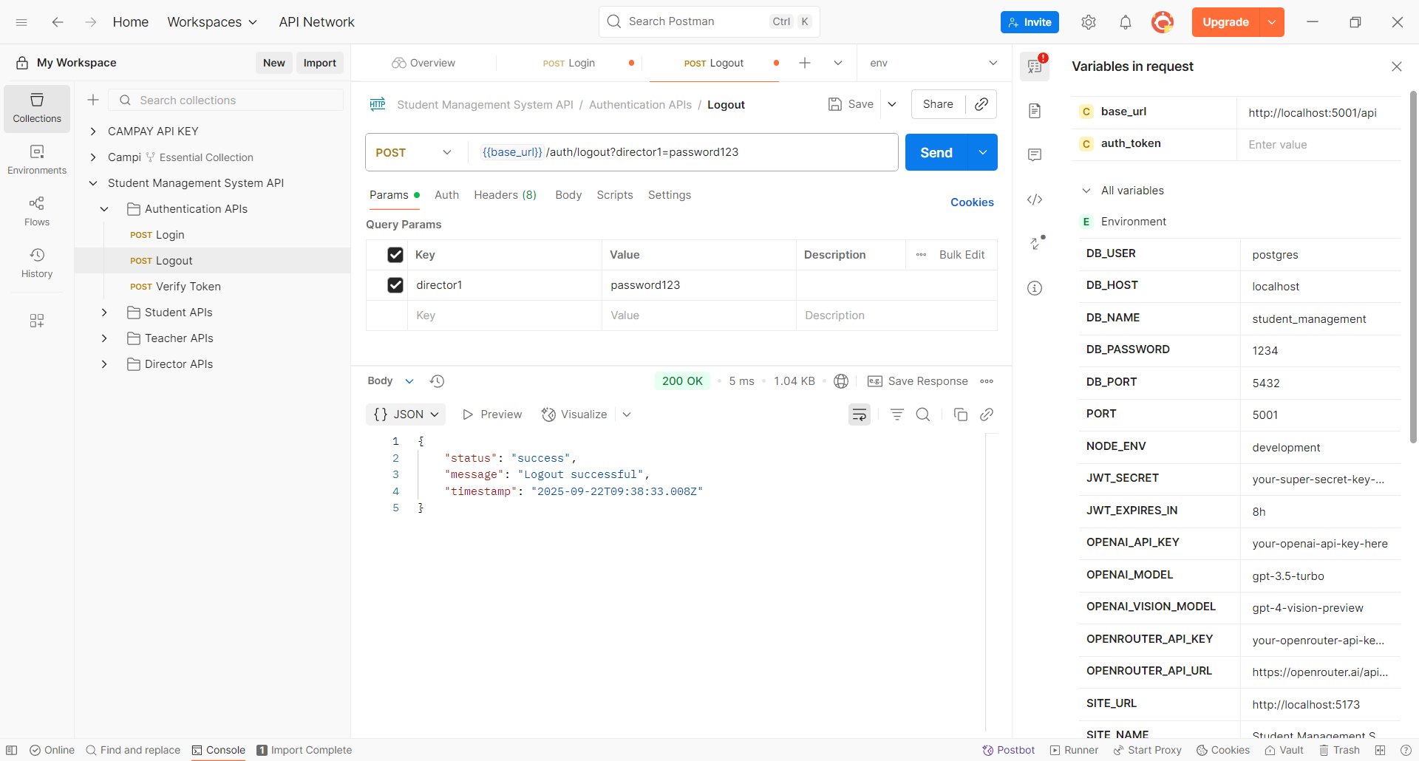
Figure 35:logout

CONCLUSION
In the test of functionality phase, we explained the different functionalities of our application and the benefits of the various users. This phase is essential in the understanding of the application

DOCUMENT SEVEN: USER GUIDE

Preamble
The purpose of the user guide is to provide users of our platform with step-by-step instructions on how to install and use the system.
Content

INTRODUCTION
- USER GUIDE
CONCLUSION

INTRODUCTION
This is the final phase of our report. In this phase, we will walk you through the requirements for our system, the necessary installation process, and accessing our system and its features, all in a step-by-step manner to facilitate the setup of the platform for first-time users. The steps of different processes will be accompanied by images. After we will showcase our application by viewing the different screens.

USER GUIDE
- The application only accepts authorized users to access the application, who must have been created by the school director

Here is the landing page of our application

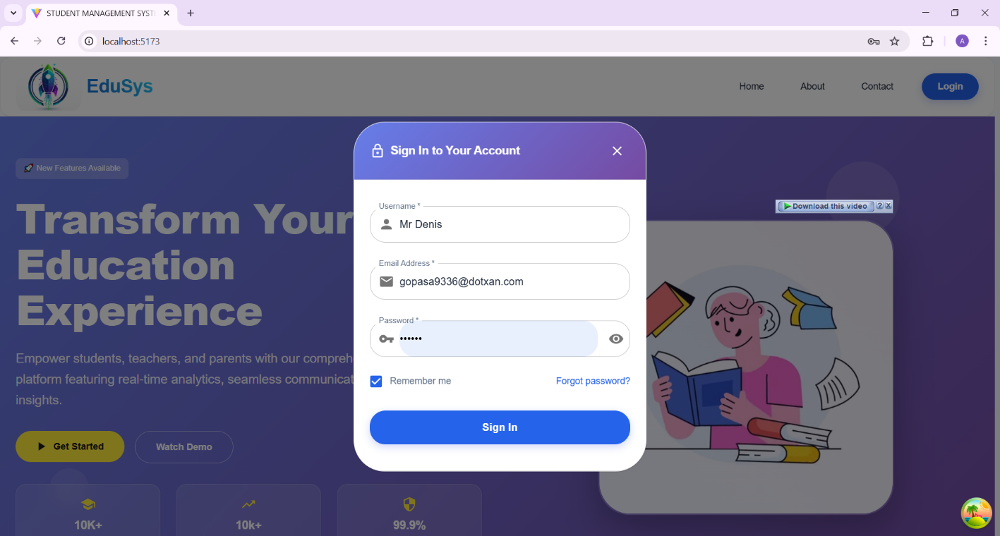
- The user clicks on the login button to access the application. He or she enters their credentials to access their dashboard, then, based on their role, they are navigated to their dashboard.

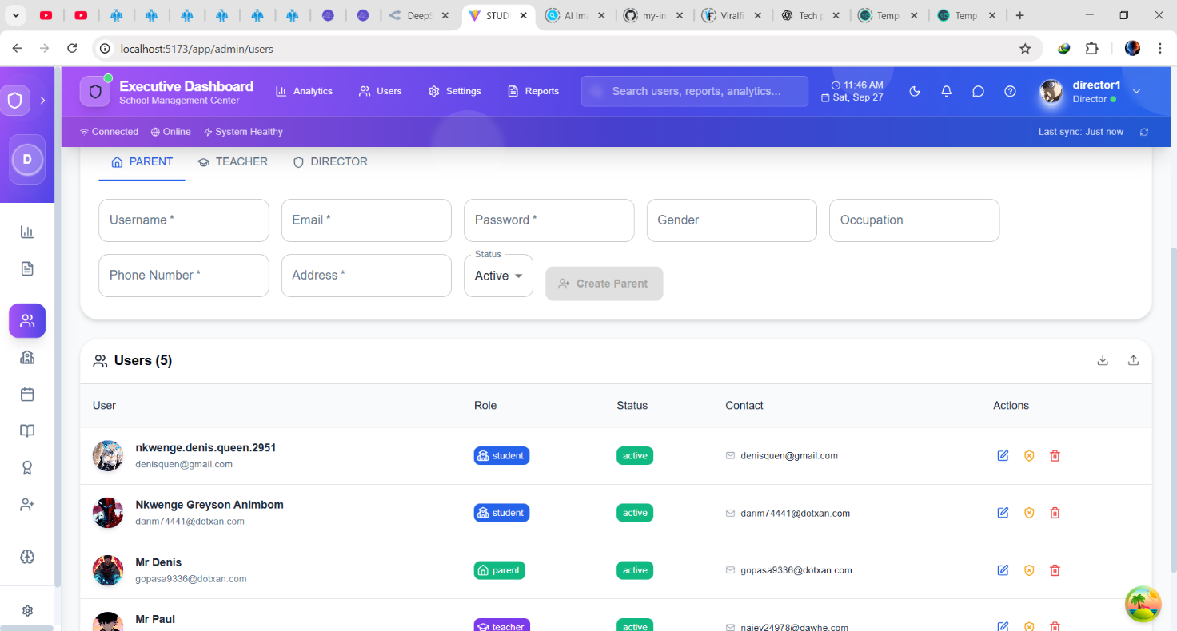
- If the user is logged in as the director, here is his dashboard, where he can view the users of the system

- If the user logs in as a parent, he or she is taken to their dashboard, where he or she can view their children’s progress
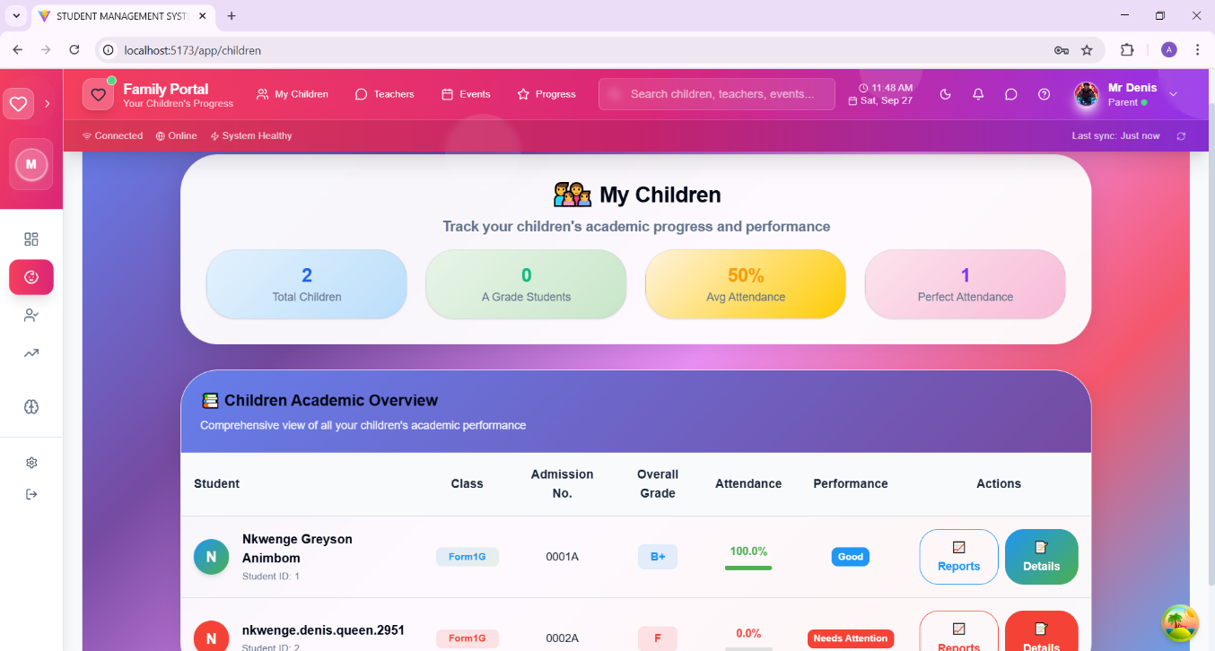
If the user logs in as a student, he or she is taken to their dashboard, where he or she can view the actions that concern them

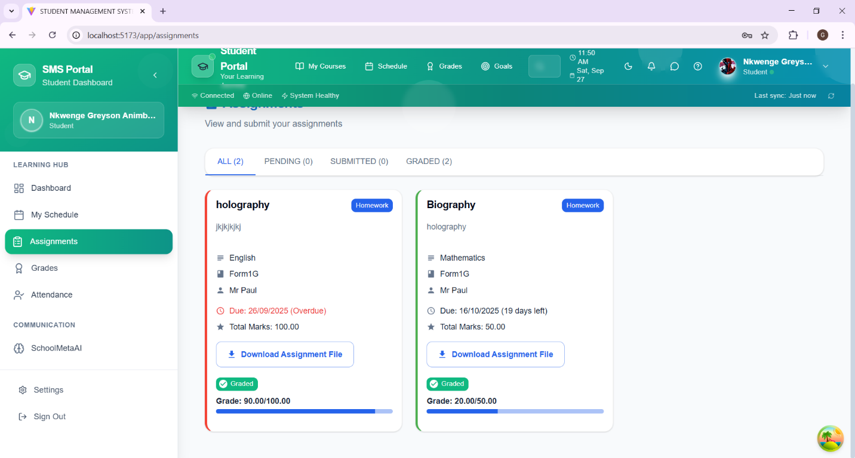

- Teacher dashboard: here, the teacher can grade students based on the class and subject they teach

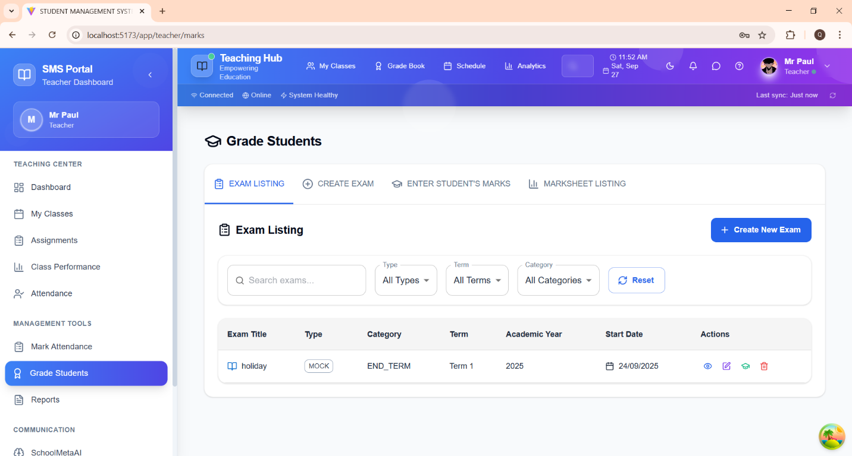

- The teacher can mark the attendance of a student
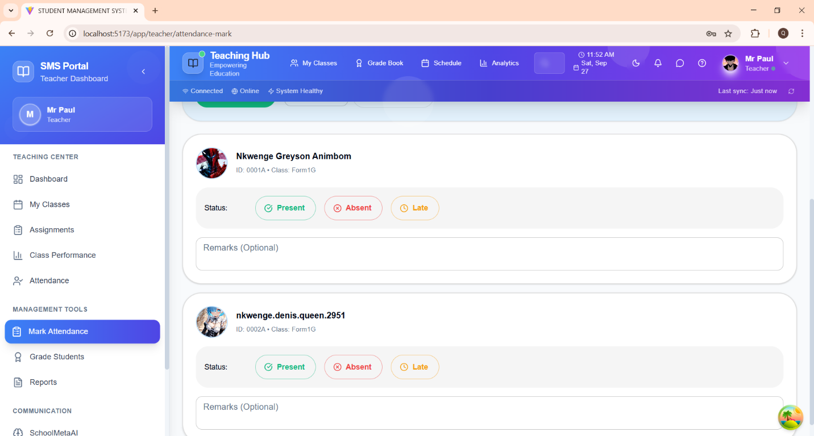

CONCLUSION
Having put in place the platform, it was not sufficient, for we had to produce a manual that would help its various users. That is why we presented the different tools to be installed and how they are to be installed to run this application without any problem, and how the users will use this platform once the environment is set up.

PERSPECTIVE
To further improve our application, we can have as perspectives:
- Add a payment system through which parent can pay their children's school fees
- Add a tutoring system where teachers who are available to tutor student can put their profiles
- Add a group chat where students can communicate and share ideas

GENERAL CONCLUSION
The internship at Shaderl, undertaken as part of the academic requirements for the Higher Technician Diploma in Software Engineering at AICS Cameroon, provided an opportunity to apply theoretical knowledge to a real-world educational challenge. The theme, “CONCEPTION AND REALIZATION OF A STUDENT MANAGEMENT SYSTEM (SMS)”, focused on addressing the inefficiencies of manual school administration in Cameroon, where processes such as attendance tracking, grade management, and parent communication remain largely paper-based.
To solve these issues, a web-based platform was developed, integrating features such as automated attendance recording, digital timetables, grade management, report card generation, real-time parent notifications, and AI-powered student assistance.
The project achieved its objectives, which included:
- Analyzing the shortcomings of existing manual systems.
- Specifying functional and technical requirements.
- Designing the system using UML based on the 2TUP methodology.
- Implementing the core functionalities for each user role (Student, Parent, Teacher, Director).
The resulting Student Management System provides a secure, efficient, and scalable solution, tailored to the realities of Cameroonian schools but adaptable to broader educational contexts.
Future enhancements may include mobile app integration, AI-driven performance analytics, and cloud-based deployment for nationwide accessibility.
This project not only strengthened my skills in system design, database management, and web application development but also highlighted the transformative role of digital solutions in improving education management.

ANNEXE

BIBIOGRAPHY
- Mr. MESSIO Ulrich UML course AICS-Cameroon 2024-2025
- Mrs. TCHOUTOUO Isabelle Scientific Writing course AICS-Cameroon 2024-2025
- Report of the student TCHOUTCHUI KAMSU MARCELLE DIGITALIZATION OF CASE MANAGEMENT IN A LAW FIRM 2023/2024

WEBOGRAPHY
Codecademy https://www.codecademy.com › get-started › free
https://www.openrouter.ai.com
https://github.com/NGA828/my-internship-project2/tree/master/student-management-system.com

TABLE OF CONTENTS

DEDICATION i
ACKNOWLEDGEMENTS ii
SUMMARY iii
LIST OF FIGURES iv
LIST OF TABLES vi
LIST OF ABBREVIATIONS vii
ABSTRACT viii
RESUME ix
GENERAL INTRODUCTION 1
PART ONE : INSERTION PHASE 2
INTRODUCTION 4
I- WELCOME AND INSERTION 5
II- GENERAL REPRESENTATION OF SHADERL 6
III- ORGANISATION OF SHADERL 8
IV- GEOGRAPHICAL LOCATION 11
V- BRIEF PRESENTATION OF THE PROJECT THEME 12
CONCLUSION 13
PART TWO: TECHNICAL PHASE 14
DOCUMENT ONE: EXISTING SYSTEM 15
INTRODUCTION 17
I. PRESENTATION OF THE THEME 18
II. STUDY OF THE EXISTING SYSTEM 19
III. CRITICISMS OF THE EXISTING SYSTEM 20
IV. PROBLEMATICS 20
V. PROPOSED SOLUTION 21
VI. DELIMITATION OF THE FIELD OF STUDY 22
CONCLUSION 23
DOCUMENT TWO: SPECIFICATION BOOK 24
INTRODUCTION 26
I. CONTEXT AND JUSTIFICATION 27
II. OBJECTIVES OF THE PROJECT 28
III. EXPRESSION OF NEEDS 29
IV. PROJECT PLANNING 31
V. PROJECT COST ESTIMATIONS 34
VI. CONSTRAINTS OF THE PROJECT 36
VII. DELIVERABLES 36
CONCLUSION 37
DOCUMENT THREE : ANALYSIS PHASE 38
INTRODUCTION 40
I. METHODOLOGY 41
A. Comparative study of UML and MERISE 41
B. Comparative study of unified process 43
II. CHOICE OF THE ANALYSIS METHOD 46
MODELLING OF THE SYSTEM 47
a) Use Case diagram 47
b) Activity diagram 55
c) Sequence diagram 61
d) Communication Diagram 66
CONCLUSION 69
DOCUMENT FOUR: CONCEPTION PHASE 70
INTRODUCTION 72
I. TECHNICAL BRANCH 73
CAPTURE TECHNICAL NEEDS. 74
III RELATED UML DIAGRAMS 77
1. Class Diagram 77
a) Definition 77
b) Formalism: 77
c) Class Diagram Elements Description 78
d) System class diagram 79
2. State Machine Diagram 80
a. Definition 80
b. Formalism: 80
c. State Machine Diagram Elements 81
d. Submit the assignment state machine 82
e. Grade student state machine 83
3. Package Diagram: 84
a) Definition: 84
b) Formalism: 84
c) Formalism for package diagram 85
d) System package diagram 86
CONCLUSION 87
DOCUMENT FIVE : REALISATION PHASE 88
INTRODUCTION 90
I. PRELIMINARY CONCEPTION: 91
1. Component Diagram: 91
a) Definition: 91
b) Formalism: 91
c) Formalism for component diagram 92
II. System component diagram 93
2. Deployment diagram: 94
d) System deployment diagram 96
III. TECHNICAL CHOICES 97
CONCLUSION 102
DOCUMENT SIX: TESTING OF FUNCTIONALITIES 103
INTRODUCTION 105
I. APPLICATION OF FUNCTIONALITIES 106
II. TEST SHOWCASE 107
CONCLUSION 109
DOCUMENT SEVEN: USER GUIDE 110
INTRODUCTION 112
I. USER GUIDE 113
CONCLUSION 117
PERSPECTIVE 118
GENERAL CONCLUSION 119
ANNEXE ix
BIBIOGRAPHY x
WEBOGRAPHY xi
TABLE OF CONTENTS xii

