REPUBLIQUE DU CAMEROUN
PAIX -TRAVAIL-PATRIE

REPUBLIQUE OF CAMEROON
PEACE-WORK-FATHERLAND



AFRICAN INSTITUTE OF COMPUTERS SCIENCES
BP: 13 719 Yaoundé (Cameroun)
Tel: (237) 22 72 99 57 / (237) 22 72 99 58
Site Web: www.iaicameroun.com

SHADERL
One Love, One Mind, One Legacy! BP : Monti(YAOUNDE)
LinkedIn: shaderl
Tel: (237) 678358509/692199722
Site Web: www.shaderl.com

ACADEMIC INTERNSHIP REPORT

THEME : CONCEPTION AND REALISATION OF AN INTELLIGENT AGRICULTURAL MANAGEMENT SYSTEM
Case study: LOCAL FARM

Internship carried out from the 1st July to 30th September 2026
In view of obtaining a Higher Technician Diploma (HTD) in Software Engineering.

Written By
NGWA PRINCE MARK DAVIS.
LEVEL 2
AICS CAMEROON

Supervised By
ACADEMIC SUPERVISOR
Mr ASANE DERICK
Lecturer at AICS-Cameroon

PROFESSIONAL SUPERVISOR
Mr. YAYA
Software Engineer at Shaderl

ACADEMIC YEAR 2025-2026

DEDICATION

THIS WORK IS DEDICATED TO THE NGWA’S FAMILY

ACKNOWLEDGEMENTS
This work would not have been successfully accomplished without the invaluable help, guidance, encouragement, and advice of the following individuals and organizations.
- We extend our profound gratitude to the African Institute of Computer Sciences (AICS), specifically to the Resident Representative, MR. ARMAND CLAUDE ABANDA.
- Our sincere thanks go to the director of Shaderl, MR. ASANE DERICK, and his entire staff for providing us with the opportunity to serve as interns at their prestigious enterprise.
- We are deeply indebted to our professional supervisor Mr. YAYA for their expert guidance throughout our internship.
- A special note of thanks to our academic supervisor and lecturer at AICS Cameroon, Mr. ASANE DERICK, for his invaluable advice, guidance, and constant encouragement.
- We also wish to thank all the teachers at the African Institute of Computer Sciences for their foundational role in our education.
- Our gratitude extends to the entire amazing Shaderl family for their tremendous support and welcoming environment during our internship period.
- On a personal note, a special thanks to my dear parents, Mr HOLL ACHILLE. and Mme.KELLY, for their unconditional love, unwavering financial support, and countless sacrifices. To my brothers and sisters, thank you for your love and support.
- We acknowledge the countless contributors of the open-source programming community, whose resources were instrumental in helping us learn essential skills and solve complex problems.
- Finally, thanks to my fellow mates, and senior Kamsu Marcelle, for their camaraderie and collaboration.

SUMMARY

LIST OF FIGURES

LIST OF TABLES

LIST OF ABBREVIATIONS

ABSTRACT
Technology has become increasingly important in modern agriculture, providing opportunities to improve farm management, monitoring, decision-making, market access, and communication. However, many farmers still rely on manual processes to manage farms, plots, crops, agricultural activities, environmental observations, and the sale of produce. These practices can lead to delayed decisions, incomplete records, inefficient monitoring, and limited access to markets. This project, titled CONCEPTION AND REALISATION OF AN INTELLIGENT AGRICULTURAL MANAGEMENT SYSTEM, aims to provide a digital platform that connects farmers, buyers, agricultural experts, and administrators while supporting efficient agricultural management. The system provides role-based registration and authentication, farm and crop management, agricultural monitoring, crop diagnosis and recommendations, direct farmer-to-buyer marketplace services, notifications, and order management. IoT technology is integrated as an optional enhancement rather than a mandatory dependency. When available, IoT sensors can automatically collect environmental information such as soil moisture, temperature, and humidity and transmit the readings to the system for analysis and alert generation. Without IoT, farmers can continue to use the core platform by entering observations manually. The system was analysed and designed using UML and the 2TUP methodology to provide a structured, secure, scalable, and user-friendly solution for agricultural management in Cameroon.
To achieve this, we researched to gather the necessary information and applied UML modeling based on the 2TUP methodology. This approach enabled us to design a complete method that covers system analysis, design, and implementation. The resulting Intelligent Agricultural Management System offers role-based access for farmers, buyers, agricultural experts, and administrators, ensuring efficient farm management, crop monitoring, agricultural diagnosis, produce marketplace services, real-time notifications, and secure role-based access. This project highlights how digitalization can transform traditional agricultural management into a smart, secure, and user-friendly platform for all stakeholders.
Keywords:
- Digitalization
- Agriculture
- Agricultural Management
- Agricultural Management
- Automation

RESUME
La technologie occupe aujourd’hui une place importante dans le développement du secteur agricole, en offrant des possibilités d’améliorer la gestion des exploitations, le suivi des cultures, la prise de décision, l’accès au marché et la communication entre les différents acteurs. Cependant, de nombreux agriculteurs utilisent encore des méthodes manuelles pour gérer leurs exploitations, parcelles, cultures, activités agricoles, observations environnementales et ventes de produits. Ces pratiques peuvent entraîner des retards dans la prise de décision, des pertes d’informations, un suivi insuffisant et un accès limité aux marchés. Ce projet, intitulé CONCEPTION ET RÉALISATION D’UN SYSTÈME INTELLIGENT DE GESTION AGRICOLE, vise à mettre en place une plateforme numérique reliant les agriculteurs, les acheteurs, les experts agricoles et les administrateurs. Le système permet la gestion des comptes et des documents, la gestion des exploitations, parcelles et cultures, le suivi agricole, le diagnostic des cultures, les recommandations, la mise en relation directe entre agriculteurs et acheteurs, la gestion des commandes et les notifications. L’IoT constitue une extension optionnelle du système et non une dépendance obligatoire. Lorsqu’il est disponible, des capteurs IoT peuvent collecter automatiquement des données telles que l’humidité du sol, la température et l’humidité ambiante afin de permettre leur analyse et la génération d’alertes. En l’absence d’IoT, l’agriculteur peut saisir manuellement ses observations et utiliser les fonctions essentielles de la plateforme. L’analyse et la conception du système sont réalisées avec UML suivant la méthodologie 2TUP afin de proposer une solution structurée, sécurisée, évolutive et conviviale adaptée au contexte agricole camerounais.
Pour y parvenir, nous avons mené une recherche pour recueillir les informations nécessaires et avons appliqué la modélisation UML basée sur la méthodologie 2TUP. Cette approche nous a permis de concevoir une méthode complète couvrant l'analyse, la conception et la mise en œuvre du système. Le Système de Gestion Scolaire qui en résulte offre un accès basé sur les rôles pour les élèves, les parents, les enseignants et les directeurs, garantissant une gestion efficace des notes, un suivi de la présence, des emplois du temps numériques, une communication en temps réel avec les parents et une génération automatique des bulletins. Ce projet met en lumière comment la numérisation peut transformer l'administration scolaire traditionnelle en une plateforme intelligente, sécurisée et conviviale pour toutes les parties prenantes.

Mots-clés :
- Numérisation
- Éducation
- Gestion Scolaire
- Administration Scolaire
- Automatisation

GENERAL INTRODUCTION
Technology is advancing at an incredible rate and is increasingly transforming agriculture and other sectors. Digitalization provides opportunities to improve how agricultural activities are planned, recorded, monitored, and communicated. In Cameroon, many farmers still depend on manual processes for managing farms, plots, crops, agricultural activities, environmental observations, and access to buyers. These practices may contribute to poor record keeping, delayed decision-making, inefficient monitoring, and missed market opportunities. The development of an Intelligent Agricultural Management System therefore provides an opportunity to bring these activities together in a single digital platform.
For this reason, we were assigned the theme “Conception and Realisation of an Intelligent Agricultural Management System” during our academic internship at Shaderl, a company specializing in providing IT solutions. The proposed system is designed around the main stakeholders of the agricultural ecosystem: farmers, buyers, agricultural experts, and administrators. It supports farm and crop management, agricultural monitoring, crop diagnosis and recommendations, direct farmer-to-buyer marketplace activities, notifications, and role-based access.
The system is also designed to operate with or without IoT technology. IoT sensors are an optional enhancement that can automatically collect environmental readings such as soil moisture, temperature, and humidity. When IoT is unavailable, farmers can still record observations manually and use the core functions of the platform. This approach makes the system accessible while allowing future integration of smart agricultural hardware.
We have structured this report into several sections, as follows:
- Insertion phase: In this book, we shall present the company in which we spent our internship period and the integration of interns.
- Existing System: Here, we shall present the already present system in place,
- Specification Book: In this book, we specify the needs of the user, taking into consideration the time and cost of the project.
- Analysis Phase: Here, we shall present the analysis method chosen, together with the presentation of all the diagrams used for the analysis of this project.
- Conception phase: This presents the generic and detailed conception of the project to bring out real-world constituents.
- Realization phase: This phase will permit us to visualize the implementation process of the solution.
- Functional testing: In this phase, we shall present to you the different functionalities or modules of our application and how they work.
- User Guide: This elaborates on all conditions necessary to use the application and how to use it.

PART ONE : INSERTION PHASE

Preamble
This section of the report will cover details of how we were welcomed in the host company, the presentation, and a brief introduction to our project.

Content

INTRODUCTION
The insertion phase in a company is a period during which we discover our work.
Environment, the staff of the company, and other interns. Here, we will begin by discussing our first two weeks in the company, how we were welcomed, and how we began adapting to our internship environment. We will proceed by exploring the history of the company, discovering its missions, learning what its major activities are, and witnessing some of its key realizations. We will also get to understand how the company is structured administratively and functionally so that it operates effectively and accomplishes its goals. Furthermore, we will look at the hardware equipment used by the company and the software resources used in its daily operations. We will then introduce our chosen theme for the internship period, briefly elaborate on it.

WELCOME AND INSERTION

We arrived at SHADERL on Wednesday 01st July 2026, at 08:30 am. we were received by the shaderl team who introduced us to our workspace, gave us an official welcome to the enterprise, its activities and its different rules and regulations. Also, we discussed on the enterprise’s preferred languages and frameworks, our professional supervisor encouraged us through his past working experiences in different enterprises.
The first two week we started with our internship report by configuring our MS WORD processor, reviewing key concepts like page numbering, styles, section breaks, page breaks etc. There was a talk on project ideas, we were advised to propose project ideas and we were assigned the tasks to carry out research on these ideas. The objective was that the enterprise did not want to impose some themes on us. For those who could not find a theme, the enterprise could propose an idea for them to think about.

GENERAL REPRESENTATION OF SHADERL

Background:
Shaderl is a dynamic, non-governmental tech startup founded in 2023 by Mr. Asane Derick with a bold vision: to bridge the gap between traditional industries and the rapidly evolving digital economy. Recognizing the urgent need for digital transformation, Shaderl is committed to providing cutting-edge IT solutions while empowering the next generation of innovators.

Mission
At Shaderl, we harness the power of AI and cutting-edge technology to democratize digital transformation. Our mission is to empower individuals and businesses with intelligent tools, accessible education, and personalized mentorship bridging the gap between today’s potential and tomorrow’s opportunities. We believe AI should augment human potential, not replace it. By making AI-driven solutions practical and ethical, we equip the next generation to lead, innovate, and thrive in an era where human creativity meets machine intelligence.

Vision
At Shaderl, we envision a world where technology unites humanity, where innovation is driven by collective purpose, not just profit. By putting “PeopleFirst”, we
strive to build a future where:
- One Love→ Technology fosters inclusion, empathy, and global collaboration, breaking down barriers.
- One Mind→ AI and digital tools amplify human potential, creating shared knowledge and opportunity.
- One Legacy→ Every individual we empower leaves a lasting impact, shaping a smarter, kinder, and more connected world.
We don’t just adapt to the digital age; we redefine it with humanity at the core.

ACTIVITIES
The activities of SHADERL range from computer sciences, engineering, and training. We can outline the following:
- Conception realization, and hosting of websites.
- Software development and maintenance.
- Training in Software related fields.
- Conception and realization of multimedia.
- AI driven solutions
- IT consulting and innovation.
NO | Name | description | LOGO
1 | ShaderlStock | ShaderlStock is an application, which helps small, medium and large businesses to manage their inventory, with the help of a QR code and AI assistance for more complex queries. | 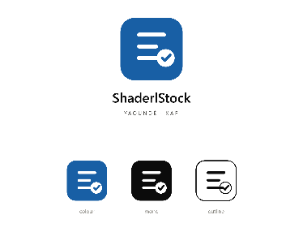
2 | ShaderlAlgorithm | It is an application, which helps individuals in the society to learn how to write algorithms and programing, despite their educational background. With the help of artificial intelligence. | 

PRODUCT

ORGANISATION OF SHADERL
Shaderl is administratively organized as follows:
Executive Leadership
This department is responsible for:
- Setting the company's vision, mission, and strategic direction
- Making high-level decisions about investments, partnerships, and growth
- Representing Shaderl in key meetings with investors and government agencies
- Ensuring all departments align with the company's core values and objectives
- Overseeing the overall performance and sustainability of the organization
Software Engineering Department
This department is responsible for:
- Designing, developing, and maintaining all of Shaderl's software products
- Implementing AI and machine learning solutions for company offerings
- Ensuring software security, scalability, and optimal performance
- Collaborating with other departments to understand technical requirements
- Staying updated with emerging technologies and industry best practices

Human Resource Department
This department is responsible for:Recruiting and onboarding top talent that aligns with Shaderl's values
- Managing employee relations, welfare, and performance evaluations
- Developing training programs to enhance staff skills and capabilities
- Maintaining company culture and ensuring a positive work environment
- Handling compensation, benefits, and conflict resolution

Communication Department
This department is responsible for:
- Managing Shaderl's public image and brand reputation
- Developing and executing marketing and PR strategies
- Handling all internal and external communications
- Managing social media platforms and digital content
- Organizing corporate events and press engagements

Department of Financial Affairs
This department is responsible for:
- Managing all financial operations and accounting
- Preparing budgets and financial forecasts
- Handling payroll, taxes, and financial reporting
- Ensuring compliance with financial regulations
- Managing investments and financial partnerships

Functional organisation
The functional branch of Shaderl is organized as follows:

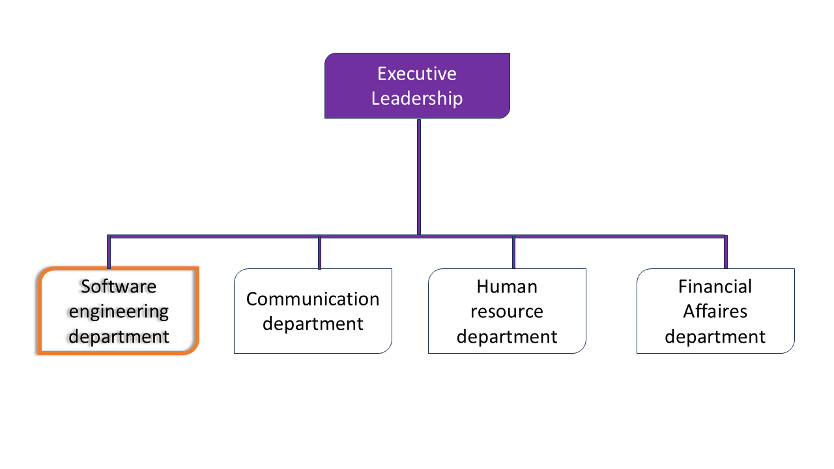
Figure 1: Organization of shaderl

GEOGRAPHICAL LOCATION OF SHADERL
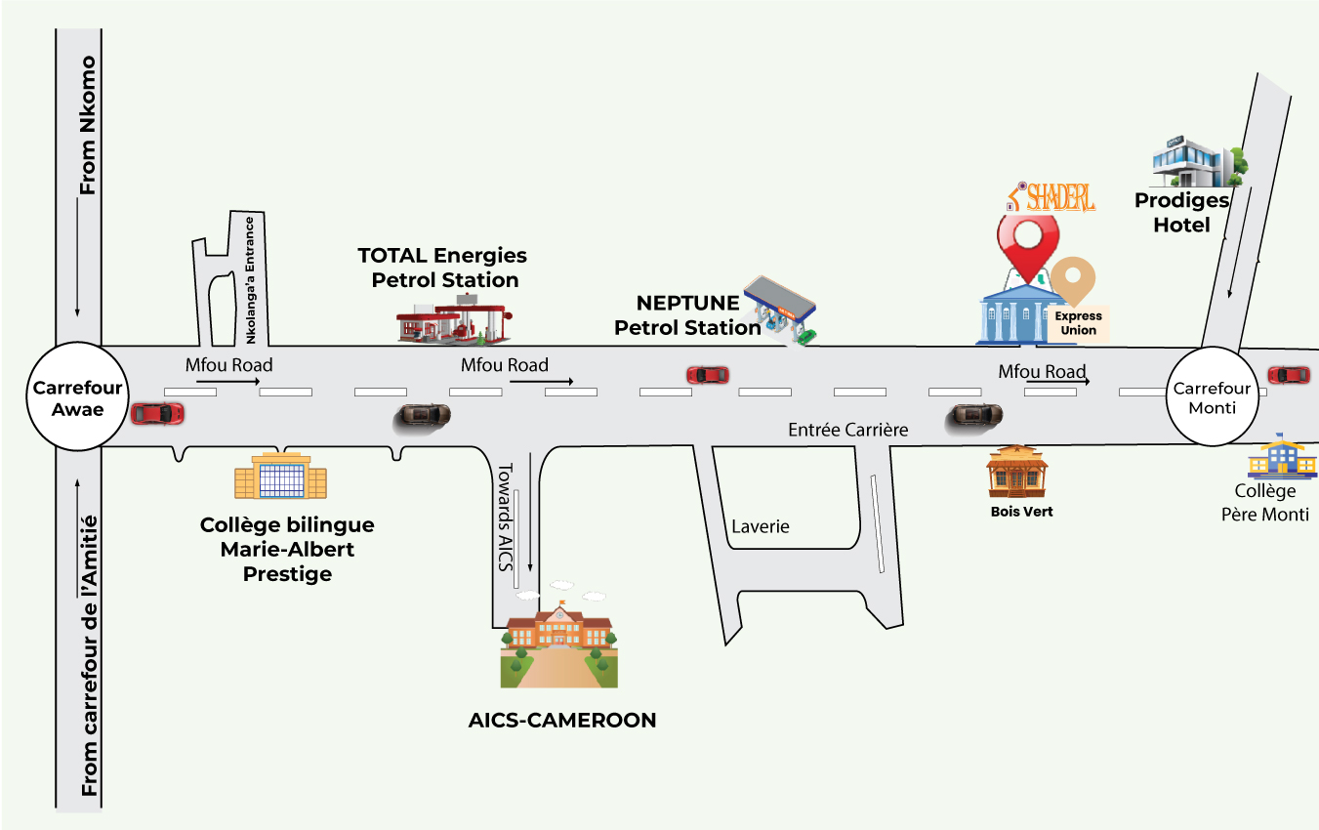
Figure 2: Geographical location of shaderl

BRIEF PRESENTATION OF THE PROJECT THEME
During the insertion phase at SHADERL, interns/students were asked to look for themes solving a specific, real, and innovative problem. After proposing and discussing ideas with the supervisor, the theme retained was the Design and Implementation of an Intelligent Agricultural Management System.

Farming in Cameroon, and across much of the region, still relies on manual, paper-based record keeping, guesswork for irrigation timing, delayed recognition of pest and disease outbreaks, and a fragmented, often unreliable link between farmers and buyers. These outdated methods waste water and inputs, reduce yields, and cause post-harvest losses. The proposed solution is a smart, all-in-one Agricultural Management System that monitors farm conditions (soil moisture, temperature, humidity), sends farmers real-time alerts for irrigation and treatment, assists with pest/disease identification, and connects farmers directly to buyers through an integrated marketplace with mobile money payment. In short, this project turns manual, disconnected farm management into a modern, data-driven system that helps every stakeholder in the agricultural value chain work better together.

CONCLUSION
At the end of the insertion phase, which covered the general presentation of the company and familiarization with the work environment, it is clear that this environment gives room for hard work, perseverance, and collaboration. The missions and activities of the company were made clear, and this phase brought an appreciation of the importance of collaborative work and of confronting the realities of a professional workspace.

PART TWO: TECHNICAL PHASE

DOCUMENT ONE: EXISTING SYSTEM

Preamble
The existing system is a document that provides a view of the system currently in place, that is how it carries out its different activities, also it provides a deep understanding of this system associated to the various limitations, the problems that result from these and the solution we propose.

Content

INTRODUCTION
- PRESENTATION OF THE THEME
- STUDY OF THE EXISTING SYSTEM
- CRITICISMS OF THE EXISTING SYSTEM
- PROBLEMATICS
- PROPOSED SOLUTION
CONCLUSION

INTRODUCTION
As engineers, the role in society is problem-solving, targeted at making life easier for everyone. To bring forth a solution, it is necessary to ask why a problem exists in the first place and how it is currently dealt with. The existing system refers to the practices currently used to carry out farm and agribusiness management in the field on which the theme is based. Understanding this system is a great step towards solving the problems identified, and it must be taken into account before proposing a suitable solution that will ameliorate or replace the current one.

PRESENTATION OF THE THEME
In the modern agricultural sector, farmers, cooperatives, and agribusinesses encounter several challenges in managing their day-to-day operations effectively. Manual processes often lead to disorganization, delayed decision-making, and a lack of transparency between farmers, agricultural experts, and buyers. To overcome these challenges, the development of a comprehensive Intelligent Agricultural Management System (IAMS) is proposed. This digital platform is designed to streamline farm operations, reduce guesswork in resource use, and improve the connection between all stakeholders in the agricultural value chain.

Our Vision
To design and implement an Intelligent Agricultural Management System that is efficient, accessible, and impactful, transforming the way farms are managed. By leveraging IoT sensing, AI-assisted decision support, and mobile technology, the solution will enhance yields, reduce waste, and provide farmers, experts, and buyers with real-time access to important farm and market information.
- Farm & Crop Management: A centralized platform to securely store and manage farm data, including plots, crops, planting dates, and activity logs.
- Smart Monitoring: Real-time soil moisture, temperature, and humidity readings from IoT sensors.
- Decision Support: AI-assisted pest/disease detection and irrigation recommendations.
- Marketplace: A module allowing farmers to list produce and buyers to order and pay through mobile money.
- Notification System: A real-time alert system to keep farmers updated on critical farm events.

STUDY OF THE EXISTING SYSTEM
Current farm management practices in Cameroon are largely dependent on manual, experience-based, and paper-based processes. These outdated methods create inefficiencies, increase losses, and limit accessibility to timely information. Below is an analysis of the existing system:

Operational Challenges
- Farm Record Keeping: Farmers still use notebooks or memory to track planting dates, treatments applied, and yields, which can easily be lost or forgotten.
- Irrigation Decisions: Watering schedules are largely based on habit or visual inspection rather than actual soil conditions, leading to over- or under-watering.

Detection Gaps
- Pest and Disease Detection: Crop diseases are often noticed only after visible, sometimes irreversible, damage has occurred, since there is no early-warning mechanism.

Market Access Limitations
- Buyer-Farmer Disconnect: Farmers rely on intermediaries or word of mouth to sell produce, often at unfavorable prices, with no direct, transparent channel to buyers.

CRITICISMS OF THE EXISTING SYSTEM
The analysis of current agricultural management practices reveals several limitations that hinder efficiency, transparency, and effective decision-making. The major criticisms include:
- Inefficiency: Manual processes slow down daily operations such as monitoring and record keeping.
- Error-Prone: Paper-based or memory-based records increase the likelihood of mistakes and lost information.
- Reactive, Not Proactive: Problems such as pest outbreaks or water stress are detected late, after damage has already occurred.
- Poor Market Access: Farmers lack a reliable channel to reach buyers directly, reducing their earnings.

PROBLEMATICS
After analyzing the existing agricultural management system and identifying its limitations, it is clear that the current approach is inefficient, reactive, and disconnected from the tools available in the modern digital economy. Since agriculture is a foundation of Cameroon's economy and food security, it is crucial to simplify and optimize farm administration to ensure efficiency, timeliness, and accessibility for all stakeholders: farmers, agricultural experts, and buyers. This leads to the core question: "How can farm monitoring be streamlined, early warning for crop threats be improved, and farmers be given better and more direct access to markets?" This question guides the research and leads to the proposal of a digital solution to modernize agricultural management in Cameroon.

PROPOSED SOLUTION
To address the challenges identified, the development of a comprehensive Intelligent Agricultural Management System (IAMS) is proposed. This platform integrates core farm monitoring, decision support, and market access functions into a single digital solution.
Key Aspects of the Proposed Solution:
- Automation of Monitoring: Soil moisture, temperature, and humidity data are collected automatically and used to trigger irrigation alerts.
- Centralized Database: All farm, crop, and transaction records are stored in a secure, centralized database.
- Real-Time Alerts: Farmers receive instant notifications regarding critical farm conditions and market activity.
- AI-Assisted Diagnosis: An integrated recommendation module assists farmers with pest/disease identification and treatment guidance.
- Integrated Marketplace: Farmers list produce and buyers purchase directly, with mobile money payment support.

DELIMITATION OF THE FIELD OF STUDY
The reason for delimiting the field of study is to focus on a particular problem and develop an efficient solution. This project focuses on developing an Intelligent Agricultural Management System, specifically designed for managing farm and crop records, sensor-based monitoring, and a produce marketplace. Relevant technologies, platforms, and documentation are explored to create an efficient solution. The study concentrates on the process of designing and implementing the system, within the following scope:
- Core farm and crop management functions.
- IoT-based (or simulated) environmental monitoring and irrigation alerts.
- AI-assisted pest/disease recommendation.
- Farmer-buyer marketplace with mobile money integration.

CONCLUSION
Having reached the end of this part, the existing system was studied to identify limitations leading to inefficiencies and losses. The proposed solution is the DESIGN AND IMPLEMENTATION OF AN INTELLIGENT AGRICULTURAL MANAGEMENT SYSTEM.

DOCUMENT TWO: SPECIFICATION BOOK

Preamble
This specification book is the document where we expose the detailed study of the project. In this section of the report, we shall discuss the project, its origins, its objectives, as well as the human, hardware, and software resources necessary for its realization.

Content

INTRODUCTION
- CONTEXT AND JUSTIFICATION
- OBJECTIVES OF THE PROJECT
- EXPRESSION OF NEEDS
- PROJECT COST ESTIMATIONS
- PROJECT PLANNING
- LIST OF PARTICIPANTS VII.
- DELIVERABLES

CONCLUSION

INTRODUCTION
The specification book gives the different directives on the product to be delivered along with the proposed solution. It presents the context in which the project is implemented and describes what the system should do and how. These specifications avoid the production of inadequate outputs, and include project details such as the team involved, constraints, budget, deadlines, target population, and deliverables.

CONTEXT AND JUSTIFICATION

Context
Over the past decade, Cameroon's agricultural sector has faced critical inefficiencies due to outdated administrative practices, limited access to timely information, and disconnection from digital tools. Despite technological advancement in other sectors, many farms still rely on manual observation for irrigation, grading, and pest detection, leading to lost yield, wasted water, and missed market opportunities. The rise of digital transformation in other sectors (finance, education, health) highlights the urgent need for agriculture to modernize. With increasing smartphone penetration and internet access, the time is ripe for an Intelligent Agricultural Management System that bridges these gaps.

Justification
Cameroon's agricultural sector serves a large and growing population, yet farmers lack the tools to match the pace of technological evolution elsewhere. An IAMS is indispensable for the following reasons:
- Dual Challenges of Scale and Complexity: Farms manage variable conditions across many plots with manual processes, increasing workload and risk of error.
- Economic and Regulatory Demands: Growing demand for traceable, quality produce requires better record-keeping and monitoring.
- Technological Readiness: Mobile adoption is high; farmers and buyers can access apps easily, and affordable cloud technology enables scalable solutions.
- Social Impact: Reduces crop loss by identifying threats early; empowers farmers to focus on productive work rather than guesswork; connects farmers directly to fairer markets.

OBJECTIVES OF THE PROJECT

General Objective
The primary goal of this Intelligent Agricultural Management System (IAMS) is to digitally transform farm administration, enabling efficient monitoring, timely decision-making, and real-time collaboration among farmers, agricultural experts, administrators, and buyers.

Specific Objectives
To achieve this, the system will:
- Digitize farm, crop, and user records: register plots, crops, planting dates, and manage user profiles.
- Enable smart environmental monitoring: capture soil moisture, temperature, and humidity readings and generate irrigation alerts.
- Provide AI-assisted decision support: help identify pest/disease issues and recommend treatment or irrigation actions.
- Streamline market access: allow farmers to list produce and buyers to browse, order, and pay through mobile money.
- Improve communication: notify farmers, experts, and buyers of relevant events in real time.

EXPRESSION OF NEEDS

Functional Needs
- The system shall allow farmers to register and manage farm/plot/crop information.
- The system shall record sensor readings (soil moisture, temperature, humidity) per plot.
- The system shall generate automatic alerts when readings cross defined thresholds.
- The system shall allow farmers to submit crop images for pest/disease diagnosis and receive recommendations.
- The system shall allow farmers to list produce for sale and buyers to place and pay for orders.
- The system shall provide role-based dashboards for Farmer, Agricultural Expert, Administrator, and Buyer.
- The system shall allow administrators to manage user accounts and system configuration.

Non-Functional Needs
- Security: user authentication and role-based access control.
- Usability: a simple, accessible, bilingual (French/English) interface.
- Performance: alerts must be generated within a reasonable delay of a threshold being crossed.
- Availability: the system should be accessible on both web and mobile-friendly interfaces.
- Scalability: the architecture should support additional farms, sensors, and users over time.

PROJECT PLANNING
The realization of this project follows a chronogram of activities, structured into phases: insertion, existing system study, specification, analysis, conception, realization, testing, and documentation.

Chronogram of Activities:
Table1:chronogram of Activities
Phase | Objectives | Duration | Output | Period
Insertion Phase | Collection of information on the enterprise | 2weeks | Insertion book | 01st July to 14 July 2026
Existing System | Bring out the structure of a system that exist | 1week | Existing system | 15th July to21st July
Specification | Specification of the user needs | 5days | Specification Book | 22nd July to 26thJuly
Analysis Phase | Capture of needs use case and textual description Modeling | 2weeks | Analysis Book | 27th July to 09 August
Conception Phase | Prelimenary conception and Detail conception | 2weeks | Conception book | 10th August to 09th August
Realisation Phase | Realization of system | 3weeks | Realization book | 24th August to 13th September
Test Of Functionalities | Running test to see how it functions | 5days | Test of functionalities | 15th September to 20th September
User Guide | Instructions on show to use the software | 5days | User Guide | 21st September to 25th September
Finalizing the report | Going through the report to see if there are errors | 4days | Final Report | 26th September to 30th September 2026

List of Participants:
Table2:list of participants
Name | Title | Role
Mr. ASANE DERICK | Lecturer at AICS-Cameroon | Academic Supervisor
Mr. YAYA | IT Engineer at Shaderl | Professional Supervisor
Mr. NGWA PRINCE MARK | Software Engineering student at AICS-Cameroon | AICS Student

Gantt Project planning:
For the success of the project, the work has been scheduled and performed in several parts, and each task represents a particular phase of progress and realization of our project. The diagram below shows the arrangement of these different phases

Figure 3: Gantt project

PROJECT COST ESTIMATIONS

Hardware Resources
Table3:hardware Resources
Resource | Designation | Quantity | Unit Cost (FCFA)
Computer | Laptop | 1 | —425000
Modem | Wi-Fi box | 1 | 25,000
Hard drive | External hard disk | 1 | 15,000
Removable disk | 64GB USB key | 1 | 3,500
Smartphone | For testing app responsiveness | 1 | 200,000
Total |  |  | 753500

Software Resources
Table4: software Resources
Resource | Designation | Usage | Unit Cost (FCFA)
Text editing & Presentation | Microsoft Office | Writing report and slides | —240,000
Operating System | Windows 10 | Computer operating system | —50,000
Database management | ProGressSQl | To communicate with the database | Free
Web browser | Google Chrome | View web pages | Free
Code Editor | Visual Studio Code | Writing application code | Free
Local server environment | XAMPP | Local PHP/MySQL development | Free
Cloud hosting | AWS EC2 | Deployment of the application | Pay-as-you-go
UML Analysis | Visual Paradigm | Drawing UML diagrams | Free/Freemium
Project planning | GanttProject | Building a Gantt chart | Free

Human Resources
Role | Number of Days | Quantity | Cost/Day (FCFA) | Total (FCFA)
Project Manager / Analyst | 45 | 1 | —350,000 | —15,750,000
Developer | 35 | 1 | —220,000 | —7,700,000
Tester | 10 | 1 | —100,000 | —1,000,000

Total estimation cost

Total1 | Total2 | Total3 | Overall total
815,500 | 300,000 | 36,415,000 | 37,530,500
THIRTY-SEVEN MILLION FIVE HUNDRED THIRTY THOUSAND FIVE HUNDRED FCFA

CONSTRAINTS OF THE PROJECT
- Technical constraint: tools chosen must be sufficiently robust to guarantee a minimum of security, extensibility, and scalability. Programming must follow technical standards for good performance within a reasonable execution time.
- Time Constraint: the project must be delivered before the end-of-year deadline set by the academic calendar.
- Cost constraint: realization requires modest expenditure in hardware, software, and possibly cloud hosting.

DELIVERABLES
At the end of this project, the following are expected to be submitted: an application, a presentation, and a document containing:
- An insertion phase.
- A specification book.
- An analysis book.
- A conception phase.
- A realization phase.
- user guide

CONCLUSION
The specification book, in which the aim of the project, its functional and non-functional needs, the project team, plan, cost, and constraints were presented, now provides a foundation for coming up with the solution required, taking the above information into consideration to avoid errors and compatibility problems.

DOCUMENT THREE : ANALYSIS PHASE

Preamble
The existing system is a document that provides a view of the system currently in place, that is, how it carries out its different activities, also it provides a deep understanding of this system associated with the various limitations, the problems that result from these, and the solution we propose.

Content

INTRODUCTION
- METHODOLOGY
- MODELLING OF THE PROPOSED SOLUTION
CONCLUSION

INTRODUCTION
The analysis phase is a systematic study that permits bringing out the differences between the various parts or components of a problem and finding solutions to it, following a well-defined methodology. Thus, after the specification of needs, the analysis is carried out using the Unified Modeling Language (UML), following the 2TUP process. Here, the various diagrams necessary for the analysis, priority functions, and elements that can help in solving the problem are determined.

METHODOLOGY

Comparative study of UML and MERISE

MERISE
MERISE stands for "Méthode d'Étude et de Réalisation Informatique pour des Systèmes d'Entreprise". MERISE is a method for designing, developing, and carrying out IT projects. The goal of this method is to achieve the design of an information system. It is based on the separation of data and processing, carried out through several conceptual and physical models. The essentials of the approach lie in its three cycles: the decision cycle, the life cycle, and the abstraction cycle, which cover data and process elements equally. The separation of data and processing ensures longevity in the model, since the arrangement of data does not have to be often overhauled, while treatments change more frequently.

UML
UML (Unified Modeling Language) is a standard notation for the modeling of real-world objects, as a first step in developing an object-oriented design methodology. UML captures information about the static and dynamic views of a system. UML 2.5 comprises 14 diagrams representing different views of a system, subdivided into structural diagrams (class, object, package, composite structure, component, deployment, profile) and behavioral diagrams (use case, activity, sequence, state machine, communication, timing, interaction overview).
UML is a modeling language and not a method or procedure. To give it an approach, UML is associated with a unified process (UP) to give the conception a methodology to follow. A unified process is a generic method for developing software, which must be adapted to the context of the project.

- Structural diagrams
- The class diagram
- The object diagram
- The package diagram
- The composite structure diagram
- The component diagram
- The deployment diagram
- The profile diagram
- Behavioral Diagram
- The use case diagram
- The activity diagram
- The sequence diagram
- The state machine diagram
- The communication diagram
- The timing diagram
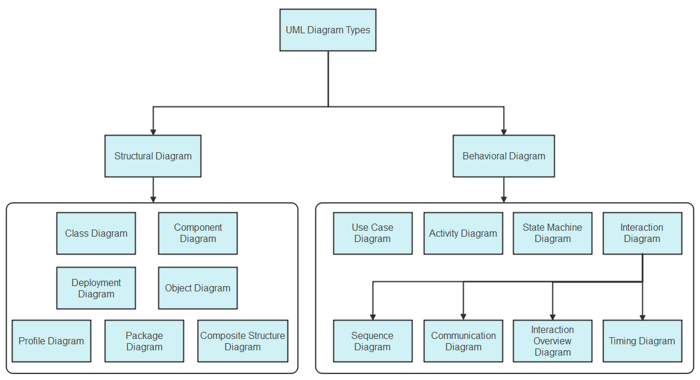
- The interaction overview diagram

Figure 4:uml diagrams

It is important to note that UML is a modeling language and not a method or procedure. Hence, to give it an approach, we need to associate UML with a unified process (UP) to give our conception a methodology to follow. A unified process is a generic method for developing software. This implies that it is necessary to adapt the UP to the context of the project.

Comparative study of unified process

Unified Process
A Unified Process is a process of software development constructed on UML; it is iterative, incremental, centered on architecture, and driven by use cases and requirements.
- Iteration is a distinct sequence of activities with a basic plan and evaluation criterion that produces an internal or external output. Either the content of an iteration is improved, or the evolution of the system is evaluated by users.
- An increment is the difference between two released products at the end of two iterations. Each iteration that the group is capable of integrating the technical environment in order to develop a final product and give users the possibility of having tangible results.
- Centered on architecture, the different models derived during the establishment of the system must be reliable and coherent.
- Driven by use case and requirements enables the clear definition of a user’s needs and priorities, respectively, thereby minimizing the risk of project failure.

The Two-Track Unified Process (2TUP)
2TUP is a unified process built on UML, aiming to bring a solution to constraints of functional and technical change imposed on information systems by strengthening controls on development capacities. It proposes a Y-shaped development life cycle that separates the functional aspect from the technical aspect, and the merging of these two forms the implementation aspect. 2TUP distinguishes two branches: the functional and technical branches. The combination of the results of these two branches forms the third: the realization branch, where the system is realized.

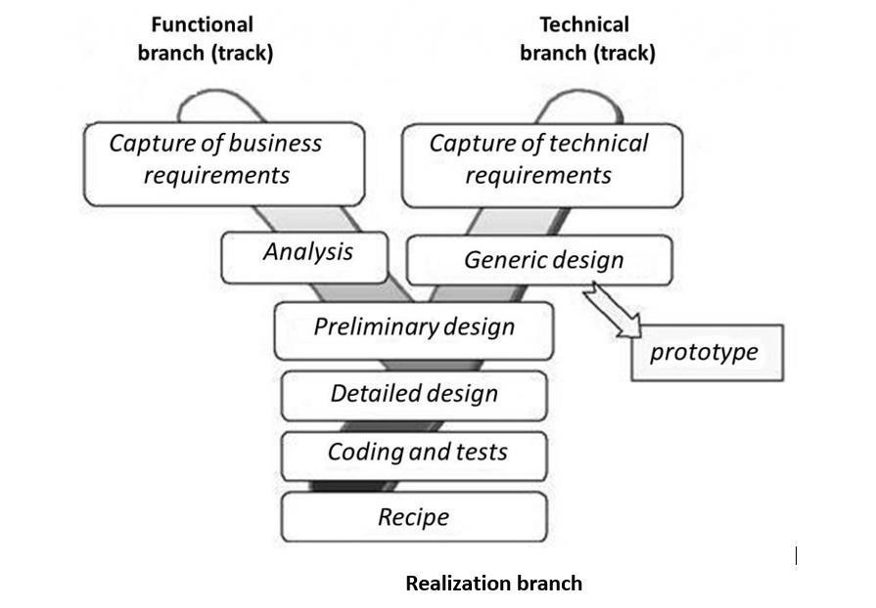
Figure 5: 2TUP
2TUP is an approach that makes it possible to visually represent the different stages and components of a software project using UML diagrams. It proposes a development cycle in the Y shape, which separates the functional aspects from the technical aspects. It begins with a preliminary study, which consists of identifying the actors that will interact with the software to be built, the messages that the actors and the system exchange.
2TUP is based on three phases:

The Functional Branch
Capitalizes on knowledge of the domain (agriculture). It includes the capture of functional needs, producing a model of needs focused on the business of the users, and analysis, which studies the functional specification to obtain an idea of what the system will achieve in terms of business, independent of technology.

The Technical Branch
Lists the technical needs and proposes a generic design validated by a prototype: inventory of technical specifications related to hardware, and inventory of software specifications.

Implementation Branch
Supports preliminary design, detailed design, coding, testing, and validation. The preliminary design represents the fusion of the functional and technical tracks, finishing when the deployment model, the operating model, the logical model (class diagrams), interfaces, and the software configuration model are defined.

CHOICE OF THE ANALYSIS METHOD
The reasons why we chose UML modelling language and the software development process 2TUP instead of many others that exist are:
- UML is the current standard for programming in object-oriented languages; it is widely understood, making it easy for a new programmer to join the project and be productive quickly.
- 2TUP is centered around the creation and maintenance of a model, rather than the production of a mountain of documents.
- UML is a graphical modelling language, issuing diagrams with named symbols to represent concepts, making it readable and understandable.
- 2TUP is iterative and incremental, enabling the project team to produce refined improvements and easily integrate them into the existing system.

MODELLING OF THE SYSTEM

Use Case Diagram

Definition
A use case diagram shows the functionalities of a system, their inter-dependencies, and how they relate to the actors of the system. A use case is a specification of behavior. Its main objectives are to provide a high-level view of the system, identify its functions, and identify the expectations of the system. Use case diagrams are completed with a textual description of each use case, intended to define it in greater detail.

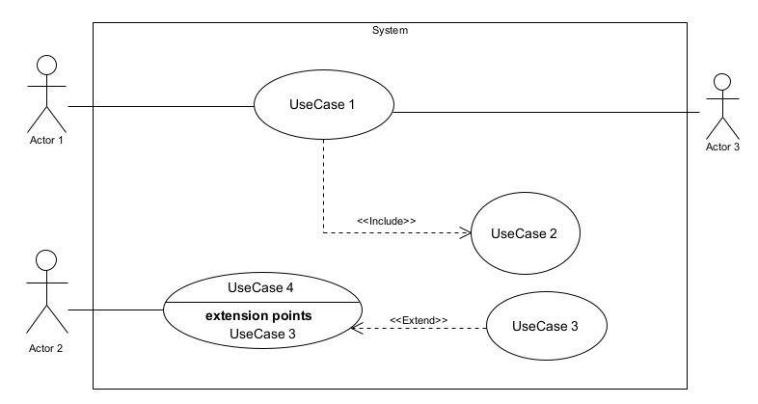
Formalism:
Figure 6: Use case formalism

Element | Notation | Description
Actor | 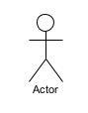 | Represents an entity that directly interacts with the system, performing possible actions on it.
Use case | Use Case  1 | Represents a functionality of the system; an action that can be performed by an actor.
Association | 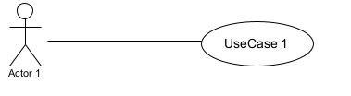 | Indicates that an actor takes part in a use case.
Include | 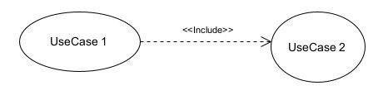 | Denotes that an included action must be performed before the including action can be performed.
Extend | 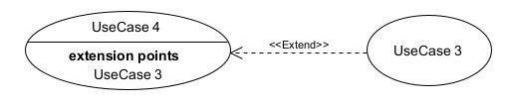 | Denotes that an extending action may be performed while an extended action is being performed.
Generalization | 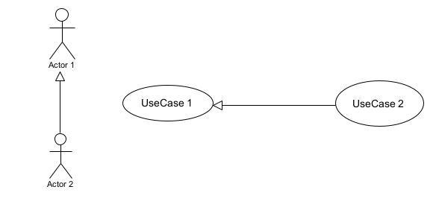 | Shows that an actor or use case is a kind of another abstract or concrete actor/use case.
System boundary | 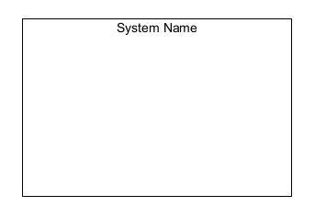 | A container of use cases that interact with external actors.

Elements of use case diagram

The Actors of the System
Actor | Action they perform
Farmer | Registers farm/plots/crops, views sensor readings and alerts, requests AI diagnosis, lists produce for sale, manages orders.
Agricultural Expert | Reviews flagged issues (disease, soil problems), validates or refines AI recommendations.
Administrator | Manages user accounts, oversees system configuration and platform integrity.
Buyer | Browses produce listings, places orders, makes payment.
IoT Sensor (system actor) | Automatically sends soil moisture, temperature, and humidity readings to the system.
Weather API (external system) | Supplies forecast data used to inform irrigation recommendations.
Payment Gateway (external system) | Handles mobile money transactions for the marketplace.

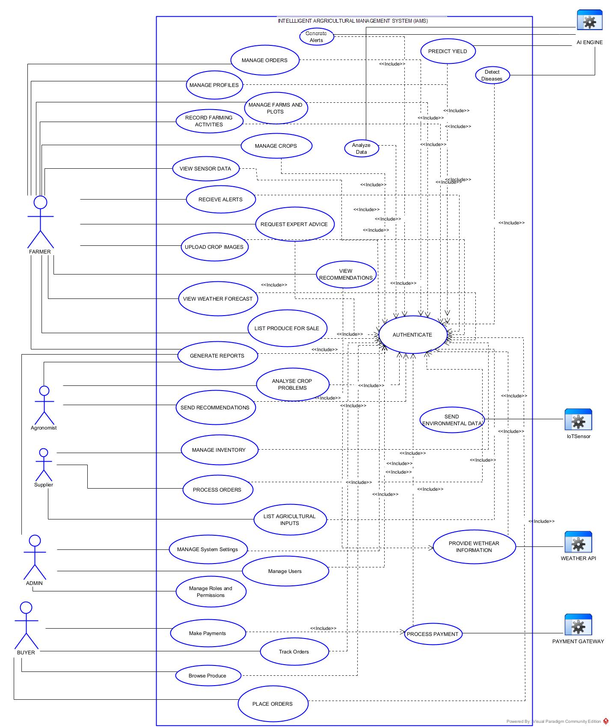
General Use case

Specific use case: Athenticate
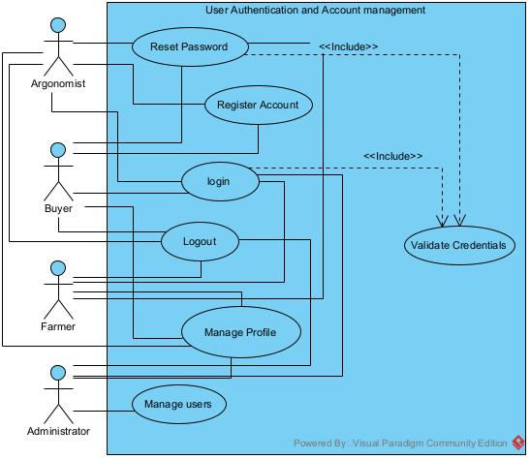

Specific use case: Agricultural MarketPlace
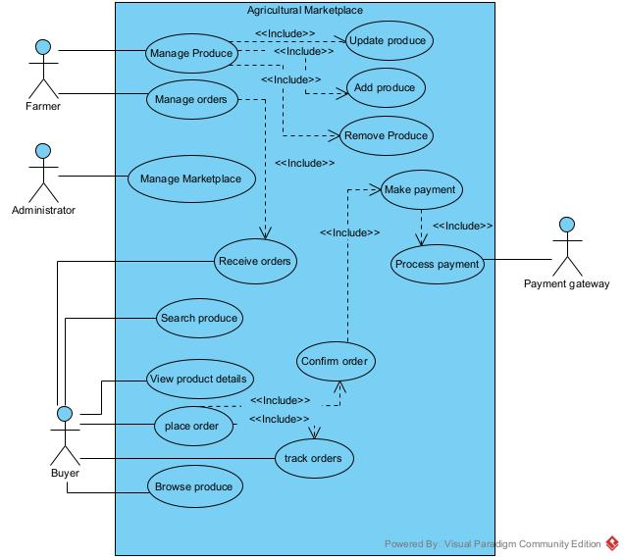

Specific use case: Monitoring and Recomendation
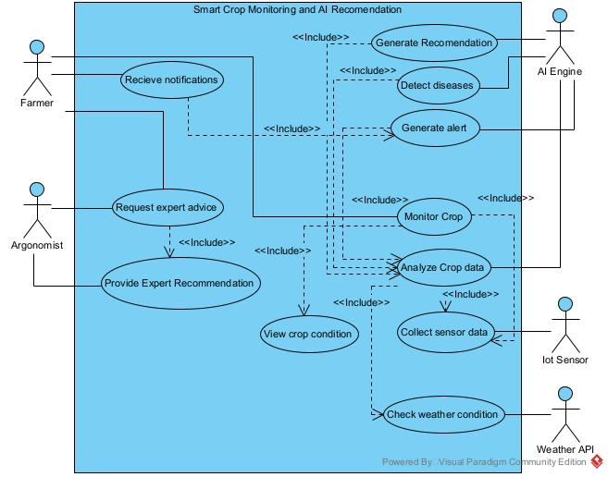

Textual Description — Authentication
Field | Description
Summary | The user needs to authenticate to access the system.
Actors | Farmer, Agricultural Expert, Administrator, Buyer
Precondition(s) | The application is launched. The user must have an account on the platform.
Trigger | The user clicks on the login button.
Nominal Scenario | - The system displays the login form.  - The actor fills and submits the form.  - The system verifies the form fields' conformity.  - The system sends the data to the DBMS.  - The DBMS executes the authentication query.  - The DBMS sends the results to the system.  - The system processes the results and redirects the actor to their role-based dashboard.
Alternative Scenario | Invalid credentials: the system displays an error message and returns to the login form.

Textual Description — Record Sensor Reading & Generate Irrigation Alert

Field | Description
Summary | The system records environmental readings from a plot and generates an irrigation/treatment alert when a threshold is crossed.
Actors | IoT Sensor (system actor), Farmer
Precondition(s) | - The plot is registered in the system and linked to an active sensor.  - Threshold values for soil moisture/temperature are configured for the crop.
Trigger | A new sensor reading is received by the system, or a scheduled reading interval elapses.
Nominal Scenario | - The sensor sends a new reading (soil moisture, temperature, humidity) to the system.  - The system stores the reading against the corresponding plot.  - The system compares the reading against the configured threshold. If the value crosses the threshold, the system generates an alert.  - The system sends a notification to the Farmer.  - The Farmer views the alert and the recommended action on the dashboard.
Alternative Scenarios | - Reading within normal range: the system stores the value without generating an alert.  - Sensor data unavailable: the system flags the plot as "no recent data" and prompts the Farmer to check the device.

Textual Description — List and Sell Produce
Field | Description
Summary | A Farmer lists produce for sale; a Buyer browses, orders, and pays for it.
Actors | Farmer, Buyer, Payment Gateway (external system)
Precondition(s) | The Farmer is authenticated. The produce item, quantity, and price are known.
Trigger | The Farmer clicks "List Produce", or the Buyer clicks "Order" on a listing.
Nominal Scenario | 1. The Farmer creates a listing with produce type, quantity, and price. 2. The system publishes the listing on the marketplace. 3. The Buyer browses listings and selects one to order. 4. The Buyer confirms the order and quantity. 5. The system requests payment through the Payment Gateway. 6. The Payment Gateway confirms payment. 7. The system updates the order status and notifies both the Farmer and the Buyer.
Alternative Scenarios | 6a. Payment failure: the system displays an error and the order remains pending. 3a. Out of stock: the system disables ordering once the listed quantity is exhausted.

Activity Diagram

Definition
An activity diagram is a graphical representation of workflows, showing the steps needed to realize a process, from a start point to an end point, through all decisions and actions that can possibly be performed. Activity diagrams model both computational and organizational processes, and the flow can be sequential, branched, or concurrent.

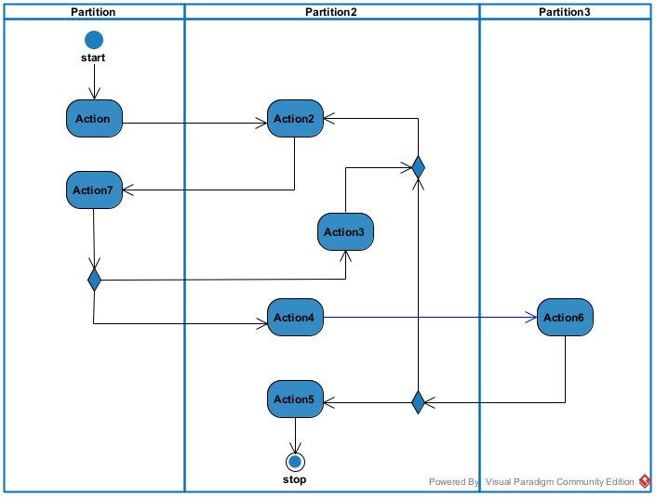
Formalism
Figure 7: formalism of activity diagram

Elements of Activity Diagram
Elements Diagrammatic Representation |  | Description
Initial node |  | Shows the beginning of an activity or set of actions.
Activity | 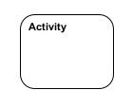 | Used to represent a set of actions.
Action |  | A directed connection between two activity nodes through which tokens may flow.
Final node |  | Stops all controls and object flows in an activity.
Action | 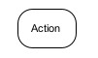 | Represents a task to be performed.
Decision node | 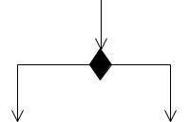 | Represents a test condition that splits an incoming activity edge into alternative outgoing edges.
Merge node | 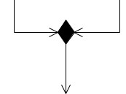 | Reunites different decision paths created using a decision node.
Fork / Join node | 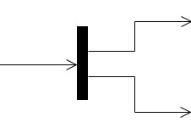 | Splits or unites parallel/concurrent flows of activities.
Swim lane | 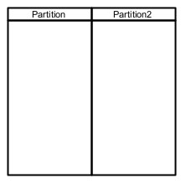 | Groups activities performed by the same actor in an activity diagram.
[Insert here: Activity diagrams for Authentication, "Record Sensor Reading & Generate Alert", and "List and Sell Produce"]

Authentication Activity diagram:

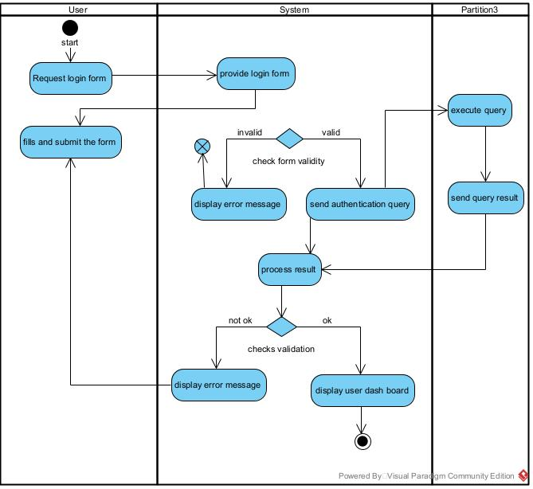

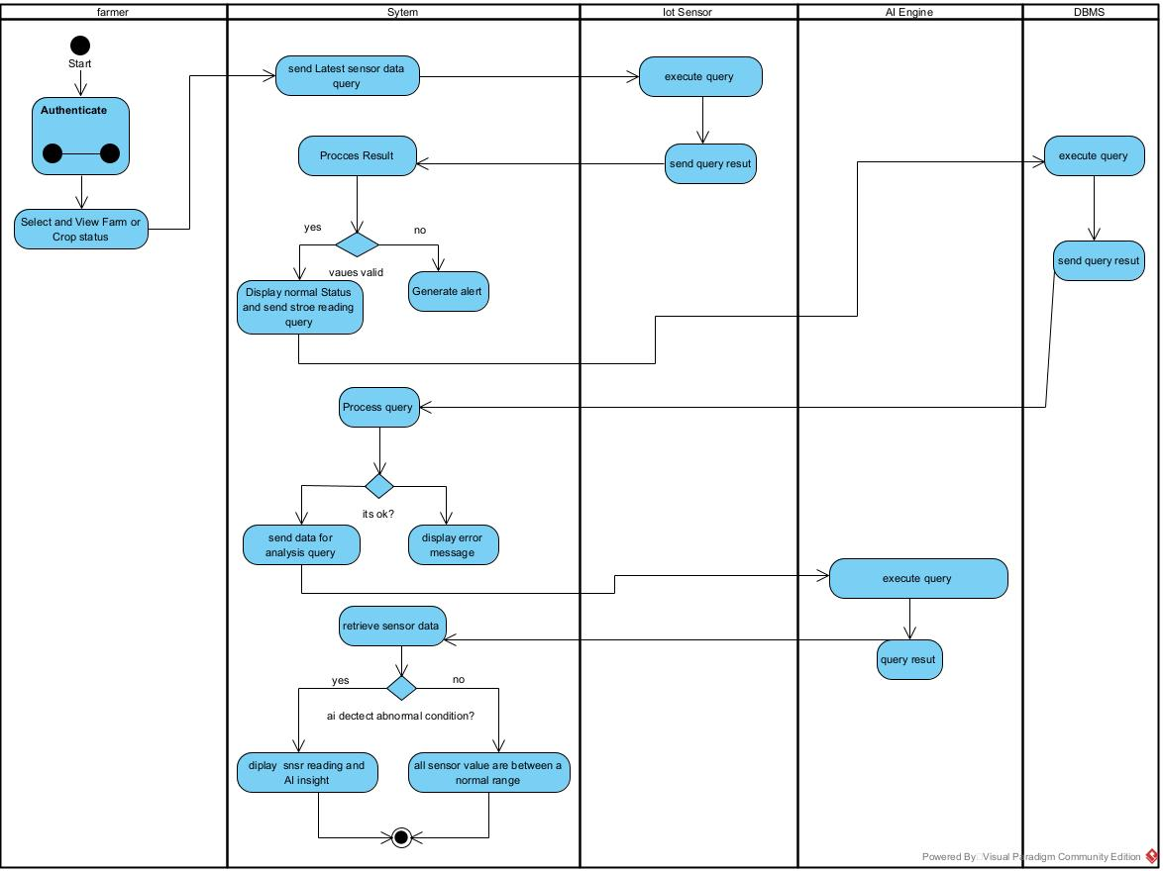
Crop monitoring and AI recommendation

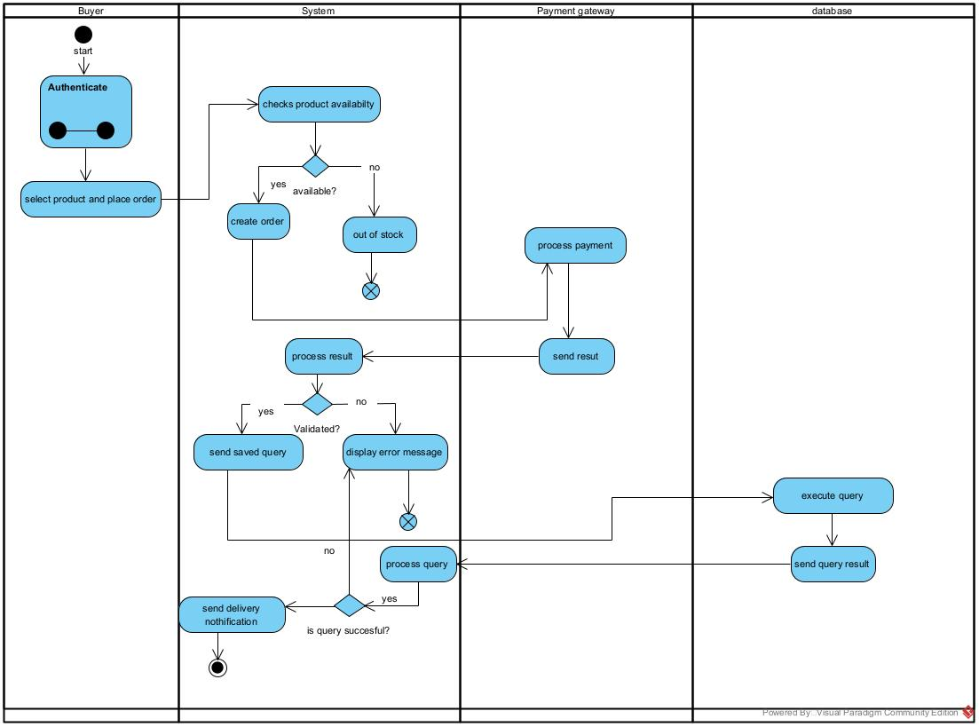
Market Place Purchase:

Sequence Diagram

Definition:
A sequence diagram is an interaction diagram that represents the flow of messages between elements in a system, portraying communication between lifelines as a time-ordered sequence of events.

Formalism
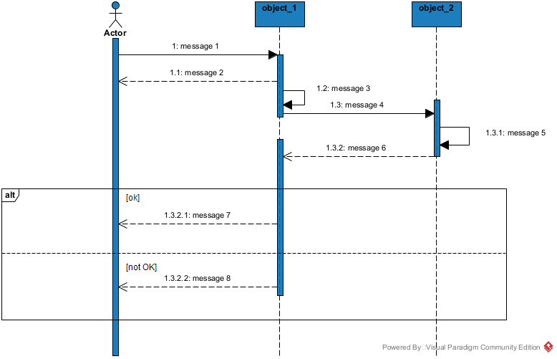
Figure 8: formalism for sequence diagram

Elements of a Sequence Diagram
Element | Representation | Description
Lifeline | 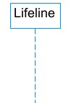 | An individual participant in a sequence diagram, positioned at the top of the diagram.
Combined fragment | 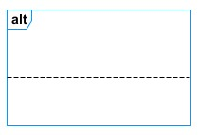 | Represents a choice of behavior in which at most one operand is chosen.
Messages | 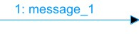  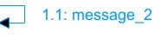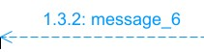 | Arrows showing the direction of message flow (synchronous, asynchronous, self-message).
Activation | 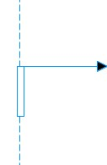 | Describes the time period in which an operation is performed by an element.

[Insert here: Sequence diagrams for Authentication, Record Sensor Reading & Generate Alert, and List/Sell Produce]

Authenticate sequence Diagram
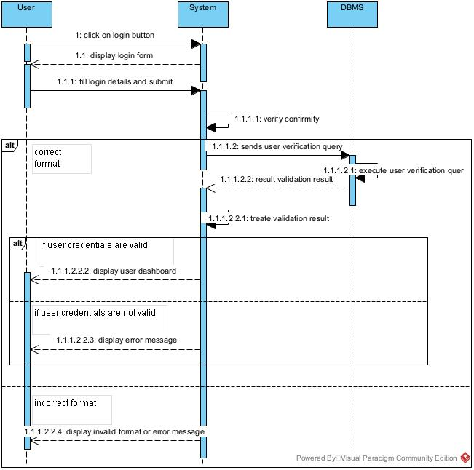

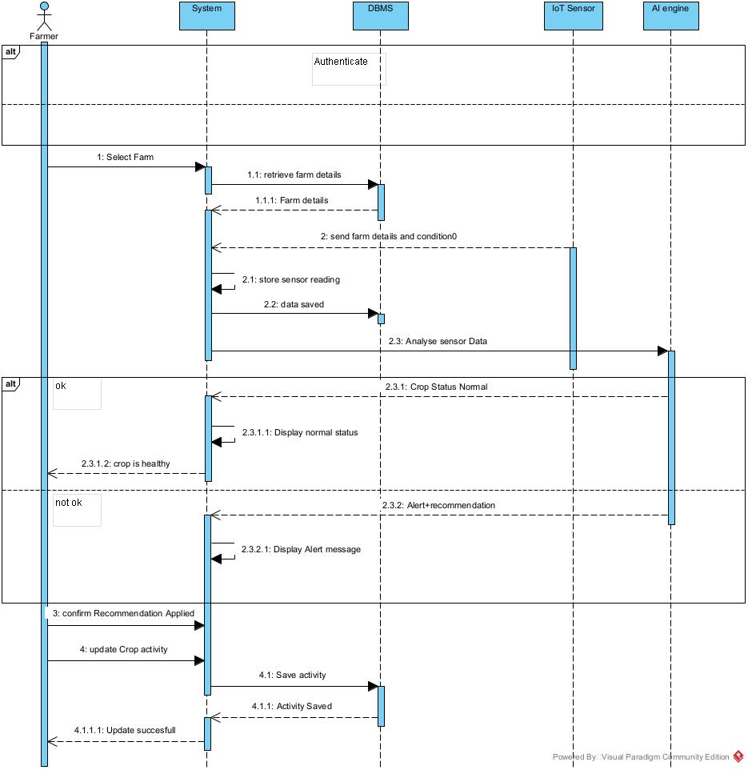
Crop Monitoring and AI Recommendation sequence Diagram

Market Place Purchase Sequence Diagram:

Communication Diagram

Definition
A communication diagram shows the relationship between the actors of a system. Both the sequence and communication diagrams represent the same information, but differently: instead of showing the flow of messages over time, it depicts the architecture of the objects residing in the system, since it is based on object-oriented programming.

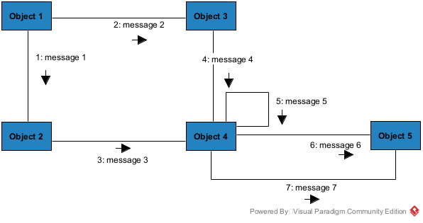
Formalism
Figure 9: formalism for communication diagram

Element of Communication Diagram

Element | Representation | Description
Object | 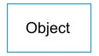 | An individual participant in the interaction.
Link |  | Connects two objects together for them to communicate.
Actor | 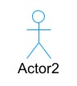 | A role played by an entity that interacts with the subjects.
Message | 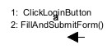 | Defines a particular communication between lifelines in an interaction.
[Insert here: Communication diagrams for Record Sensor Reading & Generate Alert, and List/Sell Produce]

communication diagram

Communication Diagram

CONCLUSION
In the analysis phase, a software development process and modelling language were chosen, the existing system, its limitations, and the proposed solution were presented. The functional needs of the system were explained through the use case diagram (showing the relationship between actors and functionalities), the activity diagram (showing the workflow of the system), and the sequence and communication diagrams (showing the interaction between actors and system components). The next phase presents the technical and realization branches of 2TUP.

DOCUMENT FOUR: CONCEPTION PHASE

Preamble
The conception phase will permit us to present in an orderly manner the components necessary for the good functioning of our software and also the architecture used for the proposed solution. It bridges the gap between the analysis phase and the realization phase.

Content

INTRODUCTION
- TECHNICAL BRANCH
- GENERIC DESIG
- CAPTURE OF TECHNICAL NEEDS
- RELATED UML DIAGRAMS
- Class Diagram
- State machine Diagram
- Package Diagram
CONCLUSION

INTRODUCTION
The conceptual phase describes in detail the necessary specifications, features, and operations that will satisfy the functioning requirements of the proposed system as modeled in the analysis phase. This phase identifies and considers essential components (hardware and software), structure, processes, and procedures for the system to accomplish its objectives, through diagrams such as the class diagram, state machine diagram, and package diagram.

TECHNICAL BRANCH

GENERIC DESIGN

Hardware Diagram of the System
The hardware diagram shows how the components of the system are deployed: IoT sensor nodes at plot level, a gateway/microcontroller relaying data over Wi-Fi/GSM, cloud servers hosting the application and database, and client devices (phones, computers) used by farmers, experts, administrators, and buyers.
[Insert here: Hardware deployment diagram]

HIGH LEVEL ARCHITECTURAL DIAGRAM OF THE SOFTWARE
The high-level architecture diagram provides an overview of the entire system, identifying the main components that would be developed for the product and their interfaces. The high-level architecture diagram below illustrates this.

CAPTURE TECHNICAL NEEDS.

Physical Architecture
The design of the Intelligent Agricultural Management System is based on an n-tier architecture that partitions the solution into separate, loosely coupled modules, so each tier can be developed, scaled, or replaced independently. Clearly defined interfaces (APIs, storage contracts) ensure each layer can evolve without disrupting others.

Client Tier (Presentation Interface)
This tier is the user-facing surface where farmers, agricultural experts, administrators, and buyers interact with the system: a web portal and mobile-friendly interface for farmers to view sensor data, alerts, and the marketplace; expert dashboards to review flagged issues; buyer interfaces to browse and order produce; and admin consoles for user and system management.

Application Tier (Business / Application Logic)
Hosted on web/API servers, this tier implements the core business logic: user authentication and role management, farm/crop/sensor data processing, threshold-based alert generation, marketplace and order processing, and notification dispatch. The application tier exposes APIs that orchestrate workflows, validate rules, and delegate tasks such as image-based diagnosis to a dedicated service.

Data Tier (Persistence & Storage)
This tier comprises the DBMS for transactional, structured data (farms, plots, crops, sensor readings, orders), along with storage for images submitted for pest/disease diagnosis. The data tier enforces security, backup, and retention policies, while enabling efficient queries for dashboards and reports.

AI / Intelligence Tier
An additional tier provides advanced features such as threshold-based or model-assisted irrigation recommendations, and image-based pest/disease recognition. These services are exposed as APIs that the application tier can call; outputs are logged for continuous improvement.
[Insert here: N-tier architecture diagram]

Logical Architecture
Model View Controller (MVC) is the software design pattern chosen for the application. Model: the lowest level of the pattern, responsible for maintaining data. View: responsible for displaying all or a portion of data to the user. Controller: handles the code that controls interactions between the model and the view. MVC

isolates application logic from the user interface and supports separation of concerns.
[Insert here: MVC architecture diagram]

RELATED UML DIAGRAMS

Class Diagram

Definition
A class diagram is a static, structural diagram describing what must be present in the system being modelled. A class is a blueprint out of which objects can be constructed. Class diagrams describe the attributes and operations of a class and constraints imposed on the system, modelling a static view of the application.

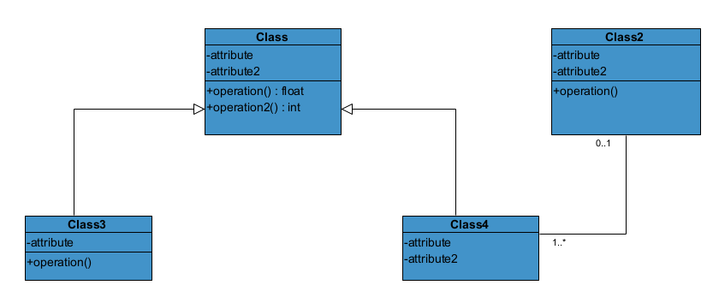
Formalism:
Figure 10 : formalism of class diagram

Class Diagram Elements Description
Element |  | Description
Class | 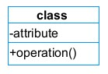 | Defines the attributes and behaviors that an object can generate (e.g. Farmer, Plot, Crop, SensorReading, Alert, Listing, Order).
Composition | 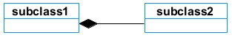 | If a parent of a composite is deleted, all its parts are usually deleted with it (e.g. Plot → SensorReading).
Aggregation | 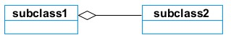 | If the parent of the aggregate is deleted, the children are not usually deleted (e.g. Farm → Farmer).
Dependency | 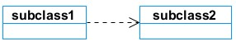 | Exists between two classes; if one changes, it may cause a change in the other.
Generalization | 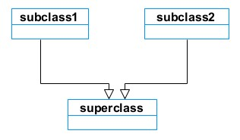 | A relationship between a superclass and a more specific subclass (e.g. User → Farmer / Expert / Administrator / Buyer).
Association | 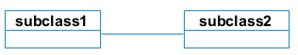 | A general relationship between elements, which may include cardinality and roles.

Candidate classes for the system include: User, Farmer, AgriculturalExpert, Administrator, Buyer, Farm, Plot, Crop, Sensor, SensorReading, Alert, DiagnosisRequest, Listing, Order, Payment, Notification.
[Insert here: System class diagram]

System class diagram

State Machine Diagram

Definition
A state machine diagram describes the behavior of a single object in response to a series of events in a system, modelling the dynamic flow of control from the state of a particular object.

Formalism:
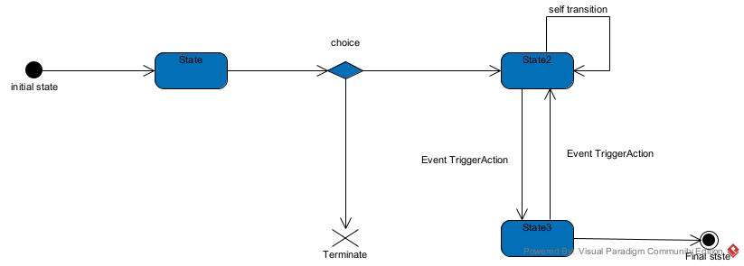
Figure 11: formalism of the state machine diagram

State Machine Diagram Elements
Element | Diagram Relationship | Description
State | 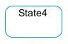 | Models a situation in which a certain invariant condition holds.
Initial State |  | Represents the default vertex, the source for a single transition to the default state.
Final State |  | A state specifying that the enclosing region is complete.
Transition | 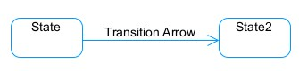 | A directed relation between a source and a target vertex.
Choice pseudo-state |  | A diamond symbol indicating a dynamic condition with branched outcomes.
Terminate | 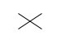 | Implies that the execution of a state by means of its context is terminated.
Diagram Overview | 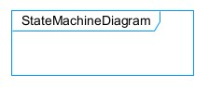 | A placeholder for the linked states in a state machine diagram.

Two candidate state machines: the Order (Placed → Paid → Confirmed → Delivered / Cancelled), and the Alert (Generated → Viewed → Resolved).

Crop Monitoring and AI Recommendation State Machine:
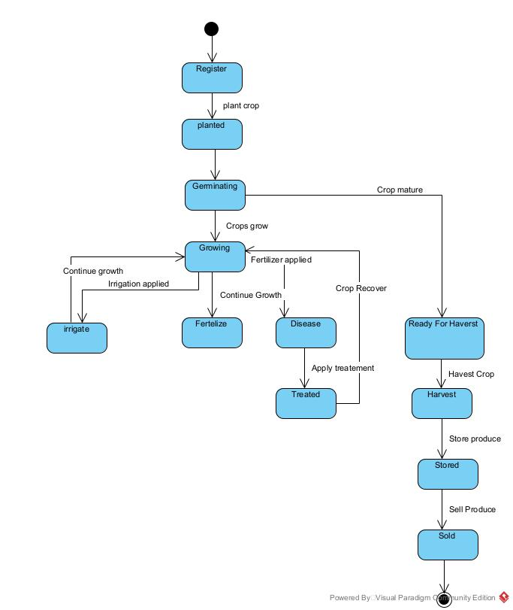

Market Place Purchase State Machine:
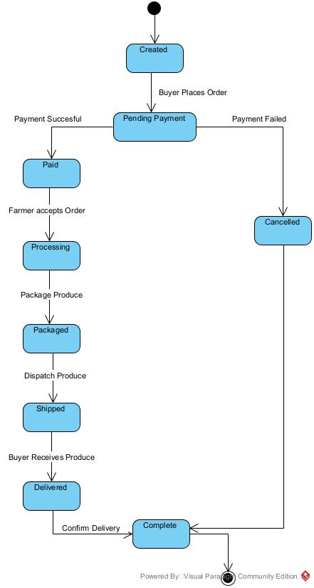

Authentication Behavioural State Machine:
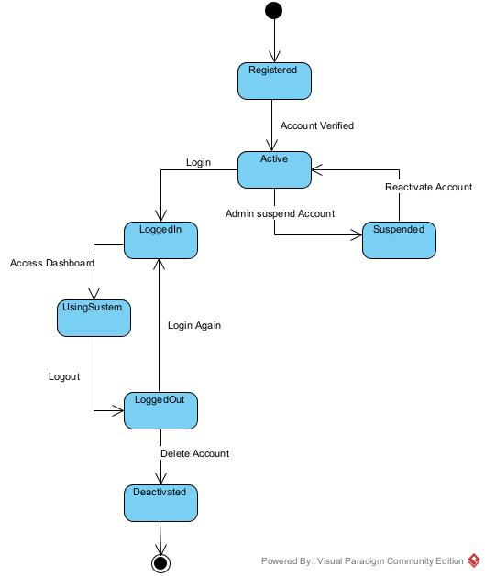

Package Diagram

Definition
A structural diagram used to show the organization and arrangement of various model elements in the form of packages — the grouping of related UML elements, such as classes, diagrams, or other packages.

Formalism:
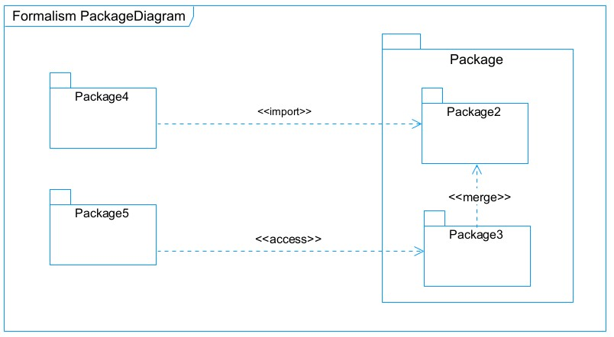
Figure 12: formalism of package diagram

Formalism for package diagram
Element |  | Description
Package | 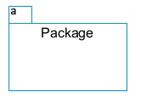 | A namespace used to group related elements into a better structure.
Package import | 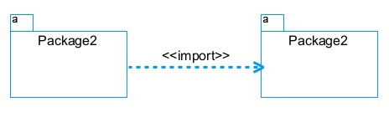 | Indicates that functionality has been imported from one package to another.
Package access | 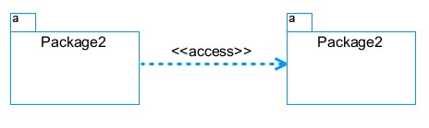 | Indicates that one package requires assistance from the function of another.
Package merge | 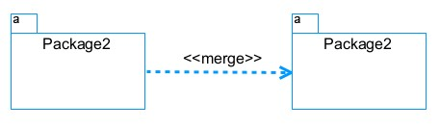 | Shows that the functionality of two packages is combined into a single function.
Candidate packages: Authentication & User Management, Farm & Crop Management, Monitoring & Alerts, AI Diagnosis, Marketplace & Payment, Notification.
[Insert here: System package diagram]

System package diagram
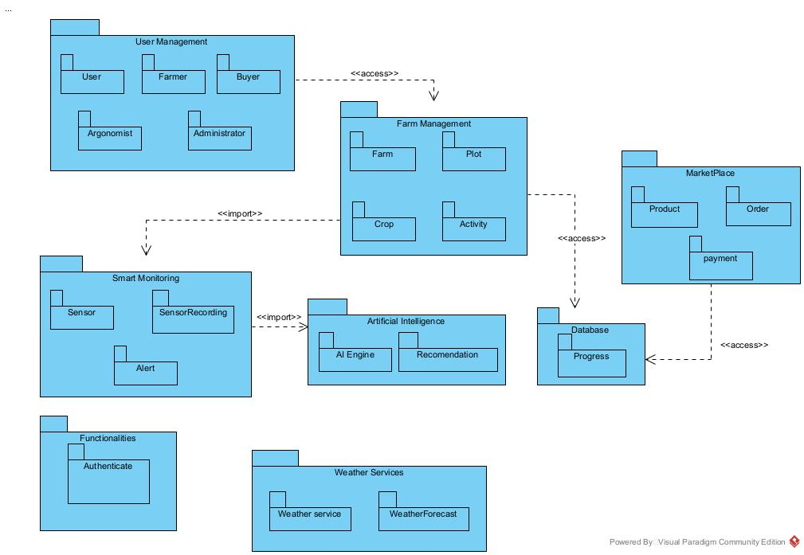

CONCLUSION
In the conception phase, the objective was to plan the different aspects of the system by showing how it will be structured and deployed. The technical constraints were taken into account, followed by identification of the system's components, their grouping, and their deployment targets. The next phase looks at aspects concerning the implementation of the system.

DOCUMENT FIVE : REALISATION PHASE

Preamble
In this phase, we will be forward in the implementation of our solution, we will base ourselves on the analysis and conception phases. Content
Content
INTRODUCTION
- PRELIMINARY CONCEPTION
- Component Diagram
- Deployment Diagram
- TECHNOLOGICAL CHOICES
- Material Choices
- Software Choices
- Technological Choices
CONCLUSION

INTRODUCTION
In the realization phase, the focus is on building or implementing the solution, based on the different analyses and conceptions carried out previously. This phase is as critical as the previous ones: the relationship between the entities of the entity-relationship diagram is examined, along with the technology choices used for implementation.

PRELIMINARY CONCEPTION:

Component Diagram:

Definition
Component diagrams model the physical aspect of a system — elements such as executables, libraries, files, and documents that reside in a node. The component diagram does not describe the functionality of the system, but the components used to implement it.

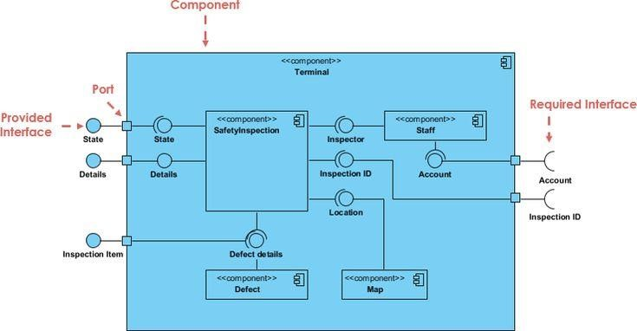
Formalism:

Element | Representation | Description
Component | 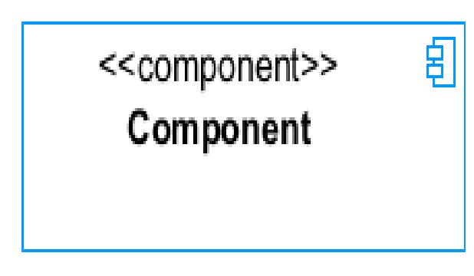 | A component is an abstract logical unit block of a system. It is represented as a rectangle with a smaller rectangle in the upper right corner, which serves as its icon for recognition.
Dependency | 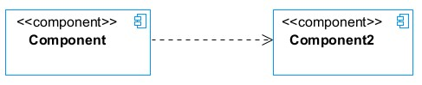 | A directed relationship showing that some components depend on others for correct functioning.
Interface | 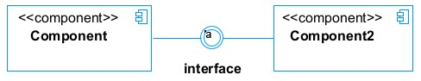 | Describes groups of operations provided or required by components.
Port | 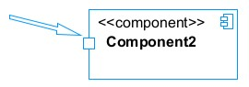 | Used when components delegate interfaces to an internal class.

System component diagram

Deployment diagram:

Definition
A deployment diagram is a structural diagram used to visualize the topology of the physical components of a system, where the software is deployed. It consists of nodes and their relationships, and is related to the component diagram, since components are deployed using the deployment diagram.

Formalism:

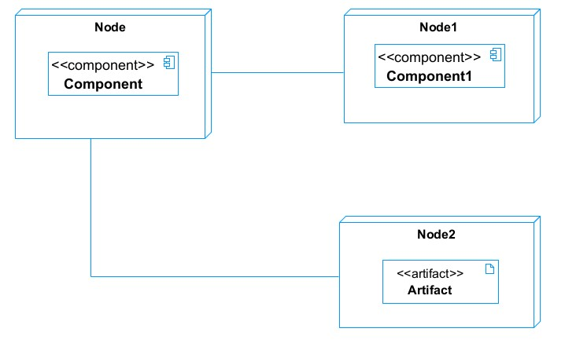

Elements of Deployment Diagram

Element | Representation | Description
Node |  | Hardware used to deploy the application (e.g. cloud server, sensor gateway, client device).
Artifact | 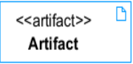 | A major product produced or used during development (e.g. data models, setup scripts).
Component |  | A modular, replaceable part of a system that encapsulates its content.
Association |  | Connects two nodes, allowing them to communicate.
[Insert here: System deployment diagram]

System deployment diagram

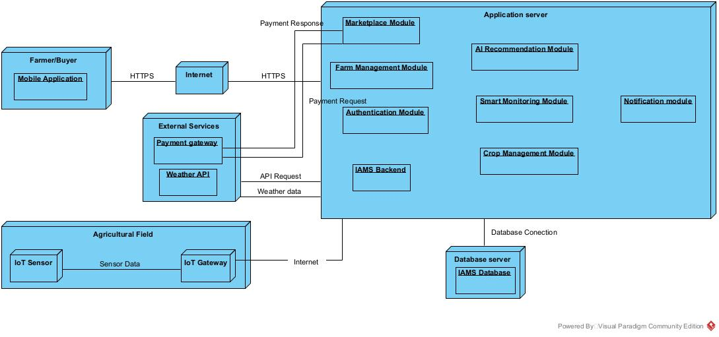

TECHNICAL CHOICES

Material | Quantity | Function | Image
FUJITSU | 1 | The computer was used for the programming of the microcontroller, the analysis, research, and the design of the system architecture. This was the main component of this project. | 
TECHNO | 1 | For testing app responsiveness | 

Software | Role | Reason for use | Image
OS  WINDOWS  10 | The operating system required to run the software is the one on which we have worked. | Windows 10 has a user-friendly interface that is familiar to many users, making it easy to navigate and use. | 
Visual Paradigm | The software engineering workshop is used for solution modelling. We utilized this tool for modelling the various diagrams of our system | . Supports multiple modelling languages and methodologies, making it suitable for various project requirements and enabling teams to adapt to different development processes. | 
Visual stAudio code | Visual Studio Code is a lightweight, open-source code editor developed by Microsoft, supporting multiple programming languages. Used for writing application code. | . Combines tools for version control, debugging, and terminal access in one interface, improving efficiency and reducing the need for multiple applications. | 

PostgreSQL | PostgreSQL is a popular open-source relational database management system | It is used to store and manage our data | 
MS Word | MS Word is a widely used word processing application that allows users to create, edit, and format text documents. Use in the creation of the report | Offers extensive options for formatting text, images, and layouts, enabling the creation of professional-quality documents. | 
MS PowerPoint | MS PowerPoint is a presentation software that allows users to create dynamic slideshows comprising text, images, videos, and animations. Able to create slideshow presentations for the application. | Its intuitive interface and templates make it easy for users to create professional presentations quickly, regardless of their technical skill level | 
Chrome | Google Chrome is a fast, secure, and user-friendly web browser developed by Google. Used to test our application UI | Chrome is optimized for fast page loading and efficient resource management, providing a smooth browsing experience. | 
GanttProject | GanttProject is a free, open-source project management tool that allows users to create Gantt charts for planning and scheduling projects | Allows users to assign tasks, set deadlines, and manage resources effectively, facilitating better project coordination and efficiency. | 
Openrouter | Opensource for ai models | Allows user to create and api key and used ai models | 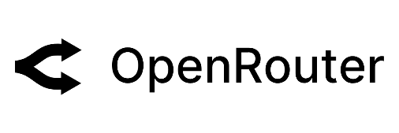

CONCLUSION
In this phase, the preliminary conception of the system (component and deployment diagrams) and the technical choices behind its realization were presented. The next phase presents the testing of the resulting functionalities

DOCUMENT SIX: TESTING OF FUNCTIONALITIES

Preamble
In this phase, we will present the various functionalities of our application.
Content
INTRODUCTION
- APPLICATION FUNCTIONALITIES
- TEST SHOWCASE
CONCLUSION

INTRODUCTION
Testing is a critical phase that verifies that the implemented functionalities behave as expected, matching the specifications defined in earlier phases. Each core functionality of the Intelligent Agricultural Management System was tested individually and in combination with related modules.

APPLICATION OF FUNCTIONALITIES
Module | Functionality | Expected Result
Authentication | Login with valid/invalid credentials | Valid credentials redirect to role-based dashboard; invalid credentials show an error.
Farm Management | Register plot and crop information | New plot/crop record is stored and visible on the Farmer's dashboard.
Monitoring | Record sensor reading | Reading is stored and displayed against the correct plot.
Alerts | Threshold crossed | Alert is generated and notification sent to the Farmer.
AI Diagnosis | Submit crop image | System returns a diagnosis suggestion or flags it for expert review.
Marketplace | List and order produce | Listing appears in the marketplace; order and payment update stock and status.
Administration | Manage user accounts | Administrator can create, edit, or deactivate accounts.

TEST SHOWCASE

Insert here: Screenshots of the login, farmer dashboard, alert notification, diagnosis result, and marketplace listing pages]

CONCLUSION
Testing confirmed that the core functionalities of the system behave as expected. Remaining edge cases and refinements are noted for future iterations, and the user guide that follows explains how to install and operate the application.

DOCUMENT SEVEN: USER GUIDE

Preamble
The purpose of the user guide is to provide users of our platform with step-by-step instructions on how to install and use the system.

Content

INTRODUCTION
- INSTALLATION
- USER GUIDE
CONCLUSION

INTRODUCTION
This section presents the tools to be installed and how they are to be installed to run the application without any problem, and how the different users will use the platform once the environment is set up.

INSTALLATION GUIDE

USER GUIDE
- The application only accepts authorized users. New farmer/buyer accounts are created through registration, and staff/expert accounts are created by the Administrator.
- On the landing page, the user clicks the login button to access the application, entering their credentials, after which they are redirected to their role-based dashboard.
- If logged in as Administrator: the dashboard displays system users and configuration options.
- If logged in as Farmer: the dashboard displays registered plots/crops, recent sensor readings, active alerts, and marketplace listings.
- If logged in as Agricultural Expert: the dashboard displays flagged diagnosis requests awaiting review.
- If logged in as Buyer: the dashboard displays available produce listings and order history.
- The Farmer can register a new plot and crop, submit an image for diagnosis, and create a marketplace listing from their dashboard.
- The Buyer can browse listings, place an order, and complete payment through the marketplace.
[Insert here: Screenshots for each step described above]

CONCLUSION
Having put the platform in place, it was necessary to produce a manual to help its various users. The tools to be installed and the way the system is used by each role have been presented, so that the environment can be set up and operated without difficulty.

PERSPECTIVE
To further improve the application, the following perspectives are considered:
- Integrate real IoT hardware (soil moisture, temperature, and humidity sensors) for live field deployment, rather than simulated readings.
- Improve the AI diagnosis module with a trained image-classification model for common regional crop diseases.
- Add a mobile app (Android/iOS) for offline-capable field use.
- Extend the marketplace with logistics/delivery tracking.
- Add multilingual support beyond French/English for wider regional adoption.

GENERAL CONCLUSION

This academic project, undertaken as part of the requirements of the Software Engineering program at AICS Cameroon (BA2A, Group 9), provided an opportunity to apply theoretical knowledge to a real-world agricultural challenge. The theme, "Design and Implementation of an Intelligent Agricultural Management System (IAMS)", focused on addressing the inefficiencies of manual farm administration in Cameroon, where processes such as environmental monitoring, pest/disease detection, and market access remain largely manual and reactive.
To solve these issues, a web-based platform was designed, integrating features such as farm and crop management, sensor-based monitoring with automated irrigation alerts, AI-assisted pest/disease diagnosis, and an integrated marketplace with mobile money payment.
The project achieved its objectives, which included:
- Analyzing the shortcomings of existing manual farm management practices.
- Specifying functional and technical requirements.
- Designing the system using UML based on the 2TUP methodology, complemented by a MERISE-based data model.
- Designing the core functionalities for each user role (Farmer, Agricultural Expert, Administrator, Buyer).
The resulting Intelligent Agricultural Management System provides a foundation for a secure, efficient, and scalable solution, tailored to the realities of Cameroonian agriculture but adaptable to broader contexts. Future enhancements may include real IoT hardware integration, AI-driven yield prediction, and mobile app deployment for nationwide accessibility. This project strengthened skills in system design, database management, and web application development, while highlighting the transformative role of digital solutions in improving agricultural management.

ANNEXE

[Insert here: any additional supporting material, e.g. database schema (MCD/MLD), extended tables, questionnaire used for the existing-system study]

9

BIBIOGRAPHY

- UML course, AICS-Cameroon, 2025-2026.
- Scientific Writing course, AICS-Cameroon, 2025-2026.
- [Add any other course notes or reference material used]

WEBOGRAPHY

- https://www.php.net
- https://dev.mysql.com/doc/
- https://aws.amazon.com/ec2/
- [Add any other web resources consulted]

TABLE OF CONTENTS

