WMS Looping Widget for ArcGIS Viewer for Flex 2.x, 3.x

# Introduction

Here are instructions for using the accompanying widget source and object code files for displaying a series of WMS (Web Map Service) layers. This widget has been tested and found to work with ArcGIS Viewer for Flex 2.1 through 2.5 and 3.0 through 3.6.

This widget’s main goals are twofold. From a user experience perspective, it provides a way to watch the way NEXRAD radar reflectance weather data has changed over a given region in the previous hour. Technically, it demonstrates how to load and display a series of temporally related WMS layers using the ArcGIS Flex API.

These instructions assume you have successfully set up a running instance of ArcGIS Viewer for Flex 2.x; you can find assistance here:

<http://help.arcgis.com/en/webapps/flexviewer/help/gettingstarted.htm>

Thanks go to Jim Westman of Esri for the initial concept and implementation of this functionality.

# Use with Application Builder

The widget files compiled for Viewer versions 2.4 through 3.0 and for Viewer version 3.3 can be used with the Application Builder utility (these directories within the distribution .zip are labeled “AppBuilder compatible”). ***You’ll need to extract the bundled zip file from the archive onto your disk.*** In AppBuilder, go to Settings > Advanced Settings > Manage Custom Widgets; click the “Add” button and browse to the .zip file you extracted. You should see a message confirming the widget was added, after which the widget’s cloud icon should show up in the list of available widgets.

# Installation into a running instance of ArcGIS Viewer for Flex

You may install and use the widget without loading it into the Flash Builder development environment or compiling it. This section describes how to add the supplied, compiled modules into an existing instance of ArcGIS Viewer for Flex 2.x. You can obtain it here:

<http://help.arcgis.com/en/webapps/flexviewer/index.html>

Copy the supplied directory “widgets\WMSLooping” into your Viewer’s “widgets” subdirectory. Note that there are two versions of the “compiled modules” directory: one for FlexViewer/Flex API versions 2.1 through 2.3.1, and another one for version 2.4. Copy the appropriate version for your installed FlexViewer and Flex API version. Don’t copy the one underneath “**WMS Looping - compiled modules**” unless you want to work with the project in Flash Builder (see the following section, below).

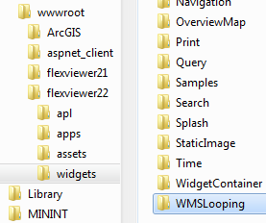

Now you’ll need to make sure there’s an entry for the widget in the Viewer’s main config file. The easiest way is to use the one supplied underneath “compiled modules”: copy it over your Viewer’s “config.xml” file.

If you prefer modifying your Viewer’s existing config.xml to replacing it, just add the following entry to the “widgetcontainer” section:

<widget label="NEXRAD Reflectance"

icon="widgets/WMSLooping/assets/images/widget.png"

url="widgets/WMSLooping/WMSLoopingWidget.swf"

config="widgets/WMSLooping/WMSLoopingWidget.xml"

preload="open"/>

Now that config.xml points to the new widget, open the Viewer in a browser. You may need to refresh the browser cache and reload to see the widget appear.

# Installation – Source Code

Source code for this widget is available under the supplied directory “WMS Looping - code”. This code is not a standalone project, but is meant for inclusion into an existing Viewer project. Ensure that the ArcGIS Viewer for Flex 2.2 project is open in Flash Builder.

First, you’ll need to add the source directory to the Viewer project build path. Open the project properties in Flash Builder; then choose the “Flex Build Path” item. Under the “source path” tab, click “Add Folder…” and browse to the location of the supplied code directory.

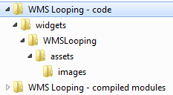

Once you click OK, it should show up in your project’s build path list:

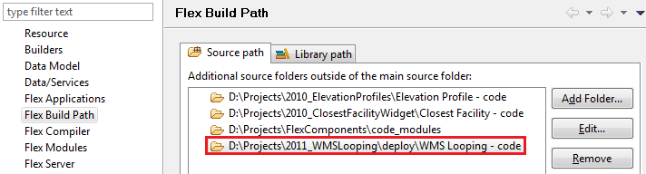

Next, you must add the widget to the project’s modules list using the Project Properties > Flex Modules dialog page. You’ll need to use the “Add…” button and dialog to choose this file: **WMS Looping - code\widgets\WMSLooping\WMSLoopingWidget.mxml**

You can choose to have the module optimized for the index.html project, or compile it unoptimized. Since this module likely won’t be useful in any application other than the Viewer app, it’s better to have it optimized.

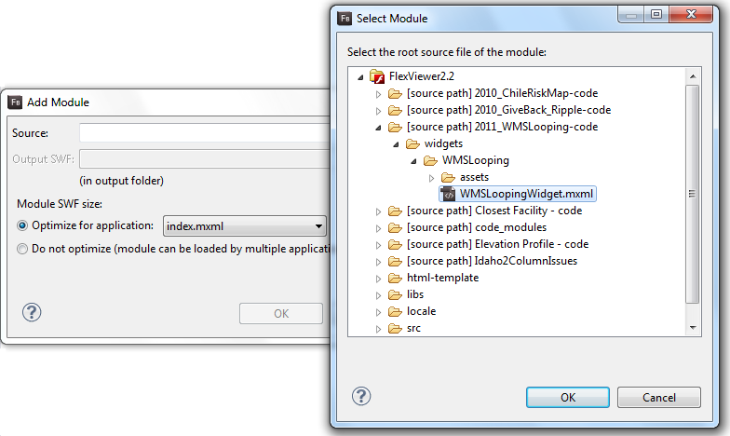

# Usage

With the widget properly installed, configured, and running, you should see a small widget interface show up in the Viewer app, along with radar reflectance images:

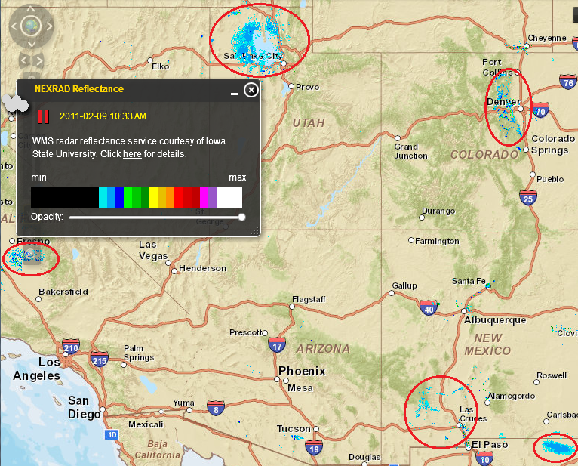

If there happens to be little or no current data for your chosen extent, try panning or zooming the map; you should eventually see some imagery show up. (Note: the app is preconfigured to use a data service covering only the United States.)

The configured images will display one-by-one at a set interval (two seconds by default). The area to the left of the yellow date/time stamp acts as a toggle button; click it to pause or resume the display.

The horizontal tracker control at the bottom of the dialog controls the transparency of the images displayed onscreen—this may be useful to see base map features hidden under large areas of intense weather activity.

# Configuration File

The configuration file for the widget (as opposed to the main Viewer-wide configuration file) is located in the same directory as the *.swf* or *.mxml* file. It’s quite basic, containing only a few options:

* *url*: The URL for the WMS service that provides images for this widget to display.
* *version*: The version of the WMS specification to be used.
* *imgFormat*: The format of the images to be retrieved and displayed. The default is “png”, a good choice for its support of transparent sections within the image. For more information, see:  
  [http://help.arcgis.com/en/webapi/flex/apiref/com/esri/ags/layers/WMSLayer.html#imageFormat](http://help.arcgis.com/en/webapi/flex/apiref/com/esri/ags/layers/WMSLayer.html%23imageFormat)
* *dateFormatString*: How each image’s retrieval date and time will be displayed by the widget. For more information, see:  
  <http://help.adobe.com/en_US/FlashPlatform/reference/actionscript/3/mx/formatters/DateFormatter.html#formatString>
* *layersToRotate*: A list of image sublayers, hosted by the WMS service, to display in a rotating fashion. These layer names depend on the chosen WMS service; you will need to examine the result of a “getCapabilities” call to the WMS service to determine which layer names are supported and valid. The “offsetMins” attribute determines the order in which the layers are displayed; the given number of minutes will be subtracted from the time the service was queried in order to determine the date and time displayed by the widget for each layer.
* *timerMsPerLayer*: The number of milliseconds to show each layer before moving on to the next one in succession.
* *startUpState*: Whether the widget should start in a running or paused state.
* *opacityDefault*: How opaque the layer is when the app starts up (0 = transparent, 100 = opaque).
* *about*: Descriptive text to be displayed in the body of the widget. This should briefly describe the layers being shown.
* *legend*: These items direct the widget to retrieve and display a given image that serves as a legend for the images. If “visible” is set to false, the legend will not be displayed and the other legend settings will be ignored.