**Airline Reservation System**

1. **Introduction**

In today’s airline industry users or customers can reserve seat or book flight as long as they are connected to internet. The innovation of technology has made travelling in the air easier for customers with airline reservation system. Thousands of people flock the airline industry these days so that they can arrive their destination within a short period of time. Through this airline reservation system, customers can reserve seat, book flight and set the date if their departure and arrival using the internet. Customers can choose the place they want to go here in the Philippines. This system contributed to fundamental changes in the structure of the industry. The places available in this system are Bacolod, Batanes, Cebu, Davao, and Palawan. In the database, the flight schedule on different routes and aircraft seating capacity is stored. Along with their deposits and their accounts. The system ensures the security of the customers. The airline reservation system take pride in monitoring, administration and maintenance of the database environment using MySQL.

1. **Objectives**

The objectives of this system are:

1. To help the customers in reserving air tickets through online system
2. To implement the airline reservation system to the best satisfaction of the customer
3. Use database MySQL to facilitate this process

The normal process of this system is to fill the data and then process the data which used to cause a lot of inconvenience to both the administrator and customers. In using databases, the reservation of airline tickets will be facilitated. The airline reservation system can be presented in views of the different involved with it. These are the administrator and customer.

1. **Sections**
2. **Administrator Page**

The administrator is the one responsible for managing and monitoring the system. The administrator must do the following:

* Check available flights
* By choosing the displayed flight number, the administrator may now be able to view the flight details of the customer
* Check the number of reservations per flight
* Schedule of all flights
* List and status of passengers

1. **Client Page**

The customer needs to know the following information:

* Availability of flights to the destination from the departure
* Reservation status for a particular flight
* Ticket price
* Different booking counters available and their addresses
* Status if it is confirmed or still in waiting list

1. **Gantt Chart**
2. **Graphical User Interface**

**Customer Sign Up**

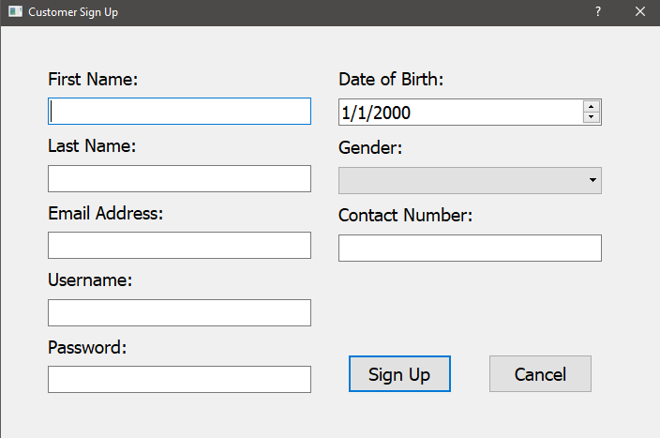

**Dialog**

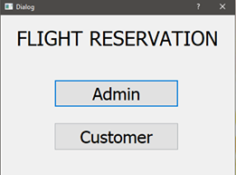

**Flight Reservation System**

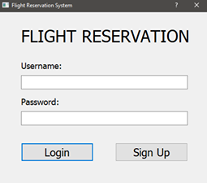

**Main Window**

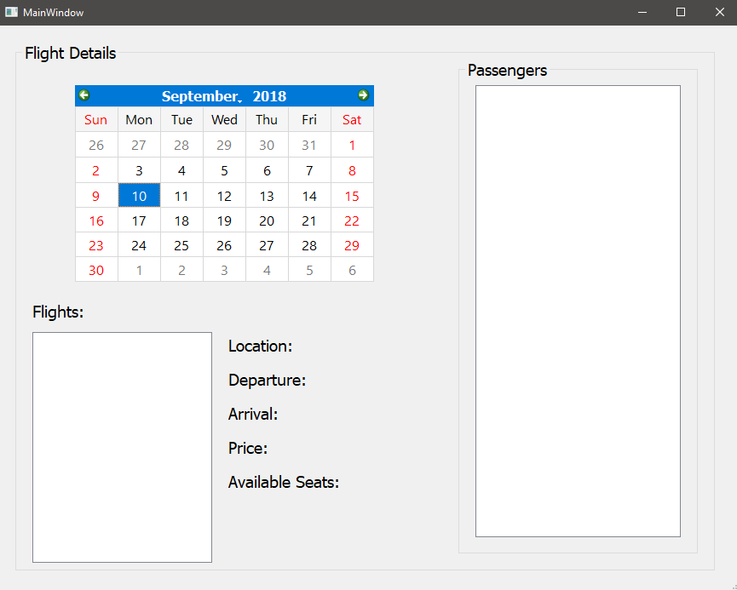

1. **Use Case Diagram**
2. **Test Case Diagram**
3. **Partial Codes**
4. **Sprint 1**
5. **Errors Encountered**
6. **Recommendation**
7. **Conclusion**