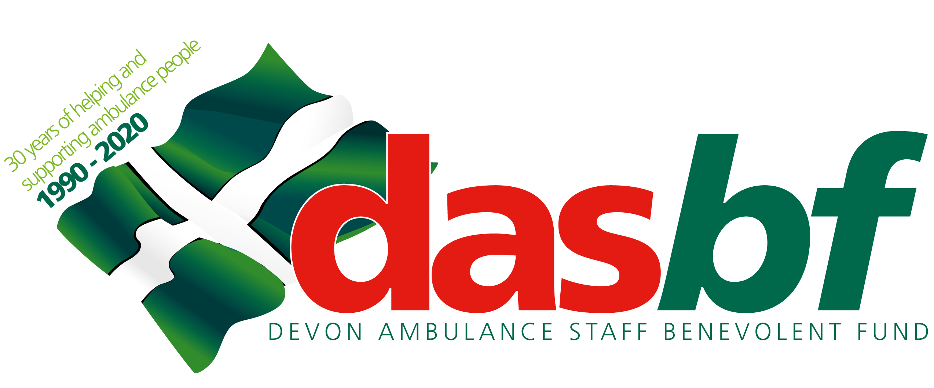
CHANGE OF DETAILS FORM
Use this form to notify the DASBF of any changes in your membership information or to change to your subscription level.
Please complete and return your form to Donna Bamford.
DASBF. Trust HQ. Unit 2, Abbey Court, Sowton Industrial Estate. Exeter. EX2 7HY.

Title: Mr / Miss / Mrs / Ms / Dr (please circle)

Surname: _ _ _ _ _ _ _ _ _ _ _ _ _ _ _ Forename(s): _ _ _ _ _ _ _ _ _ _ _ _ _ _ _ _ _ _ _ _ _

Pay Number _ _ _ _ _ _ _ _ _ _ _ _ _ _

Details of Change, e.g.
Name, Home address, Email address, Phone number, Base, Job title, Anticipated retirement date, Beneficiary.

Current information held by DASBF | Updated information.

Please note, if you change contracts from Permanent to Bank you are not eligible for DASBF membership.

Please tick the correct box below to indicate your required subscription:

Standard (£3 per month)

Standard plus the Lottery (£5 per month)

I hereby confirm the above change to my details and authorise monthly deduction from my salary, in the amount indicated above, to be paid to the Devon Ambulance Staff Benevolent Fund until further written notice.

Signed: _ _ _ _ _ _ _ _ _ _ _ _ _ _ _ _ _ _ _ Date: _ _ / _ _ / _ _ _ _

Data Protection Statement Your personal information is used only for administration purposes by the DASBF. We will not divulge it to anyone else without first gaining your consent.

