BURREN SUB AQUA CLUB  SNORKEL / DIVE PLAN  January 2017 | 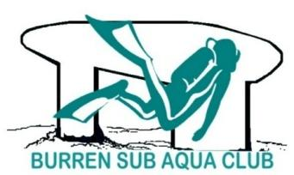

A kitted brief should take place 15 mins before dive departure times

Date |  | Venue | Time | DOD |  |  | Cox’n | HW | LW
Note: Please check with the DOD if in doubt about conditions, particularly with strong westerly winds.

All members: if you intend to dive, please text the relevant DOD by 18.00 on the preceding Friday (Sunday dives), or by 18.00 hours on the preceding Monday (Wednesday dives). This allows DODs time to plan dives and make alternative arrangements if necessary. Divers who text after the deadline will be assigned a dive only if space allows, to be treated on a first come, first served basis.

DODs / Dry Cox’ns: if you are unavailable for your slot, please arrange a swap yourself with someone else in good time and text me the new arrangement. Please text members of a DOD change to avoid confusion.

DODs / Dry Cox’ns: please communicate and check with James/Tony in good time that he is available to bring the boat to the dive site, and make alternative arrangements if necessary.

Members undertaking dives outside the dive plan should inform me; otherwise, they cannot be regarded as club dives for insurance purposes.

LIFE JACKETS MUST BE WORN ON THE BOAT

DODs: ALL DIVE LOGS MUST BE FILLED AND RETAINED. PLEASE PLACE IN THE JEEP WHEN COMPLETED.
DOD / COXN Telephone Numbers:
Brian O’Leary – 086 1735559 |  |  |  |  |  | Tadhg O’Brien – 086 8180044
Cormac McMahon – 086 8119068 |  |  |  |  |  | John Underhill – 087 7537738
James McMahon – 087 6898005 |  |  |  |  |  | Caroline Hartigan – 087 2334748
Mary O’Donnell – 087 9845073 |  |  |  |  |  | Mark Gray – 085 7127021
Alex McMahon – 086 8795949 |  |  |  |  |  | Kirill Rybalchenko – 087 9605976
Gudrun Michel – 086 3228028

