**Date:** 22 January 2020

**Task:** rfgrid 4x4 module re-design

**Time Spent on Task:** 8hrs

I’m starting off by documenting the re-design process of my original 4x4 rfgrid module. Using what I’ve learned from constructing the original prototype, I want to create a 4x4 module that can content with all 16 readers using an on-board microprocessor, which will then communicate with a master microcontroller to relay the information to the host machine.

I want to start with designing my own rfid reader which uses the MFRC522 IC and incorporate it directly into the 4x4 module unlike the previous version, which used off the shelf RFID readers made by RobotDyn.

### Interfacing with the MFRC522 IC:

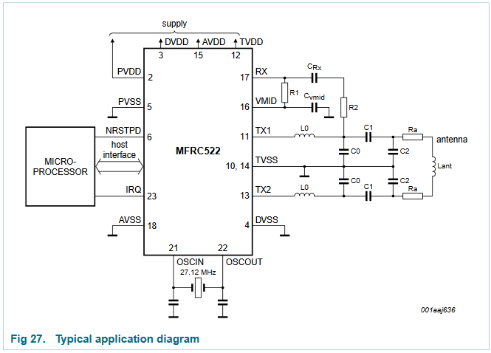



This is a typical pin configuration to interface one MFRC522 to a microcontroller. If I want to continue to use SPI, I need to also used the additional pins shown in Fig 7 (which are a stand in for the two way bus depicted in Fig 27 as “host interface”.

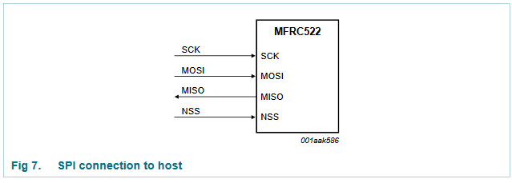

According to Table 5, The pins I’m interested in *<pin name>(pin #)* are SDA(24), D7(31), D6(30) and D5(29).

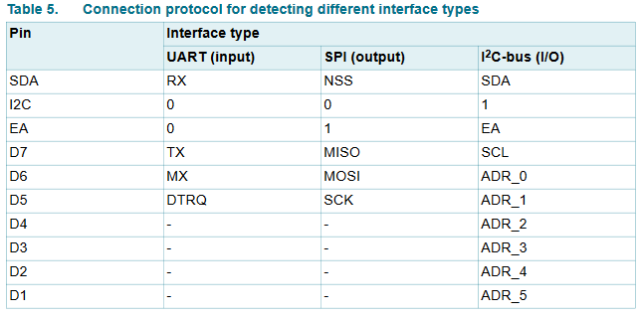

The following table shows what pins of the mfrc522 need to be considered in order to use SPI communication as the host interface:

|  |  |  |  |  |
| --- | --- | --- | --- | --- |
| **Pin Name** | **Number** | **Type** | **BASELINE** | **SPI** |
| I2C | 1 | I |  | TRUE |
| PVDD | 2 | P | TRUE |  |
| DVDD | 3 | P | TRUE |  |
| DVSS | 4 | G | TRUE |  |
| PVSS | 5 | G | TRUE |  |
| NRSTPD | 6 | I | TRUE |  |
| MFIN | 7 | I |  |  |
| MFOUT | 8 | O |  |  |
| SVDD | 9 | P |  |  |
| TVSS | 10 | G | TRUE |  |
| TX1 | 11 | O | TRUE |  |
| TVDD | 12 | P | TRUE |  |
| TX2 | 13 | O | TRUE |  |
| TVSS | 14 | G | TRUE |  |
| AVDD | 15 | P | TRUE |  |
| VMID | 16 | P | TRUE |  |
| RX | 17 | I | TRUE |  |
| AVSS | 18 | G | TRUE |  |
| AUX1 | 19 | O |  |  |
| AUX2 | 20 | O |  |  |
| OSCIN | 21 | I | TRUE |  |
| OSCOUT | 22 | O | TRUE |  |
| IRQ | 23 | O | TRUE |  |
| SDA | 24 | I/O |  |  |
| NSS | 24 | I |  | TRUE |
| RX | 24 | I |  |  |
| D1 | 25 | I/O |  |  |
| ADR_5 | 25 | I/O |  |  |
| D2 | 26 | I/O |  |  |
| ADR_4 | 26 | I |  |  |
| D3 | 27 | I/O |  |  |
| ADR_3 | 27 | I |  |  |
| D4 | 28 | I/O |  |  |
| ADR_2 | 28 | I |  |  |
| D5 | 29 | I/O |  |  |
| ADR_1 | 29 | I |  |  |
| SCK | 29 | I |  | TRUE |
| DTRQ | 29 | O |  |  |
| D6 | 30 | I/O |  |  |
| ADR_0 | 30 | I |  |  |
| MOSI | 30 | I/O |  | TRUE |
| MX | 30 | O |  |  |
| D7 | 31 | I/O |  |  |
| SCL | 31 | I/O |  |  |
| MISO | 31 | I/O |  | TRUE |
| TX | 31 | O |  |  |
| EA | 32 | I |  | TRUE |

There is a guide referenced in the data sheet. “Micore Reader IC Family; Directly Matched Antenna Design”. There are three methods covered. The first method uses the directly matched antenna approach. I think that

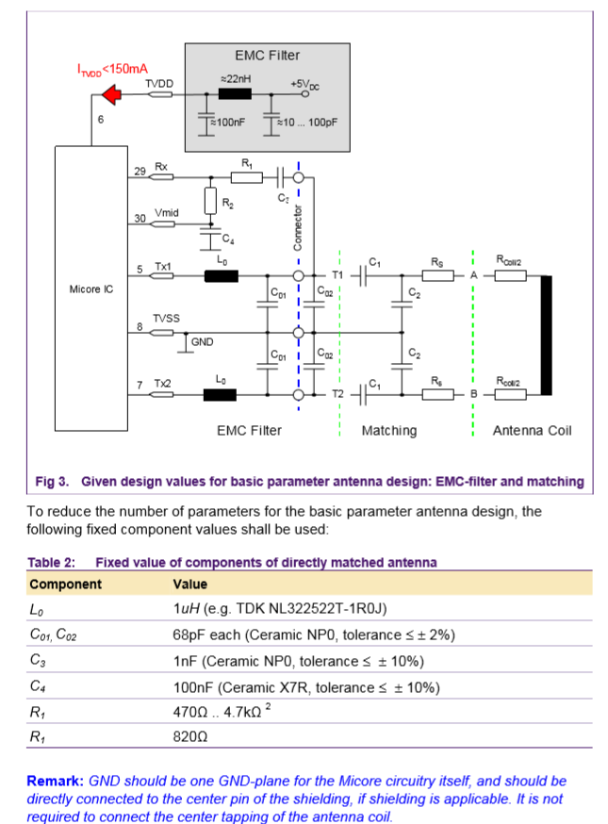

The robotdyn readers seem to use these values. The value of R1 used is 1K, and using the following antenna calculator as an approximation. I calculated the coil inductance:

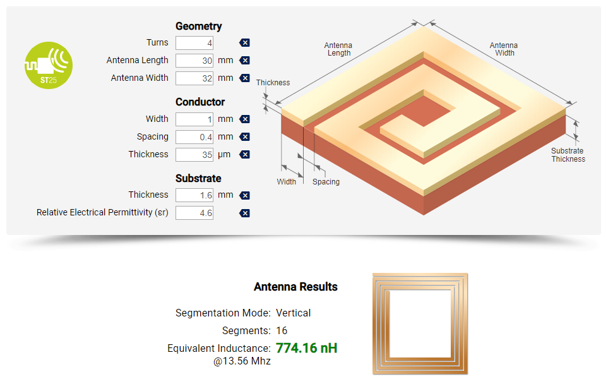

Then I used the calculator provided by NXP. And calculated the values for the matching circuit:

I chose Q to be 30 based on a design note in the matched antenna design on pg 12. I set the fres filter to 14.400 MHz based on the application note (4.1.2 pg 22). And used the default R-Match value of 43 ohms.

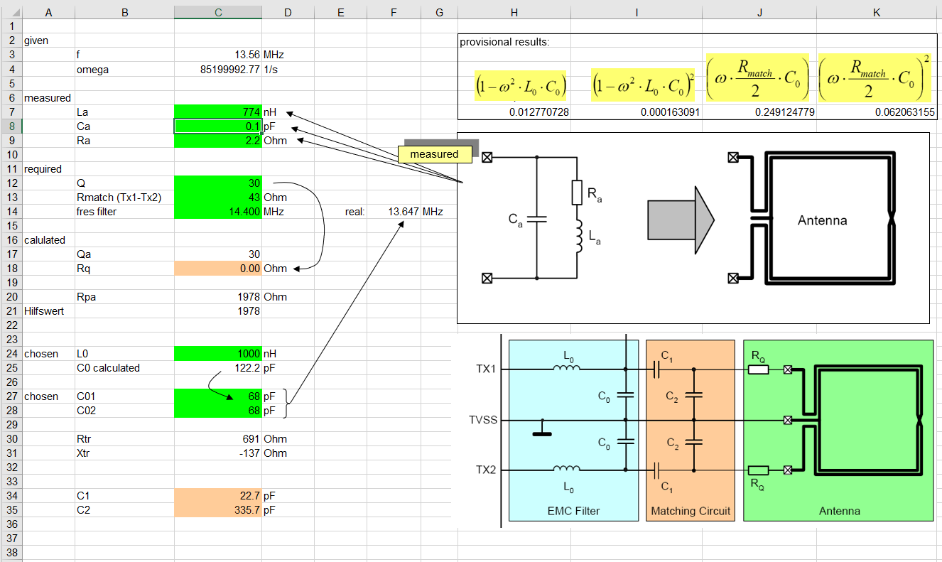

SO, if I measure the components on the robotdyn reader, I should get the following:

